ODESA I.I. MECHNIKOV NATIONAL UNIVERSITY
FACULTY OF ECONOMICS AND LAW
DEPARTMENT OF MARKETING AND BUSINESS ADMINISTRATION

Qualification project (thesis)
for obtaining the degree of higher education "master"
«The Implications of Digital Technologies on Management Practices in Chinese Companies»
«Вплив цифрових технологій на управлінську діяльність в китайських компаніях»

Performed by: full-time student
specialty 073 Management
Educational and professional program
"Management"
Li Yu / Лі Ю

Scientific supervisor: Doctor of Economics,
Prof. Hrinchenko Yu. L.
Reviewer: Doctor of Economics,
Prof. Zapsha H. M.

Recommended for defense:  protocol of the department meeting  No. ___ dated ____.____. 2024  Head of Department  (signature) | Defended at the EC meeting No. ___  protocol No. __from ____.12.2024  Assessment ______________/___  (according to the national scale/ESTS scale/points)  Head of the EC  _______  (signature)

Оdesa 2024

CONTENTS
INTRODUCTION 3
CHAPTER 1 6
THEORETICAL FOUNDATIONS OF BUSINESS MANAGEMENT UNDER DIGITAL TECHNOLOGY
1.1. Research background and significance 6
1.2 Research contents and methods 15
CHAPTER 2 20
OVERVIEW OF SHANDONG AEROSPACE SPECIAL VEHICLE COMPANY LIMITED
2.1 Overview of Shandong Aerospace Special Vehicle Company Limited 20
2.2 Value chain system of shandong aerospace special vehicle company limited under digital transformation 30
2.3 Internal value chain cost management implementation process under digital transformation 34
CHAPTER 3 47
ANALYSIS ON THE IMPLEMENTATION EFFECT OF VALUE CHAIN COST MANAGEMENT UNDER DIGITAL TRANSFORMATION OF SHANDONG AEROSPACE SPECIAL VEHICLES
3.1 Research and development function in value chain 47
3.2 Effect analysis of external value chain cost management 58
3.3 Comprehensive evaluation of value chain cost management effect based on entropy method 64
CONCLUSION 72
REFERENCES 78

INTRODUCTION

Relevance. The pervasive adoption of digital technologies has emerged as a crucial catalyst for boosting enterprises' innovative capacity and fostering economic growth of high quality. Globally, nations are accelerating the advancement, with digital transformation emerging as a novel strategy for enterprises to bolster their competitiveness. China, in recent years, has enacted pertinent digitalization policies, guiding traditional industries toward digital transformation. The construction machinery manufacturing sector plays a vital role significantly contributes to China's economic progress. Currently, amidst the rise of novel technologies, the traditional construction machinery manufacturing sector is encountering unprecedented challenges, prompting industry to align with this trend and progressively shift towards intelligent development.
In enterprise management, cost control is a pivotal aspect, closely tied to the overall efficiency and governance standards of the organization. Digital technology to facilitate the transformation and upgrading of manufacturing industries and enhance value chain cost efficiency holds immense importance for both daily operations and long-term corporate growth. Shandong Aerospace Special Vehicle Co., Ltd., a prominent player in the special vehicle industry, embarked on its digital journey many years ago. It developed a digital platform, established a digital system, continually refined the entire product production and manufacturing process, and attained remarkable outcomes in value chain cost optimization. Given this backdrop, this paper employs the case study method, with Shandong Aerospace Special Vehicle Co., Ltd. as the focus, to delve into its value chain cost management strategies within the framework of digital transformation.
Analysis of recent research and publications. This paper begins by reviewing pertinent literature and integrates transaction cost theory, value chain theory, value chain cost management principles, and strategic management accounting frameworks to lay a theoretical groundwork for the study. In the case study section, it presents the corporate background of Shandong Aerospace Special Vehicle Co., Ltd., detailing its digital transformation journey and the restructured value chain. Subsequently, the paper delves into the implementation strategy and impact assessment of cost management across various segments of Shandong Aerospace Special Vehicle Co., Ltd.'s internal and external value chains during its digital transformation. For the impact assessment, critical cost indicators are chosen to evaluate the effectiveness of cost management in each segment of the internal and external value chains. Furthermore, the entropy method is utilized to conduct a holistic evaluation, capturing the overall impact of value chain cost management and its influence on the overall operational efficiency of Shandong Aerospace Special Vehicle Co., Ltd.
Goal and tasks.The purpose of the research is theoretical and methodical substantiation of the provision of a strategic management system in Chinese companies.
Research objectives and tasks. The aim to furnish theoretical and practical guidance for management frameworks in Chinese enterprises, particularly focusing on the digital transformation phase. To accomplish this objective, the study outlines the following tasks:
- Learning the theoretical foundations of digital technologies;
- Analyze the tools that support digital technologies in the context of global challenges;
- Exploring models and methods that can support the digital transformation of enterprises;
- To analyze the management systems of Chinese enterprises;
- To develop a planning system algorithm suitable;
- To propose a comprehensive management mechanism suitable.
Research Object and Research Theme. The focus of this study is on the management systems of Chinese enterprises. The central theme revolves around exploring the theoretical foundations, methodological approaches, and practical implementations of managing these enterprises during their digital transformation process.
Research Methods.This study adopts general scientific methods, including literature research, case study and uses the entropy method for comprehensive evaluation. These methods help to address provide a comprehensive perspective for analyzing the practice of value chain cost management in Chinese companies during digital transformation
Thesis Structure and Content Scope. This thesis comprises an introduction, five chapters of content, a conclusion, and a bibliography with 39 references. It spans a total of 89 pages, inclusive of 12 tables and 1 chart. The opening chapter introduces the backdrop and importance of the study, elucidating the interplay between digital transformation and value chain cost management. The second chapter delves into the specifics of Shandong Aerospace Special Vehicle Company Limited's fundamental status, discusses the impetus behind Shandong Aerospace Special Vehicle Company Limited 's decision to embark on digital transformation, and dissects its value chain system under this transformation. The third chapter centers on Shandong Aerospace Special Vehicle Company Limited 's implementation of value chain cost management during its digital transformation. Chapter 4 compiles and examines cost data from each segment following Shandong Aerospace Special Vehicle Company Limited 's digital transformation, assessing the tangible outcomes of its value chain cost management. Chapter 5 summarizes Shandong Aerospace Special Vehicle Company Limited 's key accomplishments and lessons learned throughout its digital transformation journey, offering pertinent managerial insights.
Through this research endeavor, the paper had integrated digital transformation with value chain cost management, adopting a construction machinery industry perspective to provide a tangible example of how value chain cost management could be effectively applied during the digital transformation process within this sector. Furthermore, it was anticipated that the insights and discoveries presented in the paper would serve as a valuable resource and guidance for similar enterprises that had sought to embark on digital transformation and implement value chain cost management strategies.

CHAPTER 1

THEORETICAL FOUNDATIONS OF BUSINESS MANAGEMENT UNDER DIGITAL TECHNOLOGY

1.1. Research background and significance

Since the 21st century, the rapid development of digital technology has led the world into a new era of the industrial revolution. This revolution has not only changed the industrial structure, but also profoundly affected the management practices of enterprises. Emerging digital technologies have become key tools to drive business transformation and innovation. In this context, digital technologies have not only redefined the innovation model of products and services, but also reshaped the management style, organizational structure and operational processes of enterprises. By introducing digital technology, enterprises not only improve their management efficiency, but also gain new development opportunities in global competition.
At the macro level, the widespread application of digital technologies has brought the global economy into a new era of digital economy, and enterprise management has experienced significant transformations throughout the process.The rapid advancement of technologies like artificial intelligence, cloud computing, big data, and blockchain has driven the intelligent transformation of production, supply chain, marketing and customer service. Enterprises' decision-making processes have increasingly relied on data., management models tend to be flattened and flexible, and informatization and intelligence have become the core force driving efficient operations. In China, the government attaches great importance to the growth of the digital economy and has successively introduced policies to encourage enterprises to carry out digital transformation and support the intelligent upgrading of manufacturing and service industries through the construction of digital infrastructure.
At the meso level, the manufacturing industry, as the cornerstone of China's economy, has demonstrated the far-reaching impact of digital technology on management practices during the process of digital transformation. As global competition intensifies, traditional manufacturing enterprises face multiple challenges such as rising costs, lack of innovation, and uneven quality. Enterprises urgently need digital technology to optimize management processes, improve productivity, reduce costs and enhance market competitiveness. Digital technology facilitates automation of production processes, but also provides real-time and accurate information for decision-making through data analytics on a large scale, which enables enterprises to adjust their strategies more flexibly and respond quickly to market changes. Despite the numerous benefits digital technology offers to enterprise management, many Chinese manufacturing firms continue to struggle with issues like inefficient resource allocation, outdated management models, and inadequate cost control during their transformation journey. To tackle these challenges, enterprises must expedite digital transformation, modernize traditional management models, and restructure various in the value chain to align with evolving market demands.
At the micro level, this paper will focus on the digital transformation initiatives of Shandong Aerospace Special Vehicle Co., Ltd., a leading company in the field of special vehicles in China. Shandong Aerospace Special Vehicle Co., Ltd. is among the enterprises that embarked on digital transformation earlier in the country. As an industry pioneer, the company has significantly optimized its operational efficiency and management processes through the implementation of smart manufacturing, digital management, and technological innovation. Driven by digital transformation, Shandong Aerospace Special Vehicle Co., Ltd. has not only enhanced its production efficiency but also improved resource allocation and supply chain management by leveraging computing technologies, while reducing production costs and bolstering profitability and risk management. The successful experience of Shandong Aerospace Special Vehicle Co., Ltd. demonstrates that digital transformation can not only bolster the core competitiveness of enterprises but also effectively foster innovation and optimization in management modes.
As digital technology rapidly advances, especially driven by artificial intelligence, big data, cloud computing, the Internet of things,other technologies, the global economy is entering a new era of digitization and intelligence. This change not only promotes the optimization and adjustment of industrial structure, but also profoundly affects the management practices of enterprises. Decision-making process, cost control, resource allocation, etc. is still insufficient. Specifically, The extensive use of digital technology has given rise to new management theories and practice models, and these emerging management models provide more innovative paths for enterprises in terms of management efficiency, operation mode, decision support, and resource integration. Traditional management theories are often based on static and local analytical perspectives, ignoring the dynamic changes and systematic impacts of the introduction of digital technologies. This system will help academics better understand and explain the management innovation mechanism in digital transformation and provide a new theoretical framework and empirical evidence basis for subsequent research.
Meanwhile, the changes of digital technology on the management mode, organizational structure, production process and decision-making mechanism of enterprises have interdisciplinary research value. By systematically analyzing these changes, this paper helps to management practices, especially in the applied research. This theoretical significance not only provides new perspectives for academics, but also provides relevant theoretical basis and policy recommendations for governments, scholars and business managers.
Rapid technological evolution, Chinese enterprises, including Shandong Aerospace Special Vehicle Co., Ltd.,Especially within the traditional manufacturing sector, harnessing digital technology to elevate management efficiency, curtail costs, and propel innovation is pivotal for sustainable corporate growth. By embracing digital technology, Shandong Aerospace Special Vehicle Co., Ltd. has automated production processes, established data-driven decision-making systems, and flattened its management structure, thereby significantly enhancing operational efficiency and responsiveness to market dynamics.
Digital transformation enables the company to adapt more agilely to fluctuating market demands and optimize resource allocation, boosting both production and operational effectiveness. In this endeavor, the application of digital technology in cost control, supply chain orchestration, and production optimization holds particular importance. Leveraging big data analysis, the Internet of Things (IoT), and intelligent manufacturing, Shandong Aerospace Special Vehicle Co., Ltd. can monitor and manage various facets of its operations in real-time, streamlining resource deployment and process efficiency, effectively reducing costs and augmenting profitability.
The theoretical connotation of digital technology has been a widely discussed topic in academic circles at home and abroad. Different scholars have analyzed and interpreted the attributes First, the enumeration method, as a traditional research method, is widely used in the exploration of the connotation of digital technology. By enumerating and summarizing specific digital technology types, scholars have promoted the development of the concept of digital technology to a certain extent (Xing Xiaoqiang et al., 2019; Zheng Jianghuai, 2021).[1] However, although the enumeration method can intuitively reflect the diversity of digital technologies, it is difficult to reveal the core features of digital technologies in depth, which leads to the blurring of its conceptual boundaries and makes it difficult to completely and accurately describe the essence of digital technologies.
In contrast to the traditional enumeration approach, some scholars have turned on the importance of the constituent elements in understanding the connotations of digital technology. For example, Negroponte (1996) suggests that the essence of digital technology is a technological system with the bit as the basic unit, and he emphasizes that digital technology processes information through bits.Nambisan (2017) and Brie (2018) suggest from the perspective of entrepreneurial activity that digital technology is a type of technology that consists of three basic constituent elements - the -digital components, digital platforms, and digital infrastructures- that make up the type of technology. Digital components are software or hardware that support the operation of an application, digital platforms provide a framework for shared services, and digital infrastructure are systems and tools with computational power. This theory provides an important framework for the application of digital technologies in different fields, especially in innovation and entrepreneurship, and is widely supported by scholars in China (Cai Li et al. 2019; Zhu Xiumei et al. 2020; Guo Hai and Yang Mainen 2021). In addition, other scholars (Cenamor et al., 2019; Sturgeon, 2019) have focused more on the communication technology nature of digital technology, arguing that digital technology is essentially a technology that standardizes information and processes it through encoding, storage and transmission.
In the research on the characteristics, scholars at home and abroad have put forward different classification methods.Yoo (2010) puts forward seven characteristics of digital technology from the perspective of digital components, elaborates on its core characteristics, and points out that digital technology has self-growth and convergence, and is able to provide impetus for the continuous innovation of the product.Holmstrom (2018) argues that digital technology possesses recombination nature, capable of recombining with traditional factors of production and reshaping the mode of production.Autio et al. (2018), on the other hand, emphasize the decoupling and non-intermediation of digital technology, arguing that digital technology removes traditional intermediaries from the production process and directly affects the transmission and interaction of factors of production. In China, Liu Pingfeng and Zhang Wang (2020) argue that with the increasing modularity and standardization of digital technology, its ease of use and diffusion have been greatly released, allowing digital technology to be applied in more fields.
Regarding the attributes of digital technology, scholars have also proposed different ways. Cai Li et al. (2019) classified the attributes of digital technology into content attributes and structural attributes, in which content attributes mainly include editability and scalability, while structural attributes include openness and relevance. Cai Li et al. emphasized that these two types of attributes are complementary, and the content and structural attributes are closely intertwined. Xie Weihong et al. (2020), on the other hand, categorized the features of digital technologies into three main categories, namely computing, communication and perception, according to their functions, further refining the scope of their applications. Guo, H. and Yang, J. E. (2021) further categorized the features of perception category into two categories: connection and application, highlighting the key role of digital technology in intelligent applications.
Whether it was in product innovation, production mode reconstruction, or operational efficiency improvement and supply chain optimization, digital technology plays a crucial role. The purpose is to explore how digital technology has a profound impact on Chinese enterprise management practices, especially in the context of digital transformation.How it can promote the sustainable development of enterprises by optimizing value chain management, improving operational efficiency, and strengthening risk control. Therefore, an in-depth understanding of digital technology and an accurate grasp of its characteristics are crucial to analyzing its application in Chinese enterprise management practices.
Digital transformation has become the core development direction for enterprises seeking to bolster their competitiveness and secure market advantages. Especially for manufacturing enterprises, this transformation is an unavoidable path to their survival and growth. With the rapid development of intelligent technology, manufacturing enterprises continue to promote intelligent production, which can not only improve production efficiency, but also promote the transformation of enterprises to intelligence and automation. Frankowiak (2004) pointed out that intelligent technology is closely related to industrial production, and the application of intelligent equipment can provide enterprises with a more efficient and accurate production method, so as to realize the development of intelligence[16]. . Li Cangshu et al. (2019) also found through research that the essence of digital transformation lies in enhancing data mobility through digital technology and improving the efficiency of resource allocation, thus enhancing the core competitiveness of enterprises [17].Scott Jenkins (2019), on the other hand, argued that the adoption of advanced digital technologies such as big data and the Internet can significantly improve the efficiency of business operations [18]. As for the motivation of digital transformation, Chi Yudong (2020) pointed out that with the rise of the global digital economy, enterprises are facing an increasingly competitive environment, and therefore, intelligent transformation has become a key path for enterprises to enhance their competitiveness [19]. From the perspective of enterprises' own needs, Jian Chen (2020) argued that consumers' demand for personalized customization is increasing, and the application of digital technology can help enterprises accurately understand consumer preferences and generate greater value for consumers at a lower cost [20]. In addition, Wang Zhitao and Wang Mengjiao (2022) emphasized that when the business strategy of an enterprise does not match the internal environment, digital transformation can help the enterprise to adjust its strategy and achieve the optimal allocation [21]. In terms of transformation effects, scholars generally agree that digital transformation can not only improve enterprise performance, but also inject new vitality for future development.Christian Lerch (2015) suggests that enterprises should apply digital technologies to products and services to enhance innovation and inject new development power into manufacturing industry [22].Yu's (2016) study finds that through the in-depth mining of data, enterprises can more accurately grasp consumer demand and optimize pricing strategies accordingly, thus enhancing profitability [23].
The value was proposed by Porter (1985), which argues that all the production and operation activities of an enterprise together constitute a value chain, and that the enterprise should focus on the linkages between the links and develop an overall strategy [24]. With the deepening of research, Hines (1993) further extended this theory, emphasizing includes the value creation activities of external links such as suppliers, distributors and consumers [25]. This perspective makes the management of the value chain not only focus on the improvement of internal efficiency, but also covers collaboration and value sharing with external parties.Janie Richard (2002) suggested that enterprises should consider both upstream suppliers and downstream customers when researching their value chain [26]. In the era of informatization, the innovative impact of Internet technology on the value chain has also garnered widespread attention. Li Boxin et al. (2022) conducted an empirical study based on the background of “Internet +”, explored the impact of Internet technology on the enterprise value chain, and analyzed the mechanism in depth [27]. The study indicates that digital tools not only furnish technological backing for the transformation of the value chain, but also assist enterprises in selecting apt digital strategies to enhance the overall performance of the value chain. The penetration of digital technology into the manufacturing industry, especially in the links of research and development, production, assembly [28] (Jingting Shao, 2019). For instance, the extensive application of digital technology not only refines business processes but also offers enterprises potential value-growth opportunities, particularly playing a crucial part in reducing costs and enhancing efficiency. [29] (Zhang Qing and Yu Jinping, 2020). Regarding the research on value chain cost management, Hoque (1985) initially suggested integrating the concepts of strategic cost management, highlighting the importance of continually monitoring each stage to enable enterprises to achieve better cost control and maximize value creation [30]. Anderson (2009) contended that value chain analysis serves not merely as a tool for cost management, but also as a means to bolster enterprises' cost management capabilities and enhance cost efficiency, ultimately leading to increased profits[31]. On this basis, Mu Linjuan and Jia Qi (2012) found through a case study that an enterprise's strategy based on value chain cost management can promote inter-organizational collaboration and resource integration, and help the enterprise gain an advantage in competition [32]. Through refined management, enterprises can more precisely delineate internal operational activities, optimize the cost structure, and attain both cost control and profit maximization. [33] (Bo Siping, 2016).
With the progression of digital transformation, the influence of digital technology on value chain management has become increasingly profound. Xiao Jinghua (2020) analyzed the impact of digital transformation on the enterprise value chain, concluding that digital means enhance value chain cost management effectiveness by reducing costs and increasing efficiency through more efficient data access, internal collaboration, and external supply chain synergies [34]. When enterprises carry out digital transformation, they must combine their own advantages, choose suitable digital means, and reshape and optimize their value chains to better adapt to market changes and competitive environments [36] (Wu Haoqiang and Liu Huiling, 2021). At the practical level, many scholars have explored the far-reaching impact of digital transformation on enterprise value chains through case studies. Through case studies, scholars have explored the profound impact of digital transformation on enterprise value chains. Feng Yuan (2021) demonstrated that it not only boosts operational efficiency and output but also enhances cost management effectiveness from both economic [37]. In addition, SMEs can foster interdepartmental and supply chain collaboration through integration with Internet platforms, thereby lowering costs across and enhancing overall operational efficiency [38] (Fifi Yu, 2019).
Digital technology was a pivotal driver of enterprise management transformation, exerting a profound influence on management practices [39]. Whether in product innovation, production method reconstruction, or in operational efficiency improvement, supply chain optimization, etc., digital technology plays a key. Notably in China, the acceleration of digital transformation has positioned digital technology as a central engine for boosting enterprise competitiveness and fostering innovation. Digital transformation presents unprecedented opportunities for optimizing enterprise value chains. While traditional management centered on internal production and operations, digital technology has expanded the enterprise value chain to include suppliers, partners, and customers. This expansion allows for data-driven resource allocation and improved decision-making, ultimately bolstering overall operational performance.
Simultaneously, digital technology has empowered the manufacturing industry with intelligent and automated production methods, bolstering production flexibility and resource utilization. Intelligent manufacturing systems, for instance, leverage real-time monitoring and data analysis to refine production processes, minimize waste, and enhance efficiency. The introduction of digital technology also promotes the innovation of enterprise management mode. In the realm of supply chain management, IoT and cloud computing technologies enable enterprises to monitor the flow of raw materials, inventory status, and the operation of each link in real time. By utilizing data gathering and interpretation, enterprises gain insights into the cost status of each segment promptly, uncover potential cost-saving avenues, and devise more rational cost management strategies. For example, a cloud-based cost management system help achieve cross-departmental data sharing and collaboration, thereby optimizing the cost structure of the entire value chain. In addition, digital technologies help enterprises reduce resource wastage and further lower operating costs by enhancing supply chain transparency. Through enterprises are better able to predict market demand, adjust production plans, and quickly optimize products based on consumer feedback. This agile responsiveness has helped enterprises quickly adapt to market changes and improved the market competitiveness of their products. Moreover, digital technology fosters cross-industry collaboration and resource integration among enterprises, advancing their sustainable development through novel operational frameworks and technological advancements.
Digital technology not only helps enterprises optimize their value chains and improve operational efficiency, but also provides a new impetus for innovation and strategic adjustment.

1.2 Research contents and methods

By synthesizing relevant literature and integrating the theoretical framework, this paper delves into the utilization of digital technology in the management practices of Chinese enterprises, with a particular emphasis on its impact on value chain cost management. To gain a deeper understanding of how digital transformation influences the management strategies of Chinese enterprises, this paper selects Shandong Aerospace Special Vehicle Limited Company (Shandong Aerospace Special Vehicle) as a case study. Shandong Aerospace Special Vehicle has been a proactive explorer of digital transformation, making its experience in implementing value chain cost management within a digital context highly relevant and instructive for other enterprises.
The paper is organized as follows:
Chapter 1: It elucidates the connection between digital transformation and value chain cost management, surveying pertinent literature on both topics and their integration. Furthermore, it outlines the scope, approach, and structure of the study, highlighting its unique contributions.
Chapter 2: Shandong Aerospace Special Vehicle Limited Company (SASVC) Profile. This section offers an in-depth look at SASVC, exploring its motivations for embracing digital transformation. It examines the evolution of SASVC's value chain system under digital transformation and strategies for redefining its various components through digital technologies.
Chapter 3: Implementing Value Chain Cost Management in SASVC's Digital Transformation. This chapter details how SASVC integrates value chain cost management into its digital transformation journey. It categorizes internal value chain management into cost control strategies for research and development, design, production, and marketing, while external value chain management encompasses cost optimization techniques for supply chain and customer relationship management.
Chapter 4: Assessing the Outcomes of Value Chain Cost Management in SASVC's Digital Transformation. This chapter evaluates the impact of SASVC's value chain cost management by analyzing cost data from various stages post-digital transformation implementation.
Chapter 5: Conclusion and Lessons Learned. This chapter summarizes SASVC's key accomplishments and experiences during its digital transformation process, drawing insights from the analysis of value chain cost management outcomes. It concludes that digital transformation substantially boosts operational efficiency and innovation. Additionally, it acknowledges limitations such as sample size and data acquisition complexities, while suggesting potential avenues for future research.
Before the study commenced, this paper conducted an exhaustive review of domestic and international literature pertaining to digital transformation, value chain optimization, and cost management. By meticulously organizing and summarizing the existing research, a solid theoretical foundation was established for analyzing the instance of Shandong Aerospace Special Vehicle Company Limited. This foundational work facilitated a deeper understanding of the pivotal role digital transformation plays in enhancing enterprise management efficiency and refining cost management strategies within Shandong Aerospace Special Vehicle Company Limited.
This paper selects Shandong Aerospace Special Vehicle Company Limited as a case study to explore the strategies for enhancing value chain cost management during its digital transformation journey. Shandong Aerospace Special Vehicle Company Limited has amassed extensive experience in digital transformation endeavors, particularly in pioneering innovations within its value chain management, which stands out as highly illustrative. By examining its management practices within the context of digital transformation, this paper intends to extract its successful methodologies and offer insights for other enterprises to emulate.
This paper conducts a vertical analysis of Shandong Aerospace Special Vehicle Company Limited's cost-related data over the past decade to assess the impact of digital transformation on cost management efficiency across various stages of its value chain. Additionally, Shandong Aerospace Special Vehicle Company Limited is compared horizontally with peer enterprises, such as to analyze its strengths and discrepancies in the context of digital transformation initiatives. This comparison aims to highlight Shandong Aerospace Special Vehicle Company Limited's competitive stance within the industry.
In the evaluation of effects, this paper employs the entropy method to perform quantitative analysis on Shandong Aerospace Special Vehicle Company Limited's value chain cost management performance. After selecting and standardizing the relevant financial indicators, the entropy method is utilized to determine the weight of each indicator, leading to the calculation of a comprehensive score.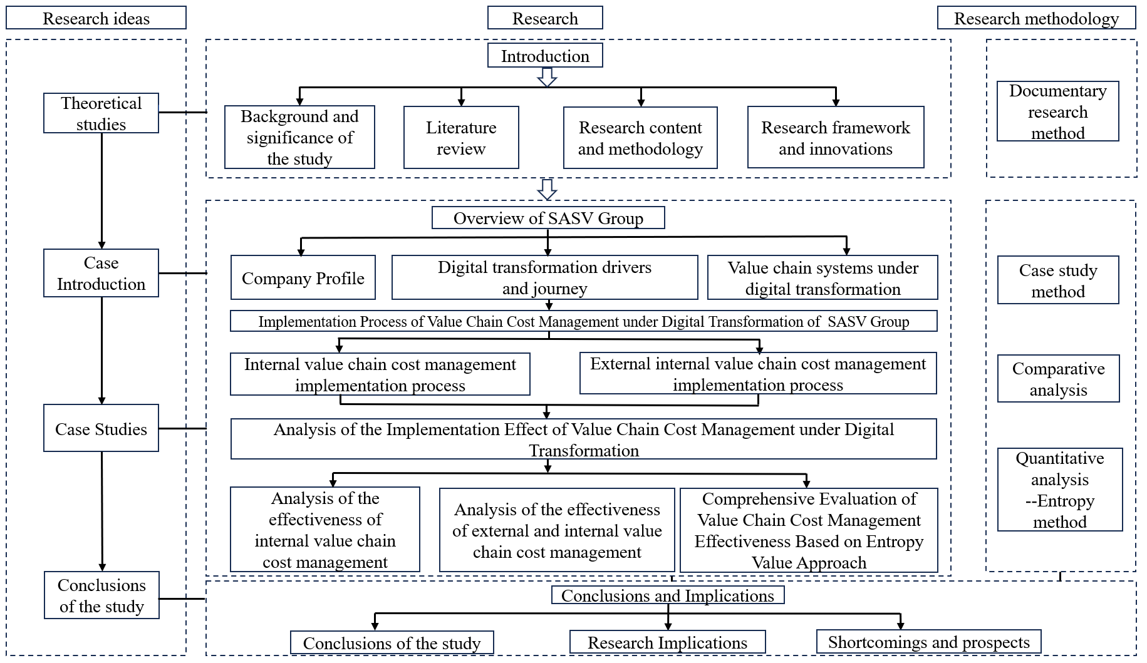

Figure 1.1 Frame diagram of this paper

Firstly, the majority of existing research on digital transformation predominantly centers on the appliance sector within the manufacturing industry. Conversely, this paper will specifically concentrate on the engineering machinery segment of the traditional manufacturing industry, given that this sector utilizes substantial human and material resources during production, rendering cost control paramount for enterprises. By selecting Shandong Aerospace Special Vehicle Company Limited as the research subject, this paper aligns with the current trend of digitalization intertwining with related industries and serves the paper's objective, thereby carrying significant relevance.
Secondly, Thus, this paper integrates digital transformation with enterprise value chain cost management, selects representative case companies, and examines the implementation process and outcomes of enterprise value chain cost management. In the final section dedicated to effect analysis, the entropy method will be employed in conjunction with cost management-related indicators to provide a comprehensive assessment. This will allow for a deeper observation of the effectiveness of value chain cost management under digital transformation and its influence on the overall corporate performance.

CHAPTER 2

OVERVIEW OF SHANDONG AEROSPACE SPECIAL VEHICLE COMPANY LIMITED

2.1 Overview of Shandong Aerospace Special Vehicle Company Limited

Shandong Aerospace Special Vehicle Co., Ltd. head office located in Tai'an City, Shandong Province. The company focuses on the R&D, manufacturing and sales of special vehicles, with a wide range of products covering military applications, fire-fighting services, environmental protection, emergency response and logistics, etc., which significantly impact crucial domains like national security, public safety frameworks, urban governance efficiency, and emergency response capabilities. Leveraging its robust technological backbone and remarkable innovative prowess, Shandong Aerospace Special Vehicle holds a pivotal position within China's special vehicle manufacturing sector. Amid the global surge towards digital transformation, Shandong Aerospace Special Vehicle recognizes the profound impact of digital technologies on reshaping business models and corporate structures, prompting it to proactively pursue digital transformation. This endeavor aims to bolster the company's competitiveness, refine management processes, and elevate production efficiency. The enterprise actively delves into the integration and deployment of avant-garde technologies, including smart manufacturing, the industrial internet, big data analytics, and artificial intelligence. It strives to integrate these technologies across all facets of operations, particularly in refining production processes, fostering supply chain collaboration, enhancing customer service, and driving product innovation. Through this digital integration, the company seeks to breathe new life into its operational efficiency and innovation drive.
In the practice of digital transformation, Shandong Aerospace Special Vehicle focuses on promoting intelligent manufacturing and digital supply chain management, achieving significant improvement in production efficiency and resource allocation. At the production level, the company adopts industrial Internet and Internet of Things (IoT) technology to build an advanced intelligent manufacturing system, which achieves accurate resource scheduling, automated production management and forward-looking equipment maintenance through real-time monitoring of equipment, in-depth data collection and intelligent analysis. This series of initiatives not only significantly improves production efficiency, reduces equipment failure rate and operating costs, but also extends the service life of equipment. With the digital production scheduling system, the company is able to make dynamic adjustments based on real-time data, which enhances the flexibility of production and market response speed, and accelerates the R&D and marketisation process of new products, further enhancing market competitiveness. In the realm of supply chain management, Shandong Aerospace Special Vehicle leverages a digital platform for immediate data gathering and insights. By harnessing big data and cloud computing, the company fine-tunes its raw material procurement, inventory control, and production planning. This allows for swift adaptation to market fluctuations, ensuring efficient and adaptable resource allocation. Consequently, product delivery is enhanced in both timeliness and precision.
Shandong Aerospace Special Vehicle attaches great importance to data-driven management decision-making and product innovation in the process of digital transformation. The company has constructed a data-based decision support system, market and customer data to provide management with accurate decision support, optimise production plans and sales strategies, and improve customer service. By optimising the customer relationship management system, Company has enhanced the accuracy of demand forecasting and after-sale response efficiency. At the level of product development, Shandong Aerospace Special Vehicle adopts advanced simulation technology, virtual reality and augmented reality technology to improve research and design accuracy, and shorten the product development cycle. And the enterprise uses big data technology to conduct in-depth analysis of market demand and promote personalised product customisation services to meet diversified customer needs. It is also worth mentioning that Shandong Aerospace Special Vehicle also promotes the green manufacturing process of digital technology, optimises the energy management strategy, reduces the waste of resources, and improves the product lifecycle management, actively practicing the sustainable development strategy.
Over the past few years, Shandong Aerospace Special Vehicle has gained significant momentum in its core strategy through digital transformation. As a pioneer in China's special vehicle manufacturing sector, the company recognizes the immense potential of digital technology in boosting production efficiency, optimizing resource allocation, fostering innovation, and gaining market competitiveness. Starting from the early 2010s, Shandong Aerospace Special Vehicle has been actively advancing its information technology infrastructure, constructing digital platforms, and analyzing production data to facilitate data-driven decision-making and management. The company is progressively integrating production intelligence with information technology.
The adoption of intelligent manufacturing technology has revolutionized traditional production methods at Shandong Aerospace Special Vehicle. By establishing several 'smart factories' and applying advanced technologies like the Internet of Things (IoT), Big Data, and Artificial Intelligence (AI), the company has significantly enhanced the flexibility, accuracy, and responsiveness of its production processes. Intelligent production lines have made production scheduling more efficient and real-time monitoring of production status possible, enabling precise control and refined management. This has led to improved production efficiency, cost reduction, and enhanced product quality.
Furthermore, Shandong Aerospace Special Vehicle emphasizes digital product design and development, utilizing virtual simulation and digital modeling technologies to shorten the research and development cycle, improve design accuracy, and accelerate product market adaptation. Leveraging big data analysis, the company can more accurately predict market demand and develop customized and personalized products to cater to diverse customer needs. These digital transformation initiatives have not only strengthened Shandong Aerospace Special Vehicle's technological innovation capabilities but also significantly bolstered its global market competitiveness, providing robust support for the company's sustainable development and industry leadership.
Against the background of accelerating global environmental protection and energy transformation, electrification has become a key development path for the special vehicle industry. Shandong Aerospace Special Vehicles has taken the initiative to adapt to this trend and incorporate electrification into the core of its future development strategy. The Company focuses core technologies such as electric drive technology, battery management system (BMS) and electric drive axle, and plans to expand its electrification product line and promote the integration and application of electric, hybrid and hydrogen fuel cell technologies. Through intelligent electrification design. In the future, the company will accelerate the research and combine it with electric drive systems to create more environmentally friendly and energy-saving special vehicles. This strategy not only enables the company to comply with the global energy transition, but also gains technological advantages in the fields of energy saving, emission reduction and green manufacturing, enhances market competitiveness of the special vehicle industry.
Under the background of globalization, the internationalization strategy of Shandong Aero-special Vehicle plays a key of its market competitiveness and sustainable development. 2006, the relied on overseas direct investment to establish industrial bases, and took this as the starting point to gradually promote the global layout. Through mergers and acquisitions, cooperation and independent construction, Shandong Aerospace Special Vehicle has successfully built production bases, R&D centers and sales networks in many countries and regions, forming a global industrial chain system.
In the global push for sustainable development, Shandong Aerospace Special Vehicle embraces the green development philosophy and leverages digital technology to refine its production processes, ultimately aiming to minimize energy consumption and environmental impact while bolstering the enterprise's overall competitiveness. The firm actively fosters the adoption of green manufacturing practices and eco-friendly technologies, focusing on creating energy-efficient and eco-conscious special vehicle products to offer the world greener, more sustainable transportation alternatives.
At the core of product design and production, Shandong Aerospace Special Vehicle deeply integrates energy-saving and emission-reduction principles, utilizing IoT technology to monitor and optimize energy usage in real-time, thereby mitigating energy wastage. Concurrently, the company stays abreast of market trends and dedicates itself to developing high-efficiency, low-emission electric and hybrid green vehicles to meet evolving market demands.
Furthermore, Shandong Aerospace Special Vehicle champions the idea of total life cycle management, utilizing a digital platform for meticulous oversight across all product stages. This approach enhances resource utilization efficiency, prolongs product lifespan, and alleviates environmental strain. This green strategy underscores the company's dedication to sustainability and underscores the pivotal role of digital technology in optimizing management, efficiency gains, and advancing green manufacturing. Consequently, Shandong Aerospace Special Vehicle fosters a green and eco-friendly corporate persona in the global market, paving the way for its long-term sustainable growth.
The digital transformation of Shandong Aerospace Special Vehicle is an inevitable choice of global competition and the rapid iteration of technology, which is driven by multiple factors, the change of the industry environment and the demand for enterprise competitiveness enhancement. This transformation not only conforms to the strategic direction of digital transformation of China's manufacturing industry, but also significantly strengthens Shandong Aerospace Special Vehicle's technological advantages and market position in the global special vehicle market. Through the transformation, the company had improved its production efficiency, optimised its management processes and strengthened its competitiveness in the global market, laying a solid foundation for long-term development.
Chinese government has actively promoted the integration of the digital economy with the real economy, especially in the manufacturing sector, through the ‘Made in China 2025’ and ‘Digital China’ strategies, clarifying the combination of manufacturing upgrading of digital technology, and promoting the digital and intelligent of the whole industry. As a leader in the aerospace special vehicle industry, Shandong Aerospace Special Vehicle follows the national strategy, actively responds to the government's call, and increases the investment in digital technology and intelligent manufacturing. The national policy not only provides technological innovation, capital and policy protection for Shandong Aerospace Special Vehicle, but also creates a good external environment to promote its digital transformation. This move helps Shandong Aerospace Special Vehicle to enhance its technological advantages in the global special vehicle market, improve its market position, and accelerate its progress towards digitalisation, intelligence and greening.
The cyclical market fluctuations in the aerospace special vehicle industry constitute an important driving force for the digital transformation of Shandong Aerospace Special Vehicle. In this industry, product demand is often accompanied by cyclical changes, resulting in unstable market demand. When the industry cycle changes, Shandong Aerospace Special Vehicle faces the challenges of rising labour costs, production efficiency improvement and capacity adjustment in production and management. Under the traditional production mode, the labour cost fluctuation is significant, and the production efficiency is limited by manual operation. The application, automated production lines and big data analysis, can significantly improve production efficiency, reduce labour costs, and effectively cope with the market challenges brought by cyclical fluctuations in the industry. In addition, with the evolution of customer demand, consumers are no longer only concerned about the price of products, but also pay more attention to product quality, and after-sales service. This upgraded demand has prompted Shandong Aerospace Special Vehicle to accelerate its digital transformation. Through the transformation, the Company will not only be able to better adapt to market changes, but also make use of the accurate collection and analysis of customer data to provide customised products and services to meet the growing personalised demands, so as to maintain its leading position in the fiercely competitive market.
With the deepening of the globalisation process, the competition in the aerospace special vehicle industry is getting hotter and hotter day by day. As an industry leader, Shandong Aerospace Special Vehicle faces severe challenges from domestic. Shandong Aerospace Special Vehicle deeply recognises that the traditional production mode and market strategy can no longer cope with the intensified competition and changing market environment, and is in urgent need of strategic transformation. Digital transformation to break through the predicament and achieve leapfrog development. Through the introduction of big data, artificial intelligence, Internet of Things and other advanced technologies, Shandong Aerospace Special Vehicle has optimised its internal management processes, improved its production efficiency, reduced the waste of resources and costs, and enhanced the competitiveness of its products in the market. And digital transformation enables the company to gain a sharper insight into changes in market demand, improve the level of product intelligence, and enhance market attractiveness and differentiated competitive advantages. Driven by intelligent manufacturing and digital transformation, Shandong Aerospace Special Vehicle not only consolidates its leading position in the domestic market, but also significantly improves the core competitiveness of the enterprise, enhances the competitiveness of the international market, and lays a solid foundation for long-term development.
In the rapid evolution of global digital technology, the technical benchmarks and trajectory of the aerospace special vehicle industry are undergoing significant shifts. Shandong Aerospace Special Vehicle, a trailblazer in this sector, recognizes the pivotal role digital technology will play in future competitions and is consequently augmenting its investments in digital technology research, development, and deployment.
By integrating advanced automation and intelligent technologies into its production processes, Shandong Aerospace Special Vehicle has achieved remarkable gains in production efficiency, shortened product delivery timelines, and effectively curbed production costs, positioning itself competitively in the global arena. As its internationalization strategy deepens, Shandong Aerospace Special Vehicle faces intensifying competition in the global market.
The digital transformation undertaken by Shandong Aerospace Special Vehicle has facilitated a qualitative leap in its production and operations, fortifying its global market competitiveness with robust technical backing. Leveraging digital platforms and cloud computing, the company has achieved precise management of its global supply chain, significantly boosting the international competitiveness of its products and enhancing its agility in responding to global market dynamics, thereby ensuring steady enterprise growth amidst globalization.
The digital transformation of Shandong Aerospace Special Vehicle has gone through several key stages, successfully realising the leap from preliminary information construction to comprehensive and in-depth transformation. This transformation responds positively to digital economy and manufacturing industry, and is in line with the global trend of Industry 4.0. Driven by technological innovation, Shandong Aerospace Special Vehicle has achieved remarkable results in improving production efficiency, optimising resource allocation, deepening intelligent manufacturing and data-driven decision-making, laying a solid foundation for the company's sustainable development and competitiveness.
From 2007 to 2012, Shandong Aero-space Special Vehicle entered the early stage of information technology platform construction. Shandong Aero-space Special Vehicle deeply recognised the core role of information technology in improving production efficiency and strengthening enterprise management, and started to build the enterprise's information infrastructure. Benefiting from the positive influence of national policies, the aerospace special vehicle industry has entered into a period of rapid development, Shandong Aisino Special Vehicle grasped this historical opportunity and used information technology to lay the cornerstone for the subsequent digital transformation. 2007, Shandong Aisino Special Vehicle formally launched the information technology strategy, such as the ERP system, and on this basis developed the Manufacturing Execution System (MES), which realises the fine management of the production process. Through real-time collection and monitoring of production data, it optimises resource allocation and significantly improves production efficiency.In 2009, the company further strengthened the construction of digital intelligence, and actively established cooperative relationships with top domestic and international technology suppliers, gradually introducing advanced industrial software and hardware equipment to support the in-depth refinement. By 2012, Shandong Aerospace Special Vehicle had initially completed the digital integration of information flow, material flow and capital flow, laying a solid foundation for the subsequent comprehensive digital transformation.
From 2013 to 2017, Shandong Aerospace Special Vehicle has entered a decisive stage of business process informatisation and intelligent construction. Shandong Aerospace Special Vehicle has continuously deepened the application, and comprehensively promoted the digital upgrading of production management, supply chain management, sales and customer service, etc. In 2013, Shandong Aerospace Special Vehicle embarked on the digital lifecycle management of its products, striving to establish a digital factory and officially launching the Intelligent Manufacturing Project. By then, significant strides had been made in automating production while actively fostering the intelligent transformation of business processes. Gradually, digital synchronization was achieved across production lines, warehousing, logistics, and supply chain management.
As big data, cloud computing, and artificial intelligence technologies matured in 2015, Shandong Aerospace Special Vehicle accelerated the upgrading of its information technology systems, constructing a more adaptable and efficient big data platform complemented by an intelligent decision-making support system. By comprehensively collecting and analyzing production data, the company gained real-time insights into the operational status of its production equipment, enabling accurate predictive maintenance and anticipating equipment failures. This technological advancement notably enhanced production efficiency, minimized downtime, and reduced maintenance costs.
In 2016, Shandong Aerospace Special Vehicle achieved a milestone in building its 'intelligent factory' by fully integrating the Internet of Things (IoT) technology, fostering seamless connectivity among production links and equipment. Utilizing sensors and data collection tools, the company gained real-time monitoring capabilities for equipment operations. Furthermore, in-depth analysis of production data was conducted to continually refine the production process, elevate product quality, further abbreviate delivery timelines, and markedly bolster market competitiveness.
Since 2018, Shandong Aerospace Special Vehicle has comprehensively deepened the digital transformation, and fully implemented the three core strategies of ‘digitalisation, intelligence and networking’, not only made significant progress of manufacturing intelligence, but also strengthened the digital reconstruction of the management and service system. Through the cooperation with global leading science and technology enterprises, Shandong Aerospace Special Vehicle builds the industrial internet platform as the core support of intelligent manufacturing. In 2020, Shandong Aerospace Special Vehicle accelerated the construction and upgrading of ‘intelligent factory’ and took the lead in introducing 5G technology to achieve equipment interconnection and remote control. The establishment of the intelligent factory not only significantly improves the production efficiency, but also significantly enhances the manufacturing precision and consistency of products. With the help of intelligent production line, Shandong Aerospace Special Vehicle is able to flexibly adjust the production plan and quickly respond to the changes in market demand, which greatly improves the production flexibility and response speed. By 2021, Shandong Aerospace Special Vehicle will have achieved comprehensive digital transformation in many business segments, conducted real-time simulation of the production process through the establishment of a ‘digital twin’ system, and deployed intelligent scheduling systems in various factories to optimize the allocation and scheduling of production resources. In terms of global layout, Shandong Aisino Special Vehicle has used digital means to improve the service efficiency in overseas markets and constructed a global digital supply chain network. By 2023, Shandong Aerospace Special Vehicle has completed the enterprise-wide digitalization construction and formed significant innovation advantages in many fields. By continuously deepening digital transformation, Shandong Aerospace Special Vehicle has not only improved its internal management efficiency, but also significantly enhanced its competitiveness in market. Looking into the future, Shandong Aerospace Special Vehicle will continue to promote the application of manufacturing and digital technology, continuously improve its technological innovation capability, and push the enterprise to develop in the direction of higher-level digitization and intelligence.

2.2 Value chain system of Shandong aerospace special vehicle company limited under digital transformation

Against the backdrop of the widespread application of digital technology, Shandong Aerospace Special Vehicle is actively promoting digital transformation at all nodes of the whole value chain, comprehensively optimising the entire chain of R&D.
The internal value chain of Shandong Aerospace Special Vehicle includes R&D .In the wave of digital transformation, Shandong Aerospace Special Vehicle has actively absorbed cutting-edge technologies such as Big Data, Artificial Intelligence, Internet of Things, etc., to optimise the operational efficiency of each link, and to promote the enterprise's digital management process on a global scale.
In the R&D and design stage, Shandong Aerospace Special Vehicle has introduced advanced product lifecycle management system, and significantly improved product design quality and development efficiency with the help of data-driven analysis tools. Through big data analysis, Shandong Aerospace Special Vehicle is able to accurately capture the market demand, customer preferences and the latest dynamics of technological development, so as to formulate a product strategy that is more in line with the market demand at the early stage of product development. The application of digital tools enables designers to significantly reduce the cost and time of physical tests through virtual simulation and analogue testing, accelerating the product development process and ensuring that the products have excellent reliability and performance at the design stage.
Enhancing this, the fusion of automation and robotic technology amplifies the productivity and adaptability of the production line, enabling swift adjustments to production plans based on order demands. This fosters intelligent and customizable production processes.
Simultaneously, Shandong Aerospace Special Vehicle leverages IoT technology and intelligent sensors for remote monitoring and predictive maintenance of equipment. This significantly cuts down equipment downtime and maintenance expenses, bolstering the overall stability and dependability of production operations.
In the sales and service phase, Shandong Aerospace Special Vehicle provides a more personalised service experience through in-depth analysis. Through real-time analysis of sales data, Shandong Aero-space Special Vehicle is able to flexibly adjust its market strategy and optimise resource allocation to ensure that its products can accurately meet customers' needs. Shandong Aerospace Special Vehicle has built a digital service platform to collect customer feedback in real time and provide timely technical support, remote diagnostic service and spare parts management according to customer needs, so as to ensure that customers can have an efficient and convenient service experience in the process of using the products. These digital transformation initiatives significantly boost Shandong Aerospace Special Vehicle's operational efficiency and provide a solid foundation for its sustainable expansion in the global market.
Shandong Aerospace Special Vehicle has made use of digital technology to strengthen the connection with external partners and realise the expansion and deep synergy of the value chain. Shandong Aero-space Special Vehicle has built a digital supply chain platform, which realises instant information sharing and collaborative operations with global suppliers. Through the use of supply chain management system and big data analysis, Aero-space Special Vehicle has accurately predicted the market demand, optimised the procurement strategy, and significantly improved the response speed and flexibility of the supply chain. We cooperate with suppliers to develop digital tools and platforms, jointly promote intelligent manufacturing and green production, and are committed to providing customers with efficient and environmentally friendly solutions. The effective use of digital platforms enables Shandong Aerospace Special Vehicle to control procurement costs, reduce inventory pressure, and enhance the transparency and visualization of the supply chain.
At the customer interaction level, Shandong Aerospace Special Vehicle leverages big data and AI technologies to gain profound understanding of customer demands and behaviors. Utilizing a CRM system, it precisely tracks customer requirements and adjusts marketing strategies based on feedback. Leveraging digital marketing channels, including social media, online ads, and e-commerce platforms, Shandong Aerospace Special Vehicle swiftly engages potential customers and expands market reach. Additionally, the digital service platform offers online consultation, technical assistance, and remote diagnostics, significantly enhancing customer satisfaction and loyalty.
The digital transformation of Shandong Aerospace Special Vehicle is not only a digital innovation of the internal, but also a model of deep integration and synergy between the two, successfully building an intelligent enterprise ecosystem with seamless connection and data interoperability.
Regarding information flow and logistics integration, Shandong Aerospace Special Vehicle has removed data silos among internal departments and external collaborators by integrating platforms like ERP, SCM, and CRM. This has established a seamless information and logistics pathway. The synchronized operation of these systems guarantees timely tracking and accurate management of the process, spanning from order receipt to product delivery and post-sales service. Furthermore, it achieves optimal resource allocation across the supply chain and swiftly adapts to market fluctuations and evolving customer needs.
In building a customer-oriented value chain, the digital transformation of Shandong Aerospace Special Vehicle always focuses on customers and is committed to precise optimisation. The Enterprise Control Center (ECC) and the data analysis platform are able to capture and analyse key information such as customer feedback, sales data and market trends in real time, and provide rapid decision-making support for R&D, production, marketing and other links. By closely connecting customer demand with product design, production plan, procurement process and other key links, Shandong Aerospace Special Vehicle has achieved rapid product customisation and accurate delivery, which has significantly improved customer satisfaction and market competitiveness.
In terms of creating a digital closed loop, Shandong Aerospace Special Vehicle integrates all aspects of customer orders, product development, manufacturing, sales and after-sales service into the scope of digital management through a digital platform, forming a complete closed loop of information feedback. The real-time data of each link provides the decision-making basis for the subsequent links, ensuring the high efficiency and flexibility of the enterprise operation. In addition, the real-time feedback mechanism of the digital platform enables Shandong Aerospace Special Vehicle to achieve self-regulation and optimisation in the whole value chain, which further enhances the enterprise's continuous innovation ability and market adaptability, and lays a solid foundation for the long-term development of the enterprise.
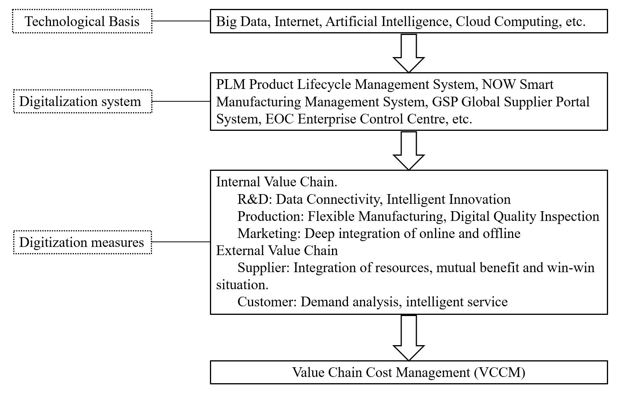

Figure 2.1 Value chain system of Shandong aerospace special Vehicle Co. under digital transformation

3.3 Internal value chain cost management implementation process under digital transformation

This chapter discusses the value chain cost management strategy and practice of Shandong Aerospace Special Vehicle Co., Ltd. in the context of digital transformation, and meticulously deconstructs the internal value chain of the enterprise into three core links.
Shandong Aerospace Special Vehicle Co., Ltd. has taken the lead in building a comprehensive R&D platform based on big data in the journey of digital transformation, realizing seamless data sharing and efficient collaboration in key aspects such as R&D, design and testing. By deeply integrating internal and external data and resources, the platform has injected a strong impetus for the R&D and innovation of intelligent products.
In the manufacturing sector, Shandong Aerospace Special Vehicle has transformed the traditional production line by integrating digital technology with lean manufacturing principles, resulting in an intelligent production system. This system utilizes industrial robots, smart sensors, and the Industrial This not only boosts productivity but also minimizes material waste and energy consumption.
Furthermore, Shandong Aerospace Special Vehicle has embraced the Integrated Product Development (IPD) framework, fostering seamless integration among R&D, production, procurement, and marketing departments. Through this approach, the company leverages big data analytics to gain deep insights into customer requirements and promptly translates this information into targeted guidance for product innovation and manufacturing, fostering a mutual enhancement of technological advancement and production efficiency.
Additionally, the digital platform facilitates the smooth exchange of cross-departmental information, enhancing the efficiency and fluidity of communication between R&D and production teams. This acceleration of technical research, product development, and manufacturing ensures that offerings align closely with market demands.
Moreover, the company employs a data-centric decision-making framework, enhancing the scientific rigor and precision of the R&D and production process.
Finally, in order to shorten the cycle from design conception to market launch, Shandong Aerospace Special Vehicle Co., Ltd. has innovatively built a set of comprehensive digital trial production and production management platform. The platform deeply integrates the whole process data chain from trial production to mass production, realizing real-time and fine monitoring of trial production and production process, thus ensuring that the design scheme can be efficiently verified and quickly transformed into actual productivity. This platform not only greatly promotes the accelerated iteration of product development and manufacturing, but also effectively reduces the potential in the trial production and production stages, enabling the product to achieve large-scale production with a more economical cost structure and a shorter time frame. Shandong Aerospace Special Vehicle Co., Ltd. makes full use of the advanced advantages of digital technology to form a seamless closed loop of R&D, This series of initiatives not only highlights the company's profound accumulation and forward-looking layout on the road of digital transformation, but also provides solid support for its continued leading position in the complex and changing market environment.
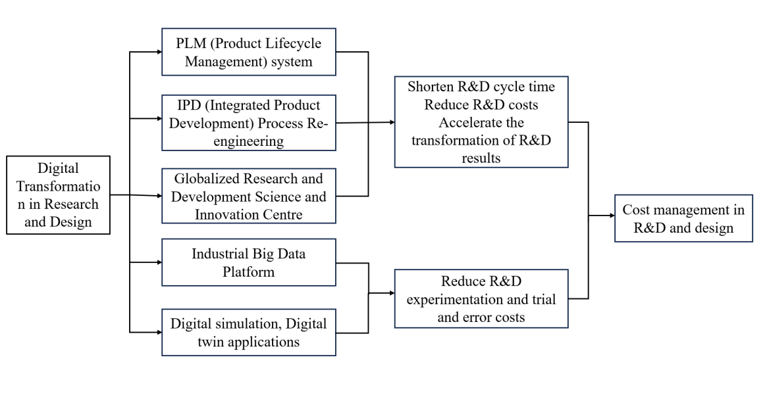
Figure 2.2 Cost management process in the research and design stage of Shandong aerospace special vehicle Co., Ltd

In the era of intelligence, Shandong Aerospace Special Vehicle Co., Ltd. has effectively improved its production efficiency by comprehensively promoting the digital transformation, while reducing production costs and strengthening the market competitiveness of the enterprise. Through these innovations, the company's production efficiency has been significantly improved and the production cycle has been significantly shortened. Taking the smart factory as an example, the time for major products to come off the production line has been shortened by 98%, the production cycle has been shortened by 40%, and 80% automation. This not only greatly improves production capacity, but also reduces production costs while ensuring quality.
In body manufacturing, the company introduced intelligent welding robots and automatic painting equipment, improving welding precision by 35% and painting efficiency by 50%, while reducing energy consumption and pollutant emissions. In final assembly, the company ensures a more efficient and precise assembly process by adopting automatic guided vehicles (AGVs) and an intelligent parts distribution system. These measures not only significantly improve production efficiency, but also ensure the consistency and stability of product quality. In addition, the company also makes extensive use of digital twin technology in production to monitor and optimize the production process in real time through virtual simulation, which effectively reduces waste and failure rate in the production.
Beyond other achievements, the company has successfully implemented real-time monitoring and optimization across production, warehousing, logistics, and associated operations through the introduction of the Factory Control Center (FCC) and an enhanced MOM Intelligent Manufacturing Management System. The MOM system interfaces seamlessly with various production and management systems, facilitating agile adjustments to production schedules, quality assurance, and warehousing operations, thereby enhancing production flexibility and precision.
Furthermore, the system is fully integrated with the IoT platform, which continuously gathers real-time data from across all factories. This data-driven approach enables swift adjustments to the operational status of production lines, machinery, equipment, and automated guided vehicles (AGVs), fostering a refined production scheduling mechanism. This demand-driven production model significantly accelerates the order-to-delivery cycle, minimizes inventory holding costs, and bolsters capital turnover efficiency.
Regarding flexible production, Shandong Aerospace Special Vehicle Co., Ltd. has significantly enhanced the adaptability of its production lines by adopting a "mixed-model assembly line" approach. Unlike traditional lines limited to producing 1-2 models, the digitized line can accommodate 5-10 different models simultaneously, with the capability to assemble up to 69 product types at once. This transformation allows the company to swiftly adapt to market fluctuations and offer tailored products to meet diverse customer needs.
In addition, the company has implemented a modular production model for the individual needs of special vehicles. By products into functional modules, different modules can be flexibly combined according to customer needs, so as to quickly complete the production of customized vehicles. This mode not only improves the production efficiency, but also reduces the complexity and cost brought by diversified production. Combined with the modular design, the company has optimized the parts management process and realized the efficient universality and standardization of parts.
Shandong Aerospace Special Vehicle Co., Ltd. also vigorously applies 5G technology, robots and AGV trolleys and other advanced technologies to ensure 24-hour continuous operation of the production process. The extensive use of automated equipment not only reduces a large number of labor costs, but also improves the efficiency of warehouse management, shortens the storage time of materials and reduces idle costs. Through real-time data analysis, the company is able to dynamically adjust the allocation of production resources, thus realizing rapid response to market changes.
It is estimated that this series of measures led to an overall reduction of 20-30% in production costs. Through these digital means, Shandong Aerospace Special Vehicle Co., Ltd. has realized the intelligence, flexibility,which not only enhances the production capacity, but also strengthens to respond quickly to changes in market demand. In the increasingly competitive global market, the company has laid a solid foundation for future development by virtue of advanced production technology and efficient flexible manufacturing mode, while setting up a model of intelligent and low-cost production for the industry.
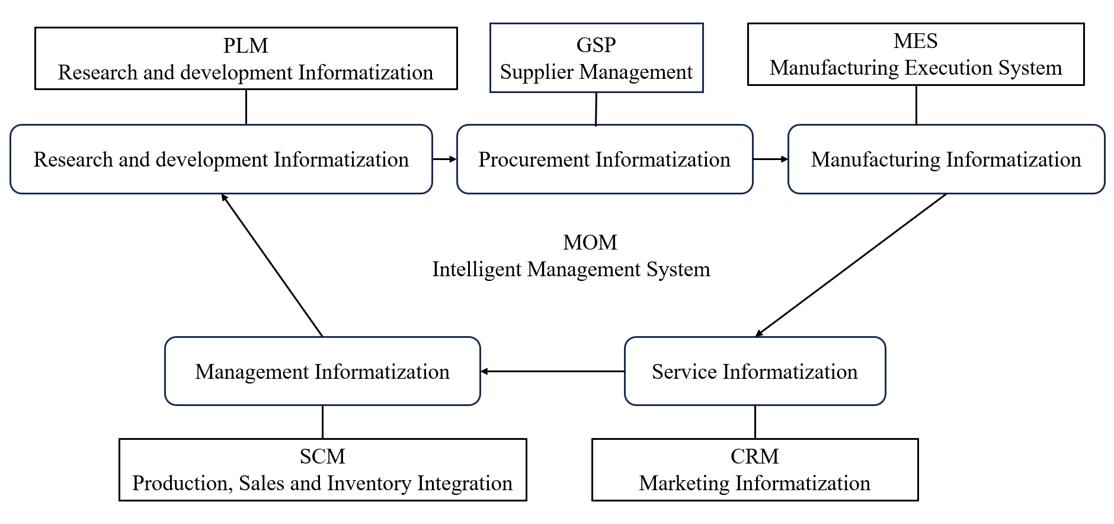

Figure 2.3 Operation process of MOM intelligent management system

In the traditional quality inspection field, low efficiency, high cost, serious brain drain and recruitment problems follow, manual quality inspection is not only a heavy task, and it is difficult to ensure that the quality standards continue to be unified, for enterprises to improve production efficiency and strengthen quality management has brought serious challenges. In the face of this predicament, Shandong Aerospace Special Vehicle Co., Ltd. has resolutely embarked on the road of digital transformation and successfully revolutionized the quality inspection system. The company independently developed and implemented a set of digital quality inspection system, which seamlessly connects with the existing MES (Manufacturing Execution System) and several sets of management platforms, thus realizing all-weather, all-round monitoring and management of product quality. This system can accurately capture the quality data of each production link and each product, and quickly analyze it to find out and resolve potential quality hazards in time.
What's more remarkable is that the company has introduced the mobile inspection platform and barcode technology in the quality inspection process, which completely subverted the traditional manual inspection mode. This innovation not only greatly improves the quality inspection efficiency, but also makes the fully electronic, significantly reducing manual intervention, effectively reducing the human error rate. The application of system significantly reduces the rate of product rework and defective products, reduces the additional costs incurred due to quality problems, and the rate of product return to the factory has also dropped significantly. At the same time, the integration of intelligent technology effectively reduces the burden of manual quality inspection, reasonable control of labor costs. In short, Shandong Aerospace Special Vehicle Co., Ltd. with the depth of the application, not only significantly improve the accuracy and efficiency of quality management, but also significantly reduce the cost of quality inspection, for the enterprise in the fierce market competition to win a stronger competitiveness and broader space for development.
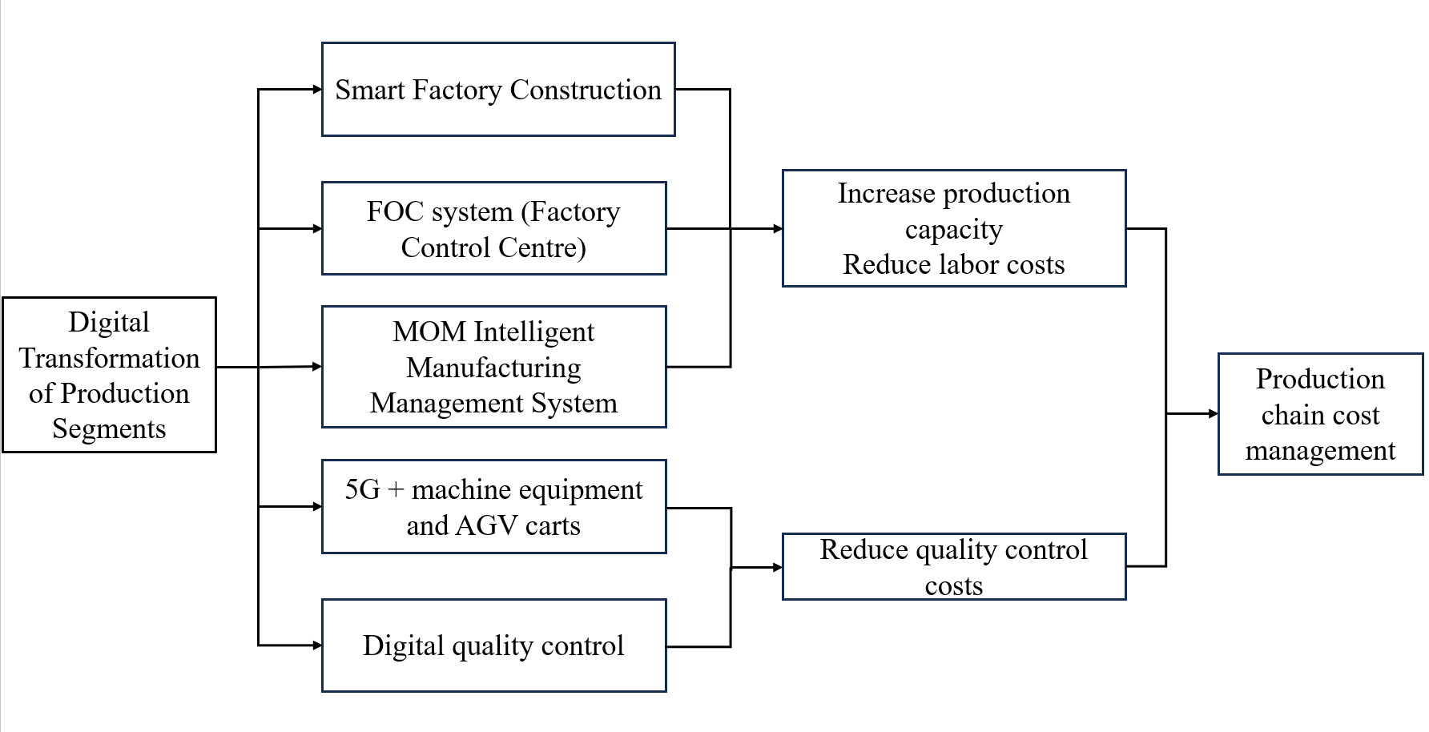
Figure 2.4 Cost management process in the production stage of shandong aerospace special vehicle Co., Ltd

With the rapid development of information technology, enterprises that rely excessively on traditional offline agents and sales channels will limit their potential for market expansion and innovation. In the face of this challenge, Shandong Aerospace Special Vehicles Co., Ltd. has responded positively to the market demand, adapted to the trend of digitalization, re-examined and adjusted its marketing strategy, and promoted the fusion of online and offline through digital transformation to further expand the market boundaries.
Ltd. explored the frontier of the industry as early as 2015, when it pioneered the introduction of the O2O (online marketing to lead offline consumption) model, utilizing the official platform of WeChat and the power of social media to carry out interactive marketing activities, which effectively stimulated the enthusiasm of consumers to participate, and promoted the significant growth of consumption. With the booming of short video platforms, the company has keenly captured this emerging trend and quickly laid out cutting-edge sales models such as online malls and live streaming with goods, realizing the in-depth fusion of online and offline and complementing each other. Its online mall not only covers the company's official website, but also integrates multiple distribution channels such as “small store” and “everyone store”, which not only broadens the external customer base, but also greatly strengthens the marketing ability of internal agents and business units, and builds up the marketing capability from basic parts and components to used equipment and after-sales service. We have built an all-round sales ecological chain from basic parts to second-hand equipment and after-sales service.
With the marketing strategy of both online and offline, Shandong Aerospace Special Vehicle Co., Ltd. not only greatly simplifies the purchase process and reduces the sales cost, but also further consolidates and enhances its leading position in the fierce market competition.
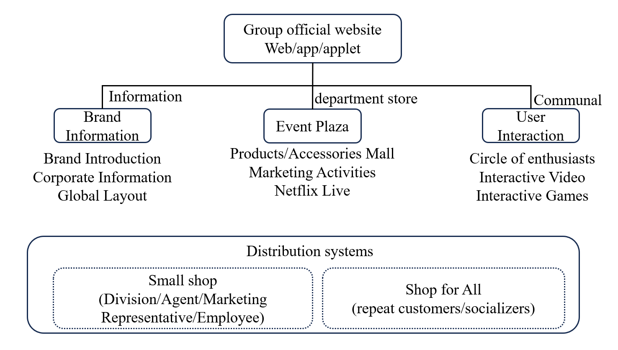

Figure 2.5 Digital marketing process of Shandong aerospace special vehicle Co., Ltd.

At the internal management level, Shandong Aerospace Special Vehicle Co., Ltd. is also at the forefront of digital transformation and has successfully deployed a CRM system, which gives wings to the marketing efficiency and customer management capability. The system deeply mines the big data of user behavior to provide tailor-made and differentiated service solutions for each customer. Meanwhile, by seamlessly connecting with enterprise WeChat and other digital platforms, the company greatly optimizes the interactive experience with customers, which not only improves the marketing conversion rate, but also effectively reduces customer acquisition costs. In addition, the Company has followed the wave of digitization and vigorously developed intelligent logistics services, skillfully using the Internet and intelligent systems to make the logistics process more accurate, efficient and controllable. Thanks to intelligent analysis and operation, the speed of information flow and material flow has been significantly improved, and logistics costs have been effectively controlled, thus injecting stronger power for the enterprise's market competitiveness.
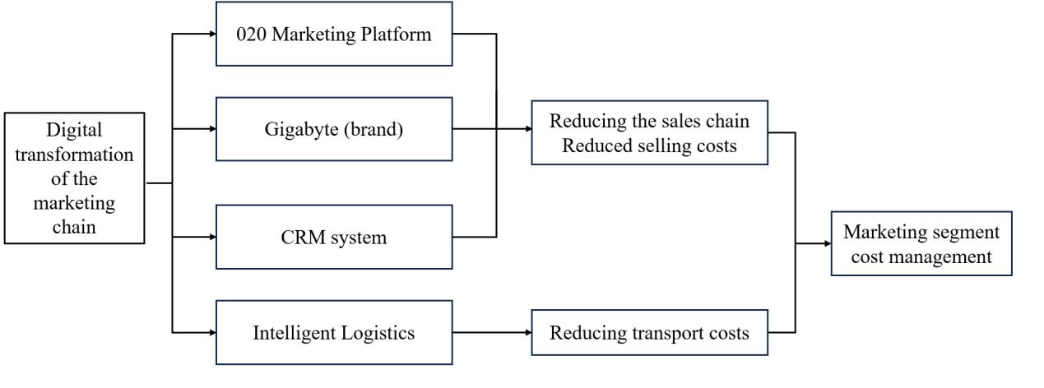

Figure 2.6 Cost management process in the marketing stage of shandong aerospace special vehicle Co., Ltd.

Facing the intricate challenges posed by collaborating with numerous suppliers, especially given the prolonged procurement and production cycles specific to the special vehicle industry, Shandong Aerospace Special Vehicle Co., Ltd. recognizes the potential perils of poor supplier coordination: disruptions in production, burgeoning inventory, and escalating costs, all of which undermine corporate efficiency.
In procurement management, Shandong Aerospace has introduced an innovative digital supply chain management platform. This platform automates and intelligently manages suppliers, while also providing real-time monitoring of production dynamics and supply capabilities. This real-time data offers robust support for the company to precisely forecast future supply demands and effectively manage procurement costs. The system facilitates instant access to order information for suppliers and enables them to provide timely updates on production progress. This not only streamlines procurement decision-making but also boosts the operational efficiency of the entire supply chain.
Furthermore, utilizing the digital procurement system, Shandong Aerospace conducts more scientific and efficient evaluations and optimizations of suppliers. By establishing a close digital connection with suppliers, the company significantly reduces communication costs, mitigates transaction risks, and further enhances the stability and reliability of the supply chain. In this way, Shandong Aerospace is able to foster win-win collaborations with suppliers, ultimately strengthening its position in the market.
In addition, the company also introduced a supply chain financing model to further enhance the liquidity of suppliers. Through the “Golden Ticket” supply chain payment platform, payment can be made online, and suppliers can choose to split, transfer or hold the maturity amount and the financing institutions will provide fast loan support. This initiative not only improves the company's ability to pay, but also helps suppliers to recover funds in advance and reduce procurement costs through discounts, ultimately realizing a win-win situation for all parties. By integrating suppliers' data and its own production data, Shandong Aerospace Special Vehicle Co., Ltd. is inventory and product demand, so as to optimize the order allocation strategy and reduce waste and cost. In addition, the company also shares its digitization experience with its suppliers, assisting them to improve production management, enhance efficiency and reduce costs. The operational efficiency of the supply chain has been effectively improved.
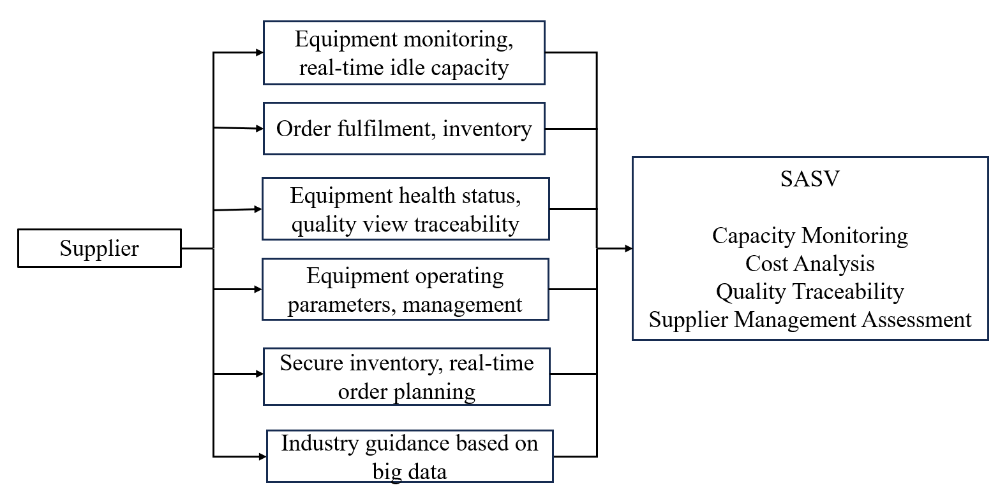

Figure 2.7 Vendor collaboration management process

In advancing the digital transformation of its supply chain, Shandong Aerospace Special Vehicle Co., Ltd. has deployed a comprehensive Supply Chain Management (SCM) system. This system seamlessly integrates information, logistics, and capital flows across the supply chain through a unified digital platform, ensuring the smooth and efficient operation of the company's production and business activities. Since the inception of the SCM project in 2020, Shandong Aerospace has witnessed substantial improvements. Work efficiency has soared, nearly tenfold, while product planning accuracy has jumped by approximately 66 percentage points. Additionally, the product delivery cycle has been trimmed by 11%, and sales have experienced rapid growth. The SCM system has been deeply embedded into every facet of production, sales, and inventory management, fostering a data-centric decision-making framework. This framework significantly enhances the transparency and agility of the supply chain, empowering Shandong Aerospace to swiftly adapt to market fluctuations. Through continuous iterative optimization and enhancements of the SCM system, Shandong Aerospace has not only drastically improved internal process efficiency but also laid a robust digital foundation for implementing lean management and bolstering market responsiveness. These advancements have further solidified the company's competitive edge in the industry.
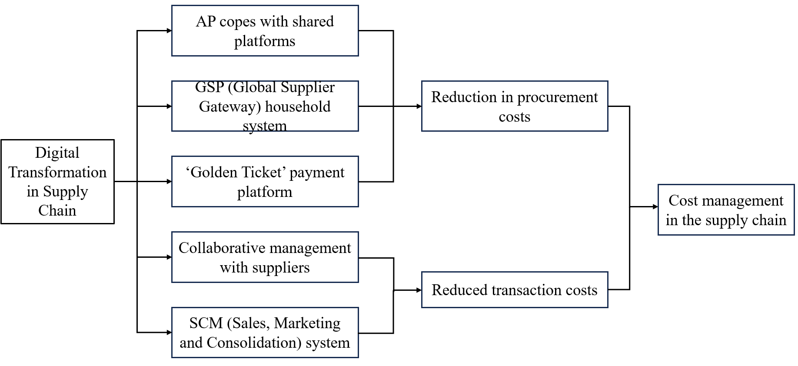

Figure 2.8 Cost management process in the supplier area of shandong aerospace special vehicle Co., Ltd.

Shandong Aerospace Special Vehicle Co., Ltd. actively embraces this trend, leveraging the robust impetus of digital technology to facilitate a transformation from the traditional "equipment manufacturing" model to a "equipment manufacturing + service" hybrid model. Our objective is to offer customers a seamless, comprehensive, and superior service experience.
During its evolution, Shandong Aerospace Special Vehicle Co., Ltd. has effectively implemented a customer relationship management (CRM) system, which not only optimizes the customer demand response mechanism, but also promotes a comprehensive innovation by customer demand. the CRM system ensures the immediacy and high efficiency of customer communication through the seamless docking with the diversified online customer interaction platforms, and relying on the powerful data analysis capability, accurately captures the core needs of customers, and provides the basis for the refinement of product design and the improvement of product quality. At the same time, relying on powerful data analysis capabilities, the CRM system accurately captures customers' core needs, provides strong support for the refinement of product design and personalized customization, effectively reduces transaction costs, and significantly improves customer satisfaction. On the side, the company has further optimized its production and supply chain management processes through the in-depth integration of data resources and meticulous analysis of order information, which has greatly enhanced its market response speed and comprehensive competitiveness. In the field of after-sales service, the company also digital technology to innovatively provide diversified solutions and further consolidate its service advantages.
To sum up, Shandong Aerospace Special Vehicle Co., Ltd. has not only realized the comprehensive upgrade of customer experience and effective reduction of after-sales service cost through the all-round penetration and application of digital technology, but also completed the gorgeous transformation from equipment manufacturing to intelligent service, which not only greatly improves customer satisfaction, but also constructs a solid competitive barrier in the fierce competition
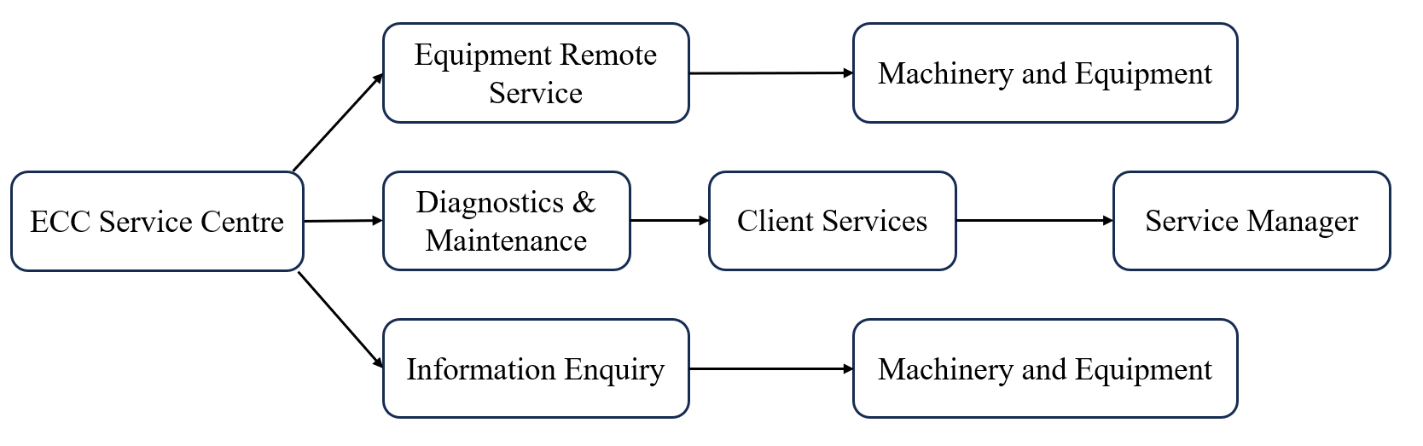

Figure 2.9 Operation process of ECC enterprise control center

In 2021, Shandong Aerospace Special Vehicle Co., Ltd. offered varied financing options to address customers' fund shortages by collaborating with several financial institutions. By providing mortgage loans and inventory financing, we efficiently catered to the capital requirements of both customers and dealers, enhancing capital utilization efficiency and ensuring prompt and stable repayments.

CHAPTER 3

ANALYSIS ON THE IMPLEMENTATION EFFECT OF VALUE CHAIN COST MANAGEMENT UNDER DIGITAL TRANSFORMATION OF SHANDONG AEROSPACE SPECIAL VEHICLES

4.1 Research and development function in value chain

Shandong Aerospace Special Vehicles has demonstrated its profound emphasis and unwavering commitment to technological innovation through its investments and strategic adjustments in the research and development (R&D) sector in recent years. Since 2017, the company has accelerated its digital transformation and progressively increased its R&D investment ratio, particularly in digital products and intelligent manufacturing platforms. Despite the impacts of the global pandemic and economic fluctuations between 2019 and 2020, Shandong Aerospace Special Vehicles remained steadfast in advancing its electrification, intelligence, and internationalization strategies. The company continuously increased its R&D investment in new energy special vehicles and intelligent products.Especially in 2023, the company placed greater emphasis on electrification and intelligence R&D, continuously enhancing its technological innovation capabilities through a combination of independent research and external collaboration, and actively introducing advanced technologies from both domestic and international markets to drive continuous product upgrades and optimizations.
Concurrently, Shandong Aerospace Special Vehicles also focused on market expansion and the implementation of its internationalization strategy. While developing new products, the company actively sought market opportunities, striving to bring more high-quality products to the international market. The digital transformation and sustained R&D investment have yielded significant results for Shandong Aerospace Special Vehicles, not only improving R&D efficiency but also achieving remarkable progress in smart manufacturing, product design optimization, data insight capabilities.
Table 3.1
Shandong Aerospace Special Vehicles's R&D Investment 2014-2023
vintages | 2014 | 2015 | 2016 | 2017 | 2018 | 2019 | 2020 | 2021 | 2022 | 2023
CapitalisedR&Dinputs($bn) | 8.65 | 6.96 | 6.30 | 4.81 | 11.45 | 9.43 | 10.55 | 12.68 | 11.88 | 9.03
Expensed R&Dinputs ($bn) | 10.70 | 9.06 | 5.70 | 6.43 | 7.71 | 11.58 | 36.44 | 49.92 | 65.09 | 69.23
R&D investment asa percentage ofoperating revenue (%) | 5.18 | 5.28 | 5.14 | 4.83 | 5.00 | 5.38 | 6.21 | 6.30 | 7.25 | 9.78
Share of R&D investment capitalisation (%) | 44.70 | 43.45 | 52.48 | 42.79 | 59.77 | 61.42 | 22.44 | 20.25 | 15.44 | 11.54
Costed R&D investment (%) | 55.30 | 56.56 | 47.50 | 57.21 | 40.24 | 38.59 | 77.55 | 79.74 | 84.57 | 88.46

Shandong Aerospace Special Vehicles has also achieved remarkable results in promoting digital transformation, particularly in the areas of product development and technological innovation. By fully implementing the PLM system, the company has built a digital platform integrating design.
Driven by digital transformation, Shandong Aerospace Special Vehicles has made significant breakthroughs in technological innovation. Notably in 2023, the company launched multiple world-leading special vehicle products across various fields, demonstrating its robust R&D capabilities.
In the light of patent applications, Shandong Aerospace Special Vehicles has equally performed outstandingly. In 2023, the company applied for a total of 2,663 patents domestically and internationally, receiving authorization for 1,787 patents. This achievement not only underscores the company's strength in technological innovation but also reflects the significant outcomes of its digital transformation. Since initiating the digital transformation in 2017, the company's patent application numbers have risen annually, positioning it as one of the leaders in the domestic special vehicle industry. These patent achievements not only provide a solid technical foundation for the company's long-term development but also actively contribute to technological advancements.
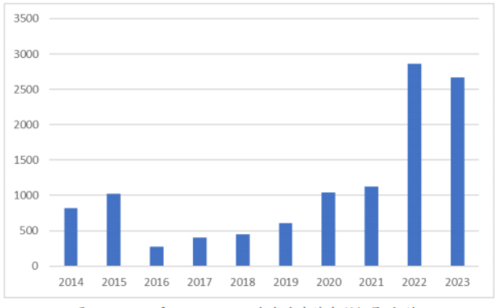

Figure 3.1 Number of annual patent applications from 2014 to 2023 (items)

Furthermore, the digital transformation had profoundly impacted the talent structure of Shandong Aerospace Special Vehicles. With the continuous advancement of technology, traditional workers had gradually transformed into skilled technical workers. Although employees had been streamlined, the proportion of highly educated and technical talents had increased significantly. This optimization of the talent structure had not only enhanced the company's innovation capabilities but also promoted an increase in per capita revenue generation, injecting strong momentum into the company's sustainable development. In summary, Shandong Aerospace Special Vehicles had significantly improved its R&D efficiency and optimized its talent structure, laying a solid foundation for the company's long-term development.
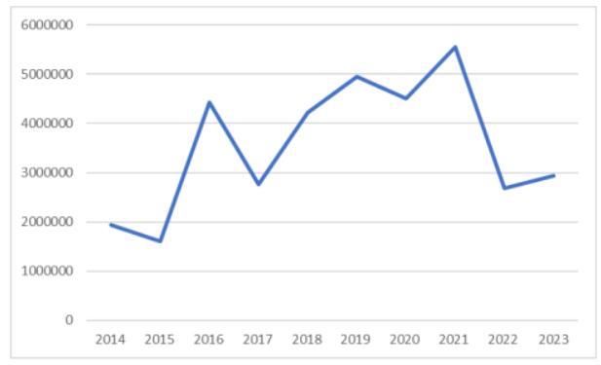

Figure 3.2 Ratio of R&D Investment to Patent Applications for Shandong Aerospace Special Vehicles from 2021 to 2023

In response to the evolving and diverse needs of customers, Shandong Aerospace Special Vehicles encountered challenges in achieving high-quality and diversified production during its manufacturing processes. To address this, the company introduced a flexible production model, employing a "mixed product assembly + assembly line" strategy and establishing an intelligent management platform through digital systems like MOM, IoT, and WMS, complemented by intelligent robots. This innovative approach allows a single production line to produce multiple products, and through digital drive and process optimization, it significantly cuts production expenses, boosts production efficiency, and more effectively fulfills customers' personalized requirements.
Over the past 10 years, the cost composition of Shandong Aerospace Special Vehicles' production processes has also undergone significant changes. Especially around 2015, production personnel and labor costs constituted the major portion of production costs, with labor costs exhibiting a certain upward trend. Additionally, depreciation and amortization expenses were also continuously increasing, posing a considerable impact. However, since Shandong Aerospace Special Vehicles initiated its digital transformation strategy in 2017, the composition of production costs has undergone notable changes. With the widespread application of automation and intelligent technologies, the proportion of production personnel and labor costs has significantly decreased. However, since Shandong Aerospace Special Vehicles initiated its digital transformation strategy in 2017, the composition of production costs has undergone notable changes. With the widespread application of automation and intelligent technologies, the proportion of production personnel and labor costs has significantly decreased, directly reflecting in production efficiency and a reduction in labor demand. Concurrently, the implementation of digital management systems has optimized equipment utilization efficiency and reduced the rate of depreciation and amortization, thereby further easing the company's cost pressures.
Table 3.2
Production link cost composition of Shandong Aerospace Special Vehicles from 2014 to 2023
vintages | 2014 | 2015 | 2016 | 2017 | 2018 | 2019 | 2020 | 2021 | 2022 | 2023
Percentage of production staff (%) | 60.07 | 59.88 | 58.37 | 63.58 | 61.92 | 59.48 | 50.08 | 48.88 | 39.41 | 39.32
Labour costs (%) | 8.71 | 9.06 | 8.68 | 7.91 | 7.70 | 6.63 | 5.11 | 4.74 | 4.58 | 4.45
Depreciation and amortisation (%) | 3.72 | 4.40 | 5.82 | 5.97 | 3.25 | 2.47 | 2.07 | 1.53 | 1.60 | 2.18
Other (%) | 2.04 | 2.42 | 2.60 | 2.79 | 2.14 | 1.88 | 2.55 | 2.95 | 5.36 | 8.10

Since Shandong Aerospace Special Vehicles comprehensively initiated its digital transformation in 2017, it had achieved significant reductions in unit production costs. Through the widespread application of intelligent manufacturing and the establishment of advanced production management systems, the digital transformation has greatly optimized cost management processes, production costs of products to continue and significantly decrease. Meanwhile, Shandong Aerospace Special Vehicles has also seen a notable increase in production capacity. Taking 2016 as a benchmark, by 2023, its annual production volume has increased significantly, with a growth rate far exceeding the industry average. This growth is not only attributed to the improved production efficiency brought about by the digital transformation but also to the company's continuous investment in production layout and technological innovation. By setting up a digital flexible equipment manufacturing system, Shandong Aerospace Special Vehicles has not only drastically enhanced production efficiency and significantly boosted productivity but also managed to cut unit production costs by roughly 25%. Despite the increasing pressures from higher raw material and labor costs, the digital transformation has enabled the company to maintain cost control, simultaneously elevating product quality and production efficiency.
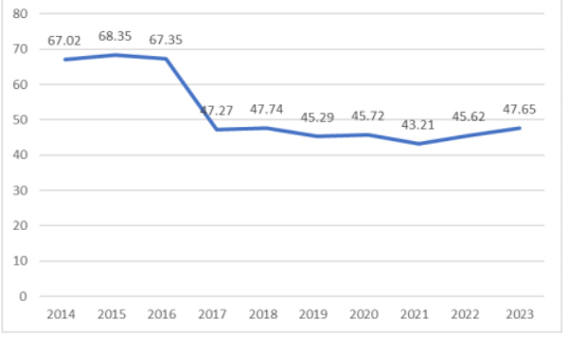

Figure 3.3 Unit production cost of Shandong Aerospace Special Vehicles from 2014 to 2023 (10,000 yuan per unit)

As shown in Figures 4-4 and 4-5, during the digital transformation process of Shandong Aerospace Special Vehicles, labor costs and equipment depreciation are also considered two core elements in cost management within production processes. To deeply assess the actual effectiveness of the digital transformation, this study conducted a comparative analysis between Shandong Aerospace Special Vehicles and two other renowned enterprises within the same industry, namely Aerospace Chenguang and Northern Microelectronics, focusing on their labor costs and depreciation & amortization ratios as percentages of operating revenue
Although Shandong Aerospace Special Vehicles may be slightly inferior in asset size, resulting in relatively lower numerical values for its labor costs and depreciation & amortization ratios, with the deep implementation of the digital transformation strategy, the optimization effects of its cost management have gradually emerged. Especially since 2017, Shandong Aerospace Special Vehicles has shown a clear downward trend in the proportions of labor costs and equipment depreciation,.
Compared to Aerospace Chenguang and Northern Microelectronics, Shandong Aerospace Special Vehicles has experienced more significant reductions in the proportions of labor costs and equipment depreciation, gradually narrowing the gap with these two companies. This change not only reflects the positive role of digital transformation in reducing labor costs and minimizing equipment depreciation but also further demonstrates the significant contribution of digital transformation to enhancing overall production efficiency.
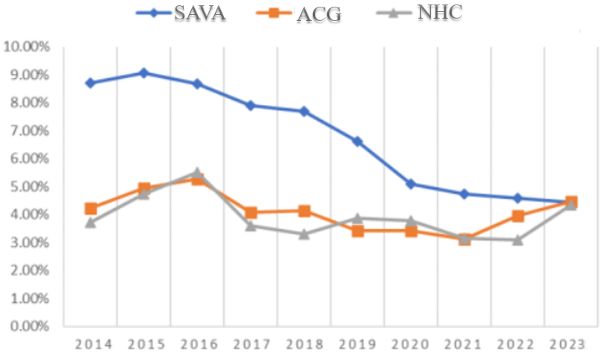

Figure 3.4 Labor cost as a percentage of revenue for the three companies from 2014 to 2023

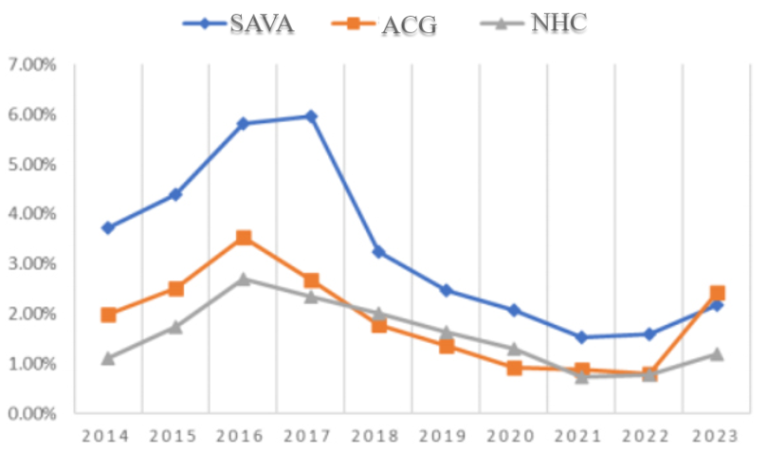

Figure 3.5 Depreciation and amortization as a percentage of revenue for the three companies 2014-2023

In the marketing segment, Shandong Aerospace Special Vehicles has leveraged digital transformation to achieve a deep integration of online and offline channels, innovatively introducing an O2O (Online-to-Offline) marketing model. Through a multi-channel layout encompassing e-commerce platforms, online events, and social media, and its sales pathways and significantly enhanced its market influence. Leveraging an advanced CRM system, Shandong Aerospace Special Vehicles has achieved precise targeting in market promotion, which has not only improved marketing conversion rates but also effectively controlled conversion costs. By integrating online and offline resources and conducting sales activities with widespread public engagement, the company has reduced the hierarchy of marketing information dissemination and drastically decreased advertising and marketing expenses, thereby establishing a robust digital marketing competitiveness.
Table 3.3 presents the trend in marketing cost changes for Shandong Aerospace Special Vehicles over the past decade. The data indicates that, with the deepening of digital transformation, the proportion of sales personnel to total employees has been increasing annually, reflecting the company's enhanced direct sales efforts and the tight integration of online and offline sales. Meanwhile, the proportion of the dealer sales model has gradually decreased, marking a strategic adjustment in Shandong Aerospace Special Vehicles' sales approach. Post-digital transformation, the average revenue generation capability per salesperson has significantly improved, validating the effectiveness of the online and offline sales strategy. Compared to the initial stages of the transformation, the company's sales expense ratio has notably declined, indicating remarkable achievements in cost management within the marketing segment. Despite facing certain challenges in the overall planning market environment in 2023, in the long run, digital transformation has effectively optimized Shandong Aerospace Special Vehicles' sales cost structure. This is attributed to the by of precise marketing through digital platforms, which has effectively reduced advertising expenditures and balanced the cost increase resulting from the addition in sales personnel. This trend underscores the dual effectiveness of Shandong Aerospace Special Vehicles' marketing digital transformation in enhancing efficiency and cost control.

Table 3.3
Overview of Shandong Aerospace Special Vehicles's marketing costs from 2014 to 2023
vintages | 2014 | 2015 | 2016 | 2017 | 2018 | 2019 | 2020 | 2021 | 2022 | 2023
Percentage of sales staff (%) | 7.39 | 8.76 | 9.90 | 8.59 | 9.36 | 11.83 | 13.10 | 14.60 | 15.61 | 13.11
Revenue generation per salesperson (billions of yuan) | 0.18 | 0.15 | 0.15 | 0.20 | 0.29 | 0.27 | 0.31 | 0.28 | 0.29 | 0.25
Sales expense ratio (%) | 8.16 | 9.46 | 8.30 | 10.13 | 10.00 | 7.97 | 7.25 | 5.33 | 6.31 | 7.79
Advertising costs as a percentage (%) | 5.85 | 4.70 | 3.25 | 3.39 | 1.44 | 1.21 | 1.18 | 1.20 | 1.14 | 1.12

As illustrated in Figure 3.6, Shandong Aerospace Special Vehicles exhibits certain differences in sales expense ratios compared to Aerospace Sunrise and Northern Huachuang over the past decade. In most years, Shandong Aerospace Special Vehicles' sales expense ratio was lower than that of Northern Huachuang but higher than Aerospace Sunrise, particularly in 2022 and 2023 when Northern Huachuang's sales expense ratio increased. Although Shandong Aerospace Special Vehicles' sales expense ratio declined after advancing its digital transformation, narrowing the gap with Aerospace Sunrise, Aerospace Sunrise's sales expense ratio experienced a more significant drop from 2022 onwards. This suggests that Shandong Aerospace Special Vehicles still has room for improvement in optimizing its sales expense ratio, especially when faced from competitors. While digital transformation has achieved certain results, there is still potential to be explored in cost management and efficiency enhancement. Therefore, Shandong Aerospace Special Vehicles needs to continuously optimize its sales strategies and expense management to enhance its overall market competitiveness.
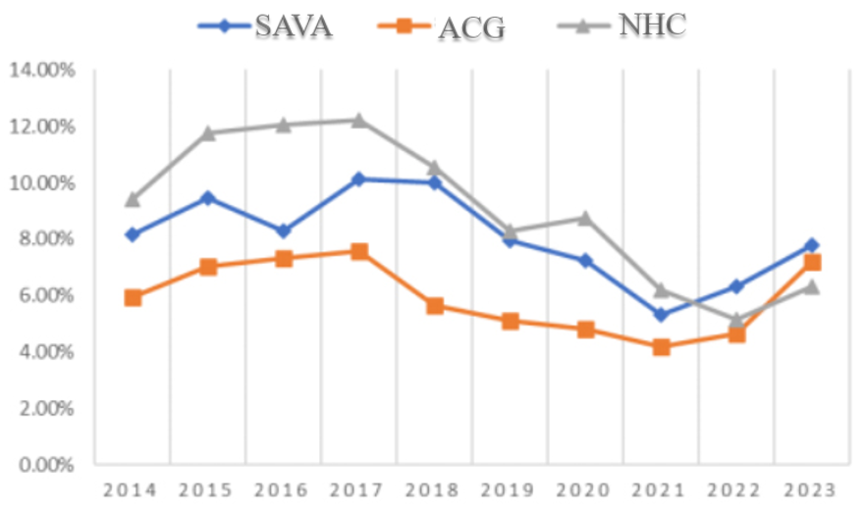

Figure 3.6 Sales expense ratio of the three enterprises from 2014 to 2023

As illustrated in Figures 3.7 and 3.8, Shandong Aerospace Special Vehicles observed a decline in both sales gross profit rate and net income margin from 2014 to 2016, accompanied by a rising period expense ratio. This was primarily driven by market challenges and internal management adjustments. However, from 2017 onwards, with the comprehensive rollout of digital transformation, these key financial metrics began to gradually improve. The deep integration of digital technology and lean management significantly enhanced production efficiency and optimized cost control, leading to a steady rise in both gross profit rate and net income margin, with particularly notable growth in the latter. Additionally, the period expense ratio exhibited a downward trend. This transformation underscores the profound impact of digital transformation on cost-benefit management. Notably, due to external factors such as global economic slowdown and market demand fluctuations, Shandong Aerospace Special Vehicles' operating revenue and profitability experienced fluctuations in 2022 and 2023. Hence, ongoing efforts to manage and control period expenses remain crucial to mitigate these challenges.
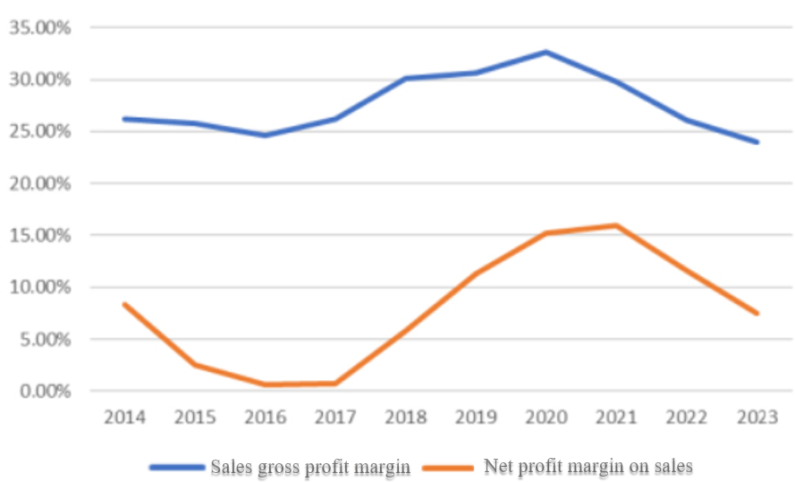

Figure 3.7 Sales gross profit margin and net profit margin of Xugong Group in 2014-2023

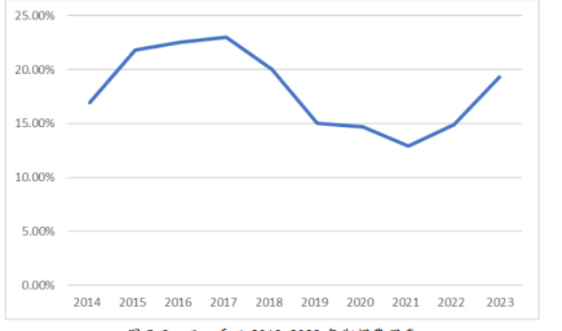

Figure 3.8 Expense ratio of Xugong Group during 2014-2023

3.2 Effect analysis of external value chain cost management

Shandong Aerospace Special Vehicles leverages its SCM system to inject digital momentum into the supply chain, establishing a digital interaction platform encompassing multiple parties. This has facilitated efficient information and capital flows with upstream and downstream partners and customers. Through effective resource integration and sharing, it has strengthened collaboration among all parties in chain, not only achieving effective cost control but also improving resource utilization efficiency and the synergistic benefits of technical management. This has established a firm basis for maintaining production and operational stability, as well as continually refining and enhancing the supply chain's efficiency.
After implementing these digital management initiatives, Shandong Aerospace Special Vehicles effectively reduced transaction costs and strengthened its monitoring of supplier costs. Simultaneously, by deepening strategic cooperation with suppliers, it has promoted mutual development, reduced dependence on single suppliers, and enhanced the flexibility in the supply chain. According to Shandong Aerospace Special Vehicles' procurement data, from 2017 to 2023, the procurement proportion of the top five suppliers gradually decreased, and there were no related party procurements, reflecting the positive results of diversified supplier cooperation. Additionally, Account reduction payable turnover further verifies the company's successful practices in optimizing supplier management and procurement planning during its digital transformation.
Table 3.4
Purchases of the top five suppliers of Shandong Aerospace Special Vehicles from 2014 to 2023
vintages | 2014 | 2015 | 2016 | 2017 | 2018 | 2019 | 2020 | 2021 | 2022 | 2023
Purchases from top five suppliers ($bn) | 34.68 | 22.62 | 25.45 | 16.01 | 27.05 | 52.78 | 58.91 | 86.38 | 75.94 | 53.84
Share of total annual purchases (%) | 15.31 | 13.80 | 14.24 | 13.96 | 12.94 | 13.62 | 10.90 | 12.03 | 11.19 | 12.75
Related-party purchases from top five suppliers (billions of yuan) | — | — | 5.40 | 0 | 0 | 0 | 0 | 0 | 0 | 0
Share of total annual procurement (%) | — | — | 3.21 | 0 | 0 | 0 | 0 | 0 | 0 | 0
Accounts payable turnover rate (times) | 5.39 | 4.98 | 4.76 | 4.17 | 4.43 | 4.32 | 4.42 | 3.75 | 3.47 | 3.58

Figure 3.9 presents a comparison of the proportion of raw material costs to operating revenue among Shandong Aerospace Special Vehicles, Aerospace Chenguang, and Northern Huachuang. There has been evidence that Shandong Aerospace Special Vehicles' proportion of raw material costs has consistently remained at a lower level among the three, and since the digital transformation, its proportion of raw material costs has tended to stabilize, maintaining a level below 60%. Compared to the fluctuations before 2017, after the digital transformation, the fluctuation range of Shandong Aerospace Special Vehicles' raw material costs has significantly decreased, demonstrating stronger cost control capabilities. To further optimize supply chain efficiency, Shandong Aerospace Special Vehicles has launched a global digital collaboration platform for suppliers. This platform supports online communication and transactions among suppliers, effectively reducing costs associated. Through this platform, Shandong Aerospace Special Vehicles can broadly collect product information from high-quality suppliers worldwide and conduct large-scale global procurement activities, enhancing its negotiating position with suppliers and further reducing transaction costs. The digital transformation has enabled Shandong Aerospace Special Vehicles to achieve more precise and efficient cost control.
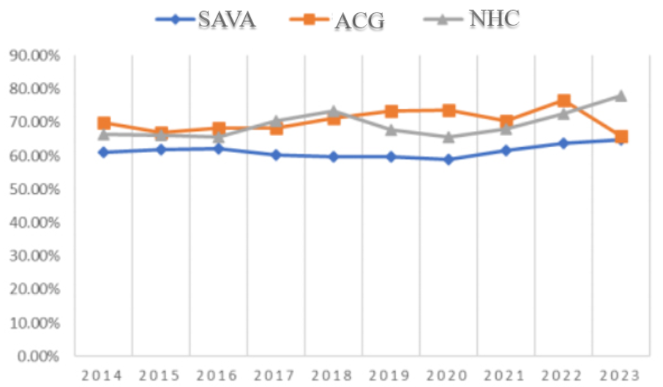

Figure 3.9 Raw material cost as a share of revenue for the three companies from 2014 to 2023

Leveraging digital transformation, Shandong Aerospace Special Vehicles has established a full-time service system, providing 7×24-hour online ordering and after-sales support, significantly enhancing customer loyalty and reducing customer acquisition costs. Through the deep integration of the CRM (Customer Relationship Management) system and the e-commerce center platform, Shandong Aerospace Special Vehicles intelligence in its service processes, enabling it to capture customer needs instantly and respond rapidly. Additionally, the CRM system has optimized cash flow management by monitoring fund flows in real-time, accelerating capital turnover, and effectively reducing transaction costs. These digital initiatives have significantly improved Shandong Aerospace Special Vehicles' competitiveness.
Table 3.5 provides a summary of Shandong Aerospace Special Vehicles' accounts receivable and default patterns spanning the last ten years. The figures reveal a clear downward trajectory in the days sales outstanding (DSO) as digital transformation progresses. While DSO saw a minor surge in 2023 amidst industry volatility and heightened market competition, it has generally improved dramatically compared to earlier periods, marked by quicker delivery cycles and accelerated collections. The age composition of accounts receivable has shifted positively, with an increasing proportion falling within one year, while the percentages of those aged 1-2 years and over 2 years have decreased steadily. Notably, the provision for bad debts has decreased significantly since 2017, indicating a substantial upgrade in the quality of accounts receivable. Additionally, between 2014 and 2016, Shandong Aerospace Special Vehicles witnessed an elevation in overdue payments on customers' behalf and a rise in the overdue ratio. However, with the thorough implementation of digital transformation, these ratios have decreased markedly, effectively controlling default costs. These shifts underline the beneficial impacts of digital transformation on Shandong Aerospace Special Vehicles' accounts receivable management.
Table 3.5
Accounts receivable and defaults of Shandong Aerospace Special Vehicles from 2014 to 2023
vintages | 2014 | 2015 | 2016 | 2017 | 2018 | 2019 | 2020 | 2021 | 2022 | 2023
Accounts receivable turnover days (days) | 162.51 | 228.69 | 314.38 | 301.91 | 171.15 | 124.14 | 99.74 | 78.47 | 69.83 | 91.00
Accounts receivable within 1 year (%) | 82.83 | 73.48 | 62.07 | 54.37 | 60.67 | 70.75 | 81.86 | 85.28 | 85.97 | 83.66
1-2 years accounts receivable as a percentage (%) | 5.78 | 14.66 | 19.61 | 15.31 | 11.73 | 6.48 | 2.49 | 4.04 | 5.44 | 5.88
Percentage of accounts receivable over 2 years (%) | 7.68 | 7.61 | 12.87 | 17.16 | 18.42 | 13.48 | 8.34 | 10.68 | 8.75 | 10.46
Provision for bad debts as a percentage of operating income (%) | 2.49 | 4.60 | 7.89 | 7.62 | 6.40 | 4.58 | 3.24 | 2.55 | 2.29 | 2.45
Overdue advances on behalf of customers ($ billion) | 38.89 | 48.89 | 68.22 | 47.17 | 41.61 | 23.34 | 13.30 | 9.77 | 8.55 | 9.36
Overdue rate (%) | 20.77 | 24.63 | 32.55 | 26.08 | 22.66 | 11.59 | 6.10 | 4.54 | 4.35 | 4.57

Figure 3.10 contrasts the accounts receivable turnover ratios of Shandong Aerospace Special Vehicles, Zoomlion Heavy Industry, and Aerospace Chenguang. Prior to 2017, Shandong Aerospace Special Vehicles' ratio was on par with the industry norm, lacking a notable edge. However, as digital transformation intensified, the company's ratio experienced a substantial surge, ultimately surpassing its peers. Despite minor variations in 2023, it maintained an elevated level. This enhancement is primarily due to Shandong Aerospace Special Vehicles' enhanced management of accounts receivable, facilitated by digital platforms that enable precise control and real-time monitoring. Additionally, the company adopted robust risk management strategies, centralizing the management of key accounts receivable, thereby further optimizing capital turnover efficiency.
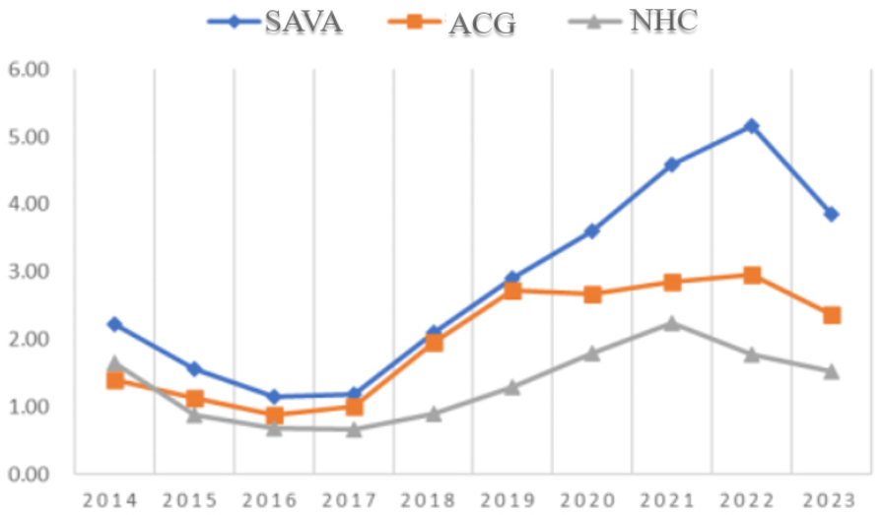

Figure 3.10 Accounts receivable turnover ratio of the three enterprises 2014-2023 (times)

3.3 Comprehensive evaluation of value chain cost management effect based on entropy method

The entropy method, as an objective and practical statistical tool, has wide applications in data analysis and is particularly suitable for assessing the comprehensive effectiveness of enterprise digital transformation. Using this method, we can conduct quantitative analysis on the cost management of Shandong Aerospace Special Vehicles' internal and external value chains. The aim of this section is to provide a thorough assessment of Shandong Aerospace Special Vehicles' digital transformation efficacy, employing the entropy method to uncover its actual performance in cost management and overall profitability.
Firstly, we carefully selected financial and non-financial indicators closely related to cost management, ensuring their relevance and importance. Depending on the actual situation, this paper selected eight core indicators covering production, marketing, supply chain management, and finance. These indicators not only have a high degree of quantification but also comprehensively reflect the far-reaching impact of digital transformation on various aspects.
In the implementation process of the entropy method, we first standardized the data for each indicator, and finally obtained the comprehensive score of Shandong Aerospace Special Vehicles in the context of digital transformation. This evaluation system can accurately measure the optimization effect of digital transformation on enterprise cost management and provide a solid scientific basis for future management optimization.
When constructing the evaluation indicator system, the following principles were followed: Firstly, a primary indicator layer was set up to comprehensively summarize the effectiveness of value chain cost management for Shandong Aerospace Special Vehicles in the context of digital transformation. Secondly, a secondary indicator layer was established, with eight specific indicators carefully selected, as shown in Table 4-6. These indicators not only include financial indicators that directly reflect the effectiveness of cost management, and period expense ratio, but also incorporate indicators that indirectly reflect operational efficiency. Together, they reveal the cooperation benefits among upstream and downstream enterprises in the supply chain. By utilizing the entropy method to conduct a comprehensive indicators were analysed, we can thoroughly evaluate the cost management performance of each key link in Shandong Aerospace Special Vehicles' value chain after digital transformation, and provide strong data support and decision-making references for the company to optimize its management strategies.
Table 3.6
Selection of evaluation indicators
Level 1 indicators | Secondary indicators | Indicator properties
Value chain cost management effectiveness | Cost-expense margin (x1) | forward
Value chain cost management effectiveness | Gross margin on sales (x2) | forward
Value chain cost management effectiveness | Net sales margin (x3) | forward
Value chain cost management effectiveness | Accounts receivable turnover (x4) | forward
Value chain cost management effectiveness | Accounts payable turnover (x5) | reverse direction
Value chain cost management effectiveness | Sales expense ratio (x6) | reverse direction
Value chain cost management effectiveness | Management cost ratio (x7) | reverse direction
Value chain cost management effectiveness | Period cost ratio (x8) | reverse direction

Shandong Aerospace Special Vehicles has comprehensively promoted digital transformation since 2018. The 2016 to 2023, aiming to evaluate the effectiveness of its value chain cost management by comparing the data changes before and after the transformation. Firstly, we adopt the min-max normalization method to process the selected indicators. Given that the normalized data may contain zero values, which can affect the subsequent calculation accuracy, in order to guarantee data integrity and avoid information loss the removal of zero-value data, we uniformly add 0.001 to all normalized data. This step guarantees the smooth progress of subsequent calculations, thereby ensuring the accuracy and practicality of the analysis results.
1) Data standardization
As indicators of different nature will have a greater impact, so in the calculation process to remove the impact of the quantitative outline, the data standardization process, the processing is as follows:
For the reverse indicator is treated as:
$r_{ij}=\left[x_{ij}-min\left(x_{ij}\right)\right]/\left[max\left(x_{ij}\right)-min\left(x_{ij}\right)\right.$ (3.1)
For the reverse indicator is treated as:
$r_{ij}=\left[max\left(x_{ij}\right)-x_{ij}\right]/max\left(x_{ij}\right)-min\left(x_{ij}\right)$ (3.2)
For the moderate indicator the treatment as:
$r_{ij}=\left[x_{ij}-\left(max\left(x_{ij}\right)+min\left(x_{ij}\right)\right)/2\right]/\left[max\left(x_{ij}\right)-min\left(x_{ij}\right)\right.$ (3.3)
Where 𝑥𝑖𝑗 is the original data, 𝑟𝑖𝑗 is the dimensionless data, and max(𝑥𝑖𝑗) and min(𝑥𝑖𝑗) are the maximum and minimum values in the original data. To ensure the validity of the indicator after the standardization process, 0.0001 is added after the result.
2) Define the standardized value
Calculate the weight of the nth indicator under each evaluation object:
$p_{ij}=r_{ij}/\sum_{i=1}^{m}{ }r_{ij}$ (5-4)
3) Calculate indicator entropy
$e_{i}=-k\sum_{i=1}^{m}{ }p_{ij}ln⁡\left(p_{ij}\right),(k>0.k=1/ln⁡(n),1≥e≥0)$ (5-5)
4) Calculate the difference coefficient
$d_{i}=1-e_{i},\left(1≥d_{i}≥0\right)$ (5-6)
5) Calculate the weight of each indicator
$w_{i}=d_{i}/\sum_{i=1}^{m}{ }d_{i}$ (5-7)
6) Calculate the final financial performance score based on standardized P-values and weights
Table 3.7
Dimensionless data after processing
 | 2014 | 2015 | 2016 | 2017 | 2018 | 2019 | 2020 | 2021 | 2022 | 2023
x1 | 0.4188 | 0.1312 | 0.0103 | 0.0001 | 0.3392 | 0.6916 | 0.9618 | 1.0001 | 0.6550 | 0.4103
x2 | 0.2521 | 0.2038 | 0.0714 | 0.2544 | 0.6986 | 0.7619 | 1.0001 | 0.6698 | 0.2418 | 0.0001
x3 | 0.5008 | 0.1236 | 0.0001 | 0.0073 | 0.3395 | 0.6958 | 0.9494 | 1.0001 | 0.7173 | 0.4494
x4 | 0.2669 | 0.1048 | 0.0001 | 0.0101 | 0.2370 | 0.4365 | 0.6136 | 0.8580 | 1.0001 | 0.6061
x5 | 0.0001 | 0.1704 | 0.2913 | 0.6155 | 0.4726 | 0.5331 | 0.4781 | 0.8463 | 1.0001 | 0.7693
x6 | 0.4105 | 0.1397 | 0.3814 | 0.0001 | 0.0272 | 0.4501 | 0.6001 | 1.0001 | 0.7959 | 0.4876
x7 | 0.2630 | 0.1660 | 0.1165 | 0.0001 | 0.5389 | 0.4958 | 0.3406 | 0.4139 | 0.7544 | 1.0001
x8 | 0.6015 | 0.1138 | 0.0476 | 0.0001 | 0.2919 | 0.7894 | 0.8191 | 1.0001 | 0.8013 | 0.3661

Table 3.8
P-value data
 | 2014 | 2015 | 2016 | 2017 | 2018 | 2019 | 2020 | 2021 | 2022 | 2023
x1 | 0.0907 | 0.0284 | 0.0022 | 0.0000 | 0.0735 | 0.1497 | 0.2083 | 0.2165 | 0.1418 | 0.0888
x2 | 0.0607 | 0.0491 | 0.0172 | 0.0612 | 0.1682 | 0.1834 | 0.2408 | 0.1612 | 0.0582 | 0.0000
x3 | 0.1047 | 0.0258 | 0.0000 | 0.0015 | 0.0710 | 0.1455 | 0.1985 | 0.2091 | 0.1500 | 0.0940
x4 | 0.0646 | 0.0254 | 0.0000 | 0.0024 | 0.0573 | 0.1056 | 0.1484 | 0.2076 | 0.2420 | 0.1466
x5 | 0.0000 | 0.0329 | 0.0563 | 0.1189 | 0.0913 | 0.1030 | 0.0924 | 0.1635 | 0.1932 | 0.1486
x6 | 0.0956 | 0.0325 | 0.0888 | 0.0000 | 0.0063 | 0.1049 | 0.1398 | 0.2330 | 0.1854 | 0.1136
x7 | 0.0643 | 0.0406 | 0.0285 | 0.0000 | 0.1318 | 0.1212 | 0.0833 | 0.1012 | 0.1845 | 0.2446
x8 | 0.1245 | 0.0236 | 0.0098 | 0.0000 | 0.0604 | 0.1634 | 0.1696 | 0.2070 | 0.1659 | 0.0758

Table 3.9
Weights of indicators at each level
 | norm | entropy (physics) | coefficient of variation | weights
x1 | cost-effectiveness ratio | 0.8508 | 0.1492 | 0.1370
x2 | Gross sales margin | 0.8567 | 0.1433 | 0.1316
x3 | net sales margin | 0.8529 | 0.1471 | 0.1351
x4 | Accounts receivable turnover ratio | 0.8342 | 0.1658 | 0.1522
x5 | Accounts payable turnover | 0.9109 | 0.0891 | 0.0819
x6 | sales expense ratio | 0.8659 | 0.1341 | 0.1231
x7 | management cost ratio | 0.8799 | 0.1201 | 0.1102
x8 | period cost ratio | 0.8597 | 0.1403 | 0.1289

Table 3.10
Final scores of indicators at each level
 | 2014 | 2015 | 2016 | 2017 | 2018 | 2019 | 2020 | 2021 | 2022 | 2023
x1 | 0.0574 | 0.0180 | 0.0014 | 0.0000 | 0.0465 | 0.0948 | 0.1318 | 0.1370 | 0.0898 | 0.0562
x2 | 0.0332 | 0.0268 | 0.0094 | 0.0335 | 0.0919 | 0.1003 | 0.1316 | 0.0881 | 0.0318 | 0.0000
x3 | 0.0676 | 0.0167 | 0.0000 | 0.0010 | 0.0459 | 0.0940 | 0.1282 | 0.1351 | 0.0969 | 0.0607
x4 | 0.0406 | 0.0160 | 0.0000 | 0.0015 | 0.0361 | 0.0665 | 0.0934 | 0.1306 | 0.1523 | 0.0923
x5 | 0.0000 | 0.0140 | 0.0238 | 0.0504 | 0.0387 | 0.0436 | 0.0391 | 0.0693 | 0.0819 | 0.0630
x6 | 0.0506 | 0.0172 | 0.0470 | 0.0000 | 0.0033 | 0.0554 | 0.0739 | 0.1232 | 0.0980 | 0.0600
x7 | 0.0290 | 0.0183 | 0.0128 | 0.0000 | 0.0594 | 0.0547 | 0.0375 | 0.0456 | 0.0832 | 0.1102
x8 | 0.0775 | 0.0147 | 0.0061 | 0.0000 | 0.0376 | 0.1017 | 0.1055 | 0.1289 | 0.1032 | 0.0472

Table 3.11
Shandong Aerospace Special Vehicles''s comprehensive rating and ranking by year
 | Composite indicators | arrange in order
2014 | 0.3559 | 7
2015 | 0.1416 | 8
2016 | 0.1006 | 9
2017 | 0.0864 | 10
2018 | 0.3594 | 6
2019 | 0.6109 | 4
2020 | 0.7412 | 2
2021 | 0.8578 | 1
2022 | 0.7370 | 3
2023 | 0.4896 | 5

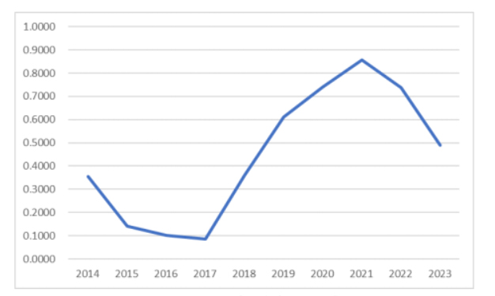

Figure 3.11 Shandong Aerospace Special Vehicles' 's Comprehensive Score by Year

As shown in Table 3.11 and Figure 3.12, the entropy method was used to conduct a quantitative analysis of several key indicators that directly affect or are indirectly related to value chain cost management, and comprehensive scores for each year were obtained. Shandong Aerospace Special Vehicles has comprehensively promoted digital transformation since 2018, gradually optimizing and upgrading both its internal and external value chains. Observing Figure 3.12 it is evident that the comprehensive scores of Shandong Aerospace Special Vehicles after digital transformation have significantly increased, indicating that digital transformation has had a positive effect on value chain cost management. Especially in 2020 and 2021, the comprehensive scores reached their peaks. This transformation fully demonstrates that through digital transformation, Shandong Aerospace Special Vehicles has not only improved cost management efficiency but also further enhanced overall operating benefits. However, since 2022, Shandong Aerospace Special Vehicles has faced multiple external challenges. Rising raw material costs, the ongoing global pandemic, and the aerospace special vehicle industry entering a new cyclical adjustment phase have significantly changed the company's operating environment. In addition, the implementation of epidemic prevention and control measures has had a significant impact on traditional offline transaction modes, directly affecting the sales link in the external value chain.
The comprehensive evaluation of Shandong Aerospace Special Vehicles' value chain cost management effectiveness during digital transformation, utilizing the entropy method, integrates various indicators that reflect both direct and indirect aspects of cost management efficacy. The annual scores align with prior analytical insights. The results indicate that Shandong Aerospace Special Vehicles' digital transformation has significantly optimized and enhanced its value chain cost management, corroborating previous assessments on the transformation's impact. As the digital transformation strategy deepens, the company's internal and external value chain cost management has seen notable advancements. Although recent years have witnessed temporary fluctuations in overall performance due to challenges like the pandemic and industry competition, Shandong Aerospace Special Vehicles has retained its industry leadership and progressed with its digital transformation strategy. Looking ahead, as market conditions improve, the company's digital transformation-driven value chain management will pave the way for future growth, showcasing considerable market potential and expansion opportunities.

CONCLUSION

Shandong Aerospace Special Vehicles, as a traditional enterprise specializing in the manufacture of aerospace special vehicles, in order to enhance its market competitiveness in the aerospace and special vehicle fields, has implemented a comprehensive digital transformation strategy, reconstructing and upgrading its internal and external value chains, thereby achieving significant improvements in cost control and benefits. This paper first outlines the corporate background, digital transformation journey, and value chain system of Shandong Aerospace Special Vehicles. Subsequently, it conducts an in-depth analysis and evaluation of value chain cost management under digital transformation, combining both financial and non-financial indicators. The research finds that Shandong Aerospace Special Vehicles' digital transformation strategy has penetrated into all aspects of its value chain, significantly enhancing its cost management capabilities and driving overall benefit improvements. The specific conclusions are as follows:
Firstly, digital transformation has optimized all aspects of Shandong Aerospace Special Vehicles' internal value chain, leading to outstanding cost management results. Within the internal value chain, digital transformation has driven innovations in multiple stages. By building digital platforms and introducing software and hardware facilities, the company has achieved full lifecycle digital management from product design, production to sales. In the research and development (R&D) stage, digital tools and platforms are leveraged to accelerate product innovation, shorten the R&D cycle, and effectively control R&D costs. During the production phase, the deployment of intelligent production systems boosts efficiency and adaptability, while minimizing energy use, equipment degradation, and labor expenses. Moving to the marketing phase, the fusion of online and offline sales channels via digital marketing platforms enables precise market demand identification and strategic marketing refinement, leading to substantial cost savings. Furthermore, digital advancements elevate supply chain transparency, refining inventory handling and logistics coordination for an overall operational efficiency boost. Overall, digital transformation has significantly enhanced the efficiency and cost control capabilities of Shandong Aerospace Special Vehicles' internal value chain, particularly in production and R&D stages, effectively lowering operational costs. However, despite these remarkable overall achievements, some indicators such as selling expenses ratio necessitating continuous monitoring and optimization.
Secondly, digital transformation has significantly enhanced the synergistic effect among the entities in Shandong Aerospace Special Vehicles' external value chain, making cost management even more prominent. At the level of the external value chain, digital means have played a crucial role in optimizing supply chain management. Leveraging an order-driven intelligent procurement process, Shandong Aerospace Special Vehicles has closely connected suppliers, distributors, and end-customers, forming a community of shared interests that promotes the coordination of all parties' interests and effectively reduces transaction costs. Especially in upstream supplier management, the company has established a global supplier information system to enable online sharing and intelligent matching of supplier information, which not only expands global material procurement channels but also leverages economies of scale to significantly reduce procurement costs. Concurrently, digital platforms fortify the resilience of supply chain risk management, empowering the company to adeptly navigate the volatility and unpredictability of the global market. In downstream customer management, Shandong Aerospace Special Vehicles fully utilizes the CRM system and its self-built cloud service platform to promptly capture market dynamics and achieve rapid information feedback, reducing the time and cost of communication processes. These platforms not only allow the company to make more precise market forecasts but also enable it to respond quickly when customer needs change, maintaining high customer satisfaction and further enhancing market competitiveness. In addition, digital tools effectively assist the company in managing accounts receivable, improving capital turnover efficiency, reducing financial risks, and further cutting related transaction costs. Overall, through digital transformation, Shandong Aerospace Special Vehicles has tightened the connections among all parties in the external value chain, deepened the mutually beneficial and win-win situation, and significantly improved the benefits of cost management.
Thirdly, digital transformation has driven the overall performance improvement of Shandong Aerospace Special Vehicles, with value chain cost management playing a pivotal role. Digital transformation has enabled efficient collaboration across all links of Shandong Aerospace Special Vehicles' internal and external value chains, significantly optimizing key areas such as production, research and development, sales, and supply chain management, thereby enhancing overall operational efficiency and cost management capabilities. Comprehensive evaluations using the entropy method indicate that after digital transformation, Shandong Aerospace Special Vehicles' value chain cost management capabilities have been significantly enhanced, leading to notable improvements. Customer service, the application of digital means has brought remarkable benefits to Shandong Aerospace Special Vehicles. Despite facing certain market challenges and fluctuations in overall performance in 2022 and 2023 global pandemic and domestic economic adjustments, Shandong Aerospace Special Vehicles has maintained its competitive advantage within the industry through digital transformation. During the pandemic, the company leveraged digital platforms to maintain close communication with suppliers and customers, ensuring the stable operation of the supply chain and effectively reducing risks arising from external uncertainties.
Firstly, when advancing digital transformation, enterprises need to formulate practical strategies based on their own development needs. Digital transformation is not only an effective way to enhance enterprise benefits and reduce costs but also a crucial measure to build long-term competitive advantages. Enterprises need to thoroughly analyze their operational status, development goals, and resource endowments to scientifically plan and execute their digital transformation blueprints. Blindly following the transformation models of other enterprises may lead to resource misallocation and poor transformation outcomes. Taking Shandong Aerospace Special Vehicles as an example, at the initial stage of digital transformation, it started with the research and development segment of its internal value chain and gradually integrated digital technology into various levels such as production, marketing, and supply chain management. Shandong Aerospace Special Vehicles also focused on collaboration with external partners, utilizing digital tools to strengthen connections with upstream suppliers and downstream customers, significantly improving supply chain efficiency and reducing transaction costs. This customized transformation strategy, based on its own characteristics, has enabled Shandong Aerospace Special Vehicles to achieve remarkable results in value chain cost management, further enhancing its market competitiveness.
Secondly, enterprises should accelerate their digital transformation and continuously strengthen their value chain cost management capabilities. Digital transformation has become a core path competitiveness. Shandong Aerospace Special Vehicles has achieved smooth operation across all links of the value chain and effectively optimized cost drivers through the continuous application of digital means. This transformation has not only improved the efficiency of internal management but also enabled the enterprise to demonstrate greater flexibility and efficiency when facing market competition. To further implement the cost leadership strategy, Shandong Aerospace Special Vehicles needs to continuously deepen its digital transformation, enhance the overall management level, and information-based construction, thereby comprehensively improving overall benefits and maximizing enterprise value.
Finally, enterprises should strengthen the close linkage between internal to promote collaborative development. In the wave of digital transformation, cost management for enterprises not only relies on the refinement of internal management but also requires close collaboration with external partners. Shandong Aerospace Special Vehicles has leveraged digital platforms to deepen cooperation. Digital technology has not only revolutionized internal management within enterprises but also promoted collaborative operations across upstream and downstream links in the industry chain, achieving optimal resource allocation and value co-creation. For traditional manufacturing industries, digital transformation signifies a more open cooperation model and a mutually beneficial ecosystem for all parties. Therefore, while enhancing their own strengths, enterprises should actively promote in-depth cooperation with external parties to seek common development and achieve mutual benefit and win-win results.
Shandong Aerospace Special Vehicles holds a prominent position in the aerospace vehicle sector and has been a pioneer in exploring digital transformation, accumulating extensive experience and implementing various cost management strategies across its internal and external value chains. By examining Shandong Aerospace Special Vehicles as a case study, this paper delves into the implementation process and impact of its value chain cost management during digital transformation, drawing insightful conclusions with practical implications. However, it is important to acknowledge the limitations of this study.
Firstly, the data and information used in this paper primarily originate from publicly accessible sources such as official websites and corporate annual reports. The constraints associated with these public data sources have resulted in limited disclosure of certain internal cost data, potentially affecting the precision and depth of some analyses. Access to more granular internal data would undoubtedly strengthen the credibility of the research findings.Secondly, the aerospace vehicle industry possesses unique characteristics that make it challenging to directly compare its digital transformation experiences with those of other industries. Hence, the applicability of the conclusions drawn in this paper to other industries or companies necessitates a thorough analysis tailored to specific contexts. To avoid repetition and ensure originality, the paper has been refined to emphasize key points while minimizing redundancy.
In the digital era, research on digital transformation and value chain cost management is increasing, and the relevant theoretical system is continuously being improved. In the future, more scholars are expected to delve into this field, helping enterprises better understand the importance of digital transformation and promoting more enterprises to strengthen this aspect in practice to reduce costs and enhance overall competitiveness. Despite facing performance variations influenced by external conditions in recent times, Shandong Aerospace Special Vehicles has notably enhanced its cost management capabilities through its digital transformation endeavors. Looking ahead, Shandong Aerospace Special Vehicles should continue to maintain its cost advantage, further enhance its core competitiveness, continuously innovate and optimize its products and services, in order to address industry challenges and consolidate and strengthen its leading position in the market.

REFERENCES
- Xing X, Wang, H, Liu, J, Li, M. (2021). Digital Transformation, Business Model Innovation, and Inclusive Market Expansion. Journal of Business Research, 132, 456-467.
- Zheng Jianghuai, Zhang Rui, Chen Yingwu. The Digital transformation of China's economic development: New stage, new concept and new pattern [J]. Academic Monthly,2021(7):45-54.
- Negroponte N. Being Digital[M]. Haikou: Hainan Press, 1996.
- Nambisan S. Digital Transformation and Business Model Innovation: A Study on the Inclusive Development of Entrepreneurship. Journal of Small Business and Entrepreneurship, 35(4), 675-692.
- Briel F V, Davidsson P, Recker J. Digital technologies as external enablers of new venture creation in the IT hardware sector[J]. Entrepreneurship Theory and Practice, 2018, 42(1): 47-69.
- CAI Li, Yang Yaqian, Lu Shan, Yu Haijing. Review and Prospect of the Impact of digital Technology on entrepreneurial activities [J]. Studies in Science of Science,2019,37(10):1816-1824+1835.
- Zhu Xiumei, Liu Yue, Chen Haitao. Digital entrepreneurship: Research on elements and kernel generation mechanism [J]. Foreign Economics and Management, 2019,42(04):19-35.
- Guo Hai, Yang Zhuen. From Digital Technology to Digital Entrepreneurship: Connotation, characteristics and Internal Relations [J]. Foreign Economics and Management, 201,43(09):3-23.
- Cenamor J, Parida V, Wincent J. How entrepreneurial SMEs compete through digital platforms: The roles of digital platform capability, network capability, and ambidexterity[J]. Journal of Business Research, 2019, 100(7): 196-206.
- Sturgeon T J. Upgrading strategies for the digital economy[J]. Global Strategy Journal, 2019: 1-24.
- Yoo Y. Computing in everyday life: A call for research on experiential computing[J]. MIS Quarterly, 2010: 213-231.
- Holmstrom J. Recombination in digital innovation: Challenges, opportunities, and the importance of a theoretical framework[J]. Information and Organization, 2018, 28(2): 107-110.
- Autio E, Nambisan S, Thomas L D W, et al Digital affordances, spatial affordances, and the genesis of entrepreneurial ecosystems[J]. Strategic Entrepreneurship Journal, 2018, 12(1).
- Liu Pingfeng, Zhang Wang. How can digital Technology Empower Total factor productivity in Manufacturing? [J]. Research in Science,2021,39(08):1396-1406.
- Xie Weihong, Lin Peiwang, Li Zhongshun, Guo Haizhen. Digital innovation: Connotation, characteristics, Value creation and Prospect [J]. Foreign Economics and Management, 2019,42(09):19-31.
- Frankowiak M , Grosvenor R , Prickett P .A review of the evolution of microcontroller-based machine and process monitoring[J].International Journal of Machine Tools and Manufacture, 2004, 45(4/5):573-582.
- Li Cangshu, Shen Yan. Identification, measurement, Prevention and Control of risks of new financial formats in the era of digital economy [J]. Management World,2019,35(12):53-69.
- Scott Jenkins. Workforce 4.0: The Human Side of Digital Transformation[J]. 2019, 126(12):13-16.
- Qi Yudong, CAI Chengwei. Multiple impacts of digitalization on Manufacturing enterprise Performance and its mechanism [J]. Learning and Exploration,2020(07):108-119.
- Chen Jian, Huang Shuo, Liu Yunhui. From Enabling to Enabling -- Enterprise Operation Management in Digital environment [J]. Management World, 2019,36(02):117-128+222.
- Wang Zhitao, Wang Mengjiao. Strategic transformation of enterprises based on co-performance theory: A case study of Wanda Group [J]. Science Research Management,202,43(06):53-62.
- Lerch C , Gotsch M .Digitalized Product-Service Systems in Manufacturing Firms: A Case Study Analysis[J].Research Technology Management, 2015, 58(5):45-52.
- Yu M, Debo L, Kapuscinski R. Strategic Waiting for Consumer-Generated Quality Information: Dynamic Pricing of New Experience Goods[J]. Social Science Electronic Publishing, 2016, 62(2): 410-435.
- PORTER M E. Competitive Advantage[M]. New York: The Free Press, 1985.
- Hines P. Integrated Materials Management: The Value Chain Redefined[J]. The International Journal of Logistics Management, 1993, 4(1): 13-22
- Chang Janie, Nen-Chen Richard Hwang. The effects of country and industry onimplementing value chain cost analysis[J]. International Journal of Accounting, 2002, 37
- Li Boxin, Dong Yu, Zhu Chengliang. Research on Dynamic iterative spillover effect of "Internet Plus" on innovation value chain [J]. Journal of Management,2023,20(02):231-239.
- Shao Jingting. Research on the remodeling of enterprise value Chain by digital and Intelligent Technology [J]. Economic & Cultural Review,2019(09):95-102.
- Economic Review,2020(06):72-89.
- Hoque Z. Strategic Management Accounting: Concepts Processes and Issues[M]. Pearson Prentice Hall, 1985: 321340
- Shannon W, Anderson, Henri C, Dekker. Strategic Cost Management in Supply Chains, Part 1: Structural Cost Management[J]. Social Science Electronic Publishing, 2009, 23(2): 201-220.
- Mu Linjuan, Jia Qi. Cross-organizational resource integration based on value chain cost management: a field study [J]. Accounting Research,2012(05):67-71+94.
- Bai Siping, Lu Ziping, Zhong Jinyun. Analysis on target Cost Management of Guangxi Dadu under Value Chain Theory [J]. Friends of Accounting,2016(09):87-89.]
- Xiao Jinghua, Wu Xiaolong, Xie Kang et al. Information Technology Drives the transformation and upgrading of Chinese Manufacturing: A longitudinal case study of Midea Intelligent Manufacturing's leapfrog strategic Transformation [J]. Management World, 2019,37(03):161-179+225+11.
- Loebbecke C , Picot A .Reflections on societal and business model transformation arising from digitization and big data analytics: A research agenda[J].Journal of Strategic Information Systems, 2015, 24(3):149-157.
- Wu Haoqiang, Liu Huiling. A study on value chain reconstruction of publishing enterprises enabled by digital technology -- Based on a double case study of CITIC Publishing Group and Zhonghua Book Company [J]. Technology and Publishing,2021(10):61-70.
- Feng Y. Cost Management innovation under the background of digital reform [J]. Financial Monthly,2021(23):68-75. (in Chinese)
- Yu Feifei, Dong Fei. Research on the development path of Integration between Small and medium-sized Manufacturing Enterprises and Internet in China under Platform ecosystem [J]. Science and Technology Progress and Countermeasures,2019,36(20):77-84.
- Zhu Xiumei, Lin Xiaoyue. Enterprise digital transformation value chain remodeling mechanism: a longitudinal case study from Huawei Group and Midea Group [J]. Science and Technology Progress and Countermeasures,2023,40(17):13-24

