ODESA I.I. MECHNIKOV NATIONAL UNIVERSITY
FACULTY OF ECONOMICS AND LAW
DEPARTMENT OF MARKETING AND BUSSINESS ADMINISTRATION

Qualification project (thesis)
for obtaining the degree of higher education "master"
« Marketing Aspects of Management in the Context of Industry 5.0»
« Маркетингові аспекти менеджменту у контексті Індустрії 5.0»

Performed by: full-time student
specialty 073 Management
Educational and professional program "Management"
Zhai Wei / Чжай Вей

Scientistic supervisor: Doctor of Economics,
Prof. Chaikovska M.
Reviewer: Doctor of Economics,
Prof. Nemchenko V.V.

Recommended for defense:  protocol of the department meeting  No. ___ dated ________. 2024  Head of Department  Prof. Olena SADCHENKO  (signature) | Defended at the EC meeting No. ___  protocol No. __from ____.12.2024  Assessment ______________/___  (according to the national scale/ESTS scale/points)  Head of the EC  Prof. Eduard KUZNETSOV  (signature)

Оdesa 2024
CONTENTS
INTRODUCTION 3
CHAPTER 1 8
THE THEORETICAL BASIS OF DIGITAL ECONOMY AND MARKETING IN THE ERA OF INDUSTRY 5.0 8
1.1 Background and purpose of the research 8
Purpose of the study 10
1.2 The theoretical basis of the comprehensive relationship between the digital economy and enterprise marketing 12
1.2.1The relationship between digital economy and enterprise marketing 12
1.2.2 Strategic theory of digital marketing 18
1.2.3 Definition and characteristics of digital economy 20
1.3 The impact of the digital economy on the market and consumers 24
1.3.1 Impact of digital economy on market environment 24
1.3.2 The impact of digital economy on consumer behavior 29
CHAPTER 2 ANALYSIS OF THE MARKETING STATUS AND DEVELOPMENT STRATEGIES OF ENTERPRISES UNDER THE BACKGROUND OF DIGITAL ECONOMY 35
2.1 The marketing status quo of enterprises 35
2.2 Problems existing in enterprise marketing innovation 38
2.3. Innovative marketing strategies and case analysis 40
2.3.1 Innovative marketing strategies 40
2.3.2 Successful case analysis 48
CHAPTER 3 55
3.1 Technological innovation and integration of omni-channel marketing 55
3.2 Deepening of personalized marketing 60
3.3 Personalization and cross-cultural marketing 66
CONCLUSIONS 76
REFERENCES 79

INTRODUCTION
Topicality of the study. This study focuses on the product marketing strategies of enterprises in the context of Industry 5.0 and the digital economy. Firstly, it elaborates on the research background, including the new challenges and opportunities faced by enterprise marketing in the digital economy era and the changes brought about by Industry 5.0. It analyzes the research purpose, that is, to explore the innovation of enterprise product marketing strategies to enhance market competitiveness. Then it discusses the relationship between the digital economy and enterprise marketing, such as how the digital economy expands the sales market and reduces marketing costs; elaborates on the strategy theory of digital marketing, including the role of data in marketing and the principles and techniques of social media marketing; introduces the definition and characteristics of the digital economy, as well as its impact on the market environment and consumer behavior. Subsequently, it analyzes the current situation and problems of enterprise marketing innovation, including the status quo of live streaming marketing and digital platform construction, as well as problems such as insufficient understanding of digital marketing and lack of personalized marketing models. It proposes innovative marketing strategies, such as digital marketing price strategies and channel strategies, and analyzes successful cases such as Sankeshu. Finally, it summarizes the research conclusions, emphasizing that enterprises need to continuously innovate marketing strategies and use digital technology to enhance competitiveness. At the same time, the government and society should strengthen support and guidance. It looks forward to future research directions, including the integration of technological innovation and marketing, omni-channel marketing integration, sustainable marketing and social responsibility, the deepening of personalized marketing, international market expansion and cross-cultural marketing.
Analysis of recent research and publications. Analysis of the latest research and publications.Anett Erdmann，José M. Ponzoa，Iryna Montrin，Michael Christofi，Grigorios Lambrinos Kos，Duc Khuong Nguyen，Phuong Tra Tran，Constantine Katsikeas，Leonidas Leonidou，Athina Zeriti，Zineb Bachiri，Naima El Haoud，Molka Triki Ellouze，Amel Chaabouni，Fang-Yi Lo，Nayara Campos，Jing Wang，Qi Zhang，Li Chen，Hao Liu，Emily Davis，Ryan Smith，Sarah Johnson，Mark Thompson，David Brown，Linda Wilson，Michael Wu，Xiaoyan Zhang，Emma Green，Andrew Clark，Olivia Taylor，James Adams, Olena Sadchenko, Maryna Chaikovska, Yuriy Robul, Yuriy Grinchenko, Eduard Kuznetsov, Yevgen Maslennikov, Irina Nenno, ets.
The research and scientific work of et al. shed light on the characteristics of marketing in the context of the digital economy in the era of Industry 5.0. The level of theoretical elaboration of these studies and scientific works is quite high, and the relevant methods have been applied in some regions and industries, but there is not much in-depth research and analysis of the application in China. This paper will focus on the characteristics of marketing under the background of digital economy in the era of industry 5.0, combined with the cases of Chinese enterprises, and put forward the best plan in line with the Chinese market.
Goals and tasks. The purpose of this study is to explore the product marketing strategy innovation of enterprises under the background of industry 5.0 and digital economy, so as to help enterprises better adapt to the new market environment and enhance market competitiveness.
In order to achieve the objectives of the qualification program, the following tasks must be set and addressed:
- Study the background and theoretical basis of Industry 5.0 digital economy;
- Current situation and problems of enterprise marketing innovation;
- Innovative marketing strategies and case studies;
- Conclusions and prospects;
The object of this study is the marketing strategy of digital economy in the era of industry 5.0.
The subject of the research is to analyze the impact of the transformation of marketing strategies in the digital economy in the era of industry 5.0 on enterprises and the direction of future development in combination with the Chinese market.
This paper mainly adopts the following research methods:
Literature research method.Through the research of relevant literature, the impact of industry 5.0 and digital economy on enterprise marketing is deeply understood, and the theoretical basis for enterprise marketing strategy innovation is provided.
Case analysis. Analysis of the status quo of enterprise marketing innovation: The development status of enterprise live marketing is illustrated with the example of cause-related live broadcasting; Taking New District City Investment Group as an example, this paper expounds the construction status of enterprise digital platform.
Analysis of successful cases.The digital marketing cases of Sankeshu are analyzed in detail, including its product launch, market competition strategy, solution and marketing digital practice. At the same time, it also draws on the successful cases of Starbucks, Apple, Tiktok, Alibaba and other enterprises to verify the effectiveness of innovative marketing strategies.
Data analysis method. In the digital marketing price strategy part, through the analysis of market data, consumer behavior data, sales data, etc., to understand consumers' sensitivity and demand for prices, so as to optimize product prices; In the part of channel strategy, the data shows that enterprises adopting channel integration strategy can improve the marketing effect, etc., which reflects the application of data analysis in the research.
Comparative approach. When studying the impact of digital economy on the market environment, the paper compares the transformation of consumer behavior between the digital economy era and the traditional economy era, such as the differences in information acquisition channels, purchase decision-making process, shopping methods, etc. On the market competition pattern, the paper compares the threshold of new enterprises entering the market and the globalization of competition under the digital economy.
Recognition of the results. According to the results of master qualification certification, publish a report paper:
Zhai Wei. Marketing management in Industry 5.0. Discussion papers of the 80th Lecture of I. I. Mechnikov Odessa State University (23-25 April 2024), Odessa, Oldi +, 2024. Pages 328-330.
Structure and scope of work. The paper consists of an introduction, three chapters, a conclusion, and a bibliography. The total number of pages of the qualification project is 86. This article includes 1 tables and 26 graphs.
The first chapter studies the theoretical basis of digital economy and marketing in the era of Industry 5.0.
The second chapter studies and analyzes the marketing problems of Chinese enterprises under the background of digital economy.
The third chapter puts forward the suggestions on the marketing methods of Chinese enterprises in the future.
Keywords: Industry 5.0; digital economy; enterprise marketing; marketing strategy innovation

CHAPTER 1

THE THEORETICAL BASIS OF DIGITAL ECONOMY AND MARKETING IN THE ERA OF INDUSTRY 5.0

Background and purpose of the research
In the era of digital economy, corporate marketing is facing new challenges and opportunities, and Industry 5.0 further promotes changes.
In modern era of booming digital economy, the market environment in which enterprises operate has undergone earth-shaking changes. With the rapid progress of information technology, emerging technologies such as big data and artificial intelligence are constantly emerging, bringing unprecedented opportunities for enterprise marketing. According to statistics, at present, the main sources of Internet data are super platforms such as "Baidu Department", "Ali Department" and "Tencent Department". These platforms have accurate assets, cloud the core competitiveness in the era of big data [34] (fig. 1.1, 1.2, table 1.1).
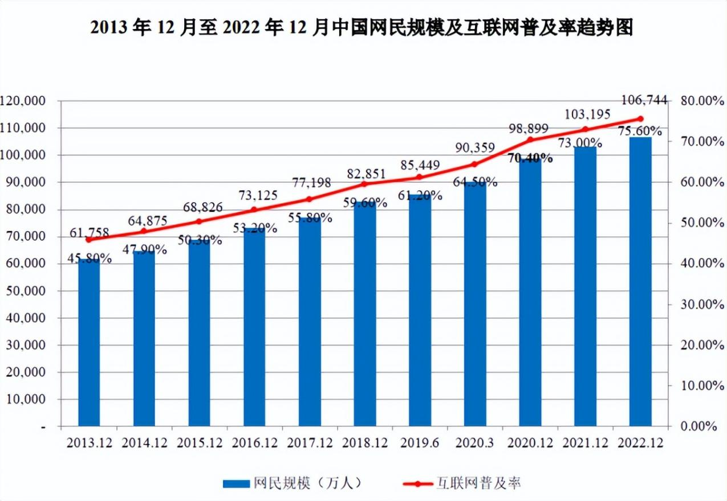
Scale of netizens (ten thousand people) Internet penetration rate.
Figure 1.1. The Trend of the Scale of Chinese Netizens and the Internet Penetration Rate from 2013 to December 2022
(Source: compiled by the author based on [34])
Table 1.1
The detailed market share of relational database management software in China
Company | Market share
Alibaba | 26.23%
Tencent | 14.90%
Huawei | 11.14%
Amazon | 8.29%
Oracle | 7.48%
Microsoft | 4.16%
Dameng Data | 2.73%
China Telecom | 2.52%
SAP | 2.40%
IBM | 1.99%

Figure 1.2 The detailed market share of relational database management software in China
(Source: compiled by the author based on [34])
The arrival of Industry 5.0 has brought new challenges and opportunities to enterprise marketing. Industry 5.0 emphasizes people-centered, sustainability and industrial resilience, with a greater focus on social and ecological values compared to Industry 4.0. In the era of Industry 5.0, enterprises should not only pay attention to production efficiency and quality, but also put the interests of workers at the center of the production process, respect and protect the earths ecology, and achieve social goals other than employment and growth.
The integration of digital economy and Industry 5.0 has brought new ideas and methods to enterprise marketing. Enterprises need to use digital technology to innovate marketing strategies and enhance market competitiveness to adapt to the changing market environment. For example, enterprises can use big data analysis technology to accurately grasp consumer needs and realize personalized marketing; Use artificial intelligence technology to optimize marketing processes and improve marketing efficiency; Leverage social media platforms to expand brand awareness and influence, and enhance user stickiness [22].

Purpose of the study
The purpose of this study is to explore the innovation of product marketing strategies of enterprises in the context of Industry 5.0 and digital economy, so as to help enterprises better adapt to the new market environment and enhance market competitiveness.
In the era of Industry 5.0, enterprises are facing many challenges and opportunities. On the one hand, Industry 5.0 emphasizes people-oriented, requiring enterprises to pay more attention to the interests and well-being of employees, and improve employee job satisfaction and loyalty. On the other hand, Industry 5.0 focuses on sustainability and industrial resilience, requiring enterprises to pay more attention to environmental protection and resource utilization in the production process, and improve their sustainable development capabilities. At the same time, the development of digital economy has also brought new opportunities and challenges to enterprise marketing. In the era of digital economy, consumers behavior and needs have undergone tremendous changes. Enterprises need to use digital technology to accurately grasp consumers needs and realize personalized marketing [3].
In order to achieve this research purpose, this research will be carried out from the following aspects:
First, it analyzes the challenges and opportunities faced by enterprise marketing in the context of Industry 5.0 and digital economy. Through the research of relevant literature and the analysis of actual cases, we can deeply understand the influence of Industry 5.0 and digital economy on enterprise marketing, and provide theoretical basis for enterprise marketing strategy innovation.
Secondly, it discusses the product marketing strategy innovation of enterprises under the background of Industry 5.0 and digital economy. Combined with the characteristics of digital economy and the requirements of Industry 5.0, this paper puts forward innovative ideas and methods of enterprises in product positioning, price strategy, channel strategy and promotion strategy [19].
Finally, through the actual case analysis, the effectiveness of product marketing strategy innovation of enterprises under the background of Industry 5.0 and digital economy is verified. Select some successful enterprises in the fields of Industry 5.0 and digital economy, and deeply analyze their practical experience in product marketing strategy innovation to provide reference and reference for other enterprises.

The theoretical basis of the comprehensive relationship between the digital economy and enterprise marketing

1.2.1The relationship between digital economy and enterprise marketing
As an important driving force of current economic development, digital economy has had a profound impact on corporate marketing. Not only does it bring new opportunities for businesses, but it also brings a series of challenges.

1.2.1.1 Digital economy expands sales market
In the era of digital economy, small and medium-sized enterprises have ushered in unprecedented development opportunities. The digital economy breaks through geographical constraints, enabling SMEs to bring products and services to broader markets. For example, through e-commerce platforms, SMEs can easily sell their products to all parts of the country or even around the globe. According to statistics, at present, the e-commerce transaction volume of small and medium-sized enterprises in China is increasing year by year, which has become an important force to promote economic development.
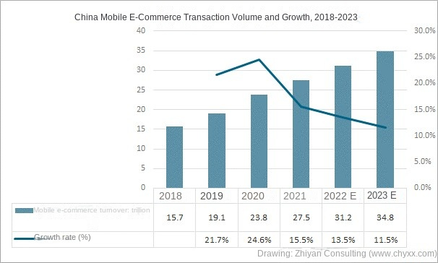
Figure 1.3 China Mobile E-Commerce Transaction Volume and Growth. 2018-2023
(Source: compiled by the author based on [51])
The digital economy also provides more marketing channels for small and medium-sized enterprises. Digital marketing means such as social media platforms, search engines, content marketing, etc., enable SMEs to reach potential customers at a lower cost. Taking WeChat as an example, many small and medium-sized enterprises have carried out brand promotion and product sales activities through WeChat WeChat official account, small programs and other platforms, and achieved good results [51].
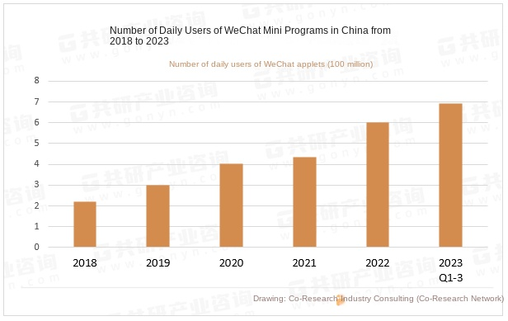
Figure 1.4 Number of Daily Users of WeChat Mini Programs in China from2018 to 2023
(Source: [28])
In addition, the digital economy has also promoted the development of cross-border e-commerce. Small and medium-sized enterprises can export their products to overseas markets and expand international sales channels through cross-border e-commerce platforms. According to relevant data, the import and export scale of cross-border e-commerce in China has continued to grow in recent years, providing strong support for small and medium-sized enterprises to expand overseas markets [28].
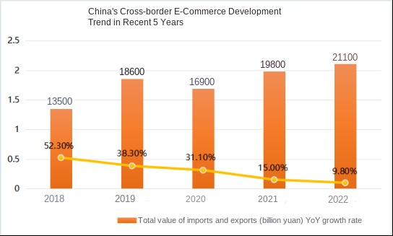
Figure 1.5 China's Cross-border E-Commerce Development Trend
in Recent 5 Years
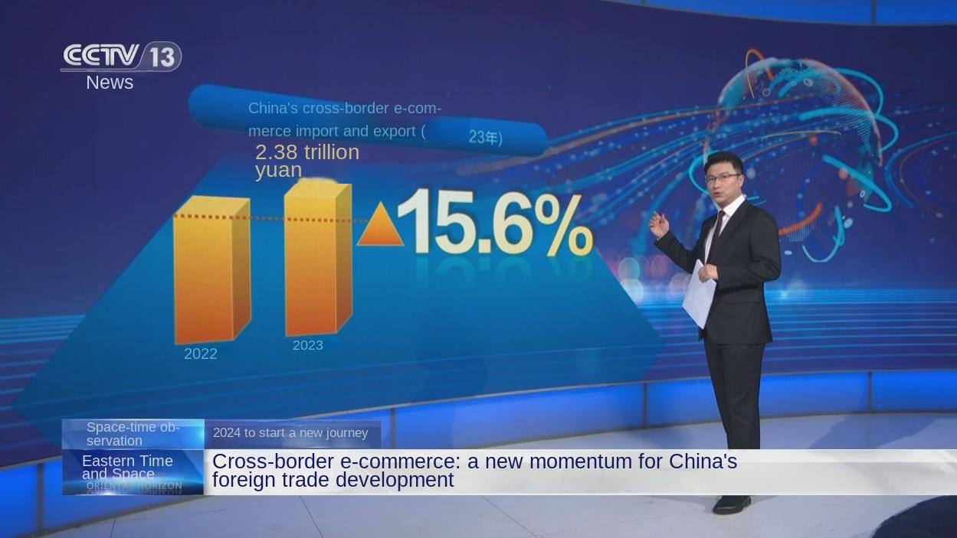
Figure 1.6 China Central Television reported that cross-border e-commerce in China continues to grow
Source: [35]

1.2.1.2 Digital economy reduces marketing costs
The development of digital technology has greatly improved the operational efficiency of enterprises and reduced operating costs. First of all, digital marketing can accurately locate target customers and reduce the waste of marketing resources. Through big data analysis, enterprises can understand customers needs, preferences and behavior habits, so as to formulate more accurate marketing strategies. For example, enterprises can push personalized advertisements and promotional information to customers based on their browsing history and purchase records to improve marketing effectiveness [15].
Secondly, digital technology can optimize marketing processes and improve work efficiency. For example, automated marketing tools can automate the execution of marketing campaigns, reduce human intervention and improve marketing efficiency. At the same time, digital marketing can also realize real-time monitoring and evaluation of marketing effects, adjust marketing strategies in time, and improve marketing effects [26].
Furthermore, the digital economy can also reduce the marketing costs of enterprises. For example, the cost of digital marketing methods such as email marketing and social media marketing is relatively low, but the effect is no less than that of traditional marketing methods. In addition, the development of cloud computing and SaaS services has also reduced hardware investment and software procurement costs for enterprises. According to statistics, enterprises that adopt cloud computing and SaaS services can reduce IT costs by more than 30% on average.
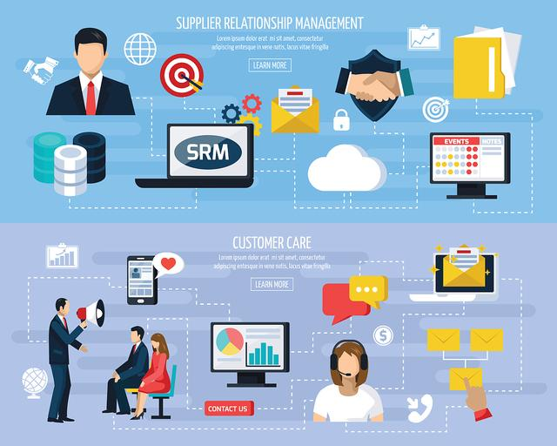
Figure 1.7 The digital economy has a profound impact on enterprise marketing
Source: [31]

In conclusion, the digital economy has had a profound impact on corporate marketing. It not only expands the sales market of enterprises, but also reduces the marketing cost of enterprises, and brings new opportunities for the development of enterprises. Enterprises should make full use of the advantages of the digital economy, innovate marketing strategies, and enhance market competitiveness [31].

1.2.2 Strategic theory of digital marketing
As an important means for enterprises in the era of digital economy, digital marketing covers a variety of strategies and provides strong support for enterprises to win advantages in the fierce market competition.

1.2.2.1 The role of data in marketing
Data plays a crucial role in marketing. By collecting, analyzing and mining a large amount of data, enterprises can deeply understand customers needs, preferences and behavior patterns, so as to achieve accurate customer segmentation. For example, according to their age, gender, region, consumption habits and other factors, customers are divided into different groups, and personalized marketing strategies are formulated for different groups. According to statistics, enterprises that adopt data-driven customer segmentation strategies have improved their marketing effectiveness by more than 30% compared with traditional marketing methods [20].
The data can also be used for marketing effectiveness evaluation. Through the data monitoring and analysis of marketing activities, enterprises can understand the exposure, click-through rate, conversion rate and other indicators of marketing activities, and evaluate the effectiveness of marketing activities. For example, businesses can understand the impact of marketing campaigns on brand awareness, customer engagement, sales performance, and more by analyzing website traffic data, social media data, sales data, and more. At the same time, enterprises can adjust marketing strategies in time according to the data evaluation results to improve marketing effects.

1.2.2.2 Principles and techniques of social media marketing
Social media has become an important platform for enterprise marketing, with a wide user base and strong communication power. When doing social media marketing, businesses need to follow certain principles and techniques.
First, businesses need to clarify the goals of social media marketing. Is it to increase brand awareness, increase product sales, improve customer satisfaction, or other goals? After defining the goal, the enterprise can formulate corresponding marketing strategies and plans [42].
Secondly, enterprises need to choose the right social media platform. Different social media platforms have different user groups and characteristics, and enterprises need to choose suitable social media platforms according to their own target customers and marketing goals. For example, WeChat is suitable for in-depth communication and service with customers, Weibo is suitable for brand promotion and topic marketing, and Douyin is suitable for short video marketing and creative display [34].
Furthermore, businesses need to publish valuable content. On social media, users focus on valuable information and interesting content. Enterprises need to publish valuable content related to their own brands and products to attract the attention and participation of users. For example, enterprises can publish product usage tutorials, industry information, user cases and other content to show their professional image and product advantages.
In addition, businesses also need to interact with users. Social media is a highly interactive platform. Enterprises need to actively interact with users, reply to users comments and private messages, and solve users problems and needs. By interacting with users, enterprises can enhance user stickiness and loyalty, and improve brand reputation [19].
Take Coca-Cola, which is hailed by The Big Money as "the company that makes the best use of facebook". Coca-Colas Global Happy Journey 206 campaign is the companys biggest social media project. It uses blogs, photo and video sharing, tweets and social media apps to promote the Coca-Cola brand, and has achieved great success. Through this campaign, Coca-Cola not only improved brand awareness and reputation, but also enhanced user engagement and loyalty.
For another example, Starbucks uses social media platforms, such as Facebook, Twitter and Instagram, for brand promotion and customer relationship management. Attract users attention and interaction by publishing brand stories, new product recommendations, limited-time offers, etc. At the same time, social media platforms are used to conduct user research, collect customer feedback, and optimize products and services. Starbucks social media marketing strategy has achieved remarkable results, increasing brand exposure and user engagement, and boosting online sales [18].
In short, the strategy theory of digital marketing provides important guidance and support for enterprises marketing activities in the era of digital economy. Enterprises need to fully realize the role of data and social media in marketing, master corresponding strategies and skills, constantly innovate and optimize marketing activities, and enhance market competitiveness.

1.2.3 Definition and characteristics of digital economy
Digital economy is a new economic form that takes digital knowledge and information as the key factors of production, digital technology as the core driving force, and modern information network as the important carrier. Through the deep integration of digital technology and the real economy, it continuously improves the digitalization, networking, and intelligence level of the economy and society, and accelerates the reconstruction of economic development and governance models [38].
The digital economy has the following salient features:
1.2.3.1 Data becomes a key factor of production
In the era of digital economy, data, like oil in the industrial age, has become the core element in promoting economic development. According to the International Data Corporation (IDC), by 2025, the total global data volume will reach 175ZB. By collecting, analyzing and utilizing a large amount of data, enterprises can better understand market demand, customer behavior and competitive situation, so as to formulate more accurate marketing strategies. For example, enterprises can use big data analysis technology to tap the potential needs of customers and provide customers with personalized products and services; Through real-time monitoring of market data, product prices and promotion strategies can be adjusted in time to improve market competitiveness [25].
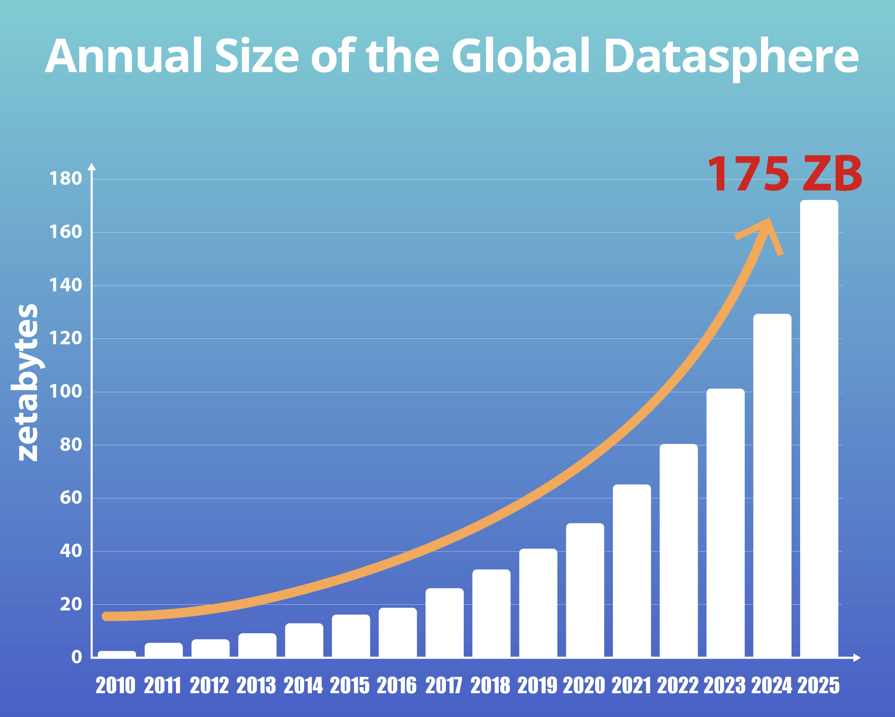
Figure 1.8 Annual Size of the Global Datasphere
Source: [25]

1.2.3.2. Driven by digital technology innovation
The development of digital economy is inseparable from the continuous innovation of digital technology. The widespread application of emerging digital technologies such as artificial intelligence, big data, cloud computing, Internet of Things, and blockchain has provided a powerful impetus for the development of the digital economy. For example, artificial intelligence technology can realize intelligent customer service, intelligent recommendation, intelligent marketing and other functions, and improve the service quality and marketing efficiency of enterprises; Big data technology can help enterprises carry out precise marketing, risk assessment, decision support, etc., and improve the management level and operational efficiency of enterprises; Cloud computing technology can provide enterprises with flexible, efficient and low-cost computing resources and services, and reduce enterprise IT costs and operational risks; Internet of Things technology can realize the interconnection and intelligent management of equipment, and improve the production efficiency and product quality of enterprises; Blockchain technology can ensure the security, credibility and traceability of data, and provide reliable technical support for the development of digital economy [14, 46].
1.2.3.3 The rise of platform economy and sharing economy
In the era of digital economy, platform economy and sharing economy are rising rapidly. By building a digital platform, the platform economy connects the supply and demand sides, and realizes the optimal allocation and efficient utilization of resources. For example, e-commerce platforms, online travel platforms, shared travel platforms, etc. provide consumers with convenient and efficient shopping, travel, travel and other services, and at the same time create new business opportunities and value for enterprises [23]. The sharing economy improves the utilization rate of resources and reduces social costs by sharing idle resources. For example, bike-sharing, shared car, shared office, etc. meet peoples diverse needs, and at the same time promote green development and sustainable development.
1.2.3.4 Industrial integration and innovation acceleration
The development of digital economy has promoted deep integration and innovation among different industries. The integration of digital technology and traditional industries has promoted the digital transformation and upgrading of traditional industries and created new industrial formats and business models. For example, the integration of digital technology and manufacturing has given birth to emerging industries such as intelligent manufacturing and industrial Internet; The integration of digital technology and agriculture has promoted the development of agricultural modernization and smart agriculture; The integration of digital technology and service industry has created new service formats such as digital finance, digital medical care, and digital education. At the same time, the development of digital economy has also accelerated the pace of innovation. By continuously innovating products and services, enterprises can meet the increasingly diverse and personalized needs of consumers and improve market competitiveness [9].
In short, as a new economic form, the digital economy has the characteristics of data becoming a key factor of production, digital technology innovation driving force, the rise of platform economy and sharing economy, and industrial integration and innovation acceleration. In the era of Industry 5.0, the digital economy will bring more opportunities and challenges to corporate marketing. Enterprises need to fully understand the characteristics and development trends of the digital economy, actively innovate marketing strategies, and enhance market competitiveness [39].

1.3 The impact of the digital economy on the market and consumers

1.3.1 Impact of digital economy on market environment
The booming development of the digital economy has had a profound and widespread impact on the market environment, reshaping the competitive landscape and marketing model of enterprises.
1.3.1.1.Changes in consumer behavior
The digital economy has caused significant changes in consumer behavior. First of all, the channels for consumers to obtain information are more diversified. In the digital age, consumers can obtain information about products and services through search engines, social media, online reviews and more. According to statistics, about 70% of consumers will search for information through the Internet before making a purchase decision. This makes enterprises need to pay more attention to brand building and information dissemination on digital channels to attract consumers attention [11].
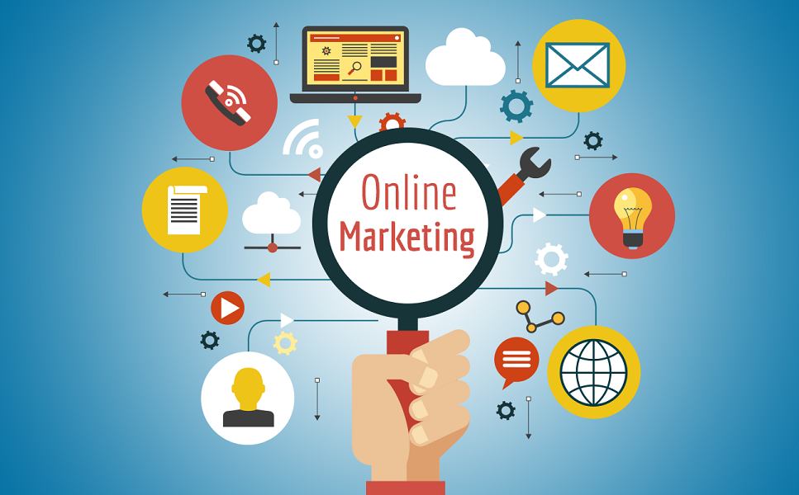
Figure 1.9 Online shopping is becoming more and more common [11]
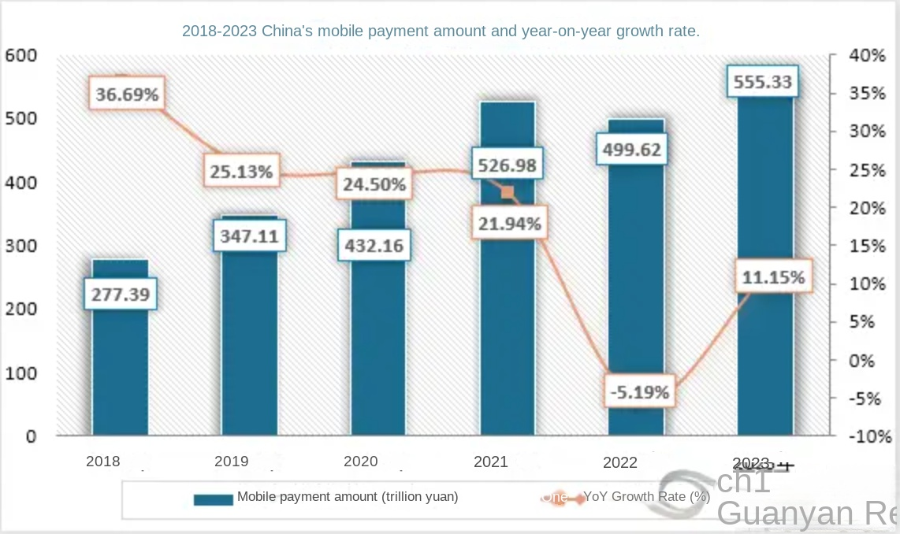
Figure 1.10 2018-2023 China's mobile payment amount and year-on-year growth rate
Source: [11]
Secondly, consumers purchasing decision-making process is more complicated. The digital economy provides consumers with more choices, and consumers can easily compare information such as price, quality, word-of-mouth, etc. of different brands and products. At the same time, consumers also pay more attention to personalized and customized products and services. For example, through big data analysis, enterprises can understand the individual needs of consumers and provide them with customized product recommendations and marketing solutions. According to the research, personalized marketing can improve consumers purchasing intention and loyalty, and the marketing effect is more than 20% higher than that of traditional marketing methods [2].
In addition, the way consumers shop has changed. With the rise of e-commerce, consumers can shop anytime and anywhere, and the proportion of online shopping is increasing. At the same time, the popularity of mobile payment also provides consumers with more convenient payment methods. For example, in China, the market size of mobile payment has exceeded one trillion yuan, making it one of the main payment methods for consumers to shop.
1.3.1.2. Changes in market competition landscape
The digital economy has intensified the intensity of market competition. On the one hand, the development of digital technology has lowered the market entry threshold, making it easier for new enterprises and entrepreneurs to enter the market. For example, through e-commerce platforms, small and medium-sized enterprises can compete with large enterprises on the same platform, breaking the monopoly pattern of traditional markets [12].
On the other hand, the digital economy makes competition among enterprises more global. In the digital age, businesses can bring products and services to the global market through the Internet, competing with businesses from different countries and regions. This requires enterprises to have a stronger international vision and competitiveness, and constantly innovate and optimize products and services to meet the needs of global consumers [40].
In addition, the digital economy also promotes cooperation and integration among enterprises. The rise of platform economy and sharing economy enables enterprises to share resources and complement each others advantages through cooperation, and jointly create greater value. For example, enterprises can share data and collaborate with partners in the supply chain to improve the efficiency and competitiveness of the supply chain.
1.3.1.3 Innovation of marketing model
The digital economy has driven the innovation of marketing models. First of all, digital marketing has become the main way of enterprise marketing. Enterprises can accurately locate target customers and improve marketing effects through various digital marketing methods such as search engine marketing, social media marketing, content marketing and email marketing. For example, businesses can leverage social media platforms for branding and user interaction, providing valuable information and solutions through content marketing to attract potential customers [1].
Secondly, big data and artificial intelligence technologies are becoming more and more widely used in marketing. Enterprises can understand consumers needs and behaviors through big data analysis, and provide data support for precision marketing. At the same time, artificial intelligence technology can realize intelligent customer service, intelligent recommendation, intelligent marketing and other functions, and improve marketing efficiency and user experience. For example, enterprises can use artificial intelligence algorithms to provide consumers with personalized product recommendations, improving the accuracy and conversion rate of recommendations [38].
Furthermore, experiential marketing and interactive marketing have become important marketing tools. In the digital age, consumers pay more attention to shopping experience and sense of participation. Enterprises can create a good shopping experience and attract consumers attention and purchase by providing high-quality products and services. At the same time, enterprises can also enhance consumer participation and loyalty through interactive marketing activities, such as lottery, quiz and games. For example, businesses can host interactive marketing campaigns on social media to engage users and increase brand awareness and reputation.
In conclusion, the digital economy has had a profound impact on the market environment. Enterprises need to fully understand the changes brought about by the digital economy, actively respond to challenges, innovate marketing strategies, and enhance market competitiveness to adapt to the market environment in the digital economy era.

1.3.2 The impact of digital economy on consumer behavior
The rise of digital economy has profoundly changed consumers behavior patterns and brought new challenges and opportunities to enterprises marketing strategies.
1.3.2.1 Changes in consumption decision-making process
In the era of digital economy, consumers decision-making processes are more complex and diversified. First, the abundance of information access channels enables consumers to collect large amounts of information about products or services in a short period of time. According to statistics, more than 80% of consumers will search and compare on multiple platforms before purchasing, including search engines, social media, e-commerce platforms, etc. This requires businesses to provide consistent and attractive information across different channels to meet the needs of consumers [47].
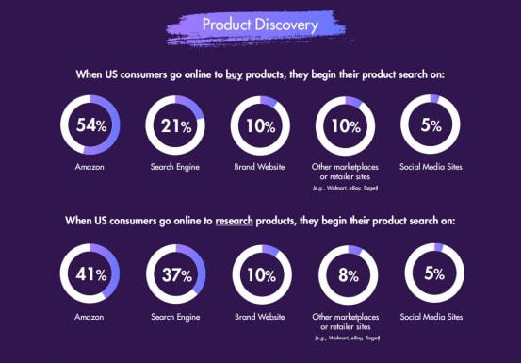
Figure 1.11 The shopping channels that American consumers will choose according to reviews [47]

Secondly, consumers evaluation of products or services is more dependent on the feedback of other consumers. Online reviews, user ratings, etc. have become important factors affecting consumers decision-making. For example, when purchasing electronic products, consumers often refer to the experience and evaluation of other users. According to the data, about 70% of consumers say they will decide whether to buy a product based on online reviews. Therefore, enterprises need to actively manage and guide consumers evaluation and improve the reputation of products or services.

Figure 1.12 The proportion of consumers' demand for product personalization
(Source: compiled by the author based on [24])

In addition, the decision time for consumers is also shortening. The convenience of the digital economy allows consumers to shop anytime and anywhere, which also leads them to make purchasing decisions more quickly. Enterprises need to attract consumers attention and prompt them to make purchasing decisions in a short time through precise marketing methods.
1.3.2.2 The growth of personalized demand
The digital economy makes consumers pay more attention to personalized products and services. With the development of big data and artificial intelligence technology, enterprises can better understand consumers needs and preferences, and provide them with personalized recommendations and customized products. For example, some e-commerce platforms provide consumers with personalized product recommendations by analyzing consumers browsing history and purchase records, thus improving consumers purchase conversion rate [24].
At the same time, consumers are also willing to pay higher prices for personalized products and services. According to the survey, about 60% of consumers said they were willing to pay extra for customized products. This provides new business opportunities for enterprises, which can meet the needs of consumers and increase the added value of products by providing personalized products and services.
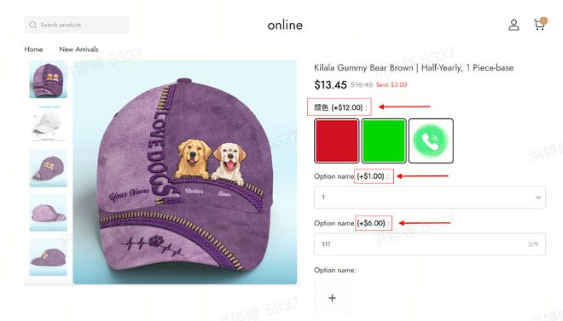
Figure 1.13 Consumers on the Amazon website can customize personalized products for an additional fee
Source: [24]

1.3.2.3 The importance of consumer experience
In the era of digital economy, consumers have higher and higher requirements for consumption experience. A good consumer experience includes not only the quality of products or services, but also the convenience of shopping and after-sales service. For example, consumers want to be able to easily complete their purchases from their mobile phones or computers and be able to receive their items in a short amount of time. At the same time, they also hope that enterprises can provide high-quality after-sales service and solve their problems in time [21].
Enterprises can improve consumers consumption experience through digital technology. For example, leveraging virtual reality and augmented reality technologies to allow consumers to better understand products before purchasing; Answer consumers questions in a timely manner through online customer service and intelligent customer service; Provide fast logistics and distribution services to meet the needs of consumers.

Figure 1.14 Virtual reality technology enhances the consumption experience of consumers
Source: [21]

1.3.2.4.The influence of social factors
In the era of digital economy, social factors have an increasing influence on consumer behavior. Consumers are often influenced by friends, family and social media to make purchasing decisions. For example, a consumer who sees a product recommended by a friend on social media may be interested in buying it. At the same time, consumers will also share their shopping experiences through social media, influencing other peoples purchasing decisions [37].
Enterprises can use social media platforms for marketing, and expand the influence of brands and attract consumers attention through social advertising and online celebrity marketing. In addition, enterprises can enhance consumer participation and loyalty by building brand communities.
In conclusion, the digital economy has had a profound impact on consumer behavior. Enterprises need to deeply understand the changes of consumers behavior, innovate marketing strategies, meet consumers needs and improve market competitiveness.

CHAPTER 2

ANALYSIS OF THE MARKETING STATUS AND DEVELOPMENT STRATEGIES OF ENTERPRISES UNDER THE BACKGROUND OF DIGITAL ECONOMY

2.1 The marketing status quo of enterprises

2.1. 1 Development status of live broadcast marketing
In recent years, the enterprise live broadcast marketing market has shown a rapid growth trend. Take cause-based live broadcast as an example. Enterprise live broadcast has become an important tool for enterprise marketing and training today. More and more enterprises are beginning to realize the advantages of live broadcast in marketing and training, and have joined the ranks of corporate live broadcast.
The overall growth of the live broadcast industry has also driven the expansion of the enterprise live broadcast market. The national policy encourages enterprises to develop live broadcast business, providing a more relaxed development environment for the industry. At the same time, the continuous upgrading of live broadcast technology, such as high-definition, smooth and stable live broadcast, is no longer a problem , the application of new technologies such as VR/AR and AI has also brought more possibilities to corporate live broadcasts.
The application scenarios of enterprise live broadcast are also constantly expanding. In addition to traditional live broadcasts of product displays and marketing events, corporate live broadcasts are also widely used in online training, internal communication, meeting recording and other fields. Diversified application scenarios make enterprise live broadcast continue to expand its business scope and become an indispensable new marketing method for enterprises.
For example, Jiazi Guangnian pointed out that 93% of CMOs use corporate live broadcast products in their marketing business, and improving sales results, enhancing brand image and building a data live broadcast system have become the selection factors of TOP. Enterprise live marketing concentrates a large number of offline visit/meeting time in traditional B2B marketing online, and provides a variety of online forms. Live marketing has completed the return of data and solved the synchronization problem of lead collection, conversion, activation and precipitation in the B2B field.
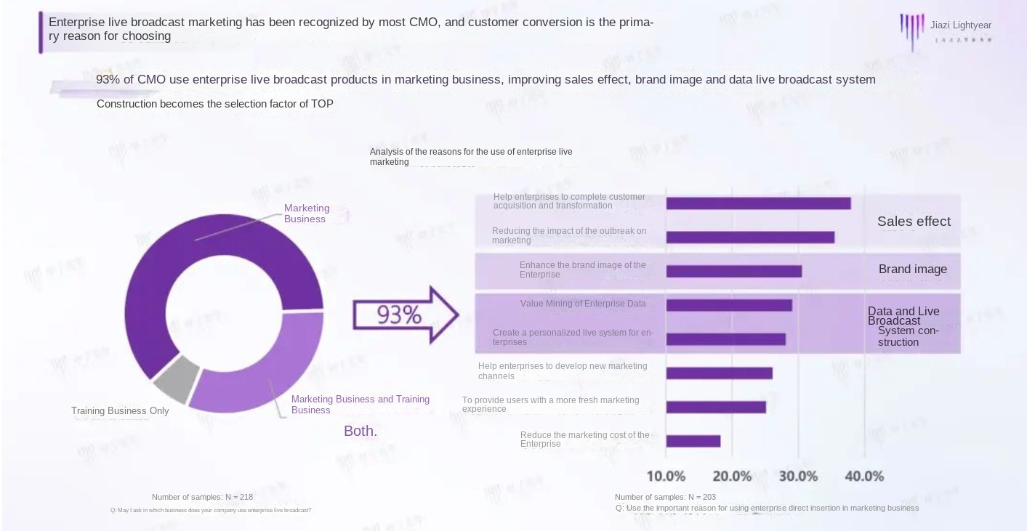
Figure 2.1 The report of Jiazi Guangnian confirms that the application scenarios of enterprise live streaming are constantly expanding
(Source: compiled by the author based on [49])

2.1. 2 Current status of digital platform construction
At present, the construction of digital platform for enterprises in China is showing a trend of rapid development. Large enterprises are actively deploying, and small and medium-sized enterprises are gradually following suit. The construction of enterprise digital platform is a key step to realize enterprise transformation and upgrading. It can help enterprises improve efficiency, reduce costs, enhance user experience, and lead innovation.
Take the New District Urban Investment Group as an example. The group insists on digital construction and constantly improves the innovation and competitiveness of enterprises. The Group has built a "digital and intelligent" operation and management platform from high-level decision-making, to company operations, and then to business practical operations, making full use of information technology to promote the standardization, standardization, digitalization and refinement of the groups operation and management, and realizing the improvement of enterprise management. amplification, superposition and multiplication effects.
The core elements of enterprise digital platform construction include technical architecture, business process reengineering, data asset management, and talent training and incentives. Technical architecture is the cornerstone of enterprise digital platform construction, including modern information technologies such as cloud computing, big data, and Internet of Things. Business process reengineering is to adapt to the needs of the digital age, optimize and adjust the business processes of enterprises, and improve business efficiency. Data asset management refers to the unified management and application of internal and external data resources of an enterprise to maximize the value of data. Talent cultivation and incentive are the keys to the success of enterprise digital platform construction, and it is necessary to pay attention to employee skills improvement and incentive mechanism.

2.2 Problems existing in enterprise marketing innovation

2.2.1 Lack of awareness of digital marketing
Some enterprises have a misunderstanding of digital marketing, thinking that digital marketing can achieve marketing goals simply by placing advertisements on the Internet, or setting up an official website or social media account. However, digital marketing is much more than that.
For example, some businesses don`t set goals for digital projects, leading to a lack of planning for marketing campaigns from the get-go. I don’t` know what I want to achieve through digital marketing, whether its more potential customers, brand awareness, or promoting new products. The lack of clear goals makes it difficult to focus marketing activities, and it is impossible to effectively control the focus, which is prone to frustration.
There are also companies that don`t pay attention to analysis or there are problems with analysis. A lot of businesses simply dont track the implementation of their digital marketing initiatives, and even though there are simple ways to analyze the performance of campaigns and draw conclusions from them, they tend to overlook this. Without analytical data, or having data without in-depth analysis, it is impossible to adjust measures, improve performance, and put money into the right marketing tools, channels, or actions.
In addition, some enterprises have no error culture and do not test online activities. Many marketing activities are set in stone and thrown directly into the market. If they are unsuccessful, they are considered a complete failure. Digital marketing is an area that needs constant optimization. Enterprises should find out the source of errors through analysis, adjust content, channels and other aspects according to the needs, and test them through different versions to obtain activities that are suitable for the goals.

2.2.2 Lack of personalized marketing model
Insufficient personalized marketing will have many adverse effects on the development of enterprises. In the era of digital economy, consumers pay more attention to personalized products and services. If enterprises can`t` provide personalized marketing mode, it will be difficult to meet the needs of consumers, thus losing market competitiveness.
On the one hand, the lack of personalized marketing can lead to lower consumer engagement and loyalty. When consumers can`t find a choice that meets their individual needs among the many brands and products, they are likely to turn to other brands. For example, on the e-commerce platform, consumers can easily compare the characteristics of different brands and products. If the marketing model of enterprises is the same and the personalized advantages of their products are not highlighted, it will be difficult to attract consumers attention and purchase.
On the other hand, the lack of personalized marketing will also affect the brand image and reputation of enterprises. In today`s highly developed social media, consumer evaluations and feedback are crucial to the brand image of a business. If businesses fail to provide consumers with a personalized experience, consumers are likely to share their grievances on social media, influencing other potential consumers purchasing decisions.
According to the data, about 60% of consumers said they would prefer to buy brands that can provide personalized services. Therefore, enterprises should make full use of technologies such as big data and artificial intelligence to deeply understand consumers needs and preferences, provide them with personalized marketing solutions, improve consumer participation and loyalty, and enhance the brand image and reputation of enterprises.

2.3. Innovative marketing strategies and case analysis

2.3.1 Innovative marketing strategies
In the era of Industry 5.0, enterprises are facing a more complex and changeable market environment and consumer demand. In order to stand out in the fierce competition, enterprises need to constantly innovate their marketing strategies to adapt to the development of the times.

2.3.1.1 Digital marketing price strategy
In digital marketing, price strategy is a crucial part. Reasonable product pricing can attract consumers, improve market competitiveness and achieve the profit goal of enterprises.
Product pricing
Product pricing needs to comprehensively consider multiple factors, including cost, market demand, competitor prices, etc. First of all, enterprises should accurately calculate the cost of products, including production cost, marketing cost, logistics cost, etc. On this basis, combined with market demand and competitor prices, a competitive price is formulated. For example, for products with high market demand, the price can be appropriately increased; For products with lower prices from competitors, a low price strategy can be adopted to attract consumers.
According to statistics, enterprises that adopt cost-oriented pricing method can control the product price between 120% and 150% of the cost on average, which can not only ensure the profitability of enterprises, but also have certain competitiveness in the market.
Price strategy
- Differentiated pricing strategy
Different prices are set according to the differences in product functions, quality and service. For high-end products, a high-price strategy can be adopted to highlight the quality and uniqueness of the products; For mid-to low-end products, low-price strategies can be adopted to meet the needs of different consumers. For example, Apples iPhone, the price of different models is quite different, which meets the needs of different consumers.
Data show that companies that adopt differentiated pricing strategies can increase their market share by 20% to 30% on average.
2. Dynamic pricing strategy
Adjust product prices in real time according to market demand, competitor prices, cost changes and other factors. For example, during the peak tourist season, hotels can raise room rates; During the off-season, hotels can reduce their room rates. Through dynamic pricing, enterprises can better adapt to market changes and improve profitability.
According to research, enterprises that adopt dynamic pricing strategies can increase their profits by 15% to 20% on average.
3. Price promotion strategy
Attract consumers to buy products through discounts, full discounts, gifts, etc. Price promotion strategy can increase product sales in the short term, but attention should be paid to controlling the intensity and frequency of promotion, so as not to affect the brand image and long-term profitability of products. For example, in e-commerce shopping festivals such as JD.COM 618 and Taobao Double 11, major merchants have attracted a large number of consumers to buy products through price promotion strategies.

Figure 2.2 Taobao Double 11 promotional poster [42]
Methods to optimize prices
- Data analysis
By analyzing market data, consumer behavior data, sales data, etc., we can understand consumers sensitivity and demand to price, so as to optimize product prices. For example, enterprises can understand consumers price preferences and provide them with personalized price recommendations by analyzing consumers purchase history and browsing records.
The data shows that enterprises that use data analysis to optimize prices can increase the sales conversion rate by 10% to 15% on average.
2. Market research
Conduct regular market research, understand competitors price strategies and market dynamics, and adjust their own price strategies in time. For example, enterprises can understand consumers satisfaction and expectations of product prices through questionnaires, interviews, etc., and provide a basis for price optimization.
- Customer Feedback
Pay attention to customer feedback, and adjust product prices according to customer opinions and suggestions. For example, enterprises can collect customer feedback on product prices through customer service channels and online reviews, solve customer problems in time, and improve customer satisfaction.

2.3.1.2 Digital marketing channel strategy
In the era of Industry 5.0, the construction and management of digital marketing channels is crucial. Enterprises need to make full use of the Internet and digital technology, expand online channels and improve marketing efficiency.
Online channel construction
- E-commerce platform
Establish your own e-commerce platform or settle in third-party e-commerce platforms, such as Taobao, JD.COM, Pinduoduo, etc., to expand product sales channels. E-commerce platform has the advantages of large number of users, convenient transactions and diverse marketing methods, which can help enterprises quickly increase product sales and popularity.
According to statistics, at present, the scale of Chinas e-commerce market has exceeded one trillion yuan, and it has become one of the important channels of enterprise marketing.
The shares of major e-commerce platforms in China in 2023
Figure 2.3 The shares of major e-commerce platforms in China in 2023
(Source: compiled by the author based on [42-43])

2. Social media platforms
Leverage social media platforms such as WeChat, Weibo, TikTok, etc. for branding and product marketing. Social media platforms have the advantages of high user activity, fast communication speed, and strong interactivity, which can help companies quickly improve brand awareness and product exposure.
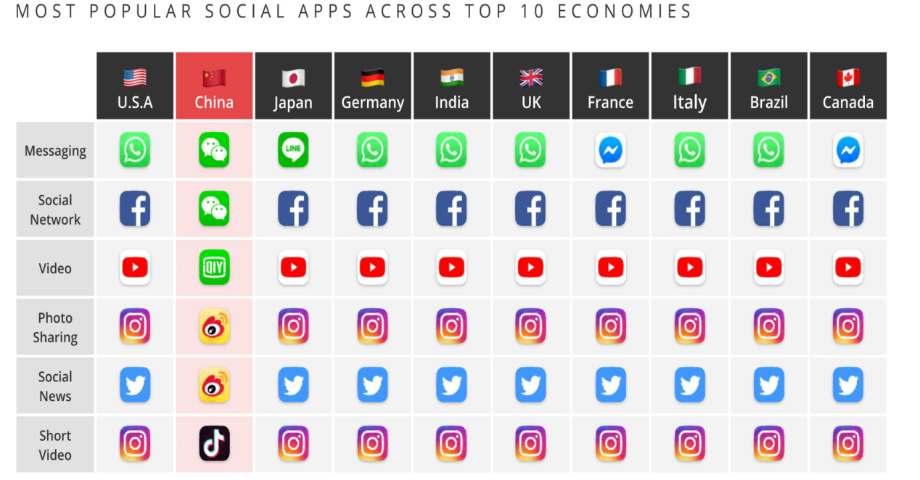
Figure 2.4 most popular social apps across top 10 economies [44]
For example, Xiaomi conducts product launches and marketing activities through social media platforms such as Weibo and WeChat, attracting the attention and participation of a large number of fans.

Figure 2.4 Pictures on Xiaomi's Weibo homepage [45]
3. Content marketing platform
Through content marketing platforms, such as Zhihu, Xiaohongshu, bilibili, etc., product promotion and brand building. Content marketing platform has the advantages of accurate users, high content quality and good word-of-mouth effect, which can help enterprises improve brand reputation and user loyalty.
Unit:Hundred million person-times
Figure 2.5 Daily active users (DAU) in China
(Source: compiled by the author based on [1, 48, 51])
For example, Perfect Diary promotes products and interacts with users through content marketing platforms such as Xiaohongshu, and has become one of the representative brands of domestic beauty products.

Figure 2.6 Perfect Diary's promotional homepage on Xiaohongshu [46]

Online channel management
- Channel integration
Integrate different online channels to achieve data sharing and collaborative marketing. For example, integrate e-commerce platforms, social media platforms, content marketing platforms, etc., and improve marketing efficiency and user experience through a unified user management system and marketing activities.
The data shows that enterprises that adopt channel integration strategies can improve their marketing results by 30% to 40% on average.
2. Channel optimization
Regularly optimize online channels to improve the quality and efficiency of channels. For example, optimize the store page of e-commerce platform to improve users shopping experience; Optimize the content of social media platforms to increase the attention and interaction rate of users.
- Channel innovation
Constantly innovate the marketing methods and means of online channels to improve the attractiveness and competitiveness of channels. For example, use emerging marketing methods such as live delivery, short video marketing, and social e-commerce to expand product sales channels.
Taking Douyin as an example, through live delivery and short video marketing, it provides enterprises with brand-new marketing channels and methods, helping enterprises quickly increase product sales and popularity.

2.3.2 Successful case analysis

2.3.2.1 3TREES digital marketing path
As a well-known brand in the coatings industry, 3TREES has made remarkable achievements in digital marketing. Through cooperation with Osais, 3TREES officially launched a new digital super brand engine in 2018. In just 6 months, it helped 3TREES sell its new products to 220 million, creating a sales miracle.

Figure 2.7 Three Trees logo [47]
In terms of product launch, 3TREES new standard of Health + was strongly launched in 2018. At the same time, seven new odor-free products of latex paint and wood paint were launched, redefining the standard of healthy paint. In order to cooperate with the groups listing, 3TREES needs a major marketing event to build momentum and vigorously promote the concept of "Health +".
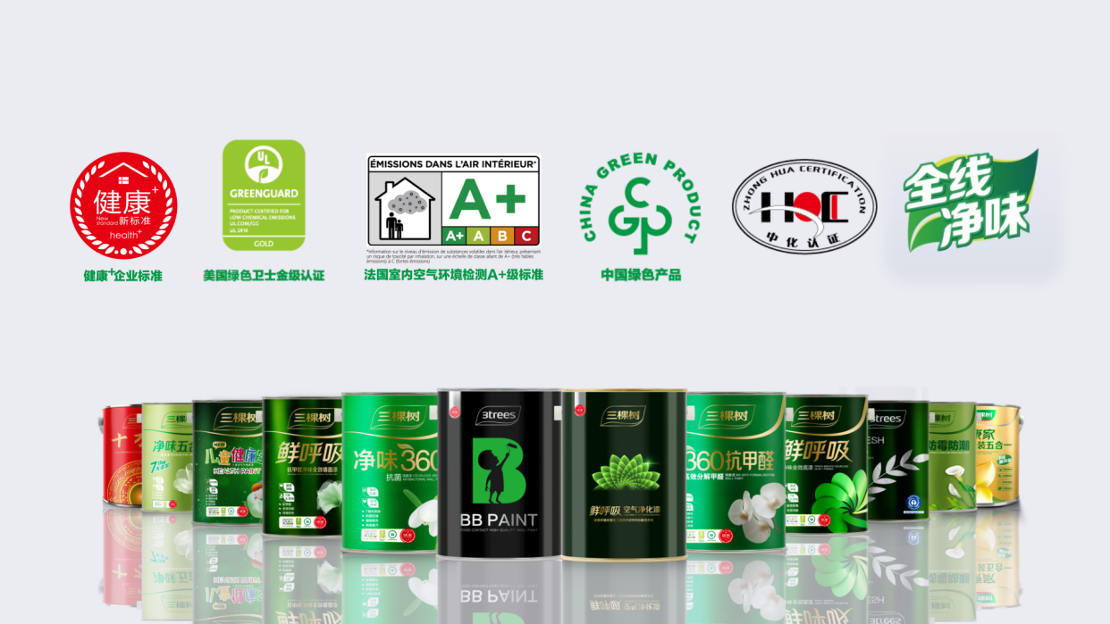
Figure 2.8 Three Trees Health+ main products include [48]
In the market competition, facing the two mountains of Nippon Paints refreshed concept and Duluxs main color concept, 3TREES has surpassed in three aspects: concept, cognition and implementation. Put forward the concept of healthy paint Health +, surpassing traditional brands in terms of consumer perception, distinguishing healthy paint from environmental protection and color, and emphasizing the advantages of safer, greener, odorless, and formaldehyde-free products. At the same time, the company has consistently implemented the health + grand strategy inside and outside, tapped its advantages internally, and carried out a series of cross-cutting activities around online and offline.

Figure 2.9 Health+ BB Series Latex Paint [49]
In terms of solutions, 3TREES first determined the target group, and determined the communication theme as "Health +" around the six decoration scenarios in a persons lifetime. This is not only the strategy of 3TREES, but also the major theme of communication. On this basis, 3TREES has carried out a series of innovations to implement perfect strategies throughout execution. For example, formulate a digital marketing plan, implement it around "Health +" from beginning to end, and launch phenomenal marketing activities such as "Swipe my card and I spoil you", "Recruit the Chief Respiratory Officer" and "30 New Health Standards in Life", setting off a wave of communication with the time chain of cross-integrated marketing communication, forming a huge and continuous brand voice.
At the same time, 3TREES has also carried out a series of offline experience promotion activities. It not only detonates online and places fixed-point outdoor advertisements offline, but also enhances its brand image and volume through large-scale activities, and completes the final implementation in small-scale experience promotion activities.
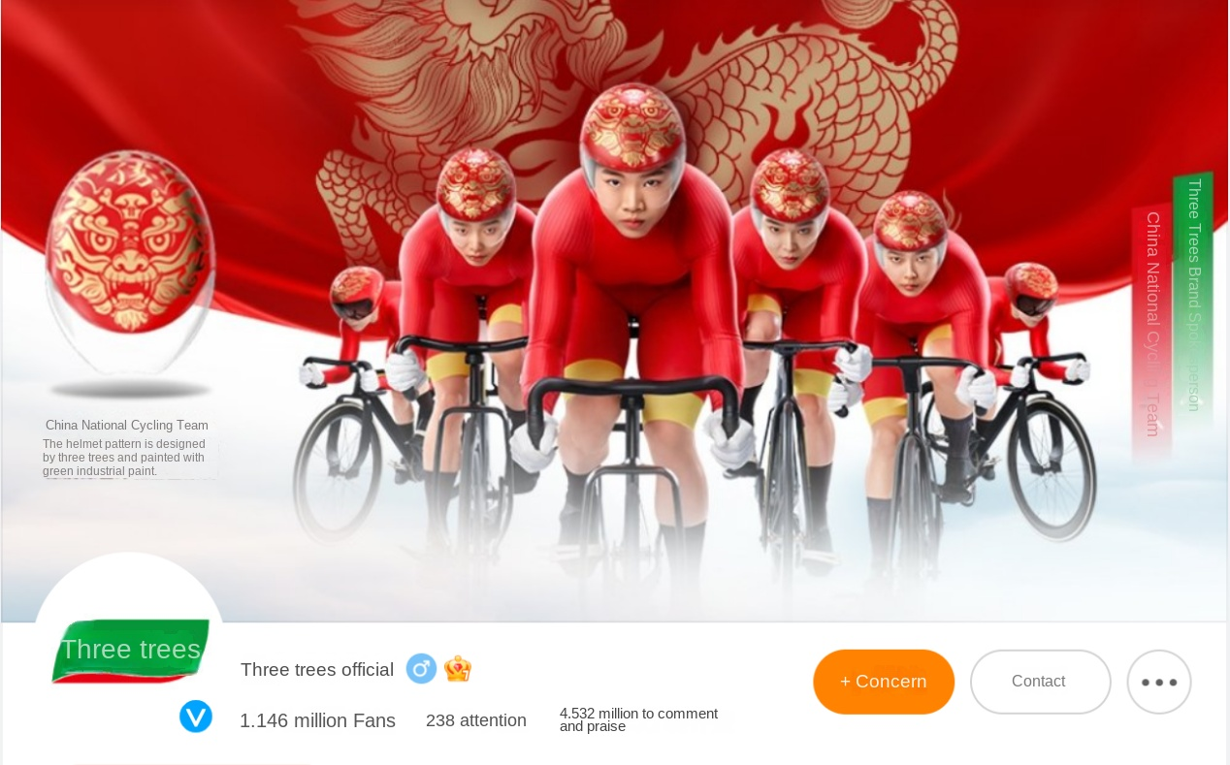
Figure 2.10 The official Weibo homepage of Three Trees [50]
In terms of marketing digitalization, 3TREES focuses on two key points: focus and innovation. Focus on rhythmic delivery, amplify brand volume, and maintain the output of marketing activities with consistent themes. Innovative combination of online and offline, and promotional activities become experience activities. Focusing on the theme of "Health +", 3TREES has launched various innovative marketing activities. For example, on platforms where young people gather such as Douyin, a sincere 517 yuan home improvement benefit was launched through marketing activities VIP card, a single card is worth nearly 10,000 yuan, including a high deduction amount, home improvement alliance coupons, free 10-year repair of 10 square meters of paint, etc. This affordable digital VIP card can directly deduct the corresponding preferential amount when spending in offline stores, which is quite practical.
In addition, 3TREES has also done a lot of work around precise delivery. Carry out accurate delivery on platforms such as WeChat, Weibo, Toutiao, etc. According to the content that users are most concerned about and the information they want to know most, put the corresponding advertising content to accurately target the target group. At the same time, 3TREES also uses big data systems to support accurate delivery, build complete user portraits, and provide data decision-making reference for accurate delivery through data desensitization, screening, reshaping, and analysis, so as to achieve data-driven marketing.
In terms of small video content marketing, 3TREES quickly keeps up with the trend. On the Doukuai platform, official brand channels such as "3trees 3trees" and "3trees Painting Service" can see many exquisitely produced production effect comparisons, brand promotions, launch topic activities, and sell free services; In many dealers, it is a more real and down-to-earth buyer show mode, and the two content forms play a complementary role. However, 3TREES also realizes that at present, brand numbers are more arranged for activity volume and business card collection, and dealers are more doing it for the sake of doing it, without a complete conversion link. Based on this, 3TREES can transfer the video content matrix to the video account for publishing, which can solve three problems: First, from content to conversion, there is only a small program mall interval, which is more diversified than the product window of Douyin Kuaishou. marketing options, and you can also grasp first-hand user receipts; Second, the mini program mall upgrades the social cloud store to solve the conversion link of dealers; The third is the unified visual presentation and differentiated content presentation of the video account of the brand and the dealer, allowing brand marketing to focus on the creation of the brand itself and image, and allowing the dealer to create an atmosphere and convert users.
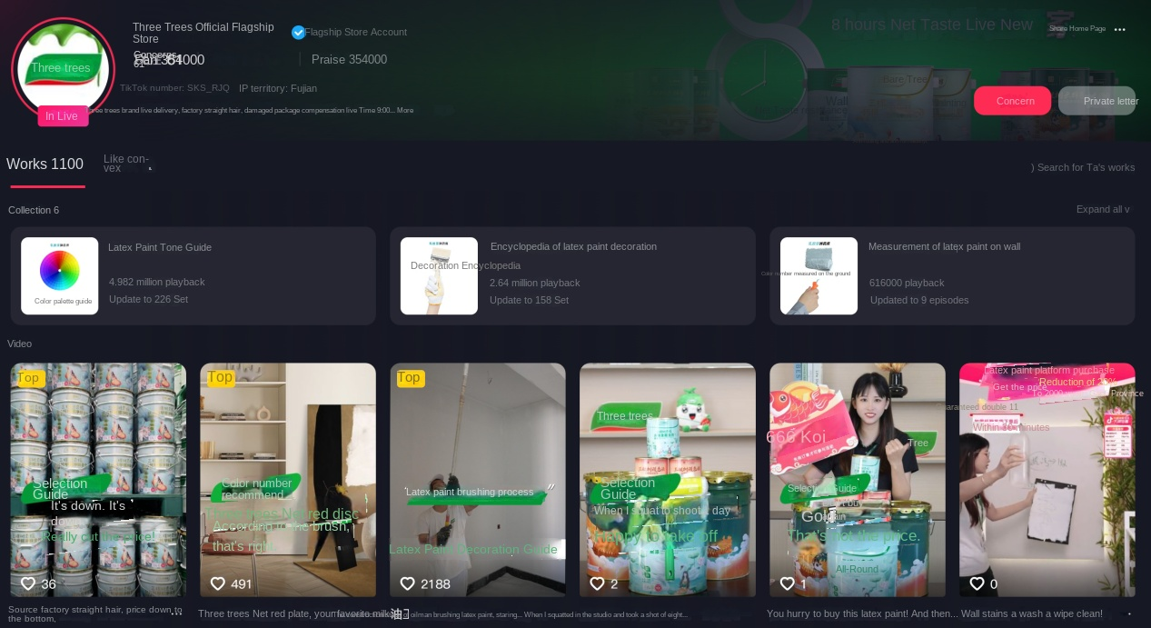
Figure 2.11 Picture of Three Trees Online Mall [51]

2.3.2.2 Learning from successful cases of other enterprises
Starbucks: Starbucks utilizes social media platforms, such as Facebook, Twitter, and Instagram, for branding and customer relationship management. Attract users attention and interaction by publishing brand stories, new product recommendations, limited-time offers, etc. At the same time, social media platforms are used to conduct user research, collect customer feedback, and optimize products and services. Starbucks social media marketing strategy has achieved remarkable results, increasing brand exposure and user engagement, and boosting online sales.
Apple: Apple adopts a differentiated pricing strategy, and sets different prices according to the differences in product functions, quality and service. For high-end products, such as iPhone, a high-price strategy is adopted to highlight the quality and uniqueness of the products. At the same time, Apple also pays attention to brand building and user experience, and improves user loyalty and reputation through high-quality products and services. Data show that Apple, which adopts differentiated pricing strategies, can increase its market share by 20% to 30% on average.
Douyin: Douyin provides enterprises with brand-new marketing channels and methods through live delivery and short video marketing. Enterprises can take advantage of the advantages of Douyin platform, such as large number of users, fast communication speed and strong interactivity, to carry out brand promotion and product marketing. For example, through live broadcast, enterprises can directly display the characteristics and usage methods of products to attract users to buy; With short video marketing, businesses can produce interesting, valuable content that attracts user attention and sharing. Taking Douyin as an example, through live delivery and short video marketing, it provides enterprises with brand-new marketing channels and methods, helping enterprises quickly increase product sales and popularity.
Alibaba: As a world-renowned e-commerce platform, Alibaba has a huge user base and rich marketing resources. Enterprises can expand product sales channels and increase product sales and popularity by settling in Alibaba platform. At the same time, Alibaba also provides a series of marketing tools and services, such as Taobao through train, diamond booth, etc., to help enterprises carry out precise marketing. In addition, Alibaba also pays attention to data analysis and user experience, and provides accurate marketing decision support for enterprises through the analysis of user behavior data; Increase user satisfaction and loyalty by optimizing the platforms shopping experience.

CHAPTER 3
THE FUTURE RESEARCH AND DEVELOPMENT DIRECTION OF ENTERPRISE MARKETING

3.1 Technological innovation and integration of omni-channel marketing
The contemporary marketing environment is in a state of constant development due to technology breakthroughs, fundamentally altering how businesses engage with customers across many channels. Artificial intelligence-driven marketing automation tools signify a pivotal transformation in client interaction tactics. Advanced algorithmic processing allows for immediate examination of extensive data sets, enhancing real-time decision-making across integrated marketing channels. Machine learning algorithms always improve, adjusting to shifting customer behaviors and market conditions, while concurrently enhancing marketing campaign success via advanced pattern detection. Predictive analytics serves as a fundamental element of modern marketing automation, utilizing past data patterns to anticipate future customer actions and industry trends. By employing advanced statistical modeling and data mining tools, businesses acquire exceptional skills to predict client demands and preferences. Marketing automation tools link effortlessly with current corporate systems, establishing a cohesive environment for customer data management and campaign implementation. Neural networks and deep learning algorithms analyze intricate consumer interaction patterns, allowing advanced segmentation and targeting tactics across many channels concurrently.
The use of artificial intelligence into marketing automation systems transforms campaign optimization methods. Natural Language Processing (NLP) algorithms examine client interactions across several channels, deriving significant insights regarding sentiment, preferences, and behavioral trends. Automated A/B testing systems consistently enhance marketing messaging and content distribution techniques, optimizing engagement rates and conversion potential. Real-time optimization algorithms modify campaign settings immediately according to performance measurements, guaranteeing optimal resource distribution across marketing channels. Marketing automation technologies enable the seamless integration of many consumer touchpoints, fostering unified brand experiences across both digital and physical channels. Sophisticated monitoring systems observe client travels across several platforms, offering extensive insight into interaction patterns and engagement metrics. Advanced attribution modeling algorithms effectively assess the influence of diverse marketing strategies, allowing exact optimization of marketing expenditures across channels. The use of mobile marketing automation features guarantees uniform interaction with a progressively mobile-oriented customer demographic. Predictive analytics skills surpass basic forecasting by integrating sophisticated scenario modeling and risk assessment features. Marketing automation tools utilize artificial intelligence to detect growing possibilities and possible difficulties across diverse market sectors. Multi-channel attribution models offer detailed insights into client acquisition and retention trends, facilitating the accurate optimization of marketing campaigns. Advanced segmentation algorithms generate precise client profiles, enabling tailored interaction tactics across unified marketing channels.
Implementations of enterprise-scale marketing automation necessitate advanced infrastructure and flawless interaction with current business systems. Cloud-based technologies offer scalable options for overseeing intricate marketing activities in international marketplaces. The capacity for real-time data processing guarantees prompt reactions to fluctuating market conditions and customer behaviors. The incorporation of security processes and privacy protection measures guarantees adherence to changing regulatory standards while preserving operational efficiency.
Marketing automation solutions progressively include sophisticated visualization features, facilitating intuitive interpretation of intricate data patterns. Interactive dashboards offer immediate insight into campaign performance indicators across several channels. Automated reporting systems produce detailed analyses of marketing efficacy, enabling data-informed decision-making processes. The use of business intelligence technologies facilitates advanced study of market trends and customer behavior patterns.
Artificial intelligence is always advancing, presenting ever complex functionalities in marketing automation systems. Natural language generation algorithms provide customized content en masse while preserving a uniform brand voice across many media. Computer vision technologies provide sophisticated analysis of visual content efficacy and enhancement. Voice recognition and processing skills enable integration with new marketing channels and platforms.
The Internet of Things technology dramatically alters consumer contact models across marketing channels, creating unparalleled interconnectedness between physical and digital touchpoints. Advanced sensor networks gather detailed data on client actions and preferences, allowing real-time enhancement of marketing efforts. Advanced IoT solutions interface effortlessly with current marketing frameworks, establishing holistic ecosystems for client interaction and data administration. Connected devices produce incessant streams of behavioral data, offering profound insights into user journeys and interaction patterns. Real-time cross-channel data synchronization signifies a groundbreaking development in marketing technology architecture. Advanced data processing algorithms guarantee immediate changes across many platforms and channels, ensuring uniformity in client experiences. Edge computing capabilities facilitate the rapid processing of IoT-generated data, allowing for instantaneous responses to user actions and preferences. Marketing platforms utilize sophisticated APIs and integration protocols to ensure uninterrupted data transfer among diverse systems and channels.
Intelligent retail settings demonstrate advanced execution of IoT-driven consumer interaction enhancement. In-store sensors monitor client movement patterns, allowing the dynamic modification of product placement and advertising tactics. Digital displays modify information according to real-time user proximity and behavioral data, so generating individualized retail experiences. Mobile applications interface with actual retail infrastructure, facilitating smooth transitions between digital and real purchasing environments.
Cross-channel data synchronization technologies enable advanced customer journey mapping and optimization. Advanced analytics solutions concurrently process data from several sources, generating holistic insights into customer behavior patterns. Machine learning algorithms discern similarities among various touchpoint engagements, facilitating predicted enhancement of client experiences. Real-time synchronization guarantees uniform consumer identification across several channels and platforms. The IoT infrastructure facilitates sophisticated customisation features in marketing initiatives. Data from linked devices enables dynamic content distribution techniques, enhancing relevance and engagement. Environmental sensors offer enhanced customer context, facilitating precise targeting and timing of marketing communications. Integration with customer relationship management systems allows thorough monitoring of client interactions across both physical and digital touchpoints. Marketing automation tools utilize IoT data sources for advanced campaign optimization. Real-time performance indicators provide prompt modifications to marketing campaigns across several platforms. Advanced attribution modeling integrates IoT-generated data points, enabling accurate assessment of marketing efficacy. Automated optimization algorithms perpetually enhance client engagement methods with real-time interaction data [52].
Location-based marketing possibilities get unparalleled sophistication with IoT integration. Bluetooth beacons and WiFi networks provide comprehensive maps of client mobility patterns inside physical environments. Mobile devices function as personal identity tokens, facilitating effortless recognition across many places and settings. Geographic positioning systems offer further levels of contextual information for marketing enhancement. Security issues are essential in the creation of IoT-based marketing infrastructure. Encryption techniques safeguard sensitive consumer information during collection and transfer. Privacy-preserving computing methodologies provide advanced analysis while safeguarding consumer confidentiality. Regulatory compliance methods guarantee the proper management of personal information across interconnected systems. Cross-channel data synchronization transcends conventional marketing platforms to include new technology. Voice interfaces amalgamate with current client connection channels, offering novel engagement options. Augmented reality apps utilize synced consumer data to generate immersive brand experiences. Wearable gadgets provide supplementary behavioral data to cross-channel marketing solutions.

3.2 Deepening of personalized marketing
Personalized marketing experiences a profound revolution with the advanced application of machine learning algorithms and real-time analytics capabilities. Advanced neural networks analyze extensive datasets of consumer information, detecting nuanced patterns and connections that conventional analytical techniques may miss. Behavioral modeling systems utilize deep learning technologies to provide progressively precise forecasts of client preferences and subsequent behaviors. Advancements in processing power allow for immediate analysis of intricate client contact patterns, enabling real-time customisation on an unparalleled scale.
Machine learning algorithms progressively enhance their prediction accuracy and customisation capabilities via ongoing exposure to fresh client data. Advanced modeling approaches integrate several data aspects, encompassing transactional history, browsing behaviors, social media engagements, and demographic details. Neural networks discern concealed correlations among ostensibly unrelated client activities, facilitating sophisticated customisation tactics. Real-time processing capabilities facilitate the prompt implementation of newly acquired behavioral insights into marketing strategies. Advanced client segmentation arises from the utilization of cluster analysis and pattern recognition techniques. Machine learning methods discern micro-segments within larger client demographics, facilitating precisely focused marketing strategies. Behavioral clustering algorithms categorize clients according to intricate combinations of qualities and behaviors, beyond conventional demographic-based segmentation. Real-time data analytics allow the dynamic modification of client segments according to changing behavioral trends.
The combination of artificial intelligence with classical statistical approaches enhances predictive modeling capabilities. Advanced algorithms predict client lifetime value, churn likelihood, and buy propensity with enhanced precision. Natural language processing examines client interactions across several channels, collecting emotional context and sentiment trends. Computer vision technology analyzes visual content interaction data, offering more dimensions for behavioral research.
Real-time analytics tools provide immediate reactions to evolving client behaviors. Stream processing algorithms evaluate client interactions in real-time, enabling prompt personalized modifications. Advanced event processing systems detect intricate patterns across various client interactions, facilitating sophisticated trigger-based marketing initiatives. Machine learning models perpetually refine client profiles utilizing real-time interaction data, ensuring precise behavioral representations. Marketing automation solutions utilize behavioral insights for advanced campaign optimization. Personalization algorithms modify content, timing, and channel selection according to individual consumer preferences and historical reaction patterns. Sophisticated testing methods perpetually enhance customization tactics via automated experimentation. Attribution modeling utilizes behavioral data to assess marketing efficacy across diverse client groupings. Privacy-preserving computational methods provide advanced behavioral analysis while safeguarding consumer confidence. Federated learning methodologies enable the enhancement of machine learning models without the centralization of sensitive consumer data. Differential privacy approaches safeguard individual customer data while facilitating beneficial aggregate insights. Encryption techniques guarantee the secure handling of behavioral data in remote computer systems.
The use of external data sources improves behavioral modeling skills. Climatic patterns, economic metrics, and societal trends offer supplementary background for the research of consumer behavior. Machine learning algorithms discern relationships between external variables and client behaviors, facilitating more precise predictions. Real-time data streams facilitate the prompt integration of pertinent external information into customization techniques. Behavioral modeling methods progressively include emotional and psychological aspects. Sentiment analysis algorithms analyze consumer conversations to discern emotional states and preferences. Psychological profiling methodologies utilize machine learning to comprehend client decision-making behaviors. Advanced natural language processing facilitates intricate analysis of client feedback and social media interactions.
Advanced visualization tools facilitate the intuitive comprehension of intricate behavioral patterns. Interactive dashboards provide multifaceted perspectives on customer behavior data. Sophisticated graphical representations enable the recognition of behavioral patterns and irregularities. The ability to see data in real-time facilitates the prompt identification of developing trends and possibilities.
Dynamic content customisation transforms marketing strategies using advanced real-time personalization tools. Sophisticated algorithms perpetually scrutinize user interactions, autonomously modifying content components to align with personal preferences and behavioral tendencies. Machine learning algorithms enhance content distribution across several channels, guaranteeing optimal relevance and engagement for each client category. Platforms powered by artificial intelligence provide immediate content alterations informed by real-time user input and engagement metrics. Adaptive marketing tactics continually change through intricate feedback loops and automated optimization methods. Marketing automation tools utilize sophisticated analytics to determine the most effective time and channel for content distribution. Personalization engines automatically modify messaging components according to individual client profiles and historical interaction trends. Real-time testing techniques facilitate the ongoing enhancement of content personalization tactics via automated experimentation and performance evaluation.
Content optimization algorithms utilize several data variables to generate highly tailored user experiences. Natural language processing skills provide the adaptive modification of communications tone and style according to individual preferences. Visual content optimization algorithms autonomously pick and adjust pictures according on user engagement trends. Sophisticated recommendation systems propose pertinent content pieces by an extensive analysis of user behavior and interests. Marketing automation tools enable the smooth integration of dynamic information across many channels and platforms. Advanced content management systems provide instantaneous alterations of marketing assets across several channels. Automated workflow mechanisms provide uniform content personalization across various marketing channels. Integration with customer relationship management systems allows thorough monitoring of content performance and engagement data.
Machine learning algorithms perpetually enhance content personalization techniques by analyzing performance data. Enhanced pattern recognition abilities discern effective content components and optimization prospects. Neural networks analyze intricate interaction data to forecast ideal content arrangements for various user categories. Real-time performance monitoring facilitates prompt modification of content strategy according to engagement measurements. Adaptive marketing methods utilize advanced segmentation techniques to provide tailored content experiences. Dynamic segmentation algorithms perpetually revise client classifications according to behavioral patterns and engagement indicators. Personalization engines modify content distribution tactics according to segment-specific preferences and response patterns. Advanced testing procedures allow the automatic enhancement of content strategy across various client categories.
Content customisation transcends conventional marketing channels to include emerging platforms and technology. Mobile optimization algorithms provide smooth content adjustment across various devices and screen dimensions. Voice interface technologies adaptively modify material delivery for auditory interactions. Augmented reality apps provide advanced customization of immersive multimedia experiences. Marketing systems use sophisticated automated features for content enhancement and distribution. Automated content production systems provide customized iterations of marketing materials on a large scale. Dynamic testing mechanisms consistently assess content efficacy across various user segments. Machine learning algorithms enhance the timeliness of information distribution by analyzing individual user interaction habits. Privacy considerations are completely integrated with dynamic content customisation methods. Advanced encryption mechanisms safeguard sensitive user information during content customisation procedures. Techniques for privacy-preserving computing provide advanced content optimization while ensuring user anonymity. Regulatory compliance methods guarantee the proper management of personal information in content customisation procedures.
Cross-channel synchronization guarantees uniform content experiences across many touchpoints. Advanced integration protocols provide real-time content changes across many platforms and devices. Advanced tracking systems assess content efficacy across several channels and forms. Attribution modeling tools evaluate content efficacy across various consumer categories and interaction touchpoints.
Environmental variables affect dynamic content customisation tactics via the intricate integration of external data sources. Weather patterns, local occurrences, and seasonal trends guide automatic content modification procedures. Real-time data streams provide instantaneous content optimization in response to fluctuating market conditions. Machine learning algorithms discern relationships between external variables and content performance indicators.

3.3 Personalization and cross-cultural marketing
Personalized marketing undergoes a significant transformation with the sophisticated use of machine learning algorithms and real-time analytics capabilities. Advanced neural networks examine large quantities of consumer information, identifying subtle patterns and relationships that traditional analytical methods may overlook. Behavioral modeling systems employ deep learning technology to deliver increasingly accurate predictions of client preferences and subsequent actions. Improvements in computing capacity allow the instantaneous analysis of complex customer contact patterns, permitting real-time customization on an unprecedented scale. Machine learning algorithms incrementally improve their predictive accuracy and customization skills through continuous exposure to new client data. Advanced modeling techniques use several data elements, including transactional history, surfing activities, social media interactions, and demographic information. Neural networks identify hidden similarities among seemingly unrelated client behaviors, enabling advanced customization strategies. Real-time processing capabilities enable the swift integration of freshly obtained behavioral insights into marketing plans.
Advanced customer segmentation results from the application of cluster analysis and pattern recognition methodologies. Machine learning techniques identify micro-segments within broader customer demographics, enabling highly targeted marketing campaigns. Behavioral clustering algorithms classify customers based on complex combinations of attributes and actions, beyond traditional demographic segmentation. Real-time data analytics facilitate the adaptive alteration of customer segments in response to evolving behavioral patterns. The integration of artificial intelligence with traditional statistical methods improves predictive modeling efficacy. Sophisticated algorithms forecast customer lifetime value, churn probability, and purchasing inclination with increased accuracy. Natural language processing analyzes client interactions across several channels, gathering emotional context and sentiment patterns. Computer vision technology examines visual content interaction data, providing additional dimensions for behavioral study.
Real-time analytics systems offer instantaneous responses to changing customer behaviors. Stream processing systems assess customer interactions instantaneously, allowing immediate tailored adjustments. Advanced event processing systems identify complex patterns in diverse customer encounters, enabling sophisticated trigger-based marketing strategies. Machine learning models continuously enhance customer profiles by employing real-time interaction data, guaranteeing accurate behavioral representations.
Marketing automation systems employ behavioral insights for enhanced campaign optimization. Personalization algorithms adjust content, timing, and channel selection based on individual customer preferences and previous response patterns. Advanced testing methodologies continuously improve customisation strategies through automated experimentation. Attribution modeling employs behavioral data to evaluate marketing effectiveness across various client segments. Privacy-preserving computational techniques provide sophisticated behavioral analysis while maintaining customer trust. Federated learning techniques facilitate the improvement of machine learning models while preserving the decentralization of sensitive customer information. Differential privacy methodologies protect individual customer information while enabling valuable aggregate insights. Encryption methods ensure the secure management of behavioral data in distant computing systems.
Utilizing external data sources enhances behavioral modeling capabilities. Climatic patterns, economic indicators, and sociological changes provide further context for the study of consumer behavior. Machine learning algorithms identify correlations between external data and client behaviors, enabling more accurate predictions. Real-time data streams enable the swift incorporation of relevant external information into customizing methods.
Behavioral modeling techniques increasingly incorporate emotional and psychological dimensions. Sentiment analysis algorithms evaluate customer dialogues to identify emotional states and preferences. Psychological profiling techniques employ machine learning to analyze client decision-making habits. Advanced natural language processing enables complex analysis of client feedback and social media interactions. Advanced visualization techniques enhance the intuitive understanding of complex behavioral patterns. Interactive dashboards offer diverse insights into client behavior data. Advanced graphical representations facilitate the identification of behavioral patterns and anomalies. The capacity to see data in real-time enables the swift recognition of emerging patterns and opportunities. Dynamic content customization revolutionizes marketing methods with sophisticated real-time personalization technologies. Advanced algorithms continuously analyze user interactions, independently adjusting information elements to correspond with individual tastes and behavioral patterns. Machine learning algorithms optimize content distribution across many channels, ensuring maximum relevance and engagement for each customer segment. Artificial intelligence-driven platforms provide instantaneous content modifications based on real-time user feedback and engagement analytics.
Adaptive marketing strategies consistently evolve through complex feedback mechanisms and automated optimization techniques. Marketing automation systems employ advanced analytics to identify the optimal timing and channel for content dissemination. Personalization engines autonomously adjust message elements based on individual client profiles and past interaction patterns. Real-time testing methods enable the continuous improvement of content customization strategies through automated experimentation and performance assessment. Content optimization algorithms employ many data factors to provide highly customized user experiences. Natural language processing capabilities enable the tailored adjustment of communication tone and style based on personal preferences. Visual content optimization algorithms independently choose and modify images based on user interaction patterns. Advanced recommendation systems provide relevant material by a comprehensive study of user behavior and preferences.
Marketing automation technologies facilitate the seamless integration of dynamic information across several channels and platforms. Advanced content management systems enable immediate modifications of marketing materials across several platforms. Automated workflow systems deliver consistent content customisation across several marketing channels. Integration with customer relationship management systems allows comprehensive tracking of content performance and engagement metrics. Machine learning algorithms continuously improve content customization methods through the analysis of performance data. Improved pattern recognition skills identify successful content elements and optimization opportunities. Neural networks examine complex interaction data to predict optimal content configurations for different user segments. Real-time performance monitoring enables immediate adjustments to content strategy based on engagement metrics.
Adaptive marketing strategies employ sophisticated segmentation methodologies to deliver customized content experiences. Dynamic segmentation algorithms continuously update client categories based on behavioral patterns and engagement metrics. Personalization engines adjust content distribution strategies based on segment-specific preferences and response behaviors. Sophisticated testing methodologies allow the automated improvement of content strategy across diverse client segments.
Content customization beyond traditional marketing channels to encompass emerging platforms and technologies. Mobile optimization techniques provide seamless content adaptation across diverse devices and screen sizes. Voice interface technologies dynamically adjust content presentation for auditory engagement. Augmented reality applications offer sophisticated personalization of immersive multimedia experiences. Marketing systems employ advanced automated functionalities for content optimization and dissemination. Automated content generation systems deliver tailored versions of marketing materials at scale. Dynamic testing methods continually evaluate content effectiveness across diverse user groups. Machine learning algorithms improve the promptness of information dissemination by examining individual user interaction patterns.
Privacy considerations are fully incorporated with dynamic content customization techniques. Advanced encryption methods protect critical user data throughout content customization processes. Methods for privacy-preserving computing provide sophisticated content optimization while maintaining user anonymity. Regulatory compliance measures ensure the appropriate management of personal data in content customization processes.
Cross-channel synchronization ensures consistent content experiences across several touchpoints. Advanced integration protocols provide real-time content modifications across several platforms and devices. Sophisticated tracking tools evaluate content effectiveness across several channels and formats. Attribution modeling tools assess content effectiveness across diverse customer segments and interaction channels. Environmental factors influence dynamic content customization strategies through the complex integration of external data sources. Climatic patterns, regional events, and seasonal trends inform automated content adjustment protocols. Real-time data feeds enable immediate content optimization in reaction to varying market conditions. Machine learning algorithms identify correlations between external factors and content performance metrics.
Cultural intelligence systems transform marketing strategies by integrating advanced automatic adaption features and market-specific customisation technology. Advanced artificial intelligence tools analyze intricate cultural data streams, facilitating real-time modification of marketing material across many markets. Machine learning algorithms systematically examine cultural trends, autonomously refining content components to align with regional preferences and societal standards. Natural language processing technologies enhance comprehension of cultural context, allowing for refined modification of marketing messaging. Market-specific customisation utilizes sophisticated analytical skills to develop highly focused marketing strategies. Advanced segmentation algorithms discern unique cultural groupings among larger market populations, facilitating accurate targeting tactics. Behavioral analysis systems evaluate several data aspects tailored to distinct cultural contexts, facilitating a thorough comprehension of local market dynamics. Real-time processing capabilities guarantee the prompt application of cultural insights to marketing strategies.
Automated content adaption systems integrate advanced language processing skills. Sophisticated translation algorithms maintain cultural subtleties while modifying material across many languages. Sentiment analysis methods consider cultural differences in communication patterns and emotional expression. Machine learning models consistently enhance language adaption skills by engaging with many cultural settings, hence increasing accuracy and cultural relevance.
Platforms for visual content optimization utilize sophisticated computer vision technologies for cultural adaptation. Advanced image processing algorithms autonomously modify design components to conform to regional aesthetic inclinations. Style transfer skills facilitate the effortless alteration of creative assets for various cultural contexts. Machine learning techniques determine ideal visual arrangements according to market-specific engagement trends. Integration with customer relationship management systems allows thorough monitoring of cultural adaption efficacy. Advanced attribution modeling assesses the influence of culturally-adapted material across various market segments. Performance monitoring systems facilitate the ongoing enhancement of adaption techniques via automated analysis of engagement measures. Real-time feedback systems enable prompt modification of content in accordance with market reactions.
Social media research yields significant insights for cultural intelligence systems. Advanced sentiment analysis algorithms analyze social media interactions across various cultural settings, detecting new trends and preferences. Machine learning algorithms examine social media interaction trends to enhance content adaption tactics. Real-time monitoring facilitates prompt responses to evolving cultural dynamics inside social media contexts. Regulatory compliance systems guarantee conformity to local cultural norms and commercial demands. Advanced monitoring systems evaluate marketing content in relation to cultural standards and regulatory frameworks. Automated validation procedures assess cultural appropriateness prior to content dissemination. Real-time compliance verification facilitates prompt modification of marketing materials to adhere to local regulations.
Marketing automation tools enable the efficient execution of culturally tailored tactics. Sophisticated workflow procedures provide uniform cultural adaption across various marketing platforms. Integration protocols provide synchronized content updates across several platforms and devices. Attribution modeling methods assess the efficacy of cultural adaptation across various consumer segments and interaction touchpoints. Environmental variables affect cultural adaption tactics via advanced data integration. Local events, seasonal trends, and market-specific dynamics guide automated content modification procedures. Real-time data streams provide prompt optimization in response to evolving cultural dynamics. Machine learning algorithms discern relationships between environmental variables and content efficacy across several marketplaces.
Cross-channel synchronization guarantees uniform cultural adaption across many touchpoints. Advanced integration protocols provide real-time content changes across several platforms and locales. Advanced tracking systems assess adaption efficacy across several channels and formats. Attribution modeling methods evaluate the efficacy of cultural adaption tactics across various market sectors. Privacy issues are intricately linked with cultural adaption processes. Advanced encryption mechanisms safeguard critical market data during content customisation. Privacy-preserving computational methods provide advanced adaptability while ensuring data confidentiality. Regulatory compliance frameworks guarantee the proper management of personal data across various cultural settings.

CONCLUSIONS
Marketing management experiences a major transition in Industry 5.0, propelled by technical innovation and digital evolution across all dimensions. A thorough research of corporate marketing tactics and technical applications reveals significant findings about future development trajectories and strategic necessities. Digital transformation profoundly alters marketing paradigms by integrating artificial intelligence, machine learning, and sophisticated analytics capabilities. Marketing automation tools utilize advanced algorithms for the real-time enhancement of consumer interaction methods, facilitating exceptional degrees of customisation and targeted precision. The integration of Internet of Things technology establishes entire ecosystems for recording client interactions and analyzing behavior, enabling the seamless optimization of marketing strategies across both physical and digital channels.
The powers of personalization attain remarkable sophistication with the application of modern consumer behavior modeling and real-time analytics technologies. Machine learning algorithms systematically analyze extensive datasets of client information, discerning intricate patterns and connections that facilitate precisely focused marketing strategies. Dynamic content customisation systems provide the prompt adjustment of marketing materials according to individual preferences and behavioral patterns, hence optimizing engagement efficacy across various client categories.
Cross-cultural marketing tactics develop through the sophisticated use of culturally adapted artificial intelligence systems. Advanced algorithms provide a detailed comprehension of cultural differences in customer behavior and tastes, allowing for the automatic modification of marketing content across several markets. Cultural intelligence solutions amalgamate several data aspects to foster a thorough comprehension of local market dynamics, facilitating accurate targeting and customisation techniques.
Omni-channel marketing integration is essential for effective company marketing strategy. Advanced synchronization mechanisms provide uniform consumer experiences across all touchpoints, while real-time data processing facilitates the instant enhancement of marketing strategies based on performance measurements. The use of artificial intelligence and machine learning enhances the automation of marketing operations, allowing for the scalable execution of tailored engagement tactics. Privacy considerations and regulatory compliance measures are easily integrated with enhanced marketing capabilities. Advanced encryption mechanisms and privacy-preserving computational methods offer robust analysis and customisation capabilities while ensuring consumer anonymity. Automated compliance monitoring solutions guarantee conformity to changing regulatory mandates across various markets and geographies.
Enterprise marketing strategies increasingly utilize predictive analytics and machine learning for strategic planning and optimization. Advanced forecasting algorithms provide precise predictions of market trends and customer behavior patterns, allowing for proactive adjustments in marketing strategies. Real-time monitoring capabilities provide prompt responses to fluctuating market conditions and consumer preferences.
Marketing automation solutions are always advancing via the integration of innovative technology and functionalities. Natural language processing facilitates advanced analysis of consumer interactions and automated content creation. Computer vision technology enables the sophisticated optimization of visual material across many channels and circumstances. The incorporation of voice interfaces generates novel prospects for client connection and interaction.
The efficacy of cross-cultural marketing is enhanced by the application of sophisticated localization frameworks and cultural adaption algorithms. Advanced content management systems provide the automatic modification of marketing materials in accordance with local cultural standards and preferences. Machine learning systems perpetually enhance cultural adaption tactics by analyzing market-specific performance data. Marketing management in Industry 5.0 necessitates ongoing technology innovation and strategic adaptability. Organizations must adopt advanced digital technology while prioritizing consumer wants and preferences. The use of artificial intelligence and machine learning facilitates the scalable execution of tailored marketing strategies in international marketplaces. Success in the contemporary marketing landscape necessitates a balanced strategy that integrates technology proficiency with a profound comprehension of human behavior and cultural dynamics.

REFERENCES
1. Abdulhafedh A. Incorporating k-means, hierarchical clustering and PCA in customer segmentation. Journal of City Development. 2021. Vol. 3, No. 1. P. 12-30.
2. Alexa L., Pîslaru M., Avasilcăi S. Transition from industry 4.0 to industry 5.0 in EU enterprises. Sustainability and Innovation in Manufacturing Enterprises: Indicators, Models and Assessment for Industry 5.0. 2022. P. 221-231. DOI: 10.1007/978-981-16-7365-8_8.
3. Assarkhaniki Z., Sabri S., Rajabifard A. Utilizing open data for the detection of informal settlement patterns: a step towards inclusive SDG achievement. Big Earth Data. 2021. Vol. 5, No. 4. P. 497-526. DOI: 10.1080/20964471.2021.1948178.
4. Bakator M., Đorđević D., Ćoćkalo D. Modelling the influence of product development on business performance and competitiveness in manufacturing enterprises. Technical Journal. 2019. Vol. 26, No. 6. P. 1628-1634.
5. Brenner M. The Changing Role of Marketing in 2021 - Culture and Customer Experience. Marketing Insider Group. 2020. URL: https://marketinginsidergroup.com/marketing-strategy/changing-role-marketing-culturecustomer-experience/
6. Carter G. 7 Exceptional Ways To Boost ROI With Consumer Generated Content. SocialPilot. URL: https://www.socialpilot.co/blog/boost-roi-with-consumergenerated-content
7. Cheng Y., Jiang H. Customer–brand relationship in the era of artificial intelligence: understanding the role of chatbot marketing efforts. Journal of Product & Brand Management. 2022. Vol. 31, No. 2. P. 252-264.
8. Chaikovska M. P. Conceptual and methodological principles of management of marketing IT projects in the conditions of digital transformations: monograph. Odesa: ALDI-PLUS, 2021. 370 p.
9. Chaikovska M., Mashika H., Mankovska R., Liulchak Z., Haida P., Diakova Y. Digital Marketing Tools for Managing the Development of Park and Recreation Complexes. IJCSNS International Journal of Computer Science and Network Security, VOL.22 No.5, May 2022. P. 154-162.
10. Experts T. How Consumer Behaviors Have Changed In The Digital Age. The Next Scoop. 2019. URL: https://thenextscoop.com/consumer-behaviors-changed-in-the-digitalage/
11. Følstad A., Skjuve M. Chatbots for customer service: user experience and motivation. Proceedings of the 1st International Conference on Conversational User Interfaces. 2019. Vol. 1. P. 1-9.
12. From the Agenda of the World Economic Forum 2019, Society 5.0 / I.T. Sphinx. 2019. URL: https://www.sphinx-it.eu/fromthe-agenda-of-the-world-economic-forum-2019-society-5-0/
13. Ganesan S., Gopalsamy S. Marketing 5.0: Digital Marketing Trends Analysis. Digital Business E-Commerce Management. 2022. Vol. 141.
14. George A. S., George A. H. Industrial Revolution 5.0: The Transformation of the Modern Manufacturing Process to Enable Man and Machine to Work Hand in Hand. Modern Manufacturing Process. 2020.
15. Gilboa S., Seger-Guttmann T., Mimran O. The unique role of relationship marketing in small businesses' customer experience. Journal of Retailing and Consumer Services. 2019. Vol. 51. P. 152-164.
16. Hair J. F. Jr., Sarstedt M. Data, measurement, and causal inferences in machine learning: opportunities and challenges for marketing. Journal of Marketing Theory and Practice. 2021. Vol. 29, No. 1. P. 65-77.
17. Huang S., Wang B., Li X., Zheng P., Mourtzis D., Wang L. Industry 5.0 and society 5.0—comparison, complementation and co-evolution. Journal of Manufacturing Systems. 2022. Vol. 64. P. 424-428.
18. Javaid M., Haleem A. Critical Components of Industry 5.0 Towards a Successful Adoption in the Field of Manufacturing. Journal of Industrial Integration and Management. 2020.
19. Kitchenham B. Procedures for Performing Systematic Reviews. Keele University. 2004. Vol. 33. P. 1-26.
20. Kitchenham B., Brereton O. P., Budgen D., Turner M., Bailey J., Linkman S. Systematic literature reviews in software engineering–A systematic literature review. Information and Software Technology. 2009. Vol. 51, No. 1. P. 7-15.
21. Kotler P., Kartajaya H., Setiawan I. Marketing 5.0: Technology for Humanity. John Wiley & Sons, 2021.
22. Kumar N., Sharma B., Narang S. Emerging communication technologies for industrial Internet of things: industry 5.0 perspective. Proceedings of Third International Conference on Computing, Communications, and Cyber-Security: IC4S. Singapore: Springer Nature, 2021. P. 107-122.
23. Kumar R., Gupta P., Singh S., Jain D. Human Empowerment by Industry 5.0 in Digital Era: Analysis of Enablers. Book Chapter. 2021.
24. Laurie S., Mortimer K. How to achieve true integration: the impact of integrated marketing communication on the client/agency relationship. Journal of Marketing Management. 2019. Vol. 35, No. 3-4. P. 231-252.
25. Maddikunta P. K. R. et al. Industry 5.0: a survey on enabling technologies and potential applications. Journal of Industrial Information Integration. 2022, p 186.
26. Maderna R., Pozzi M., Zanchettin A. M., Rocco P., Prattichizzo D. Flexible scheduling and tactile communication for human–robot collaboration. Robotics and Computer-Integrated Manufacturing. 2022. Vol. 73. Article 102233.
27. Mansurali A., Harish V., Ramakrishnan S. Marketing Co-creation in the era of industry 5.0. Transformation for Sustainable Business and Management Practices: Exploring the Spectrum of Industry 5.0. Emerald Publishing Limited, 2023. P. 5-15.
28. Martynov V. V., Shavaleeva D. N., Zaytseva A. A. Information technology as the basis for transformation into a digital society and industry 5.0. 2019 International Conference on Quality Management, Transport and Information Security, Information Technologies (IT&QM&IS). IEEE, 2019. P. 539-543. DOI: 10.1109/ITQMIS.2019.8928305.
29. Mitić S., Popović J., Poštin J., Ćilerdžić V., Szabó L. Information technology as an indicator of the level of organizational performance. Journal of Engineering Management and Competitiveness. 2021. Vol. 11, No. 1. P. 29-41.
30. Moher D., Liberati A., Tetzlaff J., Altman D. G., Prisma Group. Preferred reporting items for systematic reviews and meta-analyses: the PRISMA statement. International Journal of Surgery. 2010. Vol. 8, No. 5. P. 336-341.
31. Munusamy S., Murugesan P. Modified dynamic fuzzy c-means clustering algorithm–Application in dynamic customer segmentation. Applied Intelligence. 2020. Vol. 50, No. 6. P. 1922-1942.
32. Nahavandi S. Industry 5.0—A Human-Centric Solution. Sustainability. 2019.
33. Nakanishi H. Modern society has reached its limits: Society 5.0 Will Liberate Us. World Economic Forum, Keidanren. 2019. URL: https://www.weforum.org/agenda/2019/01/modern-society-has-reached-its-limits-society-5-0-will-liberateus/
34. Nawang Aasma. Digital marketing in the era of society 5.0 by applying design thinking. International Conference Faculty of Economics and Business. 2022. Vol. 1, No. 1. P. 290-301.
35. Nguyen A. T., Parker L., Brennan L., Lockrey S. A consumer definition of eco-friendly packaging. Journal of Cleaner Production. 2020. Vol. 252. Article 119792.
36. Nicastro D. What Is Marketing Automation and How Does It Help Marketers? CMS Wire. 2021. URL: https://www.cmswire.com/marketing-automation/what-ismarketing-automation-and-how-does-it-help-marketers/
37. Nikiforova A. Smarter open government data for society 5.0: are your open data smart enough? Sensors. 2021. Vol. 21, No. 15. P. 5204.
38. Nikiforova A., Flores M. A. A., Lytras M. D. The role of open data in transforming the society to Society 5.0: a resource or a tool for SDG-compliant Smart Living? Smart Cities Digital Transformation. 2023. P. 219-252.
39. Özdemir V., Hekim N. Birth of Industry 5.0: Making Sense of Big Data with Artificial Intelligence, "The Internet of Things" and Next-Generation Technology Policy. OMICS: A Journal of Integrative Biology. 2018.
40. Page M. J., McKenzie J. E., Bossuyt P. M., Boutron I., Hoffmann T. C., Mulrow C. D. The PRISMA 2020 statement: an updated guideline for reporting systematic reviews. Business Management Journal. 2021. Vol. 372. P. 71.
41. Paschek D., Luminosu C. T., Ocakci E. Challenges and perspectives for manufacturing systems in society 5.0 within industry 5.0 context. Sustainability and Innovation in Manufacturing Enterprises: Indicators, Models and Assessment for Industry 5.0. 2022. P. 17-63. DOI: 10.1007/978-981-16-7365-8_2.
42. Rather R. A. Customer experience and engagement in tourism destinations: the experiential marketing perspective. Journal of Travel & Tourism Marketing. 2020. Vol. 37, No. 1. P. 15-32.
43. Sarıoğlu C. İ. Industry 5.0, digital society, and consumer 5.0. Handbook of Research on Perspectives on Society and Technology Addiction. IGI Global, 2023. P. 11-33.
44. Sheth J. New areas of research in marketing strategy, consumer behavior, and marketing analytics: the future is bright. Journal of Marketing Theory and Practice. 2021. Vol. 29, No. 1. P. 3-12.
45. Skobelev P. O., Borovik S. Y. On the Way from Industry 4.0 to Industry 5.0: From Digital Manufacturing to Digital Society. Industry 4.0. 2017. Vol. 2, No. 6. P. 307-311.
46. Society 5.0: Co-creating the future / Keidanren. 2018. URL: http://www.keidanren.or.jp/en/policy/2018/095_excerpt.pdf
47. Sołtysik-Piorunkiewicz A., Zdonek I. How society 5.0 and industry 4.0 ideas shape the open data performance expectancy. Sustainability. 2021. Vol. 13, No. 2. P. 917.
48. Trstenjak M., Mustapić M., Gregurić P., Opetuk T. Implementing green technologies in industry 5.0 for enhanced logistics. Technical Journal. 2023. Vol. 17, No. 3. P. 471-477. DOI: 10.31803/tg-20230518185836.
49. Uzir M. U. H., Al Halbusi H., Thurasamy R., Hock R. L. T., Aljaberi M. A., Hasan N., Hamid M. The effects of service quality, perceived value and trust in home delivery service personnel on customer satisfaction: evidence from a developing country. Journal of Retailing and Consumer Services. 2021. Vol. 63. Article 102721.
50. Verma A., Bhattacharya P., Madhani N., Trivedi C., Bhushan B., Tanwar S., Sharma R. Blockchain for industry 5.0: vision, opportunities, key enablers, and future directions. IEEE Access. 2022. Vol. 10. P. 69160-69199. DOI: 10.1109/ACCESS.2022.3186892.
51. Zizic M. C., Mladineo M., Gjeldum N., Celent L. From industry 4.0 towards industry 5.0: a review and analysis of paradigm shift for the people, organization and technology. Energies. 2022. Vol. 14, No. 15. P. 5221.
52. Kuznetsov E. A. New “normality" of the professional management system. Development of the competitiveness of the economy in the conditions of international integration: macro-, meso- and micro-levels: materials of International science and practice conf. (Odesa, May 25, 2021). Odesa: ONU, 2021. C.23-28.
53. Zhai Wei. Marketing management in Industry 5.0. Discussion papers of the 80th Lecture of I. I. Mechnikov Odessa State University (23-25 April 2024), Odessa, Oldi +, 2024. Pages 328-330.
54. Sadchenko O., Robul I. Economic And Environmental Marketing Space Of The Economics Of Experience. Economic innovations, 2020, 22(1(74)), 129–139.
55. Hrinchenko Y. Design And Dynamics Of Business Ecosystems In The Context Of «Industry 4.0» Concept. Market economy: modern management theory and practice, 2023, 21(1(50)), 149–161.
56. Nenno I. M., Grinchenko Y. L. Formation of integrated corporate structures focused on creating added value for the consumer. Bulletin of the Odessa National University named after I. I. Mechnikov. Series: Economics. 2020, Vol. 25. Issue 1(80). Pp. 60-66.
57. Maslennikov Y., Churkina I. Management research on innovation policy and strategy of a business entity. Market economy: modern theory and practice of management 2022. 21 (2 (51)), 97-112.
58. Chaikovska М., Oklander M., Oklander T., Yashkina O., Pedko I. Analysis of technological innovations in digital marketing. Eastern-European Journal of Enterprise Technologies. 2018. Vol. 5. № 3(95). P. 80-91.

