ODESA I.I. MECHNIKOV NATIONAL UNIVERSITY
FACULTY OF ECONOMICS AND LAW
DEPARTMENT OF MARKETING AND BUSSINESS ADMINISTRATION

Qualification project (thesis)
for obtaining the degree of higher education "master"
«Innovative Tools for IT Projects Management in the Context of Digitalization»
«Інноваційні інструменти управління ІТ-проектами в умовах цифровізації»

Performed by: full-time student
specialty 073 Management
Educational and professional program "Management"
Yu Bo / Юй Бо

Scientistic supervisor: Doctor of Economics,
Prof. Chaikovska M.P.
Reviewer: Doctor of Economics,
Prof. Меlnyk Y. М.

Recommended for defense:  protocol of the department meeting  No. ___ dated ________. 2024  Head of Department  Prof. Olena SADCHENKO  (signature) | Defended at the EC meeting No. ___  protocol No. __from ____.12.2024  Assessment ______________/___  (according to the national scale/ESTS scale/points)  Head of the EC  Prof. Eduard KUZNETSOV  (signature)
Оdesa 2024
CONTENTS
INTRODUCTION 3
CHAPTER 1 THEORETICAL FOUNDATIONS OF THE RESEARCH QUESTION 6
1.1 Analysis Of Digitalization Processes 6
1.2 Conceptual Apparatus Of Project Management 19
1.3 The Role Of It Projects In The Processes Of Digitalization Of Society 30
CHAPTER 2
2.1 Features Of It Project Management (Software Implementation Projects) 39
2.2 IT project management life cycle models 48
2.3 Problems and risks of IT project management 60
CHAPTER 3 PROVIDING AN IT PROJECT MANAGEMENT SYSTEM BASED ON INNOVATIVE TOOLS 68
3.1 Innovative tools (CASE technologies) 68
3.2 Application Examples Of Innovative Tools 75
3.3 Recommendations For The Use Of Innovative Models (Tools, Technologies) For It Project Management 86
CONCLUSIONS 91
REFERENCES 95

INTRODUCTION

With the advent of the digital age, IT project management faces unprecedented challenges. Traditional project management methods can no longer meet the rapidly changing market needs. Effective management of IT projects is a key determinant of organizational success. This article explores innovative tools for IT project management in the context of digitalization, aiming to address the inherent complexities and challenges in the modern project environment.
Relevance. The increasing reliance on IT projects to drive digital transformation across industries underscores the relevance of this research. As organizations strive to leverage technology for competitive advantage, understanding and implementing innovative tools in IT project management is critical to achieving strategic goals.
Analysis of recent research and publications. Recent research and publications have highlighted a paradigm shift in IT project management, emphasizing the need for agility, adaptability, and innovation. Various aspects of this topic, with an emphasis on various factors of influence and consequences, have been studied by such scientists as: K.Schwalbe, D. Brandon, V.Sima, , I.Gheorghe, J. Subi, D. Nancu, Liu Mingliang, Song Yuewu, O.Sadchenko, M.Chaikovska, Y. Robul, Y. Grinchenko, E. Kuznetsov, Y.Maslennikov, I. Nenno, ets. By synthesizing and analyzing these findings, this study aims to contribute to the existing body of knowledge by providing practical insights and recommendations.
Connection of the qualification project with scientific projects, plans, and topics. The master's thesis was completed at the department of marketing and business administration in accordance with the plan of scientific research of the scientific research topic of I. I. Mechnikov Odesa National University "Marketing systems and management technologies in conditions of multilevel convergence" (state registration number 0120U102481 2020-2024). Evaluation and practical application of IT project management.
Objectives and Tasks. The main objective of this study is to explore innovative tools for IT project management and evaluate their effectiveness in improving project outcomes. To achieve this goal, the following tasks will be carried out:
- Conduct a thorough analysis of digitalization processes and their impact on IT project management.
- Evaluate project management conceptual tools in the context of modern IT projects.
- Investigate the role of IT projects in driving the digital transformation of society.
- Identify and analyze the capabilities, lifecycle models, and risks for managing modern IT projects
- Provides practical examples and suggestions for using innovative tools in IT project management.
Purpose: The purpose of this study is to gain a comprehensive understanding of the theoretical basis, methodology, and practical implications of using innovative tools in IT project management. By focusing on CASE techniques, this study aims to improve the efficiency and effectiveness of IT project management practices.
Research methods. This study uses general scientific methods to systematically collect and analyze data to explore the inherent laws and mechanisms of specific problems. Through a literature review, the research results and shortcomings of previous studies on this issue were sorted out. In the data collection stage, a variety of methods were used, including questionnaires, in-depth interviews and field observations, to obtain rich and comprehensive information. Actual case analysis was used to further verify and deepen theoretical understanding. Through this series of research processes, it provides strong support for the theoretical development of related fields and can provide useful references and inspiration for solving practical problems.
Approbation of the results. Based on the results of the master's qualification work, theses of the reports were published:
Yu Bo. Problems and features of IT-project management in modern conditions: A collection of abstracts of reports of students, postgraduates and applicants - participants of the 80th reporting conference of the Odessa National University named after I. I. Mechnikov. Section of Economic and Legal Sciences (April 23–25, 2024, Odesa) / resp. ed. O. V. Poberezhets; ed. coll.: O. I. Donchenko, E. I. Maslennikov, A. L. Svyatoshniuk, and others. – Odesa: Oldi+, 2024. C. 325-328.
Structure and Scope of Work. The work includes introduction, three chapters, conclusion, bibliography and 4 tables and 23 figures.
The paper is divided into three main chapters, each of which focuses on a specific aspect of IT project management in the context of digitalization. Chapter 1 provides the theoretical basis for the research problem, Chapter 2 discusses the methodological support for managing modern IT projects, and Chapter 3 proposes an IT project management system based on innovative tools. The scope of work includes a comprehensive analysis of digital processes, project management conceptual tools, and the practical application of innovative tools in IT project management.

CHAPTER 1

THEORETICAL FOUNDATIONS OF THE RESEARCH QUESTION

1.1 Analysis Of Digitalization Processes

The evolution of digitalization is a multifaceted journey marked by major milestones and technological advances that have reshaped industries, society, and the global economy. In 1784, the first industrial revolution in human history emerged. The first industrial revolution used water and steam power to achieve mechanized production, greatly improving production efficiency. By 1870, the second industrial revolution emerged. The second industrial revolution used electricity for large-scale production, bringing broader prospects for human development. In 1969, the third industrial revolution emerged with the automation of production through electronic information technology [1]. The concept of Industry 4.0 was proposed at the Hannover Fair in 2011[2, p.2]. The fourth industrial revolution is building on the third industrial revolution, the digital revolution that has been taking place since the middle of the last century. It is characterized by the fusion of technologies, blurring the boundaries between the physical, digital, and biological spheres (fig.1.1).
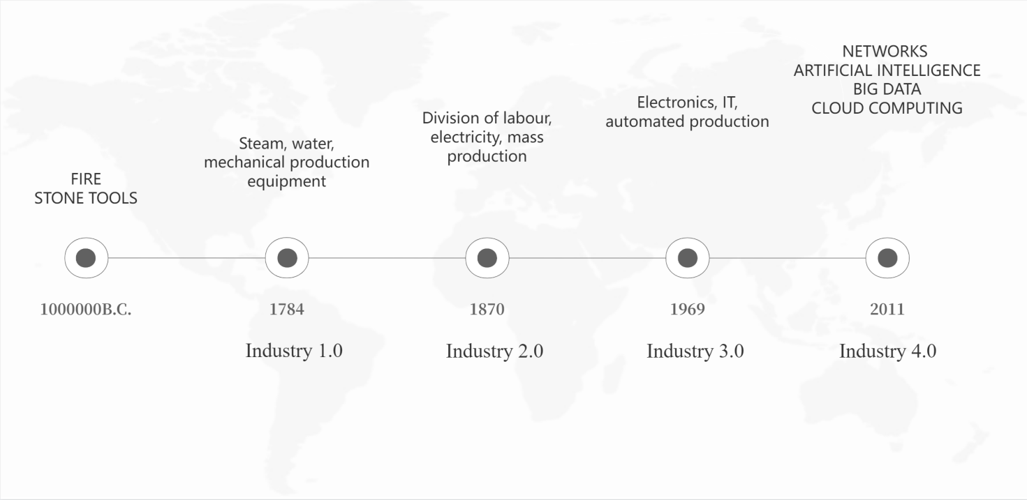
Figure 1.1 Industrial Revolution
(Source: compiled by the author based on [1],[2])

As human history progresses, every revolution has brought unprecedented changes to the world. The invention and popularization of computers have unprecedentedly improved the speed of information transmission and processing. The birth of the Internet has enabled people around the world to communicate in real time and broadened people's horizons. From the steam age to the digital age, humans have not only made great progress in productivity, but also changed their way of life and work with the development of science and technology. Digitalization has become an inevitable trend in the development of all walks of life. It optimizes and transforms traditional business processes, activities or services through the use of digital technology to improve people's efficiency and experience in all aspects. The driving factors of digital development mainly include three aspects: technological progress, changes in human behavior and competitive landscape.
1.Technological advance
In recent years, Google's self-driving cars have traveled thousands of miles on American highways. In the near future, digital technologies with hardware, software, and networks at their core will be able to diagnose diseases more accurately than doctors, apply large data sets to change people's decisions , and complete many tasks that were once thought to be only human-capable [3] . The rapid development of technologies such as the Internet, artificial intelligence, big data, and cloud computing has provided strong technical support for the digitalization process, making digitalization the only way for all industries to transform and upgrade.
The Internet is a vast interconnected network of computers and other devices that enables global communication, information sharing, and collaboration. As a digital infrastructure, it facilitates data transmission and allows users to access, exchange, and interact with large amounts of information. The Internet runs on a series of protocols such as TCP/IP and has become an indispensable part of modern life, connecting individuals, businesses, and society around the world. As of 2023, 67% of the world's population (or 5.4 billion people) are now online [4]. The rapid development of Internet technology has not only changed people's lifestyles, but also had a profound impact on the global economy, society, culture, and other fields. As other technologies continue to mature, the application scenarios of the Internet are becoming more and more diverse, and it has become an indispensable part in communications, e-commerce, education, and other fields.
- Communications: The Internet has revolutionized communications by providing email services, instant messaging, and social media platforms. It enables real-time interactions, transcends geographical boundaries, and facilitates global connectivity.
- E-commerce: With the advent of the Internet, traditional business models have quietly changed, giving rise to new transaction methods such as online shopping, digital payments and e-marketing. E-commerce platforms connect global buyers and sellers, creating a borderless market.
- Education: Online education and electronic learning have been accepted by people. People can find the educational resources they need through the Internet and study flexibly and conveniently. The Internet provides a platform for educational resources such as distance learning and digital libraries.
The profound impact of the Internet has spread to all industries and people's lives. It has laid the foundation for promoting innovation, interconnection and information sharing on a global scale.
Artificial intelligence is a revolutionary field in computer science that was first proposed at the Dartmouth Conference in 1956 [5]. Artificial intelligence encompasses a variety of technologies, including machine learning, natural language processing, computer vision, and robotics, which work together to give machines the ability to learn, reason, perceive, and understand language.
- Machine learning is a key aspect of artificial intelligence that enables machines to learn from data without being explicitly programmed. This iterative learning process enables systems to improve their performance over time, a capability that has seen rapid progress, especially with the rise of deep learning and neural networks in recent years. Such developments in machine learning are a key driver in realizing the potential of artificial intelligence.
- Natural language processing further expands the scope of AI by enabling effective communication between machines and humans. Natural language processing enables machines to understand, interpret, and generate human language, thereby facilitating the development of voice assistants, language translation, and other applications that bridge the gap between technology and human interaction.
- Computer vision is another key component of AI that enables machines to interpret and understand visual information. From image and video recognition to applications in healthcare and self-driving cars, computer vision expands the scope of AI into the physical world.
- Robotics is an application of AI that integrates human-like intelligence capabilities into physical machines. This enables robots to perform tasks with precision across industries from manufacturing to healthcare. The synergy between AI and robotics is changing the way we automate and augment human capabilities.
The capabilities of artificial intelligence are gradually redefining the way people live and work. In the process of digitalization, artificial intelligence can not only help enterprises realize automated and intelligent production and management and improve production efficiency , but also liberate humans from mundane and repetitive tasks, allowing people to focus on creative and complex work. Artificial intelligence has developed from a theoretical concept to a transformative force that shapes the future of technology.
Big data refers to the massive, high-velocity, and diverse data generated in today's era, including structured data from databases, unstructured data from sources such as social media, and semi-structured data from sensors and devices. Driven by the exponential growth of digital information, the emergence of big data as an important concept has attracted attention in the early 21st century. As the amount of data has surged to the PB and EB range, traditional data processing methods have proven to be insufficient. The term "big data" became widely recognized in the mid-2000s, reflecting the need for new methods to manage, analyze, and extract useful information from these large and diverse data sets for people's decision-making, life, and other aspects.
The main functions of big data can be summarized as three Vs: volume, velocity, and variety [6.p.4-5]. The scale of data is so huge that traditional data processing tools are not up to the task; the speed of data is so fast that it needs to be processed and analyzed in real time or near real time; the types of data are diverse, including structured, semi-structured, and unstructured data. Big data has applications in various fields, such as business intelligence, smart transportation, and modern medicine. In these fields, big data has brought us tremendous convenience and benefits.
- Business intelligence is a comprehensive approach to transforming raw data into meaningful insights, enabling organizations to make informed strategic decisions. It involves a range of tools such as the collection, analysis, and visualization of business data to enable stakeholders to clearly understand key performance indicators and trends, ultimately driving business success.
- Smart transportation refers to the use of big data technology to conduct real-time analysis of traffic data, which can effectively alleviate traffic congestion. Urban management departments can grasp road conditions in real time, reasonably adjust traffic light timing, and improve road traffic efficiency. In addition, big data can also provide optimization solutions for public transportation systems, such as optimizing bus route settings and dispatching taxi capacity.
- Modern medicine refers to the use of big data technology to analyze accumulated medical data to help doctors better diagnose conditions, develop treatment plans and predict disease trends. By mining and analyzing massive amounts of data, medical researchers can discover new treatments and drugs, thereby improving medical standards.
In our interconnected digital world, big data redefines the way we collect, process and use information, making people more insightful in the digital world.
Cloud computing refers to the provision of online computing resources to customers on demand by third-party service providers. As a way of sharing computing resources, it has changed the digital landscape and provided people with elastic, efficient, and reliable computing and storage capabilities. Cloud computing can quickly deploy business applications, achieve elastic expansion of business, reduce costs, improve operational efficiency, reduce hardware equipment and energy waste, and build a new path for healthy and sustainable green IT [7, p.2]. It is a revolutionary paradigm in the IT field and has completely changed the way computing resources are delivered and used. Unlike traditional local infrastructure, cloud computing allows users to access a large number of computing services through the Internet, providing on-demand resources such as storage, processing power, and applications. This approach enables organizations and individuals to dynamically expand their IT infrastructure, pay only for the resources they use, and reduce the need for a large amount of physical hardware. There are three main types of cloud computing services: infrastructure as a service, platform as a service, and software as a service: Infrastructure as a Service (IaaS): Providers provide basic infrastructure elements such as virtual machines, storage, and networks. This enables enterprises to build, manage, and expand their IT infrastructure without the need for physical hardware; Platform as a Service (PaaS): Providers provide a platform that allows developers to build, deploy, and manage applications without the need for complex infrastructure management. It simplifies the development process and facilitates faster application deployment; Software as a Service (SaaS): Providers deliver software applications over the Internet without requiring users to install, maintain, and update the software locally. Common examples include email services, customer relationship management (CRM) tools, and online collaboration platforms [7, p.3].
Cloud computing has a wide range of applications, touching all areas. In the field of entertainment, cloud computing provides seamless streaming services, allowing users to access movies, music, and TV shows anytime, anywhere. In the field of education, cloud computing provides students with an online learning platform, promoting distance learning and collaboration. In the field of scientific research, cloud computing provides powerful computing power and massive data storage, accelerating the progress of scientific research. Cloud computing has become a key force in promoting the digital transformation of various industries.
The maturity and popularity of technologies such as the Internet, artificial intelligence, big data and cloud computing have enabled people to enjoy the convenience brought by digitalization more easily. Therefore, technological progress has greatly promoted the development of digitalization. Not only that, the continuous breakthroughs and innovations in technology have also provided a continuous source of power for the development of digitalization. At the same time, with the government's strong support for scientific and technological innovation, technological changes have been further accelerated, pushing digitalization towards a higher level of goals.
2.Changes in human behavior
In the context of the rapid development of modern infrastructure such as the Internet, transportation and logistics, human behavior and the way people meet their needs are undergoing profound changes. Today, the average British person goes online for 24 hours a week, 20% of adults go online for up to 40 hours, and people aged 16 to 24 go online for an average of 34.3 hours a week [8, p.93]. The average British person checks their smartphone every 12 minutes, and American teenagers spend an average of more than 7 hours a day looking at screens (Tabl.1.1, fig.1.2).
Table 1.1
Statistics Of Internet Users
Database Annual
Year : LATEST10
Indicators | 2023 | 2022 | 2021 | 2020 | 2019 | 2018 | 2017 | 2016 | 2015 | 2014
Number of Internet Users (10000 persons) | 109200 | 106744 | 103195 | 98899 | 90359 | 82851 | 77198 | 73125 | 68826 | 64875

Source: [9]
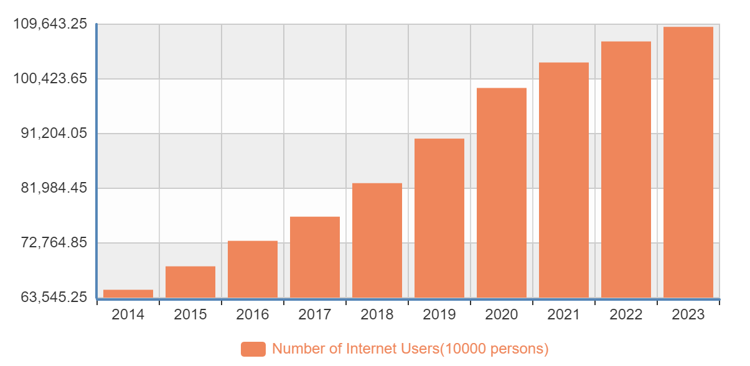
Figure 1.2 Trend Of Internet Users
Source: [9]

By 2023, the number of Internet users in China will grow from 648.75 million in 2014 to 1,092 million, a growth rate of 68.3%. This figure not only reflects the vigorous development of China's Internet industry, but also reflects the Chinese people's strong pursuit of and increasing dependence on digital lifestyles.
Digital technology is closely connected with our lives and affects the development of human behavior. In the past, certain activities often took place at specific times and places. Now, they are increasingly taking place in an “anytime, anywhere” mode. This change has not only changed how we consume, transmit information and socialize, but also reshaped our work and lifestyles [2, p.19].
The huge change in consumption patterns has gradually replaced traditional physical store shopping with online shopping. In the past, people were accustomed to offline shopping in fixed sales places such as supermarkets and vegetable markets, and used cash payment and other traditional lifestyles. With the popularization of the Internet and the high-speed circulation of goods, people can buy the goods and services they need anytime and anywhere through e-commerce platforms. According to the e-commerce transaction volume data released by the National Bureau of Statistics of China, China's e-commerce transaction volume in 2022 will increase from RMB 21,792.2 billion in 2015 to RMB 43,829.9 billion, a growth rate of about 101.2% (Tabl.1.2, fig.1.3).
Table 1.2
E-Commerce Transaction Statistics
Database Annual
Year : LATEST10
Indicators | 2023 | 2022 | 2021 | 2020 | 2019 | 2018 | 2017 | 2016 | 2015 | 2014
Volume of E-commerce transaction(100 million yuan) | - | 438299 | 423284 | 372078 | 348069 | 316257 | 291593 | 261049 | 217922 | -

Source: [9]

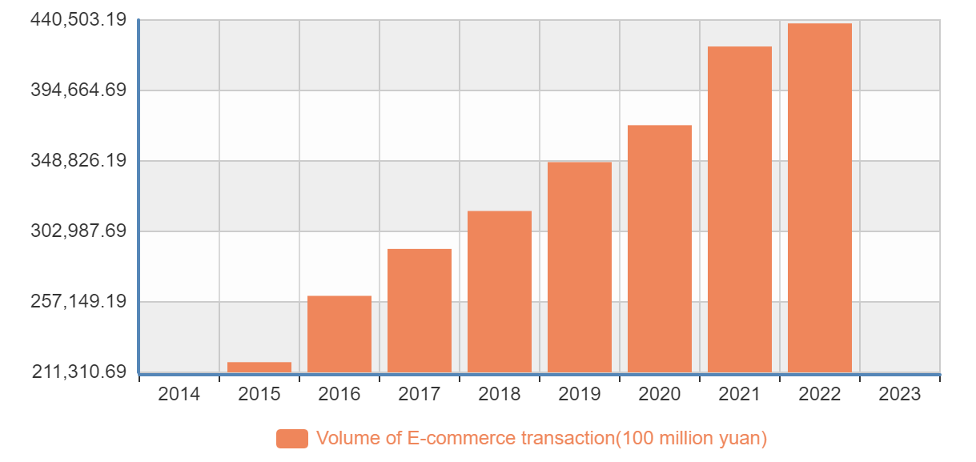

Figure 1.3 E-Commerce Transaction Volume Trend Chart
Source: [9]
Online shopping not only provides more choices and convenience, but also changes people's consumption habits. This change not only promotes enterprises to carry out digital reforms to meet the changing needs of consumers, but also accelerates the development of digitalization.
In ancient times, people relied on pigeons to deliver information. This method was limited by the flying speed and distance of pigeons, and the speed and range of information delivery were greatly limited. With the advancement of technology, we have faster and more convenient ways to deliver information, such as email, instant messaging tools, and social media. These digital tools have not only changed the way we deliver information, but also greatly improved the efficiency and accuracy of information delivery. Now, we can send and receive information anytime, anywhere, keep in touch with people around the world, and share our thoughts and feelings. Digital information delivery has penetrated into our daily lives and has become an indispensable part of us.
Due to the impact of the coronavirus, work, education, and social activities around the world have been forced to move online, and remote work and online learning have become the new normal [8, p.96]. In order to follow social isolation and stay safe, people are forced to work and study at home, which has further promoted the popularization and application of digital tools and platforms. Looking ahead to the next few decades, some occupations will gradually be replaced by industrial robots, and traditional roles in production, agriculture, and utilities may gradually disappear. However, new job opportunities are expected to emerge in some emerging fields, which requires people to adjust their status quo and learn new skills to remain competitive in the digital world [2, p.20].
3.Competitive landscape
In the digital age, competition has become one of the key drivers of development. According to data released by the National Bureau of Statistics of China, China's software and information technology services industry has shown strong growth momentum in the past few years (Tabl.1.3, fig.1.4).
Table 1.3
Statistics On Income Of Information Technology Enterprises
Database Annual
Year : LATEST5
Indicators | 2023 | 2022 | 2021 | 2020 | 2019
Software Income(10000 yuan) | 1232580000.0 | 1077901282.0 | 955019881.2 | 815859101.5 | 720718724.7
Software Products Income(10000 yuan) | - | 248629876.8 | 229703618.2 | 210450057.4 | 208572000.8
Income from IT Service(10000 yuan) | - | 705975650.4 | 626910430.1 | 525880061.2 | 435803399.9
Information Safety Income(10000 yuan) | - | 14689305.5 | 13970427.3 | 12937782.0 | 13017845.8
Embedded System and Software Income(10000 yuan) | - | 108606449.3 | 84435405.6 | 66591200.9 | 63325478.2
Software Export(10000 USD) | - | 6426502.8 | 6299082.2 | 6201679.3 | 5693938.1
Note: Cover enterprises with revenue from principal business of over 5 million yuan of software and IT service etc.

Source: [9]
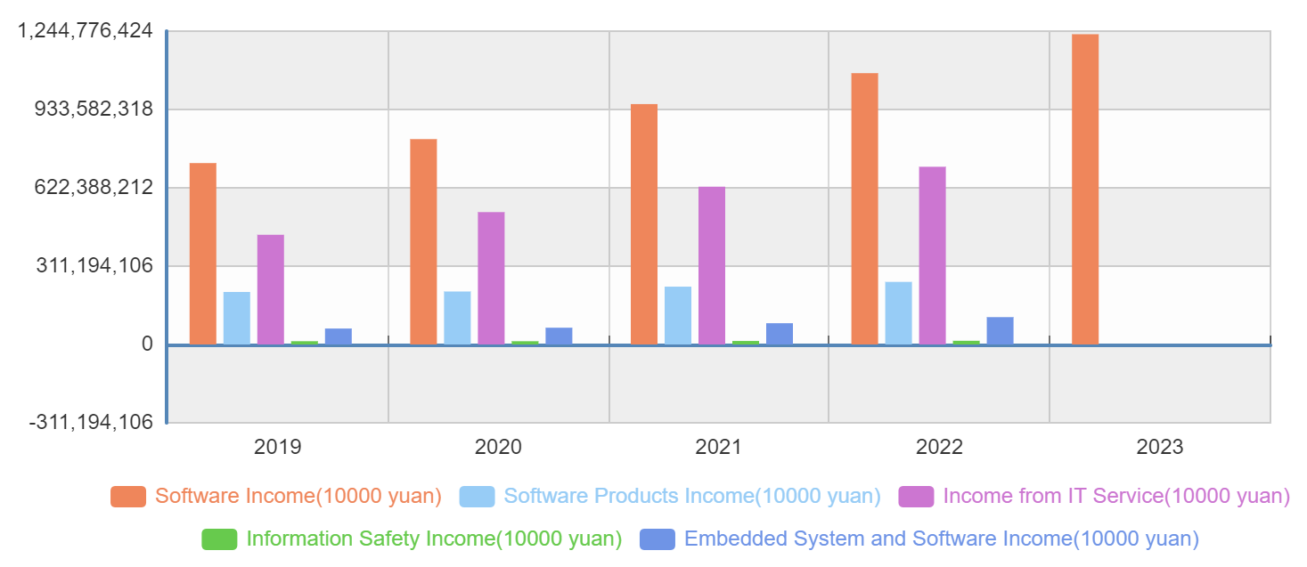
Figure 1.4 Revenue Trend Of Information Technology Related Industries
(Source: [9])

From the data, we can see that in recent years, software business revenue has continued to grow, the trend of digitalization is accelerating, and the IT industry has developed vigorously. At the same time, there are more and more software and information technology companies, and the competition is becoming more and more fierce (Tabl. 1.4, fig. 1.5.).
Table 1.4
Information Technology Enterprise Statistics
Database Annual
Year : LATEST5
Indicators | 2023 | 2022 | 2021 | 2020 | 2019
Number of Legal Entities, Information Transmission, Software and Information Technology (unit) | - | 1747117 | 1488072 | 1285534 | 1047408

Source: [9]

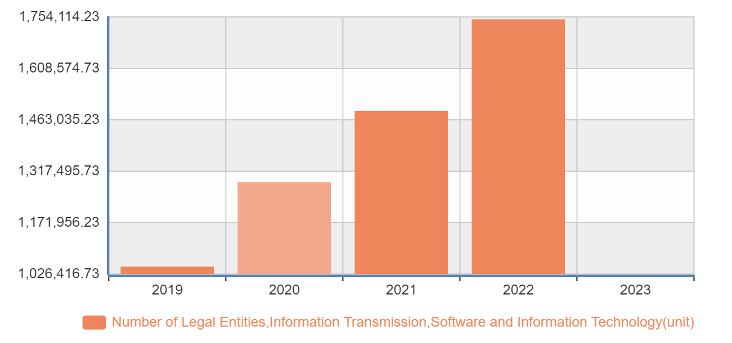
Figure 1.5 Software Enterprise Trend Chart
(Source: [9])

In order to gain a competitive advantage, companies have to seek support from digital technologies to improve their operations, products and services.
The development of digital technology has fundamentally changed the way enterprises operate. Digital tools and platforms enable enterprises to operate and manage in a more efficient and flexible way. For example, large supermarkets sell millions of products to millions of people every day. A large proportion of people living in developed countries rely on supermarkets to provide them with daily necessities. How can supermarkets provide the right products at the right time and in the right place so that the right people can buy them? This requires changing the traditional way of operation and using big data analysis to understand customer needs and provide consumers with the products they want to buy [10]. Amazon, as the world's largest online retailer, has achieved accurate product recommendations, efficient logistics distribution and high-quality customer service by using technologies such as big data, cloud computing and artificial intelligence. This digital operation model has enabled Amazon to occupy an important position in the retail market and posed a huge challenge to traditional retailers.
The complexity of modern products may be beyond imagination. Products that used to consist of only mechanical and electrical components have now become complex systems that combine hardware, sensors, data storage, microprocessors, software, and connectivity in a variety of ways. These new products have changed the industry structure and the nature of competition, exposing companies to new competitive opportunities and threats [11]. For example, electric car manufacturer Tesla has completely changed the automotive industry by deeply integrating hardware, software, data analysis, and artificial intelligence. Tesla's vehicles not only have excellent performance and endurance, but also can continuously optimize the user experience through software updates and realize advanced functions such as autonomous driving. This digital and intelligent product has enabled Tesla to stand out in the fiercely competitive automotive market and become an industry leader.
The rise of technology giants such as Google, Apple, and Facebook that master advanced digital technologies has made the digitalization and intelligence of services a new focus of industry competition. These technology giants have provided users with a rich variety of services through continuous technological innovation and digital layout, thereby winning huge market share and profits. For example, Google provides users with accurate search results, efficient data processing, and personalized recommendation services through technologies such as search engines, cloud computing, and artificial intelligence; Apple provides users with the ultimate user experience through the deep integration of design, hardware, and software; Facebook provides users with social interaction, information sharing, and precision marketing services through social media and data analysis. These digital and intelligent services have enabled these technology giants to occupy an important position in the market.

1.2 Conceptual Apparatus Of Project Management
What is a project? A project is a temporary task that requires creating unique products, services or results within a limited time and resource environment, with the goal of achieving specific goals and objectives [12, p.184]. For example, developing a new online video chat software, building a bridge or organizing a large conference can all be considered projects. Their common characteristics are temporary, unique and goal-oriented. These projects require careful planning, organization, motivation and control to ensure the effective use of resources and the successful completion of the project. In the process of project execution, operations management is easily confused with it. The two are interrelated but different. Operations management focuses on the continuous production of products and the continuous provision of services [12, p.190]. For example, after the online video chat software is developed and delivered for use, how to continue to attract more users and continue to serve users falls into the scope of operations management, while project management focuses more on achieving project goals within limited time and resource conditions. The main characteristics of a project include temporary and unique.
- Temporary: A project starts with clear scope, purpose, and objectives, and ends with achieving specific goals. It may end due to results delivery, early termination, or lack of necessity. For example, software development projects start with requirement gathering and end with deployment. Each version iteration can be considered a project.
- Uniqueness: Each project aims to create a unique product, service, or result due to specific needs, technology, resources, or market conditions. For instance, medical research projects develop new drugs to solve health problems, with unique research objectives, drug designs, and clinical trials (fig 1.6).

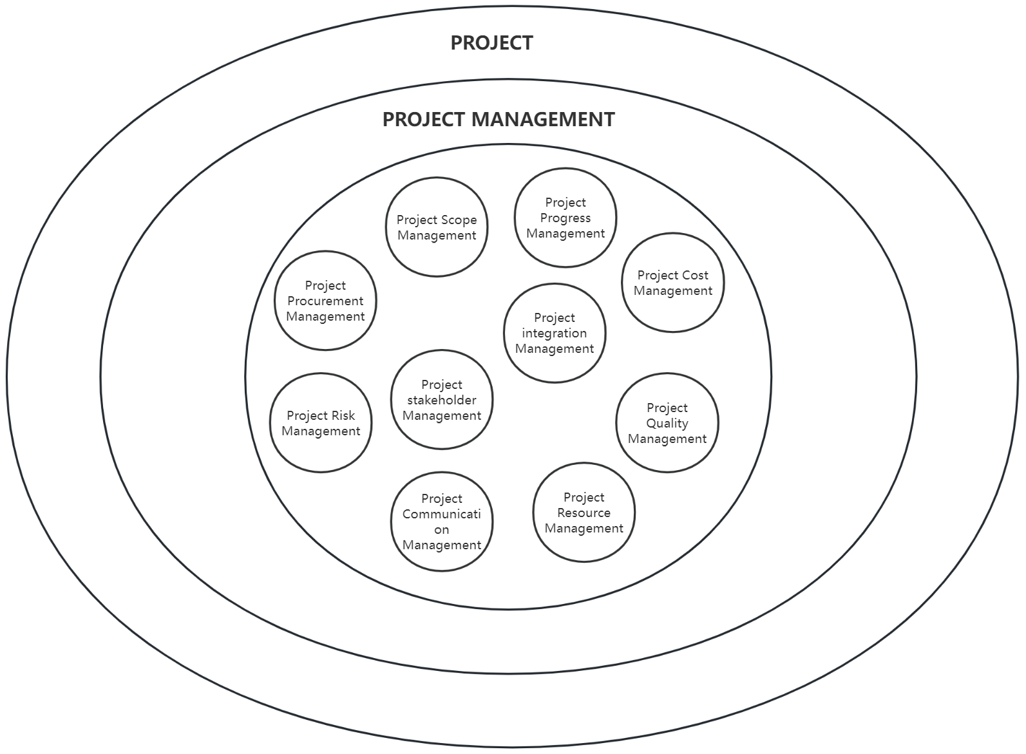
Figure 1.6. Project and Project Management
(Source: compiled by the author based on [12],[13])

Project management is the process of planning, organizing, directing and controlling projects through a series of methods, tools and techniques during the execution of the project to ensure that the project can be completed in accordance with the predetermined goals, time, budget and quality requirements. The Project Management Institute of the United States has developed a knowledge system for the professional scope of project management, which includes a description of the knowledge, skills and tools required for project management [12, p.183]. The sixth edition of the Project Management Guide summarizes the knowledge areas commonly used by most projects into ten areas, including project integration management, project scope management, project schedule management, project cost management, project quality management, project resource management, project communication management, project risk management, project procurement management and project stakeholder management [13, p.23-24].
1.Project integration management
Project integration management refers to the process of comprehensively identifying, accurately defining, organically combining, unifying and coordinating, and effectively managing the various processes and activities within the project management process group. In project management practice, integration has multiple functions such as unified planning, merging resources, communication and coordination, and establishing close connections, which run through the entire life cycle of the project [13, p.69]. It ensures that all parts of the project can work together to meet project requirements to the greatest extent possible. Project integration management involves several key stages, each of which plays a vital role in the success of the project. These stages include: developing a project charter, developing a project management plan, directing and managing project work, project knowledge management, monitoring project work, implementing overall change control, and closing the project or phase [13, p.70].
- Develop a project charter: This document formally authorizes the project, appoints a project manager, and provides direction for the project. It includes objectives, scope, budget, timeline, milestones, and deliverables.
- Develop a project management plan: This detailed plan describes how to execute, monitor, and control the project. It includes sub-plans for scope, time, cost, quality, human resources, communication, risk, and procurement management.
- Direct and manage project work: The project manager coordinates team members, monitors progress, cost, and quality, and deals with issues like change requests and risk events.
- Project knowledge management: This involves collecting, organizing, sharing, and utilizing project knowledge to improve efficiency and reduce errors.
- Monitor project work: The project manager regularly evaluates progress, cost, and quality using tools like earned value management and the critical path method, and takes corrective measures.
- Implement overall change control: The project manager evaluates and decides on change requests, and implements changes to ensure the project stays on track.
- End the project or phase: When the project or phase is completed, the project manager finalizes documents, conducts a post-project evaluation, and summarizes lessons learned.
Project integration management is one of the core processes of project management, which involves all aspects of project management. Through effective project integration management, project managers can ensure that all parts of the project can work together to achieve the project's predetermined goals. At the same time, project integration management can also help project managers improve the efficiency and effectiveness of project management, thereby increasing the success rate of the project.
2.Project scope management
Project scope management aims to ensure that the project covers all necessary work and avoids unnecessary work, so as to smoothly advance the various stages of the project. Its core lies in clearly defining which work content should be included in the project scope and which should not be included, and ensuring the smooth progress of the project through effective control. The project scope management process covers several key steps: planning scope management, gathering requirements, defining scope, creating a work breakdown structure, confirming scope, and controlling scope [13, p.129].
- Planning scope management: Defines how to manage the project scope, including developing a scope management plan, clarifying the scope statement, and establishing scope management processes.
- Requirements gathering: Communicates with stakeholders to understand their needs and expectations using techniques like interviews, questionnaires, and focus groups.
- Define scope: Clarifies the project's goals, outputs, and functional characteristics based on collected requirements and prepares a scope statement.
- Create a work breakdown structure: Breaks down the project scope into smaller, manageable work packages to assign resources and time.
- Confirm scope: Reviews and confirms the project scope with stakeholders through a formal acceptance process to avoid scope creep.
- Control scope: Continuously monitors the project scope during execution to ensure it aligns with the plan and evaluates scope change requests.
Project scope management helps ensure the successful implementation of the project. Through steps such as clarifying the project scope, collecting requirements, creating a work breakdown structure, confirming the scope, and controlling the scope, the project manager can ensure that all project work is effectively managed to meet the needs and expectations of project stakeholders. At the same time, project scope management also helps to improve the transparency and predictability of the project, laying a solid foundation for the successful implementation of the project.
3.Project schedule management
Project schedule management aims to ensure that the project is successfully completed within the specified time. It systematically manages all processes involved in the project, covering multiple key links such as planning schedule management, defining activities, arranging activity sequences, estimating activity durations, formulating project schedules, and controlling progress, so as to ensure the efficient advancement and successful implementation of the project [13, p.173].
- Planning schedule management: Establishes a comprehensive schedule management plan to monitor and manage project timelines.
- Define activities: Breaks down the project into specific, executable tasks with clear timelines.
- Arrange activity order: Clarifies the logical relationships between tasks to arrange the project schedule effectively.
- Estimate activity duration: Estimates reasonable timeframes for each task based on various factors.
- Develop project schedule: Creates a detailed schedule with start and end dates, milestones, etc.
- Control progress: Monitors project progress, identifies delays, and takes corrective measures to ensure timely delivery.
Project schedule management is of great significance to ensure that the project is delivered on time. Through planning schedule management, defining activities, arranging activity sequences, estimating activity durations, developing project schedules, and controlling schedules, project managers can fully control the project schedule and ensure that the project is successfully completed within the specified time. At the same time, project schedule management also helps to improve the transparency and predictability of project management, laying a solid foundation for the successful implementation of the project.
4.Project cost management
Project cost management aims to maximize project benefits and ensure effective management and control of project costs through a series of processes: planning, estimating, budgeting, financing, raising funds, managing and controlling costs, so as to achieve successful completion of the project within the budget. The process of project cost management includes planning cost management, estimating costs, formulating budgets and controlling costs [13, p.231].
- Planning cost management: Establishes a framework and strategy for managing project costs, including setting objectives, principles, methods, responsibilities, processes, and estimation/budgeting methods.
- Estimating costs: Makes preliminary estimates of direct and indirect project costs based on requirements, scope, resources, and technical specifications.
- Budgeting: Develops a detailed project budget based on cost estimates, ensuring cost control and providing financial support.
- Cost control: Monitors project costs during execution, analyzes deviations, and takes corrective measures to ensure the project stays within budget.
Project cost management is of great significance to ensure that the project is completed within the budget. Through the steps of planning cost management, estimating costs, making budgets and controlling costs, project managers can fully control project costs and ensure that the project is successfully completed within the budget. At the same time, project cost management also helps to improve the transparency and predictability of project management, laying a solid foundation for the successful implementation of the project. In actual operation, project cost management also needs to be coordinated with project scope management and schedule management to ensure that the project is fully and effectively managed in terms of quality, cost and schedule.
5.Project quality management
Project quality management refers to the implementation of a series of processes to ensure that the project and its products meet the established quality requirements and meet the expectations of all stakeholders. The project quality management process includes planning quality management, managing quality, and controlling quality[13,p.271].
- Planning quality management: Determines quality goals, standards, strategies, methods, and tools. Develops a quality management plan, clarifies responsibilities, sets up inspection and control processes, and determines quality standards and assessment methods.
- Manage quality: Ensures project quality meets standards through quality assurance activities such as audits, reviews, and process improvements. For software, this includes code review, unit testing, and integration testing.
- Control quality: Continuously monitors project quality, inspects, tests, and accepts work. Rectifies and repairs issues that don't meet quality requirements. For software, this involves user acceptance testing, defect tracking, and version releases.
Project quality management is essential to ensure that project quality meets expectations and requirements. Through steps such as planning quality management, managing quality, and controlling quality, project quality can be comprehensively managed and controlled to ensure that project results meet established quality standards and the expectations of all stakeholders.
6.Project resource management
Project resource management involves comprehensive identification, effective acquisition, and precise management of resources required for a project to facilitate successful completion of the project. The key is to ensure that the project manager and the project team can use the required resources at the right time and place. The process of project resource management includes planning resource management, estimating activity resources, acquiring resources, building a team, and managing a team [13, p.307].
- Planning resource management: Clarifies project resource needs (human, material, financial) and develops a resource management plan. Considers resource availability and cost-effectiveness for optimal allocation.
- Estimate activity resources: Estimates required resources based on project factors like requirements, scope, schedule, and cost. In software projects, includes estimating developer numbers, skills, and equipment.
- Obtain resources: Acquires resources based on the resource management plan and estimates. Involves communication and coordination with suppliers, partners, or internal departments.
- Team building: Focuses on team selection, role allocation, and training to improve cohesion and execution for project success.
- Team management: Continuously manages team work and performance during project execution. Includes monitoring progress, resolving conflicts, and providing support and guidance to ensure member enthusiasm and efficiency, promoting project progress.
Through steps such as planning resource management, estimating activity resources, acquiring resources, building teams and managing teams, you can fully control project resources and ensure that the project is reasonably guaranteed and supported in terms of resources.
7.Project communication management
Project communication management refers to the process of ensuring that the information needs of the project and its stakeholders are met by carrying out a series of information exchange activities. This process covers two core components: first, strategy formulation, which aims to ensure that communication methods have practical benefits for stakeholders; second, implementation of necessary activities to effectively implement the established communication strategy. The process of project communication management includes planning communication management, managing communication, and supervising communication [13, p.359].
- Planning communication management: Clarifies project communication needs and goals, and develops a detailed communication management plan. Determines communication frequency, method, channel, content, and responsible parties. Ensures effective information transmission and sharing.
- Management communication: Executes communication activities according to the plan, including meetings, reports, and notifications. Ensures timely and accurate information conveyance. Adjusts communication strategies as needed.
- Communication supervision: Continuously monitors and evaluates communication effectiveness. Records, analyzes, and summarizes communication activities. Provides feedback and improves communication to ensure efficiency and transparency in project management.
Project communication management is important to ensure the effective transmission and sharing of project information. Through planning communication management, managing communication and supervising communication, it ensures that project information is effectively transmitted and shared within the team and among stakeholders.
8.Project risk management
Project risk is an uncertain event or condition that may have a positive or negative impact on the achievement of project objectives [12, p.431]. The core goal of project risk management is to optimize the likelihood and potential impact of positive risks, while reducing the probability and potential impact of negative risks, thereby increasing the overall probability of project success. Project risk management includes planning risk management, identifying risks, conducting qualitative risk analysis, conducting quantitative risk analysis, planning risk responses, implementing risk responses, and monitoring risks [13, p.395].
- Plan risk management: Develop a risk management plan detailing methods, tools, resources, and timeline. Ensure coverage of risk identification, analysis, response, and monitoring.
- Identify risks: Organize team and stakeholders to identify potential risks through various methods. Consider technology, market, policy, and environmental risks impacting project progress, cost, and quality.
- Conduct qualitative risk analysis: Assess likelihood, impact, and priority of identified risks. Determine which risks require focus and response.
- Implement quantitative risk analysis: Quantify qualitative analysis results and evaluate risk impact on project objectives. Provide basis for risk response measures.
- Plan risk response: Formulate specific risk response strategies and measures, including risk avoidance, reduction, transfer, and acceptance.
- Implement risk response: Take measures according to the risk response plan during project implementation. Adjust strategies as needed.
- Risk supervision: Continuously supervise and evaluate the risk management process, including risk identification, analysis, response, and monitoring activities. Evaluate and improve risk management effectiveness.
9.Project procurement management
Project procurement management refers to a series of processes by which a project team purchases or acquires the required products, services or results from external entities, mainly including planning procurement management, implementing procurement and controlling procurement [13, p.495].
- Planning procurement management: Clarify procurement needs, develop a procurement plan, and determine the procurement strategy based on project needs and risks. The plan should include detailed descriptions, schedules, budget allocations, and supplier selection criteria.
- Implementation of procurement: Execute procurement activities according to the plan, including negotiations, contract signing, and order issuance. Ensure compliance with laws, regulations, and company policy. Maintain communication with suppliers to ensure contract requirements are met.
- Control procurement: Continuously monitor and supervise procurement activities, including supplier delivery progress, cost control, and contract execution. Address delays, quality issues, or cost overruns promptly. Record and archive procurement activities for audits and reviews.
Project procurement management is of great significance to ensure the timely acquisition of project resources and the smooth implementation of the project. Through the steps of planning procurement management, implementing procurement and controlling procurement, the project team can effectively manage the procurement activities of the project and ensure that the project is reasonably guaranteed and supported in terms of resources.
10.Project stakeholder management
Project stakeholders refer to those who are directly or indirectly affected by the project, or who can have a direct or indirect impact on the project[12,p.503]. Project stakeholder management is the process of managing the needs, expectations, and interests of these stakeholders to ensure that they can effectively participate in the project and have a positive impact on the success of the project. The process of project stakeholder management includes identifying stakeholders, planning stakeholder participation, managing stakeholder participation, and monitoring stakeholder participation [13, p.503].
- Identify stakeholders: Comprehensively analyze project goals, scope, risks, etc., and communicate with team members and stakeholders to identify direct and indirect stakeholders, along with their interests, needs, and expectations.
- Plan stakeholder engagement: Develop a stakeholder engagement plan outlining roles, responsibilities, and participation methods, along with a communication plan detailing method, frequency, and content.
- Manage stakeholder participation: Execute stakeholder management according to the plan, including communication, coordination, conflict resolution, and ensuring planned participation. Adjust plans based on stakeholder feedback.
- Supervise stakeholder participation: Continuously monitor and evaluate stakeholder management processes, recording activities, analyzing participation, and evaluating effectiveness to ensure efficiency and transparency in project management.

1.3 The Role Of It Projects In The Processes Of Digitalization Of Society

An IT project is a project that uses information technology to build products, services or achieve specific goals by using computer hardware, computer software, and network technologies. For example, a technology company is committed to developing an efficient resource management system based on market demand, or building a powerful e-commerce platform to provide users with a convenient and smooth online shopping experience [14, p.4-5].
- Computer hardware: including but not limited to computer mainframe, monitor, keyboard, mouse and other peripherals, as well as hard disk, central processing unit and other core components. Computer hardware forms the foundation of IT technology, supporting complex data processing and efficient information management system.
- Computer software: Software tools and systems are the core of modern IT projects, including operating systems, database management systems, various application software and development tools. Software not only provides an interface for user operations, but also implements multiple functions such as data analysis, resource management and online interaction through algorithms and applications.
- Network technology: The network is the link that connects global computing resources, including the Internet, enterprise LANs, WANs, and the latest 5G and Wi-Fi 6 technologies. Network technology ensures the efficient transmission and real-time sharing of information and is an indispensable infrastructure for the operation of modern society.
IT project construction is to meet the needs of information processing, management and transmission in different scenarios, promote the digitalization process, and improve work efficiency and quality of life. The types and scope of IT projects include but are not limited to system integration projects, software development projects, network construction projects, database construction projects, information security projects, artificial intelligence projects, cloud computing projects, big data projects and Internet of Things projects.
- System integration projects: integrating hardware, software and network resources to provide organizations with comprehensive information solutions, such as data center construction, office automation, enterprise resource planning systems, etc. These projects help companies achieve optimal resource allocation and efficient management of information flow.
- Software development projects: Develop customized computer software according to customer needs, including desktop applications, mobile applications, website development, game development, etc.
- Network construction projects: including network planning, design, deployment and maintenance to ensure reliable connection and secure transmission of information resources. These projects are crucial to establishing a stable enterprise information system.
- Database construction projects: Establish and maintain database systems to support efficient storage, retrieval and analysis of data. These systems provide powerful data support for enterprises and are an indispensable part of the big data era.
- Information Security Project: Strengthen the security of information systems and protect data from threats by implementing security policies, risk assessments, and continuous monitoring. These measures are critical to preventing data breaches and cyberattacks.
- Artificial Intelligence Projects: Using artificial intelligence technologies, such as machine learning and natural language processing, to provide intelligent solutions. These projects have shown great potential in areas such as medical diagnosis, customer service and market forecasting.
- Cloud computing projects: Provide cloud-based computing, storage and network services such as software as a service, platform as a service and infrastructure as a service. Cloud computing projects enable enterprises to operate in a more flexible and cost-effective way.
- Big Data Projects: Process and analyze large-scale data sets to support enterprise decision making. These projects reveal business insights through data mining and analysis to support strategic planning and operational optimization.
- Internet of Things Project: Integrate sensors, devices and platforms to achieve interconnection and intelligent management of devices. Internet of Things technology has a wide range of applications in smart homes, smart cities and industrial automation.
IT projects have become a key force in promoting social digitalization and technological innovation. They not only optimize the operational processes of enterprises and improve the quality of decision-making, but also improve people's daily lives, enabling society as a whole to develop in a more efficient and intelligent direction. Their main functions include optimizing cost structures and improving efficiency and effectiveness; strengthening service quality and achieving model upgrades; enhancing people's well-being and improving their quality of life; promoting environmental protection actions and achieving green development; stimulating innovation vitality and promoting sustainable development.
1.Optimize cost structure and improve efficiency and effectiveness
Successfully implemented IT projects, with their outstanding capabilities, not only optimize the enterprise's decision-making process and improve the efficiency of business operations, but also significantly promote a leap in organizational productivity. By cleverly using IT technology, enterprises can achieve efficient processing of decentralized decisions, optimize cumbersome business processes, and directly promote a huge increase in organizational productivity, thereby achieving the dual goals of reducing costs and improving efficiency [15, p.17-19].
- Decentralized decision-making: Through the implementation of IT projects, enterprises can collect, process and share information more quickly and accurately, which makes the decision-making process faster and more accurate. For example, the real-time information provided by the enterprise resource planning system ensures the accuracy of organizational decisions and the precision of predictions [16]. By analyzing the acquired real-time data through data analysis tools, enterprises can conduct in-depth research on market trends, consumer behavior, etc., so as to make more informed decisions. At the same time, through the application of technologies such as cloud computing, enterprises can realize centralized storage and processing of data, so that employees scattered around can access and use this data anytime and anywhere, greatly improving the efficiency and accuracy of decision-making.
- Optimize business processes: IT projects can help enterprises optimize business processes, reduce repetitive and ineffective work, and improve work efficiency. For example, in the manufacturing industry, from the procurement of raw materials to the fine management of the production process to the delivery of the final product, each link requires efficient organization and coordination. The enterprise resource planning system helps enterprises achieve this goal through its advanced manufacturing module [16]. Specifically, the enterprise resource planning system significantly improves product quality through standardized management, wins higher market share and customer loyalty for the enterprise, and thus drives sales and organizational profit growth. At the same time, the system also provides real-time visibility of the entire production process, enabling manufacturers to accurately grasp inventory status, predict future demand, and make corresponding production and procurement decisions accordingly, which not only reduces inventory costs but also improves the flexibility and responsiveness of the supply chain.
- Directly promote the improvement of organizational productivity: Through the implementation of IT projects, the skills of employees can be effectively improved, enabling them to complete tasks more quickly and efficiently, reducing work repetition, and thus achieving precise control of work tasks and improving efficiency. This process directly promotes a significant improvement in organizational productivity [17, p.32]. For example, the traditional document processing process often consumes a lot of time due to cumbersome steps. By introducing efficient online office software, employees can quickly and accurately complete tasks such as document writing, approval, and sharing, and ensure that employees can work at any time and any place through the Internet, further enhancing work efficiency and thus improving the productivity of the entire organization.
2.Strengthen service quality and achieve model upgrade
With the implementation of advanced IT projects and the combination of emerging information technology, enterprises can significantly improve customer satisfaction, optimize service quality and strengthen customer relationship management, thereby consolidating their position and achieving sustainable growth in a fiercely competitive business ecosystem [18].
- Improve customer satisfaction: With the development of technology, the traditional customer service model can no longer meet the needs of modern enterprises. To solve this problem, many companies have begun to introduce online customer service robots. These robots not only provide 24/7 uninterrupted service, greatly reducing customer waiting time, but also can quickly and accurately answer customer questions through pre-set algorithms and rules [19, p.16-17]. This automated service model greatly improves service response speed, enhances customer experience, and makes customers feel more satisfied and comfortable.
- Optimizing service quality: In addition to improving customer satisfaction, big data analysis also plays an important role in optimizing service quality. By collecting and analyzing various data such as customer behavior habits and purchasing preferences, companies can gain a deep understanding of customer needs and expectations. This in-depth understanding provides companies with the possibility of customized services and products, enabling them to better meet the personalized needs of customers. This customer-oriented service model not only improves service quality, but also wins more market share for companies.
- Strengthen customer relationship management: Information technology also plays a vital role in customer relationship management. By analyzing and using customer personal information, companies can provide customers with more intimate and personalized services. For example, sending blessings and benefits on customers' birthdays or special holidays can make customers feel the care and warmth of the company, thereby enhancing customer loyalty and stickiness. In addition, companies can also interact with customers more directly and frequently through channels such as social media, and understand customer feedback and needs in a timely manner, so as to more accurately adjust service strategies and product directions. This customer-centric service model not only strengthens the connection and communication between companies and customers, but also wins more customer trust and support for companies.
3.Improve people's well-being and quality of life
e-government IT projects has enabled citizens to handle various services online through the Internet or telephone, which has not only improved the efficiency of government services, but also enabled citizens to enjoy government services more conveniently [20] . These services cover education, medical care, transportation and other aspects, directly improving the quality of life of the people.
- Smart education: Using online learning platforms to provide students with rich interactive and multimedia content, breaking the traditional textbook-based teaching model, enhancing students' learning experience, and enhancing students' understanding of the knowledge they have learned through sensory stimulation [21]. The emergence of online education platforms has enabled children in regions with different levels of development to break through geographical restrictions and access broader and higher-quality educational resources. They are no longer restricted to the traditional classroom model, but can learn new knowledge anytime and anywhere and interact with famous teachers in real time, which greatly improves learning outcomes. In addition, the government has also used data analysis tools to accurately grasp the educational needs of various regions, providing a scientific basis for the rational allocation of educational resources and further promoting educational equity.
- Smart healthcare: E-government projects have greatly simplified healthcare services. E-health systems allow citizens to manage their medical records online and effectively participate in healthcare services. They facilitate online appointments, prescription information, and telemedicine services to ensure continuous patient care. They provide doctors with detailed medical histories and test results of patients, helping them make more accurate diagnoses and treatment plans [22]. Government authorities use big data and artificial intelligence technologies to intelligently dispatch and optimize the allocation of medical resources, effectively alleviating the problem of tight medical resources and improving the accessibility and quality of medical services.
- Smart transportation: Through the construction of intelligent transportation systems, traffic data is collected by sensors and communication technologies, valuable information is extracted by data analysis technology, and real-time and accurate traffic information is provided to users through smart mobile devices and vehicle systems. Citizens can check the operation of buses, subways and other transportation tools in real time, arrange travel time reasonably, and reduce the time and energy wasted due to traffic congestion [23]. Government departments use big data analysis to monitor and predict traffic flow, road conditions and other information in real time, providing strong support for urban transportation planning and management. This not only alleviates urban traffic pressure, but also provides citizens with a more convenient and safe travel environment.
4.Promote environmental protection actions and achieve green development
Global warming has made environmental problems increasingly serious. Green environmental protection has become a core issue in today's society. In 1992, the concept of green IT emerged [24]. As people's awareness of environmental protection increases, IT projects are playing an increasingly important role in promoting green environmental protection. By applying information technology, environmental resources can be more effectively monitored and managed, promoting sustainable development and the realization of a green economy.
- Environmental monitoring: IT projects have shown great potential and value. By introducing cutting-edge technologies such as the Internet of Things, big data, and artificial intelligence, we can achieve real-time monitoring and data analysis of environmental indicators such as air, water quality, and soil. These technologies can not only help us discover and solve environmental problems in a timely manner, but also predict and evaluate environmental risks, providing a scientific basis for environmental protection work. For example, through the Internet of Things technology, we can achieve real-time monitoring of pollution sources and take timely measures to prevent the spread of pollution; through big data analysis, we can understand the trends and laws of environmental changes and provide data support for the formulation of environmental protection policies.
- Resource management: Traditional resource management methods often have problems such as low efficiency and waste of resources. However, through cloud computing, big data and other technical means, we can achieve digital management and intelligent scheduling of resources, improve resource utilization efficiency, and reduce resource waste and pollution emissions. For example, the construction of smart grids can achieve real-time monitoring and scheduling of electricity, reduce energy loss and emissions; the application of intelligent transportation systems can reduce traffic congestion and emission pollution, and promote the green development of urban transportation. In addition, through cloud computing technology, we can also achieve real-time monitoring and management of various links such as enterprise production and supply chain, helping enterprises to achieve green production, reduce production costs, and improve market competitiveness.
5.Stimulate innovation and promote sustainable development
With the rapid development of information technology, IT projects have become an important force in optimizing service quality, strengthening customer relationship management, improving people's livelihood and promoting industrial upgrading. They are like a stream of clear springs, injecting new vitality into all walks of life and driving the continuous development of the entire society.
IT projects not only provide enterprises with strong technical support and platforms, but also play a vital role in the field of innovation. By introducing advanced technologies such as cloud computing, big data, and artificial intelligence, enterprises can achieve comprehensive innovation in business models, products and services. Taking the sharing economy as an example, with the help of information technology, people can share resources more conveniently and improve resource utilization efficiency, while also bringing more choices and convenience to consumers. Similarly, the development of unmanned driving, intelligent manufacturing and other fields cannot be separated from the support and promotion of IT projects. These innovations not only improve the core competitiveness of enterprises, but also bring more convenient, efficient and environmentally friendly new products and services to society.
While promoting innovation, IT projects also provide new impetus for economic growth. With the widespread application and in-depth implementation of information technology, more and more traditional industries have begun to integrate with information technology, promoting industrial upgrading and transformation. Traditional manufacturing has achieved automated and intelligent production by combining with information technology, greatly improving production efficiency and market competitiveness. At the same time, IT projects have also promoted innovation, entrepreneurship and talent training, providing a strong guarantee for the sustainable development of the economy and society.

CHAPTER 2

METHODOLOGICAL SUPPORT FOR MANAGING MODERN IT PROJECTS

2.1 Features Of It Project Management (Software Implementation Projects)

The characteristics of software implementation type IT project management include complexity, innovation, specialization, customer demand orientation and continuous optimization and upgrading [25].
1.Complexity
Complexity is a core challenge that must be faced in order to successfully implement a project. The multifaceted complexity challenge includes the complexity of the project itself, the complexity of the project environment, and the complexity of project risks [26, p.2-12].
- Complexity of the project itself: First, the wide scope of the project is an important manifestation of complexity, especially in software implementation projects. For example, a large-scale enterprise-level resource planning (ERP) system implementation project often involves multiple business areas and functional departments such as finance, supply chain, production, and sales [16]. The project team needs to integrate the data, modules, and business processes of various systems to ensure accurate transmission and sharing of information. This cross-domain integration work not only increases the complexity of the project, but also requires the project team to have rich business knowledge and technical strength. Secondly, the uncertainty of requirements is another important aspect of the complexity of the project itself. As the project progresses, users often put forward new requirements for software functions or modify the original requirements. Such changes in requirements may lead to adjustments in the scope of the project and increase the difficulty of project management. For example, in a customer relationship management (CRM) system implementation project, the customer may only put forward basic customer information management requirements at the beginning of the project, but during the project execution, they hope to add advanced functions such as market analysis and sales forecasting. This requires the project team to be able to flexibly respond to changes in requirements and adjust project plans and resource allocation in a timely manner. In addition, the popularization of the Internet has led to an explosive growth in the amount of information, making project requirements more complex and changeable. It is estimated that by 2025, connected consumers will interact with digital data once every 18 seconds (5,000 interactions per day) on average [27]. Therefore, project teams need to process and analyze large amounts of data to better understand user needs and market trends and make accurate decisions. Finally, technical complexity is also a challenge to the successful implementation of projects. Software implementation projects involve a variety of technologies and tools, such as programming languages, databases, frameworks, etc. The selection and application of technology has a significant impact on the success of the project. For example, in a mobile application development project, the project team needs to select the appropriate development framework, database, and testing tools. At the same time, they also need to consider compatibility issues with different devices, operating systems, and network environments. The selection and application of these technical factors will increase the complexity of the project.
- Complexity of project environment: First, the rapid changes in the market environment have an impact on the technology selection, cost control and delivery cycle of the project. For example, with the development of technologies such as cloud computing, big data and artificial intelligence, the needs of enterprises for software systems are also changing. The project team needs to pay close attention to market trends and adjust the technology selection in a timely manner to meet customer needs. Secondly, the strict requirements of industry regulations are also an important aspect of the complexity of the project environment. Different industries have different regulatory requirements for software projects. The project management team needs to pay close attention to industry trends to ensure project compliance. For example, in the financial industry, there are strict regulatory requirements for data security and privacy protection. The project team needs to take corresponding security measures and technical means to ensure that the project meets regulatory requirements. Thirdly, the diversity of organizational structures may also lead to difficulties in project communication, coordination and execution. For example, in a multinational company, branches in different regions may adopt different organizational structures and business processes. The project team needs to adapt to different organizational structures and communicate and coordinate effectively with employees of various branches to ensure the smooth implementation of the project. Finally, the complexity of interpersonal relationships is also an important aspect of the complexity of the project environment. Software implementation projects involve multiple stakeholders, such as users, developers, suppliers, etc. The handling of interpersonal relationships is crucial to the success of the project. For example, during the project execution, users may complain or question the software functions due to dissatisfaction. The project team needs to respond to user needs and feedback in a timely manner and actively communicate with users to solve problems and improve user satisfaction.
- Complexity of project risks: Technical risks, market risks, personnel risks and management risks may all have adverse effects on the project. For example, in terms of technical risks, if the technical solution selected by the project team is defective or unstable, it may lead to project delay or failure. In terms of market risks, if changes in market demand or adjustments in competitors' strategies cause the project to lose market competitiveness, it may also lead to project failure. In terms of personnel risks, if team members are lost or lack skills, it may affect project execution and team morale. In terms of management risks, if the project plan is unreasonable, resources are improperly allocated or quality control is lax, it may lead to project loss of control and failure.
2.Innovation
Innovation is another prominent feature of software implementation project management. With the continuous development of technology and the changing market demand, software implementation projects need to innovate continuously to adapt to these changes. This innovation is reflected in three aspects: technological innovation, business innovation and management innovation [26, p.9], [26, p.1018-1019].
- Technological innovation: With the rapid development of science and technology, project management teams need to keenly capture the development trends of new technologies, such as artificial intelligence, big data, cloud computing, etc., and introduce these technologies into projects in a timely manner. Taking artificial intelligence as an example, the introduction of artificial intelligence technology in project management can realize intelligent prediction of project progress, intelligent identification of risks, etc., greatly improving the efficiency and quality of projects. At the same time, the use of cloud computing technology can realize dynamic allocation and elastic expansion of resources, so as to better meet the changing needs of projects. In the field of software development, cloud computing technology makes the development environment more flexible and efficient, and the project team can work anytime and anywhere, greatly improving the response speed of the project.
- Business innovation: Software implementation projects are not only technical projects, but also business projects. The project management team needs to have a deep understanding of business needs and propose innovative business solutions in combination with technological innovation. Taking the e-commerce field as an example, by using big data analysis and artificial intelligence technology, the project team can accurately analyze user behavior and needs and provide users with a more personalized shopping experience. This innovative business solution not only improves the user's shopping experience, but also brings more business opportunities and profit growth points to e-commerce companies. This kind of business innovation is a challenge and an opportunity for the project management team, which requires the team to have a deep technical foundation and keen market insight.
- Management innovation: Project management teams need to continuously optimize project management processes and methods to improve the efficiency and effectiveness of project management. In this process, it is particularly important to introduce new management concepts and methods such as agile management. Research shows that the share of agile projects in the entire project is steadily increasing, from 9% in 2010 to 25% in 2019[28]. Agile development methods emphasize rapid iteration and continuous feedback, which helps to discover and solve problems in a timely manner and improve the flexibility and responsiveness of projects [14, p.73]. At the same time, agile management also focuses on teamwork and communication, and advocates cross-departmental and cross-role collaboration, so that project teams can better cope with complex and changing market environments and technical challenges.
3.Specialization
The implementation of software IT projects involves a large number of professional positions, which are divided into management, technical, and design categories, such as project managers and project assistants in the management category; software engineers, front-end development engineers, back-end development engineers, test engineers, database administrators in the technical category; and UI designers, UX designers, interaction designers in the design category. The existence of these professional positions requires software implementation projects to have highly specialized knowledge and skills [14, p.67-69], [14, p.391-393].
For project management positions, project managers need to have comprehensive project management knowledge, including project planning, project execution, project monitoring, project change control, etc. At the same time, project managers also need to have good communication and coordination skills, be able to handle various conflicts and problems in the project, and ensure the smooth progress of the project.
For technical positions, software engineers need to have a solid programming foundation and deep business domain knowledge, and be able to develop high-quality software products according to demand. Test engineers need to have rigorous testing thinking and methods, be able to find loopholes and problems in the software, and ensure the quality and stability of the software. Database administrators need to be proficient in database technology and management methods, and be able to ensure the security, stability and efficient operation of the database.
For design positions, UI designers need to have good visual design and interaction design capabilities, and be able to provide users with beautiful, easy-to-use, and efficient interface designs. UX designers need to have a deep understanding of user needs and experiences, propose innovative solutions, and enhance the user experience of products. Interaction designers need to be proficient in interaction design principles and methods, and design interaction processes that are in line with user habits and easy to operate.
In the famous Chinese novel Journey to the West, the story of Tang Seng and his four disciples going to the West to seek Buddhist scriptures actually implies the wisdom of software implementation project management. If Tang Seng is regarded as a project manager, then Sun Wukong, Zhu Bajie and Sha Seng are the technical backbones of the project team, and the journey to the West is the project they have to complete together. First of all, as a project manager, Tang Seng has a firm goal orientation and excellent leadership ability. Although he encountered countless difficulties and challenges in the process of seeking scriptures, he always sticks to his original intention and leads the team to move forward. Although his decisions are sometimes questioned by team members, they are finally proved to be correct. This is just like the project manager needs to make various decisions during the project, and these decisions are often based on the overall grasp of the project and trust in team members. Secondly, as a leader among technical backbones, Sun Wukong has excellent skills and problem-solving ability. Whether facing demons and monsters or difficulties and obstacles, he can quickly find solutions and put them into practice. His existence provides strong technical support and guarantee for the entire team. In software implementation projects, the role of technical backbones is equally important. With their profound technical skills and rich experience, they provide solid technical support for the successful implementation of the project. Although Zhu Bajie and Sha Seng's skills are not as outstanding as Sun Wukong's, they each have their own unique value and contribution. Zhu Bajie is good at interpersonal communication and coordination, and he plays the role of a bridge and bond in the team. Sha Seng is loyal, reliable, and hardworking. He is responsible for executing and implementing various tasks in the project. In the software implementation project, team members also need to give full play to their respective strengths and advantages and contribute to the success of the project.
The existence of different professional positions requires software implementation projects to have highly specialized knowledge and skills. Reasonable division of labor based on project requirements and personal abilities allows each member to maximize their value in a position that suits them. This is the key to achieving project success.
4.Customer-oriented
Demand refers to the core requirements and capabilities that a product, service, or result must achieve under a specific agreement or other binding specifications. In software implementation projects, the actual needs of customers are the starting point and end point of project implementation, the prerequisite for project success, and the basis for the scope of work required to be completed by the project [12, p.131-133], [12, p.272-273]. In-depth understanding and effective resolution of the actual needs of customers are of vital importance to the overall success of the project. Customer needs run through the entire life cycle of a software project, from initial project planning to final delivery, and are the core of the project team's work.
During the project initiation phase, in-depth communication and exchanges with customers are required to clarify the project's goals and scope and understand the customer's business background, workflow and expectations. The purpose is to ensure that the project team has a clear and accurate understanding of the customer's needs and lay a solid foundation for subsequent project implementation.
During the requirements collection phase, we focus on in-depth communication and exchange with customers to fully understand their actual needs and expectations. Through questionnaire surveys, we can understand customers’ overall expectations and needs for software products; through face-to-face communication, we can gain an in-depth understanding of customers’ specific workflows and pain points; through requirements analysis meetings, we can discuss solutions with customers and clarify the functions and features of software products, ensuring that the project team can accurately grasp customers’ expectations and needs [12, p.278-280].
During the requirements analysis and design phase, the collected requirements need to be analyzed and organized in depth to clarify the core functions and features of the software product, including prioritizing requirements, refining requirements, and conducting feasibility analysis on requirements [12, p.275-276]. At the same time, innovative solutions should be proposed based on industry trends and technological development to provide customers with more advanced and practical software products. During this phase, the project team also needs to maintain close communication and collaboration with customers to ensure that the design plan meets customer expectations and needs.
During the code development phase, it is necessary to strictly follow the requirements specifications and design documents, select the appropriate programming language, and ensure that the functions and performance of the software product can meet the actual needs of customers. In addition, it is necessary to pay attention to the quality and maintainability of the code, adopt appropriate programming standards and design patterns, and improve the stability and scalability of the software [12, p.140-141].
During the testing phase, strict testing needs to be carried out according to the test plan and test cases, with an emphasis on defect management and repair, and timely discovery and repair of vulnerabilities and problems in the software to ensure that the software product meets user needs and quality [12, p.141], [29, p.482-483].
During the launch and maintenance phases, we conduct systematic training based on user requirements to ensure that customers can master the methods and techniques of using software products. We maintain close communication and collaboration with customers, promptly resolve problems and difficulties encountered by customers during use, and ensure that the software products finally delivered can meet customer expectations and requirements.
5.Continuous optimization and upgrading
The success of any software product is not achieved overnight, but requires continuous improvement and upgrading. In software implementation projects, factors such as technological updates, changes in the application environment, and higher customer usage requirements all require software products to be continuously optimized and upgraded. Optimization and upgrading are not only a reflection of technological progress, but also a positive response to user needs and expectations [29, p.10-11]. With the rapid development of science and technology, software products need to go through a process of continuous iteration and improvement from design to release to subsequent maintenance.
Technological updates and iterations provide a continuous driving force for the optimization and upgrading of software products. The emergence of new programming languages, frameworks, and tools not only improves the efficiency of software development, but also brings more functions and features to software products. For example, in recent years, with the rise of artificial intelligence and big data technologies, many software products have integrated functions such as intelligent recommendation and data analysis, providing users with more personalized and efficient services.
Changes in the application environment also pose new challenges to the optimization and upgrading of software products. With the expansion of user scale, the growth of business volume and the continuous accumulation of data, the operating environment of software products will also change accordingly. For example, a software originally designed for small enterprises may need to process more data and more complex business logic as the number of users increases. At this time, the project team needs to optimize and upgrade the software accordingly, such as improving data processing capabilities, optimizing algorithms, etc., to ensure that the software can run stably in the new environment.
Changes in user usage needs are factors that cannot be ignored in software product optimization and upgrading. User feedback and opinions are important references for software product improvement. For example, users may suggest that the interface is not friendly enough or the operation is not simple enough. These suggestions can be used as the basis for software product optimization and upgrading, making the software more in line with user expectations and habits, continuously improving user satisfaction, and enhancing the stickiness between users and software products.

2.2 IT project management life cycle models

The software life cycle refers to the entire process from the conception of software to its final use. It includes a series of stages such as software requirements analysis, design, coding, testing, deployment, and maintenance. These stages may be carried out in sequence, iteratively, or overlapping [12, p.213]. The software life cycle model is a typical practical reference of the software life cycle summarized by people to develop better software. It divides the software life cycle into several stages, each with clear tasks and goals, thus helping the development team to better control and manage the software development process.
There is a close connection and difference between the software life cycle model and the software life cycle. The connection is that the software life cycle model is a practical method proposed for different stages of the software life cycle, aiming to help the development team better manage the software development process, thereby improving software quality and development efficiency. The difference is that the software life cycle model emphasizes the control and management of the software development process, while the software life cycle focuses more on the evolution process and life cycle management of the software itself.
In the development history of software life cycle models, many software life cycle models have emerged, such as waterfall model, rapid prototyping model, agile development model , spiral model and spiral model . These models have made different divisions and adjustments to the software life cycle to adapt to different software development needs and scenarios. The software life cycle model provides a framework and plan to follow for software development, enabling the development team to better organize and manage the development process, thereby improving the efficiency and quality of software development. At the same time, the software life cycle model can also help the development team better predict and control the cost and risk of software development.
1.Waterfall Model
The waterfall model is a classic model in the software development process. It was proposed by Winston Royce in 1970. Its core idea is to gradually improve the software requirements and design through a series of stage reviews to ensure the quality and stability of software development. The model divides the software life cycle into six basic activities, including planning, requirements analysis, software design, program writing, software testing, and operation and maintenance stages [30, p.95]. These activities are carried out in a fixed order from top to bottom and interconnected. The beginning of each step is accompanied by the end of the previous step, like a waterfall, hence the name (fig.2.1).
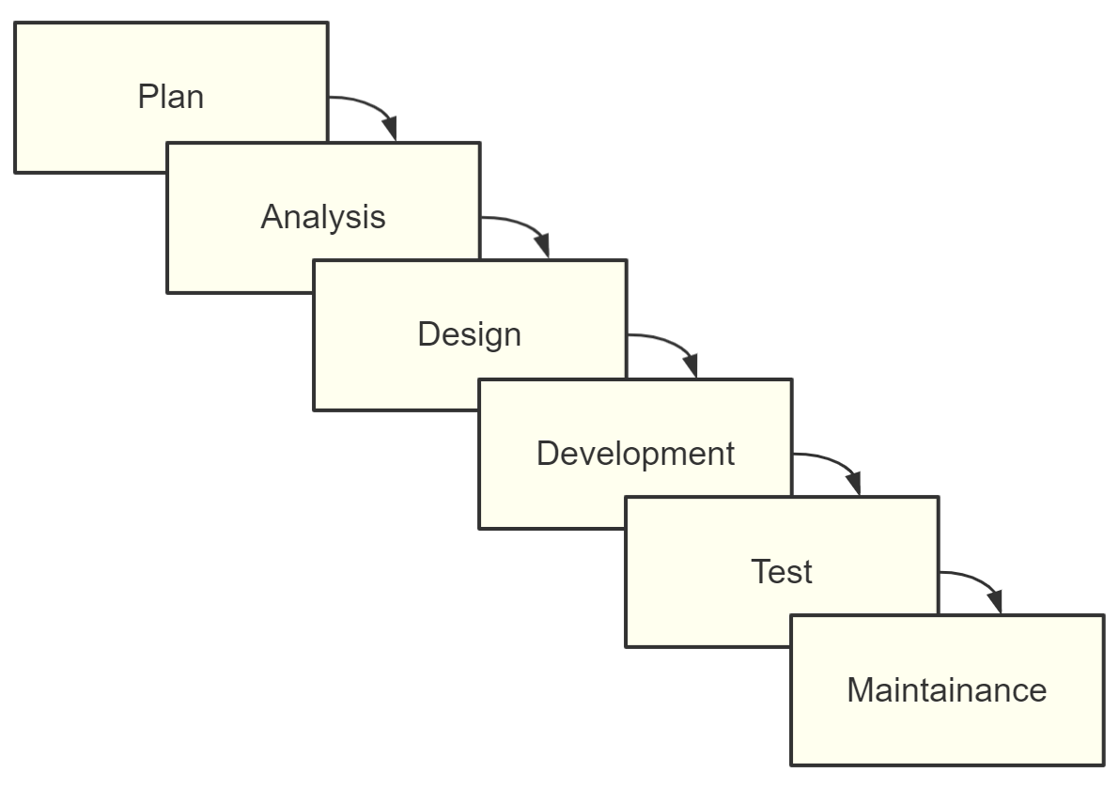
Figure 2.1 Waterfall Model
(Source: compiled by the author based on [30])
The waterfall model emphasizes adequate planning and requirements analysis in the early stages of a project to ensure that subsequent development work can proceed smoothly. In the waterfall model, each stage must be completed before entering the next stage, and the output of the previous stage serves as the input of the next stage [30,p.95]. This sequential development method helps reduce project risks because a rigorous review is conducted before the end of each stage to ensure the quality of the work in that stage and that the expected goals are met.
Among the various stages of the waterfall model, planning is the starting point of the project, which involves planning and budgeting the entire project. The requirements analysis stage focuses on collecting and analyzing user requirements to ensure that the software can meet user expectations. The software design stage designs the overall architecture of the software and the functions of each module based on the results of the requirements analysis. The program writing stage is the process of converting the design into actual code. The software testing stage tests the written code to ensure the quality and stability of the software. Finally, the operation and maintenance stage focuses on the operation and maintenance of the software to ensure that the software can run stably and for a long time.
A notable feature of the waterfall model is the emphasis on stage review of the process. At the end of each stage, a strict review is conducted to ensure the quality of the work in that stage and to meet the expected goals. The review results will have an impact on the work of the next stage. If problems are found, they need to be adjusted and corrected in a timely manner. Stage reviews are usually jointly participated by the project team, users and other stakeholders to ensure the fairness and effectiveness of the review. Take an e-commerce platform as an example.
Suppose the platform decides to adopt the waterfall model for software development. In the planning stage, the project team needs to plan the development cycle, budget, and personnel division of the entire project. In the demand analysis stage, the project team needs to fully communicate with users to understand their needs and expectations for the e-commerce platform, such as product display, shopping cart, order management and other functions. In the software design stage, the project team needs to design the overall architecture of the e-commerce platform and the functions of each module, such as front-end and back-end separation, database design, etc. In the program writing stage, the project team needs to convert the design into actual code to implement the various functions of the e-commerce platform. In the software testing stage, the project team needs to test the written code to ensure the quality and stability of the e-commerce platform, such as performance testing and security testing. Finally, during the operation and maintenance phase, the project team needs to focus on the operation and maintenance of the e-commerce platform to ensure that the platform can operate stably in the long term and handle user feedback in a timely manner.
In the waterfall model, emphasis on document management is also one of its characteristics. At the end of each stage, the project team needs to output the corresponding documents for review and later maintenance. These documents include project plans, requirements specifications, design documents, user manuals, etc. These documents are of great significance for ensuring project quality and reducing the risk of later modifications. For example, the requirements specification can help the project team and users clarify the requirements and reduce the risk of later requirements changes; the design document can help developers understand the system architecture and module functions and improve development efficiency; the user manual can help users better use the e-commerce platform and improve user satisfaction.
Of course, the waterfall model also has some limitations [29, p.39-41]. For example, the waterfall model overemphasizes the sequential nature of the project. This means that each stage of the project must be carried out in a fixed order, and the completion of the previous stage is a prerequisite for the start of the next stage. Although this strict sequential nature helps to ensure the stability and controllability of the project, it may also lead to a longer project cycle.
For example, in a software development project, if problems arise in the requirements analysis phase, resulting in frequent changes in requirements, then according to the sequential nature of the waterfall model, these changes must wait until the requirements analysis phase is completed and reviewed before they can be passed to the next stage. This not only increases the uncertainty of the project, but may also lead to a longer project cycle.
In terms of scope of application, the waterfall model is mainly applicable to scenarios where demand is stable, the project size is moderate, and the development team is relatively experienced. In these cases, the waterfall model can effectively ensure the stability and controllability of the project and reduce project risks. However, for projects with frequent demand changes, large project sizes, or inexperienced development teams, the waterfall model may not be well adapted.
2.Rapid Prototyping Model
The rapid prototyping model is a software development method that focuses on rapid prototype creation and meets customer needs by accepting continuous customer feedback and optimization. It focuses on customer needs and meets customer expectations by quickly creating and iterating prototypes, making the product closer to actual needs [29, p.39-41]. The core of this model is to emphasize user-centeredness, attach importance to practical operations, and minimize unnecessary documentation. It breaks the shackles of traditional software development methods and injects new vitality and innovation into modern software development.
In the rapid prototyping model, the product designers of the project team will first build a simple prototype, which can be a simple interface, a basic functional module, or a preliminary solution. Afterwards, the project team will have in-depth communication and exchanges with the customer to receive feedback and suggestions from the customer.
Based on the customer's feedback, the project team will improve and optimize the prototype to make it more in line with the customer's needs and expectations. This process is repeated until the customer is satisfied with the prototype. Once the prototype is approved by the customer, the project team will carry out detailed development work based on the prototype to gradually improve the product's functions and performance (fig.2.2).
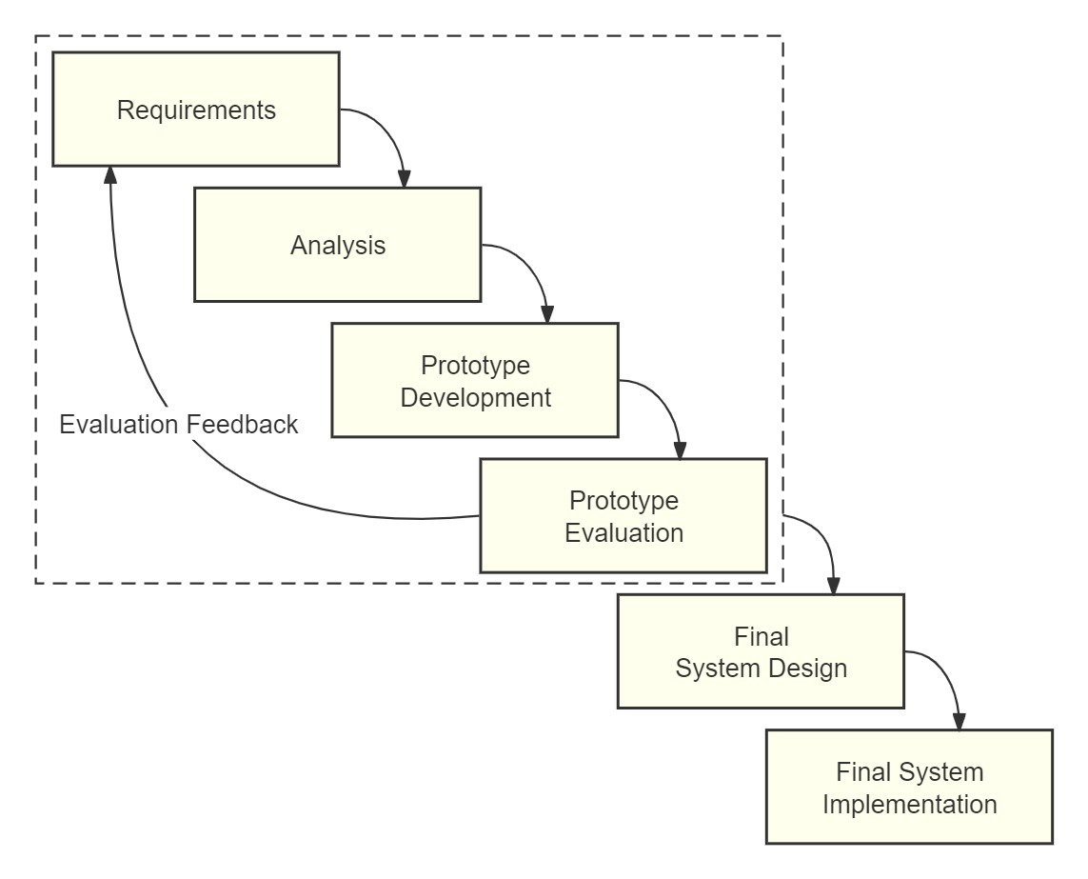
Figure 2.2 Rapid Prototyping Model
(Source: compiled by the author based on [29],[31])

The rapid prototyping model is characterized by its ability to effectively avoid the defects of the waterfall model and reduce the development risks caused by unclear software requirements. It is suitable for software system development projects where requirements cannot be accurately defined at the beginning of the project [31]. First, it emphasizes confirmation and feedback. Through continuous confirmation and feedback, potential problems can be discovered and solved in a timely manner to ensure that the product better meets customer needs. This confirmation and feedback method not only improves the flexibility and adaptability of the project, but also enables the project team to have a deeper understanding of customer needs and expectations. Second, the rapid prototyping model reduces project risks. In traditional software development methods, projects often discover potential problems and risks in the late stages of development, leading to project failure or delayed delivery. The rapid prototyping model allows multiple tests and adjustments to be conducted at the beginning of the project, thereby discovering and solving problems in a timely manner and reducing potential risks. In addition, the rapid prototyping model also increases customer participation. Customers are always involved in the project development process, guiding and adjusting the product in real time. This close cooperation method not only helps to ensure that the products developed by the project team truly meet customer needs, but also enhances customer trust and satisfaction with the project. Finally, the rapid prototyping model can also help save costs and time. By quickly creating and optimizing prototypes, project teams can avoid lengthy and complex development processes, reducing unnecessary development costs and time costs.
However, the rapid prototyping model also has some disadvantages and challenges. First, it requires high team capabilities. The project team needs to have high agile development capabilities and collaboration capabilities to cope with various challenges during the project process. If the team capabilities are insufficient, it may lead to slow project progress or quality problems. Second, the rapid prototyping model may increase project uncertainty [29, p.43-44]. Due to the need for continuous iteration and adjustment, the uncertainty of project schedule and cost may increase. This is a challenge for project management and control, and requires the project team to have high risk management and response capabilities. In addition, if the project team makes too many improvements and optimizations in the rapid prototyping model, it may lead to an increase in development costs. Therefore, the project team needs to strike a balance between meeting customer needs and controlling costs to avoid over-development or under-development.
In terms of scope of application, the rapid prototyping model is suitable for projects with uncertain requirements, projects that pursue innovation, time-sensitive projects, and projects that require a high degree of customization. For example, when developing a new social media application, due to the high uncertainty of market demand and user behavior, the rapid prototyping model can quickly build and iterate product prototypes, discover and solve problems in a timely manner, thereby meeting user needs and improving product competitiveness. For projects with stable requirements, limited budgets, or high requirements for stability, the rapid prototyping model may not be suitable. For example, when developing a core banking business system, due to the complex business logic and extremely high requirements for stability, the traditional waterfall model may be more appropriate.
3.Agile development model
The agile development model is a software development method that is people-centric, iterative, adaptive, and quick to respond to changes [32]. In the agile development model, projects are divided into multiple short iteration cycles, each of which includes complete stages such as development, testing, and optimization [33]. This cyclical iteration method enables the project team to respond to changes and solve problems more quickly. At the end of each iteration cycle, the team will adjust and optimize the product based on customer feedback and then enter the next iteration cycle. This continuous iterative process enables the product to continuously move towards a more perfect goal (fig.2.3).
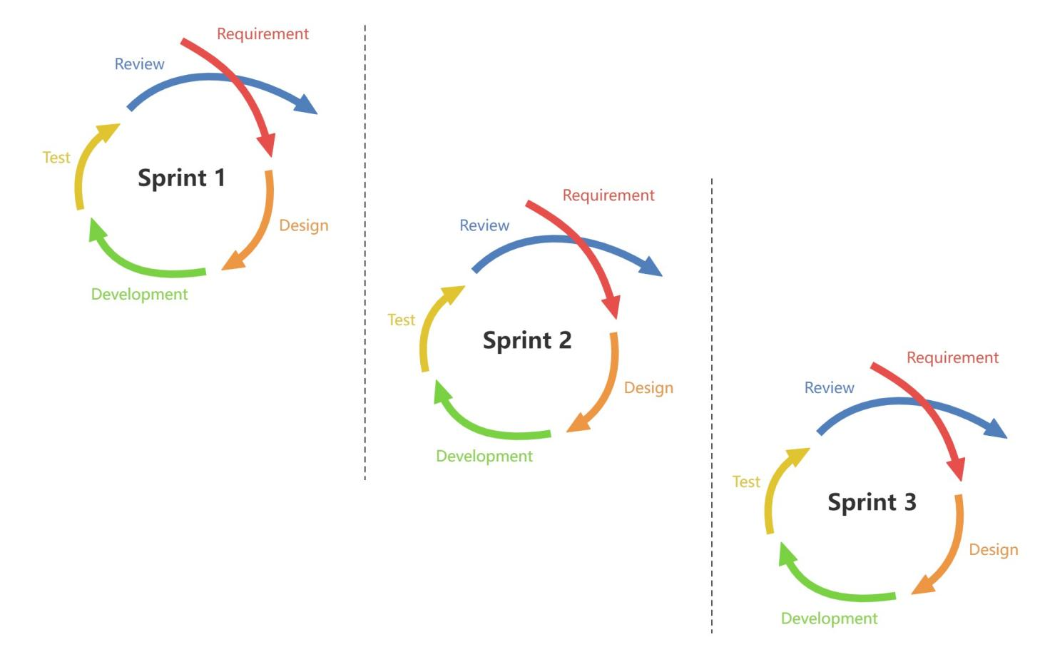
Figure 2.3 Agile Development Model
(Source: compiled by the author based on [32],[33])
The agile development model emphasizes teamwork, flexibility, and continuous delivery to meet the ever-changing needs and expectations of customers. In the agile development model, the project team can be divided into multiple groups, each of which is responsible for a short-term iteration cycle. At the end of each iteration cycle, the team will adjust and optimize the product based on customer feedback, and then enter the next iteration cycle. Through continuous iteration, the product is gradually improved to meet the ever-changing needs and expectations of customers.
The core idea of the agile development model is to construct customer needs into user stories and gradually improve the product based on the previous iteration [34]. Through user stories, the team can clearly understand customer needs and expectations, thereby ensuring that each iteration cycle moves towards achieving the final product goal. This approach not only improves product quality and satisfaction, but also enhances customer trust and participation in the project.
The advantages of the agile development model are that it has continuous delivery, the ability to quickly respond to changes in requirements, improve team collaboration and communication capabilities, reduce project risks, and increase customer participation [35]. First, the agile development model can quickly adapt to changes in requirements, thereby increasing the success rate of the project. In a rapidly changing market environment, changes in requirements are inevitable. The agile development model enables the team to quickly respond to these changes through iterative development and continuous delivery, thereby ensuring the smooth progress of the project. Secondly, the agile development model emphasizes team self-management and collaboration, which is conducive to improving the communication efficiency and collaborative spirit of team members. In an agile team, communication between members is frequent and effective. This communication method not only helps team members understand each other's work progress and difficulties, but also promotes cooperation and coordination among team members. Furthermore, the agile development model, through short-term iterations and continuous delivery, is conducive to timely discovery and resolution of problems, thereby ensuring the stability and sustainability of the project. Finally, the agile development model requires customers to actively participate and provide feedback, which helps to ensure that the project team better understands customer needs, thereby improving product quality and satisfaction.
Of course, any model has its limitations. The agile development model has disadvantages such as lack of predictability, high dependence on the team and customers, and increased costs [36]. First, due to the emphasis on flexibility and iteration, the project plan may not be detailed and accurate enough. In agile development, project plans are often adjusted dynamically, which may lead to team members lacking a clear understanding of the overall progress and goals of the project. Second, the agile development model has high requirements for team quality. Team members need to have high self-management capabilities and a spirit of collaboration, otherwise it may affect the implementation of the project. In addition, due to the emphasis on flexibility and iteration, there may be greater uncertainty in project costs and time. This may pose certain challenges to the project budget and schedule.
In terms of scope of application, the agile development model is suitable for scenarios where requirements change frequently, the project complexity is high, the team size is moderate, or there is a need to respond quickly to market changes. For example, agile development models are often used in areas such as Internet products, mobile applications, and software customization development. In these areas, customer requirements are often adjusted as the market changes, and project teams need to respond quickly and make corresponding adjustments. The agile development model enables teams to better cope with these challenges through iterative development and continuous delivery, thereby ensuring the successful implementation of the project. For some areas and projects, the agile development model may not be applicable. For example, for projects that require strict compliance with specifications and standards, such as aerospace, medical equipment, etc., the traditional waterfall model may be more suitable. In these areas, project requirements are relatively stable, and strict specifications and standards need to be followed to ensure product quality and safety. For smaller teams or projects, the agile development model may be too complex and cumbersome. In this case, a simplified development model may be more suitable.
4.Spiral Model
The spiral model proposed by American software engineer Barry Boehm is a software development process model that combines the iterative characteristics of rapid prototyping with the systematic features of the waterfall model. It emphasizes risk assessment and management at every stage of the project to ensure the successful implementation of the project (fig.2.4).
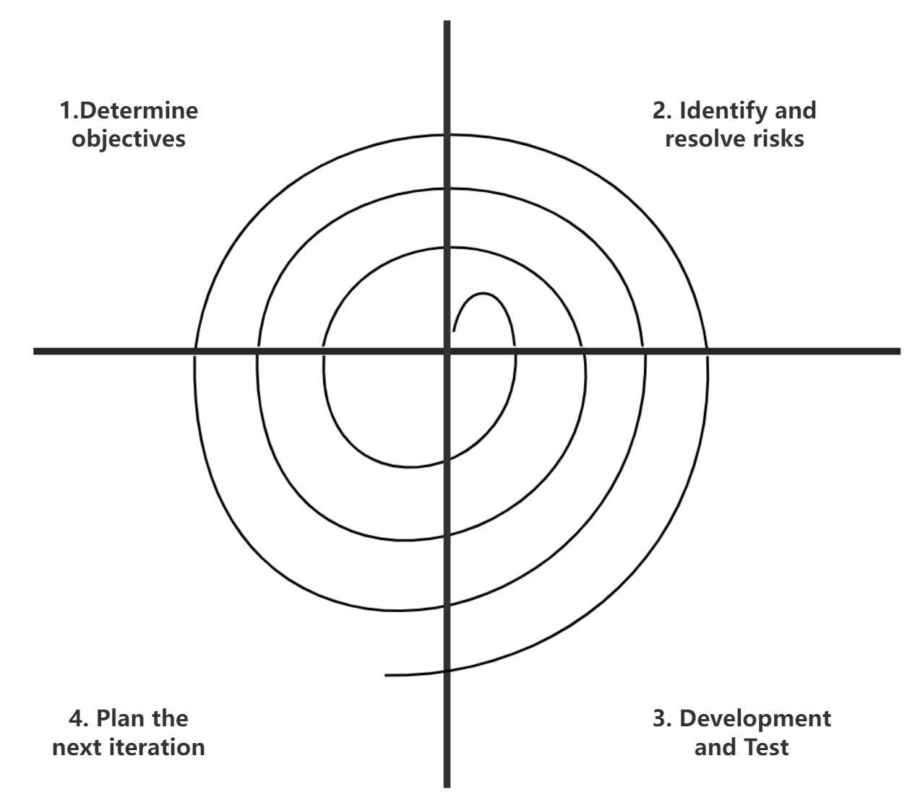
Figure 2.4 Spiral Model
(Source: compiled by the author based on [37])

In the spiral model, the advancement of the project is not a straight line, but a series of closely connected spiral cycles. Each cycle includes multiple key stages such as planning, risk assessment, development, testing and delivery. This structure ensures that the project can be fully reviewed and evaluated at each stage, so that problems can be discovered and adjusted in a timely manner.
Take the core system upgrade project of a large bank as an example. The project involves complex technology, wide scope, and far-reaching impact, so the risk is extremely high. In this context, the spiral model has become an ideal choice for project management. At the beginning of the project, the team first conducted a comprehensive risk assessment and identified multiple potential problems such as technical difficulties, data migration risks, and user acceptance. In response to these problems, the team developed detailed response strategies and gradually implemented them in the subsequent development. As the project progresses, the team will re-evaluate risks at the beginning of each spiral cycle. This approach not only ensures that the project always stays on the right track, but also allows timely adjustments when necessary. For example, in one cycle, the team found that users' acceptance of the new system was lower than expected, so they immediately adjusted the training plan and marketing strategy, and finally successfully improved user satisfaction.
Of course, the spiral model is not a panacea. Its biggest challenge lies in the high requirements for the team's risk management capabilities. A team that cannot accurately identify and assess potential risks is likely to get into trouble in the project. In addition, since risk assessment and adjustment must be carried out in each cycle, the project plan may become unstable and unpredictable. This requires the team to be sufficiently forward-looking and flexible when making plans. In addition to the high requirements for team capabilities, the spiral model may also require more time and resources for risk assessment and management. This may lead to an increase in project costs, which may become a considerable burden for some projects with limited budgets.
In terms of scope of application, the spiral model is more suitable for large, complex projects that require frequent releases and have higher risks [38]. For example, in projects that develop complex software systems, embedded systems, or involve new technologies and innovations, the spiral model can help teams better manage risks and ensure the successful implementation of the project. However, for small, simple, or low-risk projects, the spiral model may be too complex and cumbersome

2.3 Problems and risks of IT project management

The process of IT project management is like a ship sailing on the sea. It is difficult to avoid various waves and reefs. IT project management faces unique challenges that are different from traditional project management. These problems and risks may hinder the success and efficiency of the project. Common problems are mainly reflected in scope creep, insufficient risk management, resource allocation problems, and communication barriers [39, p.13], [39, p.174-175].
1.The scope has spread
Scope creep is the uncontrolled expansion or change of project scope without corresponding adjustments in time, resources, or budget [12, p.293] Scope creep is one of the most pervasive problems in project management and can quietly derail projects, leading to cost overruns, schedule delays, and reduced project quality [39, p.241]
There are many reasons for scope creep, some of the main ones include:
- Unclear project goals: If the project goals are not clearly defined and quantified, it may lead to unclear scope boundaries. Project team members and stakeholders may have different understandings of project expectations and deliverables, which may lead to scope expansion.
- Continuous input from stakeholders: Project stakeholders or customers may continuously propose new requirements or change existing requirements during the project execution. Without an effective change control process, these changes may gradually expand the scope of the project.
- Lack of initial requirements gathering: In the project kick-off phase, if the requirements analysis is inadequate or key information is omitted, it may lead to incomplete scope definition. As the project progresses, these omitted requirements may be re-proposed, leading to scope creep.
- Inadequate change control process: Without a strong change control process to manage changes to the project scope, scope creep can occur. Change requests should be evaluated, approved, and executed to ensure they do not adversely affect the project.
The risks of scope creep are huge. Once the scope of a project gets out of control, it is difficult to get it back on track, and it often leads to waste of resources and project failure. These risks include:
- Budget overruns: As the scope of a project grows, the originally allocated budget may not be sufficient to cover the additional tasks and activities. This may require additional funds to support the project, resulting in budget overruns.
- Project Delays: Scope creep can cause project timelines to lengthen. The added tasks and activities can prevent the project team from completing their work on time, leading to missed critical deadlines and contractual obligations.
- Resource strain: Scope creep may increase the human resources, supplies, and technical support required for the project. This may overwhelm available resources, leading to decreased team morale and reduced efficiency.
- Quality compromise: As the project team needs to split its attention to cope with the ever-increasing scope of tasks, the overall quality of the project deliverables may be affected. This may damage the reputation of the project and the satisfaction of the client.
In order to avoid scope creep, a series of measures can be taken to ensure the smooth progress of the project. The measures that can be taken are mainly:
- Clear Scope Document: During the project initiation phase, develop a comprehensive and clear project scope document. This document should describe the project's objectives, deliverables, work breakdown structure, and exclusions in detail. The scope document should be approved by all key stakeholders and serve as a baseline for project execution.
- Stakeholder Engagement: Communicate and engage with stakeholders regularly to align their expectations with the progress and constraints of the project. Establish clear communication channels and feedback loops to respond to stakeholder needs and change requests in a timely manner.
- Change Control Process: Establish a formal change control process that requires all change requests to be documented, analyzed, and approved. This process should assess the impact of changes on project resources, budget, and schedule, and ensure compliance with the overall goals and strategy of the project.
- Regular Reviews: Conduct regular project reviews and scope audits to ensure that the project work is aligned with the initial goals and deliverables. This helps to detect signs of scope creep early and adjust the project direction in a timely manner.
- Education and Training: Educate and train the project team and stakeholders to understand the impact and consequences of scope creep. By increasing the level of knowledge of project management fundamentals, a shared understanding of project constraints and responsibilities can be fostered, thereby reducing the risk of scope creep.
2.Inadequate risk management
Inadequate risk management is an often overlooked but extremely important aspect of IT projects. When risk management is inadequate, projects may face unforeseen challenges and difficulties that could have been avoided or mitigated with proper planning and management. Risk management plays a vital role in IT projects, involving multiple aspects such as project stability, time, cost and quality. The main reasons for inadequate risk management include lack of risk identification, poor risk assessment, lack of risk response plans and insufficient monitoring and control.
- Lack of risk identification: The purpose of risk identification is to identify and determine risk factors that may have an adverse impact on the project [12,p.436-437]. In practice, many organizations or teams may skip or perform the risk identification process superficially, resulting in some major threats being overlooked.
- Poor risk assessment: Risk assessment is the process of quantitatively and qualitatively analyzing identified risks in order to understand their potential impact and likelihood and to provide a basis for prioritization. If risk assessment is poor, it may lead to an inadequate understanding of the risks, resulting in ineffective prioritization.
- Lack of Risk Response Plan: Risk response plan is the strategy and measures developed to deal with the identified risks. Without clear strategies to deal with these risks, the project is vulnerable to these risks.
- Inadequate monitoring and control: Monitoring and control is the process of continuously monitoring risks and mitigation strategies to ensure the effectiveness of the risk management process. Failure to continuously monitor the effectiveness of risks and mitigation strategies can cause risks to become a problem.
The consequences of inadequate risk management can be severe, affecting all aspects of the project, including schedule, cost, scope, and satisfaction [40, p.425-428].
- Project Delays: Unaddressed risks can cause significant disruptions, leading to delays beyond the planned schedule.
- Cost overruns: Unexpected problems arising from unmanaged risks often require additional resources to resolve, resulting in budget overruns.
- Scope creep: Risks associated with poor scope management or customer requirements can evolve uncontrollably without a risk mitigation plan.
- Stakeholder dissatisfaction: Failure to effectively manage risks can lead to unfulfilled expectations and dissatisfaction among customers and stakeholders.
To improve the effectiveness of IT project risk management, a number of proactive strategies can be implemented:
- Systematic Risk Identification: Conduct thorough risk identification sessions during the project planning phase and periodically throughout the project. Utilize techniques such as brainstorming, SWOT analysis, and expert judgement to ensure comprehensive risk coverage.
- Detailed Risk Analysis: After identifying the risks, a detailed analysis is performed to determine their likelihood and potential impact. This analysis helps in prioritizing the risks based on their severity.
- Proactive risk response plan: Develop and implement a strategy for each identified risk. Common responses include risk avoidance, mitigation, transfer, or acceptance. The plan should also specify who is responsible for managing each risk.
- Continuous Monitoring and Review: Establish a routine to monitor risk status and effectiveness of mitigation measures. Review and update the risk management plan regularly to reflect new risks and changes in project dynamics.
- Stakeholder Engagement: Involve stakeholders in the risk management process by communicating potential risks and their impacts. Their participation can provide additional insights, facilitate faster decision making, and increase support for risk management activities.
3.Resource allocation problem
Resource allocation involves the efficient allocation of available resources, such as time, money, equipment, and personnel, across the various tasks and phases of an IT project. Resource allocation problems can arise from poor planning, insufficient understanding of project requirements, or unexpected project changes, which can severely impact project efficiency, leading to delays, reduced quality, and budget overruns . [41]
of resource allocation problems include inaccurate project estimates, lack of resource visibility , poor scheduling , and failure to adapt to project changes [12,p.380-411].
- Inaccurate project estimates: Estimating project requirements without a thorough understanding can lead to scarce or excessive resources.
- Lack of resource visibility: Not having a clear understanding of available resources and their current engagement can complicate allocation decisions.
- Improper Scheduling: Overlapping schedules and conflicting resource requirements can cause bottlenecks that delay project progress.
- Failure to adapt to project changes: Lack of flexibility in reallocating resources in response to project changes or unexpected challenges leads to inefficiencies.
Improper resource allocation can bring multiple risks to the project:
- Delays in project delivery: Inadequate or misallocated resources can slow down project progress and cause significant delays.
- Decreased productivity: Resources being spread too thin or assigned to inappropriate tasks can lead to decreased efficiency and low morale among team members.
- Increased costs: Misallocation often requires additional expenditures, either hiring more resources or paying overtime, which negatively impacts the project budget.
- Quality Compromise: Limited resources may lead to rushed work and cutting corners, thus compromising the overall quality of the project.
To address these risks and improve resource allocation, a number of effective strategies can be adopted:
- Detailed resource planning: Develop a comprehensive resource plan that is consistent with the detailed project schedule. The plan should include not only the allocation of human resources, but also the allocation of tools, equipment, and financial resources.
- Use resource management tools: Implement tools that provide visibility into resource availability, skills, and utilization. These tools help make informed decisions and adjust allocations as needed.
- Regular Resource Reviews: Review resource allocations frequently as the project progresses to ensure that resources are being used effectively and to adjust for any changes in project scope or timeline.
- Flexible resource allocation: Keep resource allocation flexible to quickly adapt to project changes or unexpected issues. This includes developing contingency plans for key resources and cross-training team members to handle multiple roles.
- Stakeholder Communication: Keep all stakeholders informed of resource status and constraints. Regular updates can help manage expectations and facilitate discussions about priority setting, which is critical when resources are limited.
4.Communication barriers
barriers occur when important information cannot be shared between project stakeholders. If communication barriers are not addressed in a timely manner, they can lead to inconsistent project goals, misunderstanding of requirements, and overall inefficiency of the project. In serious cases, they can lead to the failure of the entire project [40, p.390-418].
Causes of communication barriers include cultural and knowledge barriers , lack of a structured communication plan , inadequate communication tools , and information silos .
- Cultural and knowledge barriers: Projects involving teams from different cultural or knowledge backgrounds may face difficulties in clear communication.
- Lack of a structured communication plan: Lack of a clear communication strategy detailing what, when, how and with whom to communicate.
- Inadequate communication tools: Relying on outdated or inefficient tools that fail to meet the communication needs of the team.
- Information silos: occur when information is limited to certain groups or individuals, creating knowledge gaps throughout the project.
Communication breakdowns can severely impact several aspects of a project:
- Misunderstandings and errors: Miscommunication can lead to incorrect implementation and costly rework.
- Decreased team morale: Lack of clear communication can lead to frustration and disengagement among team members.
- Unsatisfied stakeholders: Inadequate communication with stakeholders can lead to unmet expectations and loss of trust.
- Project Delays: Failure of important information to reach the right people at the right time can lead to delays in project milestones.
Effective strategies for preventing communication breakdowns include:
- Develop a communication plan: Create a comprehensive communication plan that outlines communication requirements, channels, frequency, and responsible parties. This plan should be incorporated into the overall project plan and shared with all stakeholders.
- Leverage modern communication tools: Leverage modern tools that facilitate efficient communication, such as project management software, instant messaging applications, and video conferencing tools. These tools should support real-time collaboration and ensure that information is accessible to all stakeholders.
- Regular meetings and updates: Schedule regular meetings to discuss project updates, challenges, and next steps. These meetings should include all relevant stakeholders whenever possible to ensure everyone is on the same page.
- Encourage open communication: Create an environment where team members feel comfortable sharing ideas and feedback. This can be facilitated through regular one-on-one check-ins and an open-door policy.

CHAPTER 3

PROVIDING AN IT PROJECT MANAGEMENT SYSTEM BASED ON INNOVATIVE TOOLS

3.1 Innovative tools (CASE technologies)

CASE (Computer-Aided Software Engineering) technology is a method that uses computer technology and tools to assist software development [42]. CASE technology covers all stages of software development, including requirements analysis, design, coding, testing, and maintenance, and aims to improve development efficiency, reduce development costs, and improve software quality [43]. In IT project management systems, the introduction of CASE technology can assist project managers in better project management and improve the efficiency and quality of project development.
1. Project management tools
Project management tools such as Microsoft Excel , Microsoft Project, and Zentao can help project managers develop project plans, allocate resources, track project progress, and manage project budgets to ensure the achievement of project goals.
Microsoft Excel is a versatile spreadsheet application that can be used for many business tasks, including statistics, finance, data management forecasting, analysis, inventory, billing, and business intelligence [44]. Although not originally designed as a project management tool, it is widely used to manage projects, and its flexibility allows it to be customized to track tasks, manage calendars, and perform budget analysis. Its main features include:
- Spreadsheets: Provides a grid-like structure that is ideal for organizing information, performing calculations, and managing data.
- Data Analysis Tools: Advanced data analysis features such as pivot tables, conditional formatting, and complex math functions.
- Visualization: Tools for creating a variety of charts and graphs that help visualize data and trends during the project lifecycle.
With Microsoft Excel, project managers can manually create to-do lists, Gantt charts, and track project milestones for task tracking and planning. At the same time, the financial calculation and reporting functions it provides can help project managers and financial teams understand project costs, budget execution, and revenue forecasts in real time to ensure the financial stability of the project.
Microsoft Project is a project management software designed for project managers to control and manage complex projects. It aims to assist project managers in making schedules, allocating resources to tasks, tracking progress, managing budgets, and analyzing workloads [45]. It has the following features:
- Gantt chart: A visual timeline showing project tasks and their duration, helping managers plan and schedule tasks efficiently.
- Resource Management: Tools for assigning resources to tasks, managing resource allocation, and visualizing how resources are used.
- Reporting: Advanced reporting capabilities allow detailed reports to be created to track progress and share with stakeholders.
- Integration: Seamless integration with other Microsoft Office applications for enhanced functionality and ease of use.
Whether it is complex project scheduling, resource allocation or budget management, Microsoft Project
Both can provide strong support for project managers. By utilizing its powerful project planning tools, project managers can develop detailed project plans, ensure that each task has a clear start and end time, and that resources are reasonably allocated.
Zentao is an open source full-lifecycle project management software designed based on agile and CMMI management concepts. It integrates product management, project management, quality management, document management, organizational management, and transaction management, and fully covers the core processes of project management [46]. By supporting Scrum practices and agile methodologies, Zentao provides teams with powerful agile project management capabilities, making it an ideal choice for managing software development projects. Product and sprint planning functions help teams achieve detailed planning through story management and task decomposition to ensure the smooth progress of projects. At the same time, the integrated bug tracking system enables teams to efficiently record, track, and solve problems in the development process. In addition, Zentao also provides comprehensive document management functions, including document storage, sharing, and version control, which promotes effective knowledge management and team collaboration. Whether it is tracking progress in software development projects, managing to-do items, or maintaining seamless communication and information sharing in team collaboration, Zentao can provide strong support for teams, enabling them to better cope with the challenges of agile development.
2. Drawing tools
Diagramming tools are used to create data flow diagrams, entity relationship diagrams, and other graphical representations that aid in the planning and analysis phases of software development. Microsoft Visio and Process On are popular diagramming tools that are widely used in IT project management to visualize, create, and document complex processes, systems, and data flows.
Microsoft Visio is a diagramming application that is part of the Microsoft Office family. It provides a wide range of drawing tools, templates, and shapes for creating professional diagrams, including flowcharts, organizational charts, network diagrams, business processes, database models, etc. It is well integrated with other Microsoft products, enhancing its usefulness in environments that rely on Office applications [47].
Visio is characterized by its wide selection of templates and shapes to meet the needs of different disciplines. In addition, it supports teamwork, allowing multiple team members to work on diagrams at the same time, improving work efficiency. Through the data link function, users can directly connect diagram shapes to data sources such as Excel, SQL databases, or SharePoint lists to achieve real-time visualization of data. Visio is particularly widely used in IT project management. Project managers can use it to create network diagrams and visualize network layouts, which helps with network planning and troubleshooting. Database architects can use Visio to design database architectures and visualize the relationships between database entities to optimize database design and implementation.
Process On is a web-based collaborative drawing tool that allows users to create, store, and share business diagrams. It can be used for drawing a variety of graphics, such as prototype diagrams and network topology diagrams [48]. Its main features are:
- Fully online: It can be accessed from any device that can access the Internet and does not require any software to be installed, alleviating the user's trouble of installing software.
- Collaborative design: Supports real-time collaboration, allowing multiple users to work on diagrams online at the same time.
- Chart Type Library: Provides a variety of chart templates and shapes to suit different industries and use cases.
Process On is widely used in IT project management. By creating wireframes and user flow diagrams, prototype designers can ensure the user-friendliness of the product; project managers can use Process On to create project timelines and Gantt charts to visualize and effectively manage project progress; project teams can use Process On to create decision trees and SWOT analysis diagrams to visualize different options and their potential impacts, helping the team make wise decisions.
3. Prototyping tools
Axure RP and Modao are two widely used prototyping tools that play a vital role in the design and development phase of IT project management.
Axure RP is a prototyping tool designed for complex projects. It helps users create high-fidelity wireframes and prototypes for applications and web services by providing core features such as dynamic content, collaboration, documentation, and integration [49]. In IT project management, Axure RP plays a vital role in user experience design, allowing UX designers to create interactive prototypes to test and refine user interfaces and interactions. These high-fidelity prototypes are essential for obtaining feedback and approval from stakeholders, ensuring that the final results are accurately visualized before the development phase begins. With Axure RP, teams can collaborate more effectively, share, and manage design files in a project, while taking advantage of automatically generated comprehensive documentation to guide development teams and stakeholders.
Modao is a web-based prototyping tool that is unique in that it perfectly combines simplicity and speed, adapting to the current fast-paced working environment. It allows teams to quickly build functional prototypes of web and mobile applications [50].
Modao is widely acclaimed for its user-friendly interface and easy-to-learn features, which allow even beginners to quickly get started. It has an extensive widget library that provides a variety of ready-to-use widgets and templates, which greatly speeds up the prototyping process. Successfully created interactive prototypes can simulate the behavior of the final product, allowing project teams and stakeholders to foresee the final form of the product at an early stage. In IT project management, it is particularly suitable for projects that require rapid iterations, allowing teams to quickly develop prototypes and iterate based on user feedback to continuously optimize products. At the same time, as a cloud-based tool, it enables team members in different locations to collaborate in real time and jointly advance the design and prototyping process of the project.
4. Code development tools
An Integrated Development Environment (IDE) is an essential tool for developers that provides a comprehensive workspace, such as Eclipse, IntelliJ IDEA, and PyCharm.
Eclipse is an open source integrated development environment (IDE). It was originally designed for Java application development, but through its unique extensible plug-in system, Eclipse has been successfully expanded to support other mainstream programming languages, making it widely used in enterprise, Web, and mobile application development. Eclipse's Rich Client Platform framework provides developers with a solid foundation for building and deploying rich client applications [51]. In IT project management, Eclipse is particularly suitable for Java-based projects. Whether it is large-scale enterprise-level applications or Android application development, Eclipse can provide strong support for development teams with its powerful framework and extensive community support.
IntelliJ IDEA, an integrated development environment (IDE) developed by JetBrains, is popular among developers for its excellent code completion and refactoring efficiency, as well as its extensive support for multiple programming languages and frameworks (especially Java) [52]. IntelliJ IDEA's intelligent code completion function provides context-aware code suggestions, greatly improving the efficiency of writing code. At the same time, its inline debugger allows developers to view source code directly in the editor and mark variable values in real time, making debugging more convenient. In addition, the IDE also integrates support for multiple version control systems, such as Git and SVN, to facilitate collaborative development by development teams. In IT project management, IntelliJ IDEA is particularly suitable for projects using a microservice architecture. Its support for Docker and Kubernetes enables developers to manage containerized applications directly from the IDE, providing great convenience for the development, deployment, and management of microservices.
PyCharm, also developed by JetBrains, is an integrated development environment (IDE) designed specifically for Python programming, suitable for data science and web development [53]. PyCharm provides a set of customized tools and functions for Python developers, especially supporting various frameworks including Django, making Python development more efficient and convenient. In addition, PyCharm also supports remote development, allowing developers to deploy and debug Python code on remote computers or virtual environments. At the same time, its integrated database tools support SQL, and the professional version is equipped with data science tools, providing comprehensive support for data science projects. In IT project management, PyCharm is widely used in Python-based data science projects, which greatly promotes the smooth progress of projects by providing data manipulation, visualization, and machine learning development functions in a single environment.
5. Quality assurance and testing tools
Quality Assurance (QA) and testing are key components of successful IT project management to ensure that the software meets its specified requirements and operates effectively in real-world scenarios. Selenium and JMeter are two popular tools that are widely used during the testing phase of software development projects.
Selenium is an open source automated testing framework designed for web applications. It supports testing across multiple browsers (such as Chrome, Firefox, Internet Explorer, and Safari) to ensure that applications perform consistently across different platforms. By using multiple programming languages such as Java, C#, and Python, testers can write scripts to automatically perform operations such as web page navigation and user input, thereby quickly verifying the functionality of the application [54]. In addition, Selenium has excellent integration and can be easily integrated with other software tools such as TestNG and JUnit to achieve test case management and report generation. At the same time, it also perfectly integrates with continuous integration tools such as Jenkins to provide powerful automation support for projects. Selenium is widely used in IT project management. It is often used to perform regression testing to ensure that new changes or enhancements do not adversely affect existing functions in complex web application projects. In addition, Selenium can also automatically check the compatibility between different browsers, greatly reducing the time and effort required for manual testing and improving testing efficiency.
Apache JMeter is an open source load testing tool designed for performance analysis of web applications. It can simulate concurrent users and impose heavy loads on servers, networks, or objects to evaluate their performance under various pressures [55]. JMeter not only supports the HTTP protocol, but also covers a variety of protocols such as FTP, SOAP, LDAP, TCP, JMS, and SMTP, making it widely applicable. In addition, its extensibility allows users to add custom plug-ins to further enhance its functionality. In IT project management, JMeter is widely used in performance testing to help teams understand how applications behave under different pressures and loads, thereby identifying possible problems and optimizing them.
There are many more tools like this, all of which play a key role in different aspects of IT project management. It is critical for project management teams to understand and choose the right tools for their project needs. Choosing the right tools can improve development efficiency, reduce errors, ensure projects are delivered on time, and meet customer needs.

3.2 Application Examples Of Innovative Tools

IT company is a professional information technology integration company that develops customized software for customers based on user needs. In 2022, it undertook a smart city management system construction project for a certain city. The construction period of the project is from January 31, 2022 to June 30, 2023, and the estimated cost is RMB 15 million ((fig.3.1).
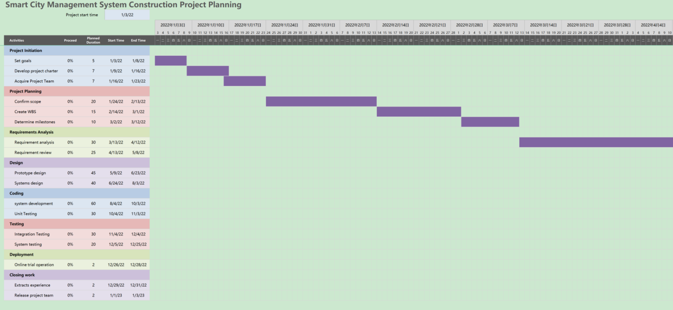
Figure 3.1 Project Implementation Plan
(Source: compiled by the author using Microsoft Excel)

The project aims to build a smart city management system, including government data collection, urban emergency management, etc. In order to ensure the smooth progress of the project, IT company adopts the waterfall model for project development. In each stage of project implementation, IT company uses a variety of innovative tools and project management theories to improve the efficiency and quality of project management.
At the beginning of the project, IT company used Microsoft Excel to develop a detailed project implementation plan and risk register (fig.3.2.).
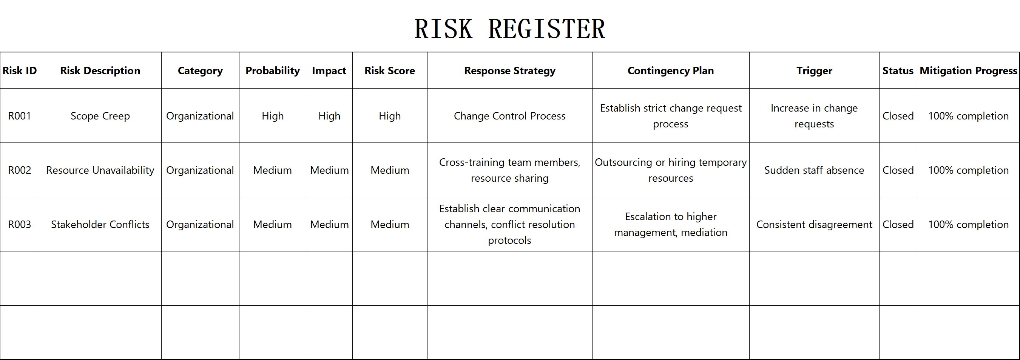
Figure 3.2 Risk Register
(Source: compiled by the author using Microsoft Excel)

At the same time, this project was entered into the ZenTao software to facilitate the tracking and management of test issues in the later stages of the project (fig.3.3).
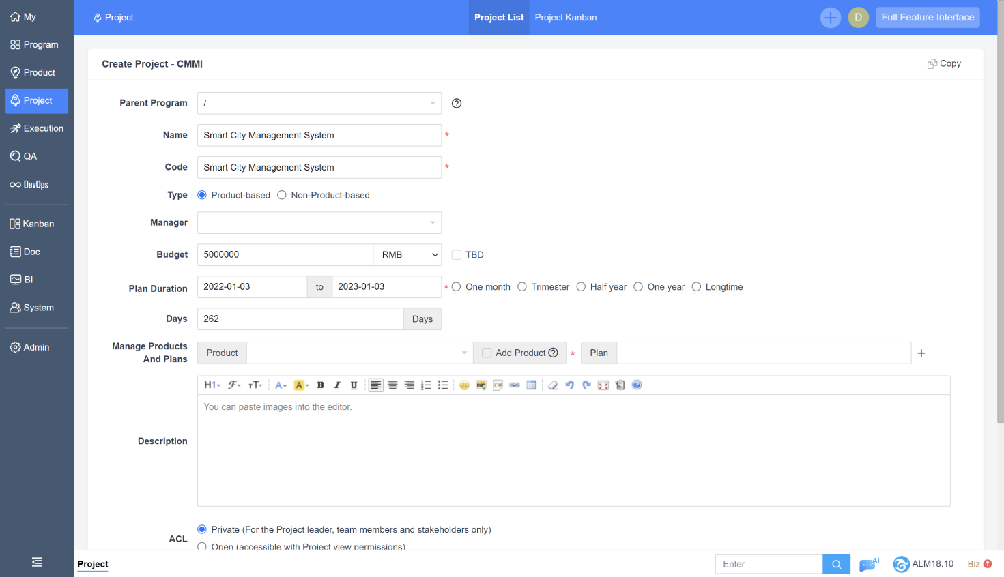
Figure 3.3 Create A New Project
(Source: compiled by the author using ZenTao Software)
During the implementation of the project, different innovative tools were used to carry out work at each stage.
1.Requirements analysis phase
During the demand analysis phase, IT company used mind mapping to help the project team collect user requirements, understand requirements more clearly, and sort out the correlations between requirements. Through mind mapping, the project team can display requirements more intuitively, facilitating communication and collaboration among team members (fig.3.4).

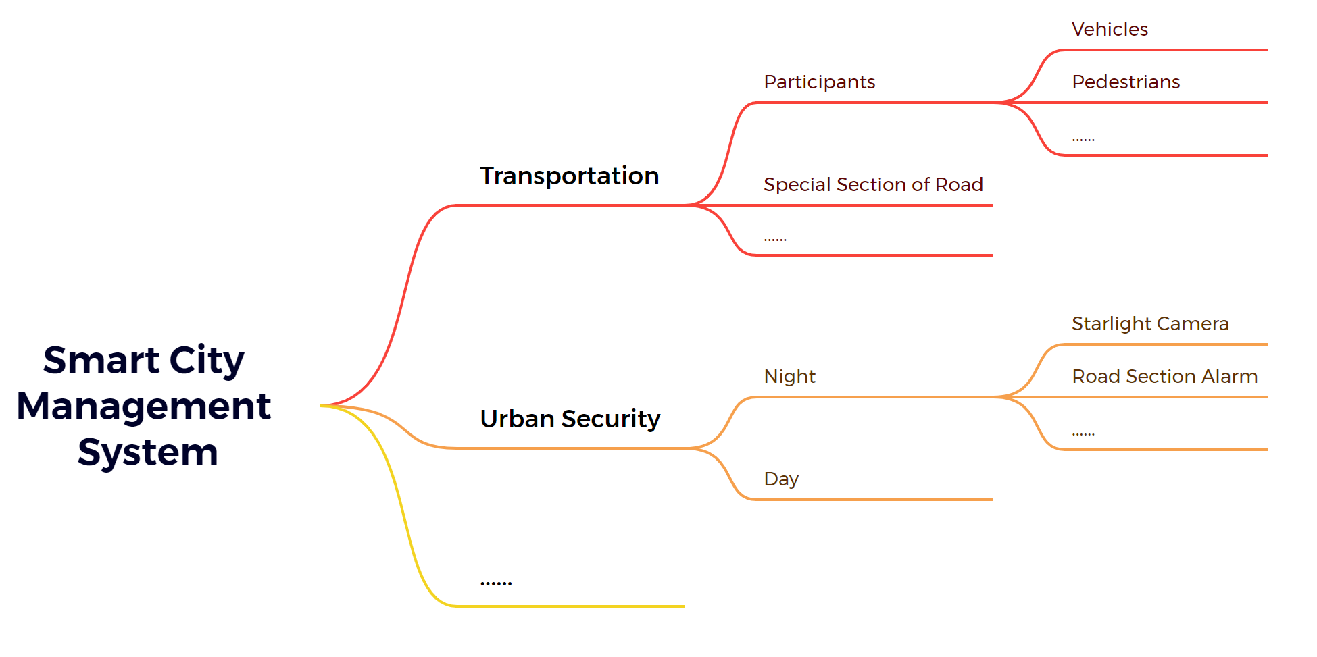
Figure 3.4 Sort And Organize Requirements
(Source: compiled by the author using XMind Software)

At the same time, IT company also used the fishbone diagram tool to analyze the requirements. For each functional point of the requirement, H represents high, M represents medium, and L represents low to find out the priority of the requirements, which improves the project team's understanding and grasp of the requirements. Through the analysis of the fishbone diagram, the team can more clearly understand the priority of the requirements, so as to reasonably allocate resources and time to ensure the smooth implementation of key functions (fig.3.5).
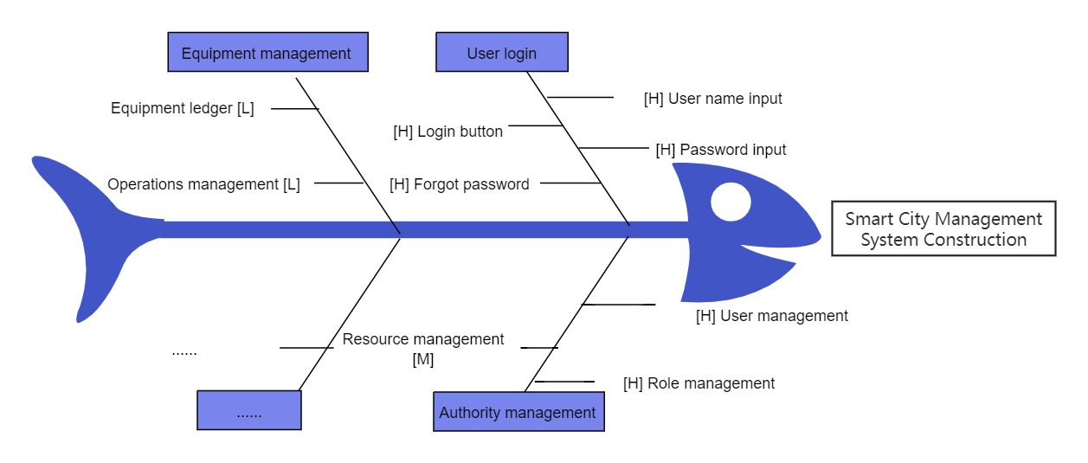
Figure 3.5 Demand Analysis By Fishbone Diagram
(Source: compiled by the author using ProcessOn Website)

2.Design phase
During the design phase, IT company also used flowchart tools to model the system's various business processes so that team members could better understand the system's operating mechanism. Through the display of flowcharts, the design team can find potential problems and improvement points, thereby optimizing the system design (fig.3.6).
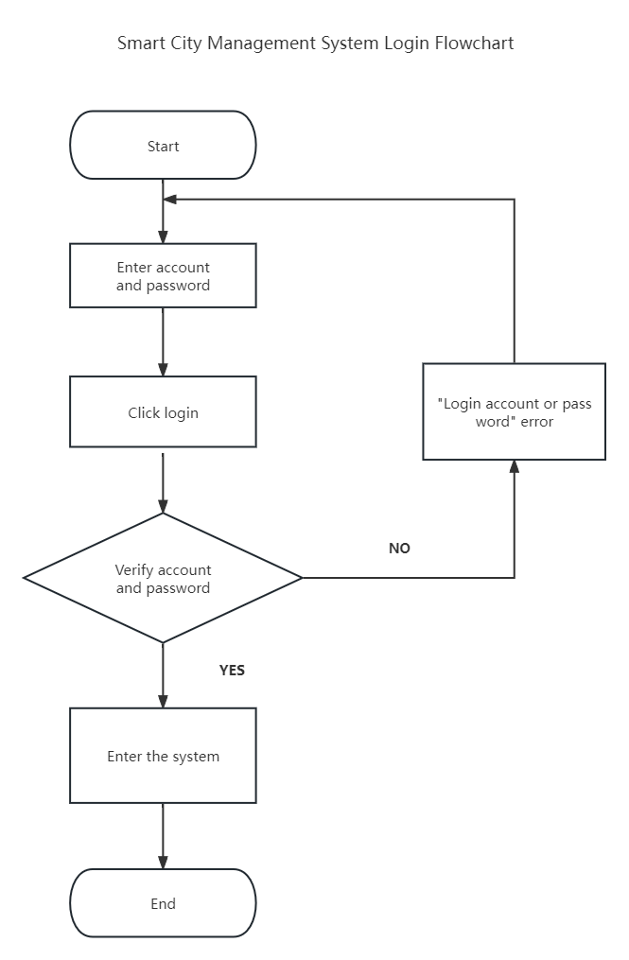
Figure 3.6 Designing System Login Process Using Flowchart
(Source: compiled by the author using Processon Website)

IT company also used Modao software to design a prototype based on the results of the demand analysis and produced a prototype of the system so that customers could better understand the system functions and interface design and improve the accuracy of demand confirmation (fig.3.7).
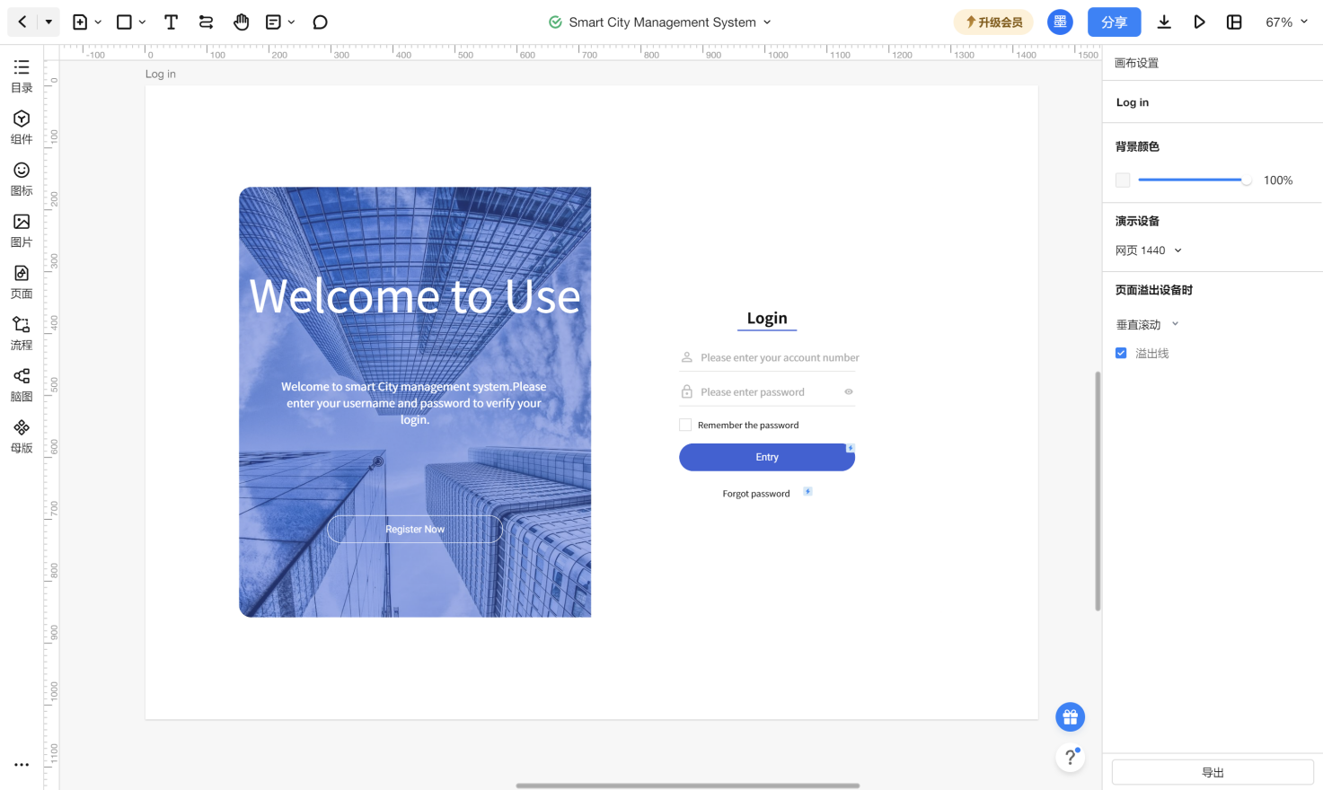
Figure 3.7 Design System Prototype
(Source: compiled by the author using Modao Software)

3.Coding phase
Based on the technical characteristics of the project, IT company chose IntelliJ IDEA integrated development tool as its main code development tool. IntelliJ IDEA has greatly improved the programming efficiency of developers with its intelligent code completion, syntax highlighting, automatic refactoring and other functions. At the same time, IntelliJ IDEA also has powerful debugging and testing functions, which helps developers quickly locate and fix code problems and ensure project quality. At the same time, in order to ensure the quality and maintainability of the code, IT company uses the Git version control system to manage the project code. Git can help the team quickly commit, merge and roll back the code to avoid code conflicts and duplication of work. At the same time, Git provides rich logs and statistical information, which makes it convenient for the team to track and analyze the code history (fig.3.8).

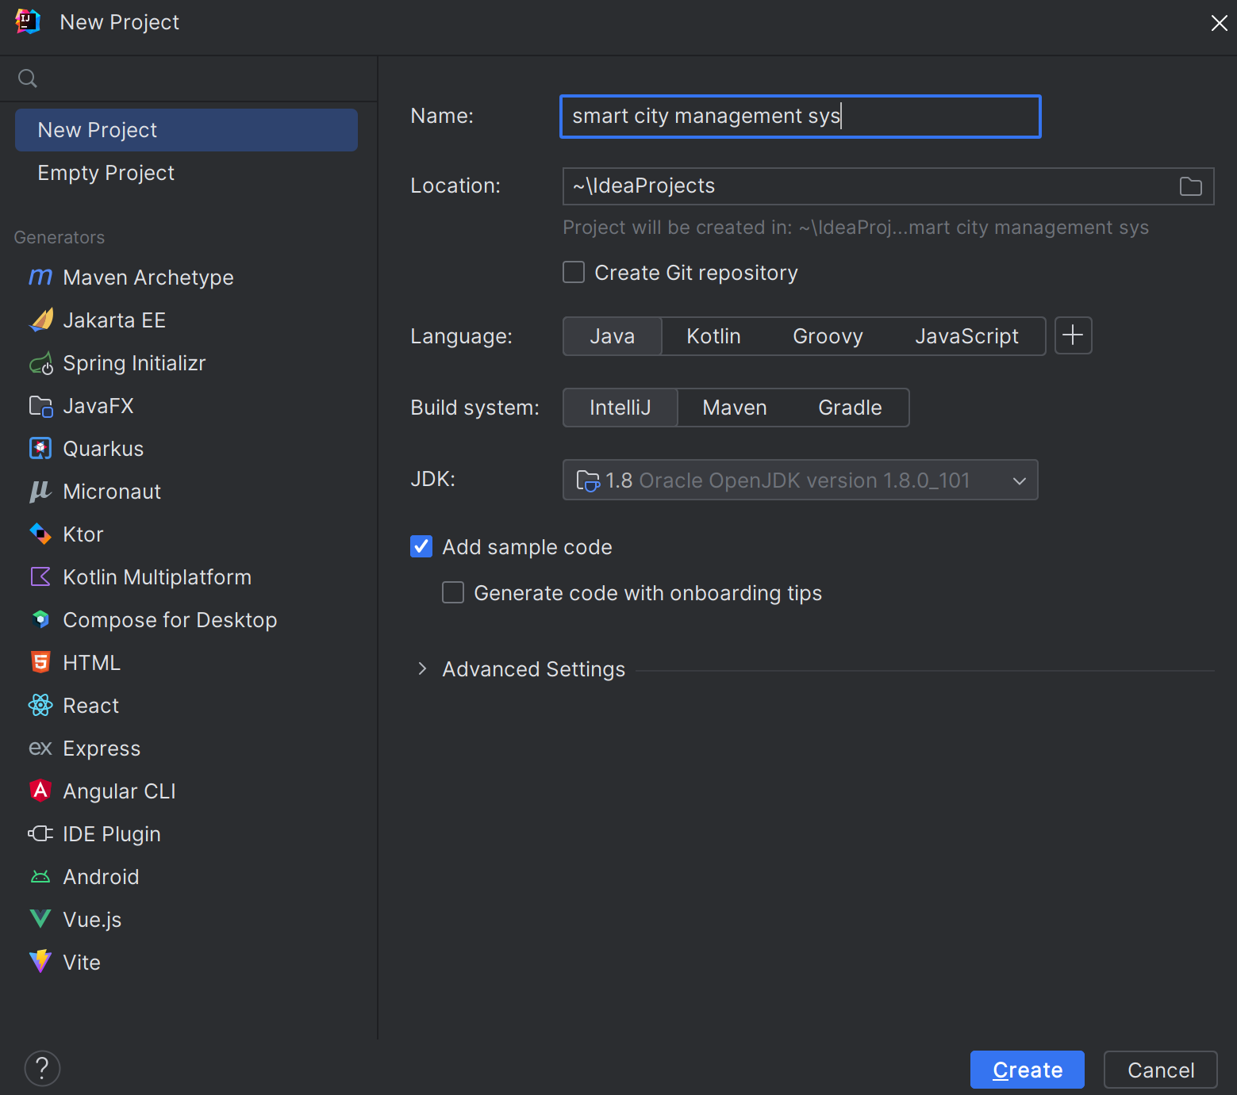
Figure 3.8 Program Development
(Source: compiled by the author using IntelliJ IDEA)

Based on the results of the design phase, testers used Microsoft Excel to write test cases, achieving full coverage of system functions and improving the comprehensiveness and accuracy of the test (fig. 3.9).

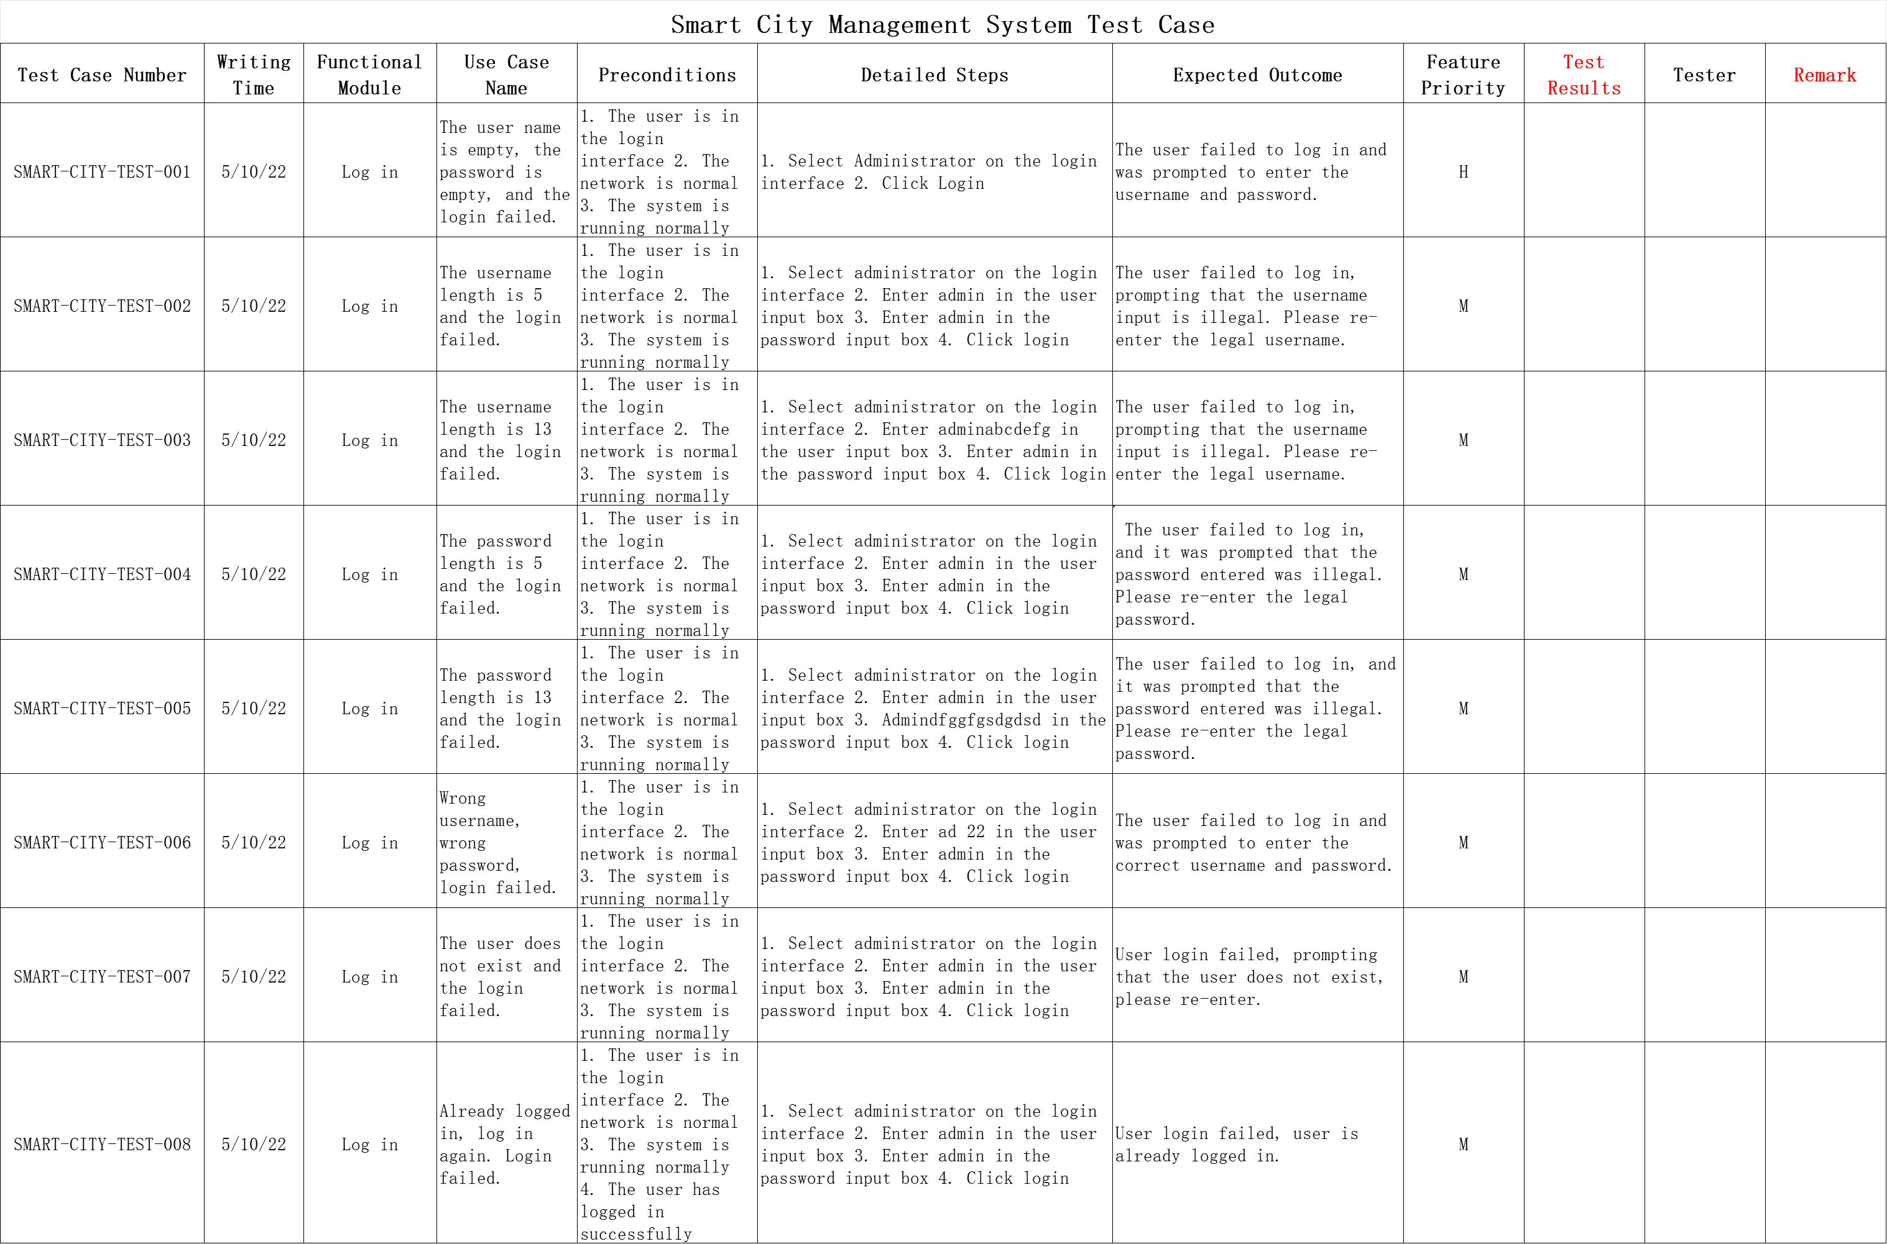
Figure 3.9 Write Test Cases
(Source: compiled by the author using Microsoft Excel)

4.Testing phase
During the system testing phase, testers perform tests according to test cases and record the test execution results of each test case (fig.3.10).
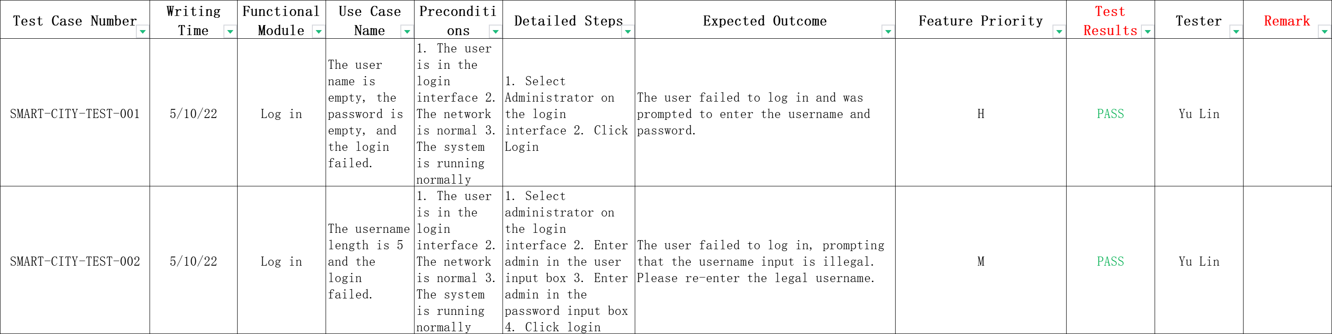
Figure 3.10 Record Test Results
(Source: compiled by the author using Microsoft Excel)
At the same time, ZenTao software is used to manage system defects to ensure that defects are repaired and tracked in a timely manner (fig.3.11)? (fig.3.12).

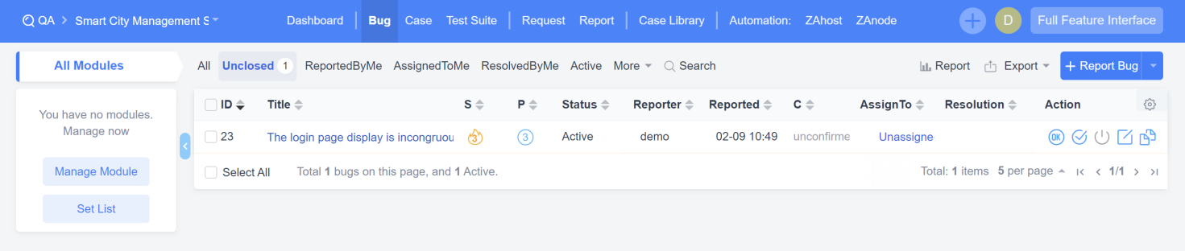
Figure 3.11 Problem Assignment
(Source: compiled by the author using ZenTao Software)

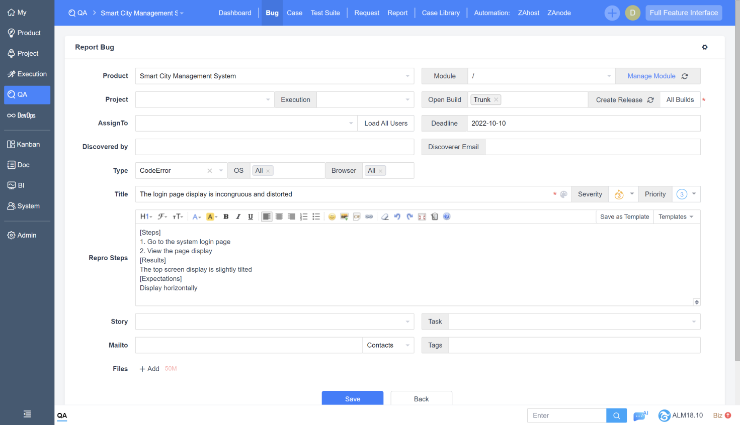
Figure 3.12 Issue Tracking
(Source: compiled by the author using ZenTao Software)

For the performance testing of the system, the testers used JMeter software to conduct performance testing to evaluate the stability and load capacity of the system (fig.3.13).

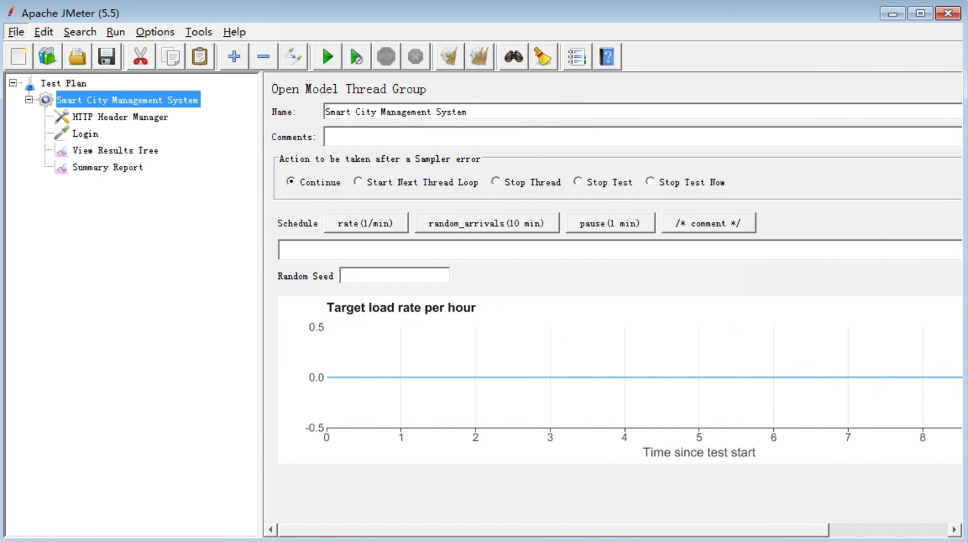
Figure 3.13 Performance Testing
(Source: compiled by the author using Jmeter Software)

5.Operation and maintenance phase
After the system is put into operation, the Zabbix monitoring system is used for operation and maintenance management to ensure the stable operation of the system. Zabbix can monitor the system's performance, availability and other indicators in real time, and notify relevant personnel by email or other means so that problems can be handled in a timely manner.
By applying these innovative tools in the smart city management system construction project, the project was successfully delivered on time on June 30, 2023, with an actual project cost of RMB 13.2 million.
The project performance was analyzed using the earned value analysis method. In this project, the actual cost was RMB 13.2 million. At the end of the project, all work had been completed, and EV was equal to the total budget of the project, which was RMB 15 million. Therefore, CPI = RMB 15 million / RMB 13.2 million ≈ 1.14. The CPI value is greater than 1, and the actual cost of the project is lower than the budgeted cost. The actual progress of the project is consistent with the planned progress, that is, EV is equal to PV. Therefore, SPI = EV/PV = 1, indicating that the actual progress of the project is consistent with the planned progress, with no advance or lag.
The project team has fully utilized the advantages of these innovative tools in various stages such as requirements analysis, design, coding, testing and operation and maintenance. The cost performance index CPI and schedule performance index SPI of this project have shown good performance. The cost is lower than the budget and the progress is in line with expectations, which shows the effectiveness and efficiency of project management. Specifically, mind mapping and fishbone diagrams help the team better understand and sort out requirements, improving the accuracy of requirements analysis; flowcharts and Modao software help the team better design and display systems, improving the rationality of design and user experience; tools such as IntelliJ IDEA and Excel improve the efficiency of coding and testing and ensure the quality of the project; while Git and Zabbix play an important role in code management and operation and maintenance, ensuring the stability and maintainability of the project. ZenTao software plays a key role in the entire project. It is not only used in the initial stage of project management to track and manage the progress of the project, but also used for defect management in the subsequent testing stage. Through ZenTao software, the project team can track the status of defects in real time to ensure that each problem is properly handled. This centralized defect management method greatly improves the efficiency and quality of project management.
IT company successfully applied a variety of innovative tools and project management theories in the smart city management system construction project to improve the efficiency and quality of project management. These tools not only helped the team better understand and deal with the complexity of the project, but also ensured that the project was completed on time, on budget, and with quality

3.3 Recommendations For The Use Of Innovative Models (Tools, Technologies) For It Project Management

1.Comprehensively understand the advantages and applicable scenarios of innovative tools
- Understand the basic principles of innovation models: When applying innovation models, you first need to understand their basic principles and components. For example, innovation models such as design thinking and agile development have their own theoretical systems and methodologies. By mastering these basic principles, project managers can better guide the team to carry out innovation practices and ensure the smooth progress of the project.
- Choose innovation tools based on project characteristics: There are many types of innovation tools, such as MindMapping, user story maps, agile project management software, etc. Project managers should choose appropriate innovation tools based on project characteristics and team needs. For example, in the demand sorting stage, MindMapping tools can be used to help the team sort out demand points and ideas; in the project planning stage, agile project management software can be used to improve team collaboration efficiency.
- Focus on the practicality and ease of use of innovation tools: In practical applications, innovation tools should have high practicality and ease of use. When selecting innovation tools, project managers should fully consider the ability of team members to use them and avoid selecting tools that are too complex or difficult to use.
2.Choose the right innovation tool based on actual conditions
- Select innovation tools according to the project stage: Different project stages have different problems and concerns to be solved, so you should choose the corresponding innovation tools according to the stage of the project. For example, in the early stage of the project, you can focus on demand exploration and concept verification. At this time, you can use tools such as user portraits and story maps to help the team better understand user needs and market trends; in the middle of the project, you can adopt agile development methods such as Scrum and Kanban to improve project execution efficiency; in the later stage of the project, you can use risk assessment tools such as SWOT analysis and PESTLE analysis to ensure the smooth launch of the project and reduce potential risks.
- Consider the scalability and integration of innovation tools: When choosing innovation tools, pay attention to their scalability and integration so that new technologies and functions can be easily introduced and integrated in future project development. The ability to integrate multiple innovation tools can improve the efficiency of project management. For example, integrate project management software with team collaboration tools, code management tools, etc. to achieve unified management and sharing of project data.
- Pay attention to the matching degree between innovation tools and organizational culture: The application of innovation tools needs to be consistent with organizational culture to achieve better results. When choosing innovation tools, we should fully consider the cultural characteristics of the organization, such as transparency, collaborative spirit, rapid iteration, etc. For example, for organizations that focus on teamwork, we can choose innovation tools that support teamwork, such as project management software, knowledge sharing platforms, etc.; for organizations that advocate rapid iteration, we can introduce tools such as agile development methods and innovation workshops.
- Conduct pilot projects to evaluate the effectiveness of innovation tools: Before formally applying innovation tools, you can conduct pilot projects to verify them. Through pilot projects, you can understand the effectiveness of innovation tools in actual projects, evaluate the degree of improvement in project management, and the adaptability of team members. Based on the feedback from the pilot projects, adjust and optimize the innovation tools to ensure their successful application in formal projects.
3.Regularly evaluate and adjust innovation strategies
During the application of innovation tools, project managers can regularly evaluate their effects and make adjustments based on the actual situation of the project. This ensures that the innovation strategy is always consistent with project requirements and team capabilities, and achieves continuous optimization of project management.
- The actual application effect of the innovation tool: evaluate the role of the innovation tool in the project, such as whether it improves project management efficiency and the collaboration ability of team members.
- Feedback from team members: Understand team members’ experience with innovation tools, including practicality, ease of use, learning cost, etc.
- Overall effect of project management: Comprehensively consider the performance of project progress, quality, cost and other aspects, and evaluate the impact of innovative strategies on the overall effect of project management.
4.Strengthen cross-departmental communication and collaboration
The application of innovative tools in project management involves multiple departments and teams, so cross-departmental communication and collaboration are essential. Project managers can take the initiative to establish a good communication mechanism with other departments to ensure that the application of innovative tools can be supported and coordinated by relevant departments.
- Demand Sharing: Maintain close communication with other departments to understand project requirements and business dynamics, and ensure that the application of innovative tools can meet actual needs.
- Resource integration: Make full use of cross-departmental resources, such as technology, manpower, and market, to provide support for innovative projects.
- Collaborative innovation: Organize cross-departmental innovation activities, such as innovation workshops and hackathons, to stimulate the creativity of team members and promote continuous innovation in project management.
5.Establishing a training and sharing mechanism for innovative tools
In order to ensure the effective application of innovation tools in project management, project managers can establish a training and sharing mechanism for innovation tools. This will help improve team members' mastery of innovation tools and enhance the overall innovation capabilities of the team.
- Develop training plans: Develop training plans for innovation tools based on the needs of team members and project stages to ensure that team members can master the required innovation tool skills.
- Provide training resources: Integrate internal and external training resources, such as professional lecturers, online courses, practical cases, etc., to provide team members with rich learning materials.
- Evaluate training effectiveness: Evaluate the effectiveness of training and understand the improvement of team members in the application of innovation tools in order to continuously optimize the training plan.
6.Monitor and learn from industry innovation trends
In order to ensure the continuous optimization and upgrading of innovative tools in project management, project managers can pay close attention to industry development dynamics and innovation trends, draw experience and lessons from them, and provide strong support for project management.
- Pay attention to industry dynamics: Understand industry development trends and innovation dynamics by reading industry reports, attending industry conferences, and communicating with people in the same industry.
- Analyze successful cases: Study successful innovation project cases in the industry, analyze the innovation tools and project management methods behind them, and provide reference for the project.
- Learn advanced concepts: Actively learn advanced concepts and methods in the field of innovation, such as agile development and continuous integration, to inject new vitality into project management.
7.Promote the establishment of organizational innovation culture
The application of innovative tools cannot be separated from the support of organizational innovation culture. Project managers can actively promote the construction of organizational innovation culture and create a good environment for the application of innovative tools in project management.
- Establish the concept of innovation: popularize the concept of innovation within the organization, let team members realize the importance of innovation and enhance their awareness of innovation.
- Establish an incentive mechanism: set up an innovative reward system to stimulate the enthusiasm and creativity of team members.
- Create an open atmosphere: encourage the circulation and exchange of information within the organization and absorb excellent external innovative resources.
8.Build innovation awareness among all employees
In order to maximize the advantages of innovation tools, project managers can guide team members to establish an innovative consciousness and encourage them to actively participate in innovation activities.
- Training and promotion: Organize training and promotion activities on innovation-related knowledge to enhance team members’ awareness of innovation and let them understand the importance of innovation to projects and organizations.
- Innovation sharing: Regularly hold innovation sharing sessions to allow team members to exchange innovation ideas and practical experience, and inspire and promote each other.
- Cross-team communication: Encourage team members to actively participate in cross-team communication activities, learn from other teams' innovation experiences and methods, and stimulate innovation inspiration.

CONCLUSIONS
After in-depth research, we came to the following conclusions and suggestions:
As an important milestone and embodiment of technological progress in the industry, society and the global economy, digital evolution has gradually penetrated into the development of all walks of life. From the first industrial revolution to the third industrial revolution, and now to the fourth industrial revolution, digitalization has become an inevitable trend to promote the transformation and upgrading of the industry. Its driving factors mainly include technological progress, changes in human behavior and the evolution of the competitive landscape. Digitalization optimizes and transforms traditional business processes, activities or services by using advanced digital technologies, thereby improving efficiency and user experience in all aspects.
A project, as a temporary task, aims to create a unique product, service or result within a limited time and resource conditions to meet specific goals and needs. Project management involves the systematic planning, organization, guidance and control of projects during project execution through the use of a series of methods, tools and techniques to ensure that the project can be successfully completed in accordance with the predetermined goals, time, budget and quality requirements. The project management knowledge system usually covers multiple areas such as project integration management, scope management, schedule management, cost management, quality management, resource management, communication management, risk management, procurement management and stakeholder management.
Operation management focuses on the continuous production of products and the stable provision of services to ensure that enterprises can meet market demand efficiently and stably. Relatively speaking, as an important force in promoting social digitalization and technological innovation, IT projects play a key role in optimizing enterprise operation processes, improving decision-making quality, and improving people's daily lives. Through the implementation of IT projects, society as a whole can continue to develop in a more efficient and intelligent direction. Its main role is reflected in optimizing cost structure, improving efficiency and effectiveness, strengthening service quality, achieving model upgrades, and improving people's welfare. In addition, the implementation of e-government IT projects will also help improve the efficiency of government services, so that people can enjoy the various services provided by the government more conveniently.
Software implementation projects, due to their complexity, innovation and specialization, place higher demands on project management teams. During project implementation, project management teams not only need to have highly specialized knowledge and skills, but also need to be keen on capturing the development trends of new technologies, and timely introduce new technologies into projects. At the same time, they need to have an in-depth understanding of business needs, propose innovative business solutions, and continuously optimize project management processes and methods to ensure smooth implementation and high-quality completion of projects.
In the process of software development, the software life cycle model is an important reference. Among them, the waterfall model and the rapid prototyping model are the two most common models. The waterfall model emphasizes sequential development and attaches importance to the stage review of the process. It is suitable for scenarios with stable demand, moderate project scale and relatively experienced development teams. The rapid prototyping model focuses on customer needs, quickly creates prototypes and performs iterative optimization to meet customer needs. It is suitable for projects with uncertain demand, time sensitivity and high customization. These two models have their own advantages and disadvantages. The project management team needs to choose and use them flexibly according to the characteristics of the project and the team's capabilities.
In the IT project management process, scope creep, insufficient risk management, resource allocation issues and communication barriers are common challenges. To address these challenges, the project management team needs to develop clear scope documents, strengthen risk identification and assessment, develop effective response plans and continuously monitor risk changes; at the same time, it is also necessary to use resource management tools to allocate and schedule resources to ensure the rational use of resources; in addition, strengthening communication between stakeholders is also the key to improving project success rates.
In IT project management practice, the application of innovative tools is of great significance to improving project management efficiency and quality. This article introduces four common innovative tools and their applications in IT project management, including CASE technology, project management tools, drawing tools, prototyping tools, and code development tools. These tools play an important role in different stages of software development. For example, project management tools such as Microsoft Excel and Microsoft Project can help project managers develop detailed project plans, track project progress, and monitor project risks; drawing tools such as Microsoft Visio and ProcessOn can be used to create and record complex business process diagrams, organizational charts, etc., to help team members better understand and analyze project situations. By using these innovative tools, project management teams can conduct project management more efficiently and improve project success rates.
IT company successfully applied innovative tools and project management theories in the smart city management system construction project, significantly improving the efficiency and quality of project management. The company used tools such as Microsoft Excel to develop a detailed project implementation plan and risk register, and used project management tools such as ZenTao software to comprehensively manage the project; at the same time, it also used innovative tools such as mind mapping and fishbone diagrams for demand analysis and design; and made full use of advanced technologies such as Modao software and integrated development tools in the coding, testing and operation and maintenance stages. The application of these innovative tools not only helped IT company better understand and cope with the complexity of the project, but also ensured that the project was completed on time, on budget and with quality, fully demonstrating the effectiveness and efficiency of project management.
Regarding how to better use innovation models (tools, technologies) in IT project management, we put forward the following suggestions: First, the project management team should fully understand the advantages and applicable scenarios of various innovation tools, and select appropriate tools for application based on the characteristics of the project; second, pay attention to the practicality and ease of use of innovation tools, and select tools that can truly improve project management efficiency and quality; at the same time, it is also necessary to consider the scalability and integration of innovation tools to ensure that they can be seamlessly connected with existing systems and processes; in addition, the project management team should also pay attention to the matching degree between innovation tools and organizational culture, and promote the construction of organizational-level innovation culture; finally, evaluate the effectiveness of innovation tools through pilot projects and other means, and establish corresponding training and sharing mechanisms to promote the widespread application and continuous improvement of innovation tools in project management.
In summary, through in-depth research and practical exploration, we can find that digital evolution and IT project management play an important role in promoting social progress and corporate development. In future development, we should continue to strengthen the application of digital technology and the research and development and application of innovative tools, and continuously improve the efficiency and quality of project management to better meet the needs of society and enterprises.

REFERENCES
1. The Fourth Industrial Revolution: what it means, how to respond URL: https://www.weforum.org/agenda/2016/01/the-fourth-industrial-revolution-what-it-means-and-how-to-respond/ (Access date: 04/09/2024).
2. Sima, V. , Gheorghe, I. G. , Subi, J. , & Nancu, D. . (2020). Influences of the industry 4.0 revolution on the human capital development and consumer behavior: a systematic review. Sustainability, 12(10), 4035.
3. Brynjolfsson, E., & Mcafee, A. (2014). The second machine age: work, progress, and prosperity in a time of brilliant technologies. Business horizons. Vol. 3.
4. Population of global offline continues steady decline to 2.6 billion people in 2023 URL: https://www.itu.int/en/mediacentre/Pages/PR-2023-09-12-universal-and-meaningful-connectivity-by-2030.aspx (Access date: 04/09/2024).
5. Cordeschi, R. . (2007). Ai turns fifty: revisiting its origins. Applied Artificial Intelligence, 21, 259-279.
6. McAfee, Andrew, Brynjolfsson, & Erik. (2012). Big data: the management revolution. (cover story). Harvard Business Review. Vol. 5. Pp. 150-165.
7. Bisong, E. (2019). What Is Cloud Computing? Cloud Technologies. https://www.oreilly.com/library/view/building-machine-learning/9781484244708/html/463852_1_En_1_Chapter.xhtml
8. Hoehe, M. R. , & Thibaut, F. . (2020). Going digital: how technology use may influence human brains and behavior. https://pmc.ncbi.nlm.nih.gov/articles/PMC7366947/
9. National Bureau of Statistics, https://data.stats.gov.cn/english/adv.htm?m=advquery&cn=C01 (Access date: 04/18/2024).
10. Big Data in Practice: How 45 Successful Companies Used Big Data Analytics to Deliver Extraordinary Results URL: https://bernardmarr.com/wp-content/uploads/2022/05/Big-Data-Esampler-1.pdf (Access date: 04/10/2024).
11. How Smart, Connected Products Are Transforming Competition URL: https://hbr.org/2014/11/how-smart-connected-products-are-transforming-competition (Access date: 04/10/2024).
12. Liu, Mingliang, Song, Yuewu, (2023). The 4th edition Computer exam for Information System Project Managers. Tsinghua University Press.
13. Project Management Institute. (2017). A guide to the Project Management Body of Knowledge (PMBOK guide) (6th ed.). Project Management Institute.
14. Schwalbe, K. (2018). Information Technology Project Management (9th ed.). CENGAGE Learning Custom Publishing.
15. Smith, J. (2012). Information Technology’s Influence on Productivity. Proquest, Umi Dissertation Publishing.
16. Hasan, T. (2018). Impact of ERP System in Business Management. International Journal of Management Studies, V(4(4)), 24. https://doi.org/10.18843/ijms/v5i4(4)/03 Pp28
17. The Impact of Office Automation on Worker’s Productivity at all Organizational Levels at King Abdul-Aziz University Library: A case study. (n.d.).
18. Talebi, H., & Khatibi Bardsiri, A. (2023). The impact of Information Technology on service quality, satisfaction, and customer relationship management (case study: IT organization individuals). Journal of Management Science & Engineering Research, 6(2), 24–31. https://doi.org/10.30564/jmser.v6i2.5823
19. The Impact of AI-Powered Chatbots on Customer Satisfaction in E-commerce Marketing. (n.d.). TAM Approach.
20. The Impact of E-Government Success Factors on Citizen Satisfaction: The Context of UAE. (n.d.).
21. Hamedi, M. A., & Ezaleila, S. M. (2015). Digital textbook program in Malaysia: Lessons from South Korea. Publishing Research Quarterly, 31(4), 244–257. https://doi.org/10.1007/s12109-015-9425-4
22. Tiik, M., & Ross, P. (2010). Patient opportunities in the Estonian Electronic Health Record System. Studies in Health Technology and Informatics, 156, 171–177.
23. Smart Mobility 2030 - ITS Strategic Plan for Singapore CHIN Kian Keong and Grace ONG. (n.d.).
24. What is green IT (green information technology)? Results URL: https://www.techtarget.com/searchcio/definition/green-IT-green-information-technology (Access date: 04/18/2024).
25. Yu Bo. Problems and features of IT-project management in modern conditions: A collection of abstracts of reports of students, postgraduates and applicants - participants of the 80th reporting conference of the Odessa National University named after I. I. Mechnikov. Section of Economic and Legal Sciences (April 23–25, 2024, Odesa) / resp. ed. O. V. Poberezhets; ed. coll.: O. I. Donchenko, E. I. Maslennikov, A. L. Svyatoshniuk, and others. – Odesa: Oldi+, 2024. C. 325-328.
26. Kerzner, H. R. (2009). Project management: A systems approach to planning, scheduling, and controlling (10th ed.). John Wiley & Sons.
27. Chaikovska M., Yashkina O., Filatova V. Artificial Intelligence in Mobile Marketing: Conditions, Obstacles and Prospects of Using. Marketing and digital technologies. 2020. Volume 4. No. 2.
28. Chaikovska M., Levitskaia A. Modern approaches to managing mobile marketing IT projects. Scientific journal. Marketing and digital technologies. 2020. Vol. 4. № 1.
29. Pressman, R. S. (2010). Software Engineering: A Practitioner’s Approach SEVENTH EDITION. McGraw Hill Higher Education.
30. Bai Jing, Li Zhe. (2012). Research on online course development model based on Optimized waterfall model. China Audio-visual Education (5), 5.
31. Waterfall, V, W, Rapid prototyping model, incremental, spiral model, URL: https://blog.csdn.net/qq_36502272/article/details/121155075 (Access date: 04/25/2024).
32. What is Agile Methodology? URL: https://www.geeksforgeeks.org/what-is-agile-methodology/?ref=lbp (Access date: 04/26/2024).
33. Agile Model URL: https://www.javatpoint.com/software-engineering-agile-model (Access date: 04/26/2024).
34. User Stories in Agile Software Development URL：https://www.geeksforgeeks.org/user-stories-in-agile-software-development/?ref=lbp (Access date: 04/26/2024).
35. Advantages of Agile Methodology URL：https://www.geeksforgeeks.org/agile-methodology-advantages-and-disadvantages/?ref=lbp (Access date: 04/26/2024).
36. Disadvantages of the Agile Methodology URL：https://www.geeksforgeeks.org/agile-methodology (Access date: 04/26/2024).
37. The Spiral Model: An Overview URL：https://www.baeldung.com/cs/spiral-software-development-model (Access date: 04/26/2024).
38. Spiral Model – Software Engineering URL：https://www.geeksforgeeks.org/software-engineering-spiral-model/ (Access date: 04/26/2024).
39. Brandon, D. M. (2006). Project Management for Modern Information Systems. IRM Press.
40. Schwalbe, K. (2015). Information Technology Project Management (8th ed.). Cengage Learning.
41. Identify, prevent, and mitigate potential digital project risks URL：https://mariana-n.medium.com/identify-prevent-and-mitigate-potential-digital-project-risks-f4c8dba834d5 (Access date: 05/02/2024).
42. Computer-Aided Software Engineering URL: https://ithandbook.ffiec.gov/it-booklets/development-and-acquisition/development-procedures/software-development-techniques/computer-aided-software-engineering (Access date: 05/03/2024).
43. Computer Aided Software Engineering (CASE) URL: https://www.geeksforgeeks.org/computer-aided-software-engineering-case/ (Access date: 05/03/2024).
44. Introduction to Microsoft Excel URL: https://ccsuniversity.ac.in/bridge-library/pdf/DHA_Shikha_BHI_204_Unit4.pdf (Access date: 05/03/2024).
45. MS Project - Introduction URL: https://www.tutorialspoint.com/ms_project/ms_project_introduction.htm (Access date: 05/03/2024).
46. Zentao project management software URL: https://www.easycorp.cn/software/zentao-78999.html (Access date: 05/03/2024).
47. Visio URL: https://www.microsoft.com/zh-cn/microsoft-365/visio/flowchart-software?aid=60 (Access date: 05/06/2024).
48. ProcessOn URL: https://www.processon.com/ (Access date: 05/06/2024).
49. Axure URL: https://www.axure.com/ (Access date: 05/06/2024).
50. Modao product prototype tool URL: https://modao.cc/usergrowth/prototype-b.html (Access date: 05/06/2024).
51. Eclipse Cross-platform open source integrated development environment URL: https://www.oschina.net/p/eclipse?hmsr=aladdin1e1 (Access date: 05/06/2024).
52. IntelliJ IDEA URL: https://www.jetbrains.com/zh-cn/idea/ (Access date: 05/06/2024).
53. PyCharm URL: https://www.jetbrains.com.cn/pycharm/ (Access date: 05/06/2024).
54. Selenium URL: https://www.selenium.dev/about/ (Access date: 05/06/2024).
55. Apache JMeter URL: https://jmeter.apache.org/ (Access date: 05/06/2024).
56. Kuznetsov E. A. New normality" of the professional management system. Development of the competitiveness of the economy in the conditions of international integration: macro-, meso- and micro-levels: materials of International science and practice conf. (Odesa, May 25, 2021). Odesa: ONU, 2021. C.23-28.
57. Sadchenko O., Robul I. Economic And Environmental Marketing Space Of The Economics Of Experience. Economic innovations, 2020, 22(1(74)), 129–139.
58. Hrinchenko Y. Design And Dynamics Of Business Ecosystems In The Context Of «Industry 4.0» Concept. Market economy: modern management theory and practice, 2023, 21(1(50)), 149–161.

