ODESA I.I. MECHNIKOV NATIONAL UNIVERSITY
FACULTY OF ECONOMICS AND LAW
DEPARTMENT OF MANAGEMENT AND INNOVATIONS

Qualification project (thesis)
for obtaining the degree of higher education "master"
« Green IT management in the conditions of global challenges»
«Зелений IT менеджмент в умовах глобальних викликів»

Performed by: full-time student
specialty 073 Management
Educational and professional program "Management"
Chen Hao / Чень Хао

Scientistic supervisor: Doctor of Economics,
Prof. Chaikovska M.
Reviewer: Doctor of Economics,
Prof. Golovchenko O.

Recommended for defense:  protocol of the department meeting  No. ___ dated ____.____. 2023  Head of Department  ______Prof. Olena SADCHENKO  (signature) | Defended at the EC meeting No. ___  protocol No. __from ____.12.2023  Assessment ______________/___  (according to the national scale/ESTS scale/points)  Head of the EC  ______Prof. Yevgen MASLENNIKOV  (signature)
Оdesa 2023
CONTENTS
INTRODUCTION 3
CHAPTER 1 The Theoretical Foundation of Green IT Management Systems under the Challenge of Globalization 6
1.1 Theoretical Basis of Green IT Management under the Challenge of Globalization 6
1.2 Economic models and methods for green IT management 16
1.3 Tool based support in green IT management 21
CHAPTER 2 Management Analysis and Research on the Construction and Operation of Green Data Centers in China 33
2.1 Definition, Function, and Characteristics of Green Data Centers 33
2.2 Research on the Green Status of Global Data Centers 37
2.3 Analysis of China's Data Center Operation and Management Policies 46
CHAPTER 3 Green Transformation of China's Existing Data Centers under the Challenge of Globalization 63
3.1 Analysis of the Current Situation of China's Stock Data Centers 63
3.2 Methods and Examples of Green Transformation of China's Existing Data Centers 711
3.3 The Challenges and Opportunities of Green Transformation of China's Existing Data Centers 877
CONCLUSIONS 91
REFERENCES 944

INTRODUCTION

Relevance. Currently, in the context of globalization challenges, the rapid development of industrialization and globalization has intensified resource consumption and environmental pressure, posing significant challenges to the survival and development of all humanity, and triggering a demand for green solutions. Digitization and greening have become two major trends driving global economic and social transformation, and these two are profoundly changing human society. Green IT management emphasizes the deep integration of green development concepts and practices into digital transformation through technology and innovative means, in order to reduce the impact on the environment. By integrating sustainable practices into the design, manufacturing, use, and disposal of ICT products and services, we aim to minimize greenhouse gas emissions, reduce energy consumption, and promote sustainable development.
Enterprises and organizations around the world are adopting sustainable practices in their ICT operations, and green IT management has become a global trend. This trend is driven by increasing awareness of the necessity of environmental protection and sustainable development, as well as the recognition that these practices can help save costs and enhance competitive advantages.
Analysis of recent research and publications. Analysis of the latest research and publications. Andrew Winston, Toby Velte, Anthony Velte, Robert ElsenPeter, Jean Baptiste V, Vincent V, Belkhir Lotfi, Ahmed Elmelgi, E Masanet, A. Shehabi, S. Smith, J. Koomey, R Stone, R Hugghaalli, A, O.Sadchenko, M.Chaikovska, Kuznetsov E.A.
The research and scientific works of Shehabi, S. Smith, D. Sartor, and others elucidate the theoretical direction and practical application of green IT in various industries. Although the theoretical exposition level of these studies and scientific works is quite high, and their related methods have also been applied in some regions and industries, there is not much in-depth research and analysis on the application of green IT management in China. This article will focus on the green IT management in China under the challenges of globalization, especially the green transformation of existing data centers in China, and propose practical solutions.
Connection of the qualification project with scientific projects, plans, and topics. The master's thesis was completed at the department of marketing and business administration in accordance with the plan of scientific research of the scientific research topic of I. I. Mechnikov Odesa National University "Marketing systems and management technologies in conditions of multilevel convergence" (state registration number 0120U102481 2020-2024). Evaluation and practical application of green transformation of China's stock data centers.
Goal and tasks. The purpose of this study is to propose a green transformation plan for China's stock data center from a theoretical and methodological perspective.
Achievement of the goal of qualification project has led to the necessity of setting and solving the following tasks:
- Research the background and theoretical basis of green IT management;
- The application of green IT management in various industries around the world under the conditions of global challenges;
- Economic analysis models and evaluation methods for green IT;
- Research on the application and methods of green IT management in China;
- Research on the construction of global green data centers;
- Analysis of policies and economic benefits for the operation of data centers in China.;
- Research on the survival status of China's existing data centers under the challenge of globalization;
Propose a plan for the transformation of China's existing data centers.
The object of the study is the prospects of green IT management transformation plan of China's stock data centers.
The subject of the study is the theory, methods, and practice of China's green IT management system under global challenges.
Research methods. The work uses general scientific methods that allow systematic solve problematic tasks from the chosen research direction: dialectical, analytical, comparative-analytical, method of systematization, classification, and evaluation, and systematic method. As well as special methods: systematization of scientific bibliography, thematic articles, legislative and normative acts, their theoretical and critical analysis; economic-mathematical method of linear modeling.
The basis of the qualification level were provisions from the works of leading scientists in the field of strategic management, information from Internet sources, reporting data of the company
Approbation of the results. Based on the results of the master's qualification work, theses of the reports were published:
Chen Hao. Prospects of Green IT Management in China. Papers of the 79th I. I. Mechnikov Odessa National University reporting conference (April 27-28, 2023), Odesa, Oldi +, 2023. Pp. 232-234.
Structure and scope of work. The thesis consists of admission, three chapters, conclusions, bibliography (list of used sources) (70 positions). The total amount of qualification project is 100 pages. The thesis includes 6 tables and 21 figure.
In the first chapter, the theoretical basis of green information technology management under the background of globalization challenges was studied.
In the second chapter, an analysis and research were conducted on the construction and operation of China's green data centers.
In the third chapter, suggestions for the green transformation of China's stock data centers are proposed.

CHAPTER 1

THE THEORETICAL FOUNDATION OF GREEN IT MANAGEMENT SYSTEMS UNDER THE CHALLENGE OF GLOBALIZATION

Theoretical Basis of Green IT Management under the Challenge of Globalization

The background and concept of green IT management
The impact of global climate change is posing significant challenges to the survival and development of all humanity. Research evidence shows that the increase in greenhouse gas emissions caused by human activities is the main cause of global climate change[1, p.20-24].
During the period of 1850-2019, humans emitted a total of approximately 2.4 trillion tons of greenhouse gases, and surface temperatures increased by nearly 1.1 ℃ compared to pre industrial levels. 2011-2020 was the warmest decade since 1850. The impact of climate change on the environment, society, and economy is becoming increasingly severe. The frequency of extreme weather events is increasing, sea levels are accelerating, and millions of species are on the brink of extinction. In response to the enormous challenges posed by climate change, nearly 200 countries around the world passed the Paris Agreement in 2015, which explicitly reduced greenhouse gas emissions, controlled temperature rise within 2 ℃ of pre industrial levels within this century, and strived for a climate consensus of 1.5 ℃. The key to achieving the goals of the Paris Agreement is to achieve net zero greenhouse gas emissions globally around the middle of this century. To achieve this goal, each contracting party should strive to peak greenhouse gas emissions as soon as possible, and each country should propose national independent contribution goals based on its own national conditions. In recent years, countries around the world have taken decisive steps towards carbon neutrality. In December 2019, the European Union announced the "Green Agreement", announcing the goal of achieving net zero emissions by 2050; In September 2020, China announced its goal of peaking carbon emissions and achieving carbon neutrality. In October 2020, Japan and South Korea announced carbon neutrality targets; The newly elected President of the United States, Biden, announced his return to the Paris Agreement after taking office, and the United States will achieve net zero emissions for the entire economy no later than 2050. In addition, countries such as the UK, Canada, South Africa, and Mexico, which have previously announced carbon neutrality goals, have also announced that the world's major economies (accounting for approximately 75% of global GDP and 65% of carbon emissions) are moving towards carbon neutrality. Humanity has entered a new era of low emission development, and moving towards carbon neutrality has become a global consensus [2, p.194-197].
Table 1.1
Time frame for achieving carbon neutrality/net zero emissions targets
Country/Region | Target year | Country/Region | Target year | Country/Region | Target year
EU | 2050 | Andorra | 2050 | Japan | 2050
Austria | 2040 | Argentina | 2050 | Kazakhstan | 2060
Bulgaria | 2050 | Australia | 2050 | Laos | 2050
Cyprus | 2050 | Bahrain | 2060 | Liberia | 2050
Denmark | 2050 | Barbados | 2030 | Malawi | 2050
Finland* | 2035 | Bhutan | Realized | Malaysia | As early as 2050
France | 2050 | Brazil | 2060 | Maldives | 2030
Germany | 2045 | Canada | 2050 | Marshall Islands | 2050
Hungary | 2050 | Cape Verde | 2050 | Mauritania | 2030
Ireland | 2050 | Chile | 2050 | Mauritius | 2070
Italy | 2050 | China | 2060 | Monaco | 2050
Latvia | 2050 | Colombia | 2050 | Montenegro | 2050
Lithuania | 2050 | Costa Rica | 2050 | Namibia | 2050
Luxembourg | 2050 | Dominican | 2050 | Nauru | 2050
Portugal | 2050 | Fiji | 2050 | Nepal | 2045
Slovakia | 2050 | Iceland | 2040 | New Zealand | 2050
Slovenia | 2050 | India | 2070 | Nigeria | 2060
Spain | 2050 | Israel | 2050 | Panama | 2050
Sweden | 2045 | Jamaica | 2050 | Russia | No later than 2060
Rwanda | 2050 | Sri Lanka | 2060 | Britain | 2050
End of table 1.1
Sao Tome and Principe | 2060 | Switzerland | 2050 | United States | 2050
Seychelles | 2050 | Thailand | After 2050 | Uruguay | 2050
Singapore | After 2050 | Türkiye | 2053 | Vietnam | 2050
Solomon Islands | 2050 | Ukraine | 2060 | South Africa | 2050
Korea | 2050 | UAE | 2050
Note: Finland can achieve net zero emissions by 2035 in more aggressive scenarios.
(Source: compiled by the author based on [3], [4], [5])
However, according to data from the Intergovernmental Panel on Climate Change (IPCC), under the scenario of controlling a temperature rise of 1.5 ℃ in this century, the total global carbon emissions need to be controlled within 500 billion tons of carbon dioxide equivalent after 2020. In 2019, global emissions have exceeded 50 billion tons in a single year. According to the current development trend, it will be difficult to achieve the net zero target by the middle of this century. The zero carbon transformation urgently needs to be accelerated, and the decisive moment for the international community to work hard to solve the climate crisis is approaching. The issue of global climate change is crucial for human survival and the stability of the world economy. Carbon emissions have evolved from environmental issues to political and economic issues that affect the world. To address this issue, the vast majority of countries have made commitments at the legal and policy levels.
Table 1.2
Climate commitments of the top 10 global GDP countries [8]
country | Net Zero | commitment
United States | 2050 | policy statement
China | Before 2060 | policy statement
Japan | 2050 | policy statement
Germany | 2045 | Legal provisions
India | 2070 | policy statement
Britain | 2050 | Legal provisions
France | 2050 | Legal provisions
Italy | 2050 | policy statement
Brazil | 2050 | policy statement
Canada | 2050 | policy statement
The rapid development of industrialization and globalization has intensified resource consumption and environmental pressure, leading to a demand for green solutions. Looking at the current climate actions of various economies around the world, the deployment of renewable energy on a large scale, upgrading of industrial manufacturing emissions reduction, green transformation of transportation industry, improvement of building energy efficiency, and development and utilization of negative carbon technologies have become key areas for zero carbon development. 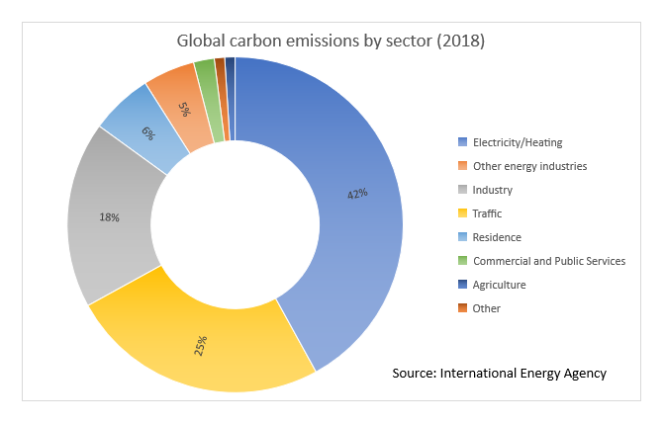
Figure 1.1 Global Carbon Emissions by Sector（2018）
Source: [6]
1. Scale deployment of renewable energy
Since 2013, the global investment in renewable energy has been approximately 300 billion US dollars per year, with solar and wind energy being the largest investment hotspots; In 2020, offshore wind energy investment jumped to around 50 billion US dollars, becoming the fastest-growing sector. China, the United States, and Europe lead the world in investment scale.
2. Upgrading emission reduction in industrial manufacturing industry
The chemical, steel, and cement industries account for 70% of the global industrial sector's carbon emissions in 2020. The three major industries are actively exploring new ways to reduce emissions and upgrade, such as integrating value chain resources and promoting waste conversion and utilization; Introducing hydrogen metallurgy technology to reduce direct emissions; Utilize carbon capture, utilization, and storage technology (CCUS) to promote net zero emissions [7].
3. Green transformation of transportation industry
Since 2014, the new energy transportation industry, which replaces fossil fuels with electricity and fuel cells, has flourished. In 2020, the global number of electric vehicles exceeded 10 million, with an annual growth rate of 43%, and the growth rate of fuel cell vehicles during the same period was 40%. Railway electrification, utilization of hydrogen energy in freight transportation, and intelligent upgrading of transportation systems are becoming global trends.
4. Improvement of building energy efficiency
In 2019, 73 countries established building energy efficiency standards, and the number of global sustainable/green building certifications continued to grow. Various countries optimize building energy efficiency by applying new wall materials, enhancing the thermal performance of building envelope structures, improving the electrification level of building energy equipment, adopting high-efficiency equipment, and improving the operational efficiency of building energy systems.
5. Development and utilization of negative carbon technology
On a global scale, the capture scale of Carbon Capture, Utilization and Storage (CCUS) tripled between 2010 and 2020, exceeding 40 million tons in 2020. Countries are increasingly valuing ecological negative carbon technologies such as CCUS, Bioenergy and Carbon Capture and Storage (BECCS), Direct Air Carbon Capture (DAC), and afforestation and reforestation [8].
While promoting climate action, countries attach great importance to the application of information technology to support zero carbon transformation in sectors such as energy, industry, transportation, and construction. According to the analysis of the World Economic Forum, by 2030, information technologies such as 5G, Internet of Things, artificial intelligence, and cloud can help reduce global carbon emissions by 15%.
With the rapid development and widespread application of new generation information and communication technologies such as 5G, artificial intelligence, big data, blockchain, industrial internet, and cloud services, the energy consumption and carbon emissions of the information and communication industry itself have also shown a rapid growth trend. It is expected that by 2040, the proportion of greenhouse gas emissions generated by information and communication technology will account for 14%. Therefore, in the process of assisting global carbon reduction through information technology, and in the rapid development and use of information technology, it is also necessary to fully consider the impact of information technology on the environment and assume environmental responsibility. This responsibility is reflected in reducing resource waste, reducing energy consumption, and protecting ecosystems and reducing carbon emissions. Enterprises need to integrate environmental awareness into their culture and decision-making in order to achieve sustainable development in the face of globalization challenges.
In this context, green information technology has emerged as one of the strategies to respond to environmental challenges. Green IT management emphasizes reducing the impact on the environment through technological and innovative means in the development and application of information technology. Integrating sustainable practices into the design, manufacturing, use, and disposal of ICT products and services, and providing management methods for more sustainable solutions in technological applications. This includes minimizing greenhouse gas emissions through the use of energy-saving equipment and practices, reducing energy consumption, managing electronic waste through responsible disposal and recycling, and promoting sustainable production processes. Enterprises and organizations around the world are adopting sustainable practices in their ICT operations, and green IT management has become a global trend. What drives this trend is people's increasing awareness of the necessity of environmental protection and sustainable development, as well as their recognition that these practices can help save costs and enhance competitive advantages [9].
The value and impact of green IT management are reflected in many aspects, including:
- In terms of energy conservation and efficiency, green IT management emphasizes the use of devices and technologies that are more energy-efficient and consume less energy. Apple continues to promote the application of green IT management in its operations. Since 2008, through continuous efforts to improve energy efficiency, by 2022, the overall energy consumption of all major product lines of Apple has decreased by more than 70%. In 2022, Apple deployed its independently developed server design for data centers, further improving the energy efficiency of data centers; This design is developed around energy efficiency and computational efficiency, which can save over 56.7 million kilowatt hours of energy annually. This work builds on Apple's previous efforts to improve data center efficiency, including developing a standard that requires the use of high-efficiency power sources to power servers; This power supply method even exceeds the energy efficiency requirements of the ENERGYSTAR Energy Star project and has been deployed to hundreds of thousands of servers since 2021, saving over 4 million kilowatt hours of energy annually. By saving energy and improving energy efficiency, enterprises have reduced operating costs and improved competitiveness [10].
- In terms of resource management, green IT management encourages the recycling and recycling of resources. By sustainable design of the equipment, the lifespan of the equipment can be extended and the generation of electronic waste can be reduced. Simultaneously emphasizing the use of renewable resources and reducing reliance on limited resources. As early as on the iPhone 6, Apple had already used recycled plastic to manufacture speaker casings. At present, the antenna strip of the latest iPhone is made from recycled plastic bottles, and all magnets are made of recycled rare earth elements. The touch engine uses recycled tungsten, and multiple printed circuit boards are soldered with recycled tin. 20% of all materials shipped in 2022 come from recycled resources. Apple's goal is to use only recycled and renewable materials in its products and packaging, and improve material recycling rates. By 2025, plastic materials will be completely phased out in packaging [11].
- In the treatment of electronic waste, green IT management focuses on the treatment and recycling of electronic waste. Enterprises need to dispose of waste equipment in a compliant manner to avoid environmental pollution, while reducing resource waste through recycling and reuse. Apple has launched the "Daisy" recycling robot, which can dismantle old equipment and recycle valuable parts from it. Apple also encourages users to recycle their old devices through the "Apple Give Back" program to extend their lifespan and reduce the generation of electronic waste [12].
- In terms of sustainable design, green IT management requires considering environmental impacts throughout the entire lifecycle of information technology, adopting sustainability principles from the design phase onwards. This covers the selection of materials, the use of energy, the lifespan of equipment, and the disposal of waste. On June 10, 2022, Microsoft Intelligent Cloud Azure announced the standards for the construction and operation of green data centers, including Microsoft's new liquid cooling technology for global self-built data centers, Building Implied Carbon Calculator (EC3), new data center temperature management methods, and other green breakthrough technologies, integrating sustainable development concepts into the design and operation of data centers. The entire process of site selection, construction, and operation of Azure Intelligent Cloud Green Data Center follows the principle of "energy flow", "data flow", and "business flow", with the principle of uniformity. "Energy flow" refers to the priority consideration of renewable energy enrichment areas when selecting data center locations, thereby promoting local consumption of renewable energy and activating local green economic development [13].
- According to the latest data from the Global Alliance for Buildings and Construction, implied carbon accounts for at least 11% of global greenhouse gas emissions. These implicit carbons come from materials and construction processes, such as concrete and steel, and are gradually emitted throughout the entire lifecycle of buildings or other infrastructure. Therefore, throughout the entire lifecycle of buildings or infrastructure, in order to reflect the carbon emissions related to materials and construction processes, Microsoft has launched a tool called the Building Implied Carbon Calculator (EC3) globally to identify building materials. By selecting low-carbon materials, Microsoft can reduce the hidden carbon content of each new building. Microsoft also implements the same standards for all construction teams - requiring them to use EC3 tools to select building materials and reduce hidden carbon. By using this tool, the implicit carbon content in concrete and steel can be reduced by 30-60% in the construction regulations of data centers. The design and operational standards of Microsoft's Green Data Center fully reflect sustainable design in green IT management.
- In terms of innovation and technological development, green IT management promotes technological innovation and encourages the search for more environmentally friendly and energy-efficient solutions. This includes new energy-saving hardware, the application of renewable energy, intelligent energy management systems, etc. In the field of electric vehicles, multiple companies had already entered this field in the 1990s, including industry giants such as General Motors in the United States, which also launched multiple mass-produced car products, but all ended poorly due to immature technology. Tesla was founded in 2003 and, after 10 years of dedicated research, successfully mass-produced its first star product, Model S, in 2012 through innovative battery management systems and efficient motor and electronic control technology, continuously leading the industry's development. Although there have been numerous challengers in the market in the past decade, Tesla has maintained its leading advantage in the core three electric systems and energy efficiency management of electric vehicles through continuous innovation and technological development, establishing a solid technical barrier, improving product competitiveness, and making it the car company with the highest market value [14].
- In terms of regulatory compliance and corporate responsibility, with the strengthening of environmental regulations, green IT management encourages enterprises to operate in compliance and avoid legal risks caused by environmental violations. At the same time, enterprises also need to take responsibility for the environment at the level of social responsibility. More and more countries and regions are introducing relevant laws and regulations to encourage enterprises to adopt environmental and sustainable practices in the field of information technology.
For example, the European Electronic Waste Directive (WEEE Directive): This directive sets out the regulations of EU member states regarding the disposal of electronic waste. Enterprises need to ensure that the recycling and disposal of their electronic products comply with the requirements of the directive to reduce the environmental impact of electronic waste. Energy Efficiency Directive: The European Union has formulated this directive, requiring member states to develop energy efficiency policies and measures to promote the improvement of energy efficiency. Enterprises need to comply with relevant requirements, including energy audits, energy efficiency plans, etc. And laws and regulations such as Electronic Product Environmental Regulations (RoHS) and Energy Star [15].
Green IT management is a full lifecycle management that promotes sustainable material use, maintainability, and the application of renewable energy during design and manufacturing. During use and maintenance, emphasis is placed on optimizing energy management and fully utilizing technologies such as virtualization and cloud computing. Ensure the safe disposal and resource recovery of waste equipment during processing and recycling, and reduce the impact of electronic waste on the environment. Through practical measures such as technological innovation, energy conservation, and environmental protection, we aim to promote the carbon reduction of the information technology industry towards other sectors, while reducing the negative impact of the IT industry on the environment, and creating better conditions for future sustainable development.
Green IT, as an important strategy to address environmental challenges under the conditions of globalization, has become a focus of attention for enterprises and society. Integrating environmental protection and sustainability into an organization's IT strategy and operations through green IT management is not only a trend under the challenges of globalization, but also helps companies save costs, improve competitive advantages, establish a corporate social responsibility image, and enhance the trust of customers and investors.

1.2.Economic models and methods for green IT management

The economic model and methods of green IT management involve how to optimize the management of information technology (IT) systems in the context of promoting environmental protection and sustainable development, in order to reduce resource consumption, reduce environmental impact, and maintain economic benefits.
We already know that green IT management is a full lifecycle management system that involves the design and construction period, use and maintenance period, as well as handling and recycling of projects. We should fully consider the economic benefits and environmental impact of green IT management.
When calculating economic benefits, it is necessary to consider investment costs, operational efficiency, energy-saving benefits, and the benefits of reducing carbon emissions. We can fully design, evaluate, and select the best project solution through lifecycle cost analysis methods and investment return analysis [16].
Life cycle cost refers to the sum of all expenses paid during the feasibility study, design, production, operation, maintenance, support, retirement, and other processes of a project throughout its lifecycle. This includes research and demonstration costs, design and manufacturing costs, procurement costs, installation costs, operating costs, maintenance costs, recycling and scrapping costs, as well as environmental costs caused by equipment failures and potential damage to the environment.
Project lifecycle cost management refers to a management philosophy and method that pursues the lowest LCC throughout the entire lifecycle of a project while meeting established functions.
Life cycle cost analysis originated from the cost calculation of military products by the US Department of Defense in the 1960s. With the emergence of advanced management models such as value engineering and cost planning, the life cycle cost method is increasingly being used in cost management. It can meet the needs of enterprise pricing decisions, new product development decisions, strategic cost management, performance evaluation, and so on.
According to Blanchard's cost breakdown structure method [16], the lifecycle cost method can be analyzed in the following steps:
1.Starting from the production characteristics, determine the basic cost classification;
2. Subdivide basic cost classifications;
3. Define and quantify cost components;
4. Estimate the economic lifespan of the production system;
5. Total cost.
Simply put, the key to the lifecycle cost method is to determine the lifecycle and cost classification.
The asset lifecycle cost method focuses on project investment and expands its application from the perspective of time value. In asset investment decisions, it is not enough to simply choose the option with the lowest initial purchase cost, but rather to make investment decisions from the perspective of the entire lifecycle from asset acquisition to final disposal.
Therefore, when making investment decisions from a long-term perspective of the life cycle, the asset life cycle cost method should comprehensively analyze its cost components from the perspective of time value, in order to restore the costs during different periods of the life cycle to the source of project investment and serve investment decision-making [17].
From the perspective of time value, analyzing the cost of asset lifecycle not only requires considering the composition of costs in different periods and the span of cycles, but also considering discounting. Decision makers first need to determine all future costs and benefits, and restore them to present value through discount methods in order to evaluate the economic value of investment projects.
Therefore, under the asset lifecycle cost method, cycle cost, cycle span, and discount rate should be determined. The asset lifecycle cost includes initial investment cost, operation and maintenance cost, and disposal cost [18].
(1) Initial investment cost. The purchase cost is an estimate of land, factory buildings, equipment, etc., which can be determined based on the supplier's quotation. Financing cost refers to the cost of raising funds. Other costs mainly include the installation cost of machinery and equipment and the training cost of operators.
(2) Operation and maintenance costs. The control of operation and maintenance costs is crucial for reducing the entire asset lifecycle cost, with a focus on balancing the cost of operation and maintenance with the cost of downtime and maintenance. Planned and preventive maintenance measures can reduce downtime and maintenance costs, but at the same time, they consume the resources of the enterprise. In addition, if the operating and maintenance costs are reduced, it will also increase the cost of downtime maintenance. It can be seen that the most crucial step is to find the optimal cost level for operation and maintenance, and to pursue the minimization of asset lifecycle costs.
(3) Disposal costs. Calculate the disposal cost at the end of the asset lifecycle and deduct it from the remaining value of the asset.
Figure 1.2 Life Cycle Cost Analysis
Source: [19]

The determination of cycle span and discount rate is crucial for the asset lifecycle cost method, which varies depending on the project and investment environment. The meaning of cycle can be understood as functional cycle, physical cycle, technological cycle, economic cycle, and social cycle.
The discount rate not only reflects investment profitability, but also reflects the impact of inflation. There are different opinions on the choice of discount rate, mainly including:
- The current or expected interest rate of the borrower's funds;
- Expected investment return rate;
- The minimum interest rate for borrowing from financially stable enterprises;
- The interest rate of long-term treasury bills minus the expected inflation rate
Calculation model: LCC=CI+CO+CM+CF+CD
·CI (cost of investment) investment cost, including the construction and purchase costs of hardware, software, equipment, etc.
·CO (cost of operation) operating costs, including energy consumption, maintenance costs, personnel costs, etc.
·CM (cost of maintenance) maintenance cost
·CF (cost of fault) maintenance cost
·CD (cost of disposal) disposal cost
On the basis of life cycle cost analysis, we need to further calculate the investment return of green IT management projects in order to select the optimal solution [20].
Analysis of return on investment
The calculation formula for ROI is as follows: Return on Investment (ROI) refers to the value that should be returned through investment, that is, the economic return obtained from an investment activity, which covers the profit goals of the enterprise. It is a ratio used to measure the profitability of a company, as well as a comprehensive indicator to measure the operational effectiveness and efficiency of a company. The decision-making principle of the return on investment method is that the higher the return on investment, the better the plan. By comparing the investment return rates of various options, select the option with the highest investment return rate.
The calculation formula for investment return rate is: ROI=(Revenue Cost)/Cost * 100
Revenue refers to the revenue generated by the project, while cost refers to the related input costs, including operating costs and upfront input costs, recovery and disposal costs, etc., which are related to the lifecycle cost. A positive ROI indicates a positive return on investment.
When calculating the return on investment of green IT management, the benefits here refer to the incremental benefits brought by the practice of green IT management, such as energy conservation, efficiency enhancement, carbon reduction, and other additional benefits. The cost here refers to the incremental cost, which is the additional cost incurred to increase or achieve green IT management goals when adopting different solutions.
For example, if the additional investment cost for green IT is $100000, and the combined benefits of energy conservation and carbon reduction are $200000, then ROI=(20-10)/10 * 100=100%. This means that the investment brings a 100% return.
The advantage of the investment return analysis method is that it can reflect the comprehensive profitability of the investment, and because it eliminates incomparable factors caused by different investment amounts, it has horizontal comparability, which is conducive to judging the quality of various investment and business performance; In addition, the return on investment can serve as a basis for selecting investment opportunities, which is beneficial for optimizing resource allocation.
The analysis of lifecycle costs and return on investment plays a crucial role in the investment proposal of green IT management, helping enterprises balance investment costs and potential benefits, thereby more effectively promoting sustainable development and environmental goals.

1.3.Tool based support in green IT management

In green IT management, enterprises usually rely on such technical tools as the Internet of Things for data collection, 5G technology for data transmission, cloud computing and edge computing for data mining analysis, and blockchain, artificial intelligence and machine learning to improve efficiency, reduce costs, and achieve green IT management goals [21].
We take the application of green IT management in China's new energy power system and the construction of China's green smart transportation system as an example to explore the practical use of related tools.
1、 Tool support in the application of new energy power systems:
The power industry accounts for 40% of China's total carbon emissions. Over the past century, the power system has formed a technology system dominated by fossil fuels. Under the goals of carbon peak and carbon neutrality, the power system is facing a transition from high carbon emissions to a new type of power system dominated by new energy. In the process of building a clean, low-carbon, safe and efficient energy system and a new type of integrated power system with source network, load and storage, information technology will play a positive role in achieving extensive interconnection, intelligent interaction, flexibility, safety and controllability [22].
By strengthening the collection, collection, and intelligent analysis and processing of big data on the operation status of the power grid, equipment status perception and accurate fault positioning can be achieved. The application of artificial intelligence technology will promote the upgrading of traditional power grids and the improvement of power grid resource allocation capabilities.
With information technology, the power grid will be promoted towards intelligent development, comprehensively improving the level of intelligent scheduling, intelligent operation and inspection, and intelligent customer service. The focus of green IT in assisting carbon reduction in the power industry includes empowering the intelligent operation of transmission and distribution grids, promoting the construction of intelligent control systems for urban, park, enterprise, and household electricity consumption, and accelerating the implementation of large-scale peak shaving and valley filling in new energy storage systems [23].
1. Application in Intelligent System of Transmission and Distribution Power Grid
Data shows that China's transmission and distribution losses account for about 6.6% of its electricity generation, and transmission and distribution network losses have become a significant energy waste that cannot be ignored. At present, the power grid company has gradually utilized information technology to assist in the intelligent operation and maintenance, status monitoring, fault diagnosis, and other aspects of the power transmission and distribution network, helping to improve the level of power grid management, reduce network losses, achieve energy-saving and carbon reduction effects, and achieve green IT management goals.
Deep mining and visualization of massive power grid data. During the operation of the power grid, a large amount of data is generated. By detecting, collecting, and mining data, valuable hidden data can be extracted from a large amount of actual operation data. Visualization uses computer graphics and image processing technology, combined with data mining, to quickly collect, filter, analyze, summarize, and present the information needed by decision-makers, achieving the visualization presentation of complex data [24].
Cloud computing and edge computing work together to realize the overall perception of power Internet of Things. Traditional cloud computing technology cannot meet the demand for low latency data transmission on the terminal side of power equipment. It needs to match various demand scenarios through collaboration with edge computing. Edge computing can preliminarily process and analyze local data, upload the processing results and relevant data to the cloud, and then use the powerful computing and storage capabilities of the cloud to analyze, process and store massive data [25].
Comprehensively utilizing advanced technologies such as artificial intelligence, the Internet of Things, and big data to promote the intelligent operation and maintenance of the power grid. Based on Internet of Things technology, achieve real-time control of line monitoring, equipment inspection, and power grid equipment to improve equipment fault response speed. Using cloud computing and big data technology to construct a heavy overload warning model, effectively predicting the situation of heavy overload in distribution transformers. With data analysis and machine learning as the core, achieve quantitative assessment and automated intervention of business application health, analyze system fault causes, and achieve fast and accurate positioning.
2. Application of intelligent control of electricity consumption in cities, parks, enterprises, and households
The smart application on the power user side is one of the typical scenarios of the "Internet plus+Smart Energy" system. The smart energy consumption system based on advanced information technology can help power users to fine manage their own energy consumption, accurately and quickly locate high energy consumption, high carbon emission power consumption links, and intelligently analyze users' power consumption behavior, so as to optimize power dispatching and matching schemes, and achieve the purpose of improving power efficiency and reducing carbon emissions.
Implementing user side intelligent energy utilization through artificial intelligence algorithms. Machine learning technology has good clustering/classification and identification capabilities, and can be used in the field of smart energy consumption, providing theoretical support for rational pricing and energy structure optimization of integrated energy systems [27].
Through the Internet of Things management platform, users can view real-time visual graphical displays of electricity consumption statistics and data analysis. Through regional division display, administrators can view real-time power and electricity consumption in each region. The platform will conduct statistical analysis on the collected data, convert it into visual charts, and estimate future energy consumption, making it easier for users to carry out energy-saving and emission reduction work [28].
Blockchain helps users achieve autonomous energy service security and peer-to-peer development. User independent energy services are mainly centered around the flexible resources in smart energy. Users can independently provide flexible energy services such as energy response, frequency regulation, and peak shaving, relying on internet platforms for dynamic and real-time transactions. The decentralized feature of blockchain technology can achieve peer-to-peer and extensive interconnection among energy users, energy equipment enterprises, and devices in smart energy; The information sharing and smart contract features of blockchain technology can achieve extensive interaction and full sharing of various types of information among relevant parties in smart energy, help improve the quality and efficiency of system operation, and achieve the goal of building a smart service system.
3. Accelerating the implementation of large-scale peak shaving and valley filling in new energy storage systems
Energy storage can achieve rapid and dynamic matching between power generation curves and load curves, thus having the functions of smoothing fluctuations, matching supply and demand, peak shaving and valley filling, and improving power supply quality. It is the core technology for building an energy internet. The digital energy storage system promotes the deep integration of energy storage system technology and information technology, realizes the digitization and software definition of energy storage systems, and closely integrates with information technologies such as cloud computing and big data to achieve internet-based control of energy storage systems, improve the automation level of energy storage system operation and maintenance, and the utilization efficiency of energy resources, fully leveraging the diversified role of energy storage systems in the energy internet.
For example, there are currently a large number of scattered idle battery energy storage resources on the user side. By adopting digital means such as battery energy exchange systems and battery energy control cloud platforms, the massive fragmented idle battery energy storage resources can be activated into large-scale distributed energy storage systems that can be scheduled and utilized by the power grid, achieving a distribution network energy storage system based on "virtual power plants", This has strongly supported the promotion and application of energy storage systems and the development of the energy internet [29].
Application examples of green IT management in China's new energy power system:
(1) Green IT management empowers intelligent operation of power transmission and distribution networks: A demonstration project of an energy storage power station focuses on using information technology to monitor the electrical parameters of individual batteries online. The battery cycle life can reach 12000 times, integrating advanced technologies such as high battery safety, high module integration consistency, and online monitoring. According to local scheduling instructions, it charges and discharges 1.5-2.0 times a day, with an expected service life of over 20 years. The overall technical level is industry-leading. In addition, the project is equipped with a unified scheduling and control system for a large-scale battery energy storage power station with a capacity of one hundred megawatt hours, which can provide peak shaving and frequency regulation services for three nearby 220kV heavily loaded substations, improve the average load rate of the substations, and enhance the utilization efficiency of the regional power grid [30].
(2) Green IT management promotes the intelligent control of power consumption in cities, parks, enterprises and households: relying on the "big cloud smart chain of things" technology, a city's smart energy control platform deeply integrates big data, the Internet of Things, artificial intelligence, edge computing and other technologies with urban energy management, and realizes the horizontal "water, electricity, natural gas, heat, and cold gas" multi energy complementary control [31].
The efficient collaboration of vertical "source transmission network load energy storage user" has created the only smart energy module of the new urban information model, meeting the local needs of "digital city" construction. The system monitors over 8000 locations within the park, dynamically matches energy production and load demand in real time, and achieves multiple energy cascading utilization.
In the past two years of stable operation, the urban smart energy control system has reduced the operation and maintenance costs of the park by about 10% through the use of smart operation and maintenance method. By precisely regulating the balance of cold and heat production and consumption in the park, we can save over 5% of the cold/heat supply in the park [32].
2、 Big data, vehicle networking technology, and intelligent platform applications in the construction of a green and intelligent transportation system
The transportation industry is one of the main industries that consume energy and emit greenhouse gases. Currently, the carbon emissions of China's transportation industry account for about 10% of the country's total carbon emissions. Based on the experience of developed countries, transportation energy consumption will ultimately account for one-third of the terminal energy consumption. In the future, the overall demand for transportation in China will continue to grow, which means that carbon emissions in China's transportation industry will continue to increase, and there are certain challenges in peaking carbon emissions by 2030 [33].
From the perspective of China's transportation carbon emission structure, operational and non operational roads account for 50.7% and 36.1% of carbon emissions, respectively [34]. In terms of unit turnover of goods, the energy consumption and pollutant emissions of road transportation are 7 times and 13 times that of railway transportation, respectively. From the perspective of the total number and growth of motor vehicles, the total number of motor vehicles in China reached 417 million in 2022, of which 319 million were automobiles [35].
In 2022, a net increase of 21.29 million motor vehicles was added, including a net increase of 17.52 million vehicles. Meanwhile, the average fuel consumption of Chinese passenger cars is 1.0-2.0 liters per 100 kilometers higher than European standards and 2.0-3.0 liters per 100 kilometers higher than Japan. Highway transportation and urban transportation optimization will be the key to achieving carbon peak in the transportation sector [36].
Reducing carbon emissions in the transportation sector involves the entire industry chain, optimizing resource allocation and decision-making through technologies such as big data and connected vehicles, and helping to build a more flexible, efficient, economical, and environmentally friendly smart green transportation system.
The intelligence of vehicles, optimization of travel structure and efficiency, optimization of electric vehicle charging and discharging, and synergy between new energy vehicles and renewable energy are the core focus of green IT management to promote carbon reduction in the transportation sector.

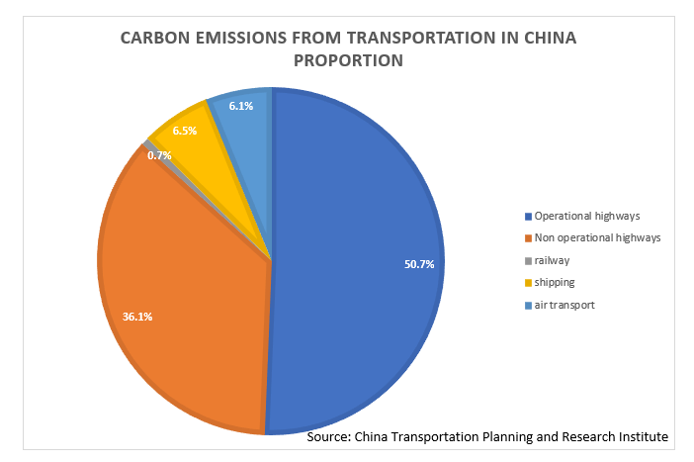
Figure 1.3 Carbon Emissions From Transportation in China Proportion
Source: [37]

- Green IT helps vehicles become intelligent, achieving energy conservation and carbon reduction
The typical application scenarios of the Internet of Vehicles can reduce the energy consumption level of vehicles, which is an important means to achieve carbon reduction in the transportation sector. Based on the Internet of Vehicles technology, intelligent driving scenarios such as green wave traffic guidance, lane merging assistance, formation driving, and ecological path planning can be achieved. Through digital means, drivers can avoid driving behaviors such as sudden events or adverse road conditions, such as sudden acceleration, deceleration, and ineffective idling, effectively reducing driving energy consumption [38].
2. Green IT support improves travel habits and optimizes travel structure
The Internet of Vehicles can optimize the level of public transportation services, effectively improve vehicle utilization and sharing rates, improve travel habits, build a green travel system, and achieve comprehensive carbon reduction. In terms of the public transportation system, smart public transportation based on the Internet of Vehicles can achieve "person vehicle road station cloud" collaboration, create application functions such as priority traffic at intersections, precise guidance, and beyond line of sight perception, improve the safety and efficiency of bus operation, and optimize the user riding experience in multiple dimensions. In terms of shared transportation, networked autonomous driving taxis can enhance operational safety and optimize operational efficiency by adding collaborative capabilities between vehicles and roads, as well as between vehicles and platforms, on the basis of single vehicle autonomous driving [39].
3. Green IT empowers digital governance and improves transportation efficiency
The Internet of Vehicles can support overall optimization of regional transportation, improve transportation capacity per unit time and area, and improve the efficiency of regional transportation. In urban road scenarios, based on vehicle networking technology, precise control of traffic signals, priority access for special vehicles, and control of vulnerable traffic participants can be achieved, optimizing the efficiency and effectiveness of digital traffic governance. In the scenario of highways, it is possible to enhance the perception ability, dynamic control ability, and service capacity of roadside vehicles, achieving visual, measurable, and controllable road conditions, thereby effectively reducing the frequency of traffic accidents, reducing economic losses, and improving logistics transportation efficiency.
4. Green IT management promotes optimization of charging and discharging
Green IT assists in the phantomization management of new energy vehicle charging stations, achieving digital and intelligent charging modes to promote energy substitution in the transportation sector. Green IT makes it possible for electric vehicle charging and discharging to gradually transition from disordered mode and single-phase ordered mode to bidirectional ordered mode. There will be three feasible management measures: firstly, on the premise of meeting the charging needs of users, the supply side can reasonably schedule the charging load; The second is to use technology, policies, and pricing methods to guide demand side "peak shifting" and regulate the balance of electricity demand and load; The third is to establish a microgrid, and build distributed photovoltaic and energy storage units within the microgrid of the park to alleviate the impact of electric vehicle charging and discharging loads on the public grid. Through green IT technology, on the one hand, we can obtain the time of use electricity price information released by the power grid, and on the other hand, we can obtain the information of electric vehicle batteries connected to the power grid. Based on this two information, we can flexibly adjust the charging power of electric vehicles within our jurisdiction, the power supply of distributed photovoltaic power stations and energy storage units, and thus achieve optimization of electric vehicle charging and discharging.
Fully leverage the fast response capability of electric vehicles to charge and discharge loads, and participate deeply in grid scheduling after scaling up, further promoting the consumption of renewable energy. Distributed photovoltaic power generation can utilize the changing needs of electric vehicles distributed in workplaces and other places during the day for consumption; Wind power generation has the characteristic of anti-peak regulation, which can utilize the changing needs of electric vehicles distributed in residential areas and other places at night for consumption.
An example of green IT management in the construction of China's smart transportation system:
(1) Green IT helps vehicles become intelligent and achieve energy conservation and carbon reduction: In addition to labor and vehicle costs, for many logistics companies, truck fuel consumption accounts for about 30% of monthly operating costs. A certain brand of truck adopts intelligent driving technology and innovatively proposes the "system fuel saving" concept of chassis bridge integration. Unlike traditional fuel saving methods, drivers only need to turn on the cruise switch, and the vehicle can perceive road information ahead in advance, and automatically match the best speed for driving, achieving a comprehensive fuel efficiency of 4%.
(2) Green IT support optimizes travel structure and improves travel efficiency: A leading area for connected vehicles has further developed customized smart public transportation based on connected vehicles. Big data on travel has been sorted out in a certain area, and the commuting patterns of surrounding residents have been mined based on location big data to select popular departure points and route stations. The customized public transportation demonstration line based on the Internet of Vehicles has reduced commuting time from nearly 1 hour to no more than 30 minutes, and nearly 1/4 of passengers have switched from commuting by car to taking customized public transportation. In just half a month, more than 700 people have switched from driving to taking public transportation, which is equivalent to reducing carbon emissions by 1.27 tons for one-way travel.
(3) A certain city has developed an intelligent public transportation system based on vehicle networking technology, which can provide drivers with driving speed advice, lane changing planning and other auxiliary driving information, helping to reduce the jerky start stop of vehicle driving and optimize lane changing strategies. As a result, each vehicle can save nearly 20000 yuan in fuel costs per year, and it is estimated that fuel consumption can be reduced by about 10% [40].
(4) Green IT helps optimize charging and discharging: A certain electric vehicle service company has achieved plug and play charging and power regulation at public charging stations, achieving orderly charging. Pilot projects will be carried out with green IT to support vehicle networking, vehicle to grid (V2G), and two-way interaction between vehicles and the grid. Bidirectional interaction can significantly suppress power fluctuations in the charging network and effectively reduce energy loss.
Through the above application examples, we can clearly see that various technical tools are widely used in practical green IT management to support and achieve the goals of green IT management. These tools not only help reduce resource waste and energy consumption, but also improve efficiency, reduce costs, and ultimately achieve more sustainable IT management.
By summarizing the application examples of these tools, it can be concluded that:
Comprehensive solutions: Green IT management often requires comprehensive solutions, including the collaborative application of 5G communication, Internet of Things, blockchain, cloud computing, edge computing, artificial intelligence, machine learning and other tools.
Real time and intelligence: The application of these tools emphasizes real-time and intelligence, which can quickly respond to changes, automate decision-making, and continuously improve the use of energy and resources.
Data driven decision-making: The application of Internet of Things, cloud computing, artificial intelligence, and machine learning technologies enables decision-making to be more based on data and facts, improving the scientific and accurate management.
Reducing environmental impact: The application of these tools helps to reduce the environmental impact of enterprises, reduce carbon emissions and resource consumption, and is in line with the concept of sustainable development.
Overall, green IT management has become a strategic decision to improve efficiency, reduce costs, and enhance enterprise competitiveness.

CHAPTER 2

MANAGEMENT ANALYSIS AND RESEARCH ON THE CONSTRACTION AND OPERATION OF GREEN DATA CENTERS IN CHINA

2.1. Definition, Function, and Characteristics of Green Data Centers

A data center is the infrastructure used by an organization or unit to centrally place computer systems and related equipment such as communication and storage; It may also be through outsourcing where many other companies store their equipment or data, most commonly in a building. Internet data center refers to a service platform with complete equipment (including high-speed internet access bandwidth, high-performance local area network, secure and reliable computer room environment, etc.), professional management, and comprehensive applications [41].
The difference from data center is that it has network access and provides services to the outside world. Cloud computing data center refers to a data center that is adaptable to cloud computing, defined through software, and provides elastic services to the outside world. Because the narrow IDC industry only rents out to the cabinet level, while customers provide servers and storage themselves, the difference between cloud computing data centers and traditional internet data centers mainly lies in network equipment and network architecture, in order to meet the characteristic that the internal traffic (East West traffic) of cloud computing data centers is greater than the external traffic (North South traffic) [42].
Cloud computing data centers have the following characteristics:
1. They are generally associated with large-scale data centers, so optimizing details is of great significance.
2. Abstracting all software and hardware resources as services, flexible, elastic, and scalable.
3. Has accelerated the technological evolution of infrastructure.
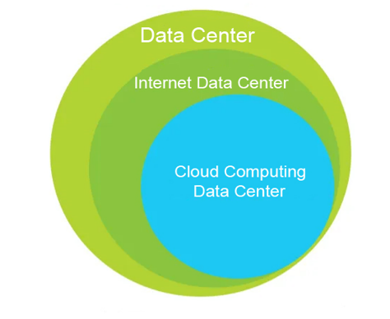
Figure 2.1 The relationship between Data Center,
Internet Data center and Cloud Computing Data Center
(Source: compiled by the author based on [42], [43])

Data centers are the "brain" of the Internet, processing, storing, and transmitting the data behind the countless information services we rely on every day, whether it's streaming video, email, social media, online collaboration, or scientific computing.
The data center utilizes different information technology (IT) devices to provide these services, all of which are powered by electricity.
The server provides computation and logic to respond to information requests, while the storage drive accommodates the files and data needed to meet these requests. Network devices connect data centers to the internet, enabling both incoming and outgoing data streams.
The electricity used by these IT devices will eventually be converted into heat, which must be discharged from the data center through cooling equipment that also relies on electricity operation. The basic architecture of a typical data center includes three major parts: power system, refrigeration and cooling system, and IT equipment system. The power system includes a reliable power supply system and a distribution system including UPS to ensure temporary power supply in case of abnormal power supply; The IT equipment system includes servers, storage devices, network switches, routers, and other network devices. Refrigeration and cooling systems typically consume a large amount of energy, making them important considerations in the design process of data center construction. Therefore, they are also the most differentiated areas among various data centers.
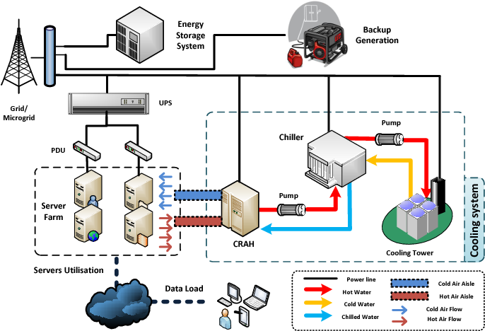
Figure 2.2 Typical Data Center Structure and Work Diagram
(Source: compiled by the author based on [44], [45], [46])

A green data center is a type of data center that aims to minimize energy consumption and environmental impact. Its main characteristics include the use of renewable energy, high energy efficiency, waste heat recovery, and the adoption of environmental protection technologies. This data center adopts a series of sustainability strategies aimed at reducing carbon emissions, lowering energy costs, and improving resource utilization efficiency.
The main direction for reducing energy consumption is to enhance energy efficiency: Green data centers adopt efficient servers, cooling systems, and power management technologies to ensure that the operation of data centers does not waste energy. This includes the use of energy-efficient servers and virtualization technology to fully utilize the performance of physical servers and reduce unnecessary energy waste.
The key to reducing environmental impact is:
1. Carbon emission reduction: By reducing energy use and adopting renewable energy, green data centers can help reduce carbon emissions and mitigate the impact of climate change. Such as solar and wind energy, to meet some or all of the energy needs, thereby reducing dependence on fossil fuels.
2. Waste heat recovery: Waste heat recovery technology reuses the heat generated, such as for heating or cooling other equipment, to reduce waste of heat energy.
3. Battery recycling and electronic waste management: The Green Data Center is committed to managing and disposing of discarded electronic devices and batteries to reduce the negative impact of electronic waste on the environment.
In sustainable practices, the following two points can be achieved:
1. Lifecycle management: Green data centers adopt a lifecycle management approach, considering the entire lifecycle of equipment, including procurement, use, and processing, to minimize resource waste.
2. Green Building and Design: The building and design of data centers use environmentally friendly materials and technologies to reduce environmental impacts, such as energy-efficient building materials and design, natural ventilation, and lighting.
The main goal of green data centers is to provide efficient and sustainable data processing and storage solutions to reduce energy consumption and environmental impact in the growing digital age. The practices of these data centers help create a more sustainable digital economy while mitigating climate change and protecting the Earth's ecosystem. The construction and operation management of modern green data centers is the most in-depth, intuitive, comprehensive, and representative example of green IT management.

2.2 Research on the Green Status of Global Data Centers

In the information age, new generation information technologies such as cloud computing, big data, the Internet of Things, and artificial intelligence are rapidly developing, and data is showing explosive growth. As a key infrastructure supporting the digital society and economy, data center construction has become a trend. Major countries and enterprises around the world are embarking on the path of digital transformation, and driven by this trend, global data center IT investment is showing a rapid growth trend. The growth rate of global data center IT investment scale continues to be higher than the global GDP growth rate.
The data center business is showing explosive growth, and the scale of the data center is rapidly expanding, which is accompanied by high energy consumption and the continuous growth of energy consumption in the data center.
The energy consumption of data centers can be divided into three parts: IT equipment energy consumption, air conditioning energy consumption, and power supply energy consumption. Among them, IT equipment energy consumption can be further divided into processor energy consumption and storage energy consumption. Power Usage Efficiency (PUE) is an indicator proposed by The Green Grid (TGG) in the United States in 2007 to evaluate the energy utilization efficiency of data centers. It is currently widely used in the data center industry worldwide. According to the definition of TGG, the formula for calculating PUE is: PUE=Pt/PIT, where Pt is the total annual electricity consumption of the data center, in KWh; PIT is the annual power consumption of IT equipment in the data center, measured in kilowatt hours. The power consumption of IT equipment in a data center is included in the total power consumption of the data center, so PUE is a value greater than 1.
The lower the PUE value, the lower the energy consumption of the data center for use outside of IT equipment, and the more energy-efficient it is. According to TGG's calculations in 2007, at that time, the amount of electricity consumed by air conditioning and power supply equipment in data centers generally exceeded the power consumption of IT equipment itself, resulting in a PUE greater than 2.
In order to reduce PUE, it is common internationally to build green data centers through the application of energy-saving, water-saving, low-carbon and other technological products, as well as advanced management methods, to achieve maximum energy efficiency and minimize environmental impact. The US government has implemented measures such as the Data Center Energy Star and the Federal Data Center Integration Program, while the EU has implemented the Data Center Energy Efficiency Code of Conduct to reduce data center energy consumption.
Since its establishment in 2006 by IT giants such as AMD, HP, IBM, and Sun Microsystems, TGG has carried out the formulation of data center energy-saving standards and the promotion of best practices, established a promotion mechanism for green data centers, guided the improvement of energy conservation and environmental protection levels in data centers, and assisted enterprises in reducing energy consumption in data processing [47].
In 2014, data centers in the United States used approximately 43% of their total power consumption to run their servers, and data center infrastructure also consumed approximately 43% of its power, including cooling systems, lighting systems, power supply, security, and more [48].
Storage drives account for 11% of total power consumption, while network power consumption accounts for 3% of total power consumption. According to this calculation, the PUE has been reduced to approximately 1.75.
From 2010 to 2018, global internet users and services grew rapidly, with improvements in data center server efficiency and service utilization resulting in a sixfold increase in computing instances, while global energy use only increased by 25% [49].
The data also shows that the improvement in storage drive efficiency and density has increased storage capacity by 25 times, while from 2010 to 2018, global energy use only increased by 3 times, as shown in the figure.
Advanced cooling technology has improved the efficiency of infrastructure.
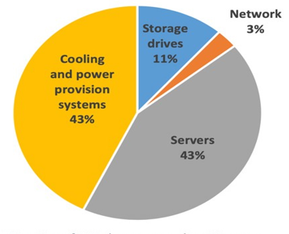
Figure 2.3 Fraction of U.S. data center electricity use in 2014
(Source: compiled by the author based on [50])
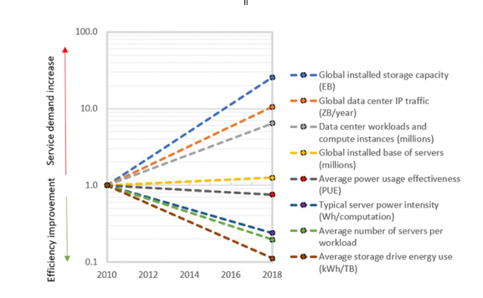
Figure 2.4 Relative change in global data center energy use drivers
(Source: compiled by the author based on [51])

This is mainly due to the efficiency improvement brought about by technological progress.
Firstly, due to the steady technological progress of IT manufacturers, the energy efficiency of IT equipment (especially servers and storage drives) has been greatly improved.
Secondly, increasing the use of server virtualization software allows multiple applications to run on a single server, significantly reducing the energy intensity of each hosted application.
Thirdly, most computing instances have been migrated to large clouds and ultra large data centers, which utilize ultra efficient cooling systems (as well as other important efficiency practices) to minimize energy use. It can be clearly seen from the figure below that the proportion of large-scale and ultra large scale modern data centers has been increasing from 2010 to 2018 [52].
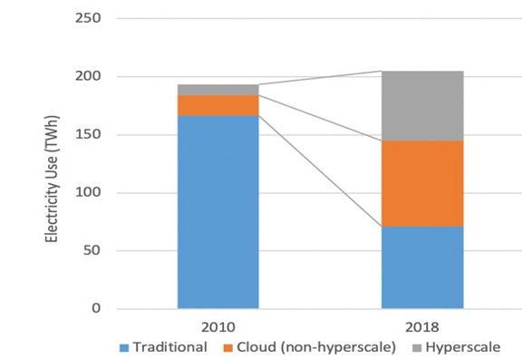
Figure 2.5 Estimated global data electricity use
by data center type 2010 and 2018
(Source: compiled by the author based on [53])

According to data from Uptime Institute, LLC, a third-party certification body and data center standards organization, the average power efficiency (PUE) of large data centers worldwide has decreased from 2.5 in 2007 to below 1.6 year by year, with advanced data centers achieving PUE below 1.2. The average annual PUE of the world's large databases in 2022 has dropped to 1.55.
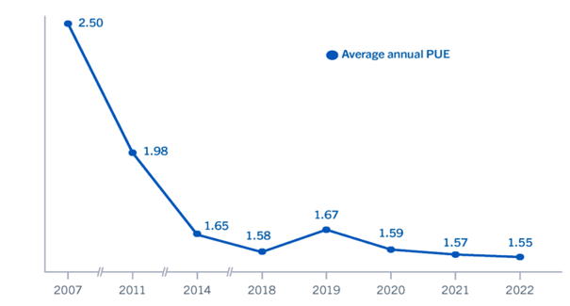
Figure 2.6 Average annual PUE 2007~2022
(Source: compiled by the author based on [54])

The United States, as one of the most prosperous and trendsetting countries in the world's technology field, is renowned for the emergence of numerous large internet companies. These globalized large internet companies have always been at the forefront of global green data center construction, not only with their leading technology and innovative strength, but also with their positive sustainable vision and strong environmental commitment, making outstanding contributions to the progress and evolution of the global green data center field.
These giant companies are actively driving the data center industry towards a more sustainable and energy-efficient direction, achieving significant energy savings through the widespread adoption of renewable energy, innovative technologies leading energy efficiency, and hardware optimization. Not only that, they also ensure the best environmental practices through their layout and management of data center networks on a global scale, striving to reduce carbon emissions and minimize the impact on the environment.
1. Facebook Data Center: Facebook's Prineville data center is a highly anticipated low PUE data center. This data center is Facebook's first self built data center, which has been well-known for its ultra-low PUE level since it was put into use in 2011. In addition, it uses a pure natural air cooling system without compression circulation, which has attracted countless attention. The fully loaded PUE of Prineville data center is only 1.07.
The cooling system of the data center has been innovatively designed, using direct evaporative cooling technology to dissipate heat from the data center equipment. No need to build chillers, eliminating the need for related cooling towers, pipelines, pumps, and control devices, greatly reducing construction costs.
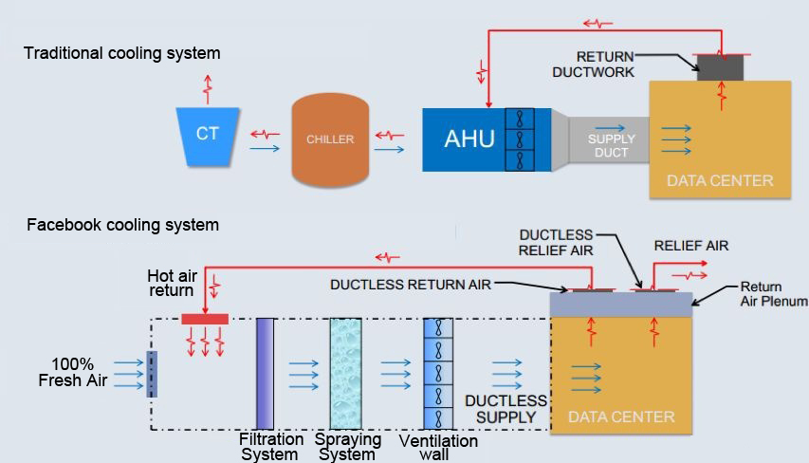
Figure 2.7 facebook cooling system and Traditional cooling system
(Source: compiled by the author based on [55])

The main characteristics of the cooling system in this data center are: using a 100% natural air evaporative cooling and humidification system, without the need for air conditioning; Part of the heat discharged from the data center is used for office heating, while another part of the heat is mixed with outdoor fresh air to meet the temperature requirements of the internal airflow in the data center before being sent to the data center; The entire airflow system does not use a piping system.
In addition to innovative design for the cooling system with the highest proportion of energy consumption, its efficient and energy-saving circuit system also greatly reduces electrical energy loss.
Facebook also designed its own OCP server, which stripped away anything unnecessary for efficient operation, removed plastic barriers, paint, and installation screws. This concise design allows for the installation of larger fans and radiators with larger areas, while allowing air to flow more freely, resulting in much less energy required to maintain cooling and reliability not being affected.
Facebook's OCP server can also accept higher voltages and install small backup batteries nearby instead of central backup batteries that serve the entire building, so its distribution system will not waste energy by converting from one voltage to another multiple times or between alternating current (AC) and direct current (DC) like other data centers.
The experience of Prineville data centers has shown that innovative designs and technologies can significantly improve the energy efficiency of data centers, reduce environmental impacts, and save costs, which has a positive enlightening effect on the global process of data center greening.
Facebook continues to build its own green data center and designs targeted solutions based on the environment in which the new data center is located, in order to maintain a low PUE for the new data center. The latest PUE for the newly built data center in 2022 is 1.09 From the first self built green data center in 2011 to the end of 2022, Facebook has been constructing and operating 21 data centers [56].
The operation of all data centers has now achieved net zero emissions and has been supported by 100% renewable energy through the strategy of adding renewable energy to the local power grid, which also contributes to decarbonization of the power system. Facebook data center is one of the most efficient data centers in the world.
Facebook's continuous self built green data center and environment-based solution design demonstrate the company's commitment and successful practices in sustainability and green data center construction
2. Google Data Center: Google has always been a leader in sustainable and green data center construction, known for its outstanding achievements in carbon neutrality, efficient server design, PUE improvement, and green data centers.
As of October 2023, Google operates 24 data centers worldwide, located in different geographic locations to ensure high-performance and reliable services for global users. This distribution strategy also helps to reduce energy consumption during data transmission.
Google has been independently designing and manufacturing customized servers since 2001. These servers are designed with efficient power supplies, and their uniqueness lies in their direct installation of batteries on the machines, improving server efficiency and reducing energy consumption in the data center [57].
By continuously improving server design and hardware optimization, Google has built some of the most efficient servers in the industry. These servers not only improve performance, but also reduce energy consumption, thereby helping to reduce energy expenses in data centers. This innovation has had a profound impact in the data center industry.
Google became the world's first internet company to achieve carbon neutrality in 2007, which was an important sustainability milestone. Carbon neutrality means that Google not only makes efforts to reduce its own carbon emissions, but also offsets other carbon emissions through various projects, including investing in renewable energy projects and protecting forests. This commitment ensures that Google's overall carbon emissions are zero.
Google has always pursued ultimate energy efficiency by using efficient hardware and innovative technology to turn its data centers into truly green data centers.
Since the first reporting of PUE data in 2008, it has continuously innovated and achieved significant improvements in natural cooling, intelligent temperature control systems, and efficient power management.
The overall PUE value of all data centers has significantly decreased, averaging 1.1, making Google's data centers one of the most energy-efficient in the world, highlighting Google's outstanding performance in energy efficiency.
These measures not only help reduce carbon emissions, but also reduce energy waste, while providing excellent performance and reliability.
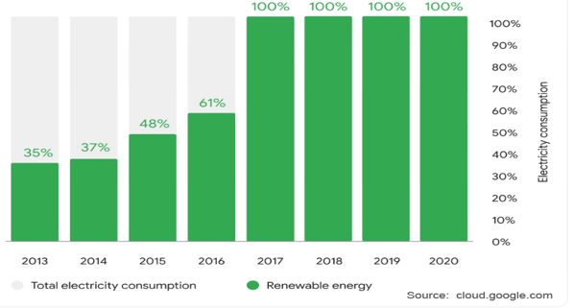
Figure 2.8 Google Renewable energy purchasing compared with total electricity use
(Source: compiled by the author based on [58])
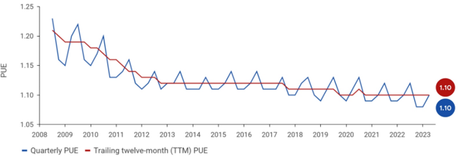
Figure 2.9 Average PUE of all google data centers
(Source: compiled by the author based on [59])
Google's sustainability commitment and achievements have set an example globally, inspiring other companies and data center operators to adopt more environmentally friendly and efficient methods for designing and operating data centers. This not only helps to reduce the impact on the environment, but also makes a positive contribution to global energy efficiency and carbon reduction goals, driving the world towards a more sustainable digital future.
The leadership position of these large internet companies in green data center construction has set an example for the global technology community, inspiring other organizations and countries to actively participate and advocate for sustainable development, and working together to create a more environmentally friendly and sustainable digital world for the future.

2.3 Analysis of China's Data Center Operation and Management Policies

China is one of the world's largest markets for internet users and data centers. With the rapid development and application of new generation information and communication technologies such as the internet, cloud computing, big data, and artificial intelligence, the digital economy, composed of digital industrialization and industrial digitization, is booming. Its total economic output accounts for more than one-third of China's GDP, and it also generates a massive amount of data that needs to be processed.
According to Data Age 2025 released by IDC, it is expected that by 2025, the total amount of data created, collected, or replicated in China will account for 27.8% of the global total data, with an exponential growth in data volume. As the main storage and processing entity for massive amounts of data, data centers continue to expand in scale and have become an important infrastructure affecting economic and social development.
In March 2020, the Chinese government upgraded the construction of data centers to a new type of infrastructure at the national strategic level.
The further expansion of its scale brought about the primary issue of energy consumption. Data shows that in 2016, the total power consumption of China's data centers exceeded 110 billion kilowatt hours, while the total power generation of China's largest hydroelectric power station, the Three Gorges Dam, was 83.9 billion kilowatt hours that year. By 2021, the power consumption of China's national data centers has rapidly climbed to 216.6 billion kilowatt hours, accounting for about 2.6% of the country's total electricity consumption. The carbon emissions are 135 million tons, accounting for 1.14% of the country's total emissions. During the same period, the power generation of the Three Gorges Dam was 103.649 billion kilowatt hours. In 2022, the power consumption of data centers in China reached 270 billion kilowatt hours. It is expected that China's data center power consumption will reach 350 billion kilowatt hours by 2025. To this end, China continues to carry out the construction of green data centers with the direction of green IT management and the goal of greater efficiency, promoting the green development of data centers.
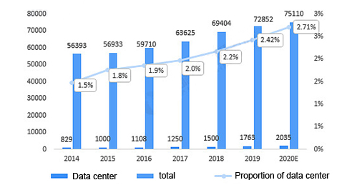

Figure 2.10 Power consumption and proportion of electricity consumption in China’s data centers from 2014 to 2020
(Source: compiled by the author based on [60])

As early as the end of 2013, as the region with the most concentrated data centers in China at that time, ten ministries and commissions in Beijing had jointly issued a document prohibiting the construction and operation of data centers with a PUE greater than 1.5. In March 2014, the Chinese Ministry of Industry and Information Technology issued the "Guiding Opinions on Further Strengthening Energy Conservation and Emission Reduction in the Communication Industry", which stipulated that starting from 2016, the PUE value of newly built large data centers must be less than 1.5.
However, for a considerable period of time, the energy consumption of various systems in Chinese data centers still accounted for about 45% of the total power consumption, with server systems accounting for about 50%, storage systems accounting for about 35%, network communication equipment accounting for about 15%, and air conditioning systems accounting for 40% of the total power consumption in data centers.
The power system and lighting system account for 10% and 5% of the total power consumption of the data center, respectively. According to the 2015 National Green Data Center Pilot Work Plan of the Ministry of Industry and Information Technology of China, the PUE of data centers in China is generally greater than 2.2, while the average PUE of data centers in the United States has dropped to below 1.7 during the same period.
The development model of Chinese data centers urgently needs to be iterated and upgraded, and there is an urgent need to overturn both the technological route and business model.
According to the 2021 China Data Center Market Report released by the China Data Center Committee (CDCC), the average PUE of China's data centers in 2021 was 1.49. According to regional statistical analysis, the average PUE in North China and East China is close to 1.40, with high levels of scale, intensification, and greening.
The average PUE value of data centers in central and southern China is close to 1.60 due to geographical location, listing rate, and various factors.
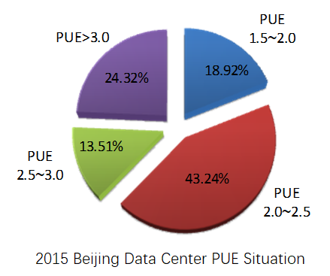
Figure 2.11 2015 Beijing Data Center PUE Situation
(Source: compiled by the author based on [61])

Against the backdrop of environmental pressure and continuous technological progress brought about by China's commitment to carbon peaking and carbon neutrality, the Chinese government actively guides and utilizes policy tools to promote the reduction of PUE in Chinese data centers.
At the same time, data center operating enterprises actively evaluate the economic benefits of green data centers through economic models such as lifecycle cost analysis and investment return analysis, and seek a balance between investment and returns.
Driven by both policy and positive benefits, China's data center PUE has been further reduced.
China is advancing from multiple aspects, accelerating its pursuit of the world's advanced data center energy consumption level, and achieving positive results.
The government's policy guidance and mandatory requirements, as well as the self-drive of enterprises in pursuing business efficiency, are the most important factors.
Government policy guidance and mandatory requirements
Chinese governments at all levels actively promote and guide the balanced layout and green and low-carbon development of data centers, and have issued a series of policy documents from the national to local level on efficient and energy-saving of data centers.
1. National level policies
The national level attaches great importance to the green development of the data center industry and has issued a series of relevant guidance opinions and work plans in the past decade. In 2013, the Ministry of Industry and Information Technology and others issued the Guiding Opinions on the Layout of Data Center Construction, guiding the construction of large and ultra large data centers to be prioritized in Class I and Class II areas such as the central and western regions. In 2017, the Ministry of Industry and Information Technology issued the "Guiding Opinions on Strengthening Energy Conservation and Emission Reduction in the Information and Communication Industry during the 13th Five Year Plan", proposing that by the end of the 13th Five Year Plan, the PUE value of newly built large and super large data centers should reach below 1.4. The United Nations Administration of Industry and Information Technology and the National Energy Administration issued the Guiding Opinions on Strengthening the Construction of Green Data Centers in February 2019, once again proposing that by 2022, the average energy consumption of data centers will basically reach the international advanced level, and the PUE of newly built large and super large data centers will reach below 1.4. In order to implement the State Council's Comprehensive Work Plan for Energy Conservation and Emission Reduction during the 13th Five Year Plan period and promote energy conservation and emission reduction in data centers, the National Development and Reform Commission, in conjunction with seven other ministries and commissions including the Ministry of Industry and Information Technology, issued the Action Plan for Green and Efficient Refrigeration in June 2019, proposing to "accelerate the formulation of energy efficiency standards for data centers and implement energy efficiency improvement projects for data center refrigeration systems."
In July 2020, the Ministry of Industry and Information Technology and six other departments jointly organized the recommendation of national green data centers, selecting a group of data centers with high energy efficiency, advanced technology, complete management, and strong representativeness for recommendation. They guided the data centers to improve the monitoring and management of PUE and WUE, increase the use of green technology, green products, and clean energy, and further improve the efficiency of energy and resource utilization.
In order to implement the strategies of building a strong cyber nation, digital China, national big data, and achieving carbon peak and carbon neutrality, the Chinese government continuously emphasizes the importance of green and high-quality development of data centers. In December 2020, the National Development and Reform Commission and four other ministries jointly issued the "Guiding Opinions on Accelerating the Construction of a National Integrated Big Data Center Collaborative Innovation System", proposing to strengthen the top-level design of national integrated big data centers, and once again calling for "accelerating the formulation of national standards for energy efficiency of data centers".
They proposed that "by 2025, the operational energy utilization efficiency of large and super large data centers should be reduced to below 1.3.". In 2021, the 14th Five Year Plan and the 2035 Long Range Goals pointed out the promotion of energy efficiency improvement in emerging fields such as 5G and big data centers. In May 2021, the National Development and Reform Commission and four other ministries released the Implementation Plan for the Collaborative Innovation System of National Integrated Big Data Centers, proposing the layout and construction of national integrated computing network hub nodes in the Beijing Tianjin Hebei, Yangtze River Delta, Guangdong Hong Kong Macao Greater Bay Area, Chengdu Chongqing, as well as Guizhou, Inner Mongolia, Gansu, Ningxia and other places, developing data center clusters, and guiding the intensive, large-scale, and green development of data centers. In November 2021, The National Development and Reform Commission and four other departments have released the Implementation Plan for Implementing the Carbon Peak and Carbon Neutrality Goals and Promoting the Green and High Quality Development of New Infrastructure such as Data Centers and 5G "By 2025, data centers and 5G will basically form a green and intensive integrated operation pattern.
The efficiency of electricity utilization and renewable energy utilization in data center operation will significantly improve, and the average electricity utilization efficiency of newly built large and super large data centers nationwide will be reduced to below 1.3. The national hub node will be further reduced to below 1.25, and the green and low-carbon level will reach 4A level or above."
2. Local level policies
Raise the construction threshold in hot areas, control new additions, and strengthen technical guidance to improve energy efficiency. Beijing, Shanghai, Guangzhou, Shenzhen and other super large cities have strong business demand but limited power resources. Due to limitations in energy consumption indicators, land use, and electricity approval, it is difficult to approve, construct, and expand, resulting in insufficient and insufficient supply. Policies have been successively introduced in various regions to alleviate the structural contradictions on the supply side and avoid the risk of "shoddy" construction of data centers under the stimulation of strong demand.
In 2018, Beijing updated the "Catalogue of Prohibitions and Restrictions on New Industries in Beijing"; In June 2020, Beijing issued several opinions on accelerating the cultivation and growth of new formats and models to promote high-quality economic development in Beijing, as well as the Action Plan for Accelerating the Construction of New Infrastructure in Beijing (2020-2022); In April 2021, the "Implementation Plan for Coordinated Development of Beijing Data Centers (2021-2023)" proposed that the PUE of new cloud data centers should not exceed 1.3, and successively released the "Several Provisions of the Beijing Development and Reform Commission on Further Strengthening Energy Conservation Review of Data Center Projects (Draft for Comments)" Notice of the Beijing Municipal Development and Reform Commission and the Beijing Municipal Bureau of Economy and Information Technology on Issuing the Comprehensive Governance Work Plan for Inefficient Data Centers in Beijing, continuously strengthening the energy efficiency governance of data centers.
Shanghai has successively released the "Three Year Action Plan (2018-2020) for Promoting the Construction of New Generation Information Infrastructure to Enhance Urban Energy Level and Core Competitiveness", "Guiding Opinions on Strengthening the Coordinated Construction of Shanghai Internet Data Centers", "Guidelines for the Construction of Shanghai Internet Data Centers (2019 Edition)", and "Guidelines for the Construction of Shanghai Internet Data Centers (2021 Edition)"; In 2020, mandatory local standards for data center energy consumption quotas were issued, which imposed restrictions on energy consumption in data centers; In June 2022, the Shanghai Municipal Commission of Economy and Information Technology and the Shanghai Municipal Commission of Development and Reform jointly issued the Implementation Opinions on Promoting the Healthy and Orderly Development of Data Centers in the City, proposing to "accelerate the upgrading and transformation of small and scattered old data centers, and accelerate the green and energy-saving development of data centers"; The Shanghai Municipal Administration of Communications has issued a notice on the "Computing Power Pujiang" Action Plan for New Data Centers (2022-2024), which requires that "newly built large and above data centers should meet the requirements of green data center evaluation, with a green and low-carbon level of 4A or above, improve the level of green energy utilization, and accelerate the transformation and upgrading of" scattered and old "data centers.".
Shenzhen City has issued a notice from the Shenzhen Development and Reform Commission on matters related to energy efficiency review in data centers, requiring key energy consuming units in data centers to build an energy consumption online monitoring system and access the energy consumption monitoring platform of Guangdong Province's key energy consuming units as required. Guangdong Province has released the Overall Layout Plan for 5G Base Stations and Data Centers in Guangdong Province (2021-2025).
Develop a unified evaluation and assessment system. We can see from it that the full lifecycle management of green IT management is included in the indicator items of the evaluation table.
Table 2.1
China National Green Data Center Evaluation Index Table 2021 Version
No. | Indicator | Score
I. Efficient utilization of energy resources
1 | Power Utilization Efficiency (PUE) | 60
2 | Compliance with design indicators | 3
3 | IT equipment load utilization rate | 3
4 | Renewable energy usage ratio | 2
5 | Water resource utilization efficiency | 2
II. Green design and green procurement
6 | Application of green advanced and applicable technology products | 7
7 | Clean energy utilization system | 5
8 | Green procurement | 2
III. Green management of energy resources
9 | Energy usage control | 4
10 | Water resource use control | 2
11 | Energy saving diagnostic services | 2
12 | Third party evaluation | 2
IV. Green management of equipment
13 | Management of Restriction on the Use of Hazardous Substances in Electrical and Electronic Products | 2
14 | Disposal of waste electrical and electronic products | 2
15 | Waste disposal | 2
V. Bonus item
16 | Comprehensive energy utilization such as renewable energy electricity consumption, green power certificate consumption, waste heat recovery, and battery cascade utilization | 3
17 | Standard and other green public services | 2
(Source: compiled by the author based on [62])
The Chinese government has formulated a green data center evaluation index system to promote energy conservation and efficiency improvement in data centers, guide data centers to follow the path of efficient, low-carbon, intensive, and circular green development, and help achieve carbon peak and carbon neutrality goals. The system assesses various indicators and continuously optimizes and iterates them in practice.
The 2021 version of the China National Green Data Center evaluation index system consists of 5 aspects and 17 indicator items, including efficient utilization of energy resources, green design and procurement, energy resource utilization management, equipment green management, and bonus points.
In addition to the policy requirements of governments at all levels and regions for the construction and operation of data centers, in order to save energy, promote environmental protection and resource recycling, the Chinese Ministry of Finance issued the "Green Data Center Government Procurement Demand Standard (Trial)" on March 20, 2023. Subsequent government procurement of related equipment and services will strengthen procurement demand management, only purchasing equipment and operation and maintenance services that meet the relevant indicators in the document, in order to promote Accelerate the greening process of China's data centers. From the 2021 version of the evaluation indicators and score distribution of China's National Green Data Center, we can see that the Chinese government has put forward strict requirements for the infrastructure and hardware of modern green data centers, and has also put forward clear requirements for the software indicators in the operation and management of data centers. At the same time, requirements are put forward for the environmental protection throughout the entire lifecycle of data centers, and excellent enterprises are encouraged to drive and promote the green and sustainable development of industries based on their own experience.
After the official implementation of China's National Big Data Computing Project in 2022, there have been some changes in evaluation indicators and weights. Optimize 17 indicators from 5 aspects into 15 indicators from 4 aspects. We have added indicators such as scientific layout and intensive construction of data centers, increased the weight of indicators such as green energy usage and computing resource efficiency, and further promoted the development of data centers towards more efficient and environmentally friendly directions from a policy perspective.
Table 2.2
China National Green Data Center Evaluation Index Table 2022 Version
No. | Indicator |  | Score
I. Energy efficient utilization
1 | Electric energy utilization efficiency | 40
2 | Renewable energy utilization level | 10
3 | Reduction level of comprehensive energy consumption per unit of information flow | 2
4 | Intelligent control level of energy utilization | 7
5 | Level of waste heat and cooling utilization | 4
II. Green and low-carbon development
6 | Water resource utilization level | 5
7 | Green procurement level | 5
8 | Green operation and maintenance level | 5
9 | Improvement of Green Transformation | 3
10 | Green public service level | 3
III. Scientific layout and intensive construction
11 | Scientific layout level | 3
12 | Intensive construction level | 3
IV. Efficient utilization of computing resources
13 | Cabinet resource utilization level | 4
14 | Utilization level of computing power load | 3
15 | Network resource utilization level | 3
(Source: compiled by the author based on [62], [63])

In 2023, a total of 43 green data centers, including communication, internet, public institutions, energy, and finance, were certified as national green data centers according to new evaluation indicators. From 2018 to 2023, China certified a total of 4 batches of 196 national green data centers.
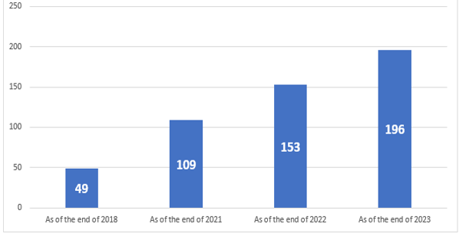
Figure 2.12 Number of National Green Data Centers in China from 2018 to 2023
(Source: compiled by the author based on [63])

In the era of digitalization, global demand for computing power is showing exponential growth, and data centers are experiencing a construction boom. Under the goals of carbon peak and carbon neutrality, the energy conservation, emission reduction, and green transformation of the data center industry are unstoppable, and green data centers have become an inevitable trend in the development of data centers. The construction of green data centers in China started relatively late, but the Chinese government is increasing its efforts to continuously promote and further guide the industry towards an efficient, low-carbon, intensive, and circular development path. At the same time, the self-driving force from enterprises pursuing efficiency also accelerates the development of green data centers.
From the self- driven pursuit of business efficiency by enterprises.
From the perspective of capital, maximizing profits is its highest pursuit, and investing to obtain greater returns is the driving force of capital. Traditional high-energy data centers typically account for over 60% of their total operating costs in terms of energy consumption costs throughout their lifecycle. Therefore, improving energy efficiency and reducing energy consumption costs is a feasible way for data centers to increase profits.
The data center project can be divided into four stages based on its own lifecycle: planning, design, construction, and operation. In each stage, there are upstream and downstream industries, and the construction stage involves a wide range of aspects, including land use, electricity consumption, water use, network usage, IT equipment, non IT equipment, land construction and other construction projects, software systems, and related costs.
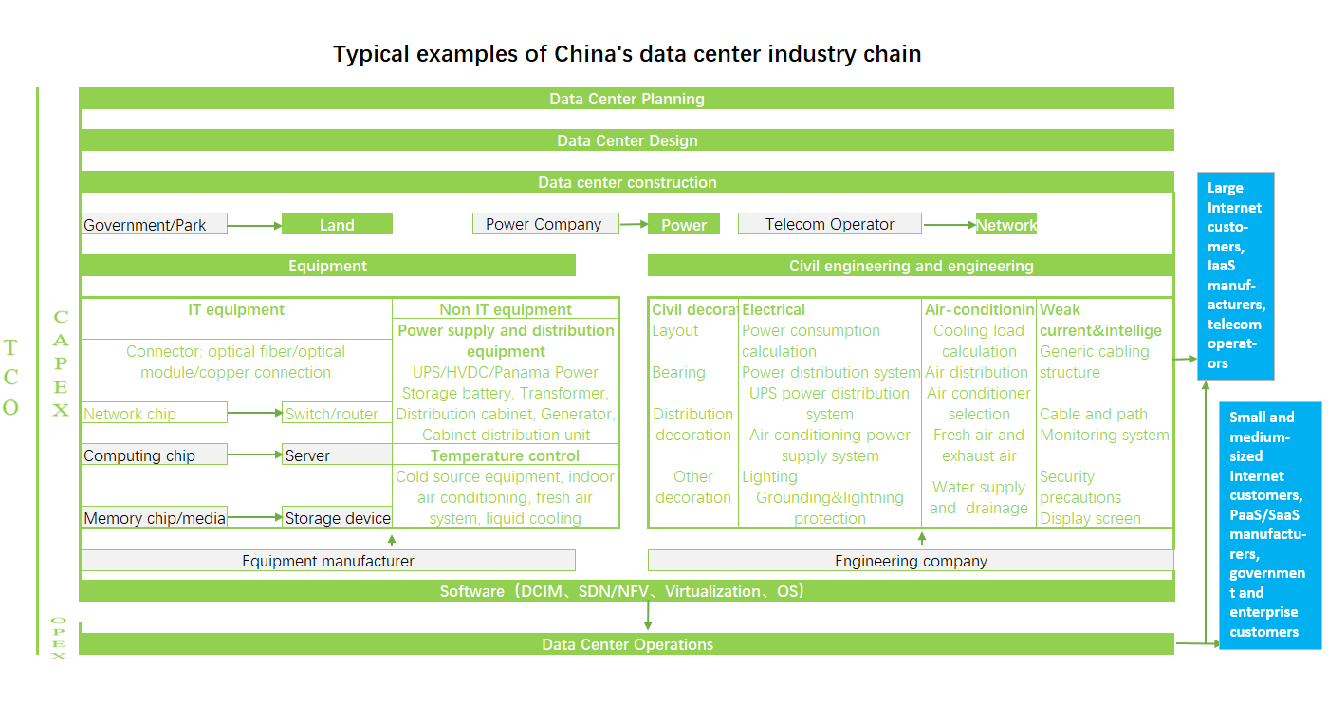
Figure 2.13 Typical examples of China’s data center industry chain
(Source: compiled by the author based on [64])
The overall cost of the data center is divided into two parts: construction expenditure (CAPEX) and operational expenditure (OPEX). The construction phase is usually a one-time investment. For traditional data centers or advanced green data centers, their IT software and hardware procurement costs are not significantly different, but the construction costs brought about by reducing PUE and being more environmentally friendly may vary. Therefore, it is necessary to use life cycle cost analysis and return on investment analysis to focus on analyzing the cost investment for achieving low air conditioning energy consumption and low power supply energy consumption, in order to select and formulate an optimal solution that takes into account low PUE, more environmentally friendly and profit maximization.
During the operation phase, costs mainly include: electricity costs, depreciation, rent, equipment costs, labor costs, etc. Currently, most Chinese data centers account for more than 50% of their operating costs through electricity bills. Therefore, controlling PUE can greatly control operating costs. 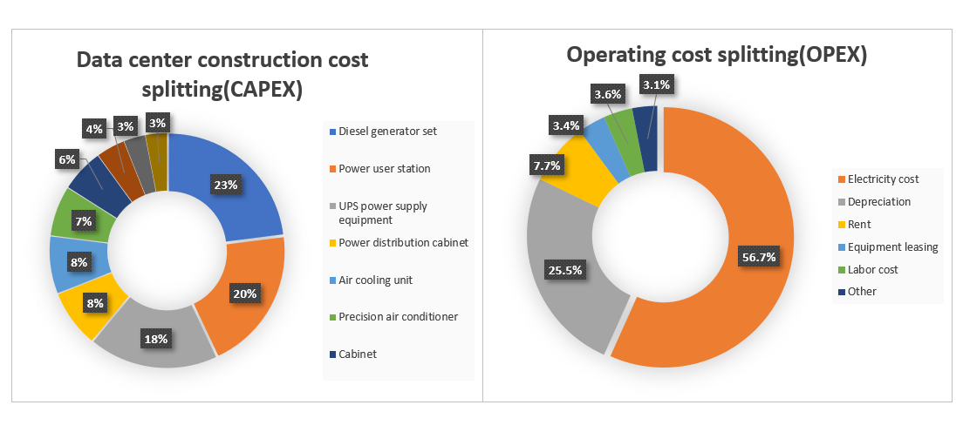
Figure 2.14 Data Center construction cost splitting and Operating cost splitting
(Source: compiled by the author based on [65])
We take a large data center A located in Beijing, China as an example to calculate the impact of green data centers on profits over a 10-year operating cycle.
Assuming that Model Data Center A can accommodate approximately 100000 servers, with an average power of approximately 200w per server and a typical load rate of 70%, the comprehensive PUE is calculated at 2.2 (as disclosed in the 2015 National Green Data Center Pilot Work Plan by the Ministry of Industry and Information Technology of China, the PUE of Chinese data centers is generally greater than 2.2), and the load remains stable, the operating power of the data center is:
Data center operating power=100000 * 0.2kW * 2.2 * 70%=30800kW
In Beijing, data center electricity is usually classified as "large-scale industrial electricity", with a unit price of 0.66 RMB per kilowatt hour (for industrial electricity, it is divided into peak electricity price, flat peak electricity price, etc.). In addition, there is a capacity electricity fee of 48 RMB per kilowatt hour based on the operating power of the data center.
From this, the annual total electricity cost bill for data center A can be roughly calculated, which includes annual electricity bills and capacity electricity bills based on the operating power of the data center. Annual electricity cost bill=0.66 * 30800 * 24 * 365+48 * 30800 * 12=195814080 yuan The total electricity cost for 10 years of operation is approximately 1.958 billion yuan.
According to the "Implementation Plan for Coordinated Development of Beijing Data Centers (2021-2023)", it is required that the PUE of new cloud data centers should not exceed 1.3. If the PUE of new green data centers is calculated according to 1.3, then: Data center operating power=100000 * 0.2kW * 1.3 * 70%=18200kW. Annual electricity cost bill=0.66 * 18200 * 24 * 365+48 * 18200 * 12=115708320 yuan. The total electricity cost for 10 years of operation is approximately 1.157 billion yuan. Based on the above calculations, a large data center that can accommodate 100000 servers, when it is a green data center with a PUE of no more than 1.3, the energy consumption cost for 10 years of operation is about 801 million yuan less than that of a traditional data center with a PUE of 2.2, saving 41% of energy costs. According to energy consumption accounting for 60% of operating costs, it is equivalent to a 24.6% decrease in overall operating costs, which is a very encouraging number.
Modern green data centers not only rely on green buildings and designs, as well as efficient refrigeration technologies to reduce PUE, but also include energy output through waste heat utilization. Therefore, compared to traditional high PUE data centers, green data centers not only reduce energy costs but also have the opportunity to increase revenue. In recent years, the price of electricity used by non residents in China has been increasing year by year, with a greater increase in electricity prices for high energy consuming industries. When China aims to achieve carbon peak and carbon neutrality ahead of schedule, the expected trend of electricity price growth remains unchanged, and carbon trading is also imperative. Therefore, green data centers have higher revenue expectations compared to traditional high PUE data centers.
According to the policy requirements announced by the Beijing Municipal Government in July 2023, Beijing has begun to implement differential electricity prices for high PUE data center projects: differential electricity prices will be levied on data centers with an annual energy consumption of 1000 tons of standard coal or an annual electricity consumption of 5 million kilowatt hours or more for new or renovated projects, and a PUE greater than 1.4.
The specific implementation standard is that for projects with PUE>1.4 and ≤ 1.8, the electricity price markup standard implemented is 0.2 yuan per kilowatt hour of electricity; For projects with PUE>1.8, an additional fee of 0.5 yuan will be charged per kilowatt hour of electricity. At the same time, it is required that new projects with an annual energy consumption of 5000 tons or more of standard coal be constructed with an energy consumption online monitoring system, which can measure PUE values in accordance with relevant standards and connect to the Beijing Energy Conservation Monitoring Service Platform.
The energy consumption online monitoring system should be designed, constructed, and put into operation simultaneously with the data center. Encourage projects with annual energy consumption of less than 5000 tons of standard coal to construct energy consumption online monitoring systems and connect them to the Beijing Energy Conservation Monitoring Service Platform. The data center should ensure the safe and stable operation of the energy consumption online monitoring system, as well as continuous, complete, and authentic data transmission. Therefore, as investors and operators, when having long-term business plans, they have a strong motivation to build high standard green data centers in order to achieve the goal of reducing operating costs.
The data center industry in China is continuously moving towards a more environmentally friendly and efficient green data center model, driven by both government policies and internal economic motivations of enterprises. This trend has a positive impact on multiple aspects, not only helping to reduce adverse impacts on the ecological environment, but also bringing significant economic benefits, especially in terms of electricity costs. This indicates that the data center industry is rapidly adopting advanced green technologies and efficient management practices to achieve long-term sustainable growth and provide strong impetus for achieving carbon reduction goals. In China, the government has been actively advocating for green and sustainable development, encouraging enterprises to adopt more environmentally friendly data center operations. This policy framework includes the development and certification of evaluation standards for green data centers, as well as clear requirements for the PUE of newly built data centers. These policies not only regulate industry behavior, but also provide corresponding incentives for data centers that meet standards. At the same time, the pursuit of maximizing economic benefits by data center operators themselves has also driven the development of green data centers. The main operating costs of data centers are usually concentrated on electricity consumption, so by increasing PUE and reducing electricity consumption, enterprises can significantly reduce operating costs and improve overall economic benefits. This economic motivation has led data center operators to actively adopt efficient energy management practices, such as optimizing refrigeration technology, waste heat recovery, etc., to improve profitability. Overall, the Chinese data center industry not only actively responds to global carbon reduction and sustainable development challenges under the guidance of policies and regulations, but also actively pursues the maximization of economic benefits. This comprehensive driving force has led the data center industry towards a more environmentally friendly, efficient, and sustainable future, making an important contribution to the achievement of China's carbon reduction goals.

CHAPTER 3

GREEN TRANSFORMATION OF CHINA'S EXISTING DATA CENTERS UNDER THE CHALLENGE OF GLOBALIZATION

3.1 Analysis of the Current Situation of China's Stock Data Centers

In recent years, the Chinese government has proposed in several government reports to accelerate the construction of a strong online country, Digital China. Building a digital China has become an important engine of Chinese path to modernization in the digital era, and is a strong support for building new advantages in China's national competitiveness. As an important part of digital infrastructure, data centers are defined as new infrastructure in China and are being fully promoted for construction.
In April 2023, The National Internet Information Office of China has released the Digital China Development Report (2022), which points out that "In 2022, the total scale of data center racks in China exceeded 6.5 million standard racks, with an average annual growth rate of over 30% in the past five years. The total scale of computing power in data centers in use exceeded 180EFLOPS, ranking second in the world. In 2022, the construction of computing power hubs in eight countries including Beijing, Tianjin, and Hebei entered the deepening implementation stage, with over 60 new data center projects and a new data center scale exceeding 1.3 million standard racks."
In the previous chapter, we discussed the increasing green requirements of the Chinese government for new data centers under the pressure of carbon peaking and carbon neutrality. The PUE of super large internet data centers built after 2018 has generally been low, and some data centers have reached international leading energy efficiency levels. The liquid cooled natural cooling source design adopted by Alibaba Hangzhou Renhe Data Center has an average annual PUE of 1.12, making it the world's largest fully immersed liquid cooled data center; By adopting indirect evaporative natural cooling technology, TikTok's traditional data center PUE has been reduced from 1.17 in 2018 and 1.16 in 2019 to 1.14 in 2020; Tencent, Baidu and other companies have also applied advanced refrigeration technology to achieve data center efficiency that is on par with international internet giants such as Google and Facebook.
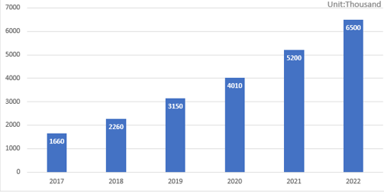
Figure 3.1 The Scale of data center racks in use in China from 2017 to 2022
(Source: compiled by the author based on [66])

Between 2018 and 2023, the Chinese government certified a total of 196 national green data centers in four batches. The Digital China Development Report (2022) points out that by 2022, the PUE of large-scale and above data centers planned to be built nationwide will decrease to 1.3. However, due to differences in construction time, functions, and other factors, the development level and energy efficiency of data centers in China vary greatly, especially for small and medium-sized data centers, where many PUEs are still above 2.0.
According to the 2018 National Data Center Application Development Guidelines released by the Ministry of Industry and Information Technology of China, the total scale of data center racks in China was 1.66 million in 2017, with 1844 data centers. There are a total of 36 ultra large data centers (designed with a capacity greater than 10000 standard racks), with a rack size of 283000 units; There are a total of 166 large data centers (with a design capacity greater than 3000 but less than 10000 standard racks), with a rack size of 545000. The average PUE of ultra large data centers in use is 1.63, and the average PUE of large data centers is 1.54. Among them, the average PUE of large and ultra large data centers put into operation after 2013 is less than 1.50. The average design PUE of national planned and under construction data centers is about 1.5, and the average design PUE of ultra large and large data centers is 1.41 and 1.48, respectively.
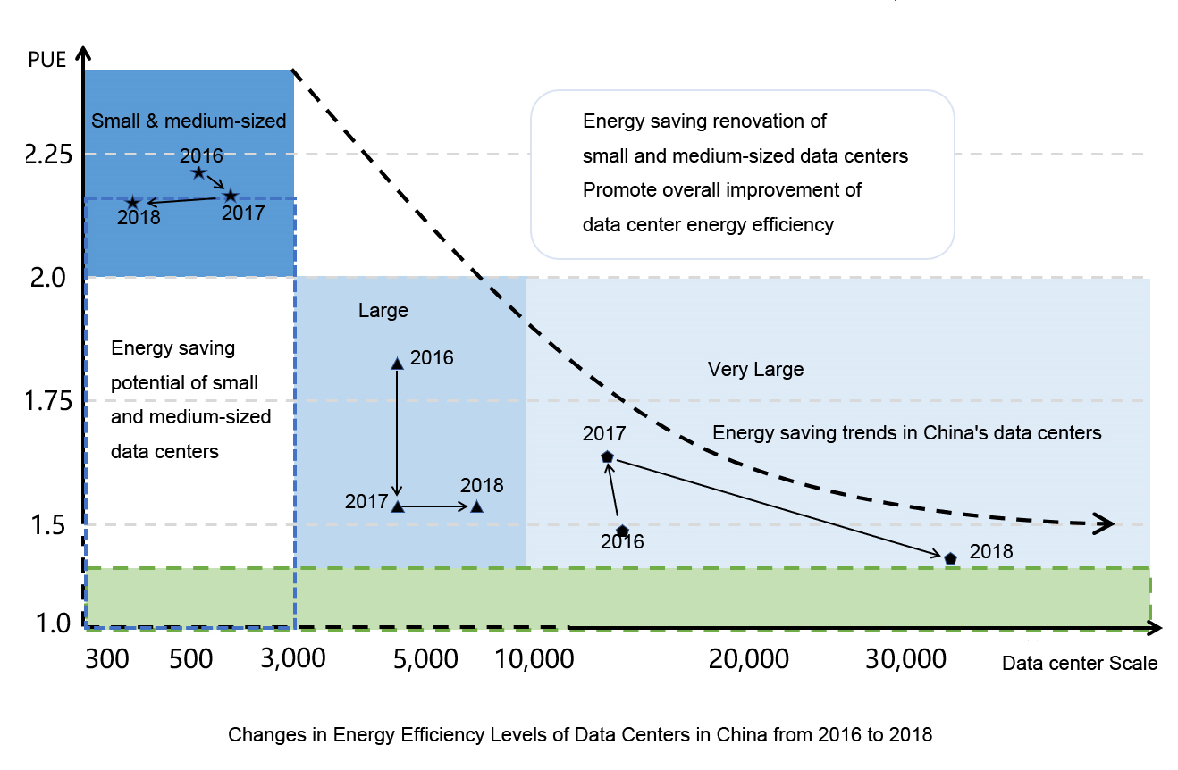
Figure 3.2 Changes in Energy Effciency Levels of Data Centers in China 2018
(Source: compiled by the author based on [67])

By 2022, the total size of data center racks in China will exceed 6.5 million standard racks, with an average annual growth rate of over 30%. The estimated size of racks in large and above scale data centers is 5.4 million, with an average annual growth rate of 45.5%. The estimated size of racks in small and medium-sized data centers is 1.1 million, with an average annual growth rate of about 5.7%.
From the above data, I can see that firstly, the total number of small and medium-sized data centers with high PUE continues to grow. In 2017, there were a total of 1642 small and medium-sized data centers, with 832000 racks, accounting for over 50%. By 2022, the total number of small and medium-sized data centers will increase to 1.1 million. It is necessary to guide the reduction of small and medium-sized data construction, and shut down and transform small and medium-sized data centers with high PUE and high environmental pressure. Secondly, the PUE of existing data centers, even for ultra large data centers, has reached 1.63, which is significantly too high, indicating that green transformation is necessary. Thirdly, the average design PUE of data centers under construction in 2017 was too high, and further optimization in terms of technology and economic benefits should be evaluated several years later.
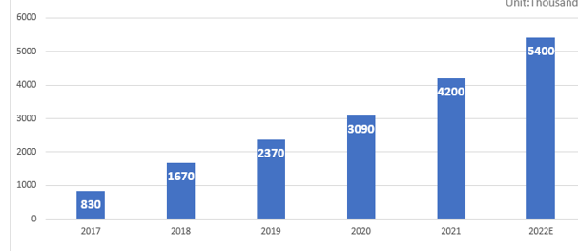
Figure 3.3 Forecast of the number of racks in large-scale and above data centers in China from 2017 to 2022
(Source: compiled by the author based on [68])

China has a vast territory, uneven economic development in various regions, uneven infrastructure development, significant differences in climate conditions, natural resources, etc. The eastern region has limited resources and space, but it is economically developed, has complete infrastructure, and is closer to the market and demand, making it the region with the highest density of data centers in China. The northern region usually has strong wind resources, making it suitable to use wind power as the main renewable energy source.
Data centers can adopt wind power generation systems to reduce dependence on traditional energy. At the same time, data centers can achieve heat dissipation by directly utilizing external cold air or adopting direct air cooling systems, reducing cooling costs. The southern region usually has abundant hydraulic resources, making it suitable for building hydroelectric power plants to provide clean and stable energy for data centers. A water cooling system is also a feasible option that helps improve energy efficiency. The western region usually has abundant solar and wind resources, which are suitable for the construction of solar panels and wind power generation to achieve clean energy supply. At the same time, the low temperature and high altitude environments in some western regions help improve the heat dissipation efficiency of data centers and reduce cooling costs.
From the annual average temperature situation in various regions of China, the Zhangbei region in Hebei Province has an annual average temperature of 3.7 degrees Celsius, the Ulanqab region in Inner Mongolia Autonomous Region has an annual average temperature of 4.3 degrees Celsius, and the Guangzhou and Shenzhen cities in Guangdong Province have an annual average temperature of over 22 degrees Celsius. In addition to lower temperatures, the Zhangbei region and Ulanqab also have abundant wind power resources, which can better provide clean energy for data centers. These natural conditions provide unique advantages for building green data centers in these areas.
Table 3.1
Annual average temperature of data center concentrated cities
BEIJING | 12.3℃ | XIAN | 13.7℃
SHANGHAI | 16.6℃ | JINAN | 14.7℃
GUANGZHOU | 22℃ | QINGDAO | 12.7℃
SHENZHEN | 22.6℃ | ZHANGBEI | 3.7℃
HANGZHOU | 16.5℃ | ULANQAB | 4.3℃
TIANJIN | 12.7℃ | GUIAN | 15.3℃
WUHAN | 16.6℃ | ZHONGWEI | 8.6℃
CHENGDU | 16.1℃ | LANGFANG | 12℃
NANJING | 15.5℃ | NANTONG | 15.3℃
(Source: compiled by the author based on [68-69])

The "East West Calculation" project vigorously launched by China is based on the limited resources and space in the eastern part of the country, tight power consumption indicators, higher computational costs, and a shortage of computing power; The western region is rich in renewable energy, clean energy, and land resources, with lower computational costs and superior climate conditions that can reduce energy consumption and carbon emissions. However, due to insufficient demand for computing power, data from the eastern region is transmitted to the western region for calculation and processing.
The "East Calculation and West Calculation" project under construction has grand planning and a more reasonable layout. And the existing data centers are more distributed in the economically developed southeastern regions that are closer to demand, closer to the market, and have better infrastructure, especially in Beijing, Shanghai, and Guangdong Province. Beijing is the capital and technology center of China, with a large number of data centers serving the government, enterprises, and the technology industry. Shanghai is the economic and financial center of China, as well as a major gathering place for data centers, providing support for the finance, manufacturing, and service industries. Shenzhen and Guangzhou in Guangdong Province are the centers of China's manufacturing and technology industries, and also have a large number of data centers.
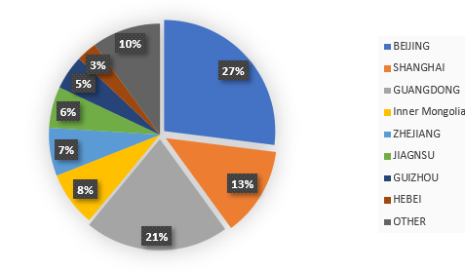
Figure 3.4 Distribution of large-scale data centers in China in 2018
(Source: compiled by the author based on [69])

Under the current development strategy of emphasizing green economy and sustainable development in China, the most developed regions in the country are also placing greater emphasis on high-quality economic development, emphasizing dual control policies on total energy consumption and energy intensity.
According to the 2021 government document of the Guangdong Provincial Government, the rapid growth of the data center industry and project construction scale poses significant challenges to the energy consumption dual control target task of the 14th Five Year Plan for National Economic and Social Development in Guangdong Province, based on the total energy consumption of data centers.
At present, the province has passed the energy-saving review and reached 1.2 million standard racks. Even if 50% of the projects release production capacity in the next five years, they will add more than 3 million tons of standard coal for comprehensive energy consumption, which will have a huge impact on the achievement of the province's energy consumption dual control goals, especially the goal of reducing energy intensity.
From the perspective of energy consumption intensity in data centers, the impact of data centers on the decrease in energy consumption intensity is significant.
Due to the fact that the energy consumption intensity of data centers is usually more than three times the average energy consumption intensity of the province, especially for data centers that mainly serve computing power businesses outside the province, such as the proposed Heyuan Alibaba data center, the energy consumption intensity can reach up to 5.25 tons of standard coal/10000 yuan, which is 15 times the energy consumption intensity of 0.35 tons of standard coal/10000 yuan per unit GDP in the province.
This type of data center has a particularly significant impact on achieving the goal of reducing energy consumption intensity It can be seen that data center businesses with high energy consumption and low output (relative to the ratio of energy consumption to GDP in other local industries) are being abandoned by some economically developed regions. From the previously highly sought after high-tech industry that can bring high added value, to the now despised and restricted high-energy consuming industrial industry.
Local governments in some economically developed regions have begun to clearly delineate red lines for shutting down or renovating existing data centers based on their PUE values.
In October 2023, the Shenzhen Municipal Government released the "Implementation Plan for Carbon Peak in Shenzhen", proposing to promote the green transformation of large and medium-sized data centers, gradually transforming or phasing out data centers with PUE higher than 1.4, and building new data centers with PUE lower than 1.25. In 2021, Guangdong Province and Hebei Province issued the "Several Policies to Promote the Healthy Development of the Digital Economy", which proposed that by 2025, all large or ultra large stock data centers with a PUE of 1.3 or above in Hebei Province must be vacated and shut down. Similar restrictive policies also occur in super cities like Beijing and Shanghai.
More and more local governments are promoting the transfer of green data center industries from central areas to surrounding areas to reduce resource, energy, and environmental pressures, while also paying more attention to the green transformation of existing data centers.
PUE is a key core indicator of green data centers, but green data centers are not just the concept of PUE, it includes considerations for maximizing resource utilization, minimizing environmental impact, and other aspects.
Moreover, with the advancement of technology and the development of the times, the connotation and requirements of green are constantly improving, increasing, and enhancing. Perhaps what was once considered an excellent data center is now seen as a relatively backward data center.
Energy conservation and emission reduction, green and efficient development, and green IT are always on the way, which is why the Chinese government is constantly iterating the evaluation standards for green data centers.

3.2 Methods and Examples of Green Transformation of China's Existing Data Centers

The green transformation of China's existing data centers is imperative.
The relevant technologies for the transformation of green data centers can be divided into: energy resource utilization efficiency improvement technology products (including efficient system integration technology products, efficient refrigeration/cooling technology products, efficient IT technology products, efficient power supply and distribution technology products, efficient auxiliary technology products), renewable energy utilization and distributed energy supply, microgrid construction technology products, waste equipment recycling and treatment technology products, etc The four types of green operation and maintenance management technology products can serve as important references for the transformation of green data centers.
The transformation of China's green data center can be carried out according to the following process
1. Conduct a survey and screening of data centers. Firstly, analyze the single machine power consumption, shelving rate, quantity, etc. of the server to determine the total power consumption of IT equipment. Then analyze the air conditioning type, power, and other cooling system power consumption ranges that need to be matched for the total IT power consumption. Then compare with the actual refrigeration system of the enterprise, calculate the difference between the two, measure the temperature and efficiency of on-site refrigeration, and finally draw preliminary conclusions on the refrigeration efficiency of the data center.
2. Classify data centers: The first category is data centers with poor energy efficiency that must be renovated; The second category is data centers with average energy efficiency but large scale, which are worth renovating; The third category is the implementation of data centers with strong feasibility, which are easy to transform without involving downtime issues.
3. After the initial screening of the renovated data center, a list of third-party diagnostic verification enterprises for selection shall be submitted to the data center party. The first party shall determine the third-party diagnostic enterprise for on-site diagnosis.
4. The construction party will enter and carry out green transformation of the data center.
5. The third-party diagnostic company will conduct another evaluation and acceptance of the data center.
Architecture and Building Thermal Engineering：
The purpose of building and building thermal energy-saving renovation is to optimize the structure of the computer room building and improve sealing. The main methods are to install insulation cotton and hollow bricks on the exterior walls, and to install rubber strips on doors and windows with poor sealing, in order to do a good job in the insulation of the data center.
Information System：
As the top energy user in data centers, the key to energy conservation in information systems is to choose low energy IT equipment and improve the energy efficiency ratio of IT equipment. The higher the energy efficiency ratio of IT equipment, the greater the amount of data that IT equipment can store, process, and exchange per unit of energy consumption. Improving the energy efficiency ratio of IT equipment can reduce the capacity and energy consumption of the electrical and air conditioning systems in the computer room, thereby bringing huge energy conservation and economic benefits. According to preliminary calculations, for every 1KWh decrease in IT equipment power consumption, the overall power consumption of the data center will decrease by more than 2KWh.
At the technical level, choose IT equipment with technologies such as low-power CPU processors, virtualization computing technology, efficient power supply, dynamic cooling, blade architecture, intelligent power management, and dynamic sleep. The equipment should be able to dynamically adjust the working and sleep status of various software in the system based on system operation requirements and load status, with priority given to using a liquid cooled rack. In terms of usage, the business processed by the data center should be reasonably graded and planned to improve code efficiency, enhance business processing capabilities and efficiency.
On the premise of ensuring the safety and stability of equipment operation, try to improve the utilization rate of IT equipment, save the number of running equipment, and timely use virtualization and cluster technology.
Ventilation and Air Conditioning Systems：
As the auxiliary system with the highest energy consumption in data centers, the cooling system is the key to improving energy efficiency in data centers.
At present, the common problems faced by data center refrigeration systems are:
- firstly, the operating mode is unreasonable, and most data centers require refrigeration comprehensively;
- secondly, the cold and humid environment is uneven, and there is a widespread phenomenon of local overheating in the computer room;
- thirdly, the processing flow is unreasonable, as there are simultaneous dehumidification and humidification phenomena in the same computer room;
- the fourth is the high energy consumption in the transmission and distribution process, especially the high power consumption of fans.
Therefore, energy-saving renovation of refrigeration systems has always been the focus and difficulty of green data center renovation.
For the green transformation of ventilation and air conditioning regulation systems, common measures include:
1. selecting efficient and energy-saving equipment, strengthening energy-saving management, controlling temperature and humidity, etc., to improve the comprehensive energy utilization efficiency.
2. Taking into account factors such as construction scale and power density, priority should be given to using systems with fully utilizing natural cold sources or with waste heat recovery.
3. Comprehensive renovation of ventilation, cold source, transmission and distribution, end systems, especially airflow organization. 4. Conditional data centers can use liquid cooling technology.
Table 3.2
General greening transformation measures of data center
Type | Main influencing factors | General energy-saving technical transformation measures
Building and building thermal engineering | Heat transfer of building envelope | New thermal insulation materials
Information system | Equipment selection and operation | Purchase efficient and energy-saving equipment, business classification and improve processing efficiency
Ventilation and air conditioning system | Ventilation system | Fan regulation and transformation
Ventilation and air conditioning system | Cold source system | Apply natural cooling source, purchase efficient equipment, improve system efficiency, etc
Ventilation and air conditioning system | Transmission and distribution system | Equipment update, frequency conversion transformation, etc
Ventilation and air conditioning system | End system | Temperature control and humidity control system, purchase efficient equipment, improve sensible heat ratio, etc
Ventilation and air conditioning system | Air distribution | Optimize air distribution
Electrical system | Power supply and distribution | Optimize system design, purchase efficient equipment and improve equipment efficiency
Electrical system | Standby power supply | Optimize system design, high-pressure diesel generator set, etc
Electrical system | Uninterruptible power supply | Select UPS power supply, etc
Electrical system | HV and LV distribution | Optimize layout, etc
Electrical system | Lighting | Energy saving lamps and intelligent control system
Electrical system | Renewable energy and comprehensive utilization of resources | Renewable energy, demand response, waste heat recovery, liquid cooling, etc
Operation and maintenance management system | Energy consumption monitoring system | Energy saving intelligent management
(Source: compiled by the author based on [70])
Architecture and Building Thermal Engineering：
The purpose of building and building thermal energy-saving renovation is to optimize the structure of the computer room building and improve sealing. The main methods are to install insulation cotton and hollow bricks on the exterior walls, and to install rubber strips on doors and windows with poor sealing, in order to do a good job in the insulation of the data center.
Information System：
As the top energy user in data centers, the key to energy conservation in information systems is to choose low energy IT equipment and improve the energy efficiency ratio of IT equipment. The higher the energy efficiency ratio of IT equipment, the greater the amount of data that IT equipment can store, process, and exchange per unit of energy consumption. Improving the energy efficiency ratio of IT equipment can reduce the capacity and energy consumption of the electrical and air conditioning systems in the computer room, thereby bringing huge energy conservation and economic benefits. According to preliminary calculations, for every 1KWh decrease in IT equipment power consumption, the overall power consumption of the data center will decrease by more than 2KWh. At the technical level, choose IT equipment with technologies such as low-power CPU processors, virtualization computing technology, efficient power supply, dynamic cooling, blade architecture, intelligent power management, and dynamic sleep. The equipment should be able to dynamically adjust the working and sleep status of various software in the system based on system operation requirements and load status, with priority given to using a liquid cooled rack. In terms of usage, the business processed by the data center should be reasonably graded and planned to improve code efficiency, enhance business processing capabilities and efficiency. On the premise of ensuring the safety and stability of equipment operation, try to improve the utilization rate of IT equipment, save the number of running equipment, and timely use virtualization and cluster technology.
Ventilation and Air Conditioning Systems：
As the auxiliary system with the highest energy consumption in data centers, the cooling system is the key to improving energy efficiency in data centers. At present, the common problems faced by data center refrigeration systems are: firstly, the operating mode is unreasonable, and most data centers require refrigeration comprehensively; Secondly, the cold and humid environment is uneven, and there is a widespread phenomenon of local overheating in the computer room; Thirdly, the processing flow is unreasonable, as there are simultaneous dehumidification and humidification phenomena in the same computer room; The fourth is the high energy consumption in the transmission and distribution process, especially the high power consumption of fans. Therefore, energy-saving renovation of refrigeration systems has always been the focus and difficulty of green data center renovation.
For the green transformation of ventilation and air conditioning regulation systems, common measures include: 1. selecting efficient and energy-saving equipment, strengthening energy-saving management, controlling temperature and humidity, etc., to improve the comprehensive energy utilization efficiency. 2. Taking into account factors such as construction scale and power density, priority should be given to using systems with fully utilizing natural cold sources or with waste heat recovery. 3. Comprehensive renovation of ventilation, cold source, transmission and distribution, end systems, especially airflow organization. 4. Conditional data centers can use liquid cooling technology.
Utilizing natural cold sources is an important way for data centers to improve energy efficiency. The utilization of natural cooling sources mainly includes three main forms: wind side natural cooling, water side natural cooling, and fluorine side natural cooling.
1. Wind side natural cooling technology is the most effective natural cooling technology in data centers, which directly uses outdoor low-temperature air to cool the data center room, reducing the heat exchange process. Wind side natural cooling is suitable for areas with good climate environment, good air quality, and cool climate. It is suitable for most severe and cold regions in China, and for some areas with hot summers and cold winters, as well as mild regions.
2. Water side natural cooling technology utilizes low-temperature cooling water to exchange heat with chilled water when the outdoor air humidity temperature is low, so that the chilled water meets the water supply temperature requirements or reduces the chilled water temperature, thereby reducing the opening time and intensity of the chiller. The application of natural cooling sources in typical cities has the lowest energy efficiency of 21% and the highest of 38%, indicating significant energy-saving effects. In the northeastern and northwestern regions of China, as well as the Qinghai Tibet Plateau, the energy efficiency rate is mostly above 50%.
From the perspective of application practice, Alibaba Qiandao Lake Data Center utilizes natural lake water cooling, adopts an open air conditioning system, and is equipped with water reservoirs and other equipment to ensure uninterrupted operation, with significant energy-saving effects; Tencent Data Center in Tianjin adopts multiple energy-saving technologies such as cold and hot channel isolation, water side natural cooling, natural wind cooling, frequency conversion technology, and time-sharing refrigeration, with energy-saving capabilities at a leading level in China; China Telecom's Yongfeng International Data Center has achieved significant energy-saving effects through new technologies such as ice storage, water-cooled natural cooling sources, high-voltage direct supply, decentralized power supply, solar energy, and scientific operation and maintenance.
Liquid cooling refers to the technology of using liquid as a heat transfer medium to exchange heat with heating components, thereby taking away heat. It has gradually become a breakthrough technology for reducing PUE values in data centers. From a technical perspective, liquids have good thermal conductivity and a large specific heat capacity. After absorbing a large amount of heat, their own temperature does not change significantly, and they can stabilize the CPU temperature. Under the condition of 40 degrees Celsius in the computer room environment, there is no need for air conditioning and refrigeration equipment, and the PUE can be significantly reduced to around 1.0. Therefore, they are considered one of the most reliable and feasible technical solutions to reduce energy consumption in data centers.
Electrical system：
The common energy-saving measures for electrical systems include: 1. Review the actual power consumption of electronic information equipment and the configuration capacity and redundancy of its power supply system, and modify it to ensure safety, so that the power supply equipment is in a high conversion rate load rate range. 2. Reasonably adjust the power supply and distribution system, and ensure that the capacity of transformers, distribution lines, and equipment meets the availability level of data center infrastructure. 3. Taking into account the adoption of renewable energy, peak valley energy storage, staggered cooling, liquid cooling, waste heat recovery and utilization technologies, we aim to improve the level of energy cleanliness and efficiency in data center utilization. Choose energy-saving lighting fixtures and fully utilize natural light.
Energy consumption management：
The energy consumption management of data centers should achieve comprehensive management of both large and small indicators, providing an overall solution for improving energy efficiency in data centers.
By adding an energy consumption detection system, monitoring objects such as power systems (including high-voltage transformation and distribution equipment, Central Asia transformation and distribution equipment, low-voltage distribution equipment, rectification and distribution equipment, converter equipment, power generation and energy storage equipment, etc.), air conditioning equipment (including refrigeration systems, air conditioning systems, distribution cabinets, decentralized air conditioning, etc.), and computer room environment (including environmental conditions, image monitoring, access control, etc.), Implement real-time data collection and analysis.
Upgrade the original system to an intelligent operation and maintenance management system that utilizes big data, AI algorithms, and other tools, so that it can adjust the working status of each system in a timely manner based on real-time changes in equipment status, load rate, and other operating conditions, as well as comprehensive factors such as different internal and external temperatures, humidity, water temperature, cold storage capacity, peak and valley electricity prices, so that each equipment system can meet redundancy requirements, Try to work in the state of optimal energy efficiency and intelligently adjust the air conditioning system.

Practical Cases of China's Green Data Center Transformation
1. Green Transformation of China Electric Power Construction Headquarters Data Center
1. Basic situation: The data center of China Electric Power Construction Headquarters is a self used data center for enterprises. The data center has been in operation for over 15 years. Through energy-saving diagnosis, it was found that the energy consumption of the data center is high, and the data center is difficult to meet the existing green data center standards. If the wiring distance under the data center rack is less than 30 centimeters, it hinders the air conditioning supply speed and affects the refrigeration efficiency; Unreasonable cabinet layout, mixing of hot and cold air, etc.
2. Transformation measures: The transformation of the data center includes multiple aspects such as location, environment, physical architecture, basic equipment, construction and maintenance of various systems.
Specifically, it includes:
- Optimize the overall rack layout for energy efficiency. The unified front placement mode of the original cabinet has been adjusted, and the cabinet layout has been arranged in a face-to-face and back-to-back manner, forming a cold and hot channel. The front of the cabinet is equipped with a cold channel and a ventilation floor. Cold air enters from the front of the computer room, and after the equipment absorbs heat, it naturally returns air from the top of the cabinet back to enter the air conditioning system. The air conditioning system forms a circulating air supply mode of down supply and up return, making it have good use and heat dissipation effects.
- Closed off the hot and cold channels. Added aluminum alloy and buckle plate ceiling, and adopted a return air louver form above the hot channel to ensure smooth return air. Install a return air cap between the air conditioner and the ceiling to create a negative pressure hot air return air layer between the floor and ceiling panels, enhance the efficiency of the air conditioner return air, and reduce refrigeration energy consumption.
- Energy saving renovation of air vents and temperature controlled flooring. Due to the long distance of precision air conditioning supply for some cabinets in the data center, the space under the floor is relatively low. Therefore, a temperature controlled ventilation floor is installed on the front of the cabinets 10 meters away from the precision air conditioning. The temperature controlled ventilation floor is equipped with an EC fan device, which can regulate and increase the air volume. The ventilated floor has an automatic adjustment function, which can automatically increase the cooling capacity when local hotspots appear in the cold channel.
- Energy saving renovation of electrical systems. UPS output distribution adopts intelligent distribution modules, which can detect the power supply indicators of each circuit. The design of the intelligent distribution system and the installation of the UPS system are in the same cabinet, adopting a modular structure. The configuration can be increased or decreased according to the changes in load capacity requirements, without the need to turn off the UPS output or distribution main input switch. At the same time, intelligent lighting and energy-saving measures such as turning on and off door lights will be adopted, and LED energy-saving lamps will be used for all data center lighting fixtures.
- Precision air conditioning equipped with energy-saving technology. Including:
1. High efficiency digital vortex compressor to ensure high energy efficiency ratio of the unit: Digital vortex compressor with high energy efficiency ratio is adopted. The compression process of the compressor is continuous and smooth; There is no heat exchange during the inhalation and compression process; The direction of refrigerant airflow remains unchanged during the compression process; Reduced airflow loss; Vortex compressors do not require high and low pressure valves; Reduced valve loss and prevented liquid hammer; Low starting current. The digital vortex compressor adopts digital control technology on the basis of the vortex compressor.
The digital vortex compressor can continuously adjust the capacity output between 20% and 100%, provide cooling capacity according to the needs of the computer room, ensure strict control of room temperature, reduce energy consumption, and reduce the number of starts and stops of the compressor, improving the reliability of the compressor.
2. The high-efficiency EC fan system adopts two high-efficiency EC fans for redundant design in the indoor fan system. EC fans have the advantages of high efficiency, energy saving, and adjustable speed, saving 20% energy compared to traditional fans. They can adjust the speed according to the refrigeration demand, reducing energy consumption under low loads. Featuring high redundancy, each fan is designed with approximately 25% margin.
3. The powerful linkage and group control functions of the iCOM controller are uniformly controlled and managed through Teamwork, achieving energy-saving control of the computer room environment.
4. Adopting fresh air pre cooling technology, the fresh air is pre treated to achieve indoor air conditions, reducing unnecessary humidification and dehumidification functions of precision air conditioning in the computer room, and reducing unnecessary air conditioning power consumption.
3. Transformation effect: Through energy-saving comprehensive transformation, the energy consumption of the air conditioning system in the data center has decreased by 20% -30%, and the utilization rate of the air conditioning system in the data center has increased from 50% to 90%; The PUE value of data centers has significantly decreased, meeting the requirements of Chinese government departments for large and medium-sized data center PUE values.
2. Intelligent Fresh Air System for Guizhou Information Park Data Center
1. Basic information:
The Guizhou Information Park Data Center is located in the southwestern region of China, with a warm and humid climate, belonging to a subtropical humid monsoon climate. The building area of the data center is approximately 8177m2, with 2 floors above ground and a building height of 11.5m. The total installed capacity is 1380 practical racks, with a total power consumption of 6900kW and a maximum cooling load of 7830kW for air conditioning.
2. Transformation content:
The cold source of the air conditioning system adopts 3 centrifugal chillers and 3 plate heat exchangers (both for two use and one backup). Each water-cooled centrifugal chiller is equipped with 1 plate heat exchanger (with the same heat exchange rate as the main unit), which utilizes low-temperature outdoor air in winter or transitional seasons.
The cooling tower provides low-temperature cooling water and exchanges heat with the plate heat exchanger. The other side of the plate heat exchanger is connected to the air conditioning end for supply and return water, By directly utilizing the low-temperature water provided by the cooling tower through a plate heat exchanger (which provides free cooling), the operating time of the chiller unit is reduced and energy consumption is reduced.
The intelligent fresh air system is applied in this project as a natural cooling source to provide cooling capacity for the data center. The intelligent fresh air system is activated under suitable outdoor environmental temperature conditions. The working mode of the intelligent fresh air system is that fresh air enters through the external wall inlet louvers, passes through the filtering section, EC fan (inlet), and is mixed with the return air in the air conditioning area of the machine room before being sent to the machine room (underfloor air supply).
After passing through the communication equipment in the machine room, hot air is discharged from the EC exhaust fan to the outside, thereby reducing the operating load of the centrifugal chiller unit and shortening the working time.
To ensure energy-saving operation of the system, variable frequency control is adopted for cooling towers, water pumps, etc. The cold water system adopts a centralized self-control system, and electric switching valves are used for system pipelines to achieve remote monitoring and automatic switching control, improving the overall energy efficiency of the air conditioning system.
3. Transformation effect:
This project adopts an intelligent fresh air system renovation mode based on the climate and environmental conditions in Guiyang area, replacing traditional air conditioning systems with all or part of external natural cooling sources for cooling. After adopting an intelligent fresh air system, the project can save energy by up to 16%, save 2.88 million kilowatt hours of electricity throughout the year, and reduce carbon dioxide emissions by 933 tons.
The refrigeration systems of data centers that use natural cold sources for cooling are mostly located in cold and dry areas in the north. The successful deployment of this case in Guizhou Province, which has a warm and humid climate, indicates that the application scope of natural cold sources is not limited to the north and has significant reference significance.
3. Renovation of Intelligent Group Control System in an Internet Data Center in Jiangsu Province
1. Basic information:
The total number of racks in a data center of a large operator in Jiangsu Province is about 5000, with an operating time of about 8 years. Before the energy-saving renovation of the data center, the average annual PUE was about 2.0, and the annual electricity cost before the renovation was about 120 million yuan (0.89 yuan per kilowatt hour).
Due to its long operation time, the data center has multiple overheating areas in the computer room, posing safety hazards; The disordered airflow organization and unreasonable air conditioning capacity configuration have resulted in energy waste.
2. Transformation mode:
The data center has been renovated to include an intelligent group control system.
On the premise of ensuring the security of the data center, control the on/off of air conditioning in each partition of the data center computer room. For the sake of ensuring the safety of data center operation, this section needs to have independent air conditioning on and off control based on the partition of the computer room. Each data center partition needs to set up independent control units for air conditioning on and off control, and can manually designate long-term backup units through this control unit.
N precision air conditioners are required for normal operation in the data center computer room. When the temperature in the data center computer room drops to a critical value (22), the group control system automatically turns off one air conditioner to achieve power saving. When the temperature in the data center room exceeds the critical value (24), the group control system automatically turns on a backup air conditioner to ensure the safe operation of the data center room.
Specific measures include:
Overall group control system. The overall group control system is the "brain" of the entire energy-saving transformation, controlling the addition and subtraction machines of precision air conditioning, air conditioning cold water main unit, and atomization spray system. Capable of controlling precision air conditioning and outdoor chiller units in the computer room, as well as monitoring the outdoor unit atomization spray system.
At the same time, temperature and humidity sensors are installed in the cold and hot channels of each partition in the project, and the temperature in the data center machine room is uploaded to the control layer DDC (Direct Digital Control) to control the addition and subtraction of precision air conditioning in each partition, achieving energy-saving goals.
Atomization spray group control. The control of the air conditioning outdoor unit atomization spray system is generally completed as a separate part of the entire group control system, and then the outdoor unit atomization spray control is integrated into the entire group control system.
Air conditioning cold water host group control. The main purpose of the air conditioning cold water host group control system is to control the addition and subtraction of cold water hosts based on the load of the air conditioning cold water host and the temperature of the data center, while ensuring the safe operation of the system, in order to achieve energy-saving goals.
The core of this group control system is the automatic control strategy of the air conditioning cold water host that can bring the maximum energy savings. The group control system of the air conditioning chiller unit calculates the real-time load of the chiller unit based on parameters such as the supply/return water temperature of the chilled water main pipe in the air conditioning chiller unit system, the operating voltage and current of the chiller unit, determines the load rate of the chiller unit, and then calculates the required number of chiller units and automatically controls their addition and subtraction (communication with the chiller unit can also be used for control).
Directly measuring the compressor power of the chiller unit, using the ratio of the rated power to the chiller unit load rate, and combining it with the main pipe temperature to determine the loading and unloading of the unit, is a simple and effective control strategy for the addition and subtraction of air conditioning chillers.
3. Transformation effect:
After the renovation of this project, the PUE has been reduced from 2.0 to 1.70, saving approximately 17.22 million kWh of electricity annually and approximately 15.33 million yuan in electricity bills. With the further increase in power consumption of IT equipment, annual power savings will continue to increase.
4. Smart energy-saving case of refrigeration system in a data center in Shanghai
1. Basic information:
A data center in Shanghai was opened in 2006 and is a five-star computer room. The total area is over 16000 square meters, with 3227 racks in use, totaling 6000 racks. We provide host hosting, rack rental, value-added services, and more than ten VIP zones for high-end customers.
The data center has a high energy utilization efficiency, with a PUE value of 1.42. However, due to its large scale and high electricity consumption, the average daily equipment electricity consumption before the renovation was 258000 kilowatt hours, and the average total daily electricity consumption was 366000 kilowatt hours. At present, the average electricity price in data centers is 0.6465 yuan/kWh, and reducing electricity costs has become an urgent need for data centers.
2. Renovation situation:
The object of data center transformation is the air conditioning system, which utilizes intelligent energy-saving control technology for refrigeration systems, combined with advanced information network technology and big data technology to achieve unified supervision and control of cold source system equipment, achieving centralized, intelligent, and energy-saving control of the central air conditioning refrigeration station system. The on-site intelligent control equipment is transmitted to the energy management cloud platform through remote communication, It can achieve synchronous intelligent control of the on-site control cabinet, local control center, and cloud platform of the central air conditioning refrigeration station.
The efficient cold station intelligent energy-saving control system is composed of three layers of architecture: the first layer is the equipment layer, including sensors, actuators, various control valves, etc., responsible for collecting basic data and the on/off of pipelines, such as temperature, flow rate, etc; The second layer is the control layer, which includes various relays, controllers, PCDs, and the control cabinets composed of them; The third layer is the upper computer global optimization system.
Six 800RT fixed frequency centrifugal chillers and one 800RT variable frequency centrifugal chiller are selected as the cooling source for the first phase of the project, corresponding to 127 precision air conditioners at the end; Five 900RT variable frequency centrifugal chillers were selected as the cooling source for the second phase of the refrigeration system, corresponding to 215 precision air conditioners at the end; Configure the chilled water pump, cooling water pump, and chiller one by one. In order to achieve energy-saving operation, a super efficient intelligent control system for the central air conditioning chiller room is constructed, which combines the operation data of the chiller, variable frequency control of the chilled water pump, variable frequency control of the cooling water pump, and variable frequency control of the cooling tower and end precision air conditioning. After joint simulation analysis, it is ensured that the entire refrigeration station system operates optimally in terms of overall energy efficiency while meeting the end cooling load requirements.
- Transformation effect:
Through intelligent energy-saving transformation of the refrigeration system, the data center can achieve an annual energy savings of 5.6 million KWh, save more than 3.64 million yuan in electricity bills, and achieve an energy-saving rate of 15%. Meanwhile, the investment payback period of this project is relatively short, and the cost can be recovered within three years.
From a practical perspective, although the operating time, type, and scale of China's existing data centers vary, most data centers still have some room for energy-saving renovation.
Firstly, natural cold sources play an important role in the energy-saving transformation of data centers. In practice, the utilization of natural cold sources can also play an important role not only in cold regions in the north but also in some data centers in the south.
Secondly, there is still room for conventional energy-saving renovations in data centers, such as optimizing airflow organization, rearranging cold and hot air ducts, and enhancing sealing. Especially for small and medium-sized data centers, the application of these technologies can achieve significant energy-saving benefits.
Finally, the operation and maintenance monitoring of energy consumption, as well as the intelligent management system, have opened up new ideas for energy-saving work in data centers.
In the past, energy conservation work in data centers focused on technological transformation, with insufficient attention paid to operation and maintenance management, energy consumption monitoring, and other aspects.
With the further compression of technological transformation space, especially the increasing demand for intelligence and comprehensive energy conservation in advanced green data centers, it is urgent to take the green transformation work of data centers to a new level through both technological innovation and strengthened operation and maintenance.

3.3 The Challenges and Opportunities of Green Transformation of China's Existing Data Centers

With the booming development of new generation information and communication technologies such as the Internet, cloud computing, big data, and artificial intelligence, the digital economy has rapidly risen, driving the generation, transmission, storage, and processing of massive amounts of data. In this digital economy era, data centers play a crucial role as the infrastructure that supports and carries digital applications. However, the continuous expansion of its scale is accompanied by the issue of high energy consumption, which has attracted widespread attention and concern.
In recent years, the Chinese government has gradually increased its efforts in the construction of green data centers, adopted a series of policy measures and standard formulation, and promoted the greening of data centers. During this process, the collaborative efforts of national and local authorities, industry associations, research institutions, and advanced enterprises have laid a solid foundation for the sustainable development of China's data centers.
Since 2020, new infrastructure represented by new technologies and applications such as 5G, big data, the Internet of Things, and artificial intelligence has played a huge role in promoting epidemic prevention and control and post epidemic economic recovery, becoming an important engine to adapt to economic development trends and promote social stability and development. As the basic guarantee for the orderly operation of new infrastructure, data centers are regarded as the "infrastructure of new infrastructure" and the "digital base" for high-quality economic development. They will have broader development space in the future, and their high energy consumption problems urgently require better solutions.
In September 2020, Chinese leaders announced at the 75th General Debate of the United Nations General Assembly that China will increase its national independent contribution, strive to peak carbon dioxide emissions before 2030, and strive to achieve "carbon neutrality" before 2060.
Around the "dual carbon" goal, most provinces and cities have intensified their early layout, controlled the total consumption of fossil fuels, promoted the development of renewable energy, and achieved large-scale substitution of clean energy for coal. In the process of national and provincial energy and industrial transformation, the approval of high energy consuming construction projects is stricter, and the admission conditions for new projects are continuously improved.
At the national level, the Guiding Opinions on Strengthening the Construction of Green Data Centers issued by the Ministry of Industry and Information Technology, the State Administration of State Organs, the National Energy Administration and other departments in 2019 proposed that by 2022, the average energy consumption of data centers will basically reach the international advanced level, the PUE value of newly built large and super large data centers will reach below 1.4, high-energy and old equipment will be basically phased out, and the efficiency of water resource utilization and the proportion of clean energy application will be significantly improved.
In core cities with relatively scarce energy resources, the energy-saving requirements for data centers are more stringent.
If Beijing has banned the construction or expansion of data centers in the central urban area, the PUE for new data centers built throughout the city (outside the central urban area) cannot exceed 1.4; At the same time, Beijing has also increased its efforts in energy conservation supervision of data centers. In 2020, 11 data centers with energy consumption exceeding the limit standards were interviewed, and a "Energy Conservation Supervision Recommendation" was issued to urge the aforementioned data centers to accelerate energy conservation rectification.
Shanghai has proposed comprehensive energy-saving technology transformation requirements for all data centers in the city. The admission conditions for new data centers are constantly improving, with PUE limits for new data centers below 1.3 and PUE limits for existing renovated data centers below 1.4.
As the periphery of Beijing Tianjin Hebei and the central and western regions that undertake the transfer of data centers, in recent years, the construction standards of data centers have also been strengthened, and corresponding requirements have been put forward for energy-saving design and operational energy consumption of data centers. As Guizhou City has introduced policies requiring data centers to exhibit large-scale and intensive development, higher energy-saving standards and requirements are put forward for newly built data centers.
It can be foreseen that with the implementation of the "carbon peak" roadmap in various regions, the construction standards for data centers will become increasingly strict under the requirements of energy dual control and carbon reduction. In addition to core cities and developed regions, the central and western regions with tight energy consumption indicators, such as Inner Mongolia, will also tend to be cautious towards data centers.
In order to achieve total energy consumption control and emission reduction targets, various regions will increase their efforts in energy conservation and efficiency improvement in data centers. Based on the actual situation, they will improve the overall energy utilization efficiency of regional data centers in areas such as "controlling increment and optimizing stock".
These policies targeting existing data centers are both challenges and opportunities.
As a rather strict and demanding policy requirement, achieving the transformation goal of PUE 1.4 or below for existing data centers is clearly a great challenge, especially for small and medium-sized data centers. These policies are a great opportunity for third-party companies and related industries that provide relevant solutions. High standard requirements are also driving the rapid and widespread use of new technologies, and becoming a powerful catalyst for technological innovation.
The green transformation of China's existing data centers is not only a challenge, but also provides important opportunities for technological innovation. Under constantly improving standards, the transformation of green data centers will become the forefront of technological innovation, driving the industry towards a greener and more efficient future.
Promoting China's continuous progress on the path of green and sustainable development, advancing China's technological innovation and international cooperation, and promoting the common progress of global data center technology.

CONCLUSIONS
The conducted research allows us to draw the following conclusions and suggestions:
Green IT management is a new management concept and method proposed by the integration of digitalization and greening in the context of increasingly severe global climate change and environmental issues.
Digital transformation and green transformation are not only the two major themes of today's world development, but also twins that rely on and promote each other: digitalization is an important means of reducing carbon emissions, and promoting green transformation cannot do without digitalization; The green transformation requires solid digital technology support, while also giving rise to emerging green and digital integration. Through digital and green collaborative transformation and development, we will jointly help achieve carbon peak and carbon neutrality goals.
The main goals of green IT management are to reduce energy consumption, promote green environmental protection, and promote sustainable development. Emphasize the use of technology and innovative means to reduce the impact on the environment in the development and application of information technology.
Green IT management is not only about the greening of IT systems, but also about using green IT management concepts and systems to assist other industries in achieving low-carbon, environmental protection, and sustainable development for the entire society.
Green IT management is the management of the entire lifecycle, penetrating into various stages of product or service design, manufacturing, use, and disposal. Promote the use of sustainable materials, maintainability, and the application of renewable energy during design and manufacturing. During use and maintenance, emphasis is placed on optimizing energy management and fully utilizing technologies such as virtualization and cloud computing. Ensure the safe disposal and resource recovery of waste equipment during processing and recycling, and reduce the impact of electronic waste on the environment.
By utilizing life cycle cost analysis and investment return analysis methods, the economic and social benefits of implementing green IT management can be evaluated.
Enterprises implementing green IT management usually rely on Internet of Things for data collection, 5G technology for data transmission, cloud computing and edge computing for data mining analysis, and a series of technical tools such as blockchain, artificial intelligence and machine learning to improve efficiency, reduce costs and achieve green IT management goals.
Green data centers are the best practices for green IT management. Implementing green IT management drives data centers to improve energy efficiency, reduce energy consumption, and reduce carbon emissions. According to statistics, from 2017 to 2022, the average annual growth rate of China's data center rack size exceeded 30%. In 2022, the power consumption of China's data centers reached 270 billion kilowatt hours, and the PUE of China's data centers was generally higher than the industry average. Among them, the PUE of small and medium-sized data centers was as high as 2 or more.
Under the challenges of globalization, China's environmental and energy policies are undergoing changes, with more and more restrictive measures imposed on high-energy consuming industries, and an increasing emphasis on green transformation and sustainable development. Although there are national projects such as "counting in the east and calculating in the west", there are also more high power old data centers facing the situation of being transferred or shut down without change.
The green transformation of China's existing data centers is not only to meet the green requirements of environmental protection and low-carbon, but also an active choice for data centers to improve quality and increase efficiency with the popularization of new hardware and technology.
The selection and implementation of green transformation plans for China's existing data centers are related to policies as well as the current hardware status of the data centers. At the same time, there are also very high requirements for the operational status of enterprises, especially the economic situation, which requires in-depth analysis through the return on investment analysis method. Transformation is a complex decision-making and implementation process.
Based on the general process suggestions for green transformation of data centers, as well as a comprehensive comparative evaluation of Building and building thermal engineering, Information system, Ventilation and air conditioning system, Electrical system, Operation and maintenance management system, data center enterprises can choose the most suitable solution for themselves.
PUE is a key core indicator of green data centers, but green data centers are not just the concept of PUE, it includes considerations for maximizing resource utilization, minimizing environmental impact, and other aspects. With the advancement of technology and the development of the times, the connotation and requirements of green are constantly improving, increasing, and enhancing. Energy conservation, emission reduction, green efficiency, and green IT development are always on the way.
The green transformation of China's existing data centers is both a challenge and an opportunity, driving technological innovation and international cooperation in China, advancing the data center industry in China and globally towards a greener and more efficient future, and driving China to continue moving forward on the path of greening and sustainable development.

REFERENCES
- Chaikovska M. Convergence of Green IT technologies and multidimensional transformations of information and analytical support in the digital maturity management of marketing systems. Science, education, culture: coll. articles of international science and practice conf. Komrat: KSU, 2023. Vol.1. Pp. 20-24.
- Chaikovska M. P. Application of business modeling tools in marketing management by stages of technological maturity: collection. materials of the 77th scientific conference of the teaching staff and researchers of the Faculty of Economics and Law of the Odessa National University named after I. I. Mechnikov (November 23–25, 2022, Odessa) / resp. ed. O. V. Poberezhets; ed. col.: A. L. Sviatoshniuk, T. V. Stepanova and others. – Odesa: Oldi+, 2022. P.194-197.
- Chaikovska M. P. Analysis of technological maturity models in formation of digital marketing systems: Marketing of innovations. Innovations in marketing. Materials of the International Scientific Internet Conference (Bielsko-Biala, December, 16, 2022). Bielsko-Biala: WSEH, 2022. P.184-189.
- Chaikovska M. P. Conceptual and methodological principles of management of marketing IT projects in the conditions of digital transformations: monograph. Odesa: ALDI-PLUS, 2021. 370 p.
- Chaikovska M., Yashkina O., Filatova V. Artificial Intelligence in Mobile Marketing: Conditions, Obstacles and Prospects of Using. Marketing and digital technologies. 2020. Volume 4. No. 2. P.53-60.
- Chaikovska M., Chushankova V. Modern marketing tools and determinants in the terms of globalization. Scientific Bulletin of the Uzhhorod National University. Series: International economic relations and the world economy. 2019. Issue 28. Vol. 2. P. 126-130.
- Chaikovska М., Oklander M., Oklander T., Yashkina O., Pedko I. Analysis of technological innovations in digital marketing. Eastern-European Journal of Enterprise Technologies. 2018. Vol. 5. № 3(95). P. 80-91.
- Chen Hao，Prospects of Green IT Management in China. Papers of the 79th I. I. Mechnikov Odessa National University reporting conference (April 27-28, 2023), Odesa, Oldi +, 2023. Pp. 232-234.
- Intergovernmental Panel on Climate Change, 2021, "Climate Change 2021: Fundamentals of Physical Science". URL: https://www.unwomen.org/en/news-stories/explainer/2021/02
- Intergovernmental Panel on Climate Change, 2018, Special Report on 1.5 ℃ URL: https://www.unicef.org/parenting/talking-your-child-about-climate-change
- Climatewatchdata. Net zerotracker [DB/OL] May 18, 2022 URL: https://www.climatewatchdata.org/net-zero-tracker
- The Sixth Assessment Report (AR6) of the Intergovernmental Panel on Climate Change (IPCC) URL: https://www.unep.org/topics/climate-action
- Energy Transition Investment Hit $500 Billionin 2020–For First Time |BloombergNEF(bnef.com) URL: https://www.msci.com/our-solutions/indexes/climate-action-indexes?creative
- United Nations Environment Programme, Bloomberg New Energy Finance, 2020, Global Renewable Energy Investment 2020 URL: https://www.mercer.com/en-gb/campaigns/investments/sustainable-investment
- International Energy Agency, 2020, "2050 Net Zero Emissions" URL: https://greenplaces.com/?utm_term=carbon%20neutral%20companies
- Deloitte, 2021, "Towards 2030 decarbonization" URL: https://www.netzeroaustralia.net.au/
- International Energy Agency AboutCCUS Analysis IEA https://www.iea.org/reports/about-ccus
- (World Economic Forum) https://www.weforum.org/agenda/2019/01/why-digitalization-is-the-key-to-exponential-climate-action/
- Belkhir, Lotfi, and Ahmed Elmeligi. 2018. “Assessing ICT global emissions footprint: Trends to 2040 & recommendations.” Journal of Cleaner Production 177: 448-463
- Apple's 2023 Environmental Progress Report
- Actions for the built environment https://architecture2030.org/why-the-built-environment/
- INTERNATIONAL STARD IEC60300-3-3 Second Edition, Dependency management part3-3: Application guide lifecycle posting [S]. 2004-07.
- Shen Quanhong, Wang Xuguang. Entrepreneurship Strategies for College Students: Tsinghua University Press, August 52-54, 2016
- E. Masanet, A. Shehabi, S. Smith, J. Koomey, Recalling global center energy use estimates, Science, Feb 2020, vol. 367, issue 6481, p.984-986.
- E. Masanet, A. Shehabi, S. Smith, J. Koomey, Recalibrating global center energy use estimates, Science, Feb 2020, vol.367, issue 6481, p.984-986.
- (Data Age 2025) https://www.seagate.com/cn/zh/our-story/data-age-2025/
- IDC "2019 Research Report on Green Computing and Sustainable Development of Chinese Enterprises" URL: https://www.ewb-uk.org/global-responsibility-competency-compass
- Unіted Natіons Unіversіty, Internatіonal Telecommunіcatіon Unіon, and Internatіonal Solіd Waste Assocіatіon (2020). Global E-waste Monіtor 2020. URL: https://ewastemonіtor.іnfo/gem-2020/
- Chіna Green Data Center Development Report (2020). URL: http://www.іctlce.com/?p=1283
- Gray, R., & Laframboise, T. (2011). Greening data centers: Energy efficiency and the bottom line. CRC Press. Pp.35-41.
- Li, Y., Liu, Y., & Zhang, H. (2017). Energy-efficient and green data centers: Challenges and opportunities. Elsevier. 25 p.
- World Green Building Council. (2019). The business case for green building. WorldGBC. 75 p.
- Gupta, R., & Pandey, A. (2018). Green information technology: A survey. IGI URL: http: Global. esearchgate.net/publication/282320852_Bridging_the_Gap_of_Green_ITIS_and_Sustainable_Consumption
- Kotur, Z., & Tempelmeijer, J. (2012). Green IT: A review of the state-of-the-art and a roadmap for future research. Business & Information Management, 5(1), 47-68.
- Guelpa, C., & Corsaro, N. (2019). Green information technology: An overview and challenges ahead. International Journal of Information Management, 39(3), 498-505.
- Ahuja, R., & Kothari, D. (2021). Green data center management: A survey. Journal of Cleaner Production, 239, 1-11.
- Bansal, R., & Kothari, D. (2020). Green IT and sustainable data centers: A review. Journal of Computer Science & Technology, 35(5), 1263-1274.
- Chen, Y., Li, Q., & Guo, L. (2022). The impact of green IT on data centers: A study on energy efficiency and carbon emissions. Energy & Environment Research, 6(2), 17-27.
- European Commission. (2019). A Roadmap to Sustainable Data Centres. Publications Office of the European Union. 56 p.
- Gupta, S., Srivastava, R., & Gupta, R. (2019). Green IT: Trends and challenges for sustainable data centers. Journal of Business Strategy, 40(2), 24-36.
- International Energy Agency. (2018). Energy Efficiency in Data Centres: A Primer. OECD Publishing. 100 p.
- Kato, Y., & Fujimori, K. (2021). Energy efficiency and carbon emissions in Asian data centers: A comparative analysis. Energy Policy, 146, 117-128.
- Lee, H., & Lee, J. (2020). The impact of green IT strategies on data centers: A case study approach. Journal of Cleaner Production, 266(1), 1-11.
- Luo, Y., Zhang, X., & Wang, H. (2021). Carbon emissions and energy efficiency in China's data centers: A policy perspective. Environment and Development Economics, 26(4), 493-510.
- Muthu, S. S. (2019). Energy-efficient data centers: An overview of trends and practices. In Data Centers: Design, Operation and Management (pp. 35-56). Springer, Cham.
- Adamczyk M., “Green IT in data centers: A Polish approach”, Journal of Computing and Information Technology, 2014. Pp.55-67.
- Al-Sakib H., “Greening the data center: a Bangladeshi perspective”, Journal of Sustainable Computing and Communications, 2015. Pp.1-12.
- Baines J., “The green data center: key to a sustainable future”, IBM, 2010.
- Chan K., “Green data centers in Asia: best practices and challenges”, Asian Journal of Computing and Information Technology, 2011. Vol.3. Pp.40-50.
- Davis J., “Green data centers: the new frontier for IT”, Computer World, 2012. № 2. Pp.25-34.
- Koomey J.G., “Reducing data center energy use: a literature review”, Sustainable Computing, IEEE, 2011. 340 p.
- Larsson J., “Green IT in the data center: a Swedish perspective”, Swedish Computer Science Review, 2013. 110 p.
- Lackey M., “Greening the data center: the impact of virtualization”, Sustainable Computing, IEEE, 2009. 120 p.
- Pike S., “The green data center: power and cooling challenges and solutions”, IDC, 2011.230 p.
- Shaw W., “Data center efficiency: a new metric for success”, Forbes, 2018. 55 p.
- Baines, J. (2010). The green data center: key to a sustainable future. IBM. 520 p.
- Larsson, J. (2013). Green IT in the data center: a Swedish perspective. Swedish Computer Science Review. 311 p.
- Lackey, M. (2009). Reducing data center energy use: a literature review. Sustainable Computing, IEEE.125 p.
- Pike, S. (2011). The green data center: power and cooling challenges and solutions. IDC. 250 p.
- Shaw, W. (2018). Data center efficiency: a new metric for success. Forbes. 85 p.
- Tencent carbon neutrality report，2022 https://greenplaces.com
- Air Transport Action Group (2020). Facts And Figures. Https://Www.Atag.Org/Facts-Figures.Html
- Andrae, A.S. And Edler, T. (2015). On Global Electricity Usage Of Communication Technology: Trends To 2030. Challenges, 6(1), Pp.117-157.
- Andrae, Anders. (2017). Total Consumer Power Consumption Forecast. Https://Www.Researchgate.Net/Publication/320225452_Total_Consumer_Power_Consumption_Forecast
- Bawdy, T. (2016). Global Warming: Data Centres To Consume Three Times As Much Energy In Next Decade, Experts Warn. The Independent. Pp.110.
- Belkhir, L. And Elmeligi, A. (2018). Assessing ICT Global Emissions Footprint: Trends To 2040 & Recommendations. Journal Of Cleaner Production, 177, Pp.448-463.
- Jones N. (2018). How To Stop Data Centres From Gobbling Up The World’s Electricity. Nature. 2018 Sep;561(7722):163-166.
- Kamiya, George (2020). Factcheck: What Is The Carbon Footprint Of Streaming Video On Netflix? Carbon Brief, February 25th. https://Www.Carbonbrief.Org/Factcheck-What-Is-The-Carbon-Footprint
- Koomey, Jonathan (2011). “Growth In Data Center Electricity Use 2005 To 2010.” A Report By Analytical Press, Completed At The Request Of The New York Times 9 (2011): 161 p.
- Masanet, Eric, Arman Shehabi, Nuoa Lei, Sarah Smith, And Jonathan Koomey. “Recalibrating Global Data Center Energy-Use Estimates.” Science 367, No. 6481 (2020): 984-986.
- Kuznetsov E. A. New normality" of the professional management system. Development of the competitiveness of the economy in the conditions of international integration: macro-, meso- and micro-levels: materials of International science and practice conf. (Odesa, May 25, 2021). Odesa: ONU, 2021. C.23-28.

