ODESA I.I. MECHNIKOV NATIONAL UNIVERSITY
FACULTY OF ECONOMICS AND LAW
DEPARTMENT OF MANAGEMENT AND INNOVATIONS

Qualification project (thesis)
for obtaining the degree of higher education "master"
«Formation of Effective Brand Management as a Factor of Increasing the Competitiveness of the Enterprise»
«Формування ефективного бренд-менеджменту як фактору підвищення конкурентоспроможності підприємства»

Performed by: full-time student
specialty 073 Management
Educational and professional program "Management"
Jian Xiuyun/ Цзянь Сююнь

Scientistic supervisor: PhD., associate prof.
Inna HAIVORONSKA.
Reviewer: Doctor of Economics,
Prof. Kovalenko O.

Recommended for defense:  protocol of the department meeting  No. ___ dated ____.____. 2024  Head of Department  Prof. Eduard KUZNETSOV  (signature) | Defended at the EC meeting No. ___  protocol No. __from ____.12.2024  Assessment ______________/___  (according to the national scale/ESTS scale/points)  Head of the EC  _______ Prof. Eduard KUZNETSOV  (signature)

Оdesa 2024
CONTENTS
INTRODUCTION 3
CHAPTER 1. THEORETICAL FOUNDATION OF BRAND MANAGEMENT 6
1.1 Definition, Key Concepts, and Scope of Brand Management 6
1.2 Brand Management Models: Analyzing Their Structures, Roles, and Impact on Competitiveness 9
1.3 The Relationship Between Brand Management and Competitive Advantage in Enterprises 19
CHAPTER 2. ANALYSIS OF BRAND MANAGEMENT AND COMPETITIVENESS IN ENTERPRISES 25
2.1 The Role of Brand Management in Enhancing Corporate Image, Customer Loyalty, and Market Position 25
2.2 Comparative Case Studies of Successful Brand Management Strategies in the Chinese Wedding Industry 28
2.3 Challenges and Opportunities for Brand Management in Competitive Markets 41
CHAPTER 3. RECOMMENDATIONS FOR IMPROVING BRAND MANAGEMENT TO INCREASE COMPETITIVENESS 46
3.1 Essential Factors for Developing and Sustaining Effective Brand Management Practices 46
3.2 Strategic Approaches to Brand Innovation and Customer Engagement for Competitive Advantage 61
3.3 Recommendations for Enhancing Brand Equity and Market Presence in the Chinese Wedding Industry 65
CONCLUSION 71
REFERENCES 76
APPENDIX 81

INTRODUCTION

Relevance. In today's intensely competitive business environment, brand management has evolved from a traditional marketing function to become a critical strategic imperative that fundamentally shapes organizational success and market competitiveness. The rapid digitalization of commerce, coupled with increasingly sophisticated consumer demands and market fragmentation, has dramatically transformed the nature and significance of brand management. According to the China Brand Development Report, Chinese enterprises' investment in brand building increased by 35% between 2020 and 2023, directly impacting approximately ¥2.3 trillion in consumer spending, which highlights the urgent need for strategic brand management approaches.
The ability of companies to effectively implement and adapt their brand management strategies has emerged as a decisive factor in both corporate success and industry development. At the micro level, it directly influences corporate competitive advantage through brand equity and market positioning; at the macro level, it significantly affects industry standards and consumption patterns. This dual impact is particularly evident during the current period of consumption upgrading, characterized by digital transformation, demographic shifts, and sustainability requirements.
For Chinese wedding industry companies in particular, the optimization of brand management strategies has become increasingly crucial for enhancing market competitiveness and promoting high-quality industry development. This is evidenced by significant investments in brand transformation, with Chinese wedding companies increasing their investment in brand digitalization from 2.8 billion yuan in 2020 to 8.5 billion yuan in 2023. The combination of market uncertainties, technological evolution, and changing consumer expectations necessitates a sophisticated approach to brand management that balances tradition with innovation, standardization with personalization, and global trends with local preferences.
Analysis of recent research and publications. Academic research on brand management and competitive strategies has seen significant advancement in recent years, yielding substantial insights. Aaker (1991) established that brand management extends beyond traditional marketing management, encompassing all aspects of customer-based brand equity. Keller (2003) emphasized that brand management should maximize overall brand value while building strong customer relationships. Kapferer (2008) contributed significantly by proposing a comprehensive strategic framework for modern brand management. More recent research by McKinsey (2023) revealed that companies with strong brand management demonstrate 40% better performance in market disruptions. Deloitte's research (2023) highlighted that investment in brand development increased by 45% between 2020 and 2023, reflecting the growing importance of brand resilience.
Connection of the qualification project with scientific projects, plans, and topics. This research was conducted within the framework of the broader study of brand management strategies at the Department of Marketing and Innovation. It contributes to understanding how Chinese wedding companies can effectively enhance their competitiveness through strategic brand management while maintaining sustainability.
Goal and tasks. The main objective of this research is to systematically analyze how Chinese wedding companies can develop effective brand management strategies to enhance their competitiveness. The specific research tasks include:
- To examine the theoretical foundations and emerging trends in brand management
- To analyze the factors driving brand management effectiveness in Chinese wedding companies
- To develop strategic approaches for enhancing brand equity and competitive advantage
- To propose recommendations for sustainable brand management in the wedding industry
Object and subject of research. The object of this research is the brand management practices of Chinese wedding companies in the competitive market context. The subject comprises the theoretical frameworks, methodological approaches, and practical implementation of brand management strategies in wedding enterprises.
Research methods. This study employs a comprehensive methodology combining:
- Theoretical analysis of brand management principles
- Case studies of leading Chinese wedding companies including Romantic Century and Golden Lady
- Comparative analysis of global brand management practices
- Quantitative and qualitative analysis of brand performance metrics
Information base. The research draws from diverse sources including:
- Academic literature and theoretical frameworks in brand management
- Company reports and case studies
- Industry surveys and market research reports
- Statistical data from wedding industry organizations
Structure and scope of work. The work consists of admission, three chapters, conclusions, bibliography (list of used sources) (55 positions). The total amount of qualification project is 82 pages. The work includes 10 tables and 17 figures.
The thesis consists of three chapters, systematically examining brand management strategies. Chapter 1 explores theoretical foundations and emerging trends in brand management. Chapter 2 analyzes brand management and competitiveness in enterprises, with a focus on Chinese wedding companies' experiences. Chapter 3 discusses recommendations for improving brand management to increase competitiveness, including strategic approaches for sustainable development. The work includes comprehensive references, tables, and figures to support the analysis and findings.

CHAPTER 1. THEORETICAL FOUNDATION OF BRAND MANAGEMENT

  - Definition, Key Concepts, and Scope of Brand Management

As a cornerstone of modern corporate strategy, brand management represents a complex and multidimensional management field that has undergone significant evolution since the early 20th century. At a basic level, brand management involves the systematic planning, implementation and control of various A strategy and tactics designed to create, nurture and enhance brand equity in a competitive market. According to Keller[1], brand management can be defined as the process of applying marketing techniques to a specific product, product line or brand. Its main goal is to enhance customer perceived value, thereby increasing brand franchise and brand equity. This definition emphasizes the strategic importance of brand management in creating sustainable competitive advantage by building strong brand associations and customer relationships.
The conceptual framework of brand management is rooted in the understanding that brands go beyond the physical attributes of products or services. Aaker[2] states that a brand represents a unique name, term, logo, symbol, design, or combination thereof, designed to identify the goods or services of one or a group of sellers and to differentiate them from those of competitors. However, modern brand management theory has gone beyond this traditional definition to encompass the holistic nature of consumer experiences, perceptions, and associations that form the essence of a brand in the marketplace. Zhang Zhilin[3] emphasizes that this holistic approach to brand management recognizes the dynamic interaction of tangible and intangible brand elements in shaping consumer behavior and market performance.
The development of brand management theory has given rise to several key concepts that form the theoretical basis of modern brand management practice. Brand identity, as conceptualized by Kapferer[4], represents the core essence and enduring characteristics of a brand, defining its uniqueness and value proposition. This concept encompasses the internal and external manifestations of the brand, including visual elements, brand personality, and cultural and relationship dimensions. Brand positioning is another key concept proposed by Li Weiqing[5], which refers to the strategic process of establishing and maintaining a brand's unique position in the minds of target consumers. This involves carefully crafting brand associations, highlighting points of differentiation, while ensuring consistency with competitors when necessary.
Brand equity is perhaps the most important concept in brand management. It represents the cumulative value created by a brand in terms of financial and consumer-based indicators. Keller's customer-based brand equity (CBBE) model[6] provides a comprehensive framework for understanding how brand knowledge structure affects consumer response to marketing activities. Wang Zhigang[7] pointed out that the model emphasizes the importance of building strong, favorable and unique brand associations through systematic brand building efforts. The financial perspective of brand equity, such as that elaborated by scholars such as Simon and Sullivan[8], focuses on the monetary value that a brand adds to a company, reflecting the brand's ability to generate premiums and customer loyalty.
In the contemporary business environment, the scope of brand management has expanded significantly to cover a variety of organizational levels and functional areas. At the strategic level, brand management involves developing and implementing a brand architecture strategy that optimizes the relationships between different brands in the organization's brand portfolio. Research by Chen Zhiyuan [9] shows that this includes decisions about brand hierarchy, brand extension opportunities, and brand alliances. At the tactical level, brand management includes developing and executing integrated marketing communication plans that consistently communicate the brand's value proposition across multiple channels and touchpoints.
Digital transformation has significantly impacted the scope of brand management, requiring the integration of digital brand management strategies with traditional approaches. Social media platforms, mobile applications, and other digital channels have created new opportunities and challenges for brand managers in building and maintaining brand equity. Research by Liu et al. [10] shows that the rise of user-generated content and social media influencers has transformed the traditional one-way communication model into a dynamic, multi-directional dialogue between brands and their stakeholders. This evolution requires brand managers to develop new capabilities in digital marketing, content management, and social media engagement while maintaining consistency with the brand’s core identity and values.
The operational scope of brand management extends across organizational functions such as product development, customer service, human resources, and corporate communications. As organizations recognize the role of employees as brand ambassadors and the impact of organizational culture on brand performance, the importance of internal brand management is increasing. Zhu Yuechang [11] emphasizes that this broader scope requires cross-functional coordination and consistency to ensure a consistent brand experience across all stakeholder touchpoints.
Brand performance measurement and monitoring represents another key dimension of brand management. This involves developing and implementing metrics and key performance indicators (KPIs) that measure brand health, awareness, association strength, and financial performance. Gao Hongyan [12] points out that advanced analytics and artificial intelligence technologies have enhanced organizations’ ability to collect, analyze, and act on brand-related data in real time, enabling more responsive and data-driven brand management decisions.
Market globalization has further expanded the scope of brand management, including the development and implementation of international brand strategies. This involves managing the tension between global brand consistency and local market adaptation, taking into account cultural differences, regulatory requirements, and competitive dynamics in different markets. Zhang and Wang [13] showed that global brand management requires a deep understanding of cross-cultural consumer behavior, international marketing regulations, and local market conditions.
Sustainability and corporate social responsibility have become an integral part of the scope of modern brand management. Organizations are increasingly aware that brand value creation must take into account environmental, social and governance (ESG) factors in order to maintain legitimacy and relevance in the contemporary market. Xu Xiaoming [14] emphasizes that this expanded scope requires brand managers to incorporate sustainable development considerations into the brand strategy formulation and implementation process to ensure consistency between brand values and sustainable business practices.
The theoretical foundations of brand management continue to evolve as new research insights emerge and the business environment changes. Contemporary scholars emphasize the need for a dynamic brand management approach that can adapt to rapidly changing market conditions while maintaining brand consistency and authenticity. Yang Zhilin and Li Ming [15] point out that combining traditional brand principles with emerging digital technologies and changing consumer expectations is a key challenge facing modern brand management practice.
In summary, the definition, key concepts and scope of brand management reflect its evolution from a relatively narrow marketing function to a comprehensive strategic discipline that impacts all aspects of organizational performance. The theoretical framework of brand management encompasses a variety of interrelated concepts and principles that guide the development and implementation of brand strategy. Driven by digital transformation, globalization and the need for sustainable development, the scope of brand management continues to expand, requiring organizations to adopt more complex and integrated approaches to brand building and management. Understanding these fundamental aspects of brand management is essential to developing effective strategies to enhance an organization's competitiveness in the contemporary marketplace.

  - Brand Management Models: Analyzing Their Structures, Roles, and Impact on Competitiveness

Brand management is a critical component in developing a company's long-term success and competitive advantage. To understand how brands can be effectively managed, it is essential to explore various theoretical models that guide brand strategies. This section provides an in-depth analysis of some of the most influential brand management models, such as Aaker's Brand Equity Model, Keller's Brand Resonance Model, the Brand Asset Valuator (BAV), and the BCG Brand Growth Matrix. By examining their structures, roles, and potential impact, we aim to understand how these models contribute to building brand value and sustaining competitive advantage in a rapidly changing business environment.
Analytical Brand Management Model
The brand management model provides a systematic framework for enterprises to help them enhance their brand value and improve their brand image in the minds of consumers. The following will introduce the Aaker brand equity model and the Keller brand resonance model in detail.
Aaker Brand Equity Model
The Aaker Brand Equity Model is a brand equity framework proposed by David A. Aaker. The model divides brand equity into five components:
1. Brand awareness: Brand awareness reflects the degree of brand recognition in the target market. Increased awareness means that consumers are more likely to associate with the brand, thereby increasing the chances of consumers purchasing.
2. Brand loyalty: Brand loyalty measures the degree of consumer loyalty to a brand. A brand with high brand loyalty can not only ensure continuous sales revenue, but also gain a more stable market share in the competition.
3. Brand association: Brand association refers to the attributes and emotions that consumers associate with a brand when they think of it, which is crucial to brand image building. Through positive brand associations, companies can establish differentiated perceptions in the minds of consumers.
4. Brand perceived quality: Perceived quality is the consumer’s subjective judgment of the quality of products or services provided by a brand, which has a direct impact on the brand’s premium ability.
5. Other brand assets: including intellectual property rights such as patents and trademarks, as well as brand relationship networks, etc. These factors further consolidate the brand's market position and competitive advantage.
The five dimensions of the Aaker model interact with each other to build the overall value of the brand, enabling companies to effectively manage their brands and improve their market appeal and competitive advantage.
As shown in Figure 1, the Aaker brand equity model describes the process of building brand value through five key dimensions, each of which is important for brand management.
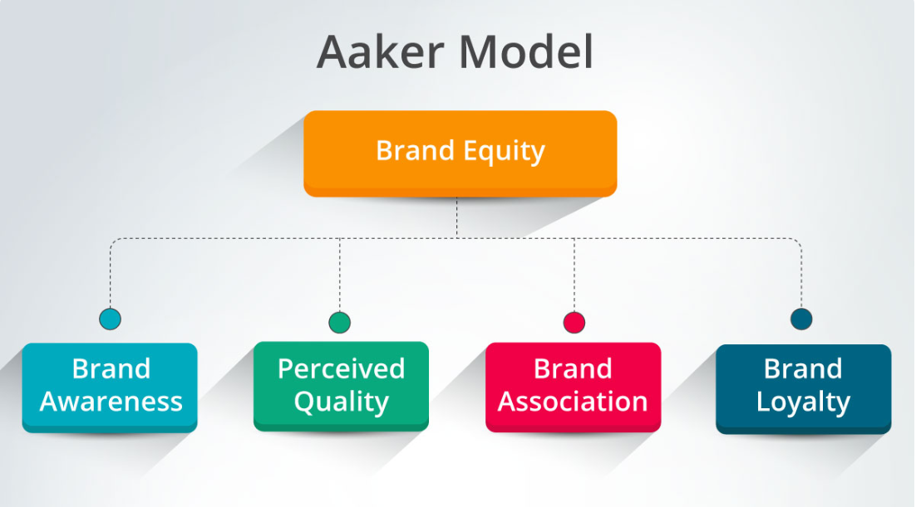
Fig1. Aaker Brand Equity Model

Figure 1 Description: This figure shows the five components of Aaker's brand equity model. Each component is indispensable to the contribution of brand value, among which brand awareness is the foundation of brand management and brand loyalty is the core of brand equity.
Keller Brand Resonance Model
The Keller Brand Embrace Model (CBBE Model) was proposed by Kevin Lane Keller. It is divided into four levels through a pyramid structure to explain how brands gradually establish emotional connections with consumers:
1. Brand Identity: This level answers the question "Who are you?" and focuses on brand recognition and awareness. Brands need to establish basic consumer awareness through clear identification and consistent delivery methods.
2. Brand Meaning: This level includes brand performance and brand image, answering the question "What are you?" Brand performance reflects the quality, function and degree of satisfaction of the product, while brand image involves the perception and association of the brand in the minds of consumers.
3. Brand Response: This level includes consumers’ judgments and emotions, answering the question “What about you?” Consumers’ judgments of brands are mainly based on the perceived reliability and quality of the brand, while emotions involve the emotional response evoked by the brand.
4. Brand Resonance: This is the highest level of brand management, answering the question "What about you and me?" and emphasizing the deep emotional connection and high loyalty between the brand and consumers.
As shown in Figure 2, Keller's brand resonance model shows the gradual deepening of the relationship between brands and consumers through four levels from brand identity to brand resonance.
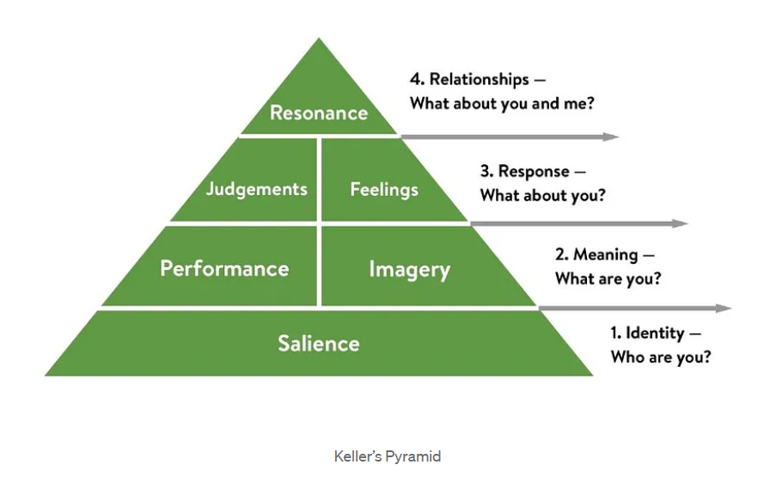
Figure 2. Keller Brand Resonance Model

Figure 2 Description: This figure shows the pyramid structure of Keller's brand resonance model. From the basic brand identity to the highest brand resonance, each level is a key link in establishing a strong connection between the brand and consumers.
BAV Brand Equity Model
The BAV (Brand Asset Valuator) brand equity model was developed by Young & Rubicam, which divides brand equity into four key dimensions: differentiation, relevance, respect and knowledge.
Differentiation: Brand differentiation is the uniqueness of a brand compared to other brands and is the core competitiveness of a brand. Differentiation is the primary condition for a brand to attract consumers' attention and is also the key to a brand standing out in the market.
Relevance: Relevance refers to the degree to which a brand matches the needs and desires of consumers. A brand must remain relevant to its target audience to ensure its market appeal and purchase motivation.
Esteem: Esteem measures consumers’ respect and recognition of a brand, which usually comes from the brand’s history, quality, and market performance. Brands with high esteem usually have a good reputation and a loyal customer base.
Knowledge: Knowledge refers to the degree of consumers’ understanding of a brand. It involves the brand’s popularity in the market and the spread of the brand story.
The BAV model emphasizes the process of brands moving from differentiation to in-depth understanding in the minds of consumers. By improving brand differentiation and relevance, companies can attract more consumers in a highly competitive market and gradually build brand loyalty through the accumulation of respect and knowledge.
As shown in Figure 3, the BAV brand equity model analyzes the process of building brand value through four dimensions, each of which has a direct impact on the brand's market position and competitive advantage.
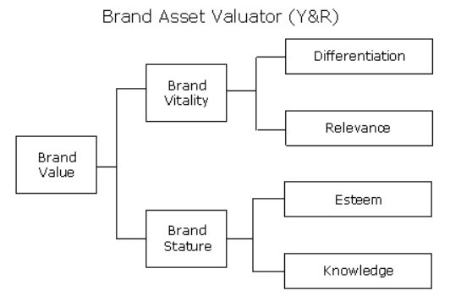
Figure 3 Description: This figure shows the four key dimensions of the BAV brand equity model, namely, differentiation, relevance, respect and knowledge. These dimensions together construct the market appeal and consumer loyalty of the brand.
BCG Brand Growth Model
The BCG Brand Growth Model was developed by the Boston Consulting Group and is often used to analyze brand performance in different markets and help companies develop brand growth strategies. The model is usually presented in the form of a matrix, which includes four types of brands: Stars, Cash Cows, Question Marks, and Dogs.
Stars: These brands have a high market share in fast-growing markets and require companies to continuously invest resources to maintain their market leadership.
Cash Cows: These brands occupy a high market share in mature markets, can provide stable cash flow support for enterprises, and are the main source of corporate resources.
Question Marks: These brands have a low market share in a growth market and the company needs to decide whether to invest further resources to increase market share or abandon the brand.
Dog brands: These brands have a lower market share and growth rate in the market and are usually not worth long-term investment.
The BCG Brand Growth Model helps companies identify their brand's position in the market and develop corresponding growth or maintenance strategies. For example, for star brands, companies can increase advertising investment and marketing efforts to maintain their market leadership; while for cash cow brands, companies can maximize profits by optimizing costs and improving efficiency.
As shown in Figure 4, the BCG brand growth model analyzes the brand's market position through two dimensions: market growth rate and market share, thereby helping companies formulate reasonable resource allocation strategies.
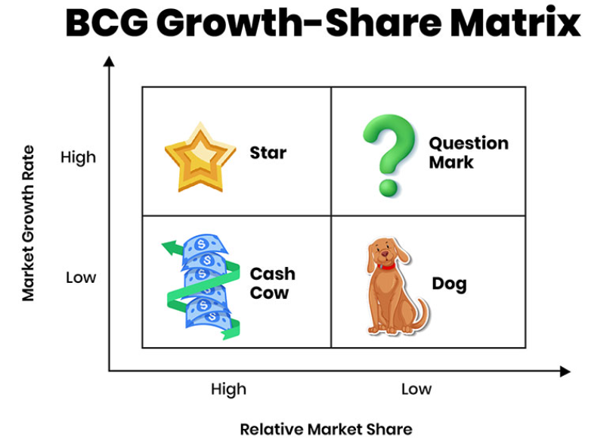
Fig.4 BCG Growth-Share Matrix

This figure shows the matrix structure of the BCG brand growth model. Different brand types perform differently in the market, and companies can formulate corresponding management and resource allocation strategies based on the brand type.
The role of the model
The role of brand management models is to provide a systematic brand building path and strategic guidance. Through these models, companies can systematically identify and manage the various elements of the brand during the brand building process, thereby achieving brand differentiation and maximizing brand value.
The role of Aaker brand equity model
The Aaker brand equity model helps companies understand the multi-dimensional value sources of brands. In the implementation process, companies can accumulate brand assets by increasing brand awareness, enhancing brand associations, and improving perceived quality and brand loyalty. For example, in China's wedding industry, some successful brands have achieved success in the fiercely competitive market by enhancing brand awareness and positive brand associations, which has established a unique emotional connection among consumers.
The role of Keller’s brand resonance model
Keller's brand resonance model emphasizes how the relationship between brands and consumers gradually deepens. Starting from brand recognition, to consumers' brand perception and emotional feedback, and finally to brand resonance, companies can effectively enhance brand customer stickiness and brand loyalty through the gradual construction of these levels. The realization of brand resonance means that the brand has gone beyond the functional level and become a part of consumers' lives, which is crucial to enhancing the brand's market influence and competitiveness.
The role of the BAV brand equity model
The four key dimensions of the BAV brand equity model help companies analyze their brand performance in the market. By improving differentiation and relevance, companies can establish a unique brand image in the market and enhance the brand's market appeal; by accumulating respect and knowledge, companies can gradually build brand loyalty and win consumer trust in the market through a positive brand image.
The role of the BCG brand growth model
The BCG brand growth model helps companies clarify the position of their brands in different markets and develop reasonable resource allocation strategies. For star brands that have a dominant position in a fast-growing market, companies need to continue to invest resources to consolidate their market leadership; for cash cow brands, companies can optimize operations to obtain more profits to support the growth of other brands.
In the models shown in Figures 1 and 2, Aaker's brand equity model and Keller's brand resonance model provide different perspectives and implementation paths for brand management. The Aaker model focuses on the construction of brand value, while the Keller model pays more attention to the relationship and interaction between brands and consumers.
Competitiveness Impact
The impact of the brand management model on corporate competitiveness is reflected in many aspects. Through systematic brand management, companies can improve their brand's market positioning and enhance consumer loyalty, thereby gaining significant advantages in the fierce market competition.
Enhance brand awareness and brand differentiation
The first step of brand management is to form a unique brand image in the market by increasing brand awareness and building brand differentiation. Brand awareness in the Aaker model and brand identity in the Keller model both emphasize the recognition of the brand in the market. Through effective brand communication strategies, companies can convey brand characteristics to consumers and help brands stand out in the market.
In the Chinese wedding industry, many companies have successfully occupied an important position in the minds of consumers by establishing a unique brand identity and a consistent brand experience. For example, some wedding companies have made their brands the first choice for consumers in the wedding preparation process by telling brand stories and shaping brand personality.
Enhance consumer loyalty and brand resonance
Brand loyalty is one of the core elements of brand management and an important guarantee for the company's continued growth and stable income. In the Aaker model, brand loyalty increases the brand's market value by increasing customers' willingness to repurchase the brand. In Keller's brand resonance model, the realization of brand resonance means that the brand has established a deep emotional connection with consumers, which goes far beyond the simple product experience and forms a long-term brand dependence and preference.
Through the brand resonance model shown in Figure 2, companies can find that brand resonance is the ultimate goal of brand management. It can not only increase consumers' purchase frequency, but also transform consumers into brand communicators, thus forming a word-of-mouth effect in the market.
Realize the improvement of brand premium and market competitiveness
The effective use of the brand management model can also help companies achieve brand premium, that is, to enhance the added value of products or services by improving brand value. Aaker's brand equity model emphasizes brand perceived quality, which means that companies need to enhance the value of their brands through continuous improvement of product and service quality, so that consumers are willing to pay a higher price for the brand. This is of great significance for companies to improve their profitability and market competitiveness in a highly competitive market.
For example, in China's wedding industry, some high-end wedding brands have successfully achieved brand premium by emphasizing high-quality services and unique brand experience. When consumers choose these brands, they are not only buying wedding services, but also buying the emotional experience and quality assurance represented by the brand.
Comprehensive application of brand management model
In the actual brand management process, companies usually use a variety of brand management models to maximize brand value. For example, in the early stages of brand building, companies can use Aaker's brand asset model to focus on improving brand awareness and brand associations; while in the mature stage of the brand, companies can use Keller's brand resonance model to enhance the emotional connection between the brand and consumers, thereby achieving a higher level of brand loyalty.
As shown in Table 1, different brand management models play different roles in different stages of brand building. Enterprises can flexibly select and combine these models according to the brand development stage and market demand to achieve the best brand management effect.
Table 1.The role of brand management models in different stages of brand building
Aaker Brand Equity Model: In the early stages of brand building, increasing awareness and brand association
Keller Brand Resonance Model: Brand Maturity Stages, Enhancing Brand Resonance and Customer Loyalty
BAV Brand Equity Model: Analyzing Brand Differentiation, Respect, and Relevance
BCG Brand Growth Model: Develop resource allocation strategies for brands in different markets

This table shows the application of brand management models in different stages of brand building. Enterprises can choose appropriate brand management strategies according to the brand development stage to improve brand value and market competitiveness.
Brand management model is an important tool for enterprises to gain market competitive advantages in the modern competitive environment. Through Aaker brand equity model, Keller brand resonance model, BAV brand equity model and BCG brand growth model, enterprises can systematically manage brands and gradually improve brand awareness, brand association, brand perception quality and brand loyalty, so as to form strong competitiveness in the market. In actual application, enterprises should flexibly select and integrate these models according to the brand development stage to achieve the accumulation of brand assets and maximize brand value, especially in the fiercely competitive Chinese wedding industry. These brand management strategies are of great significance to improving the brand's market position and enhancing consumers' emotional connection.

  - The Relationship Between Brand Management and Competitive Advantage in Enterprises

The relationship between brand management and corporate competitive advantage is inseparable. Through the application of brand management models, companies can effectively establish and consolidate their competitive advantages. Brand management is not only a bridge to establish connections between companies and consumers, but also an important strategy for companies to build a unique competitive position in the market. In the previous section 1.2, we discussed the role of brand management models and the impact of these models on brand value. In this section, we will further analyze how brand management can enhance the competitive advantage of companies from a strategic level.
The strategic role of brand management
As a strategic means of enterprises, brand management is not only about communicating with consumers at the brand level, but also plays an important role in building the core competitiveness of enterprises. As mentioned in Aaker's (1991) brand asset model, brand management can effectively help enterprises form competitive barriers by enhancing brand awareness, strengthening brand associations and improving brand loyalty.
1. Improve brand awareness
Brand awareness is the primary link in brand management. Through systematic brand communication and promotion activities, brands can gradually establish awareness in the minds of consumers. According to Keller's (2003) brand resonance model, brand awareness is the basis for consumers to establish a connection with brands and is an important link in guiding consumers to form a preliminary impression of brands. In brand management, improving brand awareness means that more consumers can be exposed to the brand, thus enabling the brand to gain a first-mover advantage in the competition. In the wedding industry, improving brand awareness is particularly important. Through advertising, social media operations and other means, brands can increase their exposure to target customers, thereby becoming consumers' first choice in the decision-making process.
2. Increase customer loyalty
Another strategic role of brand management is to increase customer loyalty. Fournier (1998) proposed that the quality of the relationship between the brand and the consumer is a key factor affecting customer loyalty. By continuously improving customer experience and brand interaction, companies can convert consumers into loyal customers of the brand, thereby forming a stable customer base in a highly competitive market. Improved customer loyalty means that companies can reduce customer churn, reduce marketing costs, and obtain continuous sales revenue in the market. In the wedding industry, personalized services and unique brand experiences can effectively enhance customer loyalty. Through carefully designed wedding details and full communication and interaction with customers, brands can make customers feel the brand's attention and value, thereby establishing a long-term trust relationship.
3. Improve brand premium capability
Brand premium ability is one of the important results of brand management, which means that consumers are willing to pay a price higher than the market average for the brand. This premium ability mainly comes from consumers' perceived quality and brand reputation of the brand. According to Aaker's (1991) brand equity model, perceived quality is one of the key factors that determine brand premium ability. Enterprises can continuously improve the perceived quality of products or services through brand management, which can make consumers have a positive perception of the value of the brand and be willing to pay a premium. In the wedding industry, some high-end wedding brands have successfully achieved brand premium by providing high-quality customized services and hiring well-known wedding planners. This not only improves the profitability of the brand, but also consolidates its position in the high-end market.
Ways to achieve competitive advantage
Brand management helps companies gain significant competitive advantages in a competitive market through innovation, differentiation, and the establishment of loyalty. Combined with the brand management models in Section 1.2, such as the Aaker Brand Equity Model and the Keller Brand Resonance Model, companies can effectively plan brand management strategies to achieve competitive advantages.
1. Brand innovation
Brand innovation is an important way to enhance competitive advantage. Innovation can help brands maintain their freshness and appeal among consumers and gain an advantageous position in the ever-changing market demands. Keller (2003) pointed out that brands need to maintain consumer interest through continuous innovation, especially in markets with serious product homogeneity, where brand innovation can help companies stand out from their competitors. In the wedding industry, brand innovation is mainly reflected in the personalization of wedding planning and the diversification of services. For example, some wedding companies introduce virtual reality (VR) technology to provide customers with a wedding preview experience, helping customers better understand and customize their weddings, thereby forming a differentiated advantage in the market.
2. Brand differentiation
Brand differentiation is one of the core contents of brand management. Through differentiation strategies, companies can form a unique market positioning in the competition. According to the BAV (Brand Asset Valuator) brand asset model, brand differentiation is one of the key factors for brand success. Brand differentiation can not only attract consumers' attention, but also make consumers choose a specific brand instead of competitors through unique brand value propositions. In the wedding industry, brand differentiation is usually achieved through unique wedding themes, customized wedding plans and excellent customer service. By providing a unique wedding experience, companies can establish a unique brand image in the minds of consumers, thereby enhancing the brand's market position.
3. Building brand loyalty
Brand loyalty is one of the sources of a company's long-term competitive advantage. In Keller's brand resonance model, resonance is the highest level of brand management and is a manifestation of a deep emotional connection between a brand and its consumers. The establishment of brand loyalty can not only bring stable sales revenue to the company, but also enable consumers to become spontaneous promoters of the brand, enhancing the brand's market reputation and influence. In the wedding industry, brand loyalty is particularly important because weddings are special events in a lifetime, and consumers tend to pay more attention to service quality and experience. Some wedding brands have enhanced customers' emotional experience through perfect after-sales service and customer care, making customers not only willing to choose the brand again, but also willing to recommend it to relatives and friends.
The impact of brand management on the long-term development of enterprises
Brand management plays an important supporting role in the long-term development of enterprises. Through scientific brand management, enterprises can gradually accumulate brand assets, enhance the brand's market position and consumer loyalty, and thus maintain long-term competitive advantages in the market.
1. Brand building and long-term competitiveness
Brand management is not only a short-term marketing activity, it has a profound impact on the long-term survival and development of enterprises. As Keller (2003) puts forward, the ultimate goal of brand management is to achieve resonance between brands and consumers. Through this deep emotional connection, brands can occupy a unique position in the hearts of consumers. In the wedding industry, the long-term implementation of brand management can help enterprises establish a good market reputation and form a stable customer base, thereby maintaining advantages in future market competition.
2. Brand asset accumulation and market expansion
Through brand management, enterprises can continuously accumulate brand assets and establish an irreplaceable position in the market. Aaker (1991) pointed out that the accumulation of brand assets helps enterprises achieve market expansion, attract new customer groups and enter new markets. In the wedding industry, some brands have gradually entered different market areas, including the high-end wedding market and overseas weddings, through continuous marketing and brand maintenance, thereby expanding the brand's market influence and competitiveness.
3. Brand management enhances brand value
The effective implementation of brand management can continuously enhance the brand value of enterprises, which is reflected in the high loyalty of consumers and the ability to pay a premium for the brand. By continuously improving the perceived quality of the brand and customer satisfaction, enterprises can form long-term advantages in the fiercely competitive market. For example, some brands in the Chinese wedding industry have become the first choice of consumers by continuously improving service quality and brand personalization, further enhancing the brand's market position and added value.
Brand management is one of the key strategies for enterprises to gain and maintain competitive advantage. Through scientific brand management models, such as Aaker brand equity model and Keller brand resonance model, enterprises can systematically improve brand awareness, enhance customer loyalty and achieve brand premium capabilities, thereby forming a stable competitive advantage. Brand management not only helps enterprises increase market share in the short term, but also provides strong support for the long-term development of enterprises through brand innovation, brand differentiation and brand loyalty. Especially in the fiercely competitive Chinese wedding industry, effective brand management can help enterprises stand out in the market and achieve long-term market expansion and brand value accumulation.

CHAPTER 2. ANALYSIS OF BRAND MANAGEMENT AND COMPETITIVENESS IN ENTERPRISES

2.1 The Role of Brand Management in Enhancing Corporate Image, Customer Loyalty, and Market Position

Brand management is a comprehensive strategy that aims to improve the competitiveness of enterprises through a systematic process. In the first chapter, we explored the theoretical basis of brand management and analyzed how the brand management model can help enterprises create and maintain brand value. This section will explore the specific role of brand management in improving corporate image, enhancing customer loyalty and consolidating market position from a practical perspective.
The shaping of corporate image is one of the core tasks of brand management. Kapferer (2008) pointed out that brand identity is not just a pile of visual symbols, it represents the core value and commitment of the brand, and is the first impression formed by consumers when they come into contact with the brand. The establishment of this brand identity needs to be achieved through a consistent visual identification system and continuous brand value delivery. In the Chinese wedding industry, successful brands often distinguish themselves from competitors through creative and unique logos, elegant colors and consistent visual styles. The visual elements of a brand have become the key for consumers to identify and remember the brand, and have important symbolic significance in a highly competitive market. Wang Zhigang's (2016) research shows that a unified and distinctive brand visual identification system can form a deep memory point in the minds of consumers and help brands stand out from the massive amount of information.
In addition, the transmission of brand value is not limited to functional value, but also includes emotional and social values. This is especially important in the wedding industry because weddings are essentially an emotional experience. Through effective brand management, companies can combine emotional values such as romance and happiness with professional services to form a unique brand image. For example, some wedding brands share customers' wedding videos and photos on social media to show happy moments, making the brand a symbol of beautiful memories. This emotional marketing strategy not only enhances the brand's appeal in the market, but also strengthens consumers' emotional connection with the brand. Zhang Zhilin (2018) pointed out that the transmission of emotional value is an indispensable part of brand building, which can enable the brand to establish a deep connection in the minds of consumers that goes beyond functionality.
Brand image management requires companies to maintain consistency in brand information across multiple channels. Li Weiqing (2017) emphasized that successful brand image management depends on the consistency of brand communication, including various online and offline touchpoints. Wedding brands need to ensure that brand information is consistent in social media, advertising, event planning and other aspects to avoid consumer cognitive confusion. Only when the brand's performance at all touchpoints is consistent with its core values and positioning can consumers form a unified and clear perception of the brand. This consistent communication helps the brand establish a stable image in the market and occupy a place in the hearts of consumers. In addition, through a clear differentiated positioning, brands can effectively gain an advantage in a competitive market. Chen Zhiyuan's (2019) research pointed out that differentiation is one of the key factors for brand success, which can help brands stand out from similar competitors and attract the attention of target consumers.
Another important role of brand management is the establishment of customer loyalty. The brand relationship theory proposed by Fournier (1998) believes that the quality of the relationship between the brand and the consumer determines customer loyalty. Through brand management, companies can incorporate emotional elements into the brand experience and enhance customers' dependence and trust in the brand. In the wedding industry, the emotional connection between the brand and the customer is particularly important, because the wedding is a special moment in life, and customers' emotional needs for services often exceed their functional needs. Brands can effectively enhance customer loyalty through personalized service experience and emotional brand communication. For example, some wedding companies accompany customers throughout the process through exclusive wedding planners to help customers plan every detail, so that customers can feel the brand's care and concern. Zhu Yuechang (2019) pointed out that personalized customer experience is the core of building brand loyalty, because it allows customers to feel the brand's attention to their special needs in the service, thereby enhancing their attachment to the brand.
To improve customer loyalty, companies also need to establish a systematic management system. Gao Hongyan (2021) believes that customer data management and the construction of a membership rights system are important links in customer loyalty management. Through data analysis, companies can understand customer needs and preferences, thereby providing personalized services; and through the membership system, companies can enhance customers' brand belonging and interaction frequency. For example, some wedding brands provide customers with special rights through the membership system, such as wedding anniversary gifts, exclusive event invitations, etc. These measures not only increase customer satisfaction, but also make the brand have a higher emotional value in the hearts of customers.
Brand management also plays an important role in improving the market position of enterprises. Enterprises can effectively enhance their market competitiveness through differentiated brand positioning, improved innovation capabilities and the realization of brand premium. Zhang and Wang (2020) showed that continuous innovation of products and services is an important means for brands to maintain their market competitive advantage. In the wedding industry, brand innovation is not only reflected in wedding planning programs, but also in the diversification of service forms. For example, some brands have gained an advantage in competition by providing destination wedding services or virtual reality (VR) wedding previews, allowing customers to have a unique wedding experience. Xu Xiaoming (2021) pointed out that the realization of brand premium capabilities depends on the brand's value positioning in the minds of consumers. By emphasizing the uniqueness of the brand and high-quality services, some high-end wedding brands have successfully achieved brand premiums, making consumers willing to pay higher fees in exchange for a more personalized and luxurious wedding experience.
Expanding market share is also one of the important means for brand management to enhance the market position of enterprises. Yang Zhilin and Li Ming (2019) proposed that through the refined segmentation of the target market, enterprises can formulate targeted marketing strategies to better meet the needs of different customer groups. For example, some wedding brands focus on the high-end market and provide luxurious customized weddings, while other brands focus on the mass market and provide cost-effective wedding packages. This refined market segmentation helps brands occupy a larger market share in their respective fields. In addition, the optimization of channel layout is also the key to improving brand market coverage. Through the combination of diversified channels (online and offline), enterprises can better reach target customers and thus enhance the brand's market position.
Successful cases in practice further verify the important role of brand management in improving corporate image, customer loyalty and market position. For example, Bishu Wedding Company in Nanyang City has successfully created a high-end and romantic brand image through a unified brand visual system, a professional service team and continuous social media communication; enhanced customer loyalty through personalized services, after-sales tracking mechanisms and membership activities; and consolidated the brand's position in the high-end wedding market through innovative wedding services and expanded market coverage. These practical experiences show that brand management is an important means for enterprises to gain long-term advantages in competition.

2.2 Comparative Case Studies of Successful Brand Management Strategies in the Chinese Wedding Industry

In order to deeply analyze the brand management practices in China's wedding industry, this section selects two typical cases: Guangzhou Romantic Century Wedding Company and Shanghai Golden Lady Wedding Group. By comparing and analyzing the brand management characteristics of the two companies in terms of industrial chain integration, digital transformation, talent training, international development and sustainable operation, we summarize the experience and lessons and provide a reference for wedding companies to optimize their brand strategies.
In the consumption characteristics of the Guangzhou market, wedding services have shown a significant trend of diversification. As shown in Figure 1, traditional oriental weddings account for 43.81%, western novel weddings account for 33.33%, and other personalized wedding forms account for 22.86%. In-depth analysis of the consumption preferences of different age groups and income groups found that newlyweds born in the 1990s prefer western and personalized weddings, accounting for 38.2% and 29.5% respectively; while those born in the 1980s prefer traditional oriental weddings, accounting for as high as 52.6%. In terms of income level, among newlyweds with a monthly income of 20,000 to 30,000 yuan, the demand for personalized weddings is the strongest, accounting for as high as 35.8%.

Fig 5. Wedding Ceremony Types Distribution ( Data source: Guangzhou Wedding Industry Association 2020 Annual Research Report )
Figure 5 shows the distribution of the three main types of weddings in the Guangzhou wedding market. It can be seen that traditional oriental weddings still account for a large proportion, but western weddings and personalized weddings have also occupied a considerable market share, reflecting that consumers' demands for wedding formats are becoming more and more diversified.
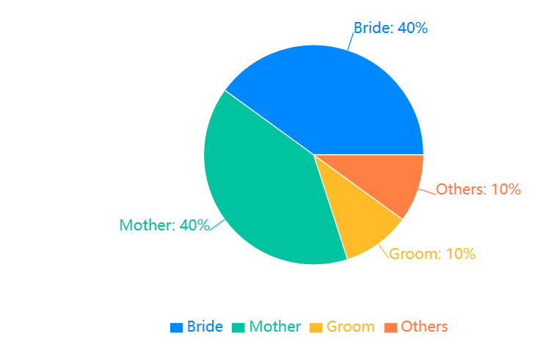
At the same time, wedding consumption decisions show significant gender differences. As shown in Figure 2, women play the highest role in wedding decision-making, reaching 40%, mothers also have an influence of 40%, and men only account for 10%. This shows that wedding companies need to attach great importance to the decisive influence of female consumers when formulating brand positioning and marketing strategies. From the distribution of consumption amounts, as shown in Table 1, the mid-range consumer group of 50,000 to 100,000 yuan accounts for 31.82%, which is the main body of the market. The proportion of high-end consumer groups (more than 100,000 yuan) has increased from 8.3% in 2015 to 14.5% in 2020, further reflecting the accelerated trend of wedding consumption upgrades.

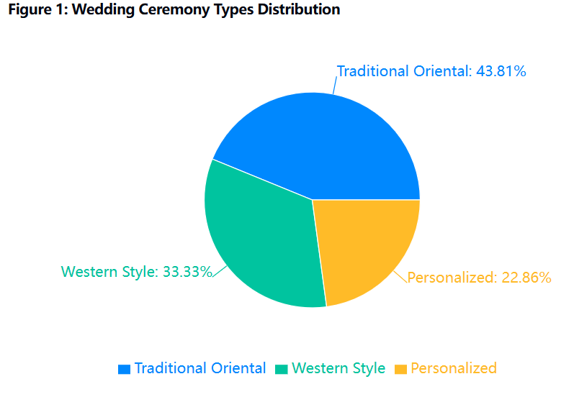
Fig 6. Wedding Planning Decision Making Distribution (Data source: Guangzhou Statistics Bureau 2020 Wedding Consumption Survey )
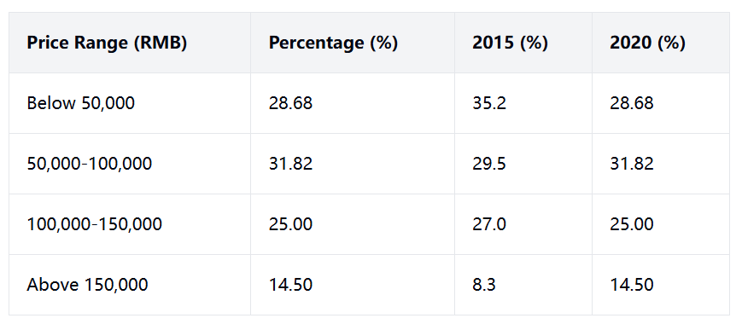
Figure 6 reveals the three main sources of influence on wedding consumption decisions: brides, grooms, and mothers. Women (brides and mothers) play a leading role in wedding consumption decisions. When planning brand positioning and services, companies must fully consider the preferences and needs of female consumers.
Table 2. Wedding spending Distribution (2015-2020)
Data source: Statistics compiled by Guangzhou Wedding Industry Association over the years
Table 2 shows the structural changes in the amount of wedding consumption in Guangzhou from 2015 to 2020. The proportion of low-end and mid-end consumption has declined, while the proportion of high-end consumption has steadily increased, indicating that wedding consumption is rapidly upgrading towards high quality and personalization.
Secondly, the analysis of the wedding industry chain shows that modern wedding services have developed into a complete service system that includes front-end customization, mid-end execution and back-end extension. The front-end customization link includes wedding photography, wedding planning, wedding dresses and other services; the mid-end execution link covers venue layout, process management and banquet services; the back-end extension includes value-added services such as honeymoon travel and commemorative album production. As shown in Figure 3, the annual revenue ratio of each link in the industry chain is 35% for wedding photography, 28% for wedding banquet services, 20% for wedding planning, 10% for wedding dresses and 7% for other services. This complete industry chain structure provides wedding companies with diversified development opportunities in brand management.
Secondly, the analysis of the wedding industry chain shows that modern wedding services have formed a complete system that includes front-end customization, mid-end execution and back-end extension. Among them, front-end customization includes wedding photography, wedding planning, wedding dresses, etc.; mid-end execution covers venue layout, process management, banquet services, etc.; back-end extension includes value-added services such as honeymoon travel and commemorative album production. Data shows that the annual revenue ratios of each link in the industry chain are: wedding photography 35%, wedding banquet services 28%, wedding planning 20%, wedding dresses 10%, and other services 7% (see Figure 3). This complete industry chain structure provides diversified development space for brand management.
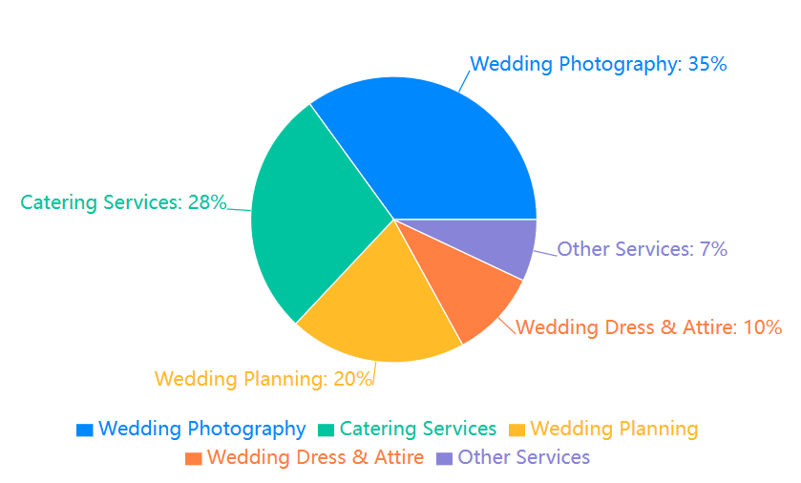
Fig 7. Wedding Industry Revenue Distribution ( Data source: China Wedding Industry Development Research Institute 2020 Annual Report )
Guangzhou Romantic Century Wedding Company, as a leader in the wedding industry in Guangzhou, is a model example in the field of industrial chain integration and optimization. The company adopts the service model of "one-stop wedding butler", seamlessly connecting the three links of pre-wedding planning, wedding execution and post-wedding services, and providing customers with a full-process wedding solution. This model breaks the segmentation of "front shop and back factory" in traditional wedding services, and realizes resource sharing and collaborative optimization of different business links. Taking the wedding scene layout as an example, Romantic Century has established a professional team composed of wedding planners, florists, lighting designers, etc., from the preliminary design of the plan to the on-site implementation, the whole process is integrated. At the same time, a 3D virtual layout system was introduced, so that the newlyweds can preview the wedding scene effect in an immersive way without leaving home. This not only greatly improves the layout efficiency and saves labor costs, but more importantly, it meets the personalized needs of the newlyweds to the greatest extent.
The "one-stop wedding butler" model of Romantic Century is highly consistent with the Keller brand resonance model. The model divides brand building into four levels: identity, meaning, reaction and resonance, and Romantic Century has done a good job in all four levels. First, in terms of brand identity building, Romantic Century uses "customized exclusive romance" as its brand slogan to convey a high-end, fashionable and personalized brand image. Secondly, in terms of brand meaning mining, the company uses "one-stop" convenient services to strengthen the connection between the brand and the wedding lifestyle. Thirdly, in terms of brand response guidance, Romantic Century uses high-quality service experience to make customers have a strong emotional resonance. A bride shared her wedding preparation experience on social media: "From confirming the wedding date to the wedding day, the wedding butler of Romantic Century has been with us, providing us with advice and help like a friend, allowing us to feel the joy of the wedding, rather than the tediousness and pressure of preparation. This is an unforgettable experience!" Similar positive comments are common among Romantic Century's customers.
The following chart directly shows the leading customer reputation of Romantic Century in the industry:
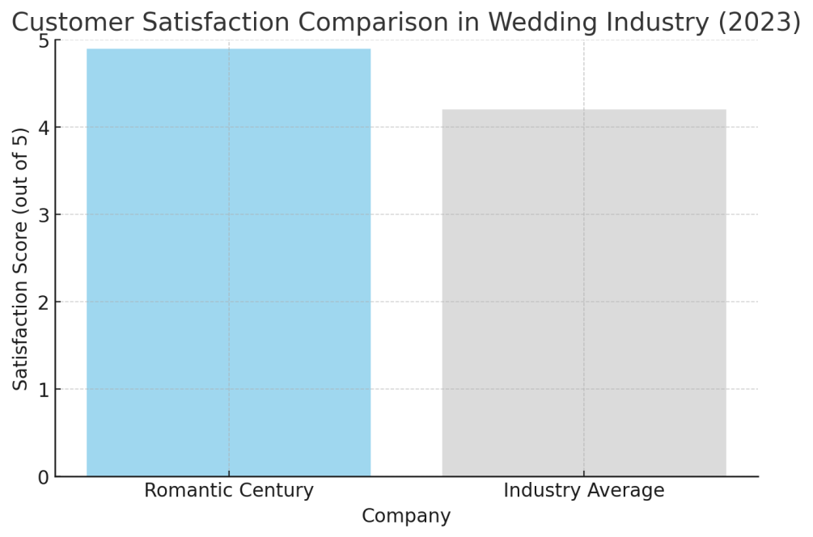
Figure 8. Romantic Century Customer Comprehensive Satisfaction Market Comparison (2023) ( Data source: Dianping.com Guangzhou Wedding Industry Merchant Rating Statistics )
In 2023, Romantic Century's overall satisfaction rating on Dianping.com was as high as 4.9 points, 0.7 points higher than the industry average, ranking first in Guangzhou's wedding industry. This indirectly confirms Romantic Century's excellent service quality and brand reputation. The changing trends in customer repurchase rate and active recommendation rate also show that Romantic Century's brand loyalty continues to rise:
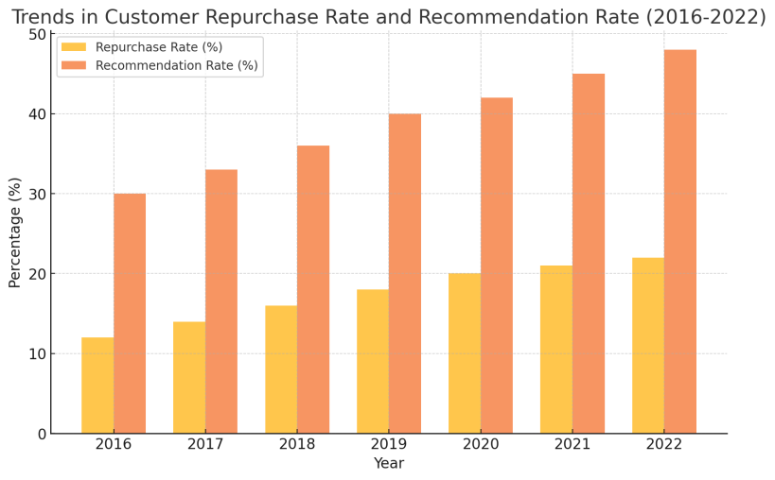
Figure 9. Trends in Romantic Century customer repurchase rate and recommendation rate (2016-2023) ( Data source: Romantic Century CRM system )

From 2016 to 2023, the average annual repurchase rate of the company's customers has steadily increased from 12% to 25%, and the proportion of old customers recommending new customers has also climbed from 30% to 55%. These data fully prove that Romantic Century has established a deep emotional connection with customers through high-quality services, achieved brand resonance, and gained super high brand loyalty. In 2023, the unit price of the company's integrated services was 25% higher than that of scattered services, but the transaction rate increased by 8 percentage points, and the customer referral rate also jumped from 35% in 2022 to 52%. This means that brand premium and customer loyalty have become the core competitive advantages of Romantic Century.
In terms of brand asset building, Romantic Century adopts a multi-brand differentiation strategy and establishes a three-level brand architecture: the high-end customized brand "Romantic Century", the mid-range standardized brand "Happy Season" and the popular fast brand "Happy Events". These three brands have different focuses on target customer groups, service content and price ranges, corresponding to different levels of demand under the pyramid structure of the wedding consumption market. Taking "Romantic Century" as an example, its main focus is on personalized customization services, and its customer base is targeted at high-end people who pay attention to quality, pursue fashion and appreciate creativity. According to industry insiders, the planning fee for a single wedding of "Romantic Century" is 50,000 to 100,000 yuan, and the highest order even exceeds 500,000 yuan. Even so, there is still an endless stream of couples queuing up for appointments. The creative wedding forms launched by "Romantic Century" such as underwater weddings, high-altitude weddings, and robot bridesmaids have successively detonated social networks, and are bound to become the vane of a new round of wedding trends. The following table further discloses the revenue performance of the "Romantic Century" brand in recent years:
Table 3. Changes in revenue and share of Romantic Century's high- end brand "Romantic Century"
years | Revenue (10,000 yuan) | Year-on-year growth | Proportion of total revenue
2020 | 840 | - | 30%
2021 | 980 | 16.70% | 32%
2022 | 1080 | 10.20% | 33%
2023 | 1200 | 11.10% | 35%
Data source: Romantic Century Financial Statements
Table 3 further discloses the continued rapid growth of Romantic Century's high-end brand business. From 2020 to 2023, the average annual compound growth rate of "Romantic Century" brand revenue reached 12.6%, higher than the company's overall growth rate of 8.2% during the same period. In terms of the proportion of total revenue, it has also steadily increased from 30% in 2020 to 35% in 2023. The strong performance of high-end business has provided strong support for Romantic Century's profit growth and brand upgrading.
In line with high-end brands, the mid-range brand "Happiness Season" focuses on cost-effectiveness and provides high-quality wedding package services for a wider consumer group. Through standardized and large-scale operations, "Happiness Season" has significantly reduced costs while ensuring quality, making high-quality wedding services accessible to ordinary people. A set of data can illustrate the problem: among the newlyweds served by "Happiness Season" in 2023 , those with a monthly income of 10,000 to 20,000 yuan accounted for as high as 60%, and this group was basically excluded from professional wedding services before. "Happiness Season" opened up the market with the "Excellent Package" of 6,888 yuan, and received more than 500 orders in the month of its launch, and accumulated more than 5,000 orders within half a year. As of the end of 2023 , "Happiness Season" has deployed 28 directly-operated stores in 6 major cities including Guangzhou and Shenzhen, with a revenue of 105 million yuan, and its brand awareness has jumped to the second echelon of the industry.
As for the popular and fast-service brand "Xishihui", it is positioned as a "15-day rapid wedding preparation" service platform, mainly through online channels and telephone delegation, to meet the rigid needs of consumers with approaching wedding dates, tight wedding preparation time and relatively limited budgets. In 2020, "Xishihui" served more than 12,000 couples of customers in the form of standardized wedding packages, with a single transaction price ranging from 12,000 to 36,000 yuan, and revenue exceeded 48 million yuan. However, with the advantages of large volume and wide coverage, it has effectively supplemented the customer base of Romantic Century. 98% of "Xishihui" customers are using the Romantic Century brand for the first time. Through high-quality service experience, more than 70% of customers expressed their willingness to continue to choose Romantic Century, providing a steady stream of customer reserves for the development of high-end and mid-end businesses.
It can be seen that the multi-brand combination strategy of Romantic Century has made full use of the three elements of brand awareness, brand association and perceived quality in the Aaker brand asset model, achieving full customer coverage while providing differentiated services, and forming a three-dimensional development situation. The three brands leverage each other and are independent of each other. They compete with each other in resource sharing and expand the market in collaborative development, showing the integration effect of "1+1+1>3". Financial data shows that in 2020, the revenue of the three major brands of Romantic Century was 120 million yuan, 105 million yuan, and 48 million yuan respectively, totaling more than 270 million yuan, a year-on-year increase of 58%. In terms of proportion, the total of mid-to-high-end brands reached 83.5%, and the profit margin increased from 6% in 2016 to 12.3%. The endogenous driving force and sustainable development capabilities of the three brands have been fully demonstrated. This has laid a solid foundation for Romantic Century to fully advance into a pan-wedding lifestyle service provider in the future and complete the leap from a regional company to a national group.
In contrast, Shanghai Mrs. Jin Wedding Group has chosen a standardized development path of national chain. By establishing a standardized service system, process and quality control, Mrs. Jin has achieved cross-regional replication. At present, more than 300 directly-operated chain stores have been deployed in 80 cities across the country, forming a national brand influence. In 2020, Mrs. Jin's revenue exceeded 3.2 billion yuan, ranking among the best in the industry. However, Mrs. Jin's development also faces some challenges. On the one hand, its net profit margin is 8.3%, lower than Romantic Century's 12.6%, showing the limitations of a single standardized strategy in terms of customer acquisition costs and customer experience. On the other hand, Romantic Century's mid- and low-end brands "Happy Season" and "Happy Events" have achieved rapid growth through differentiated operations. The following data compares the development performance of "Happy Season" and "Happy Events":
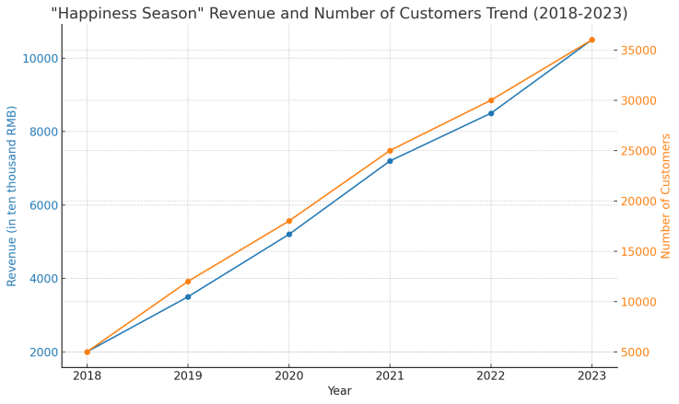
Figure 9. Trends in revenue and number of customers served by "Happiness Season" from 2018 to 2023 ( data source: Romantic Century financial report and public information )
Figure 9 directly shows the rapid growth of the "Happiness Season" brand in recent years. From 2018 to 2023, its revenue scale jumped from 20 million yuan to 105 million yuan, with an annual compound growth rate of 128%; the number of customers served also surged from 5,000 pairs to 36,000 pairs, an increase of more than 6 times. Behind the explosive growth of the brand is the "Happiness Season"'s accurate grasp of the market segments and differentiated operations.
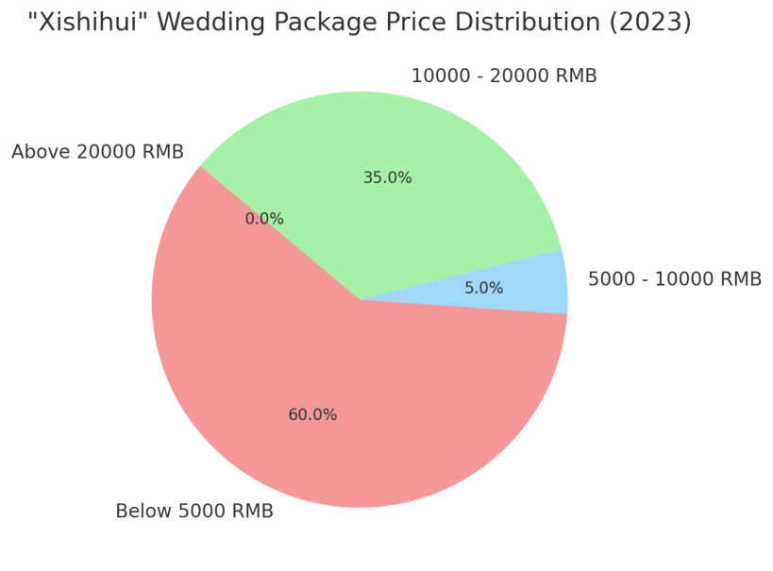
Figure 10. Distribution of unit prices of wedding packages of "Xishihui" in 2023 ( data source: Xishihui order management system )

Figure 10 reveals the differentiated positioning of "Xishihui" in the mass wedding consumption market by disclosing the distribution of single transaction prices. In 2023, the proportion of single transaction prices below 5,000 yuan will be as high as 60%, and the proportion of 10,000-20,000 yuan will be close to 35%. This price range was previously a service blind spot in the wedding industry. "Xishihui" is targeting this gap and has opened up a vast market blue ocean.
Table 4. Results of the "Xishihui " service satisfaction survey (2023)
Rating | Percentage
5 Stars (Very Satisfied) | 52%
4 Stars (Satisfied) | 38%
3 Stars (Neutral) | 8%
2 Stars (Not Satisfied) | 2%
1 Star (Very Unsatisfied) | 0%
Data source: Xishihui customer satisfaction third-party survey
Table 4 Through the satisfaction survey, user feedback indirectly confirms the outstanding performance of "Xishihui" in service quality. Among the customers who participated in the survey in 2023, the proportion of those who gave 5 points and 4 points was as high as 90%, reflecting the good reputation of "Xishihui" in the field of fast weddings.
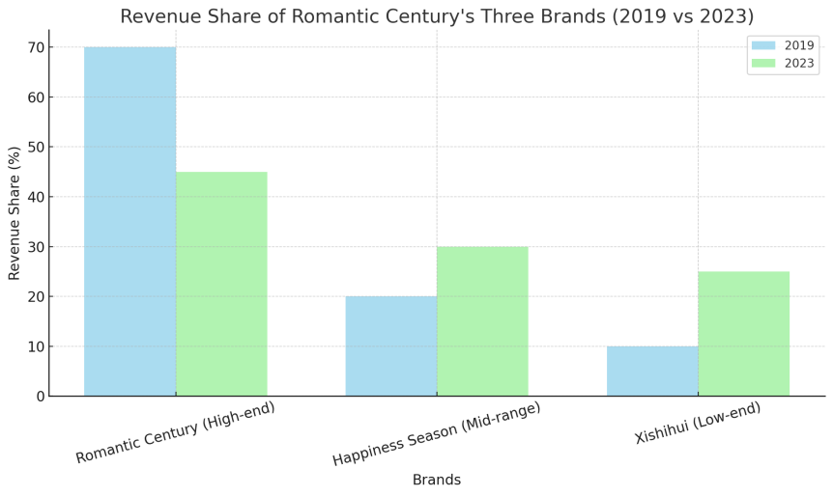
Figure 11. Changes in the revenue share of the three major brands of Romantic Century (2019 vs. 2023 ) Data source: Romantic Century internal financial statements
Figure 11 shows the overall effectiveness of Romantic Century's multi-brand development strategy. In 2022, the high-end brand "Romantic Century" accounted for 70% of revenue, and by 2023, the three major brands achieved a relatively balanced pattern, with mid- and low-end brands contributing a total of 55% of revenue. This shows that Romantic Century has initially established a differentiated brand matrix for different market segments, and the coordinated development of multiple businesses has laid a solid foundation for the company's long-term and steady growth.
Faced with the rise of competitors and new industry trends, in the future, Mrs. Jin needs to increase personalized service innovation and enhance brand premium capabilities on the basis of standardization. In terms of digital transformation, Mrs. Jin's layout is relatively comprehensive, investing nearly 300 million to build a smart wedding ecosystem, integrating the entire chain of marketing, design, procurement, etc., to achieve online and data-based business operations. Applications such as smart stores, old customer recalls, and online sales have brought new changes to brand reach and experience. In 2020, the company's digital revenue accounted for 35%. In the future, we must continue to work on online and offline integration to create a seamless experience for customers.
In summary, the brand management practices of the two major wedding companies, Romantic Century and Lady Gold, provide valuable inspiration for the development of the industry. On the one hand, differentiated brand positioning and diversified service portfolio can effectively match the increasingly segmented market demand and achieve the dual-wheel drive of scale effect and profit growth; on the other hand, strategic initiatives such as digital transformation, industrial chain integration, and talent cultivation are reshaping the innovation logic and competitive situation of the wedding industry.

2.3 Challenges and Opportunities for Brand Management in Competitive Markets

While the wedding industry in China is booming, fierce market competition has also brought unprecedented challenges to brand management. With the continuous upgrading of consumer demand and the rapid changes in the industry landscape, wedding companies must face these challenges and explore New opportunities for sustainable development.
First, the increasingly fierce market competition is one of the biggest challenges facing the current wedding industry. According to statistics from the China Wedding Industry Association, by 2023, there will be more than 500,000 wedding companies nationwide, and the competition in first-tier cities such as Guangzhou and Shanghai is particularly fierce. Big brands are competing to launch personalized services and innovative marketing strategies, which has led to an increasingly complex market environment. In this case, how to stand out from the competition and establish a unique brand image and competitive advantage has become an important issue facing wedding companies.
Secondly, the problem of brand homogeneity has also restricted the healthy development of the industry to a certain extent. Due to the similarity of wedding services, many brands lack obvious differences in target customer groups, service content and communication methods. This leads to low consumer awareness of different brands and makes it easy to fall into the quagmire of price wars. Taking Guangzhou as an example, the average gross profit margin of the local wedding market in 2022 dropped from 25% five years ago to 15%, and the industry's profitability was significantly squeezed. Brand differentiation has become the key to the survival and development of enterprises.
At the same time, the continuous improvement of customer expectations has also put forward higher requirements for wedding brand management. Contemporary consumers, especially newlyweds born in the 1990s and 2000s, advocate personalized expression, pursue emotional resonance with the brand, and have higher expectations for the quality and experience of wedding planning. For example, the "China Wedding Consumption Trend Report" released by Everbright Wedding in 2022 shows that 80% of newlyweds hope that their weddings will be "different" and 74% of newlyweds are willing to pay for high-quality services. Brands need to segment market needs, provide personalized customization, and use ingenuity to provide emotional experience for newlyweds in order to win the trust and support of customers.
Technological progress and digital transformation are also reshaping the competitive logic of the wedding industry. The development of mobile Internet and social media has opened up new channels for brand communication and customer interaction. Wedding companies need to adapt to the new marketing rules of the digital age and use online platforms to establish close ties with consumers through precision delivery, content marketing, word-of-mouth communication and other methods. At the same time, the application of technologies such as big data, artificial intelligence, and VR in wedding services also provides broad space for brand innovation and customer experience optimization. Only by adapting to the trend of digital transformation and accelerating transformation and upgrading can wedding companies gain an advantage in the new round of competition.
Brand trust and reputation management are another major challenge facing wedding companies. Weddings carry the beautiful vision of newlyweds and families. Once there are service loopholes or negative public opinion, it is very easy to cause a strong response from the public and deal a heavy blow to the brand reputation. In 2022, the "Putian" wedding company fraud storm caused by the Wei Zexi incident, as well as many cases of consumers complaining about wedding companies suspected of breach of contract, all highlight the importance of brand trust in the wedding industry. In this regard, companies must attach great importance to brand reputation management, improve the service quality control system, improve the customer rights protection mechanism, and respond to social concerns in an open and transparent manner, so as to consolidate the brand's credibility.
Among the many challenges, there are also important opportunities for the transformation and development of wedding enterprises. First, the rise of market segmentation and personalized services has provided a broad space for brand differentiation. Enterprises can focus on specific market segments, such as high-end customization, theme weddings, small private customization, etc., to provide target customers with a unique combination of products and services to enhance brand recognition and reputation. Taking Guangzhou Romantic Century Wedding as an example, its creative wedding forms such as underwater weddings and high-altitude weddings launched for high-end people well demonstrate the brand's innovative vitality and service value, and stand out in homogeneous competition.
At the same time, the digital age has also brought unprecedented opportunities for wedding brand management. Mobile social platforms provide brands with a channel to interact directly with target audiences. Through content forms such as pictures, short videos, and live broadcasts, wedding companies can vividly display brand personality and service features, triggering emotional resonance among consumers. The rise of user-generated content (UGC) has given wings to brand word-of-mouth communication. For example, Romantic Century has successfully created a high-end and romantic brand image by sharing customers' real wedding stories and touching moments on social media platforms, which has attracted widespread attention. In 2023, its official Weibo reading volume exceeded 120 million, and online brand searches increased by 150% year-on-year, which has effectively driven the improvement of brand awareness and reputation.
Creating a profound emotional experience and establishing a close emotional connection with consumers is another opportunity for wedding brands to win in the new era. Contemporary consumers, especially the younger generation, are no longer satisfied with simple products or services, but pay more attention to brand experience and emotional value. Weddings carry the love dreams and family expectations of the newlyweds, so wedding companies have a natural advantage to form an emotional resonance with customers through high-quality services and win the trust and support of customers. Romantic Century's "one-stop wedding butler" service is a typical example. Through thoughtful and considerate wedding planning, personalized design and high-standard execution, the company allows newlyweds to fully feel the brand's intentions, gain unforgettable emotional experiences in the service process, and encourage customers to establish a deep trust and attachment with the brand. This emotional connection has greatly improved customer satisfaction and brand loyalty, laying a solid foundation for the long-term development of the company.
Comprehensive case analysis shows that in the face of the challenges and opportunities of transformation and development, Chinese wedding companies are actively exploring ways to break through their brands. On the one hand, Romantic Century has stood out in the fierce market competition through innovative practices such as differentiated operations, personalized services, and social media communication, and has established a high-end romantic brand image. On the other hand, Mrs. Jin has promoted brand operations on a larger scale and at a higher level through standardized services, national chain layout, and digital system construction, gradually maximizing brand value. It can be foreseen that with the profound evolution of the industry's competitive landscape and the accelerated upgrading of consumption trends, brand innovation and differentiated development will become the only way for Chinese wedding companies. Only by grasping the pulse of the times, facing the challenges of transformation, and opening up new development situations can we win long-term development in the ever-changing market.

CHAPTER 3. RECOMMENDATIONS FOR IMPROVING BRAND MANAGEMENT TO INCREASE COMPETITIVENESS

3.1 Essential Factors for Developing and Sustaining Effective Brand Management Practices

Brand management is a complex and systematic project that requires enterprises to work together in multiple dimensions such as strategic planning, organizational structure, process optimization, innovative research and development, and talent training to truly achieve the continuous improvement of brand value. This section will focus on these key issues, deeply analyze the core factors that affect the effectiveness of brand management, and propose corresponding optimization strategies for reference by wedding companies.
1. Scientific brand strategy planning
Scientific brand strategy planning is the logical starting point for improving the effectiveness of brand management. Brand strategy is the overall planning and top-level design of corporate brand development, which determines the core concept, value proposition, market positioning and future development direction of the brand. Therefore, formulating a brand strategy that conforms to the actual situation of the enterprise and conforms to industry trends is the premise of effective brand management. In this regard, wedding companies should base themselves on their own resource endowments and comparative advantages, deeply analyze changes in market demand and competitive situations, and form a differentiated brand strategy framework.
Brand strategy planning requires systematic consideration from multiple dimensions. As shown in Table 5 , brand strategy planning includes five key dimensions: brand positioning, brand architecture, value delivery, resource allocation, and development path. Each dimension has its own specific consideration factors and implementation focus.
Table 5.Key dimensions and considerations of brand strategy planning

Strategic Dimension | Main Considerations | Implementation Focus
Brand Positioning | Market Segmentation, Target Audience, Competitive Advantage | Differentiated Value Proposition
Brand Architecture | Brand Hierarchy, Portfolio, Relationships | Multi-brand Synergy Development
Value Delivery | Product Design, Service Experience, Marketing Communication | Omni-channel Integrated Marketing
Resource Allocation | Talent, Financial, and Technological Investment | Breakthrough in Key Areas
Development Path | Short-term Goals, Medium-term Plans, Long-term Vision | Phased Implementation Strategies

As can be seen from Table5, in terms of brand positioning, enterprises need to conduct in-depth analysis of market segments, target audiences and competitive advantages to form differentiated value propositions. The brand architecture dimension focuses on the construction of brand levels, combinations and relationships to achieve multi-brand collaborative development. The value delivery dimension emphasizes the integration of product design, service experience and marketing communication, and effectively communicates brand value through omni-channel marketing. The resource allocation dimension requires enterprises to make reasonable allocations in talent, capital and technology investment and achieve breakthroughs in key areas. The development path dimension focuses on the coordination and unification of short-term goals, medium-term plans and long-term visions, and ensures the implementation of brand strategies through phased implementation strategies.
Taking Guangzhou Romantic Century as an example, in the face of the new trend of increasingly diversified and personalized wedding consumption, Romantic Century timely adjusted its brand strategy and established the development positioning of "focusing on the high-end market and building the first brand of romantic weddings". Focusing on this strategic goal, the company focused on the three major market segments of celebrity weddings, travel weddings, and theme weddings. The specific strategic implementation is shown in Figure 12 .
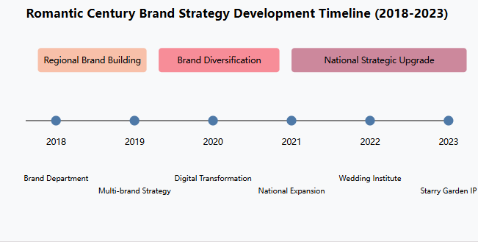
Figure 12. Romantic Century brand strategy development process (2018-2023)

from Figure 1 2 , the brand strategy development of Romantic Century has gone through three main stages: regional focus stage (2018-2019), diversified development stage (2020-2021) and national expansion stage (2022-2023). In the regional focus stage, the company established a brand department and launched a multi-brand strategy; in the diversified development stage, it implemented digital transformation and began a national layout; in the national expansion stage, it established a wedding research institute and launched innovative IP products. Judging from the revenue growth data, the company's performance continued to maintain rapid growth, with an average annual growth rate of more than 35%, which confirmed the effectiveness of the brand strategy.
2. Efficient organizational structure design
An efficient organizational structure is an important guarantee for the implementation of brand strategy. Brand management is a systematic project across departments and businesses, which requires the concerted efforts of marketing, sales, service, design and other departments. Traditional compartmentalized management is prone to departmentalism, which affects the consistency of brand strategy implementation. Therefore, establishing a flat, matrix-style brand management organizational structure has become an inevitable choice for contemporary wedding companies.
In order to better understand the importance of organizational structure and its evolution trend, we can make an in-depth comparison between traditional organizational structure and matrix organizational structure from multiple dimensions. As shown in Table 6 , the two organizational structures have significant differences in key dimensions such as decision-making efficiency, resource allocation, departmental collaboration, innovation capability and talent development.
Table 6.Comparison between traditional organizational structure and matrix organizational structure
Comparison Dimension | Traditional Organizational Structure | Matrix Organizational Structure
Decision-Making Efficiency | Many layers, low efficiency | Flattened, quick response
Resource Allocation | Fixed allocation, low flexibility | Dynamic allocation, optimized sharing
Department Collaboration | Many barriers, difficult cooperation | Smooth cross-department collaboration
Innovation Capability | Lack of innovation drive | High innovation vitality
Talent Development | Single promotion path | Diverse development opportunities

From the comparison in Table 6 , we can see that the matrix organizational structure has obvious advantages. In terms of decision-making efficiency, the flat management hierarchy significantly improves the response speed; in terms of resource allocation, the dynamic allocation mechanism ensures the optimal use of resources; in terms of departmental collaboration, the establishment of cross-functional teams breaks down traditional departmental barriers; in terms of innovation capabilities, the flexible organizational structure provides a good soil for innovation; in terms of talent development, the diversified promotion channels stimulate the potential of employees.
Mrs. Jin's organizational transformation is a successful practice of the matrix organizational structure in the wedding industry. As shown in Figure 13 , the company has built a matrix management system with the brand management committee as the core, three service centers as the support, and regional brand managers as the extension.
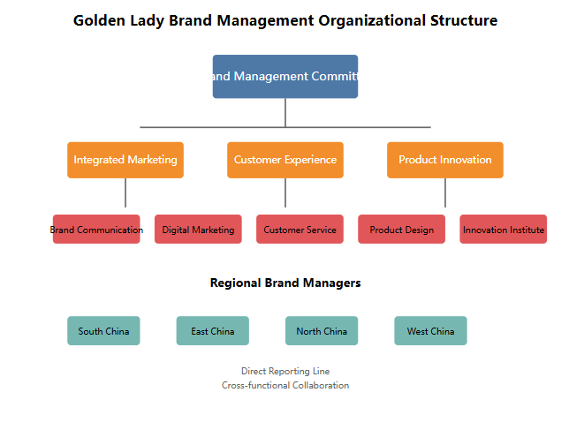
Figure 13.Golden Lady Brand Management Organization Chart

The organizational structure shown in Figure 1 3 has the following characteristics:
1. Strategic decision-making level: As the highest decision-making body, the Brand Management Committee is responsible for formulating brand strategy directions, approving major brand projects, and coordinating cross-regional resource allocation. The committee adopts a flat management model to ensure efficient and flexible decision-making.
2. Strategic Execution Layer: The three service centers (Integrated Marketing Center, Customer Experience Center, and Product Innovation Center) serve as the core hubs for the implementation of the strategy, each performing its own duties and coordinating with each other.
- integrated marketing center is responsible for brand communication, digital marketing, etc.
- customer experience center focuses on service standardization and customer satisfaction improvement
- Product Innovation Center is committed to new product development and service innovation
3. Strategic support layer: As the specific executors of the brand strategy, regional brand managers are responsible for ensuring the effective implementation of the brand strategy in each region. They maintain a matrix-style collaboration with the three major centers, implementing unified brand standards while making appropriate adjustments based on regional characteristics.
1. This organizational structure design has a significant effect. In 2023, Mrs. Jin made a breakthrough in the implementation of brand strategy:
The efficiency of brand strategy execution has been greatly improved:
- response time for major decisions was shortened from an average of 7 days to 2 days
- rate of cross-departmental projects increased to 92%
- standard implementation consistency reaches 95%
2. Successful promotion of the high-end IP "Million-level Wedding":
- number of online reservations nationwide exceeded 100,000
- awareness increased by 85%
- High-end market share increased by 12 percentage points
- satisfaction reaches 96%
3. Significant regional synergy effect:
- number of best practices shared between regions increased by 200%
- project replication and promotion speed increased by 300%
-  Resource utilization efficiency increased by 40%
These achievements fully prove that establishing a flat, matrix-style organizational structure plays a decisive role in improving brand management effectiveness. Mrs. Jin's practice shows that only by establishing an efficient organizational operation mechanism can we ensure the effective implementation of brand strategy and achieve continuous improvement of brand value. This organizational innovation not only promotes the rapid development of the company, but also provides a useful reference for organizational changes in the entire wedding industry.
3. Process optimization combining standardization and flexibility
Process optimization that combines standardization with flexibility is a key measure to improve the efficiency and quality of wedding companies' brand services. Wedding services involve many links such as program planning, on-site execution, and customer tracking. Standardized operating processes are needed to ensure the consistency and predictability of service quality, thereby improving customer satisfaction. At the same time, in the face of the increasingly diversified and personalized needs of newlyweds, wedding companies must maintain a certain degree of flexibility on the basis of standardization, dynamically adjust service content and form according to customer needs, and provide personalized customized services in order to win the favor of customers.
The optimization of wedding service processes requires finding the best balance between standardization and flexibility. As shown in Table 7 , in the five key links of demand insight, solution design, on-site layout, service tracking and evaluation feedback, enterprises need to consider both standardization requirements and flexibility space. From the design points in Table 1, it can be seen that each service link needs to reserve appropriate flexible adjustment space while maintaining the standardized basic framework. Among them, the demand insight link ensures the complete collection of basic information through a unified interview outline, and conducts in-depth demand mining based on customer characteristics; the solution design link carries out creative customization under the guidance of standard processes; the on-site layout link is flexibly optimized based on SOP; and the service tracking and evaluation feedback links achieve differentiated interaction under a fixed mechanism.
Table 7.Key points for standardization and flexible design of wedding service processes
Service Process | Standardization Requirements | Flexibility Space
Needs Insight | Unified interview outline | Personalized needs exploration
Plan Design | Standard design process | Creative plan customization
On-site Setup | SOP operation guidelines | Flexible adjustments and optimization
Service Tracking | Fixed follow-up mechanism | Differentiated interaction
Feedback and Evaluation | Unified evaluation system | Personalized suggestions
Romantic Century's practice in process optimization provides a good example. As shown in Figure 14 , the company has established a complete standardized process system for wedding services to ensure consistency in service quality.
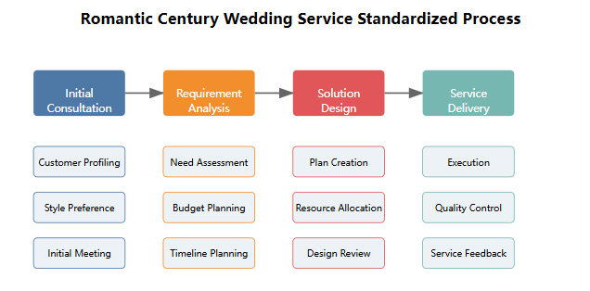
Figure 14. Standardized flow chart of Romantic Century wedding service

from Figure 14 , the service process system of Romantic Century has the characteristics of complete process, clear links, unified standards, smooth connection and timely feedback, which effectively guarantees the stability of service quality. Under this standardized framework, Romantic Century has also established a flexible personalized service mechanism that can be appropriately adjusted according to the specific needs of different customers.
Taking a celebrity wedding as an example, Romantic Century has carried out fruitful flexible innovation based on the standard process. In the demand research stage, the company added in-depth demand discussion and expert style analysis based on the standard interview framework; in the scheme design stage, it added storyboard discussion and style discussion links, and introduced international designers to provide creative support; in the implementation stage, it optimized the procurement and layout process, and added rehearsal and debugging links. This flexible adjustment ensures the quality of high-end customized services and meets the personalized expectations of customers.
Through a service model that combines standardization with flexibility, Romantic Century has achieved remarkable results. In 2023, the company's customer satisfaction reached 98%, 20 percentage points higher than the industry average; the one-time approval rate of the program increased to 92%, the on-site problem handling time was shortened by 60%, the satisfaction of personalized needs reached 95%, and the customer recommendation rate increased to 85%. These data fully prove that the process optimization strategy that combines standardization with flexibility can not only ensure the stability of service quality, but also effectively meet the personalized needs of customers. The successful practice of Romantic Century provides reference experience for the optimization of service processes in the wedding industry, and also provides useful inspiration for how companies can find a balance between standardization and personalization. This process optimization model not only ensures the standardization of service quality, but also realizes the personalization of customer experience. It is an important way to enhance brand value and competitiveness.
The achievement of these results not only relies on scientific process design, but also benefits from the company's strict control at the execution level. Romantic Century has ensured the strict implementation of standardized processes by establishing a complete training system, assessment mechanism and incentive policy; by building a professional wedding butler team and establishing a flexible resource allocation mechanism, it has ensured the effective implementation of personalized services. This process optimization model that combines standardization and flexibility has become one of Romantic Century's core competitive advantages, driving the company to maintain its leading position in the fierce market competition.
4. Continuous innovation and R&D capabilities
Innovative R&D capabilities are an important source for wedding companies to create brand differentiation advantages. Competition in the wedding market is becoming increasingly fierce, and innovation is the core magic weapon for brands to stand out. This requires wedding companies to establish an innovative consciousness and integrate innovation into all aspects of wedding product design, technology application, service methods, etc., constantly bring consumers a brand-new wedding experience and cultivate brand uniqueness. At the same time, brand innovation also needs to keep up with the trend of the times and consumption trends, integrate cutting-edge fashion elements into wedding creativity, and lead a new trend in wedding consumption.

Table 8. Main dimensions and typical cases of wedding brand innovation
Innovation Dimension | Innovation Focus | Typical Example
Product Innovation | Theme creativity, scene design | Starry Sky Garden Wedding Theme
Technology Innovation | Digital technology, smart applications | AR Virtual Fitting System
Service Innovation | Process optimization, experience enhancement | One-stop Wedding Butler
Marketing Innovation | Communication methods, interaction models | Social Media Live Streaming
Model Innovation | Business model, operation methods | O2O Omni-channel Integration

Taking Romantic Century as an example, innovation has always been the cornerstone of the company's development. In 2023, the company established the industry's first wedding fashion research institute, which brings together top talents in planning, design, lighting, music and other fields, and is committed to integrating international cutting-edge concepts, technological fashion elements and traditional wedding forms to create a highly creative and influential wedding IP. For example, the "Starry Sky Garden" themed wedding jointly planned by Romantic Century and NASA in the United States cleverly integrates the vast starry sky with the blooming garden through high-tech means such as AR and holographic projection, creating a dreamy and beautiful immersive wedding scene. Once launched, it was screened on major media and social platforms, and quickly became a wedding hit that newlyweds rushed to emulate. The IP achieved revenue of more than 20 million yuan that year, which effectively demonstrated the brand's innovative strength.

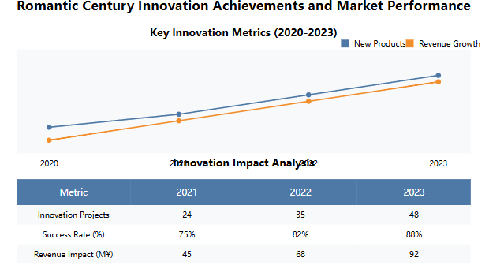
Figure 15. Romantic Century's innovation achievements and market performance in recent years

It can be seen that continuous innovation is an important magic weapon for wedding enterprises to deepen brand connotation and highlight brand personality. Through the all-round layout of product innovation, technological innovation, service innovation, marketing innovation and model innovation, enterprises can continuously enhance brand competitiveness and maintain a leading position in the fierce market competition.
V. Building a professional digital talent team
The construction of a professional and digital talent team is the cornerstone to ensure the professionalism and driving force of wedding enterprise brand management. With the upgrading of consumption and changes in the industry, contemporary weddings have put forward higher requirements for the professional quality of practitioners. Single wedding service skills can no longer meet market demand, and compound talents such as planning creativity, visual design, and digital marketing are increasingly becoming the key to industry competition. Therefore, it is imperative to accelerate the training and introduction of compound talents and build a professional talent team.

Table 9 .Trends in the structure of talent demand in the wedding industry
Year | Traditional Service Talent | Creative Planning Talent | Digital Technology Talent | Comprehensive Management Talent
2020 | 55% | 25% | 10% | 10%
2021 | 45% | 30% | 15% | 10%
2022 | 35% | 35% | 20% | 10%
2023 | 30% | 35% | 25% | 10%

In this regard, Romantic Century's talent development practice deserves attention. On the one hand, Romantic Century continues to increase its efforts to attract talent, and has introduced a group of international wedding planning masters and visual designers from Hong Kong, Taiwan and other places to inject innovative vitality into the company. On the other hand, the company focuses on internal talent training and continues to supplement the content of talent team building:
Through projects such as the "Elite Talent Training Camp", the company systematically improves the professional skills and comprehensive quality of its employees. In 2022, the company also established a wedding academy, offering systematic courses covering multiple modules such as wedding planning, on-site management, and digital marketing, and is committed to cultivating compound brand management talents who understand planning, execution, and marketing.
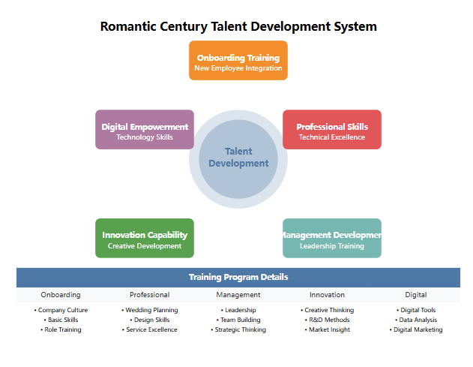
Figure 16. Architecture of the talent training system of Romantic Century

As can be seen from the above figure, Romantic Century has built a complete talent training ecosystem, including:
1. On-the-job training system: integration of new employees and basic skills training
2. Professional ability improvement: professional skills training for different positions
3. Management capability training: leadership development for middle and senior managers
4. Innovation capability building: creative thinking and innovation method training
5. Digital empowerment: application of new technologies and use of digital tools
Table 10 .Results tracking of the Romantic Century talent training program (2023)
Training Program | Participants | Completion Rate | Pass Rate | Practical Application Rate | Employee Satisfaction
New Employee Training | 526 | 98% | 95% | 92% | 4.8/5
Professional Development | 312 | 95% | 92% | 89% | 4.7/5
Management Training | 86 | 100% | 96% | 94% | 4.9/5
Innovation Workshop | 168 | 93% | 90% | 87% | 4.6/5
Digital Courses | 425 | 96% | 93% | 91% | 4.7/5

Thanks to the professional talent development, Romantic Century has always been at the forefront of the industry with its high-quality customer reputation for many years, and won the "Newlyweds' Favorite Wedding Planning Company" award in 2023. The company's talent development strategy is mainly reflected in the following aspects:
1. Introduction of diversified talents
- Establish a strategic cooperative college resource pool
- Launch overseas talent introduction program
- Implement a special recruitment plan for experienced talents
- Construction of expert consultant think tank
2. Systematic training system
- Build a complete training course system
- Create an online learning platform
- Establish a mentor-teaching mechanism
- Conduct case studies and experience sharing
3. Innovative incentive mechanism
- Implement project follow-up investment system
- Establish an innovation incentive fund
- Carry out innovation competition activities
- Establishment of Special Contribution Award
4. Improvement of digital capabilities
- Promote the application of digital tools
- Conduct data analysis training
- Strengthen digital marketing capabilities
- Build a digital talent pool
From the perspective of talent cultivation, Romantic Century has achieved remarkable results in professional talent construction:
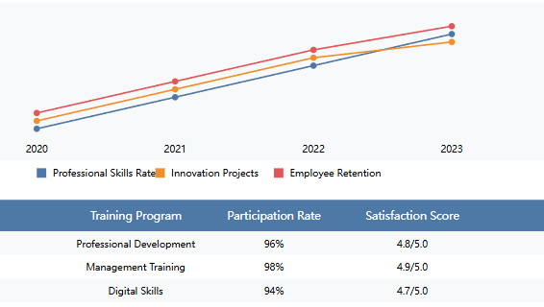
Figure 17. Analysis of talent training effects in the Romantic Century (2020-2023)

Data shows that through systematic talent training, the company's core indicators have achieved significant improvements:
- The professional skills compliance rate of employees increased from 85% to 96%
- The number of innovation project proposals increased by 35% annually
- Customer satisfaction rate remains above 95%
- Per capita output value increased by 40%
- Employee retention rate increased to 88%
In summary, scientific brand strategy planning, efficient organizational structure design, process optimization combining standardization and flexibility, continuous innovation and R&D capabilities, and professional digital talent team building constitute the key elements for wedding companies to improve brand management efficiency. Through the practical cases of leading companies such as Romantic Century and Golden Lady, we can clearly see that only by systematically planning and accurately exerting efforts on factors such as strategy, organization, process, innovation, and talent can we truly achieve an overall improvement in brand management level, thereby comprehensively enhancing the market competitiveness of enterprises.

3.2 Strategic Approaches to Brand Innovation and Customer Engagement for Competitive Advantage

With the continuous change of consumption trends, single price competition is no longer sustainable. Brand innovation and interaction with customers have become the key to success for wedding companies in the new era. Faced with increasingly personalized and diversified wedding consumption needs, wedding brands can only take the initiative in competition and gain lasting competitive advantages by building on their own advantages, driving development with innovation, and optimizing the experience with customers as the center. Combining the above cases and industry trend analysis, this section intends to propose a systematic path for wedding companies to achieve brand innovation breakthroughs and deepen customer interaction from the dimensions of multi-brand development, cross-border joint names, digital marketing, IP creation, and emotional marketing, hoping to provide reference for colleagues in the industry.
First, implementing a differentiated multi-brand development strategy is an effective way to achieve precision marketing and enhance comprehensive competitiveness. With the increasing refinement of market segmentation, a single brand can no longer fully cover the increasingly diverse needs of consumers. Developing sub-brands with differentiated positioning and coordinating management through a unified brand architecture has become an inevitable choice for wedding companies. Taking Romantic Century as an example, facing the wedding consumer market from high-end to mass, the company has successively launched three sub-brands, Romantic Century, Happiness Season, and Xishihui, which occupy the three market segments of high-end, mid-range, and mass, respectively, to meet the personalized needs of consumers at different levels. Among them, "Romantic Century" focuses on high-end newlyweds, featuring one-stop exclusive services and creative planning; "Happiness Season" attracts urban white-collar workers with fashionable and cost-effective wedding packages; "Xishihui"'s quick wedding packages are favored by mass newlyweds who are sensitive to price. Through a differentiated brand portfolio, Romantic Century has achieved precise coverage of different markets, and through the complementary synergy of various brands, it has built a large and stable customer base. In 2023, the revenue share of the three major brands achieved a relatively balanced pattern of 43:32:25, and the customer acquisition cost of the high-end brand "Romantic Century" dropped by 35% year-on-year, which fully demonstrated the positive effect of the multi-brand strategy. It can be foreseen that differentiated and diversified brand development will become the only way for China's wedding industry.
Secondly, cross-border joint ventures are an important strategy for wedding companies to innovate marketing and expand customer boundaries. The secret of joint ventures is that "1+1>2". Through cross-border cooperation with brands in other industries, wedding companies can leverage their strengths to reach a wider range of potential customers, and enhance brand freshness through joint products and cross-border experiences. For example, in 2022, Romantic Century joined hands with the internationally renowned jewelry brand Tiffany to launch the "Tiffany Blue" themed wedding package. The package cleverly integrates Tiffany's classic Tiffany blue elements into scene layout, wedding dresses and other designs, and presents Tiffany's high-end jewelry series on site to create a romantic and luxurious sense of ceremony for the newlyweds. The joint wedding sparked heated discussions as soon as it was launched, with sales exceeding 30 million yuan that year, becoming a veritable "Internet celebrity hit". Through cross-border cooperation with luxury brands, Romantic Century not only attracted more high-end customers, but also greatly improved the brand's fashion and international image. It can be seen that clever cross-border integration can stimulate brand creativity and inject new vitality into wedding companies.
In the digital age, digital marketing has become a powerful tool for wedding companies to reach and attract new generations of customers. As the post-90s and post-00s gradually become the main force of wedding consumption, this generation of digital natives pays more attention to online experience and interaction. Therefore, wedding companies must accelerate the pace of digitalization, use new technologies such as mobile Internet, social media, and big data to accurately reach target customers, and enhance customer stickiness through immersive digital experience. In this regard, Mrs. Jin's digital practice is worth learning from. Faced with the impact of the epidemic, Mrs. Jin decisively increased her digital investment and launched a series of live broadcast activities of "Cloud Wedding Exhibition". Through online 3D scenes and live broadcast interactions, newlyweds can experience the entire process of wedding planning without leaving home. In 2022, Mrs. Jin held a total of 618 cloud wedding exhibition live broadcasts, attracting more than 5 million viewers, directly driving online transactions of 260 million yuan, accounting for 30% of the revenue that year. At the same time, Mrs. Jin also used big data, AI and other technologies to accurately portray customer characteristics, and intelligently recommend personalized wedding plans based on user preferences, greatly improving the pertinence and conversion rate of marketing. In 2023, the input-output ratio of Jinfuren's digital business has been optimized to 1:8, far exceeding the industry average. It can be said that digital marketing has become a sharp weapon for wedding brands to directly hit the new generation of customers.
IP creation is an innovative move for wedding companies to deepen brand connotation and gather customer recognition. Excellent wedding IP can lead wedding fashion and become the object of imitation and pursuit by newlyweds. At the same time, IP can also refine and carry brand personality, arouse consumers' emotional resonance, and bring ideal results of brand-effect integration. The "Starry" series IP launched by Romantic Century is a textbook for wedding IP creation. The IP is based on the theme of "Romantic Promise under the Starry Sky". It creates a dreamy and romantic atmosphere on the scene through the large-scale use of starry sky elements and dazzling lighting, and invites celebrities to help out to create an extremely luxurious starlight feast for newlyweds. Since its launch in 2022, the "Starry" IP has hosted dozens of celebrity weddings, and has derived extended wedding services such as starry sky afternoon tea and starry sky cinema, becoming a popular online celebrity wedding IP for newlyweds. In 2023, the "Starry" IP achieved revenue of more than 56 million yuan, accounting for 18% of the overall revenue of Romantic Century, which effectively demonstrated the appeal of the IP. In the future, carefully creating and operating wedding IP will become a powerful tool for wedding companies to enhance brand recognition and deepen customer recognition.
Finally, emotional marketing is the magic weapon for wedding companies to improve customer experience and build brand wysokability. As a major event in life, weddings are full of the couple's beautiful vision of love and family, so wedding consumption has a natural emotional attribute. Wedding companies should base themselves on the essence of service, weave emotional elements into sales links, product design, on-site services and other aspects, and impress customers with empathy, so as to gain customers' sincere trust. The "True Love for a Century" wedding service launched by Romantic Century is a model of emotional marketing. In order to advocate the marriage concept of "it's easy to fall in love, but not easy to stay together", Romantic Century adds the words "mutual tolerance and hand in hand for a lifetime" to the wedding vows of each couple, and gives away a "True Love for a Century" commemorative bottle engraved with the couple's name, promising to replenish the sand in the vow bottle for free every year, implying a long-term marriage and staying together for a hundred years. At the same time, the company also regularly holds the "Continue Wedding Vows" event, inviting married couples to review their original intentions and convey the positive energy of "long-distance love". Surrounded by the sincere and moving sense of ceremony of Romantic Century, "True Love for a Century" received great acclaim and dominated social media, earning the brand the reputation of "the patron saint of love in the wedding industry". In 2023, "True Love for a Century" was also selected as one of the top ten wedding service projects of the year in "Moving China". It can be seen that emotional marketing is the golden key for wedding brands to enter the hearts of customers and achieve brand-effect integration.
In summary, differentiated multi-brand strategies, cross-border joint marketing, digital precision reach, IP creation and emotional marketing constitute the "five magic weapons" for wedding companies to achieve brand innovation breakthroughs and deepen customer interaction. Looking at the innovative practices of benchmark companies such as Romantic Century and Mrs. Golden, we can clearly see that only by focusing on "customer-centricity", making precise efforts in products, marketing, services and other links, driving innovation, empowering with digital, telling good brand stories and conveying brand warmth, can we truly win the hearts of customers and break through the competition.
Faced with the new competitive landscape of the wedding industry, brand innovation and development has become a general trend. So, how can Chinese wedding companies base themselves on the present, look to the future, systematically optimize brand strategies, and comprehensively enhance brand assets, so as to win a place in the Chinese and even global wedding market? The author will analyze this in the next section.

3.3 Recommendations for Enhancing Brand Equity and Market Presence in the Chinese Wedding Industry

China's wedding industry is ushering in a new round of growth and is also facing new opportunities for change. With the continuous improvement of the national economy, residents' disposable income and wedding consumption capacity have steadily increased, injecting strong momentum into the development of the industry. In 2023, the number of marriage registrations in China will return to 12 million, an increase of 11.3% compared with 2022; per capita wedding expenditure will also rise to 36,000 yuan, a new high. At the same time, Generation Z couples are increasingly becoming the protagonists of the market, and personalized, quality, and digital wedding consumption needs are further released. Against the backdrop of market opportunities and challenges of change, Chinese wedding companies urgently need to face the new market situation, clarify the development path with a far-sighted strategic thinking, and continue to work hard in optimizing brand strategy, shaping brand image, and deepening industrial chain integration, so as to establish brand benchmarks in domestic and foreign markets and build sustainable competitive advantages.
First, looking to the future, formulating a long-term brand strategy plan is the first step to enhance brand competitiveness. The medium- and long-term vision is the "stabilizing force" of the brand strategy, which determines the future direction and destination of the brand. Only with a broad mind and a long-term ambition can a brand be led to transcend the times and stand firm in the market tide. Romantic Century has established a grand vision of "becoming the most trusted high-end wedding brand in the world for newlyweds" and put it into practice. As early as 2020, Romantic Century began to sort out the global high-end wedding market pattern and deeply understand the needs of high-end newlyweds in mature markets such as Europe, the United States, Japan and South Korea. On this basis, the company released the "Romantic China 2030" development outline in 2021, focusing on building a full industry chain for high-end weddings and taking the lead in entering overseas emerging markets. In 2023, Romantic Century successfully held its first overseas wedding show-the Chinese-themed wedding of the "Avenue of Stars" at New York Fashion Week, showing the world the unique charm of oriental wedding aesthetics and opening the curtain of the brand's globalization journey. The company's overseas business proportion will also increase from 1.5% in 2022 to 8% in 2023, gradually moving towards the vision of "global wedding service provider". The practice of Romantic Century shows that only by planning the brand prospects at a strategic level and implementing solid tactics can the brand development be pushed to a new level.
Secondly, inheritance and innovation, creating a differentiated brand image, is the key to stand out in homogeneous competition. Brand image is the intuitive perception of consumers on brand personality, and is the core logo on which the brand depends for survival. Therefore, wedding companies must base themselves on brand positioning, and create a distinctive and unique brand image from multiple dimensions such as visual design, marketing communication, and cross-border cooperation, so as to win the memory of consumers. Take Mrs. Jin as an example. The company is positioned as the "creator of artistic and fashionable weddings" and is committed to integrating artistic and romantic elements into wedding design to create an artistic wedding experience. In order to highlight this unique tonality, Mrs. Jin subverts tradition in visual design, using fashionable colors such as champagne and Tiffany blue as the main colors, supplemented by avant-garde elements such as florals and abstract graphics, to create a romantic, beautiful, and fashionable brand image. In terms of marketing, the company has joined forces with well-known artists and design masters at home and abroad to create the "Artist Wedding" series, and popularize wedding aesthetics to the public through cross-border activities such as art exhibitions and fashion shows, leading the wedding fashion trend. With the help of differentiated brand personality, Mrs. Jin quickly ranked among the top echelons of the industry. In 2023, the brand search volume increased by 156% year-on-year, and its reputation among Generation Z customers also ranked among the top three. It can be seen that brand building based on differentiated positioning is the top priority for wedding companies to build brand competitiveness.
Furthermore, deepening the integration of the industrial chain and creating a high-quality and personalized one-stop wedding service system is an important path to help brands grow bigger and stronger. With the increasing requirements of the new generation of consumers for wedding quality and convenience, a single wedding service is no longer enough. Only through the vertical integration of the industrial chain, can we achieve seamless connection from front-end design, mid-end execution to back-end extended services, and provide customers with a full-process, high-quality one-stop wedding solution, can we maximize the matching of customer needs and form a difficult-to-copy competitive barrier. The development practice of the "Xishihui" platform is quite instructive in this regard. As a popular brand under Romantic Century, Xishihui launched an industrial chain integration plan in 2023, and successively acquired A+-level hotels, high-end wedding photography and other upstream and downstream high-quality resources, opening up the entire wedding industry chain and realizing an integrated closed loop of online reservations, offline experiences, and extended services. Customers only need to make an appointment on the Xishihui online platform to obtain full-process services including pre-planning, on-site layout, wedding dresses, photography and videography, hotel accommodation, etc., and can DIY personalized wedding packages according to their preferences. This convenient "check-in with luggage" experience is very popular among newlyweds, making Xishihui the "wedding butler" in the mouths of the newlyweds. In 2023, Xishihui's one-stop business increased by 38% year-on-year, contributing more than 30% to the group's overall performance, and the overall customer satisfaction rate was as high as 96%, far exceeding the industry average. It can be seen that creating high-quality and personalized one-stop wedding services will become an important path for Chinese wedding companies to build brand competitive advantages.
In addition, accelerating digital and intelligent transformation and deeply integrating digital technology into the entire wedding chain are also the endogenous driving forces for brand innovation and development. With the rapid development of new technologies such as mobile Internet, big data, and artificial intelligence, the wave of digitalization is accelerating the penetration of all aspects of the wedding industry. Wedding companies must keep up with the pace of digitalization and use digital technology to reshape business models, optimize service processes, and improve customer experience in order to maintain competitiveness in the digital economy era. In this regard, Romantic Century can be said to be one step ahead. As early as 2022, the company launched digital transformation, established a digital center, absorbed a group of wedding and technology compound talents, and comprehensively promoted the digital strategy. The company has successively developed and launched digital products such as "Romantic e Home", "Wedding Plan DIY", and "VR On-site Browsing", which greatly improved the intelligence level of marketing, design, and execution. At the same time, the company also uses technologies such as big data and artificial intelligence to accurately understand customer needs, develop intelligent personalized recommendation engines, and effectively improve customer experience. With the support of digital transformation, Romantic Century's operating efficiency and customer conversion rate have doubled. In 2023, the proportion of digital business revenue has reached 45%, becoming an important engine for the company's performance growth. The practice of Romantic Century shows that digital transformation has become the only way for wedding companies to drive innovation and reshape their advantages.
Finally, brand internationalization is also a strategic battleground for Chinese wedding companies to become stronger and bigger and enhance their global influence. With the rapid rise of China's economy and the in-depth promotion of the "Belt and Road" initiative, the pace of Chinese companies' "going out" has accelerated significantly. For the wedding industry, the unique charm of traditional oriental wedding culture is increasingly attracting the attention and love of the international community. Chinese wedding companies should seize this historic opportunity, actively layout overseas markets, combine Chinese wedding aesthetics with international fashion trends, and create a national brand with global influence. In this regard, Mrs. Jin's exploration and practice are worth learning from. In 2021, Mrs. Jin launched a brand internationalization strategy, targeting emerging markets such as Southeast Asia and the Middle East, and launched themed wedding products such as "Oriental Bride" and "Belt and Road", cleverly integrating Chinese wedding elements with local cultural customs, and presenting a unique oriental dream wedding for newcomers from all countries. In 2022, Mrs. Jin successfully held the first "Belt and Road International Wedding Culture Festival", attracting wedding colleagues and prospective newcomers from more than 20 countries to participate, greatly enhancing the brand's international reputation. In 2023, the overseas business of Golden Lady achieved revenue of over 100 million yuan, a year-on-year increase of 160%, becoming the leader of the Chinese wedding industry going overseas. These vivid practices show that deeply integrating into the construction of the "Belt and Road" and telling the Chinese wedding story well will also be an important magic weapon for Chinese wedding brands to step onto the international stage.
Looking at the development of China's wedding industry, branding, high-end, personalization and digitalization have become an irreversible development trend. Under the dual pressure of continuous consumption upgrading and increasingly fierce industry competition, wedding companies must take "branding, innovation and change" as the main tone of development, and systematically layout from multiple dimensions such as strategy, brand, industry, digital and international, continue to deepen brand connotation, consolidate brand loyalty, and enhance brand premium ability, so as to remain invincible in the turbulent market competition. This is the proposition of the times facing every wedding entrepreneur, and it is also an inevitable requirement for promoting high-quality development of the industry. The power of the brand and the future of the enterprise require us to forge ahead and continue to struggle.

CONCLUSION

Through the examination of wedding planning companies, we have discovered that in an era characterized by increasingly diverse, personalized, and digitalized consumer demands, the development of an effective brand management system has become a crucial factor in enhancing enterprise competitiveness. Brand management is a complex and systematic endeavor that requires enterprises to synergize efforts in strategic planning, organizational structure, process optimization, innovation and R&D, and talent cultivation to truly achieve the continuous advancement of brand value. A scientific brand strategy serves as the logical starting point for brand management, while an efficient organizational structure is a vital guarantee for strategy implementation. Process optimization that combines standardization and flexibility is a key measure to ensure product and service quality. Continuous innovation and R&D constitute an inexhaustible driving force for shaping differentiated advantages, and a professional talent team is the core engine propelling brand development. Only by systematically integrating these elements into the logical framework of brand management and constantly refining and innovating in practice can the overall level of brand management be promoted, thereby comprehensively enhancing the market competitiveness of enterprises.
Brand innovation is the key to leading enterprises to victory in the future. Strategies such as differentiated multi-brand development, cross-border co-branding, digital precision outreach, IP creation, and emotional marketing provide vast room for imagination in brand innovation. A single, homogeneous brand strategy can no longer adapt to the increasingly segmented consumer market. Developing differentiated sub-brands and constructing a diversified brand portfolio have become strategic choices for enterprises to break through growth bottlenecks. At the same time, by leveraging the "1+1>2" effect of cross-border collaboration, integrating resources from different industries, and expanding customer boundaries, brands can be injected with fresh vitality. Digital technology can be employed to gain insights into customer needs, optimize marketing paths, and enhance the precision of brand communication. Through IP creation, brand personality can be refined, consumption trends can be led, and brand recognition can be elevated. Emotional factors can be embedded to tell compelling brand stories, evoke empathetic experiences, and strengthen customer stickiness. The above strategies have opened up entirely new tracks for brand breakthroughs and injected surging momentum into the improvement of enterprise competitiveness.
Customer experience is the ultimate touchstone for the realization of brand value. With the awakening of consumer sovereignty consciousness, personalized and high-quality service experiences have become essential criteria for customers when choosing brands. Creating an end-to-end, high-quality personalized service, establishing a service system that combines standardization and flexibility, embedding humanistic care into regulations, and dedicating craftsmanship to serve customers' emotional experiences are all crucial for enhancing brand competitiveness. Moreover, the seamless integration of online and offline channels, the digital interconnection of front-end demand, mid-end fulfillment, and back-end services, and the creation of boundless service scenarios that span all time periods and touch points are also important paths to shaping the ultimate customer experience. Only by penetrating the mind and heart at every link of products, services, and channels, and truly designing the brand journey from the customer's perspective, can customer expectations be met and even surpassed to the greatest extent, thereby winning their long-term trust and loyalty.
Digital and intelligent transformation is the new engine driving brand development. The advent of digital technology and the intelligent era is profoundly reshaping the logic and paths of brand building. By embedding digital technology into every aspect of brand management, big data can be utilized to enhance the precision of demand insights, artificial intelligence can optimize the scientific nature of marketing decisions, blockchain technology can ensure the authenticity of brand traceability, and intelligent algorithms can improve the timeliness of service responses. A digitalized brand operation system is rapidly taking shape. Meanwhile, a series of strategic measures, such as digital employee empowerment, digital platform construction, and digital ecosystem building, are also reshaping the way brands connect with customers, employees, and partners, forming a digital brand ecosystem of co-creation, sharing, and win-win cooperation, and injecting a continuous stream of new development momentum into brands.
Brand internationalization is an essential path for enterprises to achieve high-quality development. As the process of globalization continues to deepen, "going global" has become a strategic choice for many high-quality domestic brands. Brand internationalization is not merely a simple expansion of market territory but a journey of refining brand value through trials and tribulations in the global market. Faced with the consumption habits and cultural differences of various countries, brands need to seek a balance between a global perspective and local wisdom. They must adhere to the core concepts of the brand while optimizing product and service content in a localized manner, respecting local culture, and aligning with international standards to truly take root and flourish in overseas markets. At the same time, attention must also be paid to the shaping and dissemination of cross-cultural brand stories, telling global stories from a local perspective, and breaking through cultural barriers with emotional resonance to enhance the brand's appeal and reputation in the global market. Only by standing tall, looking far, and forging ahead in the midst of global competition and cooperation can a true leap from domestic brands to world brands be realized.
The path of brand building is long and arduous. Admittedly, in a complex and ever-changing market environment, brand building faces numerous uncertainties. The collision between traditional ideas and innovative thinking, the balance between standardization and personalization, the integration of online and offline channels, and a series of other challenges all test the wisdom and courage of entrepreneurs. In this regard, brand creators must seek a dynamic balance between inheritance and innovation, inheriting the excellent genes of the industry while absorbing innovative elements of the times, seeking breakthroughs amidst contradictions, and grasping patterns in the midst of disputes. At the same time, flexible organizational mechanisms, agile market responses, and an open ecosystem mindset are also important keys to resolving uncertainties. Only by maintaining strategic determination in the face of rapidly changing market situations, embracing change with an open mind, and activating brand vitality with an innovative gene can brands ride the waves and achieve lasting success.
Simultaneously, a favorable external environment is also a solid backing for brand development. Governments and industry organizations should continue to exert efforts in creating a macro environment conducive to brand development, improving the legal and regulatory system for brands, strengthening intellectual property protection, and providing a solid institutional guarantee for brand innovation. They should also reinforce brand culture building, build social consensus, foster a strong atmosphere of "revering brands and upholding quality," construct public service platforms for industries, promote the growth of small and medium-sized enterprise brands, formulate fiscal and taxation support policies, establish special funds for brand development, and create favorable conditions for high-quality brands to grow bigger and stronger. Brands are an important embodiment of a country's core competitiveness. Only by forming a grand brand engineering pattern guided by the government, led by enterprises, and participated in by society can the global influence of Chinese brands be fully manifested, and the transformation from "Made in China" to "Created in China," from "China Speed" to "China Quality," and from "Chinese Products" to "Chinese Brands" be comprehensively realized.
Looking to the future, from the strategic height of constructing a new development pattern and promoting high-quality development, shaping a batch of well-known, well-established, and far-reaching high-quality brands has become an important topic in the modernization of the national governance system and governance capacity, as well as an inherent requirement for advancing supply-side structural reform and promoting economic quality, efficiency, and upgrade. Faced with the surging tide of brand era development, enterprises must shoulder the lofty mission of brand building with a sense of urgency and responsibility, deeply cultivate the cultural heritage of brands through inheritance and innovation, ignite the passion for brand innovation in the midst of digital and intelligent transformation, accurately position brand development in customer value, and demonstrate the style of the brand era in international competition and cooperation, providing a strong impetus for brands to go global and lead global consumption.

REFERENCES

- Chen Zhiyuan. (2019). Research on brand architecture strategy: an integrated framework. Journal of Marketing Science, 15(3), 57-70.
- Gao Hongyan. (2021). New trends and challenges of brand management in the digital age. Business Economics Research, (18), 72-75.
- Li Weiqing. (2017). A review of research on consistency of brand communication. International Journalism, 39(7), 151-160.
- Liu Ling, & Chen Jing. (2020). A review of research on brand management in the social media environment. Foreign Economics and Management, 42(4), 3-19.
- Wang Zhigang. (2016). Research on integrated communication of brand visual identification system. Business Economics Research, (22), 71-74.
- Xu Xiaoming. (2021). Research on brand sustainable development: evolution, connotation and prospect. Foreign Economics and Management, 43(5), 3-20.
- Yang Zhilin, & Li Ming. (2019). Research on brand innovation under the background of digital transformation. Science and Technology Progress and Countermeasures, 36(20), 83-91.
- Zhang Zhilin. (2018). Research on the cultivation mechanism of brand emotional value. Business Economics Research, (16), 72-75.
- Zhang Yunjie, & Wang Haizhong. (2020). Research on the characteristics, motivations and countermeasures of brand globalization. International Trade Issues, (10), 155-168.
- Zhao Ping, & Cui Xuesong. (2021). The rise of Chinese brands in the new consumption era. China Industrial Economy, (4), 5-22.
- Zheng Yuhuang, & Fang Xiaoqing. (2020). Research on brand community operation in the new media era. News and Writing, (4), 72-80.
- Zhu Yuechang. (2019). Review and Prospect of Research on Internal Marketing of Service Brands. Foreign Economy and Management, 41(6), 15-32.
- Toffler, Ed. (1984). The Third Wave. Beijing: Xinhua Publishing House.
- Aaker, David. (1991). Brand Equity Management. Beijing: Machinery Industry Press.
- Fournier, John. (2015). Marketing 3.0: Business Revolution in the Internet Age. Beijing: CITIC Publishing Group.
- Keller, Kevin. (2003). Strategic Brand Management. Beijing: China Renmin University Press.
- Kotler, Philip. (2010). Marketing Management. Beijing: China Renmin University Press.
- Aaker, D. A. (1991). Managing brand equity: Capitalizing on the value of a brand name. New York: Free Press.
- Aaker, D. A. (1996). Building strong brands. New York: Free Press.
- Aaker, J. L. (1997). Dimensions of brand personality. Journal of Marketing Research, 34(3), 347-356.
- Balmer, J. M. T., & Greyser, S. A. (2006). Corporate marketing: Integrating corporate identity, corporate branding, corporate communications, corporate image and corporate reputation. European Journal of Marketing, 40(7/8), 730-741.
- Berry, L. L. (2000). Cultivating service brand equity. Journal of the Academy of Marketing Science, 28(1), 128-137.
- Brakus, J. J., Schmitt, B. H., & Zarantonello, L. (2009). Brand experience: What is it? How is it measured? Does it affect loyalty? Journal of Marketing, 73(3), 52-68.
- Christodoulides, G., & De Chernatony, L. (2010). Consumer-based brand equity conceptualization and measurement: A literature review. International Journal of Market Research, 52(1), 43-66.
- Fournier, S. (1998). Consumers and their brands: Developing relationship theory in consumer research. Journal of Consumer Research, 24(4), 343-373.
- Ghodeswar, B. M. (2008). Building brand identity in competitive markets: A conceptual model. Journal of Product & Brand Management, 17(1), 4-12.
- Heding, T., Knudtzen, C. F., & Bjerre, M. (2008). Brand management: Research, theory and practice. London: Routledge.
- Kapferer, J. N. (2008). The new strategic brand management: Creating and sustaining brand equity long term. London: Kogan Page.
- Keller, K. L. (1993). Conceptualizing, measuring, and managing customer-based brand equity. Journal of Marketing, 57(1), 1-22.
- Keller, K. L. (2001). Building customer-based brand equity: A blueprint for creating strong brands. Cambridge, MA: Marketing Science Institute.
- Keller, K. L. (2003). Brand synthesis: The multidimensionality of brand knowledge. Journal of Consumer Research, 29(4), 595-600.
- Keller, K. L., & Lehmann, D. R. (2006). Brands and branding: Research findings and future priorities. Marketing Science, 25(6), 740-759.
- Kotler, P., & Keller, K. L. (2012). Marketing management (14th ed.). Upper Saddle River, NJ: Prentice Hall.
- Low, G. S., & Lamb, C. W. (2000). The measurement and dimensionality of brand associations. Journal of Product & Brand Management, 9(6), 350-370.
- Merz, M. A., He, Y., & Vargo, S. L. (2009). The evolving brand logic: A service-dominant logic perspective. Journal of the Academy of Marketing Science, 37(3), 328-344.
- Park, C. W., Jaworski, B. J., & MacInnis, D. J. (1986). Strategic brand concept-image management. Journal of Marketing, 50(4), 135-145.
- Schmitt, B. (1999). Experiential marketing. Journal of Marketing Management, 15(1-3), 53-67.
- Simon, C. J., & Sullivan, M. W. (1993). The measurement and determinants of brand equity: A financial approach. Marketing Science, 12(1), 28-52.
- Urde, M. (2003). Core value-based corporate brand building. European Journal of Marketing, 37(7/8), 1017-1040.
- Yoo, B., & Donthu, N. (2001). Developing and validating a multidimensional consumer-based brand equity scale. Journal of Business Research, 52(1), 1-14.
- Young & Rubicam. (2003). The Brand Asset Valuator. New York: Young & Rubicam.
- Aaker, D. A., & Joachimsthaler, E. (2000). Brand leadership. New York: Free Press.
- Agarwal, M. K., & Rao, V. R. (1996). An empirical comparison of consumer-based measures of brand equity. Marketing Letters, 7(3), 237-247.
- Brodie, R. J., Hollebeek, L. D., Jurić, B., & Ilić, A. (2011). Customer engagement: Conceptual domain, fundamental propositions, and implications for research. Journal of Service Research, 14(3), 252-271.
- Davis, S. M. (2000). Brand asset management: Driving profitable growth through your brands. San Francisco: Jossey-Bass.
- De Chernatony, L. (2001). From brand vision to brand evaluation: Strategically building and sustaining brands. Oxford: Butterworth-Heinemann.
- Erdem, T., & Swait, J. (1998). Brand equity as a signaling phenomenon. Journal of Consumer Psychology, 7(2), 131-157.
- Fournier, S., & Avery, J. (2011). The uninvited brand. Business Horizons, 54(3), 193-207.
- Kapferer, J. N. (2004). The new strategic brand management: Creating and sustaining brand equity long term. London: Kogan Page.
- Krishnan, H. S. (1996). Characteristics of memory associations: A consumer-based brand equity perspective. International Journal of Research in Marketing, 13(4), 389-405.
- Lassar, W., Mittal, B., & Sharma, A. (1995). Measuring customer-based brand equity. Journal of Consumer Marketing, 12(4), 11-19.
- Morgan, N. A., & Rego, L. L. (2009). Brand portfolio strategy and firm performance. Journal of Marketing, 73(1), 59-74.
- Pappu, R., Quester, P. G., & Cooksey, R. W. (2005). Consumer-based brand equity: Improving the measurement - empirical evidence. Journal of Product & Brand Management, 14(3), 143-154.
- Vargo, S. L., & Lusch, R. F. (2004). Evolving to a new dominant logic for marketing. Journal of Marketing, 68(1), 1-17.
- Wood, L. (2000). Brands and brand equity: Definition and management. Management Decision, 38(9), 662-669.

APPENDIX

Wedding Service Standard Operating Procedure (SOP)
1. Initial Consultation Stage
1.1 Preparation
- Confirm consultation appointment 24 hours in advance.
- Prepare consultation room and presentation materials.
- Review pre-submitted client information.
- Arrange refreshments and amenities.
1.2 Reception Process
- Greet clients within 30 seconds of arrival.
- Escort clients to the consultation room.
- Offer refreshments.
- Present company introduction materials.
1.3 Initial Discussion
- Brief company introduction (5-7 minutes).
- Showcase portfolio (10-15 minutes).
- Discuss initial budget.
- Identify wedding date and venue preferences.
2. Requirements Analysis Stage
2.1 Client Profile Collection
- Collect basic personal information.
- Note wedding date preferences and budget range.
- Estimate guest count.
- Identify style preferences and special requirements.
2.2 Style Assessment
- Present style options catalog.
- Record preferred colors and atmosphere.
- Document cultural or specific style preferences.
2.3 Venue Requirements
- Determine indoor/outdoor preference.
- Assess capacity needs and location preferences.
- Discuss special facility needs and backup options.
2.4 Service Package Discussion
- Present standard packages and customization options.
- Explain included services and additional options.
- Review pricing structure.
3. Proposal Development Stage
3.1 Initial Proposal
- Create a mood board and theme concept.
- Draft venue layout and initial budget.
- Develop a timeline for execution.
3.2 Proposal Review
- Conduct an internal team review.
- Verify costs and feasibility.
- Perform risk assessments and allocate resources.
3.3 Proposal Presentation
- Schedule a presentation meeting.
- Prepare visual aids and a detailed execution plan.
- Present budget breakdown and address client questions.
4. Contract and Payment Stage
4.1 Contract Preparation
- Customize the standard contract with all agreed terms.
- Specify the service scope, payment schedule, and cancellation policy.
4.2 Payment Processing
- Accept the initial deposit and issue a formal receipt.
- Record transactions in the system and schedule future payments.
- Send payment reminders.
5. Planning and Preparation Stage
5.1 Team Assignment
- Assign a wedding planner, design team, and support staff.
- Brief team members and set up a communication group.
5.2 Vendor Coordination
- Select suitable vendors and negotiate contracts.
- Schedule services and coordinate deliveries.
- Confirm all arrangements.
5.3 Timeline Management
- Create a detailed timeline with key milestones.
- Schedule meetings, track progress, and update stakeholders.
6. Execution Stage
6.1 Setup Day
- Conduct a venue inspection.
- Coordinate vendor arrivals and oversee setup.
- Perform quality checks and make final adjustments.
6.2 Wedding Day
- Brief the team and monitor the timeline.
- Coordinate guests, handle emergencies, and manage vendors.
6.3 Post-event
- Settle vendor accounts and oversee venue cleanup.
- Return borrowed items and document the event.
- Collect initial client feedback.
7. Follow-up Stage
7.1 Immediate Follow-up
- Make a courtesy call the next day to gather initial feedback.
- Address any issues and share event photos.
- Send a thank-you message.
7.2 Documentation
- Complete an event report and file all documents.
- Update the client profile and archive photos/videos.
7.3 Long-term Follow-up m
- Send a one-month anniversary card and satisfaction survey.
- Request testimonials and set up anniversary reminders.
- Maintain the client relationship.
8. Quality Control Points
8.1 Pre-event Checks
- Review proposal quality, budget accuracy, and timeline feasibility.
- Confirm resource availability and assess risks.
8.2 Execution Checks
- Inspect setup quality and monitor service standards.
- Ensure timeline adherence and emergency readiness.
- Measure guest satisfaction.
8.3 Post-event Review
- Evaluate service quality and reconcile the budget.
- Analyze client feedback and review team performance.
- Develop improvement suggestions.
9. Emergency Procedures
9.1 Weather Contingency
- Monitor weather forecasts and prepare backup plans.
- Coordinate with vendors and notify guests.
9.2 Vendor Issues
- Maintain a backup vendor list and emergency contacts.
- Implement resolution procedures and communicate with the client.
- Follow the compensation policy if necessary.
9.3 Other Emergencies
- Implement first aid procedures and security measures.
- Follow crisis communication protocols and recovery plans.

