ODESA I. I. MECHNIKOV NATIONAL UNIVERSITY
FACULTY OF ECONOMICS AND LAW
DEPARTMENT OF marketing and business administration

Qualification project (thesis)
for obtaining the degree of higher education "master"
"Digital business strategies, and their implications on marketing"

Performed by: full-time student
specialty 073 Management
Educational and professional program "Management"
Ge Xueyang / Ге Сюеян

Scientistic supervisor: Dr. Sc. (Economics), Prof. Yuriy ROBUL
Reviewer: Dr. Sc. (Economics), Prof. Halyna KOSHELEK

Recommended for defense:  protocol of the department meeting  No. ___ dated ____.____. 2023  Head of Department  ___________Prof. Olena SADCHENKO  (signature) | Defended at the EC meeting No. ___  protocol no. __from ____.12.2023  Assessment ______________/___  (according to the national scale/ESTS scale/points)  Head of the E.C.  _______ Prof. Yevgen MASLENNIKOV  (signature)

Odesa 2023
CONTENT

INTORDUCTION 4
Chapter 1 Literature Review Ошибка! Закладка не определена.
1.1. Overview of relevant theories and concepts related to business strategy and digitization Ошибка! Закладка не определена.
1.2. Examination of existing literature on the impact of digitization on business strategies 9
1.3. Identification of key trends, challenges, and opportunities in digital business strategy 10
1.4. Theoretical Framework. Development of a theoretical framework that integrates concepts from digital business strategy and traditional business strategy 11
1.5. Discussion of key frameworks, models, or theories that inform the study 15
1.6. Key success factors and challenges of digital business strategy 27
Chapter 2 Methodology 30
2.1. Explanation of the research approach (e.g., qualitative, quantitative, mixed methods) 30
2.2. Description of data collection methods (e.g., interviews, surveys, case studies) 32
Chapter 3 Analysis and Findings 33
3.1. Findings. Case study: Successful implementation of digital business strategy 33
3.2. Case study: Failed implementation of digital business strategy 41
3.3. Lessons learned from case studies 43
3.4. Analysis. The impact of digital business strategy on business models 43
3.5. The impact of a digital business strategy on business operations 45
3.6. The impact of digital business strategy on enterprise competitiveness 46
3.7. Examination of the impact of digitization on the content, scope, and structure of business strategies 50
3.8. Identification of emerging digital business strategies and practices 53
DISCUSSION 64
Interpretation of the findings in relation to the research objectives 64
Comparison of the results with existing literature and theories 65
Explanation of the implications and significance of the findings 66
CONCLUSION 70
REFERENCES 74
APPENDIX 1 79

INTORDUCTION

The relevance of the research topic is due to the fact that global development has determined over the past few decades a significant transformation of the paradigm of economic development: the transition from industrial to post-industrial development, the transformation of industrial development itself in the context of the concept of transition to Industry 4.0, the transition from market-hierarchical coordination of economic entities to cluster-network, and then to cross-network cluster regionalization. There is a paradigm shift underway, according to which production is moving to digital transformation. Accordingly, this context leaves room for construction and provides significant “material” for studying perceptual processes and underlying subjective interpretations. Considering the multifaceted technological base that underpins Industry 4.0, this topic provides a broad framework for research into technology perceptions and allows for a better understanding of the factors underlying business digitalization.
The research question is to formulate the following hypothesis. It is assumed that the development of the digital economy contributes to increasing the overall productivity of production factors, which directly contributes to high-quality economic development. Compared to regions with a low level of digital economy development, regions with a better base can benefit from the development of the digital economy. Total factor productivity refers to the residual value without taking into account the share of participation of all material factors of production in economic growth. Technological progress is an important factor influencing this residual value. According to endogenous growth theory, innovation is the main element that stimulates economic growth and technological progress. That is, the development of digital technologies is considered not only as an expansion of the boundaries of production possibilities, but also as an expansion of the boundaries of innovation capabilities. Thus, the digital economy can improve overall factor productivity by facilitating technological progress. Finally, the development of digitalization is transforming traditional industries. New generation information technologies such as big data, cloud computing and artificial intelligence are key production factors.
This topic is very widely covered in literary sources. Foreign researchers such as E. McAfee argue that modern technologies will soon leave people without jobs. S. Greengard proves that the future lies with technology connected to the network, and describes how the world will change in which all material objects will be able to exchange information. D. Rogers provides practical tools to help companies and business leaders of all sizes adapt, innovate, and beat the competition. A. Ross's book talks about technologies that will become the main drivers of economic and social change in the next 20 years. K. Schwab reveals the features and main trends of the fourth industrial revolution.
The purpose of the master's thesis is to determine the essence of the influence of digitalization processes on business development.
To achieve the goal, the following tasks were set and solved:
- provide an overview of relevant theories and concepts related to business strategy and digitalization;
- study of existing literature on the impact of digitalization on business strategies
- identifying key trends, problems and opportunities in digital business strategy;
- conduct a case study of successful and unsuccessful implementation of a digital business strategy;
- analyze the impact of digital business strategy on business models;
- interpretation of the results obtained in accordance with the objectives of the study.
The theoretical and methodological basis of the dissertation consists of the works of management classics, as well as research in the field of building a digital economy.

Chapter 1 LITERATURE REVIEW

1.1. Overview of relevant theories and concepts related to business strategy and digitization

Digital economy is a concept that appeared not so long ago, but every day it is increasingly used in economic sciences. It is based primarily on innovation-oriented scientific research, the development of information IT companies, achievements of scientific and technical progress, as well as socio-economic technologies of marketing and management. Currently, the digital economy, in which information technology and big data are key elements, is actively developing and becoming the main force in promoting the economic growth of various countries [11, p. 4].
In the academic field, in 1996, Don Tapscott, an American IT consulting expert, first put forward the concept of the digital economy in the report “Digital Economy: Opportunities and Risks in the Age of Networked Intelligence.” The main feature of his concept was the digital flow and transmission of information over the network. In 1998, the government report “The Emerging Digital Economy” published by the US Department of Commerce first introduced the term “digital economy”, and subsequently the concept of the digital economy was gradually recognized by governments and scientists around the world. Since then, scientific research into the digital economy has begun to grow, the concept of the digital economy has been constantly enriched and deepened, and the category of digital economy research has expanded [14, p. 330].
The evolution and availability of new ICTs has led to a reduction in cost and sudden improvement in the efficiency of such technologies. For example, many e-commerce companies are built solely on the collection and commercial use of information generated by consumers during their online activities. The ability to process personal information through new technologies such as predictive analytics gives online businesses unprecedented transactional advantages, including the ability to manipulate consumer behavior. An example is personalization, the display of online content to a specific user, where personal information is used to determine the maximum price that can be charged. This has led to the development of new areas of economic activity, as well as new business models. In the new wave of digitization of production, services, logistics, finance and marketing, markets have expanded and costs have been reduced; thus, new technologies have made it possible to create new products at lower costs. Previously, these areas were niche areas [20, p. 334].
The digital economy is developing very dynamically. The process of evolution of the digital economy is presented in Figure 1.1.

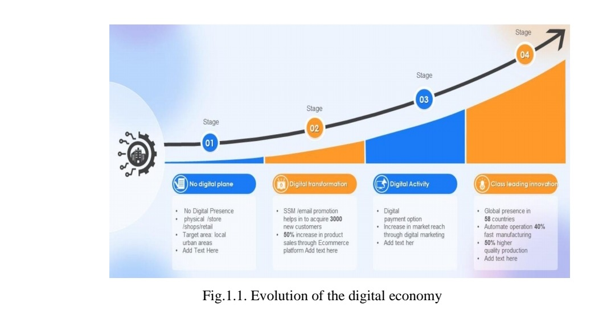

As a historical category, in the process of interaction of technologies, organizations and institutions in the economic system, the digital economy represents a macro-evolution, which is based on high coordination of human activities and continuous optimization of production activities, as well as technology-based interaction. With the deep promotion of supply-side structural reforms, digital technologies are developing and also widely penetrating various industries. Industries are gradually transforming from traditional business models to digital business models through widespread connectivity through the Internet. As stated above, this leads to a new business environment, new thinking, new methods, new concepts. The radical changes are so diverse that it has often become difficult for managers to keep up with this new “global business environment” [24, p. 265].
Ease of access, speed and low cost of obtaining information have made it possible to make the economy more flexible and ready for change, and also introduced an innovative component into the “digital economy”, which made it possible to use innovations useful to society much more efficiently, cheaper and faster. Digital transformation in industry is part of a larger digital transformation taking place around the world: every enterprise is part of it to one degree or another. In the 20th century, technological breakthroughs allowed the evolution of computer machines. Even before the advent of microprocessors and supercomputers, there were some famous scientists and inventors who helped lay the foundation for technology that has since revolutionized every aspect of modern life. It is an undeniable fact that economic processes are accelerating and becoming more complex in the context of the development of the modern world economy. This has an impact on the growing need for the development of digitalization. In other words, there is a growing need for a comprehensive expansion of digital platforms based on the Internet [1, p. 105].
Such a universal platform for accumulation and exchange as the Internet provides unlimited opportunities for humanity (both for established professionals and for people taking their first steps in a certain field). The Internet is an independent resource due to the organization of its distributed network structure. At the same time, it does not depend on the distances between users; barriers and various obstacles are greatly reduced. We can say that the Internet system is a set of platforms that make it possible to successfully implement projects in various fields of activity, including the development of digitalization of industry.
Digital platforms provide a special opportunity to overcome barriers that prevent small businesses from participating in international exchange. For example, having a website gives small businesses the ability to have an international presence without the need to set up a branch abroad - often a cost-ineffective option. Access to data-driven virtual services is another important enabler for small business growth, including online advertising and communication services, cloud computing and access to critical knowledge and information about foreign markets.

1.2. Examination of existing literature on the impact of digitization on business strategies

Now the main goal of any enterprise undertaking the creation of a digital platform is cross-platform, since the principle formulated by Robert Metcalfe suggests that the value of the network grows non-linearly as the number of network users increases, ensuring the formation of a greater number of connections between users (a type of growth also known as nonlinear). Metcalfe's law states: the utility of a network is proportional to the square of the number of users of this network: ≈ n 2 [4, p. 240].
Digitalization impacts four areas of companies’ production and trading activities:
First, the Internet enables trading of services, be it, for example, the online provision of IT, professional or financial services, or new digital services such as cloud computing. Related to this is the transformation of data flows that transform trade in goods into trade in services. For example, additive manufacturing or 3D printing, based on connectivity and information transfer, turns trade in industrial goods into a service - trade in design.
Secondly, collecting and using data also allows companies to increase the value of exports of traditional goods - part of the so-called servitization of production.
Third, Internet globalization and cross-border data flows are transforming international trade, allowing small businesses and firms in developing countries to participate in the global economy in ways that were not previously possible. Online platforms such as eBay, Etsy and Alibaba provide small businesses with access to customers around the world and, combined with online financial payment options and access to delivery services, provide an increasingly seamless cross-border e-commerce experience.
Fourth, global value chains are also supported by the Internet and global data flows. Internet voice communications such as Zoom, Whatsap enable global production coordination, and Radio Frequency Identification (RFID) devices are used to manage complex supply chains.
Digital transformationis the process of using modern digital technologies to improve production. When done correctly, digital transformation improves overall business performance, leading to increased profits. Many business owners in the industrial sector do not realize how much of an impact digital transformation can have on production.

1.3. Identification of key trends, challenges, and opportunities in digital business strategy

The digital transformation of an enterprise is determined by several stages. The first stage is the early stage of digital transformation. The industrial plant in the first stage uses manual operations and has limited or no PLC or DCS (power line communication). Early stage manufacturers are still looking to upgrade their control systems from analogue to digital. Systems such as AR (augmented reality) and ML (machine learning) are still in the long-term vision of enterprises at the first stage of digital transformation [5, p. 15].
In the second stage of industrial digital transformation, digital efforts are just beginning to take off. The enterprise already has automated systems, but there is no archiver. Such a business will likely still have many functions that require manual data entry.
In the third stage of digital transformation, all systems truly begin to transform into digital ones. Often, at this stage, the company lacks software tools, but has a vision of what is needed to move forward.
In the fourth stage, the industrial enterprise becomes mature in the use of digital tools. The key at this stage is to integrate data across the entire enterprise. It is during the fourth stage of digital transformation that the most mature industry players change their business models or at least find new ways to increase profitability.
Thus, in the fourth stage of digital transformation, leading manufacturers become “disruptive”, which obviously represents an additional competitive challenge for other manufacturers who have not yet reached the same level of maturity. The whole combination of these factors contributes to the emergence of a “knowledge spiral”, which allows us to determine the most significant resources in terms of knowledge that have a positive impact on the level of competitiveness. Significant importance in modern life, including information support, is given to IT technologies. Taking this into account, we can conclude that information plays a key role, acting as one of the most significant competitive advantages of intellectual companies.

1.4. Theoretical Framework. Development of a theoretical framework that integrates concepts from digital business strategy and traditional business strategy

Much of what constitutes industrial digitalization relies on big data. Big data refers to data sets that are larger than the capabilities of commonly used software tools to collect, process, manage, and analyze within a short period of time. According to one estimate, 90% of the data in the modern world was created in the last ten years [39]. Data is continuously generated by people and businesses, as well as by sensors embedded in products from cars to mobile devices.
Thus, the impact of big data and the global Internet is not limited to the IT sector, but is contributing to widespread economic and productive growth in industries such as manufacturing, mining and agriculture. Big data is transforming traditional manufacturing into smart manufacturing, which focuses on digitizing the entire manufacturing enterprise from early product design to end-of-life service, using advanced sensors and big data analytics to accelerate life cycles, as well as supply chain analytics.
There is broad consensus on how AI, blockchain, Internet of Things and 3D printing have the potential to fundamentally change the nature of industry. These technologies create new or reimagined products such as autonomous vehicles, intelligent robots and nanotechnology products, as well as a variety of services that are becoming dominant in the global market [40, p. 17].
In a paper for the World Economic Forum, Christine Lagarde identified several ways in which our data-driven world could force changes in the nature of industry. She points to, firstly, the huge growth in the share of trade in services, and secondly, a new wave of productivity that is using technologies such as 3D printing to bring custom manufacturing back to advanced economies, and the power of technology to create a fairer and more inclusive trading system. Some of the transformation that Lagarde talks about is already evident, especially with regard to remote data storage, a concept that was unthinkable just recently [31, p. 318]. According to McKinsey, cloud storage is now used by about 2 billion people worldwide, making it one of the best-selling cross-border services [39].
While many technological innovations are driving change, there are three in particular that are having the most fundamental impact on industry: artificial intelligence, blockchain, and the Internet of Things. The key attributes of each will be discussed below, with an emphasis on how the technology can be used to improve the architecture of modern industry.
Artificial Intelligence (AI).At the heart of AI is the recognition of patterns in data and interactive “learning” from that data—in other words, interaction with data that goes beyond the collection of information to include the creation and interpretation of rules for using that information—and “reasoning,” where the rules and the data can be used and applied appropriately to reach conclusions. This can take many forms, some of which have been around for many years (like IBM's Deep Blue or Apple's Siri), some of which will be many decades away. O'Halloran and Nowaczyk propose a fivefold classification of AIs that illustrates the wide range of their functions [25, p. 180]:
- Rule-based systems that set the parameters and conditions for testing a scenario;
- Machine learning, which applies algorithms to decipher patterns and relationships in data by continually updating the “learning” through an interactive process;
- Neural networks, which identify interconnected nodes using multi-layered data to extract meaning;
- Deep learning, which uses pools of multidimensional data to identify patterns;
- Pattern recognition, which uses tools such as natural language processing to classify and interpret data.
WTO experts primarily emphasized the potential of AI to improve efficiency in production, transport and supply chain management. This potential could include, for example, the use of autonomous vehicles throughout most of the logistics process, which significantly reduces the costs of an industrial enterprise [17, p. 2].
Internet of things. The second technology relevant to industrial control is known as IoT, a term that refers to technology that “equips everyday objects with identification, sensing, networking, and processing capabilities that enable them to communicate with each other and with other devices over the Internet to achieving specific goals” [17, p. 3]. Potential uses of the Internet of Things span the entire spectrum of human life and the economy, from wearable medical devices and automated homes to smart communities, manufacturing, agriculture and supply chain management. For example, automated sensors in a factory may respond to changes in temperature or pressure; machine components can communicate updated maintenance requirements; Smart devices have transformed agriculture by automatically adapting the use of pesticides or fertilizers to actual weather or soil conditions. The data obtained from these sensors has many applications beyond more efficient production methods and provides information also relevant to market research.
Just as containerization revolutionized maritime trade, the Internet of Things has already begun to revolutionize global supply chains and logistics practices in industrial plants, where RFID (radio frequency identification devices) can track shipments in transit. One example used in the WTO Future of World Trade Report is shipping company Maersk's use of remote devices in its refrigerated containers to monitor performance and improve preventative maintenance, which in turn can reduce costly claims against the company for damaged cargo [9, p. 8]. Another potential business benefit of automatically collected data is increased compliance and reduced risk of fraud, as well as more streamlined customs processing of goods, as production and transportation data can be collated to verify the composition, origin and attributes of goods. This is especially true when smart tags can be combined with blockchain technology.
In one of the first economic studies of blockchain, Catalini and Hans, researchers at the Laboratory of Cryptoeconomics at the Massachusetts Institute of Technology, argued that the use of blockchain affects, in particular, two key costs [8, p. 29]:
- verification costs, that is, the ability to cheaply verify transaction attributes;
- network costs, that is, the ability to launch and manage a market without the need for a traditional intermediary.
Other costs such as coordination and processing costs, financial intermediation and costs associated with foreign exchange may also be affected.
In addition to these three key technologies, others are also used that are directly related to production. Optimizing processes and productivity is the first benefit that manufacturers see from digital transformation.

1.5. Discussion of key frameworks, models, or theories that inform the study

The changes brought about by the fourth industrial revolution are global in nature and therefore require a coordinated global response. First, it is necessary to consider the essence of globalization as such. Understanding the logic of the functioning of globalization is a necessary prerequisite for understanding the paradigm of the “Fourth Industrial Revolution”.
Globalization as a process and aspect of social life originated and began its development many centuries ago. In its history, it went through several stages, and the transition to each subsequent one was served by fundamental changes in science, technology, technology, as well as people’s perception of the world. The evolution of the globalization process and its connection with industrial revolutions is summarized and schematically presented in Table 1.1.
Table 1.1
Summary characteristics of the development of the process of globalization and industrial revolutions
Globalization stage | Great geographical discoveries (XV-XVIII centuries) | Globalization 1.0 | Globalization 2.0 | Globalization 3.0 | Globalization 4.0
Export leaders | Raw materials/basic goods | Textiles/ industrial products | Factories | Global supply chain | Digital goods and services
Leading countries | Spain, Portugal, England, Holland | England | USA, USSR | USA | USA, China
Share of trade in world GDP | <5% | 6-14% | 5-15% | 15-20%
Promoting period | Scientific revolution (XV-XVII centuries) | 1st Industrial Revolution (1780s - mid-19th century) | 2nd Industrial Revolution (1870s – 1910s) | 3rd Industrial Revolution (1960s – 1990s) | 4th Industrial Revolution (2015s – 2020s)

The first industrial revolution occurred thanks to the invention of steam engines, the use of water and steam power and all kinds of other machines. Subsequently, it led to the industrial transformation of society with trains, mechanization of production, etc.
The Second Industrial Revolution is generally seen as the period when electricity and the new manufacturing "inventions" it spawned, such as the assembly line, led to the field of mass production and, to some extent, automation of production [4, p. 245].
The Third Industrial Revolution was associated with the advent of computers, computer networks (WAN, LAN, MAN), the rise of robotics in manufacturing, connectivity and, obviously, the birth of the Internet, which changed the rules of the game in the way information was transmitted.
As part of the fourth industrial revolution, society has moved from the “simple” Internet and client-server model to ubiquitous mobility, the connection of digital and physical environments (in manufacturing called cyber-physical systems), the convergence of information technologies, etc. With the passage of time, new technologies like Internet of Things, Big Data, Cloud Computing with additional accelerators like Advanced Robotics and Artificial Intelligence have emerged to take the industry to the next level.
According to the Digital Economy Report 2021 published by UNCTAD, Global data traffic reached 180 and 230 exabytes per month in 2019 and 2020, respectively (Figure 1.2). By 2026, this volume is projected to more than triple [39].
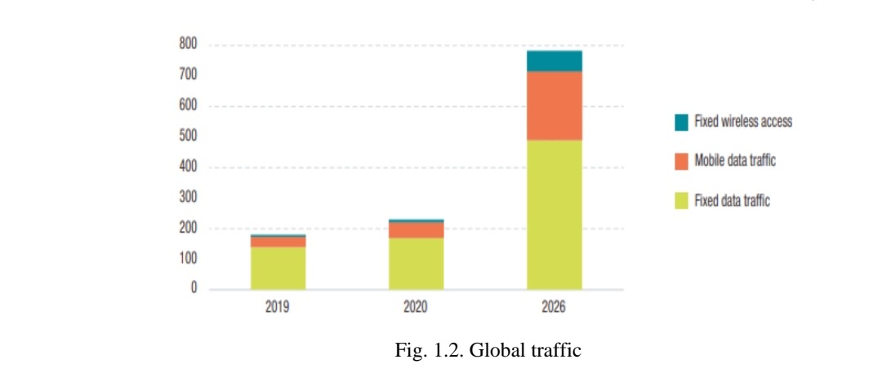
The scale of the digital economy ranges from 4.5% to 15.5% of global gross domestic product (GDP) [39]. In terms of information and communication technology value added, the United States and China account for 40% of the world's total value added, and the development of the digital economy has become a common choice for the world's major countries and regions to change global competitiveness.
Since the beginning of the new millennium in a number of high-tech countries (in the leading countries of the European Union, as well as in Israel, Japan, South Korea, Brazil, Canada, China, Iceland, Mexico, Australia, New Zealand, Switzerland, Norway, Turkey, Russia and the USA) National programs called “Information Society” are being successfully implemented.
Many studies examine the role of innovation and its success factors at the micro and macro levels. At the micro level, the role of innovative companies in the modern economy is emphasized. Companies that develop certain innovative capabilities and are often part of corporate production networks are characterized by higher rates of employment and production growth [34, p. 200].
At the macroeconomic level, innovation tends to promote capital accumulation, employment growth, and multifactor productivity. However, the relationship between research and development (R&D) spending, innovation and productivity is not straightforward.
It is worth noting that studies focusing on the development of innovation practices at the micro level tend to position their approach either from a factor or a process perspective; that is, while studies using a factor approach suggest that factors play a critical role in determining innovative behavior and R&D outcomes in companies, studies using a process approach take into account the wide range of different events that arise during the course of innovation. company process. But all studies note positive effects from the introduction of innovations in a company: expansion of the knowledge base, customer satisfaction, revenue and profitability, higher innovation indicators and, as a result, a positive result at the macro level - dynamic economic growth of the country and increased well-being of the population [31, p . 321].
This implies three main tasks of a digital economy based on innovation:
- strengthening innovative potential and developing new technologies;
- increasing competitiveness in the manufacturing and service sectors through innovation;
- reconfiguration of economic sectors.
The challenges of implementing an innovation-driven digital economy are that the intrinsic value of an innovation remains hidden until it is commercialized, and the extent to which its value is realized depends on the manner in which that commercialization takes place. For innovative practices to lead to technological innovation, a company must have a sufficiently mature technological base, which in turn depends on the company's efforts in internal research and development. Thus, all researchers agree that innovation is the main driver of the digital economy.
Figure 1.3 shows the world's leading countries in terms of ICT exports.
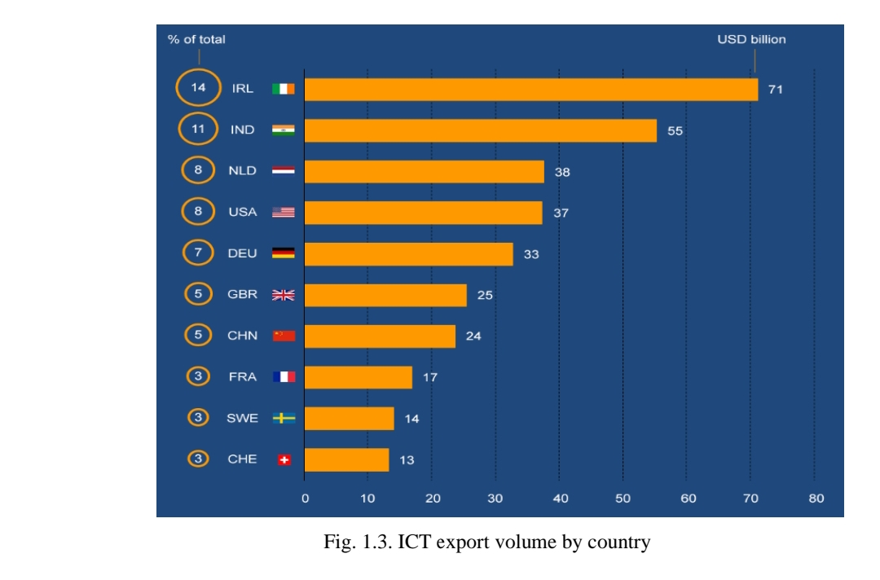

An interesting fact is that only three economically developed regions have a high share in global ICT exports – the EU-28, the USA and Japan. The remaining countries are economically developing countries, with the United States and Japan occupying 5th and 8th place. Even the second-ranked EU actor has a share that is less than half that of China. This is also of interest, since the production and export of ICTs require a “network economy”, which is quite developed in the EU. One of the main reasons may be that when it comes to exports, China's competitive position is strong. This may be due to the US transferring its manufacturing prowess to China (through FDI as well) and China taking full advantage of its competitive advantage and rapidly reducing its cost structure.
Taiwan and Singapore are close countries in terms of ICT exports compared to the EU-28 or the US. It is completely anomalous that developing countries are ahead of developed countries. Therefore, it is necessary to determine the cause-and-effect relationship between economic growth and digitalization.
The World Bank's World Development Report explains how digitalization can drive economic growth. Essentially, digitalization provides faster access to information, which stimulates innovation and knowledge sharing, and which consequently leads to economic progress [32, p. 104].
The digital wave of change has had an unprecedented impact on the competitiveness of the global value chain. It can be noted that only three developed countries have a high share of global added value in ICT production - Germany, the USA and Japan.
The impact of the digital economy on the global competitiveness of countries is visible in the Global Competitiveness Index, which is presented in Table 1.2 [43].
Table 1.2
Rating Global Competitiveness Index 4.0
Place | A country | Number of points
1 | Singapore | 84.8
2 | USA | 83.7
3 | China | 83.1
4 | Netherlands | 82.4
5 | Switzerland | 82.3
6 | Japan | 82.3
7 | Germany | 81.8
8 | Sweden | 81.2
9 | Great Britain | 81.2
10 | Denmark | 81.2
13 | Korea | 79.6
15 | France | 78.8
16 | Italy | 71.5
55 | Kazakhstan | 62.9
85 | Ukraine | 57.0

The authors of The Global Competitiveness Report believe that an influx of investment in human capital is necessary to restore growth in stagnating advanced economies. Finding a balance between technological integration and investment in human capital will be critical to enhancing international competitiveness. Evidence suggests that in some countries that have significant innovation and technological capabilities (South Korea, Italy, France, Japan), insufficient investment may increase the risk of negative social consequences. Developing countries with growing innovation capabilities, such as China, India and Brazil, also need to better balance technological integration and investment in human capital [43].
The digital economy also has a positive impact on economic growth through value chains such as e-commerce. Digital and economic growth variables are closely related; and this relationship between digital variables and economic growth has implications for developing economies. This indicates the need to study e-commerce trends in the world.
Technologies of interaction, computing, sensors, mobile or wireless communications, machine learning, rich virtual representations and hardware interfaces are rapidly evolving. These advances require marketers to rethink their practices. In particular, thanks to advanced Internet technologies and platforms, the number of online purchases has increased significantly.
2020 was a breakthrough year for the e-commerce industry as it generated over $4.2 trillion in global revenue and is projected to reach $6.38 trillion in global revenue by the end of 2023 (Figure 1.4).
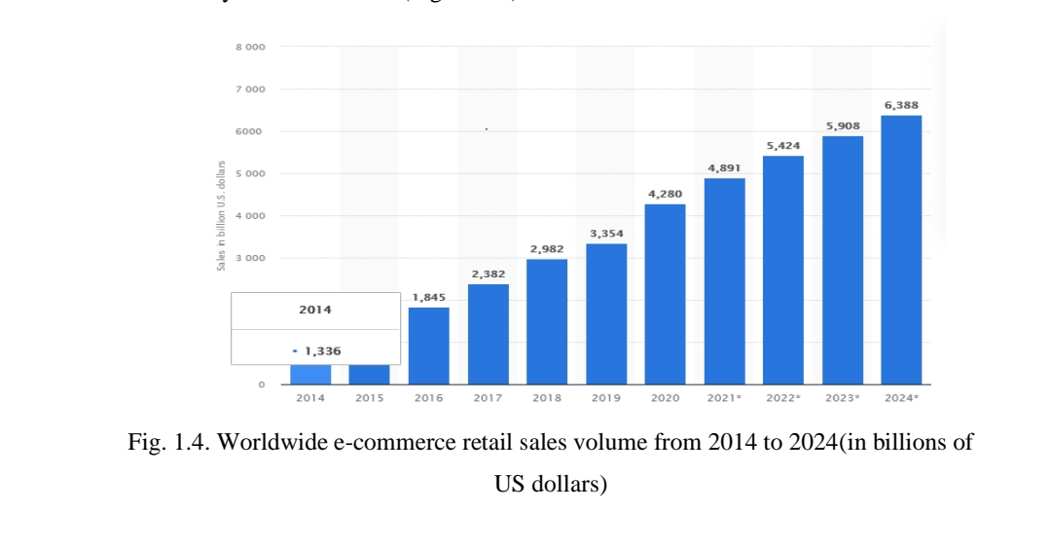

One of the biggest impacts on e-commerce growth has been COVID-19. The global population has been faced with lockdowns and store closures, and has resorted to increasingly online shopping to cope with the situation.
After each industrial revolution, human societies have experienced high and sustained rates of economic growth. Recent explanations for this sudden and massive change in economic history are that modern growth is the result of accelerating innovation. This movement of factors of production from a stagnant to a dynamic sector is necessary for the economy to take advantage of faster productivity growth in the industrial sector and the resulting higher wage growth, lower rents and higher wage-to-rent ratios observed during this period .
As stated above, much points to the central role of technology in the emergence of industrial revolutions. Indeed, England was the leader in the first industrial revolution, which was characterized by a wave of inventions and innovations in the clothing industry, mining, etc. Newcomen and Watt invented the steam engine; Arkwright, Hargreaves, Crompton and Cartwright revolutionized the textile sector; Darby and Cort found new ways to produce iron and much more.
As Meltzer wrote: “The best definition of the industrial revolution is the set of events that placed technology in the position of the main engine of economic change” [27, p. 112].
Germany is considered the founders of the fourth industrial revolution. In 2006, the German government presented its “High Technology Strategy” at the Hannover Messe exhibition. In “Die Neue Hightech-Strategie Innovationen für Deutschland” the government explained how it aims to stimulate innovation, which concerns not only technological innovation, but also “social innovation”, which focuses on society as a whole [28, p. 154].
Germany's strategic reorientation, which, among other things, determined R&D priorities, included five main elements. One of these was to prioritize the future challenges of creating value and (improving) quality of life with one of the future challenges being “digital economy and society.” It is in Germany that Industry 4.0 is first mentioned in clear connection with the advent of the fourth industrial revolution, driven by the Internet and the Internet of Things. Here, the characteristics of future industrial production have been described as follows:
- high degree of individualization (personalization) of products with high production flexibility;
- increased involvement of clients and business partners in the design and value creation processes;
- combining production and high-quality services, which will lead to so-called hybrid products.
The German government has expressed its intention to support business and academia in the development and implementation of Industry 4.0, with a particular focus on safety and the impact on labor and employment. Other digital priorities included smart services, smart data, cloud computing, digital/smart grids, digital science, digital education and digital living environments. Most of them are closely related to the future industrial revolution.
A working advisory group on innovation policy was created to study the priorities of the high technology strategy and develop recommendations on innovation. Dr. Henning Kagermann from the German National Academy of Sciences and Engineering (acatech), formerly of SAP, has been appointed to lead. In 2015, Klaus Schwab, founder of the World Economic Forum, coined the phrase “the fourth industrial revolution” to describe the impact of data-driven technologies that would bridge the boundaries between the physical and the digital, the artificial and the biological. Schwab lays out the way in which societies and their economies were transformed by successive waves of revolutions. These revolutions were, in order, the transition from an agrarian to an industrial society, globalization, the information age, and finally the approaching Fourth Industrial Revolution. Its hallmark, according to Schwab, will be the seamless merging of technology with all aspects of society, making it difficult to distinguish between traditional boundaries of the beginning and end of “technology,” while progress will occur at a scale and pace that has never been seen before [37, p. 78].
ASEAN is the first developing region to prepare a unified legal framework for e-commerce. To date, harmonization efforts have focused on electronic transaction laws, with the expectation that the latter will create legal certainty for the recognition of electronic contracts. The establishment of an ASEAN consumer protection system is a key strategic measure. The AEC Blueprint 2025 highlights the need to develop interoperable, mutually recognized, secure and user-friendly electronic identification and authorization (electronic signature) schemes. Compared to previous ASEAN e-commerce legislation, it is more consumer-focused, recognizing that promoting e-commerce requires more than a broad statement that contracts can be concluded electronically.
ASEAN members are soon expected to join the International Consumer Protection and Enforcement Network (ICPEN), which is a platform for sharing information on consumer protection issues, including best practices and legislative reforms in e-commerce. Specifically, ICPEN includes an online initiative, econsumer.gov, aimed at educating consumers about online scams and abuses. To date, only Vietnam and the Philippines have joined this organization.
Apart from ASEAN, EU countries have also made significant strides in developing e-commerce. The EU model for e-commerce lies in several aspects. The main EU instrument is the Unfair Commercial Practices Directive (UCPD). It strives to empower consumers to make meaningful choices. To this end, it prohibits certain e-commerce practices without qualification. For example, Article 5 contains a general prohibition of unfair commercial practices that are contrary to the requirements of professional prudence and are likely to distort the economic behavior of the average consumer. A material misstatement occurs when a practice limits a consumer's ability to make an informed decision, "causing the consumer to make a transaction decision that he or she would not have made otherwise." [39] The UCPD also prohibits the provision of information that is false or presented in a manner that is misleading. This directive limits marketing and sales abuses related to data profiling and personalization techniques in digital commerce.
Taking into account global experience in the field of digital trade, new standards of the digital economy should implement three main regulatory principles, namely:
- transparency;
- accountability;
- security and reliability leading to trust and traceability.
Moreover, such a design of the digital economy should help prevent distortions caused by anti-competitive behavior of market dominant enterprises, unjustified denial of network neutrality and inappropriate data localization rules.
Thus, there are currently many definitions of the concept “digital economy”. It is based primarily on innovation-oriented scientific research, the development of information IT companies, achievements of scientific and technical progress, as well as socio-economic technologies of marketing and management. The development of the digital economy helps to increase the overall productivity of production factors, which directly contributes to high-quality economic development. There is a tendency for the growth of the digital economy to accelerate in developing countries. According to endogenous growth theory, endogenous R&D and innovation are the main elements that stimulate economic growth and technological progress. That is, the development of digital technologies is considered not only as an expansion of the boundaries of production possibilities, but also as an expansion of the boundaries of innovation capabilities [42, p. 132].
Industrial modernization policy– these are strategies aimed at creating or consolidating high-tech sectors in which knowledge is important; for example, software, biotechnology and aerospace. The amount of value added in these sectors can vary widely. However, middle-income countries are embracing these sectors because they can combine low- and high-value-added activities for their unskilled and skilled workers.
Cyber-physical systems form the basis of the “Fourth Industrial Revolution” (e.g. “smart machines”). They use modern control systems, have built-in software systems and have an Internet address for connection and addressing via the Internet of Things. The structure of the cyber-physical system is presented in Figure 1.5.
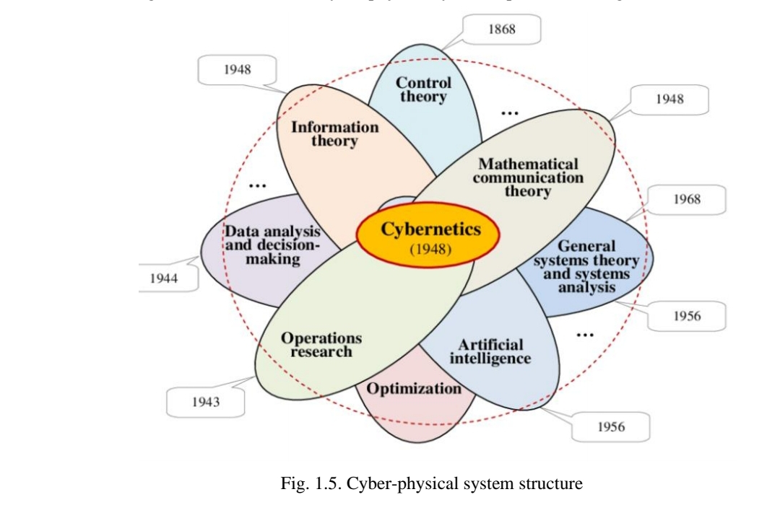
Fig. 1.5. Cyber-physical system structure

Cyber-physical systems are the foundation and enable new opportunities in areas such as product design, prototyping and development, remote management, services and diagnostics, condition monitoring, predictive and predictive maintenance, tracking and monitoring of structural health and system health, planning, innovation capabilities, flexibility, real-time applications and much more.
The new capabilities of the “Fourth Industrial Revolution” are leading to the phenomenon of “smart anything”, which is currently attracting the most attention: from smart grids, smart energy and smart logistics to smart objects including smart buildings, smart factories and smart offices, etc.
Thus, the “Fourth Industrial Revolution” is an information-intensive transformation of production (and related industries) into a unified environment of big data, people, processes, services, systems and industrial assets supported by the Internet of Things. It is characterized by the generation, amplification and use of actionable data and information as paths and means for realizing smart industry and industrial innovation.

1.6. Key success factors and challenges of digital business strategy

Digitalization of industry offers various optimization solutions, from optimal asset utilization and smoother production processes to improved logistics and inventory management.
Many of the benefits of increased productivity are related rather to internal cost and process optimization goals. However, at the same time, some of them also fit into the prospect of increasing customer focus [34, p. 201].
Digitalization covers the entire life cycle of products, and obviously manufacturing too. If you look at the entire value chain and ecosystem in which manufacturing operations are located, you can see that there are many stakeholders involved. If the end customer wants good products quickly and has higher expectations for customer experience, quality, service and products being delivered when they need them, this impacts the entire supply chain, all the way to manufacturing and beyond. Speed ​​is not just about competitive advantage and customer expectations in an increasingly real economy, it is also a matter of consistency, cost and value creation. Data and information technology again play a decisive role in solving this problem.
On the other hand, there are risks and problems that need to be addressed in the digitalization process: the more an enterprise is automated, the less work there is for people. The solution to this problem is to create cobots. Cobots are a fancy term for advanced collaborative robots, or more simply put: robots that are suitable for human-machine collaboration.
Speaking of people, the human (and social) dimension is omnipresent in the digitalization process. Improving the working conditions of people based on real-time data on temperature, humidity and other things in factories or warehouses, rapid detection and enhanced protection in case of incidents, detection of the presence of gases, radiation, etc. – advantages of digitalization [22, p. 880].
A key element of smart manufacturing is the role of data in adding value to products. This underpins new business models that focus on providing both solutions and products to customers. For example, Xerox, a printer company, is now positioning itself as a document design company by adding document maintenance and design services. Rolls Royce uses sensors to collect data from its jet engines to better tailor maintenance and minimize downtime, offering aircraft rentals based on hours in the air. Even in sectors such as mining and agriculture, data is becoming increasingly valuable as it allows businesses to offer value-added products to their consumers. For example, large mining equipment company Caterpillar developed CAT MineStar to collect real-time analytics on sorting accuracy, load quantities, and more. In the agricultural sector, sensors combined with data aggregation are used to track produce from farm to market, providing consumers with information about the farmer and harvest time.
This is just the beginning of data-driven innovation potential. Self-driving cars are close to becoming a reality, robotics is gaining widespread adoption in industry, and AI is advancing rapidly, fueled by ever larger data sets and computing power.
New risks associated with data protection and digital security are also becoming relevant. Among them are [24, p. 265]:
- Server Bandwidth – As Internet resource usage grows exponentially, traffic capacity on some servers may not be sufficient. In addition, companies must ensure that customers find the products they need as quickly as possible.
- Authentication – When orders are placed online, some important data is required from the buyer. However, the buyer must ensure that it was an authorized transaction and actually came from the company.
- Security – Both parties to the transaction (seller and buyer) want to be sure that their confidential transaction data has not been intercepted for personal gain.
- Ensuring the availability of payments - ensuring the ability to create simple, reliable and secure mechanisms for payment in multiple currencies and without large bank commissions.
New business models with digital value must become part of the production rules framework, and regulatory elements must facilitate digital innovation.
Thus, in the modern world, information is considered as one of the key factors determining the competitiveness of an industrial enterprise. The level of self-development determines the amount of information collected and the degree of staff’s ability to transform it into knowledge that positively affects the business. The end result of this process is the emergence of intellectual technology. By occupying a leadership position in the field of their implementation, the manufacturer receives additional advantages in the intense competition that is typical for any market.
Digitalization of industry, on the one hand, contributes to the concentration of wealth in large corporations and brings benefits to those who can take advantage of them. On the other hand, it promotes access to information and technology for more and more people, thereby reducing inequalities and creating opportunities for the poor that did not exist until now.

Chapter 2 METHODOLOGY

2.1. Explanation of the research approach (eg, qualitative, quantitative, mixed methods)

The research methodology was based on content analysis of periodical articles, a systematic approach and case studies using documents and secondary data.
Scientific databases Scopus and EBSCO were used to search for relevant literature for this study. Meanwhile, Google Scholar, Web of Science and Scopus were selected for citation purposes.
An effective method for understanding the evolution of digital business strategies is content analysis of articles in periodicals. This approach allows researchers to systematically examine and categorize the content of articles, facilitating the identification of trends, key themes, and emerging issues in the field.
Evaluating companies' digitalization efforts through the analysis of secondary data such as reports, news articles, and academic studies has both advantages and disadvantages. These approaches can provide valuable insight into practices and their impact on the company and society, but they also come with certain limitations that deserve consideration.
Benefits of using secondary data to study companies:
1. Availability. Information on company performance is readily available from a variety of sources, including annual reports, news articles, academic papers, and rating agencies. Researchers can access a significant amount of data without the need to collect primary data.
2. Economical. Secondary data research is usually cost-effective compared to primary research methods, which may include surveys, interviews, or field work.
3. Comparative analysis. Secondary data allows companies to be compared with other businesses or the corporate world as a whole.
4. Large data sets. Secondary data sources often provide rich data sets that facilitate quantitative analysis and statistical modeling to identify trends, correlations, and patterns in company practices.
Disadvantages of using secondary data:
1. Quality and accuracy. The reliability and accuracy of secondary data can vary significantly. Some sources may contain inaccuracies, bias, or outdated information, which requires careful evaluation by researchers.
2. Limited control. The researchers had limited control over the data collection process, which could potentially lead to information gaps. Specific aspects of digitalization that lack comprehensive documentation in secondary sources may remain unexplored.
3. Lack of context. Secondary data may not provide the context needed to fully understand digitalization initiatives. They may not shed light on the underlying motivations, obstacles and intricacies of decision-making in the field of digitalization of the company.
4. Biased reporting. The public and the media may present a biased view of a company's performance, either positively or unfavorably. This bias could potentially affect the objectivity of research findings.
5. Incomplete picture. Secondary data may not provide a holistic view of digitalization practices, especially regarding internal processes, decision-making, or sensitive information not publicly disclosed by the company.
6. Time delay. Secondary data may not reflect the most recent changes in the digitalization of companies, especially if the sources are outdated or reporting is infrequent. Digitalization initiatives can evolve quickly.
7. Inability to conduct in-depth research: Unlike primary research methods, secondary data does not allow for in-depth interviews or surveys with employees, stakeholders or managers. These primary interactions can provide valuable information that may be missing from secondary data.

2.2. Description of data collection methods (eg, interviews, surveys, case studies)

Data collection: To conduct a content analysis of articles on digital business strategies, a representative sample of articles from various periodicals was collected. The selection was aimed at ensuring a diversity of publication sources, geographic regions, and publication dates to obtain a comprehensive understanding of the topic.
Data Analysis: The data was further analyzed to identify patterns and trends. Qualitative analysis methods were used to examine the frequency of occurrence of various categories and identify relationships between them.
Content analysis of articles on digitalization provided valuable information about the evolution of digital strategy practices and its impact on various stakeholders:
It was found that over time, the focus of articles on digitalization has shifted from technology to a more holistic approach that integrates technology into core business strategies. This reflects a growing awareness that digitalization is a strategic imperative.
The systems approach is a methodological approach in scientific research, which is based on considering an object as an integral and complex entity consisting of interrelated elements. This perspective emphasizes viewing the object in its entirety as a system. To gain a comprehensive understanding of digitalization, scholars and practitioners often take a systems approach that views digitalization as an integral part of a larger system rather than as an isolated set of activities. This approach recognizes the interconnectedness of various components within and outside an organization, making it a powerful framework for studying digital strategies.
To summarize, while secondary data analysis is a valuable tool for scrutinizing companies' digital transformation efforts, researchers must be aware of its inherent limitations and judiciously weigh the advantages and disadvantages to draw informed conclusions about a company's CSR practices.

Chapter 3

ANALYSIS AND FINDINGS

3.1. Findings. Case study: Successful implementation of digital business strategy

Currently, a number of high-tech companies from the US, EU, China and other countries have already made significant progress in creating promising digital manufacturing ecosystems of the future. A number of companies such as Vespa Scooters, IKEA, Marriott and Giraffe360 are using AR/VR (virtual/augmented reality) as part of their corporate strategies. For example, Marriott, an international corporation primarily known for the hotel business, has opened virtual reality travel for its clients. With the help of special machines, similar to telephone booths, people can go to sandy beaches or see a city thousands of kilometres away.
Other major technology companies around the world, such as Amazon, Apple, Google, HTC, Microsoft, Samsung and Steam, are developing platforms, hardware and applications for the Internet of Things, which are then used in the manufacturing sector. In particular, Amazon is a leader in introducing many technological innovations into its operations. Amazon's distribution centers actively use robotic technologies to increase efficiency and reduce costs. Amazon is experimenting with drone delivery (the service is called Prime Air). In addition, the company is known for its predictive analytics capabilities, uses artificial intelligence to build and support its sophisticated personalized recommendation system, and has developed an innovative, patented one-click ordering system.
In advanced countries, the advent of digital technologies has led to a radical change in the economic landscape: the transition of the value chain from production to distribution. Owners of relevant digital technology platforms, capable of effectively uniting producers of goods and services around themselves, have become the main actors [31, p. 131].
In general, US technologies related to Industry 4.0 are associated with significant potential for optimizing intra- and inter-organizational production processes. Engineering conglomerate Razer, for example, requires its suppliers to provide virtual analogues of a physical product (called a digital twin), which are tested for functionality and compatibility, thereby building an optimal supplier base. Ski maker Blizzard collects temperature and humidity data from sensors, combines it with millions of data points from production records, and can now prevent certain material errors by adjusting machine settings based on weather forecast data. At General Motors, employees are experimenting with virtually designed parts and their placement in a physically existing chassis, allowing early detection of problems and unfeasible ideas, thereby increasing the efficiency of engineering processes [31, p. 131].
An example of the successful implementation of a digital business strategy can be considered the American automaker – Tesla.
Figure 3.1 shows how Tesla Corporation translates the company's strategy into operational scale through a combination of balanced scorecards.

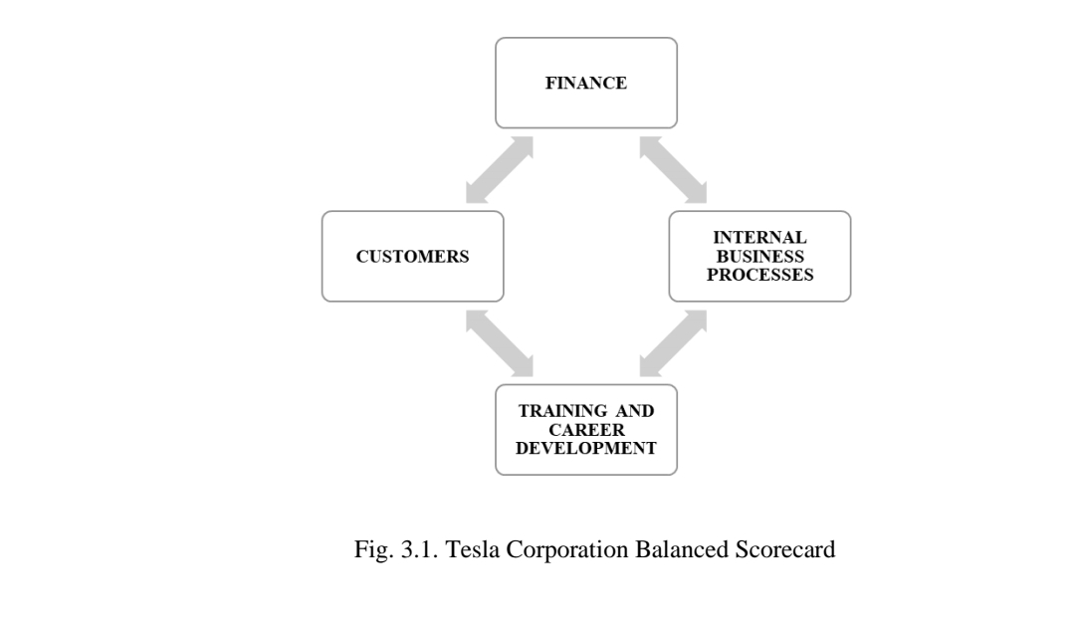

The Tesla Corporation indicators included in the system are completely dependent on the strategic goals pursued by the company, which, in turn, are the core of the strategy. The whole philosophy of the company is based on the principle of "do more with less", which leads to a "just in time" system. This system contributes to the reduction of inventory to production efficiency, which is possible through careful production planning and waste management.
Since its founding, Tesla Corporation has championed and used guiding principles to produce reliable vehicles and to develop and launch innovative and high quality products and services.
Tesla Corporation Named One of the Best Corporate Social Responsibility Companies in the US
Tesla Corporation defines Corporate Social Responsibility as a systematic activity, including the selection and application of methods for optimal interaction with key stakeholders, as a result of which mutually beneficial decisions are made. The company provides comprehensive communication both with external users (website, social networks, local offices, etc.) and with internal ones (corporate portal, corporate newspapers, an extensive feedback network).
Although Tesla's high-end electric vehicles are positioned as premium products, the company also strives to make electric vehicles more accessible to a wide range of consumers by producing more affordable models, such as the Model 3.
Notably, Tesla's revenue surged to nearly $81.5 billion in the fiscal year 2022, marking a substantial increase of 51 percent from the preceding year. The United States stands as Tesla's largest and most significant market.
The dynamics of the company's revenue is shown in Figure 3.2.
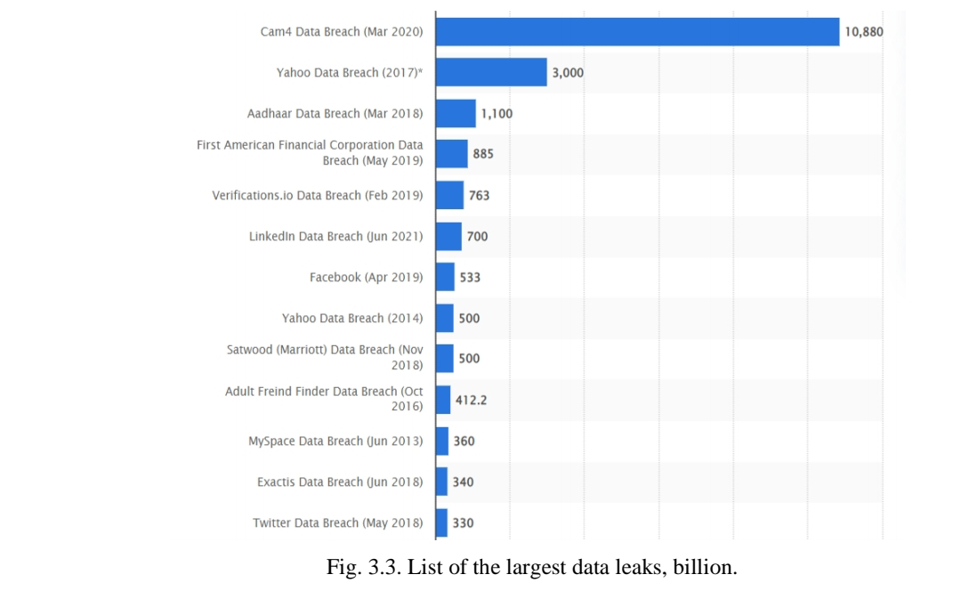

The cost of revenue shows a steady trend.
The ethical level of CSR is a key factor in creating a favorable reputation of the company not only in the eyes of consumers, but also at the internal level, that is, from the point of view of employees. Machine-building companies, like any other commercial organization, see profit maximization as their main goal. This directly correlates with the retention of qualified personnel, so one of the most important aspects that characterizes the CSR of companies is the health of employees and safety conditions in the workplace.
Elon Musk, the CEO of Tesla, has integrated corporate social responsibility into the very fabric of his product design. This commitment is manifested through innovative solutions in electric vehicles and other sustainable technologies. Tesla's approach to safety encompasses the identification of potential risks, the implementation of preventive measures to forestall potential incidents, and a robust system for informing employees and contractors about safe practices.
In terms of Lost Time Injury Rate (LTIR), Tesla Corporation's workforce remains significantly better than the engineering industry as a whole, meaning accidents in automotive manufacturing plants continue to exceed the required rate.
In response to this pressing concern, Tesla Corporation has taken proactive measures to mitigate plastic waste's impact on the environment. These efforts include an increased focus on plastic recycling and support for advancements in plastic waste recycling methods. Additionally, the company is actively researching advanced recycling solutions aimed at harnessing the potential of plastic waste, with the objective of reducing greenhouse gas emissions across the plastic's entire life cycle.
In general, Tesla Corporation takes an active part in the environmental agenda and so far has been quite successful in meeting the challenges. Tesla Corporation in the long term focuses on technological progress, which, according to professionals, will reduce the level of greenhouse gas emissions to the required minimum. The company estimates that the demand for electric vehicles will only increase in the near future due to the rapid growth of the middle class and its prosperity in society.
An alternative source of energy is hydrogen, the extraction of which is also associated with serious environmental difficulties. Today, most of the hydrogen used in the world is produced in an environmentally hostile way: by splitting methane with the accompanying release of large amounts of CO2. There is the concept of "green" hydrogen: the gas is produced by electrolysis of water, which does not harm the environment, but this is an extremely expensive process that requires high-tech and rare equipment, as well as a large amount of electricity from renewable sources. The most suitable method of hydrogen production in all respects is the splitting of methane with the simultaneous capture and storage of carbon dioxide. Hydrogen produced in this way is called "blue". This is a promising direction for the development of the company in the field of CSR.
ASEAN countries are also actively using digital technologies not only in industry. For example, Singapore's GIC uses quantum models and big data input to increase the share of systematic investments. Acadian Research is exploring the added value (over traditional sources) that big data analytics can provide to investment decisions. According to this study, big data sources are more informative, faster, cleaner and less biased, but investors must match their investment styles to the type of data used. Bajunaid and Mekkaoui argue that big data is especially useful in fundamental analyzes of stock markets [27, p. 87].
China has developed a ten-year action plan called “Made in China 2025”. The main goal of this plan is to transform China from an industrial giant relying on cheap labor into a global manufacturer based on digital technologies. To achieve this goal, new technology parks and special economic zones are being actively created in China [31, p. 131].
In particular, digital production exists in almost all developed countries. They are based on the following technologies: digital execution system, programmable logic control, OLE for process control, supervisory control and data acquisition (SCADA), enterprise applications, 3D models, unmanned aerial vehicles (UAVs).
A digital fulfillment system (MES) is an online transaction system that records all levels of production (financial transactions, inventory movements, consumption and sales).
They provide features such as IoT tracking, serial numbers, and functional testing data. However, businesses have specific needs, so each system requires customization.
An industrial programmable logic controller (or PLC) is a programmable electronic device designed to automate processes such as controlling machines in a factory or controlling industrial robots. PLC is the central unit that controls the programmable logic controller: it receives, stores and processes incoming data and determines the status of outgoing data according to the established program. A programmable logic controller receives data through its inputs. Then a specific program processes them. The result obtained is transmitted through its outputs. This processing cycle is always the same, regardless of the program. However, PLC cycle time varies depending on the size of the program and its power. When a programmable logic controller performs a safety function, it is called a safety programmable logic controller or APS.
Object Linking and Embedding (OLE) is a technology introduced in 1995 and designed to provide interoperability among industrial systems. It is not a communication protocol, but a method based on the OLE, COM and DCOM methods developed by Microsoft for its Windows operating systems. Since 2011, OLE has been renamed Open Platform Communications (OPC) due to its expansion beyond process control. OPC was developed to link Windows applications and process control software. The platform defines a consistent method for accessing live data from plant devices. This method remains the same regardless of the data type and source. OPC servers provide various software methods for accessing data from process control devices [23, p. 920].
The OPC server uses Microsoft OLE technology (also known as Component Object Model or COM) to communicate with clients. Today OPC is a registered trademark of the OPC Foundation. The methods developed by the OPC Foundation are based not only on the Component Object Model (COM) and the Distributed Component Object Model (DCOM), but also on the work of the World Wide Web Consortium (W3C) and the Organization for the Advancement of Structured Information Standards (OASIS) [31, p . 320].
A SCADA system is a computer application. This system monitors equipment or production processes at large, remote sites, receiving data in real time. A local SCADA system is a modular system designed to provide communication and/or control of various equipment in an installation located at the same location. This type of communication is carried out through a local area network (LAN). A remote SCADA system is a system that performs the same tasks as a local SCADA, but allows production to be monitored at a remote location. This is provided by a wide area network (WAN) connection. Most SCADA applications use a human machine interface (HMI). This tool allows the user to view all processes. Thus, it provides remote control of equipment.
Enterprise applications. These include various systems that allow you to control the production process [25, p. 180]:
• Enterprise Resource Planning (ERP): An integrated management software package is a software package that allows you to manage all the processes of a company by integrating functions including human resource management, financial management, sales, purchasing and e-commerce.
• Product Lifecycle Management (PLM). This is a centralized storage of product units. Inventory is analyzed in PLM applications before it is distributed to downstream applications such as ERP and MES.
• Customer Relationship Management (CRM) is a system that facilitates the process of ordering products. It provides a platform for product management, quotation management and customer order management to reduce time to market.
• Master data management (MDM) offers a single point of reference for data access. It is an application that provides up-to-date information about customer data, product location, etc.
• Supply Chain Management (SCM) is a global application that focuses on planning, forecasting and supply management.
According to analytical forecasts, by 2025, digital ecosystems will cover up to 30% of income in their regions by optimizing the chain of intermediaries between producers of goods/services and consumers [39]. Digital enterprises are becoming increasingly common in the global industrial system. As a rule, they have the following advantages over traditional enterprises: better customer focus, higher flexibility and uniqueness of production, radical efficiency of the business models applied, integration into the value chain between the manufacturer and the customer, etc. In response, traditional players in various industrial sectors are seizing the opportunity to expand their business models also through digital technologies, ensuring the viability of their businesses.
From an economic perspective, digital manufacturing technologies increase enterprise competitiveness and improve productivity, and help realize the circular economy model.

3.2. Case study: Failed implementation of digital business strategy

This case study examines the failed implementation of a digital business strategy at a Chinese company, TechCo, and identifies key factors contributing to its failure.
TechCo, a mid-sized technology company, recognized the need to evolve its business model to adapt to changing market dynamics. In 2018, the company embarked on a digital transformation aimed at streamlining operations, improving the customer experience and seizing new market opportunities. Their vision was to use new technologies such as the Internet of Things and data analytics to create innovative products and services.
Key components of a failed digital business strategy:
- Lack of a clear strategy.
TechCo's digital transformation lacked a clearly defined and communicated strategy. The leadership team did not agree with the vision, goals or expected results of the transformation. This lack of clarity led to confusion and inconsistent decision making throughout the implementation process.
- Resistance to change.
TechCo employees resisted the changes brought about by the digital strategy. The workforce was not adequately prepared for the transformation and there was a lack of clear information about how their roles would change. This resistance created friction and hindered the adoption of new digital tools and processes.
- Insufficient investment in technology.
Although TechCo had ambitious digital goals, they did not allocate sufficient resources to build the necessary technology infrastructure and tools. As a result, the company struggled to implement and scale digital solutions, resulting in frequent technical glitches and delays.
- Isolated approach.
Different departments within the company were operating in silos, preventing the free flow of information and collaboration needed for digital transformation. Lack of integration and communication between departments hindered the successful implementation of the strategy.
- Ignoring customer needs.
TechCo's digital strategy did not prioritize customer needs and preferences. Instead, the focus was on improving internal processes and reducing costs, neglecting the important aspect of delivering value to the customer.
- Inconsistency with market trends.
The technology landscape changed rapidly during the implementation period, causing some of TechCo's planned innovations to become obsolete. The company failed to adapt and respond to these changes, resulting in missed opportunities and wasted resources.
- Lack of data management.
TechCo collected huge amounts of data but failed to create a robust data management system. This has led to data security and privacy issues, eroding customer trust and compliance.
- Consequences of a failed digital business strategy.
The failure of TechCo's digital business strategy had far-reaching consequences, including:
1) Financial losses. TechCo suffered significant financial losses due to poor execution of its digital strategy. The company has expended significant resources without realizing the expected return on investment.
2) Reputational damage. Failures associated with digital transformation have negatively impacted TechCo's reputation, eroding customer and investor confidence.
3) Talent drain. Qualified employees left the company due to frustration and problems associated with a failed digital strategy, resulting in the loss of valuable talent.
4) Competitive disadvantage. TechCo's inability to adapt to changing market dynamics has put them at a competitive disadvantage compared to companies that have successfully implemented their digital strategies.

3.3. Lessons learned from case studies

The failure of TechCo's digital business strategy highlights several important lessons:
- Clear Strategy and Alignment. A well-defined and communicated digital strategy is essential, and alignment among leadership is critical for success.
- Change Management: Proper change management, including employee training and communication, is critical to overcome resistance to digital transformation.
- Investment in Technology. Adequate investment in technology infrastructure and tools is necessary for a successful digital transformation.
- Customer-Centric Approach. Always prioritize customer needs and market trends when developing a digital strategy.
- Data Governance. Establish a robust data governance framework to protect data and ensure regulatory compliance.
The failure of TechCo's digital business strategy serves as a cautionary tale for businesses seeking to embark on their own digital transformation journeys. Success in the digital age requires a clear strategy, proper change management, and continuous adaptation to market dynamics. By learning from the mistakes made in this case study, companies can better position themselves for a successful digital transformation.

3.4. Analysis. The impact of digital business strategy on business models

In addition to the direct productivity gains that companies receive from digital technologies, there are also deeper chains of indirect benefits such as spillovers within the company.
Basic technologies of the digital economy [35, p. 4]:
1. Ubiquitous data collection and network connectivity. The Internet of Things (IoT) and Industry (IIoT) generate data streams from sensors and video monitoring, clickstreams, location data, smart products, equipment, etc. Vertical and horizontal network connectivity within and between organizations and geographies (connected organizations, factories, supply chains and people).
2. Cloud computing. Centralized storage and software as a service with on-demand and mobile access. Provide continuous and automated updating of software and systems.
3. Big data analytics. Data mining based on multivariate analysis methods. Huge sample sizes provide more reliable results, new insights, and greater resilience.
4. Artificial intelligence (AI). Used from neural networks to machine learning, autonomy, prediction, replication, self-service and regulation.
The digital economy can be divided into industrial and consumer application segments. On the consumer side, smart consumer products are increasingly connected via the Internet of Things (IoT). The use of connected goods and services generates user data that allows platform owners and third parties to respond to their needs, and analysis of aggregated data can be used for other revenue-generating activities such as targeted advertising.
Before the widespread adoption of personal computers starting in the early 1980s, computers were accessed through terminals consisting only of a monitor and keyboard. All computing, including calculations and the programs that performed them, resided on centralized “mainframes.” Information storage was also centralized, first encoded on paper (punch cards) and then on magnetic and optical media (tapes and hard drives). With the advent of the personal computer, everything moved to the desktop: application software, processing (on a central chip or chipset), and storage (on floppy disks and hard drives).
The most significant difference from the mainframe era is that remote computing and storage are no longer centralized within companies, but can be distributed over the Internet, accessible to anyone with authorization. Instead of downloading programs and installing them on a PC, web browsers have become a means of manipulating software and data found online. Compute and storage infrastructure, applications and platforms can be rented (usually on a monthly subscription basis) and upgraded by the vendor. The transition from software as a product purchased in physical form on disk or as a download to software as a service (SaaS) and platform as a service (PaaS) means that the software is always available, from anywhere there is a suitable Internet connection , and always up to date. The same applies to computing infrastructure and storage (including for video-on-demand and streaming video services), access to which has rapidly moved from PCs and private networks to the public cloud.

3.5. The impact of a digital business strategy on business operations

Technology and the shift to online life have led to the massive transfer and disclosure of large amounts of personal information by users of various platforms, applications or mobile devices. These factors determined the creation of a new market: the personal data market. This ecosystem is complex and decentralized. Data is a valuable asset for companies. Monetization of data to obtain significant economic profit can be done in two main ways [41, p. 880] :
The first is internal and focuses on using data to improve operations, performance, products and services, and enable ongoing personalized conversations with customers.
The second is external and involves creating new revenue streams by providing data to customers and partners.
However, it is this accessibility and all subsequent actions that are carried out with personal data that leads to questions related to privacy and security in this ecosystem, which has a direct connection to technology.
Recognizing privacy as a fundamental right in the digital age highlights the antecedent factors that make populations vulnerable in the digital age. Possible costs that people may face due to misuse of personal information include:
Identity theft is the intentional use of another person's personal information, usually as a method of gaining financial advantage or obtaining credit and other advantages in another person's name.
A privacy breach is an incident in which protected or sensitive data could potentially be viewed, stolen, or used by an unauthorized person. In recent years, the most striking cases have been:
1) social media profile data leak that exposed 4 billion records containing information such as names, email addresses, phone numbers, LinkedIn and Facebook profile information;
2) leak of the Orvibo database (which runs on the IoT platform) with the disclosure of more than 2 billion records;
3) TrueDialog Data Breach (which creates SMS solutions for businesses large and small) exposes over 1 billion records, such as recipients' full names, TrueDialog account holders, message contents, email addresses, recipient and user phone numbers, and more.
Thus, as a result of digitalization and the Fourth Industrial Revolution, there is the potential to transform the global economic landscape.

3.6. The impact of digital business strategy on enterprise competitiveness
Different companies solve this forecasting problem in different ways. Some companies pay more detailed attention to this issue, while others have only a superficial understanding, based on current market trends. Tesla's forecasting and decision-making process is quite complex. The difficulty of assessing the prospects for market development is determined by its dependence on many factors, for example, economic, political, external and internal factors.
Tesla conducted an analysis of the performance of its innovation activities in 2020. The results are presented in Table 3.1 and 3.1. Despite the fact that innovations at the enterprise are mainly technical, they also have a social aspect (increasing the qualifications of personnel), therefore the criterion of social efficiency also belongs to the criterion base. Thus, the system for assessing the effectiveness of Tesla’s innovative activities includes the following initial data (Table 3.1).

Table 3.1
Initial data for calculating the efficiency of Tesla's innovation activities
Index | Meaning
Profitability of the enterprise during the period of innovation implementation, % | 37.42
Profitability of innovation activity after innovation implementation, % | 68.5
Production term without using the results of innovation activities, months | 18
Actual production term without using the results of innovation activities, months | 36
Volume of improved products in-house for the development and implementation of innovation, thousand dollars. | 7
The rate of change in labor productivity after the implementation of innovative activities in comparison with the period before the introduction of innovation | -
Originality Index | 1919
Part of employees who are not satisfied with working conditions after implementing innovative activities in the n-period (dismissed at their own request), % | 0.36
Part of employees who are satisfied with working conditions after implementing innovative activities in the n-period (dismissed at their own request), % | 1.28
Part of the total number of employees who are the initiators of innovative ideas, rationalization proposals during the implementation of innovative activities in the n-1st period, % | 2.15
Time spent by employees on production operations before introducing innovations, thousand people. hours | 24.2
Average level of employees who are engaged in the production of ordinary products | 19
Cost of man-hours for the production of ordinary products (according to the tariff category), dollars. | 4.5
Net present value income from innovation activity, calculated by determining the scale of the level of innovation risk, thousand dollars. | 5947.71
Discounted payback period for investments in innovation activities, years | 3.48
Discounted payback period for investments in normal activities, years | 1.8

The innovative activity of the enterprise shows good results, but the innovations introduced into production are mainly of a technical nature. At the same time, the market growth rate varies significantly from year to year. Therefore, the long-term success of a company operating in a dynamically developing market is largely determined by accurate forecasting of market developments.
The results of assessing the effectiveness of Tesla's innovative activities are presented in Table 3.2.

Table 3.2
Results of assessing the effectiveness of Tesla's innovative activities
Direction | Criterion | Index | Meaning
Company | Economic efficiency | Innovation profitability index | 0.79
Company | Economic efficiency | Modified Tobin's coefficient | 0.63
Company | Economic efficiency | Modified Lerner coefficient | 0.56
 | Economic efficiency index of innovation activity |  | 0.28
 | Scientific and technical efficiency | Production Process Optimization Index | 0.5
 | Scientific and technical efficiency | Patent-licensed activity intensity index | 0.57
 | Scientific and technical efficiency | Technology Progressivity Index | 0.86
 | Index of scientific and technical efficiency of innovation activities |  | 0.25
 | Social efficiency | Labor Productivity Index | 0.96
 | Social efficiency | Satisfaction index with working conditions | 0.4
 | Social efficiency | Personnel Innovation Activity Index | 0.37
 | Social efficiency index of innovation activity |  | 0.14
Innovation efficiency index from the enterprise's perspective |  |  | 0.07
Staff | Social efficiency | Modified index of absenteeism of working hours during innovation activities | 0.1
Staff | Social efficiency | Employee qualification index | 0.17
Innovation performance index from the personnel perspective |  |  | 0.001
Investor | Economic efficiency | Index of expected profit from investment | 0.94
 | Economic efficiency | Return on Investment Term Reduction Index | 0.51
Innovation performance index from the investor's perspective |  |  | 0.48

In addition, within the framework of digital capabilities, the challenges and risks of digital transformation can be addressed through the following components:
1) Strategy.
A clear strategy with a clear vision is a key element to a successful digital transformation of an organization. Companies that focus on growing the business as a whole, rather than on individual operational elements, tend to be more successful.
2) Digital infrastructure and platforms.
Technology infrastructure is fundamental to achieving digital transformation in the first place. The infrastructure must be integrated into operational business processes and, to achieve a higher degree of digital maturity, must also be flexible in the use and adoption of new technologies.
3) Risk management.
A digitally mature organization must be as good at digital innovation as it is at managing the risks discussed above. It is necessary to combine risk management theory with effective leadership.
4) Digital competence.
To achieve greater digital maturity, it is important for an organization to have the skills necessary to implement its business strategy.
5) UX design.
Understanding and developing solutions to meet customer needs is essential for organizations. This point relates to customer interaction in general and is important because today the customer, thanks to technological progress and the great dissemination of data and information, is moving more digitally.
6) Design for the business ecosystem.
Within an ecosystem, technology gives organizations greater ability to collaborate with partners, and when all parts of an organization's supply chain are digitally integrated, mutual benefits are created.
7) Leadership.
In a digital organization, leadership competence is very important. Leaders are the ones driving digital transformation and therefore must be able to identify the digital opportunities that create value and growth. Organizational leadership needs to create a culture within the organization that embraces innovation, collaboration among different work groups, and allows for risk-taking.
8) Business skills.
This aspect looks at an organization's adaptability to changes in the technology landscape and how they adapt their business model accordingly to remain competitive. A digitally mature organization can achieve this by, for example, constantly updating its business processes.
9) Stability of income.
This aspect means that the organization must diversify its sources of income as technological developments threaten traditional sources of income.
As such, the business continuously emphasizes on digitalization and adoption of innovative technologies to improve efficiency, accelerate the market and support customers.

3.7. Examination of the impact of digitization on the content, scope, and structure of business strategies

The role of digital technology is complex. It can be argued that intensive and expansionary technological progress generates change through different channels, each of which opens up new opportunities, but also challenges. These include:
- New actors – more choice, more competition.
- New products – more alternatives, speed of customer evaluation, opportunities. But there is greater difficulty in real knowledge of products, less efficiency in the selection process.
- The new industrial organization is a change (or potential change) in the relationship between traditional participants and the role of the financial system. It remains to be seen whether this will lead to greater efficiency and greater well-being.
- New spaces of interaction - greater speed, opportunity, transaction costs - certainly seem to be beneficial for business models, but there is no complete knowledge of how this affects the ability of consumers to make decisions.
The impact of digitalization, mainly of online transactions, has implications in terms of economic policy instruments that are only just beginning to be understood.
For example, a study published in late 2018 by the US National Bureau of Economic Research (NBER) using Amazon as an example warned of how online competition (with its algorithmic pricing technologies and Internet transparency) could change the pricing and pricing behavior of businesses. influence the dynamics of inflation [31, p. 131].
Nowadays, cyber fraud has also become quite common, and one of the specific targets of hackers is fintech companies. For example, in August 2020, Pepperstone - a leading Australian brokerage - openly admitted that they had had their client information stolen. Organizations such as national credit bureaus and large forex brokers also have data breaches. Additionally, the rise of digital networks has made the fintech sector and its clients vulnerable to IT network security breaches. Below are some of them.
Security threats.
1) Third-Party Security Threats: Banks or other financial institutions use fintech services from an unreliable service provider and end up losing their data, failing in their services and may lose consumer trust. This occurs as a result of security threats from third parties.
2) Malware attacks: Key forms of security problems in the global fintech industry are virus attacks and hacking. Several hacker attacks also occurred on the Global Society for Interbank Financial Telecommunications (SWIFT). All banks and financial institutions have weaknesses, and hackers use these vulnerabilities to launch virus attacks. Cybercrime is considered a relatively new phenomenon, but its origins can be traced back decades. For example, in 1996, a doctor named Douglas Johnson created an online digital currency called e-gold, which was entirely backed by real, real gold stored in multiple locations around the world. As its popularity grew, criminal groups saw this innovation as a money laundering opportunity. This eventually came to the attention of the US Department of Justice and subsequent action was taken. 12 years later, a new cryptocurrency called Bitcoin was developed by a Japanese man named Satoshi Nakamoto. This new decentralized cryptocurrency allowed peer-to-peer nodes to transact among themselves, which in turn eliminated intermediaries such as financial institutions.
Identity theft, hacking, invasion of privacy and internet fraud are other examples of cybercrimes committed since then.
Cybercrime is a fast-growing trend nowadays. More and more criminals are using the speed, convenience and anonymity of the Internet to commit a variety of criminal acts that transcend boundaries, both physical and virtual, causing serious harm.
Financial institutions suffer the highest losses from cyberattacks year over year because these institutions store financial data about their clients and some manage their clients' finances. The list of the largest data leaks from companies is presented in Figure 3.3.
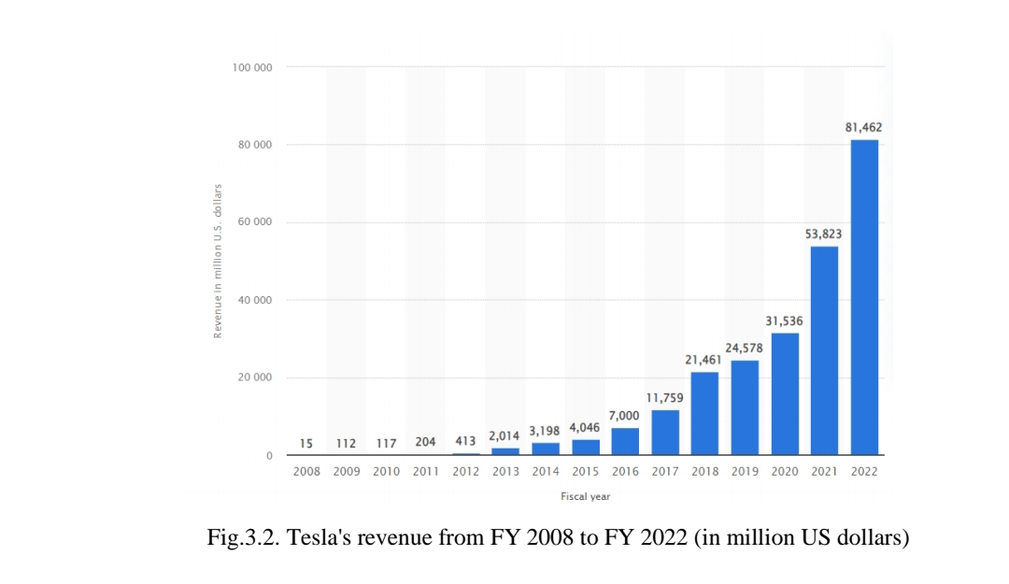

The largest data breach as of 2022 was the Cam4 data breach in March 2020, which exposed over 10 billion data records. The second largest data breach in history, the Yahoo data breach, occurred in 2013. The company initially reported one billion exposed data records, but after an investigation, the company updated the number to show three billion accounts were affected. The next significant data breach was the security breach of India's national Aadhaar ID database in March 2018, where more than 1.1 billion records were exposed. These included biometric information such as identification numbers and fingerprint scans that could be used to open bank accounts and obtain financial assistance.
So, while some businesses are more targeted than others, cybercrime affects companies in virtually every industry. As with the analysis by industry in which a business is active, there is a correlation between business size and types of cyberattacks.
Small and medium-sized businesses are more likely to be targeted by phishing and social engineering, while large companies are more likely to fall victim to more personalized attacks, such as financial fraud or malware and Trojans. Financial fraud is also more common in larger companies.
Cybercriminals often use insufficiently protected networks in their attacks, using them to support and distribute their malicious codes. In theory, any market with a large number of high-end PCs with broadband connections and poor system security could be exploited for this type of activity.
Cyber ​​risk, like operational risk, is also considered from the point of view of harm caused. Thus, cyber risk occurs in high frequency with small losses (daily cybercriminal activities) and huge losses with low frequency. When small cybersecurity-related losses occur, they are typically independent of each other. On the other hand, the huge losses associated with cyber risk are closely related to each other.
A cyber attack will impact the bottom line of the company it targets, but it can also cause legal and human resource issues, damaging reputations or reducing customer and consumer trust, so the next paragraph will look at the basic principles of ensuring an organization's economic security in the face of cyber threats.

3.8. Identification of emerging digital business strategies and practices

To ensure basic principles of economic security in the face of cyber threats, it is necessary to measure the potential impact of a cyber attack.
The impact that cybercrime has on a business varies and can have implications across the entire organization, and classifying these impacts can be challenging as they can be separated from different perspectives.
Business interruption following a cyber attack can be attributed to many factors, and in today's world where more and more company processes are connected to technology and the Internet, this can be a major cost for a company when dealing with cyber attacks. In this case, core IT systems will become unavailable and will be forced to shut down to investigate the cyberattack and minimize its impact. As systems are rebooted and rebuilt, the company loses its operational capability [15, p. 170].
It is known that companies operating in sectors such as telecommunications, media, logistics and transport can incur significant costs due to business interruptions, as their processes are optimized and tightly coupled with each other.
There are different types of cyber attacks that can cripple a company's ability to carry out day-to-day operations, and cybercriminals are getting better and better at exploiting the weaknesses of computer systems. All types of cyber attacks have the potential to cause business interruption. However, there are some that have a higher potential to cause business interruption:
- Cyber ​​attacks make a website unavailable using malicious code. This can be especially dangerous for companies that rely heavily on their websites to conduct business—e-commerce or media businesses.
- Denial of service attacks can disrupt Internet access for employees, customers, and affect the connectivity of various systems that use the Internet to communicate with each other.
- Malicious code that affects a computer network and can potentially delete important information from enterprise hard drives and other equipment.
- Ransomware is another type of malicious code that allows a cybercriminal to gain access to computer data, which is then taken “hostage” and is usually encrypted with very difficult to decipher keys. After this, the hacker will demand money or ransom. It primarily affects small businesses, but has also been known to target larger corporations, such as the attack on Office 365 users in June 2016, as well as hospitals and law enforcement agencies, such as the attack on an Arizona courthouse.
Business interruptions are costly for companies. These costs are associated with various impacts, which may include [20, p. 36]:
• Reduced employee productivity.
• Disruptions in business processes.
• Time and cost to restore systems to their original state.
• Failure to comply with the terms of client contracts, which may result in delay penalties or damages. Clients may also decide to terminate their contracts entirely.
Business data can quickly benefit a cybercriminal as it can be sold to the highest bidder and go against the party that lost it. There are many cases where the loss of information means huge costs for a company, although given the nature of the data, these are difficult to accurately calculate.
While for intangible assets, due to their nature, the impact of a cyber attack is more difficult to estimate, damage due to the impact on tangible assets is easy to calculate:
• Although not as common, a cyber attack can result in physical damage to equipment. In addition to Stuxnet, the famous worm that disabled centrifuges at a nuclear uranium enrichment facility in Iran, a second case was reported in Germany in which a steel mill was heavily damaged by a blast furnace explosion.
• Data may be deleted and computer equipment may become useless. This happened with Sony, which had data wiped on more than half of their computers (3,262 out of 6,797 PCs), and the same goes for servers, where data was wiped on 837 out of 1,555 servers). Moreover, the hackers added a computer program to overwrite it so that it could not be recovered. Sony had to invest huge amounts of money in restoring IT and financial systems, the total bill was about $35 million[24, p. 270].
The business losses that companies may suffer from cyber attacks can be viewed from different perspectives:
1. Decreased acquisition rate or loss of customers after an attack. This can be of great importance, especially for companies that do business online, and especially for those who store personal and financial data about their customers. An example of this case is TalkTalk, a telecommunications company in the UK that suffered a cyber attack in 2015. Sales disruption in the year the leak occurred was estimated at £35 million. It is estimated that 95,000 customers were lost due to this breach.
2. Revenues lost due to business interruption during the attack. Business interruption losses can be particularly significant for, but are not limited to, companies that rely on the Internet as a sales channel.
3. Opportunity cost as the cost of any opportunities that cannot be realized because the necessary resources are used to counter the impact of a cyber attack. After a cyber attack, companies need to divert part of their resources to combat the consequences of the attack, strengthen security, and cover financial losses. All of this means significant expenses that would otherwise be used to grow the business and create business opportunities. To this we can also add a shift in the focus of the entire company from business development to countering the consequences of the attack, since significant resources will be taken away from business development and directed towards combating the attack.
4. Other expenses:
-Increased insurance premiums are additional costs caused by the higher cost of the insurance premium a company must pay after a cyber attack, for the same coverage as before the attack. There is little data on how much an insurance company might additionally charge a hacked company, but based on a Deloitte report, increases of as much as 200% are not uncommon.
-Increasing cost of debt – a cyber attack can lead to a decrease in creditworthiness and, as a result, a decrease in credit ratings. This could potentially cause an increase in the interest rates a company may have to pay to raise funds.
-Technical investigation. Investigative costs following a data breach can be significant, as they can involve thousands of hours of forensic examination of databases and computer programs.
-Cybersecurity improvements. Almost always, a hacked company will need to improve its IT and security systems to prevent the attack from happening again.
Because each case is different, the costs incurred by companies following a cyberattack can vary widely and include many elements. There will be direct and indirect costs, as well as opportunity costs, and the impact of each of these elements may vary depending on the estimation methods and overall assumptions used.
In order to maintain the economic security of an organization in the face of the above cyber threats, tools and tools are used that can be divided into several categories: network security monitoring, encryption, web vulnerabilities, penetration testing, antivirus software, network intrusion detection and packet analyzers [33, p. 1].
1) Network security monitoring tools.
These tools are used to analyze network data and detect online threats. Examples of tools include Argus, Nagios, Pof, Splunk and OSSEC.
2) Encryption tools.
Encryption protects data by scrambling text so that it is unreadable to unauthorized users. Examples of tools include Tor, KeePass, VeraCrypt, NordLocker, AxCrypt, and TrueCrypt.
3) Web vulnerability scanning tools.
These programs scan web applications for security vulnerabilities, including cross-site scripting, SQL injection, and path traversal. Examples of tools include Burp Suite, Nikto, Paros Proxy and SQLMap.
4) Permeability test.
Penetration testing, also known as a penetration test, simulates an attack on a computer system to evaluate the security of that system. Examples of penetration testing tools include Metasploit, Kali Linux, Netsparker, and Wireshark.
5) Antivirus software.
This software is designed to scan for viruses and other malware, including ransomware, worms, spyware, adware and Trojan horses. Examples of tools include Norton 360, Bitdefender Antivirus, Norton AntiVirus, Kapersky Anti-Virus, and McAfee Total Protection.
6) Network intrusion detection.
An intrusion detection system (IDS) monitors network and system traffic for unusual or suspicious activity and notifies the administrator if a potential threat is detected. Examples of tools include Snort, Security Onion, SolarWinds Security Event Manager, Kismet, and Zeek.
7) Packet sniffers.
A packet sniffer, also called a packet sniffer, protocol sniffer, or network analyzer, is used to intercept, log, and analyze network traffic and data. Examples of tools include Wireshark, Tcpdump, and Windump.
8) Managed discovery services.
Managed detection services analyze, proactively detect, and ultimately eliminate cyber threats.
As such, cybercrime affects organizations all over the world, and no company, no matter its size or industry, is completely safe. The main costs that a cyber attack can have on a business have been identified:
1.Financial losses.
a)Business disruption.
b) Loss of information.
c) Loss of intellectual property.
d)Costs of cyber incidents and cybersecurity improvements.
e) Loss of the company's tangible assets (cash, etc.).
2. Reputational damage.
a)Loss of brand image.
b)Loss of clients after the attack.
c)Decreased sales during and after the attack.
d)Loss of credit ratings.
3.Legal consequences.
a) Litigation (with clients or suppliers)
b) Fines and penalties.
The financial impact of cybercrime in the business world is significant, which explains the need to restructure the mechanisms for ensuring the economic security of an organization.
The most dangerous type of cyber risk is cyber terrorism. Cyberterrorism is the use of various computer networks to cause harm and spread propaganda. Cyberterrorism is not defined as illegal activity for personal or economic gain, or obtaining classified information. Cyberterrorism is a traditional form of activism transformed into hacktivism using computer technology. While there has been a significant increase in the number of cyber incidents targeting government computer systems between 2010 and 2022, a number of these attacks have shown that private infrastructures can also be targeted by terrorists (Appendix 1).
The targeting of private corporations manifested itself in attacks on Group Anonymous. The same is true with the Stuxnet attack on Siemens equipment, where code was written to attack the materials of this particular provider. Another high-profile virus attack, Shamoon, destroyed the hard drives of tens of thousands of Saudi Aramco computers and left an image of a burning American flag on the screens of the attacked devices.
Law enforcement agencies in some countries lack the knowledge and adequate resources, appropriate level of training, or willingness to understand cyber risks and illegal cyber activities. There are also problems with web hosts in an international context. This creates obstacles to the collection of evidence in conducting comprehensive investigations to prosecute and punish offenders. To mitigate cyber risks, international cooperation in the field of high technologies is used.
The technologies used to support cybersecurity present a paradox at the global and national level. On the one hand, measures to increase international cooperation on ICT protection are at the core of preserving a free and open Internet. On the contrary, there is growing divergence in national conditions as governments tend to impose restrictions. These measures place limits on the potential of global communications through filtering, blocking, content surveillance, etc. The use of restrictions on the free flow of information violates the very idea of ​​a free Internet. Additionally, it compromises user privacy.
Various network entities are developing extensive and comprehensive forms of international cooperation to overcome cyber risk management challenges. These networks can expand the scope of regulation, strengthen trust and cooperation among actors, facilitate the exchange of information, and set standards of practice and performance.
The most used form of cooperation involves transnational cooperation between states and state actors. This does not mean that they alone make the decision; they may involve experts or participants from the private sector in various fields. However, there is still a visible divide between internal and external security and public and private sector participation in cybersecurity policy. Cybersecurity in modern corporations can be thought of as an umbrella term for numerous and differentiated security risks, all of which have one common factor: the use of cyberspace and the Internet.
Proactive management of cyber risks in modern corporations is developed within the framework of the risk management concept. This form of management can be called alternative because it is innovative in many aspects and is based on a high level of technical uncertainty. Moreover, modern corporations are testing various response techniques, including complex forms of management. Proactive management is about responding to the ongoing transformation of technological cyber risks. This requires rethinking governance and practice within a flexible regulatory framework.
The concept of proactive management is based on a specific way of analyzing potential cyber risks at an early stage, where risk identification and response must be tailored to the significant features of the risks. Proactive management entails a complex system of rules and regulations. The idea is to increase the ability to respond to events early in the process. Therefore, governance forms are designed to deal with unanticipated and fragmented risks at different stages of the governance process.
Large software companies hire certified white hat hackers to break into their own systems and fix vulnerabilities. Thus, Microsoft has been using so-called “microsurfs” for many years. These are hackers who have been co-opted into the corporate structure due to their programming and technical skills. This trend of white hat hackers in the public and private sectors is spreading because they are often the only actors with the skills to investigate security holes.
In addition, formalized PPPs are being developed to improve resilience to ICT attacks. For example, the NIS PPP is a partnership created to combat cybercrime in 2013. This project is interesting because it expands the scope of network and information security. The PPP aims to bring together relevant public and private stakeholders to identify cybersecurity best practices across all sectors and create favorable market conditions for the development and adoption of functional security controls for companies.
Various types of private security agencies are already major providers in the payment card industry, intellectual property investigation and software security. Global cybersecurity alliances are also being formed, which include partnerships with banks, telecommunications providers and government corporations.
The private sector has a responsibility to improve resilience to attacks. For example, Apple is open to cooperation by participating in major conferences with government agencies. Thus, both the public and private sectors can collaborate in developing applicable guidelines, practices and standards at at least three levels; state level, private level, public-private level in cooperation. Consequently, technical computer security actors have better domain knowledge and can more accurately assess risks. In this context, the public sector sets guidelines and private security companies develop management solutions.
Multinational corporations such as Microsoft and McAfee are involved in solving problems in the fight against cybercrime. Microsoft also announced that they have entered into a new partnership with Europol. This collaboration has already proven useful when the two parties combined their technological expertise and successfully brought down the dangerous ZeroAccess botnet, which had infected up to two million computers.
However, the application of technical regulation creates a conflict of interest. Imposing technical restrictions can have negative consequences. Dissatisfaction with the actions of the authorities can provoke hacktivism among computer users, for example, the ban on Twitter in Turkey, the securitization of which led to public protests. In 2013, it was discovered that GCHQ (Government Communications Centre) had developed sophisticated tools to manipulate online surveys, spam SMS messages, and track people.
Internet technologies open up the possibility of wider technologization, in which experts receive a significant role in the conduct of the educational process, along with securitization. Multinational corporations are involved in education and awareness of cyber risks. Companies such as CISCO, Google, McAfee, Microsoft, Symantec and Yahoo have entered into several non-profit government partnerships that offer Internet security curriculum to schools, universities and individuals. In addition, these multinational corporations provide training to government agencies on how to effectively deal with risks at the national and international levels.
For example, the Council of Europe collaborated with Microsoft to provide training for the judiciary in both Egypt and Turkey. Both McAfee and Microsoft have formed a joint venture with CoE for a similar training program in Romania, and the trend appears to be growing. Involving computer technology and security industry stakeholders in non-profit partnerships has been shown to be beneficial because of their knowledge of technical and practical computing issues.
Thus, the new security paradigm requires a different governance structure based on resilience to cyber risks. An emerging area is cybersecurity, which has had an impact on all levels of the economy, that is, the public and private sectors, as well as individuals.
Cybersecurity is the answer to the growing threat of cybercrime. One of the biggest challenges in securing cyberspace is based on interconnectedness. The Internet has evolved as an open, decentralized structure that has expanded globally beyond legal and territorial boundaries.

Due to rapid technological advances, regulatory practices and methods have not kept pace with technological advances. The problem is that the regulations cannot cover in detail all specific areas of computer technology and the risks associated with them. Modern cybersecurity strategies need to be reconsidered. This provided insight into how security is managed, cybersecurity parameters and how countries are responding to growing risks.

DISCUSSION

Interpretation of the findings in relation to the research objectives.
Any enterprise sooner or later faces the need to make decisions on how to use free assets, increase its income, optimize production or other ongoing economic processes.
As a rule, such implementations (projects) require financing, as a result of which, if it is necessary to choose between several investment projects, analysis and evaluation of calculated data is the most appropriate way to justify the decision (or its choice).
The predicted future provides an opportunity to prepare for both positive and negative trends, maximize performance and minimize losses. Thus, on the basis of the developed methodological apparatus, it becomes possible to predict activities at an industrial enterprise unambiguously, reliably and with minimal expenditure of resources and time. Methods based on neural network technology are of primary importance in the process of formalizing the first - intuitive methods.
The bifurcation economic, socio-political and geopolitical transformations of the last three years have significantly tightened the external conditions for the activities of industrial enterprises; additional destructive factors have appeared that have aggravated the crisis state of industrial production. At the same time, significant structural transformations are also taking place in global industry. Leading industrial companies are looking for ways to realize their potential within the framework of the neo-industrial model and the challenges of Industry 4.0. The first is related to the development of basic production (early stages of chains) based on access to cheap resources, highly efficient technologies and favorable logistics flows. It is obvious that the basis for implementing this strategic approach in the domestic industry is gradually disappearing. To extend the life cycle of traditional industries, increase their resource efficiency and restore the profitability of food chains based on them, systemic measures for technical and technological modernization are required, that is, the introduction of digital technologies. These approaches should be associated with the neo-industrial concept and the creation of knowledge-intensive, environmentally friendly production based on innovative technologies.
Currently, attention is focused on the following priority areas:
– increasing resource efficiency in industry, rational use of raw materials, reducing waste;
– introduction of biotechnologies and biomaterials into production;
– increasing energy efficiency, creating competitive low-carbon products;
– production of materials for modern diagnostic methods, formative technologies in medicine, cosmetology, pharmaceuticals;
– development of materials and systems for environmentally sound design and operation of transport, integrating technologies, alternative fuels;
– application of ICT systems and digital innovations along the entire chain, including modeling, design, operation, logistics, management and control of production.

Comparison of the results with existing literature and theories.

Digitalization is a process that began many years ago and is showing growing dynamics. Since 2011, when the vision of Industry 4.0 was introduced, the dynamics of digitalization have been growing in the manufacturing industry. At the same time, numerous and some far-reaching expectations have emerged regarding the impact of digitalization on productivity and its management.
Scholars typically divide the digital economy into digital industrialization and industrial digitalization. Digital industrialization is equivalent to the traditional information industry, including electronic and communications equipment manufacturing, Internet-related services, software and information technology services in the national economic industry classification.
Through the continuous integration of information technology and other industrial sectors of the national economy, added value of the digital economy is generated in traditional industries. This part is part of the digitalization of industry. In modern scientific literature, numerous theoretical works show the importance and determine the success factors of digital technologies, as well as how the results of digitalization affect a country's economic growth and productivity.
To benefit from innovation, a company's business model must take into account both the characteristics that arise from the innovation developed and the characteristics of the market in which it will be commercialized, while maintaining a clear alignment between all aspects that support the company's business strategy. Sometimes this may require a company to change (to a certain extent) its business model.
Tesla is implementing a large number of innovations that are aimed at improving production technology. Tesla's development concept involves, first of all, ensuring a high level of automation, the productivity of new technologies and equipment, and ensuring maximum flexibility for a possible transition from the production of one product and design to another.

Explanation of the implications and significance of the findings.

Changing technological improvements such as Internet Protocol (IP) technology are fundamentally changing the way basic ICT services are delivered. Increasing interdependence among service providers creates different entry points for network security gaps. Cybercrime is the most common criminal activity in which the virtual world is used to commit illegal activities.
In order to maintain the economic security of an organization in the face of the above cyber threats, tools and tools are used that can be divided into several categories: network security monitoring, encryption, web vulnerabilities, penetration testing, antivirus software, network intrusion detection and packet analyzers. This framework takes precedence because the initiatives span multiple areas of cybersecurity that are institutionalized and represented at different levels.
The compliance system is built on risk-oriented principles. This makes it possible to integrate it into the company’s overall control environment and individual control procedures.
The economic essence of compliance applied in foreign countries is that preventing violations in the field of digitalization is more profitable than eliminating their consequences. When an enterprise can independently detect and stop illegal actions in the field of digitalization, the burden of financial, legal and reputational losses for it is significantly reduced. For a compliance system to be effective, a business entity needs to make certain organizational efforts, in particular, such a system must provide risk monitoring, fit into the company’s policy, be understandable to management and staff, motivate compliance, etc.
In countries with developed market economies, such as Great Britain, Germany, France, the organization of a compliance system is aimed at achieving the following results:
- preventing conscious and unconscious actions of personnel that may violate the law, as well as reducing the number of precedents of cyber attacks, and, as a result, sanctions from the regulatory government agency;
- reducing the burden on the state regulatory apparatus;
- creation of a system of dual control (internal and external) in the field of regulation of digitalization;
- increasing trust on the part of government agencies;
- development of internal corporate ethics, acceptance by employees of the organization’s values ​​and, as a result, greater loyalty to the company;
- increasing the digital literacy of employees.
In Western European countries, the USA, as well as in some neighboring countries, this method of regulation has been successfully used for several decades. In Australia, New Zealand, Brazil, Great Britain, Germany, Italy, France, the compliance program is enshrined in law.
The implementation of a compliance system is beneficial for both representatives of business structures and government agencies. This is explained by the fact that due to conscious compliance with legal norms in the field of digital technologies, business entities reduce the risks of sanctions, legal costs and reputational losses, and due to a reduction in the number of offenses in this area, the burden on regulatory government bodies is reduced.
Outlining the overall dynamic process of compliance control, specific approaches, criteria and actions that can be used by companies in the process of digital transformation will be presented below:
-Employers, employees and their representatives will raise awareness and improve their understanding of the challenges and opportunities presented by digital transformation.
-The development of a people-centred approach to digitalization of work will be supported to support workers and improve productivity.
-Partnership between employers, employees and their representatives will be encouraged.
Job content and skills refer to learning the impact of digital technologies required to perform work and communicate digitally with management, colleagues, clients and intermediaries. The approach also takes into account aspects of fit, autonomy, variation, workloads, information and role clarity.
The first stage of the process is participatory research/preparation/framework, which involves raising awareness, preparing an appropriate framework for support and building trust so that the challenges, risks and opportunities of digitalization and its implications can be openly discussed.
The second stage of the compliance process is joint planning/assessment/analysis, which examines how successful integration of digital technologies can benefit employees and the company, as well as the associated challenges and risks. At this stage, possible criteria and actions are determined.
The third stage of joint consideration and adoption of compliance controls is the result of the previous steps. What's important here is to have a basic understanding of the challenges and opportunities, the different components and their relationships, and an agreement to define the goals of the company's digital strategies going forward.
The goal of digital technologies in compliance control is to optimize work processes and create a new business model, for which it is necessary to explore the possibilities of using user interface systems.
In all of this, the key is to ensure that user interface systems and solutions do not threaten a person's engagement and capabilities at work, but instead enhance them. The user interface also has enormous potential to improve the productivity of organizations, for the well-being of the workforce, for better division of tasks between workers, between machines and people, between different departments of the company, and to reduce exposure to hazardous working conditions.
Thus, when implementing compliance control systems, it is necessary to take into account that the system must follow the person in the management principle. The risk assessment should include options for improving safety; it must also prevent adverse effects on the psychological safety and physical integrity of a person.
The purpose of data collection should always be specific and clear. In addition, when implementing a compliance system, it must always be possible to address issues related to consent, data, control and privacy protection, while providing the appropriate capabilities and digital tools to best fulfill their obligations in the era of digitalization.

CONCLUSION

Digital innovations, according to experts, are capable of making a real revolution in the economy. Technologies such as artificial intelligence, Big Data, blockchain, cloud computing can take labor productivity to a new level and reduce the cost of most processes. As a result of digital transformations, changes are taking place in socio-economic systems, the structure and models of doing business are changing, and a significant part of the processes is moving to the online segment. Shopping for goods, banking and insurance services, remote communication online, all this has already become the norm for modern society.
Digital transformation covers the entire process of creating digital offers aimed at improving goods/services that have a material form.
The readiness of enterprises for the large-scale application of Industry 4.0 depends on: the degree of involvement of industry and the IT sector in digitalization; creating conditions for the accelerated development of industrial high-tech segments as key to economic development; supporting innovation and export activities of innovators; creating roadmaps for digital transformation in priority industries; accelerating the transition to European standards in the field of Industry 4.0.
New strategies are emerging for companies - interconnection, flexibility, remote control, leading them to more global strategies. Creating alliances, sharing data and value chains as needed can be very beneficial for SMEs and startups focused on Industry 4.0.
The transition to digitalization of industry also affects the organization of work. Digital technologies make the physical work of workers easier and lead to greater independence and responsibility. Interaction with machines occurs through human-machine interfaces, cobots.
The directions for the development of digitalization of industry can be outlined as follows:
• Education. It is necessary to train new generations in new practices of Industry 4.0 industries and support workers during the transition period.
• Investments. Digitalization requires significant investment, which many Russian companies do not have. The solution to the problem may be government support or the attraction of FDI (foreign direct investment).
• Data protection. Data protection is a challenge and a major concern when companies are interconnected. Strengthening cybersecurity will be the solution to this problem.
In China, it is advisable to use foreign experience in the field of Industry 4.0 from countries such as the USA, Germany, Japan, namely: actively support projects of large, small and medium-sized businesses focused on the development of strategic initiatives; popularize the ideas and trends of the Fourth Industrial Revolution; reach an agreement among industrial enterprises, educational, scientific institutions and the government apparatus regarding the directions of development, goals and objectives of Industry 4.0. However, it should be taken into account that the implementation of these principles in Russia will lead to the need for a significant amount of investment in the modernization of production infrastructure and, as a result, a reduction in investment in other areas.
China does not have sufficient conditions in terms of investment attractiveness for doing business with large capital investments, but has every chance of becoming at least a leader in the field of complex and knowledge-intensive engineering services by reducing import dependence, as well as the wider use of IT products and services, machines and domestically produced equipment. The priority and driving forces for the development of Industry 4.0 in China should be the following sectors: ICT, mechanical engineering, military-industrial complex, aerospace industry, integrated engineering, creation of new materials, alternative energy.
Under pressure from international competition and structural changes, businesses need to constantly innovate. The use of modern information and communication technologies provides the Russian economy with new opportunities for commercial transactions in international markets. Digitization and the application of technology reduce costs for industrial enterprises, increase operational efficiency and speed up the production process.
At the micro level, digitalization has a positive effect on the economic efficiency of an industrial enterprise. This suggests that business improvement will occur with the introduction of new technologies. Although changes in the business model can be caused by the development of technological innovations, the usual course of action for most businesses is to engage in innovation activities based on a pre-planned strategy. The important aspect here is to ensure that the strategy is properly translated into a suitable business model, and that the innovation initiative actually contributes to the company's goals and is consistent with the business model. Digital systems provide greater uptime through predictive analytics, faster switching through automated motion, quality through accuracy and repeatability, and greater sustainability through reduced waste and energy consumption.
From a macroeconomic perspective, the digital economy influences economic development by affecting production costs and production efficiency, which is reflected in the increase in factor inputs, the increase in factor allocation efficiency, and the increase in overall factor productivity caused by technological progress and technological spillovers. For developing countries, digitalization is considered the main driver of economic growth. It increases the productivity of capital and labor, reduces transaction costs and promotes the integration of countries into the global market system.
Based on the core connotation of the digital economy, with the deepening of digitalization, scholars believe that the combination of digital technology and traditional industries can achieve the following results:
- realize environmentally friendly and rapid development of GDP;
- transform the consumption structure;
- improve the quality of human capital;
- transfer the industrial economy from labor-intensive to technology-intensive;
- consolidate infrastructure construction;
- ensure full and efficient use of resources;
- strengthen technological innovation.
Therefore, China should strengthen its advantages in global digital competition, continue the research and development of key digital technologies, and further develop the entire industry chain. However, at present, despite the potential, there are some problems in the development of the digital economy, such as unbalanced and uncoordinated development. These problems are mainly concentrated in areas covering digital infrastructure, the degree of modernization of digital industry, information network security, and the deep integration of digital technology penetration and traditional industries. In conclusion, a digital economy is an economy that uses digital technology as a key factor in the production, distribution and consumption of goods and services. It covers various fields of activity, including manufacturing processes, trade, finance, media, education and healthcare. The digital economy allows companies and organizations to manage their resources more efficiently, create new business models and improve the quality of products and services. It may also lead to changes in labor demand and require new skills and training approaches. In the digital economy, production processes, consumer preferences and monetary transactions are carried out through digital technologies, which may include cryptocurrencies, blockchain, artificial intelligence, machine learning and other decentralized technologies.

REFERENCES

- Aaldering LJ, Song CH. Of leaders and laggards – Towards digitalization of the process industries // Technovation. - 2021. - Р. 105.
- Aboul-Dahab K. M. The virtual silk road between China and the Arab states //Asian Journal of Middle Eastern and Islamic Studies. – 2021. – Т. 15. – №. 1. – Р. 51-65.
- Ambalov V., Heim I. Investments in the digital Silk Road //Kazakhstan's Diversification from the Natural Resources Sector: Strategic and Economic Opportunities. – 2020. – Р. 111-149.
- Anzola-Román P, Bayona-Sáez C, García-Marco T. Profiting from collaborative innovation practices: Identifying organizational success factors along the process // Journal of Management & Organization. - 2019. - Р. 239-262.
- Bajunaid W., & Meccawy M. How to utilize big data for business intelligence in the stock market // International Journal of Computer Applications. – 2017. – Р. 13-16.
- Baumard N. Psychological origins of the Industrial Revolution / Behavioral and Brain Sciences, 2019. – 189.
- Burri M. From E-Commerce to Big Data and AI: Emerging Issues in Global Trade Law. In: Big Data and Global Trade Law / Cambridge: Cambridge University Press, 2021. –113 p.
- Catalini C. and Gans J. S. Some simple economics of the blockchain / National Bureau of Economic Research. – No 22952, 2016. – 189 р.
- Carbo-Valverde S, Cuadros-Solas P, Rodríguez-Fernández F. A machine learning approach to the digitalization of bank customers: Evidence from random and causal forests // PLoS ONE. - 2020. - Р. 1-39.
- Carbo-Valverde S. Financial Digitalization: Banks, Fintech, Bigtech, and Consumers // Journal of Financial Management, Markets & Institutions. -2020. - Р. 1-13.
- Cheng J., Zeng J. “Digital Silk Road” as a Slogan Instead of a Grand Strategy //Journal of Contemporary China. – 2023. – Р. 1-16.
- Cheney C. China’s Digital Silk Road: strategic technological competition and exporting political illiberalism //Issues & Insights. – 2019. – Т. 19. – Р. 74.
- Devanathan Sudharshan. Marketing in Customer Technology Environments: Prospective Customers and Magical Worlds / Sudharshan Devanathan. – Emerald Publishing Limited. – 2020. – 320 р.
- Dogea R, Stolt R. Identifying Challenges Related to Industry 4.0 in Five Manufacturing Companies // Procedia Manufacturing. – 2021. – Р. 328-334
- Duarte J, Rodrigues MF, Santos Baptista J. Data Digitalisation in the Open-Pit Mining Industry: A Scoping Review // Archives of Computational Methods in Engineering. – 2021. – Р. 167-181.
- Erie M. S., Streinz T. The Beijing effect: China's Digital Silk Road as transnational data governance //NYUJ Int'l L. & Pol. – 2021. – Т. 54. – Р. 1.
- Ferracane MF Restrictions on Cross-Border Data Flows: A Taxonomy // ECIPE. – Working paper no. 1, 2017. - Р. 2.
- IMD World Digital Competitiveness Ranking 2022 // [Electronic resource]. URL: https://www.imd.org/wcc/world-competitiveness-center-rankings/world-digital-competitiveness-rankings-2022/. Access date: 28.10.2023.
- Kagita MK et al. A review on cybercrimes on the Internet of Things //Deep Learning for Security and Privacy Preservation in IoT. - 2021. - Р. 83-98.
- Kassenova N., Duprey B. Digital Silk Road in Central Asia: Present and Future //Davis Center for Russian and Eurasian Studies. – 2021. – Р. 1-117.
- Keykhosravi K. et al. RIS-enabled self-localization: Leveraging controllable reflections with zero access points //ICC 2022-IEEE International Conference on Communications. - IEEE, 2022. - P. 2852-2857.
- Kocoglu I, Demir SN. Teknoloji Temelli Pazarlama Stratejilerinin Musteri Davranislarina Etkisi // Business and Management Studies: An International Journal. - 2020. - Р. 846-882.
- Lazanyuk I., Revinova S. Digital Silk Road as an Integration Project: Opportunities for Russia //2nd International Scientific and Practical Conference “Modern Management Trends and the Digital Economy: from Regional Development to Global Economic Growth”(MTDE 2020). – Atlantis Press, 2020. – Р. 916-922.
- Leukfeldt, Eric Rutger and Majid Yar. Applying routine activity theory to cybercrime: A theoretical and empirical analysis. // Deviant Behavior. - 2018. - Р. 263-280.
- Ly B. Challenge and perspective for digital Silk road //Cogent Business & Management. – 2020. – Т. 7. – №. 1. – Р. 180.
- Majcherczyk M., Shuqiang B. Digital Silk Road-The role of cross-border e-commerce in facilitating trade //J. WTO & China. – 2019. – Т. 9. – Р. 106.
- Meltzer J.P. Maximizing the Opportunities of the Internet for International Trade / E15 Expert Group on the Digital Economy. – Policy Options Paper. – E15 Initiative, Geneva, International Centre for Trade and Sustainable Development (ICTSD) and World Economic Forum, 2016. – 155 p.
- Meltzer J.P. Supporting the Internet as a Platform for International Trade: Opportunities for Small and Medium-Sized Enterprises and Developing Countries / Brookings Working Paper 69, 2014. – 320 p.
- Naughton B. Chinese Industrial Policy and the Digital Silk Road //Asia Policy. – 2020. – Т. 15. – №. 1. – Р. 23-40.
- Neilson B. Working the digital silk road: Alibaba's digital free trade zone in Malaysia //Digital Work in the Planetary Market. – 2022. – Р. 117-136.
- Niemand T, Rigtering JPC, Kallmünzer A, Kraus S, Maalaoui A. Digitalization in the financial industry: A contingency approach of entrepreneurial orientation and strategic vision on digitalization // European Management Journal. - 2021. - Р. 317-326.
- Ono K. et al. Progress of the digital silk roads project //Progress in Informatics. – 2005. – Т. 1. – Р. 93-141.
- Oreglia E., Ren H., Liao C. C. The Puzzle of the Digital Silk Road //Digital Silk Road in Central Asia: Present and Future. – 2021. – Р. 1.
- Paulo M. China–Europe investment cooperation: A digital silk road //The Belt & Road Initiative in the Global Arena: Chinese and European Perspectives. – 2018. – Р. 177-204.
- Rawat D., Chan J. H. China’s Digital Silk Road: Implications for India //Institute of South Asian Studies Insights. – 2018. – Т. 521. – №. 18. – Р. 1-6.
- Shen H. Building a digital silk road? Situating the internet in China's belt and road initiative //International Journal of Communication. – 2018. – Т. 12. – Р. 19.
- Snijders C. Big Data: Big Gaps of Knowledge in the Field of Internet Science // International Journal of Internet Science. – 2021. – P. 78.
- Spinale L. Doubling Down on Digital: The Covid-19 crisis challenges banks to increase the pace of digital transformation. Fintech labs develop products to help // Global Finance. - 2020. - Р. 48-50.
- Statista [Electronic resource] Access mode: https://www.statista.com/chart/17930/. .- Date of access: 20.10.2023.
- Stryker C. Digital Silk Road and Surveillance Technology in Central Asia //Digital Silk Road in Central Asia: Present and Future. – 2021. – Р. 17.
- Suyun HU et al. Development potential and technical strategy of continental shale oil in China // Petroleum Exploration and Development. - 2020. - T. 47. - No. 4. - Р. 877-887.
- Taidong Z., Qi X. The Digital Silk Road and Southeast Asian Countries //The Fourth Industrial Revolution and the Future of Work: Implications for. – 2020. – Р. 132.
- UNBISnet [Electronic resource]: The Modern Silk Road - China Belt and Road Initiative Growth Opportunities Report 2021 .- Mode of access: https://www.businesswire.com/news/home/20210629005526/en/The-Modern-Silk-Road---China-Belt-and-Road-Initiative-Growth-Opportunities-Report-2021---ResearchAndMarkets.com.- 20.10.2023.
- Sanjay N, Tambe PP. Integration of Internet of Things for Digitalization of Business to Business Industries - A Review // Proceedings of the International Conference on Industrial Engineering & Operations Management. – March 2021. – Р. 1182-1183.
- Snijders C. Big Data: Big Gaps of Knowledge in the Field of Internet Science // International Journal of Internet Science. – 7(1): 1, 2012. – P. 78.
- Schneider P, Sting FJ. Employees’ Perspectives on Digitalization-Induced Change: Exploring Frames of Industry 4.0 // Academy of Management Discoveries. – 2020. – Р. 406-435.
- Staiger R. W. On the Implications of Digital Technologies for the Multilateral Trading System / World Trade Report 2018 // World Trade Organization, Geneva. – Switzerland, 2018. – P. 150.
- Wheeler A. Exploring China's Digital Silk Road //The Digital Transformation of Logistics: Demystifying Impacts of the Fourth Industrial Revolution. – 2021. – Р. 185-196.
- Winter T. Geocultural power and the digital Silk Roads //Environment and Planning D: Society and Space. – 2022. – Т. 40. – №. 5. – Р. 923-940.
- Woon C. Y. ‘Provincialising’the belt and road initiative: Theorising with Chinese narratives of the ‘Digital Silk Road’(数字丝绸之路) //Asia Pacific Viewpoint. – 2021. – Т. 62. – №. 3. – Р. 286-290.
- Wright C. China's Digital Colonialism: Espionage and Repression Along the Digital Silk Road //SAIS Review of International Affairs. – 2021. – Т. 41. – №. 2. – Р. 89-113.

Appendix 1
Dynamics of known cyber attacks on private and public corporations
 |  |  | Place |  | Attack type
 | 1999 |  | Kosovo (Kosovo crisis). NATO |  | Blocked access to the Internet and repeated disruptions to the NATO home page.
 | 2007 |  | Estonia |  | The three-week attack blocked websites and froze all Internet infrastructure, meaning banks, official documents and email accounts.
 | 2008 |  | Lithuania |  | Attack on the private and public sector, more than 300 attacks (95% on the private sector and 5% on government web pages. The attacks are seen as a reaction to the adoption of a law banning Nazi and Soviet symbols.
 | 2009 |  | Georgia |  | Attacks on government websites and servers as part of state terrorism.
 | 2009 |  | United States |  | Cyber ​​attack on the US power grid. The attackers left behind software that could disrupt the system.
 | 2009 |  | South Korea and USA |  | Widespread cyber attacks on multiple US government agencies and South Korean government web pages. These attacks slowed down websites and, in some cases, caused them to shut down.
 | 2010 |  | Google/China |  | The attack on Google, alleged or supported by Chinese authorities, is an escalation of a long history of skirmishes between the two sides.
 | 2011 |  | Japan |  | Japanese arms manufacturers were attacked, i.e. data on missiles, submarines and nuclear power plants. There were viruses in more than 80 servers and computers.
 | 2011 |  | United States |  | Hackers from China gained full functional control over NASA computers.
2012 |  | Israel |  | Anonymous has launched a new campaign: OpIsrael. A series of cyber attacks on websites in Israel. DDoS attack. This followed a threat from the Israeli government to cut off all telecommunications lines in Gaza. The hackers presented a website that said: "We are anonymous and NO ONE shuts down the internet these days."
2013 |  | Interpol |  | Interpol's website has come under attack after the international police agency arrested 25 suspected members of the activist hacking group Anonymous in Europe and South America. The website briefly went offline as Anonymous supporters claimed online that it had been targeted following arrests in Argentina, Chile,  Colombia and Spain.
2014 |  | Capital One Finance  GroupiBB&T  Corporation |  | Attack on US banks; Capital One Financial Group and BB&T Corp. DoS prevented customers from accessing their online banking information. This attack is related to the attack mentioned above. Group  Kassam Cyber ​​Fighters took responsibility for the incident. The Iranian government allegedly supported these attacks.
2015 |  | HSBC |  | A British bank suffered a large-scale attack that disrupted online services as the attack targeted online banking. DDoS attack. There is no indication who was behind the attack.
2018 |  | Germany |  | An energy company specializing in renewable energy sources suffered a serious cyber attack that lasted 5 days and disabled Internet communications systems.
2019 |  | Australia |  | Australia's central bank has confirmed that it was attacked by hackers. The attack contained a malicious application that managed to bypass existing security measures, but was unable to spread throughout the computer system. China is believed to be involved in the attack.
2020 |  | South Korea |  | The virus attack disrupted and paralyzed the computer networks of broadcasters and banks in South Korea (for example, two South Korean banks, Shinhan Bank and Nonghyup, and three television channels KBS, MBS and YTN). There have also been reports of skulls appearing on some computer screens. This indicates that hackers have installed malicious code on the networks. Presumably this was an action by North Korea.
2021 |  | United Kingdom,  France and USA  state |  | Syrian hackers have targeted a number of Western media organizations in an attempt to disrupt and spread support for the Syrian regime. The Syrian Electronic Army (SEA) claimed responsibility for the incident. There have previously been random attacks, such as on the Qatari government's broadcaster Al Jazeera, where the attacks were based on "phishing".
2022 |  | United Kingdom |  | Spamhaus, which operates a filtering service used to filter out spam, has been under attack since March 18th after it added a Dutch hosting organization called Cyberbunker to its list of internet sites.

