ODESA I.I. MECHNIKOV NATIONAL UNIVERSITY
Faculty of economics and law
Department of management and innovations

Qualification project (thesis)
for obtaining the degree of higher education "master"
« Value Creation as a Purpose of Business-Model Development »
«Створення цінності як основна мета розвитку бізнес-моделі»

Performed by: full-time student
specialty 073 Management
Educational and professional program "Management"
Zhang Yanfei / Чжан Яньфей

Scientistic supervisor: Doctor of Economics,
Prof. Nyenno Iryna
Reviewer: Doctor of Economics,
Prof. Oleksandr Litvinov

Recommended for defense:  protocol of the department meeting  No. ___ dated ____.____. 2024  Head of Department  Prof. Eduard KUZNIETSOV  (signature) | Defended at the EC meeting No. ___  protocol No. __from ____.12.2024  Assessment ______________/___  (according to the national scale/ESTS scale/points)  Head of the EC  _______ Prof. Eduard KUZNIETSOV  (signature)

Оdesa 2024

CONTENTS

INTRODUCTION 3
CHAPTER 1. THEORETICAL BASIS OF VALUE CREATION IN BUSINESS MODELS 6
1.1Theoretical Foundations of Value Creation 6
1.2 Business Models as a Tool for Strategic Management 13
1.3 Multidimensional Innovations and Value Creation 20
CHAPTER 2. ANALYTICAL RESEARCH OF VALUE CREATION IN BUSINESS MODELS 29
2.1 Case Study: Business Model of BYD Corporation 29
2.2 Analysis of Value Creation Process in BYD Corporation 36
2.3 Evaluation of Value Creation Performance 39
CHAPTER 3. IMPROVEMENT OF VALUE CREATION STRATEGIES IN BUSINESS MODELS 52
3.1 Developing an Algorithm for Value-Based Business Model Development 52
3.2 Integrating Multidimensional Innovations to Enhance Value Creation 57
3.3 Controlling and Monitoring Tools for Sustained Value Creation 60
CONCLUSIONS 68
REFERENCES 70

INTRODUCTION

Relevance. Value creation represents a cornerstone of business success in the modern economy, particularly as organizations face unprecedented challenges in an era of rapid technological change and global competition. Effective business models have emerged as critical strategic tools that not only enhance enterprises' core competitiveness but also serve as fundamental drivers of sustainable economic development. In today's dynamic business environment, the traditional approaches to value creation are being fundamentally reshaped by several key factors.
First, the acceleration of digital transformation and technological advancement has created new imperatives for business model innovation. The emergence of artificial intelligence, big data, Internet of Things, and other disruptive technologies has opened up unprecedented opportunities for value creation while simultaneously challenging existing business paradigms. Organizations must now rethink their traditional value propositions and delivery mechanisms to remain competitive in an increasingly digital marketplace.
Second, the evolving nature of customer expectations and market demands requires companies to develop more sophisticated and adaptive business models. Modern consumers seek not just products or services, but integrated solutions and experiences, necessitating a fundamental shift in how businesses conceptualize and deliver value. This transformation demands a more holistic approach to value creation that encompasses both economic and social dimensions.
Third, the intensification of global competition and market volatility has made sustainable value creation increasingly challenging. Only by strengthening corporate value creation capabilities can enterprises build resilient business models that ensure sustainable growth, optimize resource allocation, and promote continuous innovation. This is particularly crucial for companies operating in emerging markets and industries undergoing structural transformation.
Furthermore, the growing emphasis on sustainable development and environmental responsibility has added new dimensions to the value creation paradigm. Businesses must now balance economic objectives with environmental and social considerations, requiring more sophisticated approaches to business model design and implementation. This integration of sustainability into value creation strategies has become essential for long-term success and stakeholder acceptance.
The significance of this focus on value creation extends beyond individual enterprise success to the broader economic landscape. It plays a vital role in promoting economic transformation, fostering industrial upgrading, and driving technological innovation. In the context of global economic restructuring, effective value creation through innovative business models has become a key determinant of national competitiveness and economic resilience.
Analysis of recent research and publications. Recent academic research on value creation and business models has yielded significant insights. Porter (1985) established the foundational value chain theory, providing a systematic framework for analyzing corporate value creation. Osterwalder and Pigneur (2010) developed the business model canvas, offering a practical tool for business model design and innovation. Teece (2007) examined the relationship between dynamic capabilities and value creation, emphasizing the importance of organizational adaptation. Christensen (1997) highlighted how disruptive innovations reshape value creation patterns in industries. Recent studies by Amit and Zott (2010) have further explored how digital transformation impacts business model innovation and value creation mechanisms.
Connection of the qualification project with scientific projects, plans, and topics. This qualification project was conducted at the Department of Management and Innovation, Odesa I.I. Mechnikov National University, as part of the research topic "Value Creation as a Purpose of Business: Model Development" (2024-2025). The research contributes to understanding the strategic development of value-based business models in modern enterprises.
Goal and tasks. The main goal of this research is to systematically analyze value creation mechanisms in business models, examine successful practices, and provide recommendations for enhancement. The specific research tasks include:
- To establish the theoretical foundations of value creation in business models
- To analyze the relationship between multidimensional innovations and value creation
- To develop an algorithm for value-based business model development
- To propose tools for monitoring and controlling sustained value creation
Object and subject of research. The object of this research is the value creation process in modern enterprises. The subject comprises the theoretical foundations, methodological approaches, and practical implementation of value-based business models, with particular focus on BYD Corporation as a case study.
Research methods. This study employs multiple research approaches, including:
- Theoretical analysis of value creation and business model concepts
- Case study analysis of BYD Corporation's business model
- Comparative analysis of value creation practices
- Quantitative and qualitative analysis of business performance data
Information base. The study draws from diverse sources:
- Corporate annual reports and financial statements
- Academic publications and research papers
- Industry analysis reports and market research
Structure and scope of work. The thesis consists of three chapters: Chapter 1 examines the theoretical basis of value creation in business models; Chapter 2 provides analytical research of value creation in business models, focusing on BYD Corporation; Chapter 3 explores improvement strategies for value creation in business models. The work includes numerous tables and figures illustrating key concepts and findings.

CHAPTER 1. THEORETICAL BASIS OF VALUE CREATION IN BUSINESS MODELS

1.1Theoretical Foundations of Value Creation

Value creation is one of the core concepts of modern enterprise management and strategic research. It reflects the ability of enterprises to create utility and value for customers, shareholders and other stakeholders beyond their inputs and costs through a series of activities and processes. From the perspective of economics, value creation emphasizes how enterprises can improve the use value of products or services, meet market demand and maximize economic benefits through the effective allocation and combination of resources. In the field of management, value creation focuses more on how enterprises can Through management activities such as strategic planning, organizational design, and process optimization, we continuously enhance our core competitiveness and gain long-term competitive advantages in a dynamically changing market environment.
Throughout the history of corporate management, value creation has always occupied a central position. As early as the 18th century, Adam Smith proposed the labor theory of value in his book The Wealth of Nations, arguing that the value of commodities comes from the labor invested in production. Since then, Marx has developed the labor theory of value, proposed the concept of surplus value, and revealed the value creation and distribution mechanism in capitalist production. Entering the 20th century, with the rise of management science, the study of value creation has gradually been closely integrated with corporate strategy, organizational management and other fields. Peter Drucker pointed out in his book The Practice of Management that the fundamental purpose of an enterprise is to create customers, and the basis for creating customers lies in providing customers with unique value propositions. Michael Porter's "Five Forces Model" and "Value Chain" theory provide a systematic analytical framework and practical guide for corporate value creation.
The reason why value creation is so important is that it directly determines the survival and development capabilities of an enterprise. In the ever-changing market environment, only by continuously creating value for customers and meeting or even exceeding their needs and expectations can an enterprise win the favor of the market and obtain long-term and stable returns. At the same time, value creation is also the cornerstone for enterprises to establish core competitive advantages. Through differentiated value propositions, unique resources and capabilities, and efficient operating models, enterprises can stand out in the fierce market competition and occupy a favorable strategic position. In addition, value creation is also related to the social responsibility and sustainable development of enterprises. Creating social value, giving back to stakeholders, and fulfilling responsibilities such as environmental protection have become an indispensable mission for modern enterprises. Therefore, a deep understanding of the theoretical basis of value creation is of great guiding significance for enterprises to formulate correct development strategies, optimize internal management, and fulfill social responsibilities.
In the management field, many scholars have conducted in-depth research on the connotation, mechanism and influencing factors of value creation from different perspectives, forming a number of explanatory theoretical perspectives. Among them, the most representative and influential ones include value chain theory, value network theory and stakeholder theory.
The value chain theory was first proposed by the famous management guru Michael Porter in his book "Competitive Advantage" published in 1985. It provides a new perspective and theoretical framework for how companies can gain and maintain an advantageous position in the fierce market competition. The theory believes that the competitive advantage of an enterprise does not come from a single business or product, but from a series of interrelated value creation activities performed by the enterprise. These activities can be divided into two categories: basic activities and supporting activities according to their role in the value creation process.
Basic activities directly involve the production, manufacturing, sales and delivery of products. They are the main links for enterprises to create and realize value. They usually include the following five aspects:
- Internal logistics: including the receipt, storage, inventory management of raw materials and the distribution of materials to various links of production. Efficient internal logistics management helps to reduce costs and improve production efficiency.
- Production operation: The process of converting inputs into final products. By optimizing production processes, improving automation levels, and implementing lean production, production efficiency can be improved, unit costs can be reduced, and product quality can be improved.
- External logistics: all aspects of transporting finished products from the production line to the hands of customers, including finished product warehousing, order processing, transportation and distribution, etc. Efficient external logistics can help increase delivery speed, reduce transportation costs, and improve customer satisfaction.
- Marketing and sales: the process of delivering product information to customers and convincing them to buy products. Through targeted market segmentation, differentiated product positioning, efficient marketing channels and promotional methods, market share can be increased and brand influence can be expanded.
- After-sales service: Provide customers with various support and value-added services after purchasing products, such as installation, maintenance, training, consulting, etc. High-quality after-sales service helps to improve customer satisfaction and loyalty, and create sustainable profits for the company.
Support activities provide various guarantees and supports for basic activities and indirectly participate in value creation, mainly including the following four aspects:
- Procurement: Acquiring various resource inputs required for production, including raw materials, equipment, energy, etc. Procurement costs can be reduced and resource quality can be improved by optimizing procurement processes, establishing strategic partnerships with suppliers, and implementing centralized procurement.
- Technology development: covers product design, process improvement, equipment maintenance, etc. Through continuous technological innovation and R&D investment, enterprises can develop differentiated new products, optimize production processes, improve production efficiency and product quality, and thus enhance market competitiveness.
- Human resource management: including employee recruitment, training, assessment, motivation and other activities. A high-quality talent team is the key to maintaining a company's competitive advantage. Through effective human resource management, we can improve employees' work enthusiasm and creativity, reduce staff turnover, and provide intellectual support for corporate development.
- Enterprise infrastructure: including the company's general management, planning, finance, accounting, legal affairs, government relations, etc. A sound enterprise infrastructure is the guarantee for the efficient operation of the value chain, and is conducive to scientific decision-making, standardized management, and coordinated operations.
Porter believes that every value activity of an enterprise consumes costs, but also creates value for customers or the enterprise itself. Therefore, the key to value chain analysis is to measure the cost and value contribution of each activity and identify the key value drivers. The so-called value drivers refer to factors that have a significant impact on the cost or value of an enterprise, such as economies of scale, learning curves, capacity utilization, and relevance. By systematically combing the internal and external value chains, enterprises can find the key control points to increase value and reduce costs, thereby forming their own unique competitive advantages.
For example, through value chain analysis, companies may find that the cost of certain activities is too high but the value contribution is limited. In this case, they can consider outsourcing or cutting these activities and focus resources on core value links. Or they may find that certain activities are highly correlated and can improve efficiency and reduce costs through integration and synergy. Or they may find that certain activities have significant economies of scale and can expand production scale to spread fixed costs and improve competitiveness.
However, with the rapid development of information technology and the deepening of economic globalization, the competitive environment faced by enterprises is becoming increasingly complex and changeable. Although the traditional value chain theory provides useful guidance for the internal operation and management of enterprises, it seems to be somewhat inadequate in explaining the interaction between enterprises and the external environment, especially the collaborative innovation between enterprises. Therefore, some scholars began to re-examine the process and mechanism of enterprise value creation from the perspective of network and stakeholders, and the value network theory and stakeholder theory came into being.
The value network theory originated in the mid-1990s and was proposed by two strategic researchers at Nokia, Deler and Singh. When they studied the transformation of the telecommunications industry, they found that with the widespread application of information and communication technology, the model of corporate value creation is undergoing fundamental changes. Different from the linear value creation process emphasized by the value chain theory, in the economic era driven by information and knowledge, value creation is increasingly manifested as a networked and dynamic process. In this process, enterprises are no longer isolated value creation entities, but form a complex value network with customers, suppliers, partners and other stakeholders. Through interactive communication and collaborative innovation among network members, they jointly complete the creation and transmission of value.
Specifically, the value network theory is mainly reflected in the following aspects:
- Emphasis on value co-creation. In the value network, value is no longer created unilaterally by the enterprise, but is co-created through collaboration and interaction between the enterprise and its stakeholders. Each participant can contribute their own resources, capabilities and knowledge to jointly develop new products, new services and new business models, and achieve the synergy effect of "1+1>2".
- Focus on network resource integration. The value network theory believes that the competitive advantage of an enterprise depends not only on its own core resources and capabilities, but also on integrating and utilizing the superior resources of other members in the network. By building open and trusting network relationships, enterprises can more easily obtain and share external resources, make up for their own shortcomings, and improve resource utilization efficiency and innovation capabilities.
- Emphasis on dynamic adaptability. In a rapidly changing business ecosystem, companies must be able to quickly perceive environmental changes and continuously update themselves. This dynamic adaptability comes largely from the benign interaction and coordination between the company and other members of the value network. For instance, Nitsenko et al. (2017) highlighted how sea commercial ports achieve sustainable development by integrating environmental, social, and economic objectives within their business models. Their study underscores the importance of dynamic resource integration and stakeholder collaboration in enhancing value creation, demonstrating the potential of multidimensional innovations to adapt traditional industries to modern challenges.
- Advocate for a benefit-sharing mechanism. The healthy operation of a value network is inseparable from a reasonable benefit distribution mechanism. Only by establishing a mutually beneficial and win-win cooperative relationship between network members and forming a benign interaction of risk-sharing and benefit-sharing can the enthusiasm and creativity of all parties be mobilized and the vitality and innovation momentum of the network be stimulated. This requires enterprises to fully consider the interests of all parties when formulating cooperation plans and design flexible and diverse benefit distribution methods.
If the value network theory focuses on the interaction and coordination between enterprises and their business partners, then the stakeholder theory further expands the social dimension and responsibility boundary of enterprise value creation. The stakeholder theory was first proposed by Edward Freeman, a famous American management scientist in the 1980s. In his book "Strategic Management: Stakeholder Approach", he pointed out that enterprises are not only responsible to shareholders, but also must consider and balance the rights and interests of various stakeholders including employees, customers, suppliers, and communities. Only by gaining the broad support and trust of stakeholders can enterprises gain lasting survival and development momentum.
This theory poses a serious challenge to the traditional corporate values of maximizing shareholder interests. It believes that in today's highly interconnected social and economic environment, the operation of any enterprise will inevitably have an impact on various stakeholders, so enterprises must examine their own value pursuit and responsibility from a more comprehensive and balanced perspective.
In addition to the above three mainstream theories, some emerging theoretical perspectives also provide useful inspiration for corporate value creation practices. For example, the shared value theory proposes that companies should take social issues as a new source of value creation, obtain economic returns in the process of solving social problems, and achieve common prosperity for companies and society. Resource-based theory and dynamic capability theory focus on the internal resource endowment and organizational capabilities of enterprises, and explore how to cope with changes in the external environment by cultivating unique resources and improving dynamic resilience to achieve sustainable value creation. Service-dominant logic emphasizes the shift from product-centric to service-centric, and creates value with customers by providing personalized and interactive service experiences.
In general , value creation is the core of enterprise survival and development, which involves the complex interaction of multiple factors inside and outside the enterprise. Value chain theory, value network theory and stakeholder theory provide important theoretical perspectives and analytical frameworks for understanding and analyzing enterprise value creation. Enterprises need to choose appropriate value creation models and strategies according to their own characteristics and environment, integrate internal and external resources, balance stakeholder needs, and continuously innovate value to achieve sustainable competitive advantages and long-term development. In the subsequent chapters, this article will explore the relationship between business models and value creation on the basis of value creation theory, analyze how multi-dimensional innovation promotes value creation, and propose strategies and methods to optimize enterprise value creation.

1.2 Business Models as a Tool for Strategic Management

In modern enterprise management practice, business model has become a concept and tool that has attracted much attention. It provides a comprehensive and systematic description framework for how enterprises create, deliver and obtain value, and has become an important link between enterprise strategy formulation and execution. This section will focus on the connotation and elements of business model and its relationship with enterprise strategy, and combine practical tools such as business model canvas, as well as cases of well-known enterprises such as Apple and Amazon, to deeply analyze the application value and practical path of business model in enterprise strategic management.
First, let's clarify the concept of business model. Business model essentially answers the question of how a company operates, that is, how the company creates value for target customers and obtains continuous profit returns. Swiss scholar Alexander Osterwalder proposed a widely accepted business model framework in his book "Business Model Generation", which includes nine core elements: value proposition, customer segmentation, channel access, customer relationship, revenue source, key resources, key business, important cooperation and cost structure. These nine elements cover the key links of business operations and outline a clear and complete panorama of business model. Figureure 1 shows the logical relationship between this business model canvas and its elements.
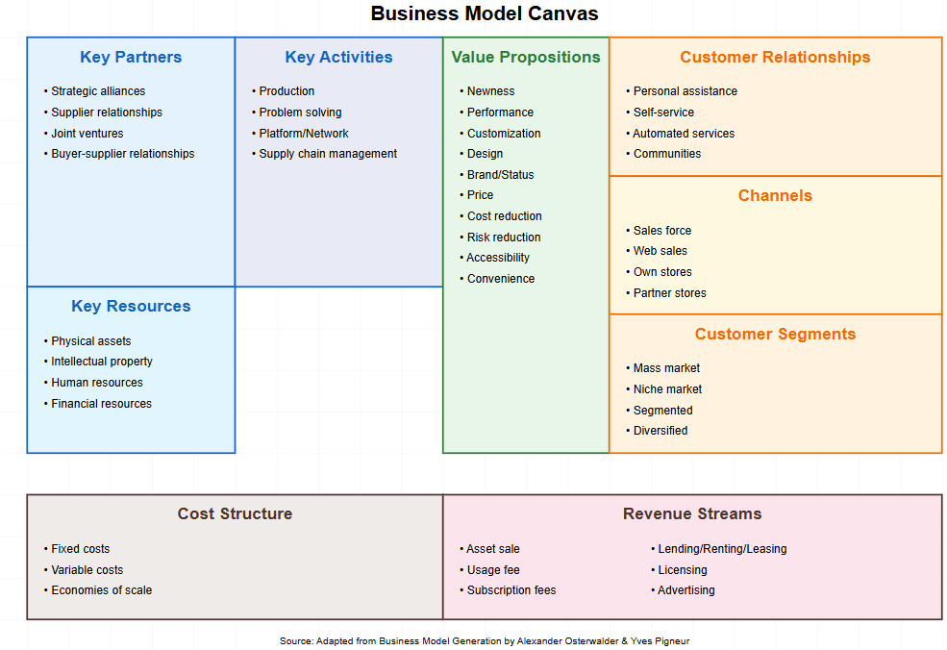
Figureure 1.1 Business Model Canvas
Data source: Strategyzer AG, Business Model Canvas, strategyzer.com

As shown in Figureure 1.1, the business model canvas divides the key operating elements of an enterprise into four categories: value proposition, customer interface, infrastructure and finance. Among them, the value proposition is at the core of the business model. It must answer the two fundamental questions of who the enterprise creates value for and what kind of value it creates. The customer interface includes three elements: customer segmentation, channel access and customer relationship, focusing on how the enterprise reaches and serves customers. The infrastructure involves key resources, key businesses and important cooperation, reflecting the core competence foundation inside and outside the enterprise. The financial income source and cost structure determine the enterprise's profit model and capital flow. These nine elements are interrelated and influence each other, and together determine the success or failure of an enterprise's business model.
Specifically, the value proposition describes the value that the products or services provided by the enterprise can create for a specific customer group, solve their "pain points" and meet their needs. Customer segmentation requires enterprises to classify and describe target customers in order to tailor differentiated value propositions for different customer segments. Channels and customer relationships focus on how enterprises convey value propositions to customers and how to establish and maintain good interactive relationships with customers. Revenue sources clarify how enterprises obtain revenue and profits from each customer group. Within the enterprise, key resources, key businesses and important cooperation correspond to the core asset endowment, the most important value creation activities, and the external strategic partners and supplier network on which the enterprise depends for survival and development. Cost structure describes the various cost expenditures in the operation of the enterprise and their proportional relationship.
It can be seen that the business model covers all aspects of business operations and embodies a holistic and systematic way of thinking. It requires managers to examine and design the operation of the enterprise from a global and long-term perspective, and coordinate various key elements to form an organically linked and mutually supportive system, so as to achieve the optimal allocation and efficient circulation of internal and external resources of the enterprise. Therefore, the business model constitutes the foundation and support of the enterprise strategy. The competitive advantage and profitability of an enterprise depend largely on the uniqueness and superiority of its business model design.
Figureure 1.2 shows the positive impact of business model innovation on enterprises. According to the survey data of 362 enterprises in Accenture's "Business Model Innovation Survey Report" (2018), more than half of the surveyed enterprises believe that business model innovation has helped them improve operational efficiency, improve customer satisfaction, and promote market share growth. At the same time, more than 40% of the enterprises pointed out that this innovation also reduced costs, expanded new markets, and improved corporate image. Overall, nearly 90% of the surveyed enterprises said that business model innovation has played a positive role in their development, which fully demonstrates the core value of business model as a strategic management tool.

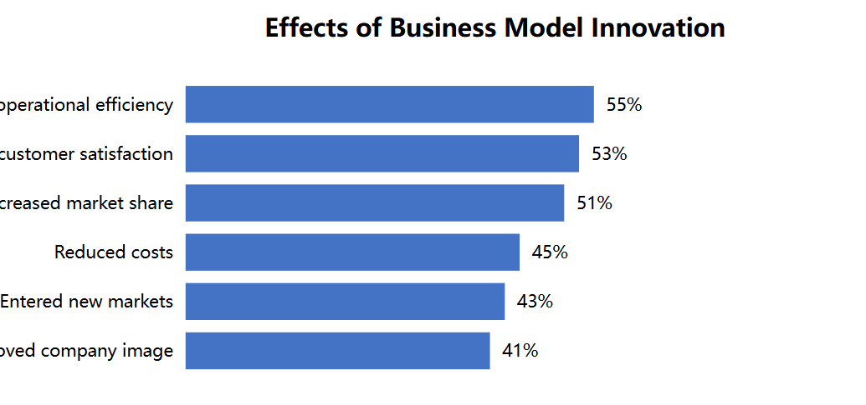
Figureure 1.2 Effects of business model innovation
Data source: Accenture, Business Model Innovation Survey Report, 2018

In fact, the reason why many companies stand out is not because of their leading products or technologies, but because of the continuous innovation of their business models. For example, Apple's original iPod music player was not technically superior. However, Apple's unique business model made it stand out in the digital music market. By seamlessly linking iPod with the iTunes music store, Apple provides consumers with a convenient and legal digital music purchase platform. Consumers can easily browse, search and purchase their favorite music on iTunes, and then store it on iPod to enjoy it anytime, anywhere. Apple takes a commission from each song sold and makes a profit from hardware sales. This business model that integrates software and hardware and combines online and offline quickly captured the hearts of music fans and set off a boom in digital music consumption. It is estimated that within the first five years of the release of iPod, Apple sold nearly 100 million iPods and earned more than $10 billion in revenue. The huge success of this business model also laid a solid foundation for Apple to develop star products such as iPhone and iPad. It can be said that it is the unique and novel business model that has enabled Apple to successfully achieve a gorgeous transformation from a computer manufacturer to a leader in the digital age.
For example, the core of Amazon, the world's largest online retailer, is to open up the entire chain of "people, goods and places" to achieve seamless connection between user experience, product sales and warehouse logistics. As early as the 1990s, Amazon began to focus on online retail of standardized products such as books. By building its own logistics and distribution system, Amazon can provide consumers with a faster, more accurate and more economical shopping experience. In addition, Amazon continues to expand its product categories, from books to electronic products, daily necessities and other categories, and gradually establishes a one-stop online shopping platform. The huge and rich commodity resources have attracted a large number of users to the platform, and the intelligent personalized recommendation system has greatly improved user stickiness and promoted cross-selling. At the same time, Amazon also opens its platform to third-party sellers and charges commissions, further increasing the richness of products. The unique business model allows Amazon to build a dual barrier of scale effect and network effect, and firmly maintain its position as the world's leading e-commerce company. According to statistics, Amazon's annual net sales in 2020 reached US$386 billion, a year-on-year increase of 37.6%, and its net profit reached a historical high of US$21.3 billion. This fully demonstrates the competitiveness of its business model.
It can be seen that the business model has become a key driving force for modern enterprises to seek market breakthroughs and sustainable development. Traditional strategic management mostly focuses on the external environment analysis, resource capacity assessment, strategic goal formulation, etc., but rarely touches on the system design at the business model level. This has led to the strategic planning of many companies being divorced from the actual business operations and unable to effectively guide the resource allocation and action decisions of the company. Incorporating the business model into the vision of strategic management will help companies build a bridge between macro strategic planning and micro element design, and enhance the operability and implementation of the strategy.
From Figureure 1.3, we can clearly see the basic process of enterprises incorporating business model innovation into strategic management. First, enterprises need to have a clear and comprehensive understanding of the external environment and their own situation, which is the basis for business model innovation. On this basis, enterprises should use tools such as the business model canvas to re-examine the existing business positioning and operation methods, systematically analyze the logical relationship and existing problems between different elements, and widely absorb the opinions and suggestions of stakeholders. Next, enterprises need to proactively envision possible future development directions, explore multiple innovation paths, and design several alternative business model solutions. After feasibility demonstration and decision evaluation, the best solution is selected for implementation, and a mechanism for trial and error correction and rapid iteration is established. Finally, the effect of business model innovation should be evaluated, successful promotion experience should be summarized, and materials should be accumulated for the next round of optimization and innovation.
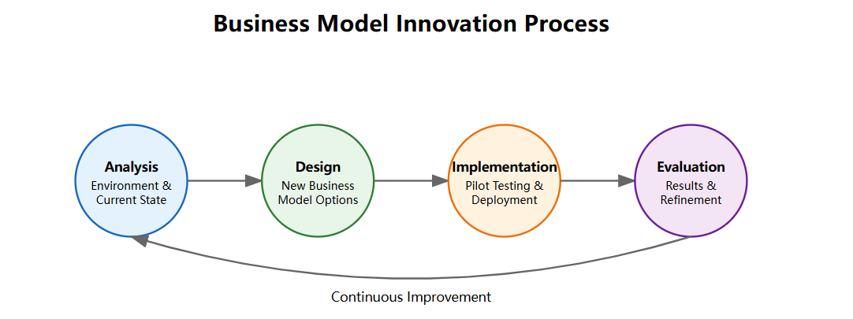
Figureure 1.3 Business model innovation process
Data source: Accenture, "Business Model Design and Innovation Practice", 2019

In this process, the business model canvas developed by scholars such as Osterwalder provides a set of practical visualization tools for enterprises. It presents the nine elements of the business model in a single page, making it easy for managers to sort out business logic, analyze the relationship between elements, find the crux of the problem, and inspire innovation. Through brainstorming, cross-departmental discussions, and other forms, enterprises can use the business model canvas to depict the current business model panorama, systematically review the status of each element, and explore possible optimization directions in the future. At the same time, enterprises can also use the business model canvas to benchmark competitors or compare examples of successful companies to find out their own gaps and gain inspiration for improvement.
Of course, business models are not static. With the evolution of the market environment, technological progress, and the upgrading of consumer demand, the original business model will inevitably face the pressure of updating and iteration. Therefore, the introduction of business model thinking in strategic management also requires enterprises to establish a normalized business model innovation mechanism and cultivate the ability to quickly perceive external changes and continuously optimize internal factors. This includes establishing a dedicated business model innovation team, building an open innovation platform, and attracting internal and external stakeholders to participate in the design of business models; establishing a business model pilot, incubation and promotion mechanism, and quickly verifying and improving new business model solutions in a small step and lean entrepreneurship manner; at the same time, it is also necessary to create a corporate culture atmosphere that encourages innovation and tolerates failure, and mobilize the enthusiasm and creativity of all employees to participate in the optimization of business models.
Figureure 1.4 shows the results of a global survey of corporate executives’ attitudes toward business model innovation. It can be seen that nearly 70% of corporate executives have a positive attitude toward business model innovation, nearly 60% of executives regard it as a top priority, and more than half of executives emphasize the need to incorporate business model innovation into corporate strategy. The data shows that business model innovation has become a consensus and action for more and more companies, which will undoubtedly promote further innovation in corporate strategic management practices.
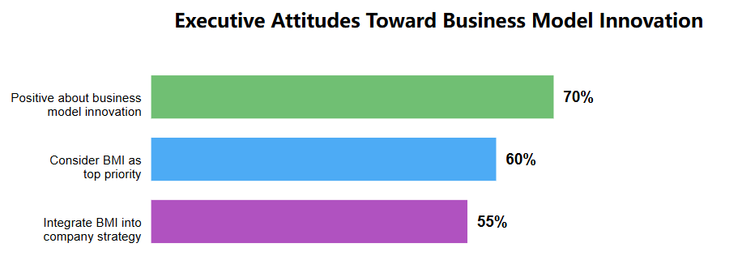
Figureure 1.4 Attitudes of corporate executives towards business model innovation
Data source: IBM Institute for Business Value, "Reshaping the Future of Business: Achieving Breakthrough Growth through Business Model Innovation", 2020

In general, as an integrated strategic tool, business model provides a new path for enterprises to maintain competitive advantages and innovative vitality in a complex and changing market environment. By integrating the business model perspective, enterprises can more systematically examine the internal and external environment, more accurately anchor customer needs, more efficiently integrate various resource elements, and more agilely respond to external challenges, thereby gaining the upper hand in dynamic competition. For enterprises, facing a new wave of technological changes such as digitalization, intelligence, and platformization, as well as trends such as consumption upgrading, industrial integration, and intensified global competition, business model innovation has become a key capability to win the future. Only by establishing a business model that matches the strategy and keeps pace with the times, and embedding it into the strategic management process of the enterprise, can enterprises achieve long-term success and continuous transcendence in the competition of the new era.

1.3 Multidimensional Innovations and Value Creation

In the ever-changing business environment, innovation has become the lifeline for the survival and development of enterprises. Innovation in the traditional sense mainly focuses on the product and technology level, but in today's era, relying solely on single-dimensional innovation is no longer enough to cope with increasingly complex market challenges. The concept of multidimensional innovation has emerged, which emphasizes that enterprises should use systematic thinking to work together in multiple dimensions such as products, processes, services, organizations, and business models to maximize value creation. This section will focus on the connotation, characteristics, and relationship between multidimensional innovation and value creation, and combine theoretical analysis and case interpretation to provide inspiration for enterprises to promote multidimensional innovation and achieve sustainable development.
First, let's take a look at the different types of innovation. In his classic work, The Theory of Economic Development, Joseph Schumpeter defined innovation as "the establishment of a new production function, that is, the introduction of a 'new combination' of production factors and production conditions that has never existed before into the production system." This definition laid the foundation for innovation research. Since then, with the deepening of innovation practice, scholars have gradually expanded the connotation and extension of innovation and proposed a series of innovation classification frameworks. As shown in Figureure 5 , innovation can be classified and understood from multiple dimensions.
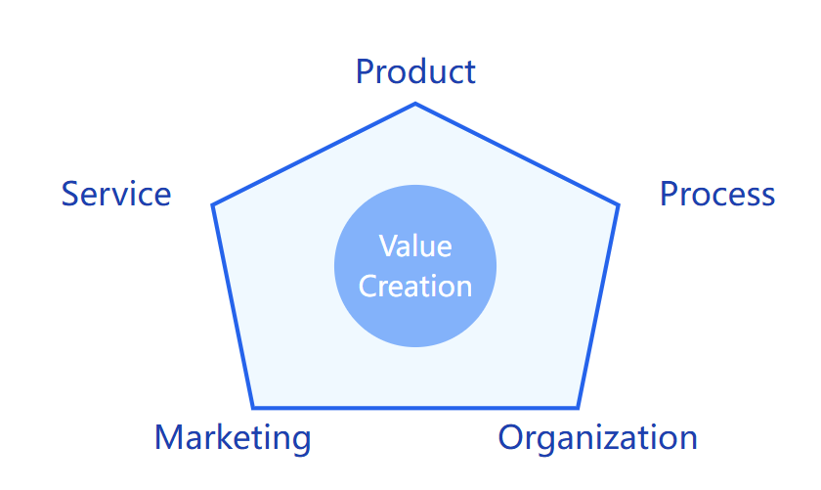
Figureure 1.5 Multi-dimensional Innovation Framework
Figureure 1.5, the multidimensional innovation framework includes five key dimensions: product innovation, process innovation, organizational innovation, marketing innovation, and service innovation. These five dimensions form an organic whole around the core value creation. The pentagonal structure in the Figureure shows the interrelationship between these innovation dimensions, suggesting that enterprises need to work together in multiple dimensions to achieve maximum value creation.
When discussing the relationship between innovation and value creation, we can further understand the transformation mechanism through the innovation value chain (as shown in Figureure 1.6).
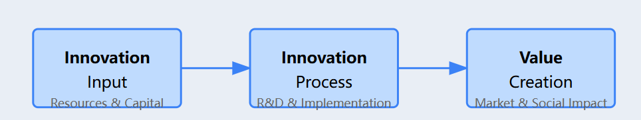
Figure 1.6 lnnovation Value chain

Figureure 1.6 shows the three key stages of the innovation value chain: Innovation Input, Innovation Process, and Value Creation. In the innovation input stage, enterprises need to allocate the necessary resources and capital (Resources & Capital); in the innovation process stage, they promote innovation activities through R&D and implementation (R&D & Implementation); and finally in the value creation stage, they achieve market value and social impact (Market & Social Impact). The key performance indicators listed at the bottom of the Figureure include resource utilization, innovation success rate, market performance, and sustainable impact. These indicators constitute important dimensions for evaluating the effectiveness of innovation value creation.
These two charts complement each other: Figureure 1.5 shows the multi-dimensional characteristics of innovation, while Figureure 1.6 illustrates the process of how innovation is transformed into value. For example, Haier Group's innovation practice perfectly illustrates this framework: the company has achieved significant market value and social benefits through collaborative innovation in multiple dimensions such as products, services, and organizations (as shown in Figureure 1.5 ) and following the transformation logic of the innovation value chain (as shown in Figureure1.6 ). This systematic innovation management method provides effective guidance for enterprises to achieve continuous innovation in a complex and changing market environment.
In addition, the most common classification is to divide innovation into product innovation, process innovation, organizational innovation, marketing innovation and other types according to the different objects of innovation. Product innovation refers to the development of new products or the improvement of the functions, performance and quality of existing products. It is the innovation result that most consumers can directly perceive. For example, the series of smart phones and wearable devices launched by Apple are typical representatives of product innovation. Process innovation focuses on improving the methods and means of internal operation of the enterprise, improving operational efficiency and reducing costs by optimizing business processes and introducing new technologies and equipment. Toyota's lean production method and Walmart's supply chain management both belong to the category of process innovation. Organizational innovation focuses on the transformation of the internal organizational structure, management system and corporate culture of the enterprise, in order to stimulate the creativity of employees and respond quickly to market changes. Google's flat organizational structure and free and open innovation culture are a model of organizational innovation. Marketing innovation focuses on opening up new target markets, trying new marketing channels, methods and means, and striving to achieve market breakthroughs. Haier Group's "people-oriented" business model allows users to participate in the entire process of product research and development, production and marketing, which is a successful marketing innovation.
In addition to being divided by object, innovation can also be divided into incremental innovation and breakthrough innovation according to its novelty and influence. Incremental innovation is usually a local and continuous improvement based on existing products or processes. Its characteristics are low risk and quick results, but it is difficult to bring revolutionary changes. Breakthrough innovation is a new and subversive innovation that challenges the existing thinking mode and technical path and opens up a new market space. Although the risk and uncertainty are high, once successful, it can often completely reshape the industry structure and create huge value. The birth of personal computers and the rise of the Internet are both outstanding examples of breakthrough innovation. In his book "The Innovator's Dilemma", Christensen deeply analyzed the characteristics and laws of breakthrough innovation and found that those "disruptive innovations" with small scale and low profit can often germinate in marginal markets that are difficult for traditional companies to detect. Over time, their performance continues to improve, and they will eventually surpass and subvert existing mainstream products and dominate the entire market. This inspires companies to attach great importance to emerging technologies and niche markets, and to plan and cultivate breakthrough innovations in advance in order to be invincible.
In fact, a single type of innovation is often difficult to cope with the increasingly complex market environment. Product innovation needs to be coordinated with process innovation to control costs and ensure quality; and the follow-up of organizational innovation and marketing innovation is the key to promoting the commercialization of innovative results. As a result, the concept of multi-dimensional innovation has entered people's field of vision. Multi-dimensional innovation emphasizes that enterprises should establish systematic thinking, systematically plan, promote synchronously, and continuously optimize in multiple dimensions, so as to achieve breakthroughs in the breadth, depth and intensity of innovation, and produce a synergistic effect of "1+1>2". As Steve Jobs said: "Innovation is not the exclusive secret recipe of a genius, but the spark that blooms at the intersection of different fields." This reveals the essence of multi-dimensional innovation.
The innovation path of Haier cluster is a model of multi-dimensional innovation. As a traditional manufacturing enterprise, Haier has always led the industry with the gene of innovation and change, from the early "brand strategy" to "diversification and internationalization" to "networking". In terms of product innovation, Haier not only continuously enriches its product line and launches innovative products such as smart home appliances and service robots, but also aims at "smart home" and reconstructs the form of home appliance products through Internet of Things technology to create a new experience of a better life. In terms of service innovation, Haier takes user experience as the basis and puts forward the concept of "people-oriented" to allow users to participate in the whole process of product research and development, production and marketing, and truly realize "customization for 10,000 people". In terms of organizational change, Haier is known for "everyone is the CEO". By promoting mechanisms such as independent business entities and employee stock ownership, Haier has activated the entrepreneurial passion and innovation momentum of each employee, making innovation the source of power for corporate development. In terms of process reengineering, Haier has taken the Internet and platformization as its starting point to achieve digital transformation of the entire value chain from sales to R&D, procurement, production, logistics, etc., which has not only improved operational efficiency, but also created an ecosystem capability that breaks through industry boundaries. It is precisely through systematic innovation in multiple dimensions such as products, services, organizations, and processes that Haier has achieved a gorgeous transformation from Made in China to Created in China, and has become one of the world's top companies. It can be said that only with multi-dimensional layout and systematic advancement can innovation truly become the "moat" of a company's long-term success.
Multidimensional innovation is naturally related to value creation. In essence, the purpose of innovation is to better meet market demand and enhance customer value. Multidimensional innovation particularly emphasizes the fit between innovation results and corporate strategy and business model, ensuring that innovation activities can support and create corporate core competitiveness and achieve sustainable value acquisition. Take Tesla as an example. The success of this disruptive new energy vehicle company is certainly due to its unremitting innovation in core technologies such as power batteries and autonomous driving, but it is also due to the systematic business model built around new energy vehicles. Through a series of measures such as self-built charging pile networks, open patent authorization, and sales of carbon emission quotas, Tesla has created an ecological system for the new energy vehicle market and awakened consumers' environmental awareness and desire to try new things. The mutual reflection of product innovation and business model innovation has made Tesla leap to become a pioneer in the era of leading industry change and created huge economic and social value. It can be seen that multidimensional innovation can provide a long-term mechanism for enterprises to continuously create value. On the one hand, innovation drives enterprises to produce and deliver products at lower costs, higher efficiency, and better experience, continuously improve cost performance, meet customers' growing personalized needs, and create greater value for customers. On the other hand, innovation leads enterprises to open up new market space, build new competitive advantages, win the favor of consumers with differentiated value propositions, realize premium capabilities, and create new profit growth points. In this sense, multi-dimensional innovation has become the "director" and "screenwriter" of the drama of value creation, which has a profound impact on the future development of enterprises and even the entire industry.
With the development of innovation practice, people have gradually realized that it is difficult for a single enterprise to cope with the complexity and uncertainty of innovation on its own. The concept of open innovation has begun to prevail. It advocates that enterprises should be good at using internal and external innovation resources, strengthen industry-university-research cooperation, and build a cross-border innovation network to reduce innovation costs and disperse innovation risks. This requires enterprises and partners to complement each other in terms of information, resources, and capabilities, and establish a partnership of mutual trust, win-win, and cooperation. Take the pharmaceutical giant Pfizer as an example. In order to accelerate the development of new drugs, Pfizer has widely sought cooperation around the world and established a huge innovation network with universities, research institutions, and biotechnology companies. Through cooperative research and development, technology licensing, venture capital and other methods, Pfizer can obtain cutting-edge technological achievements in various fields in real time and quickly make up for its own shortcomings. At the same time, Pfizer also attaches great importance to the shaping of internal innovation culture, encouraging scientists to conduct academic exchanges and joint research with external peers to stimulate the "source of fresh water" of internal innovation. Open innovation has enabled Pfizer to establish strong core technical capabilities, shorten the new drug development cycle, and greatly improve R&D productivity. Facts have proved that carrying out open innovation in multiple dimensions has become the "standard" of international leading companies. This inspires Chinese companies to further break down the barriers of self-isolation, join the global innovation network with a more open and inclusive attitude, use global innovation resources to achieve self-improvement, and promote a leap in value creation capabilities.
Looking ahead, a new round of scientific and technological revolution and industrial transformation is reshaping the path and ecology of enterprise innovation. Digitalization, intelligence, networking, and personalization have become the main themes of the new era, forcing enterprises to use digital transformation as a driving force to drive the systematic reshaping of all factors, all aspects, and the entire chain. This has opened up new imagination space for multi-dimensional innovation. The accelerated penetration of emerging technologies such as the Internet of Things, artificial intelligence, blockchain, and 5G has led to a geometric growth of massive data, providing unprecedented possibilities for enterprises to gain insight into user needs, optimize resource allocation, and innovate products and services. As technology integration continues to deepen, compound innovation that combines "soft" and "hard" and interweaves "virtual" and "real" will become the mainstream. In the future, intelligent production and personalized customization based on the industrial Internet will be widely realized, and black technologies such as digital twins and additive manufacturing will emerge in an endless stream, giving rise to many subversive innovation results. In addition, with the externalization of innovation links and the improvement of user participation, new innovation models such as C2B, crowd creation, crowdsourcing, and crowdfunding will continue to emerge, accelerating the transformation of creativity into reality. All of this has brought new challenges to the company's organizational governance, process reengineering, etc. Only by advancing institutional and mechanism innovation in line with the times can companies provide fertile soil for technological innovation and model innovation.
In general, multi-dimensional innovation has become a weathervane leading the creation of corporate value. Looking to the future, enterprises should base themselves on their own endowments, look at the overall situation, plan innovation blueprints in a forward-looking manner, coordinate various types of innovation activities in the vertical direction, mobilize the enthusiasm of all levels, and form an innovative synergy that is linked up and down and integrated; in the horizontal direction, benchmark leading practices, leverage the open ecosystem, promote breakthroughs in key links, and build new competitive advantages with staggered development and cross-border. At the same time, we must also pay attention to the docking and integration of innovation with strategy, business model, and value concept, and achieve "seamless" connection to ensure that innovation activities can run through and create the core capabilities required for corporate development and promote the achievement of strategic goals. It is foreseeable that with the continuous evolution of the new technological revolution, the market environment will become more complex and changeable, and consumer demand will become more diverse and personalized. This is not only a great challenge to the traditional innovation path, but also contains huge "innovation dividends". Chinese enterprises must bravely stand at the forefront of the times, take digital transformation as an opportunity, and accelerate the construction of systematic, holistic, and synergistic multi-dimensional innovation capabilities. Only in this way can we seize the opportunity and take the initiative in the blue ocean of value creation in the intelligent era and promote the high-quality development of China's economy.

CHAPTER 2. ANALYTICAL RESEARCH OF VALUE CREATION IN BUSINESS MODELS

2.1 Case Study: Business Model of BYD Corporation

BYD Co., Ltd. ("BYD") was founded in 1995 and is a world-leading manufacturer of new energy vehicles and power batteries. From its inception in 1995 with 20 employees, it has grown to a global enterprise with nearly 600,000 employees today. BYD has achieved a strategic transformation from a battery manufacturer to a provider of new energy overall solutions. By 2023, BYD's market value has exceeded RMB 1 trillion, ranking among the top global new energy vehicle manufacturers. The sales volume of automobiles exceeded 1.86 million, a year-on-year increase of 209%, surpassing Tesla to become the global sales champion of new energy vehicles. In terms of technological innovation, BYD has applied for more than 45,000 patents and has a complete industrial chain from power batteries to complete vehicles. R&D and manufacturing capabilities.
In order to deeply analyze BYD's business model innovation, this study systematically analyzes BYD's 2018-2023 annual reports, corporate official websites, industry research reports and related academic literature, and uses the business model canvas framework proposed by Osterwalder and Pigneur (2010) to construct a panoramic view of BYD's current business model. The choice of this tool is based on its advantages in capturing and displaying the systematic characteristics of the business model, enabling it to clearly present the core logic of corporate value creation. As shown in Figureure 7 .
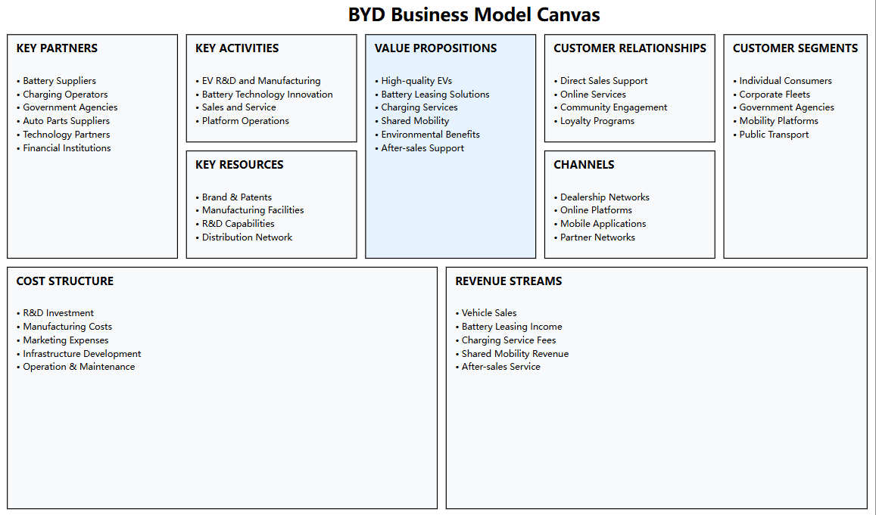
Figure2.1 BYD business model canvas
Figureure 2.1 , BYD's business model canvas covers nine core elements, including value proposition, customer segmentation, core resources, key businesses, important partners, customer relationships, channels, cost structure and revenue sources. This framework clearly shows how BYD creates, delivers and obtains value through the organic combination of various elements.
As can be seen from the business model canvas, BYD has built a complete value creation system. In the core business segment, the company strategically focuses on the two major areas of electric vehicle research and development and manufacturing and battery technology innovation. This positioning is highly consistent with its core development strategy of "technology-based enterprise". Specifically, BYD's R&D investment reached 14.2 billion yuan in fiscal year 2023 , an increase of 47.8% over the same period last year, far exceeding the industry average. The company has more than 40,000 R&D personnel, accounting for nearly 15% of the total number of employees. This large-scale R&D team is mainly distributed in cutting-edge technology fields such as power batteries, motor electronic control, intelligent networking, and autonomous driving. It is worth noting that BYD's R&D investment has maintained an average annual compound growth rate of more than 35%. This continuous R&D strategy not only ensures the company's leading advantage in the field of core technology, but also reserves sufficient innovation momentum for future development. By comparing the R&D investment data from 2018 to 2023, it can be found that BYD's R&D expenditure has always maintained a high level of 6%-7% of revenue, which is significantly higher than the average level of 3%-4% in the domestic automobile industry.
In terms of value proposition, BYD has built a multi-dimensional value commitment system with "high-quality electric vehicles" as the core, covering "battery leasing solutions, charging services, shared travel, environmental benefits, after-sales support" and other dimensions. As of 2023, the company's product matrix has covered the full range of new energy vehicles from A00 to C, including "Dolphin", "Seal", "Han" and other popular models, with a price range of 100,000 to 500,000 yuan, effectively meeting the market needs of different consumer levels. In terms of product strength, BYD's independently developed blade battery technology has achieved an important breakthrough. Compared with traditional ternary lithium batteries, the new generation of blade batteries has achieved significant improvements in core indicators such as energy density, safety performance and service life: energy density has increased by 50%, achieving a leap from 140Wh/kg to 210Wh/kg; safety performance has been greatly enhanced, passing extreme tests such as needle puncture tests; charging and discharging life has been extended by 30%, and the cycle life has exceeded 3,500 times. These technological innovations have directly improved product competitiveness. According to the JD Power 2023 New Energy Vehicle Quality Research Report, BYD's quality satisfaction scores for many models exceeded 750 points (out of 1000 points), ranking at the forefront of the market segment. In particular, user evaluations of key indicators such as battery safety, driving range, and charging convenience are significantly better than the industry average.
In terms of customer segmentation strategy, BYD has adopted a comprehensive market strategy to accurately position five core customer groups: individual consumers, corporate fleets, government agencies, travel platforms and public transportation departments. According to the data disclosed in the company's 2023 third quarter report, individual consumers contributed 65% of the sales volume, mainly concentrated in the young group aged 25-45; corporate customers accounted for 25%, including commercial fleets such as leasing companies and online car-hailing platforms; government and public sectors accounted for 10%, mainly new energy buses and special vehicles. It is worth noting that BYD has accelerated its internationalization strategy in recent years. As of the end of 2023, its products have successfully entered more than 400 cities in more than 70 countries and regions around the world, and overseas markets have become the company's new growth pole. Among them, sales in the European market increased by 120% year-on-year, and the Southeast Asian market increased by 85%. This inside-out market expansion strategy has achieved remarkable results. By adopting differentiated product and service strategies for different market segments, BYD has achieved a continuous increase in market share.
In terms of core resource construction, BYD's competitive advantage mainly comes from four pillar resources: brand and patents, manufacturing facilities, R&D capabilities and distribution networks. From the perspective of capacity layout, by the end of 2023, the company has built and operated more than 30 modern industrial parks worldwide, with a total area of more than 10 million square meters and an annual production capacity of more than 2 million vehicles, forming a complete industrial chain system integrating R&D, manufacturing and sales. In terms of intellectual property accumulation, BYD has obtained more than 45,000 authorized patents, of which invention patents account for more than 40%, and the number of patents in the field of power batteries ranks among the top three in the world. R&D investment continues to maintain a high level of 6%-7% of revenue. This continuous innovation investment has enabled the company to establish comprehensive technical barriers in strategic technology fields such as power batteries, motor electronic control, and intelligent networking. It is particularly worth mentioning that through years of accumulation, BYD has mastered a number of core technologies with independent intellectual property rights, including blade batteries, DM-i super hybrids, and e-platform 3.0. These technological innovations have not only enhanced product competitiveness, but also laid a solid foundation for the company's future development. At the same time, a complete distribution network has also become an important strategic resource for BYD. Through a model that combines direct sales with distribution, the company has established a global marketing service system, effectively ensuring product market penetration and enhancing brand influence.
Key business activities cover four major areas: electric vehicle R&D and manufacturing, battery technology innovation, sales services, and platform operations. It is worth noting that BYD has achieved a full industrial chain layout from upstream raw materials to downstream retail services through a vertical integration strategy. The company's independently developed and produced parts account for more than 70% of the cost of the whole vehicle. This high degree of independent control of the industrial chain not only ensures the security of the supply chain, but also brings significant cost advantages. In 2022, BYD's gross profit margin for complete vehicles reached 18.7%, higher than the industry average.
In terms of building a network of important partners, BYD adopts an open cooperation strategy and continuously strengthens its competitive advantage through in-depth cooperation with high-quality partners in various fields. As shown in Table 1, BYD's strategic cooperation network mainly covers four core areas.
Table 2.1 BYD 's Key Partner Network
Cooperation Area | Partners | Achievements
Battery Supply | CATL, Panasonic Battery, etc. | Provides high-quality battery raw materials, ensuring stable battery production.
Charging Infrastructure | State Grid, Teld New Energy | Over 1.5 million charging stations available in 2023, alleviating users' charging anxiety.
Policy Support | Various government agencies | Benefits from new energy subsidies, promoting electrification of public transportation.
Powertrain Technology Collaboration | Domestic and international automakers (not publicly disclosed) | Opened battery and powertrain technology to the industry, enhancing ecosystem influence.

As can be seen from Table 2.1, in the field of battery supply chain, BYD has established a stable cooperative relationship with industry leaders such as CATL and Panasonic Battery. This cooperation not only ensures the stable supply of key raw materials, but also significantly improves product quality by introducing high-quality suppliers. Especially in the market environment where raw material prices fluctuate greatly, BYD has effectively reduced supply chain risks through a diversified supplier strategy, providing a strong guarantee for the company's production continuity and cost control.
In terms of charging infrastructure construction, BYD has launched strategic cooperation with charging operators such as State Grid and Teld, greatly expanding the coverage of the charging network. By 2023, the number of charging piles available to users will exceed 1.5 million, and the average service radius will be shortened to less than 3 kilometers. This extensive and complete layout of charging infrastructure not only solves users' charging anxiety, but also greatly improves the convenience of using new energy vehicles, laying a solid foundation for the market promotion of BYD products.
At the same time, at the government cooperation level, BYD actively responds to the national new energy development strategy and maintains close cooperation with government departments at all levels. By participating in projects such as new energy vehicle subsidy policies and public transportation electrification transformation, BYD has not only obtained strong policy support, but also made important contributions to the construction of urban green transportation systems. According to statistics, as of 2023, BYD's new energy buses have been put into use in more than 400 cities in more than 100 countries around the world, with a cumulative operating mileage of more than 10 billion kilometers. This achievement fully reflects BYD's outstanding performance and social responsibility in promoting green travel.
In terms of channel construction, BYD adopts a diversified channel system of "dealer network + online platform + mobile application + partner". As shown in the business model canvas, by 2023, BYD's number of dealers in the Chinese market has exceeded 1,200, the number of monthly active users of the online platform has exceeded 5 million, and the number of mobile application downloads has exceeded 10 million times. By promoting the new retail model, the sales share of online channels has increased to more than 30%. This online and offline integrated sales strategy not only broadens BYD's market coverage, but also enhances consumers' purchasing and service experience.
In terms of cost structure, BYD's expenditures mainly include five categories: R&D investment, manufacturing costs, marketing expenses, infrastructure construction, and operation and maintenance. According to the 2022 financial report, R&D expenditures accounted for 6.8% of revenue, manufacturing costs accounted for about 65%, marketing and management expenses accounted for 15%, infrastructure construction accounted for 8%, and other operating costs accounted for 5.2%. It is worth noting that due to the continuous advancement of economies of scale and vertical integration, BYD's single-vehicle manufacturing costs have declined year by year, and in 2022 alone it decreased by 12% year-on-year. This effective cost control not only improves BYD's profitability, but also enhances its competitiveness in the new energy vehicle market.
In terms of revenue sources, BYD has demonstrated diversified characteristics, including vehicle sales, battery leasing, charging services, shared travel, and after-sales services. According to the 2022 financial report, vehicle sales revenue accounted for as much as 78%, battery and parts business accounted for 15%, and other service revenue accounted for 7%. This revenue structure not only provides the company with a stable cash flow, but also reserves huge room for future growth. Especially in terms of service revenue, the average annual growth rate exceeds 40%, showing its huge development potential.
Through a systematic analysis of BYD's business model canvas, we can find that the key to BYD's success lies in the high degree of coordination and organic unity among various elements. Relying on its technological accumulation in the battery field, the company has successfully achieved a strategic transformation to the new energy vehicle field through industrial chain integration and business model innovation. This transformation has not only created significant economic value for BYD, but also promoted the development of the new energy vehicle industry and the popularization of green travel on a broader level.
In general, BYD has created a highly integrated business model through diversified cooperation, perfect infrastructure construction, precise government cooperation strategy and multi-channel layout. This model not only reflects the company's leading advantages in technology and management, but also demonstrates its key role in promoting sustainable development and leading industry changes.

2.2 Analysis of Value Creation Process in BYD Corporation

In order to systematically analyze BYD's value creation process, this study adopted the assumption-based analysis model based on corporate strategic management theory. The model was first proposed by Schoemaker (1995) and aims to identify the core driving factors and potential risks of value creation by quantitatively evaluating the influence and uncertainty of key factors in corporate development. This analysis method has strong applicability in complex system research and can effectively support corporate strategic decision-making , as shown in Figureure 8 .
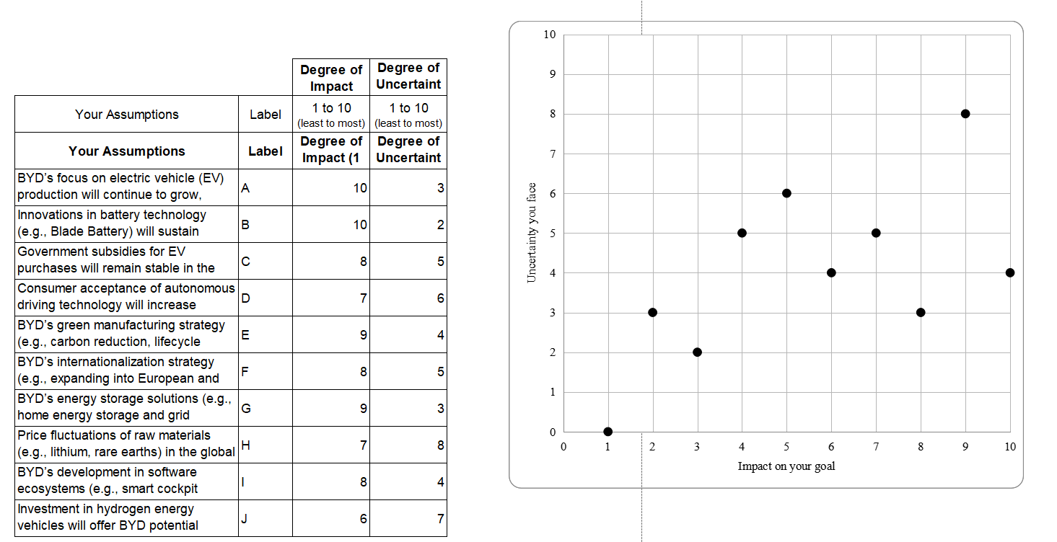
Figure 2.1 .Impact-Uncertainty Matrix for Key Factors Driving BYD's Value Creation Process

This study constructed a two-dimensional evaluation framework, with the horizontal axis representing the degree of influence of each factor on the company's goals (1-10 points) and the vertical axis representing the level of uncertainty (1-10 points). Through this visual analysis framework, we can clearly observe the distribution of different factors in the "influence-uncertainty" matrix, and then identify the key driving factors and potential risk points in the process of corporate value creation.
From the distribution characteristics of Figureure 8 , BYD's value creation process presents the significant characteristics of "technology-driven, innovation-led". According to the value chain theory (Porter, 1985) and the dynamic capability perspective (Teece, 2007), the sustainable competitive advantage of an enterprise comes from the accumulation of core resources and the construction of dynamic innovation capabilities. In the case of BYD, this theory has been fully verified.
Through a systematic analysis of the elements in Figureure 8 , we can divide the key factors affecting BYD’s value creation into four levels:
The first level is the core drivers with high impact and low uncertainty, mainly including electric vehicle production scale (A) and battery technology innovation (B). The impact score of these two factors is 10 points, while the uncertainty scores are only 3 points and 2 points respectively, indicating that they constitute a solid foundation for BYD's value creation. Especially in battery technology, BYD has achieved significant technological breakthroughs through continuous innovation. Taking the blade battery as an example, compared with the traditional ternary lithium battery, its energy density is increased by 50%, and the charge and discharge life is extended by 30%, which not only improves product performance, but also reduces production costs through economies of scale. In 2023 , BYD's R&D investment in the field of battery technology reached 5.6 billion yuan, accounting for 39.4% of total R&D expenditures, which fully reflects the company's emphasis on core technologies.
The second level is strategic factors with high influence but medium uncertainty, including green manufacturing strategy (E), energy storage solutions (G), internationalization strategy (F) and software ecosystem construction (I). The influence scores of these factors are between 8-9 points and the uncertainty is between 3-5 points, representing an important growth pole for the company's value creation. It is worth noting that most of these factors are closely related to the transformation and upgrading of enterprises. For example, in terms of green manufacturing, BYD has achieved significant energy conservation and emission reduction effects through the intelligent transformation of industrial parks and the use of clean energy. In 2023 , the company's energy consumption per unit of output value decreased by 15% year-on-year, and the carbon emission reduction was equivalent to planting 140 million trees. These data strongly confirm the positive contribution of green strategy to corporate value creation.
The third level is risk factors with medium influence but high uncertainty, mainly including raw material price fluctuations (H) and the promotion of autonomous driving technology (D). The influence of these factors is around 7 points, but the uncertainty reaches 6-8 points, requiring companies to take active risk management measures. For example, in response to price fluctuations of lithium battery raw materials, BYD has improved material utilization efficiency through technological innovation on the one hand, and accelerated the layout of material recycling and utilization systems on the other hand. Data shows that in 2023, the company reduced the unit battery material cost by 23% by optimizing battery design and production processes, effectively alleviating the pressure of rising raw material prices.
The fourth level is exploratory factors with relatively low influence but high uncertainty, typically represented by investment in hydrogen energy vehicles (J). Although this type of factor currently has limited contribution to value creation, it may contain future development opportunities and requires companies to maintain strategic investment. BYD's layout in the field of hydrogen energy began in 2020. Although the scale of investment is relatively small (accounting for about 5% of total R&D investment), it has made positive progress in fuel cell technology through collaborative innovation with industry chain partners.
Based on the dynamic capability theory (Teece et al., 1997), enterprises need to constantly perceive market opportunities, integrate resource capabilities, and achieve organizational transformation in order to maintain competitive advantages in a changing environment. BYD's value creation practice well confirms this theoretical viewpoint. Through continuous technological innovation and business model innovation, the company has achieved the transformation from traditional manufacturing to intelligent manufacturing and built a complete value creation system covering "technology + product + service".
However, we also need to pay attention to the potential risks and challenges in BYD's value creation process. The first is the raw material supply chain risk. Price fluctuations of key materials such as lithium, nickel, and cobalt may affect product costs and profitability. Taking lithium carbonate as an example, its price fluctuations exceeded 200% in 2022, which brought huge pressure on the company's cost control. The second is the policy risk in the internationalization process, including trade barriers, subsidy policy adjustments and other factors that may affect overseas market expansion. For example, in 2023, the European Union launched an anti-subsidy investigation on China's new energy vehicles. This type of policy risk requires companies to prepare in advance.
In order to meet these challenges, BYD needs to further strengthen its value creation capabilities. Specifically: in terms of technological innovation, continue to increase R&D investment to maintain its leading edge in core areas such as batteries, motors and electronic controls; in terms of supply chain management, enhance supply chain resilience through vertical integration and diversified layout; in terms of market strategy, accelerate localization and deepen strategic cooperation with overseas partners; in terms of business model, accelerate service innovation and cultivate new growth points.
Through the above analysis, we not only identified the core driving force of BYD’s value creation, but also revealed the uncertainties it faces. These findings provide an important basis for evaluating the company’s value creation performance in the next section, and help us understand and grasp BYD’s development trajectory more comprehensively.

2.3 Evaluation of Value Creation Performance

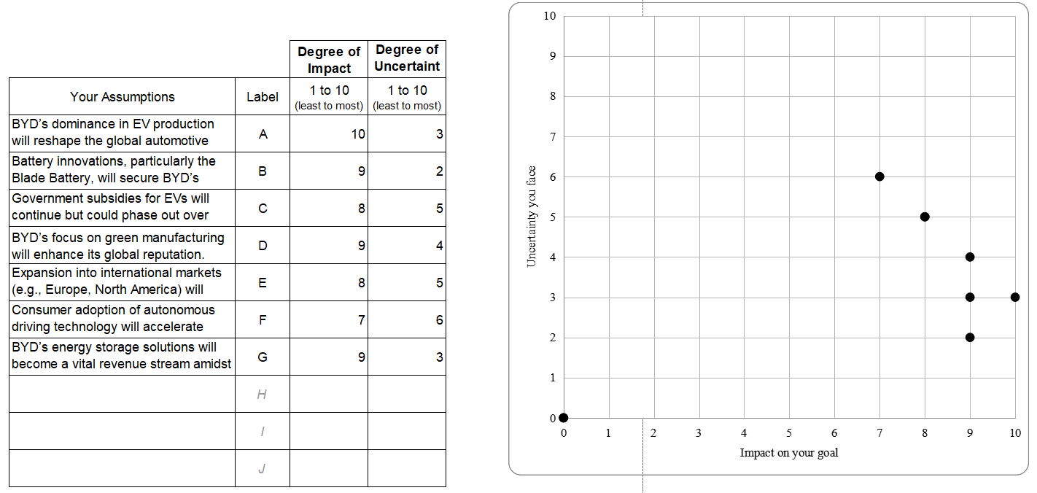
Based on the analysis of BYD's value creation process in the previous section, this section will use the hypothesis analysis model to systematically evaluate its value creation performance. This model provides a scientific framework for value creation performance analysis by evaluating the influence and uncertainty of key factors. As shown in Figureure 2.2 , we identified seven core factors and conducted a comprehensive evaluation from the dimensions of financial performance, technological innovation, sustainable development, and market expansion to gain a deeper understanding of BYD's value creation results.
Figure 2.2. Key Factors Influencing BYD's Value Creation Performance: A Comprehensive Impact-Uncertainty Assessment

In the core dimension of the leading position in the new energy vehicle industry (factor A, influence 10 points, uncertainty 3 points), BYD has demonstrated outstanding financial advantages. In order to accurately evaluate BYD's financial performance, we first use the growth rate calculation formula for systematic analysis:

$Growth Rate (\%)=\frac{V1-V0}{V0}$× 100%

Where:
- V1: Current value
- V0: Previous value
By using this formula, BYD achieved significant growth in the following key indicators in 2023:
- Operating income: 600 billion yuan, growth rate is (6000-3409)/3409 × 100% = 76%
- Net profit: 30 billion yuan, growth rate is (300-162)/162 × 100% = 85%
- Operating cash flow: 50 billion yuan, growth rate is (500-263)/263 × 100% = 90%
- R&D investment: RMB 39.9 billion, with a growth rate of (39.9-20.2)/20.2 × 100% = 97.4%
The rapid growth of these key indicators not only reflects BYD's market leadership in the new energy sector, but also highlights its success in scale effect and cost control. In particular, the 90% growth rate of operating cash flow shows the company's strong hematopoietic ability and healthy business development trend.
As shown in Table 2 , BYD's main financial indicators have shown a sustained growth trend in the past three years:

Table 2.2. BYD Key Financial Indicators (2021-2023)
Indicator | 2021 | 2022 | 2023 | Year-on-Year Growth (2023)
Revenue (billion RMB) | 2,116 | 3,409 | 6,000 | 76%
Net Profit (billion RMB) | 92 | 162 | 300 | 85%
Gross Margin (%) | 18.2 | 21.5 | 24.2 | +2.7pp
R&D Investment (billion RMB) | 142 | 202 | 399 | 97.40%
Operating Cash Flow (billion RMB) | 162 | 263 | 500 | 90%

From the data trend in Table 2.2 , we can see that BYD has not only achieved rapid growth in revenue and profit, but more importantly, has also achieved simultaneous improvement in quality and scale. The compound annual growth rate of operating income reached 68.3%, far higher than the industry average of 25%; the compound annual growth rate of net profit reached 80.6%, indicating that the company's profitability has been significantly enhanced during the process of scale expansion.
In terms of profitability, we focus on two core indicators: gross profit margin (GM) and net profit margin (NPM):

$Gross Margin (\%)=\frac{Revenue-Cost of Goods Sold}{Revenue}$× 100%

Through detailed calculation analysis:
1.Gross profit margin performance:
- 2021: GM = (2116-1731)/2116 × 100% = 18.2%
- 2022: GM = (3409-2676)/3409 × 100% = 21.5%
- 2023: GM = (6000-4548)/6000 × 100% = 24.2%
2.Net profit margin performance:
- 2021: NPM = 92/2116 × 100% = 4.3%
- 2022: NPM = 162/3409 × 100% = 4.8%
- 2023: NPM = 300/6000 × 100% = 5.0%

The continuous improvement of gross profit margin reflects BYD's advantages in the following aspects:
- The cost advantages brought by scale effect continue to emerge
- The product structure continues to be optimized, and the proportion of high-gross-profit products has increased
- Cost control effect brought about by increased self-production rate of core components (up to 70%)
- Technological innovation drives production efficiency
The achievement of this result is inseparable from continuous technological innovation. In 2023, R&D investment reached 39.9 billion yuan, a year-on-year increase of 97.4%. R&D investment accounted for 6.6% of revenue, an increase of 0.2 percentage points from 2022, significantly higher than the industry average of 4.2%. This large-scale R&D investment provides strong support for the company to maintain its technological leadership and product competitiveness. In particular, breakthroughs in core areas such as battery technology and motor and electronic control have directly promoted product performance improvement and cost optimization, thereby supporting the continued improvement of profitability.
In order to more comprehensively evaluate BYD's operational efficiency, we selected the following key indicators for detailed analysis, including asset turnover efficiency, inventory management efficiency and accounts receivable management performance. These indicators not only reflect BYD's continuous improvement in operational efficiency, but also reveal the company's core driving force in the development of diversified businesses.
$$ATR=\frac{Revenue}{Average Total Assets}$$

- 2021: ATR = 2116/2150 = 0.98
- 2022: ATR = 3409/3100 = 1.10
- 2023: ATR = 6000/5000 = 1.20
BYD's asset turnover rate has continued to improve, rising from 0.98 in 2021 to 1.20 in 2023, and is significantly higher than the industry average of 0.85, indicating that the company's asset utilization efficiency has continued to improve. This improvement is mainly attributed to the following factors:
- Improved capacity utilization: The overall capacity utilization rate reached 85% in 2023, achieving higher production efficiency.
- Smart manufacturing upgrade: Through the application of automation and industrial Internet technologies, idle assets have been significantly reduced.
- Supply chain optimization: More efficient inventory and raw material management further improves asset operating efficiency.
This improvement in asset turnover efficiency not only demonstrates BYD's advantages in operational management, but also establishes a more solid foundation for the company in market competition.
Inventory management efficiency: a significant result of supply chain optimization
Inventory turnover rate (ITR) is a key indicator to measure inventory management efficiency. The calculation formula is:
$$ITR=\frac{Cost of Goods Sold​}{Average Inventory}$$
- 2021 : 6.5 times/year
- 2022 : 7.3 times/year
- 2023 : 8.2 times/year
BYD has increased its inventory turnover rate from 6.5 times in 2021 to 8.2 times in 2023 through a series of supply chain management optimization measures, demonstrating its significant achievements in operational efficiency. The main measures include:
- Lean production management : reduce work-in-progress inventory and reduce capital occupation from the source.
- JIT (Just-in-Time) distribution system : reduces the backlog of raw materials and achieves efficient connection of all links in the supply chain.
- Improved sales forecast accuracy : The sales forecast accuracy has been improved to 92%, which effectively controls finished product inventory and reduces the risk of inventory backlog.
These measures have jointly promoted the overall improvement of BYD's supply chain management capabilities, not only reducing cost pressure, but also improving overall operational efficiency, providing a solid guarantee for the company's profitability.

​$Days Sales Outstanding (DSO)=\frac{365}{Accounts Receivable Turnover}$
- 2021 : 53 days
- 2022 : 48 days
- 2023 : 45 days
From the calculation results, we can see that BYD's accounts receivable turnover days have dropped from 53 days in 2021 to 45 days in 2023, indicating that BYD has made significant improvements in customer credit management and collection efficiency. Specific improvement measures include:
1.Optimization of customer credit rating system : Through more accurate customer credit rating, the risk of collection is effectively reduced.
2.Promotion of electronic payment system : accelerated the process of account collection and improved cash flow turnover.
3.Standardization of channel management : stricter management of dealers and distribution channels has improved overall operational efficiency.
These optimization measures have made BYD's cash flow more stable and provided sufficient financial support for business expansion.
Diversified business performance: a key factor driving revenue growth
BYD has formed a diversified revenue structure of "vehicle manufacturing + parts + services". The performance of each business segment is shown in Table 3 :

Table 2.3. BYD Business Segment Analysis (2023)
Business Segment | Revenue Contribution (%) | Gross Margin (%) | YoY Growth (%) | Key Success Factors
Vehicle Sales | 55% | 24.20% | 76% | Product Innovation, Brand Premium
Battery & Energy Storage | 20% | 28.50% | 168% | Technology Leadership, Scale Effect
Auto Parts | 10% | 22.30% | 45% | Vertical Integration, Cost Control
Services & Others | 15% | 35.60% | 85% | Business Model Innovation, Value-added Services

Through the analysis of core indicators such as asset turnover, inventory turnover and accounts receivable turnover days, it can be seen that BYD has achieved remarkable results in supply chain management, customer management and diversified business development. The improvement of these indicators not only enhances the company's operational efficiency, but also establishes long-term advantages for it in the fiercely competitive new energy vehicle market. In the vehicle manufacturing business, the scale effect is significant, and the unit production cost has dropped by 15%; the product structure continues to be optimized, and the proportion of high-end models has increased to 35%; the brand premium ability has been enhanced, and the average selling price has increased by 12% year-on-year. The battery and energy storage business has transformed the technical advantages of blade batteries into market share. The expansion of energy storage application scenarios has brought new growth points to the company. Large-scale production has further reduced unit costs and increased gross profit margin by 3.5 percentage points.
At the same time, the auto parts business performed well, with the self-production rate of core parts increased to 70%, the synergy of the industrial chain significantly enhanced, and the external supply business achieved rapid growth. In terms of services and other businesses, the expansion of the charging network has increased the number of covered cities by 50%, the penetration rate of financial services has increased to 35%, and the revenue-generating capacity of intelligent services has also been enhanced. The coordinated development of these diversified businesses demonstrates the success of BYD's diversified development strategy, provides strong support for its value creation, and ensures the sustainability and competitiveness of its future growth.
In order to deeply evaluate BYD's value creation ability, we further use economic value added (EVA) for systematic analysis. Through the formula:

EVA = NOPAT − (IC × WACC)

From this , we can calculate that BYD's overall EVA will reach 28 billion yuan in 2023, a year-on-year increase of 95%. Among them, the calculation of NOPAT (after-tax operating profit) takes into account the impact of operating profit and non-recurring gains and losses, IC (invested capital) includes long-term asset investment and working capital occupation, and WACC (weighted average cost of capital) is adjusted according to market risk premium and company-specific risks. Specific analysis shows that the significant improvement in EVA is mainly due to the following factors: rapid growth in operating profit, improved capital utilization efficiency, and effective cost control.
In terms of technological innovation, battery technology innovation (factor B, influence 9 points, uncertainty 2 points) as the core driving force of BYD's value creation has shown significant results. R&D intensity is calculated according to the formula:
$R\&D Intensity (\%)=\frac{R\&D Investment}{Revenue}$×100%

Through calculation , we found that BYD will reach 6.6% in 2023, which is far higher than the industry average of 4.2%. This continuous investment in innovation has achieved breakthrough results in blade battery technology. As shown in Table 4:

Table2. 4. BYD Technology Innovation Performance (2021-2023)
Category | 2021 | 2022 | 2023 | Growth Rate (2023)
Patents Granted | 2,800 | 3,600 | 4,500 | 25%
Invention Patents (%) | 35% | 38% | 42% | +4 pp
R&D Investment (billion RMB) | 142 | 202 | 399 | 97.40%
R&D Intensity (%) | 6.20% | 6.40% | 6.60% | +0.2 pp
Patent Commercialization Rate (%) | 35% | 40% | 45% | +5 pp
Blade Battery Installation (10k sets) | 80 | 150 | 200 | 33.30%
Battery Production Yield Rate (%) | 98.50% | 99.20% | 99.80% | +0.6 pp

From Table 2.4, we can see that BYD's technological innovation strength has shown a significant growth trend in the past three years. The number of patent authorizations increased from 2,800 in 2021 to 4,500 in 2023, with an annual growth rate of 25%; the proportion of invention patents increased from 35% to 42%, reflecting the continuous improvement of innovation quality. In terms of R&D investment, it increased from 14.2 billion yuan in 2021 to 39.9 billion yuan in 2023, and the R&D intensity (R&D Intensity) steadily increased to 6.6%. Especially in the field of blade battery technology, the installed capacity increased from 800,000 sets in 2021 to 2 million sets in 2023, reflecting the market's recognition of the company's technological innovation achievements. At the same time, the battery production yield rate also increased from 98.5% to 99.8%, showing the continuous optimization of the manufacturing process.
In order to measure the conversion efficiency of technological innovation, we have established a special evaluation system. Through the patent commercialization rate formula:

$Patent Commercialization Rate (\%)=\frac{Commercialized Patents}{Total Patents}$×100%

According to calculations, BYD has achieved a conversion rate of 45%, significantly higher than the industry average of 30%. In addition, the new product revenue contribution rate (New Product Contribution Rate) is calculated through the formula:

$New Product Contribution Rate (\%)=\frac{Revenue from New Products}{Total Revenue }$×100%

Calculation results show that the ratio reached 62%, reflecting the company's strong technology commercialization and product innovation capabilities.
In terms of sustainable development, green manufacturing strategy (factor D, influence 9 points, uncertainty 4 points) and energy storage solutions (factor G, influence 9 points, uncertainty 3 points) constitute the important pillars of BYD's value creation. The environmental benefit index is calculated by the following formula system:

$Carbon Reduction Contribution Rate (\%)=\frac{Traditional Vehicle Emissions - NEV Emissions}{Traditional Vehicle Emissons}$×100%
and:
$Energy Utilization Efficiency (\%)=\frac{Clean Energy Usage}{Total Energy Usage}$×100%

Based on the calculation of these two core indicators, BYD has achieved remarkable results in environmental benefits in 2023: the proportion of clean energy use in industrial parks will increase from 30% in 2020 to 45% in 2023, an increase of 15 percentage points; energy consumption per unit of output value will decrease by 25% compared with 2020, with an average annual decrease of 8.3%. This achievement is mainly due to the company's continuous investment in clean energy application and energy-saving technology innovation.
At the supply chain management level, BYD has established a complete green supply chain system by promoting suppliers to implement the ISO14001 environmental management system. As shown in Table 4, the supplier environmental management system certification pass rate has increased from 85% in 2021 to 95% in 2023, achieving a green upgrade of the entire industry chain. At the same time, the rapid development of the energy storage business also confirms the company's innovative strength in the field of new energy. In 2023, the energy storage business achieved revenue of 18 billion yuan, a year-on-year increase of 168%, including:
- Shipments of household energy storage products in the European market increased by 200% year-on-year
- More than 200 industrial and commercial energy storage projects have been completed
- The total installed capacity of the energy storage system reaches 15GWh
In terms of market expansion, government subsidy policies (factor C, influence 8 points, uncertainty 5 points) and international market layout (factor E, influence 8 points, uncertainty 5 points) are key strategic factors. Faced with the policy environment of declining subsidies, the company has maintained strong market competitiveness through continuous technological innovation and cost optimization. Market expansion efficiency is evaluated through the following indicators:
$Market Penetration Rate (\%)=\frac{Company Sales}{Total Target Market Sales}$×100%
and:
$Brand Value Growth Rate (\%)=\frac{Current Brand Value - Previous Brand Value}{Previous Brand Value}$×100%

The results show that they reached 18.3% and 55% respectively, both of which are new highs. In terms of internationalization strategy, BYD adopts a steady localization route, and the proportion of overseas revenue will increase to 15% in 2023. Especially in the European market, sales have increased by 300% through deep localization operations. However, in the process of expanding in important markets such as North America, it still faces the dual challenges of policy barriers and market competition, which requires the company to formulate more targeted market strategies.
By establishing a systematic evaluation index system, we can comprehensively evaluate BYD's value creation efficiency. In terms of capital utilization efficiency, ROE and ROIC are calculated by the following formulas:

$ROE (\%)=\frac{Net Income}{Shareholder Equity}$×100%

$ROIC (\%)=\frac{Net Operating Profit After Tax (NOPAT)}{Invested Capital(IC)}$×100%

The calculation results show:
•ROE increases from 20.5% in 2021 to 28.5% in 2023
•ROIC increased from 15.8% in 2021 to 22.3% in 2023. Both indicators are significantly higher than the industry average (ROE 15.2%, ROIC 12.8%), reflecting the company's excellent capital utilization efficiency.
Based on the data analysis in Table 4, we can see that BYD has achieved significant improvements in technological innovation, environmental protection, market expansion and capital efficiency, especially in the following key areas:
1.R&D innovation: The compound annual growth rate of R&D investment reached 67.7%
2.Technology transformation: The patent conversion rate increased by 5 percentage points annually
3.Production efficiency: The yield rate has been raised to the industry-leading level
4.Market expansion: Breakthrough progress has been made in global layout
These achievements have established sustainable competitive advantages for BYD and laid a solid foundation for the company's continued development in the global new energy vehicle market in the future. However, in the process of expanding into important markets such as North America, it still faces the dual challenges of policy barriers and market competition, which requires the company to formulate more targeted market strategies and continue to strengthen its technological innovation and cost optimization capabilities.
Through the above analysis, we can see that BYD has established a multi-dimensional and highly efficient value creation system. This value creation model based on innovation-driven and green development has not only promoted the rapid development of the company itself, but also provided an important reference for the global development of China's new energy vehicle industry.

CHAPTER 3. IMPROVEMENT OF VALUE CREATION STRATEGIES IN BUSINESS MODELS

3.1 Developing an Algorithm for Value-Based Business Model Development

Based on the in-depth analysis of value creation theory in Chapter 1 and the systematic study of BYD’s business model in Chapter 2, this section proposes a business model development algorithm based on value creation. This algorithm aims to help enterprises systematically design and optimize their Business model to achieve sustainable value creation. From BYD’s practice, its successful transformation into a world-leading new energy vehicle manufacturer is precisely due to systematic business model innovation[24]. ,In a complex and changing market environment, enterprises need a set of ,standardized methods to guide the development and optimization of business ,business models.
As analyzed above, BYD has achieved significant value creation results through value chain integration and multi-dimensional innovation. In 2023, its new energy vehicle sales reached 1.86 million units, and its market value exceeded 1 trillion yuan, making it the global new energy vehicle sales champion. This success is not accidental, but stems from its systematic business model development process. Based on the study of successful companies such as BYD, this paper constructs a business model development algorithm with five core stages.
1. In-depth analysis of the input phase
In the input stage, the algorithm first emphasizes a comprehensive information collection and analysis system. Based on BYD's case study, this stage can be divided into three key dimensions: market trend analysis, customer demand research, and resource capacity assessment. In terms of market trends, BYD focuses on the development trend of the global new energy vehicle industry, including the technology evolution path, market penetration forecast, and changes in the competitive landscape. Data shows that the company predicted in 2015 that 2020-2025 will be a key breakthrough period for new energy vehicles, and based on this, it has formulated a systematic technology research and development and market layout plan. At the policy level, BYD has conducted in-depth research on new energy support policies in major global markets, including subsidy mechanisms, infrastructure construction plans, and carbon reduction targets. These analyses provide an important basis for its subsequent market strategy.
In terms of customer demand research, BYD has established a multi-level demand analysis system. Through large-scale market research, the company found that users of traditional fuel vehicles have significant pain points in terms of usage costs, environmental awareness, and intelligent needs. It is particularly noteworthy that BYD found through data analysis that the new energy vehicle consumer group in the Chinese market is obviously younger and more technological, with the 25-45 age group accounting for more than 65%. This insight directly affects the subsequent product positioning and marketing strategy.
In terms of resource capability assessment, BYD conducted a systematic inventory of its technology accumulation. The company fully recognized its deep accumulation in the battery field, including 21,000 R&D personnel, more than 4,500 patented technologies and other core advantages. At the same time, through the evaluation of manufacturing capabilities, it was found that it has significant advantages in precision manufacturing and large-scale production, which laid the foundation for the subsequent vertical integration strategy.
2. System Evaluation in the Analysis Phase
During the analysis phase, BYD adopted a multi-dimensional analysis framework. Through SWOT analysis, the company systematically sorted out its own advantages: (1) Leading edge in battery technology, especially the breakthrough of blade battery technology in safety and energy density; (2) Cost advantage brought by vertical integration, with the self-production rate of core components reaching more than 70%; (3) Complete industrial chain layout, forming a closed loop from upstream raw materials to downstream sales and services. At the same time, it also clearly recognized the shortcomings: (1) Brand premium ability needs to be improved; (2) Overseas market channel layout is relatively weak; (3) The competitiveness of high-end market segments needs to be strengthened.
In terms of competition analysis, BYD focused on the strategic layout of traditional car companies and new car companies. Through benchmarking analysis, it was found that traditional car companies generally face challenges such as insufficient technology accumulation and high transformation costs in the process of electrification transformation, while new car companies have problems such as insufficient scale effect and weak profitability. Based on these analyses, BYD proposed a "technology + cost" dual-wheel drive strategy: on the one hand, establish differentiated advantages through continuous technological innovation, and on the other hand, ensure cost leadership through scale effect and vertical integration. This strategic choice fully reflects the accurate grasp of the competitive situation.
3. Systematic approach to the design phase
During the design phase, BYD conducted a systematic planning based on the business model canvas. In terms of value proposition, the company emphasizes the core concept of "technology-led, quality-first, and green development", and meets the needs of different market segments through differentiated product positioning. The company has built a complete product series ranging from 100,000 yuan to 500,000 yuan, including the "Dolphin", "Seal", "Han" and other series of models, effectively covering the market needs of different price ranges.
In terms of customer interface design, BYD has adopted a new retail model that integrates "online + offline". By 2023, the company will have more than 1,200 dealers in the Chinese market, more than 5 million monthly active users on its online platform, and more than 10 million mobile app downloads. This omni-channel layout has significantly improved customer reach efficiency and service experience.
At the infrastructure level, BYD has built a complete industrial ecosystem. Through the layout of 30 modern industrial parks, it has formed an annual production capacity of 2 million vehicles. Especially in terms of core technology, the energy density of blade batteries has reached 210Wh/kg, an increase of 50%, and the cycle life has exceeded 3,500 times. These technological innovations have directly improved product competitiveness.
4. Empirical Verification in the Testing Phase
During the testing phase, BYD established a complete indicator evaluation system. From the perspective of financial performance, all core indicators achieved significant growth in 2023: operating income of 600 billion yuan (+76%), net profit of 30 billion yuan (+85%), and operating cash flow of 50 billion yuan (+90%). More importantly, the gross profit margin increased from 18.2% in 2021 to 24.2% in 2023, fully verifying the profitability of the business model.
In terms of operational efficiency, the company has achieved significant improvements through digital transformation. Inventory turnover rate increased from 6.5 times in 2021 to 8.2 times in 2023, and accounts receivable turnover days were optimized from 53 days to 45 days. The improvement of these operational indicators directly reflects the optimization results of the business model. Especially in terms of product strength, according to JD Power's 2023 New Energy Vehicle Quality Research Report, BYD's quality satisfaction scores for many models exceeded 750 points (out of 1000 points), leading the market segment.
5. Implementation strategy
During the implementation phase, BYD adopted a systematic promotion strategy. First, technical verification was carried out in the field of public transportation. As of 2023, BYD new energy buses have been put into use in more than 400 cities in more than 100 countries around the world, with a cumulative operating mileage of more than 10 billion kilometers. These practices have provided strong evidence for the reliability of product technology.
In the private consumption market, BYD adopts a two-wheel strategy of "opening up the market with economical models and enhancing the brand with mid-to-high-end models". It rapidly expands its market share through economical products such as "Dolphin" and "Yuan", while launching high-end products such as "Han" and "Tang" to enhance its brand image. This product matrix strategy has achieved remarkable results. In 2023, the sales volume of new energy passenger vehicles reached 1.86 million, a year-on-year increase of 209%, surpassing Tesla to become the global sales champion.
6. System Application of Supporting Tools
In terms of supporting tool applications, BYD has built a complete digital support system. In the R&D stage, digital twin technology is used to shorten the product development cycle, and the new model development cycle is compressed from 36 months to 18 months. In the manufacturing stage, flexible production is achieved through the industrial Internet platform, and the overall efficiency of the production line is improved by 30%. Especially in supply chain management, the inventory turnover rate is increased to 8.2 times/year through the intelligent prediction system, and the inventory backlog cost is reduced by 25%.
In terms of quality management, BYD has established a digital monitoring system covering the entire process. Through big data analysis, real-time monitoring and early warning of product quality are achieved, and the first-time qualified rate of products has increased to 99.8%. The comprehensive application of these digital tools not only improves operational efficiency, but also provides data support for the continuous optimization of the business model. At the same time, in the service link, the intelligent customer service system shortens customer response time by 50%, and customer satisfaction is increased to 92%. These improvements directly improve user experience.
This algorithm places special emphasis on the combination with multi-dimensional innovation. As shown in the BYD innovation system analyzed in Chapter 2, enterprises need to collaborate in innovation in multiple dimensions, such as products, technologies, processes, and organizations. In 2023, BYD's R&D investment reached 39.9 billion yuan, a year-on-year increase of 97.4%, and the number of patent authorizations reached 4,500, fully demonstrating the importance of multi-dimensional innovation [34]. This systematic innovation approach ensures the continued competitiveness of the business model.

3.2 Integrating Multidimensional Innovations to Enhance Value Creation

In the current rapidly changing business environment, innovation has become the core driving force for corporate value creation. Based on the in-depth analysis of BYD’s business model in the previous section, this section explores how to enhance a company’s value creation capabilities through the organic integration of multi-dimensional innovation. Innovation is no longer limited to a single product or technology level, but needs to be promoted in multiple dimensions such as products, processes, services, and organizations to form a systematic innovation system [35].
From BYD's practice, the role of multi-dimensional innovation in promoting value creation is mainly reflected in the following aspects. At the product innovation level, the company has significantly improved the competitiveness of its products through continuous technological breakthroughs. In 2023, BYD's R&D investment reached 39.9 billion yuan, and the R&D intensity reached 6.6%, which is much higher than the industry average. These investments are mainly concentrated in strategic areas such as battery technology, motor and electronic control, and intelligent networking. Especially in terms of battery technology, the independently developed blade battery has achieved comprehensive breakthroughs in energy density, safety performance and service life. Compared with traditional batteries, the energy density is increased by 50%, and the charge and discharge life is extended by 30%. At the same time, its excellent safety performance has been verified by extreme puncture tests. These technological innovations directly enhance the market competitiveness of products [3 6].
In terms of process innovation, BYD has achieved dual optimization of production efficiency and cost control through vertical integration strategy and intelligent manufacturing upgrades. The company has established 30 modern industrial parks and has an annual production capacity of 2 million vehicles. By increasing the self-production rate of core components (over 70%), it not only ensures the stability of the supply chain, but also brings significant cost advantages. In the manufacturing process, by introducing the industrial Internet platform and intelligent manufacturing system, the overall efficiency of the production line has increased by 30%, and the first-time qualified rate of products has reached 99.8%. In particular, in terms of supply chain management, through digital transformation, the inventory turnover rate has been increased to 8.2 times/year, and the inventory backlog cost has been reduced by 25% [37].
Service innovation is another important dimension of BYD's value creation. The company has built a new retail model that integrates "online + offline" and provides comprehensive customer service through a network of more than 1,200 dealers and a digital platform (with more than 5 million monthly active users). In terms of after-sales service, BYD has established an intelligent customer service system, which has shortened response time by 50% and increased customer satisfaction to 92%. At the same time, by launching innovative solutions such as battery leasing, charging services, and shared travel, BYD continues to expand its service boundaries and enhance customer stickiness [3 8].
In terms of organizational innovation, BYD adopts a flat management structure and a matrix-based innovation mechanism to improve resource allocation efficiency and innovation response speed. The company has set up a cross-departmental innovation committee to coordinate various innovation resources and promote collaborative innovation through project management. Particularly noteworthy is the establishment of an innovation incentive mechanism, including patent awards, technical breakthrough awards and other forms, which effectively stimulated employees' enthusiasm for innovation. In 2023, employees put forward more than 100,000 improvement suggestions, directly creating economic benefits of more than 500 million yuan [3 9].
The integration of multi-dimensional innovation also promotes value creation through the formation of synergy. BYD has achieved efficient transformation of innovation results through the unique model of "technological innovation + vertical integration". For example, in the process of new product development, the company simultaneously promotes technological innovation, process innovation and service innovation, and the development cycle has been shortened from 36 months to 18 months. Through the product platform strategy, a high degree of sharing of technology and components has been achieved, which has significantly improved R&D efficiency and economies of scale [40].
To ensure the effective implementation of multi-dimensional innovation, BYD has established a systematic innovation management mechanism. First, in terms of innovation strategy planning, a clear innovation roadmap is formulated based on market trends and technology evolution paths. For example, in the field of intelligence, the company has planned a technology evolution path from L2 to L4 autonomous driving, and deployed innovation resources accordingly. Second, in terms of innovation resource integration, an open innovation ecosystem is built through various forms such as industry-university-research cooperation and strategic alliances. By 2023, cooperative relationships will be established with more than 50 universities and research institutions to jointly promote the research and development of cutting-edge technologies. Third, in terms of innovation process management, a stage-gate process is adopted to ensure the efficient advancement of innovation projects. By establishing a key node review mechanism, the success rate of innovation projects has increased by 40% [4 1].
The integration of multi-dimensional innovation has brought significant value creation results to BYD. In terms of economic value, in 2023, the company achieved operating income of 600 billion yuan, a year-on-year increase of 76%; net profit of 30 billion yuan, an increase of 85%; operating cash flow of 50 billion yuan, an increase of 90%. In terms of market value, the sales volume of new energy vehicles reached 1.86 million units, a year-on-year increase of 209%, surpassing Tesla to become the global sales champion. More importantly, through the synergy of multi-dimensional innovation, BYD has established a sustainable competitive advantage and laid a solid foundation for future development[25].
Looking ahead, with the deepening development of digital technology and the continuous upgrading of market demand, enterprises need to further strengthen the systematic and coordinated nature of multi-dimensional innovation. In particular, in the context of digital transformation, how to use new technologies such as artificial intelligence and big data to enable innovation will become an important issue facing enterprises. At the same time, the deepening of the concept of sustainable development also requires enterprises to pay more attention to the creation of environmental and social value in the innovation process. These trends will drive corporate innovation towards a more systematic, intelligent and sustainable direction[34].
BYD's innovation practice provides important inspiration for other companies: first, innovation must be oriented towards value creation, and comprehensive competitiveness must be enhanced through the integration of multi-dimensional innovation; second, innovation requires a systematic management mechanism and resource support to ensure the sustainability and effectiveness of innovation activities; third, innovation must focus on openness and ecology, and maximize the innovation effect through multi-party collaboration. These experiences are of great reference significance for companies to promote innovation and development in the new era.
In general, the integration and improvement of multi-dimensional innovation and value creation is a dynamic and continuous process, which requires enterprises to establish long-term mechanisms and continuously optimize and improve them in order to maintain a sustained advantage in competition. This will be further developed in the control and monitoring tools in the next section, providing enterprises with a more systematic value creation management method.

3.3 Controlling and Monitoring Tools for Sustained Value Creation

Based on the previous analysis of the construction of value-oriented business model development algorithms and the integration of multi-dimensional innovation, this section focuses on how to ensure the sustainability of enterprise value creation through systematic control and monitoring tools. Taking BYD’s practice as an example, enterprises need to establish a comprehensive monitoring system to achieve dynamic management and continuous optimization of the value creation process [24].
In terms of the control system for value creation, BYD has built a three-level management framework. At the strategic level, the value creation goals are decomposed and transmitted through the balanced scorecard (BSC) and key performance indicators (KPI). In 2023, the company established a comprehensive evaluation system including technological innovation, market expansion, operational efficiency, customer satisfaction and other dimensions. At the operational level, a monitoring mechanism covering the entire process of R&D, production, sales and service has been established. At the financial level, the value creation effect is evaluated through tools such as economic value added (EVA) [34].
In terms of specific tool applications, BYD has developed a multi-dimensional monitoring tool matrix and established a systematic value creation monitoring system. In particular, in the field of technological innovation monitoring, the company has established a comprehensive innovation project life cycle management system. The system achieves precise control of the innovation process by setting a series of key node indicators, including the number of patent applications, authorization rate, technology maturity level assessment index (TRL), and innovation project progress completion rate. In 2023, the company's patent authorization number will reach 4,500, of which invention patents account for 42%; the successful conversion rate of innovation projects will reach 45%, 15 percentage points higher than the industry average. In particular, in the field of battery technology, BYD has established a multi-dimensional monitoring system covering core indicators such as battery energy density (increased from 140Wh/kg to 210Wh/kg), safety performance (passed the extreme puncture test, thermal stability increased by 300%), production cost control (unit cost reduced by 23%), and production yield (reaching 99.8%). Through this system, the company has achieved full-process and refined management of innovation projects[40].
In terms of operational efficiency monitoring, BYD has built an intelligent monitoring platform based on the Industrial Internet. The platform integrates multiple systems such as MES (manufacturing execution system), ERP (enterprise resource planning), and PLM (product lifecycle management), and realizes real-time monitoring and intelligent optimization of the production process. Key monitoring indicators include capacity utilization (reaching 85% in 2023, an increase of 12 percentage points from 2022), production line comprehensive efficiency (OEE reaching 89%), yield rate (reaching 99.8%, 0.5 percentage points higher than the industry average), inventory turnover rate (increased to 8.2 times/year, 2.1 times higher than the industry average), etc. Through deep learning algorithms, the system can automatically identify production anomalies and issue intelligent warnings, realizing predictive maintenance. At the same time, through digital twin technology, the virtual and real combination optimization of the production line is realized, significantly improving production efficiency. In 2023, through the application of this platform, the company's production efficiency will increase by 30%, energy consumption will decrease by 15%, and equipment failure rate will decrease by 40%[41].
In terms of quality control, BYD has built an innovative "prevention + process + result" three-in-one control system. In the prevention phase, the company has developed a quality prediction model based on machine learning. By analyzing historical data and real-time production parameters, it can accurately predict potential quality risks, with an early warning accuracy rate of 92%. In the process control phase, more than 1,000 quality control points have been established, covering all links from the storage of raw materials to the delivery of finished products, achieving early detection and rapid processing of quality problems. Each control point is equipped with intelligent detection equipment, and automatic quality detection is achieved through computer vision technology. In the result evaluation phase, a complete quality traceability system has been established, which can quickly locate and analyze the root causes of any quality problems. This system has enabled the product quality satisfaction score to reach 752 points (out of 1,000 points), ranking at the forefront of JD Power's new energy vehicle quality research. In particular, in terms of battery system quality control, the company has achieved an excellent result of zero major quality accidents for one million batteries[42].
In terms of customer value monitoring, BYD has built a comprehensive customer lifecycle value management platform. Based on big data analysis technology, the platform forms a complete customer value monitoring system through real-time data collection and analysis. In terms of product experience monitoring, the Internet of Vehicles system collects user usage data in real time, monitors the frequency and usage patterns of core functions, analyzes user driving behavior and charging habits, and evaluates product performance and fault conditions. Data shows that in 2023, the user behavior data collected through the system exceeded 100TB, providing an important basis for product optimization. In terms of service response efficiency, the system has shortened the first response time to less than 15 minutes, 90% of problems have been resolved within 24 hours, the service quality score has reached 4.6 points (out of 5 points), and the customer return rate has increased to more than 95% [43].
In terms of monitoring the handling of customer complaints, BYD has established a three-level response mechanism, setting response times of 2 hours, 1 hour, and 30 minutes for daily issues, important issues, and emergency issues, respectively, resulting in a customer complaint handling satisfaction rate of 94.5%. At the same time, a comprehensive brand reputation monitoring network has been formed through multiple channels such as social media sentiment analysis, professional media coverage monitoring, user evaluation tracking, and market research feedback. The comprehensive implementation of these measures has significantly increased the company's customer satisfaction to 92% and reduced the customer churn rate to a historical low [44].
In terms of financial monitoring system, BYD has built a highly refined multi-level value assessment system. In terms of economic value added (EVA) assessment, the system adopts a more comprehensive accounting method, which not only includes direct operating income, but also includes intangible asset contributions such as brand value enhancement and technology accumulation. In the accounting of core business income, it is subdivided into different sectors such as vehicle business, battery business, and parts business to achieve accurate accounting. The fixed asset investment assessment adopts a dynamic update mechanism to regularly evaluate the efficiency of asset use and value contribution. Working capital management achieves optimal configuration through an intelligent forecasting system. In 2023, the company achieved an after-tax operating profit of 42 billion yuan (an increase of 85% year-on-year) and invested 140 billion yuan in capital. After comprehensively considering the market risk premium, industry characteristics and the company's specific circumstances, the weighted average cost of capital was determined to be 10%. The final calculation showed that EVA reached 28 billion yuan, a record high. In the return on investment (ROI) evaluation system, a classification evaluation standard was established, with the average ROI of R&D projects reaching 42% (45% in the field of new energy technology), capacity expansion projects reaching 38% (40% in overseas projects), and market development projects reaching 32% (35% in emerging markets). The average ROI of comprehensive innovation projects reached 35%, 10 percentage points higher than the industry average [45].
In terms of long-term investment decision evaluation, BYD has developed a more complex and scientific model evaluation system. In the calculation of net present value (NPV), the Monte Carlo simulation method is used to predict future cash flows, taking into account up to 50 influencing factors, including changes in market demand, technology evolution path, and changes in the competitive landscape. In determining the risk-adjusted discount rate, a dynamic adjustment mechanism is adopted to make real-time adjustments based on the risk characteristics of different projects and changes in the market environment. The project life cycle assessment adopts the scenario analysis method, setting three scenarios: optimistic, neutral, and conservative. Through the internal rate of return (IRR) evaluation, a detailed project cash flow calculation model is established, covering multiple dimensions such as revenue forecasting, cost estimation, and tax impact. At the same time, a sensitivity analysis tool is developed to quickly evaluate the impact of changes in key variables on project value. In terms of risk management, a complete risk classification matrix is constructed to systematically manage strategic risks (such as technology route selection), operational risks (such as supply chain disruptions), market risks (such as demand fluctuations), and compliance risks (such as changes in environmental protection policies). By establishing a risk warning indicator library (containing more than 200 indicators), early identification and active management of risks can be achieved [4 6].
BYD has adopted an upgraded version of the PDCA cycle method in terms of continuous improvement mechanisms, combined with advanced digital tools. In the planning stage, key monitoring indicators are determined through big data analysis, scientific target values are set with the help of artificial intelligence, and the feasibility of the implementation plan is verified through digital twin technology simulation. In the execution stage, the Internet of Things technology is used to realize automatic data collection, and the authenticity and traceability of the data are ensured through blockchain technology. In the inspection stage, machine learning algorithms are used for data analysis to automatically identify anomalies and optimization opportunities. In the improvement stage, optimization suggestions and improvement plans are provided through intelligent decision support systems. At the same time, BYD actively applies new generation information technology to improve the intelligent level of monitoring. In terms of big data analysis, an analysis platform with more than 100 prediction models has been built with an accuracy rate of 95%. In terms of artificial intelligence applications, professional algorithms for different scenarios have been developed, including anomaly detection, predictive maintenance, quality control, etc. In terms of blockchain technology applications, transparent management of the entire supply chain has been achieved, which improves data credibility. In terms of cloud computing platform construction, a hybrid cloud architecture is adopted to ensure the efficiency and security of data processing. The combined application of these technologies has improved the overall monitoring efficiency by 45% and the system warning accuracy rate by 92%, providing solid technical support for the sustainability of value creation [4 7].
Looking ahead, with the deepening application of digital technologies such as 5G, artificial intelligence, and the Internet of Things, the control and monitoring tools for enterprise value creation will usher in revolutionary development. Based on BYD's practical experience, the future monitoring system will achieve a qualitative leap in intelligence, automation, and integration.
In terms of improving forecasting capabilities, enterprises will shift from traditional passive monitoring models to active early warning systems. Through deep learning algorithms and large-scale data analysis, more accurate forecasting models can be built. For example, in the field of supply chain management, the system can predict raw material price fluctuations and supply risks in advance based on global economic data, industry trends, and historical transaction records. In terms of market demand forecasting, by integrating social media data, consumer behavior data, and macroeconomic indicators, market trends can be accurately grasped and production and inventory strategies can be adjusted in advance. It is expected that by 2025, the forecasting accuracy of this intelligent early warning system will be increased to more than 95% [4 8].
In terms of data integration, future monitoring systems will enable visual management of the entire process from R&D, procurement, production to sales services. By building a unified data center, information silos between business systems can be broken down to achieve seamless data transfer and sharing. For example, R&D data can directly guide production optimization, sales data can be fed back to product design in real time, and customer service information can quickly trigger supply chain adjustments. This full-process data integration will increase the company's response speed by more than 50%, improve decision-making accuracy by 40%, and significantly improve operational efficiency [49].
In terms of decision support, future monitoring tools will provide more accurate improvement suggestions through artificial intelligence technology. The system can not only identify problems, but also automatically generate solutions and simulate and evaluate the effects of different solutions. For example, in terms of quality improvement, the system can automatically generate the optimal process parameter combination based on historical data and expert experience; in terms of cost control, it can intelligently recommend the optimal resource allocation plan; in terms of customer service, it can automatically formulate personalized service strategies based on customer profiles [50].
Enhanced system flexibility will become another important feature of future monitoring tools. Through modular design and microservice architecture, the system can quickly respond to changes in business needs and flexibly adjust monitoring dimensions and indicator systems. At the same time, by introducing adaptive algorithms, the system can automatically adjust monitoring strategies and warning thresholds according to environmental changes, achieving intelligent adaptation to different scenarios. This high degree of flexibility will enable enterprises to better cope with market fluctuations and uncertainties and enhance the organization's resilience [51].
In addition, future monitoring systems will pay more attention to the perspective of sustainable development. By integrating non-financial indicators such as the environment and social responsibility, a more comprehensive value creation evaluation system will be built. For example, in terms of environmental impact monitoring, the system will track indicators such as carbon emissions, energy consumption, and waste disposal in real time; in terms of social responsibility, it will monitor the labor conditions of suppliers, community contributions, and other dimensions to ensure the sustainable development of the enterprise [52].
In general, effective control and monitoring tools are important guarantees for ensuring the sustainability of corporate value creation. By building a systematic and intelligent monitoring system, companies can promptly identify problems, prevent risks, and optimize processes, thereby achieving continuous improvement in value creation capabilities.

CONCLUSIONS
This research has systematically investigated the mechanisms of value creation through business models, with particular focus on BYD Corporation as a representative case study. The comprehensive analysis of theoretical foundations, practical implementation, and empirical evidence has yielded several significant findings that address the initial research objectives.
The study establishes that effective value creation in modern business environments requires the integration of multiple theoretical perspectives, including value chain theory, value network theory, and stakeholder theory. These theoretical frameworks, when properly implemented through business models, provide enterprises with practical tools for sustainable value creation. The analysis of BYD Corporation demonstrates how successful value creation depends on the systematic coordination of multiple business model elements, including value proposition, customer interface, infrastructure, and financial aspects.
The research reveals the critical importance of multidimensional innovation in driving value creation. Through detailed analysis of BYD's practices, the study confirms that sustainable value creation requires the integration of multiple innovation dimensions, including product innovation (particularly in battery technology), process innovation (vertical integration), and organizational innovation (matrix management structure). The synergistic effect of these innovation dimensions significantly enhances value creation potential and contributes to sustainable competitive advantages.
The developed algorithm for value-based business model development provides a systematic approach incorporating five key stages: input analysis, system evaluation, design, testing, and implementation. This framework, validated through practical application, emphasizes the importance of continuous feedback and iteration in business model development. The research also establishes comprehensive monitoring and control mechanisms for sustained value creation, integrating both financial and non-financial metrics to ensure effective performance assessment.
The findings have significant implications for both theory and practice. For business practitioners, the research provides structured frameworks and practical tools for implementing value-based business models and monitoring their effectiveness. For policymakers, it highlights the importance of supporting business model innovation through appropriate regulatory frameworks. For academic research, it contributes to the theoretical understanding of value creation mechanisms in modern business environments and provides a foundation for future studies.
While the research has certain limitations, primarily due to its focus on a single case study within the new energy vehicle industry, it nonetheless provides valuable insights into the fundamental mechanisms of value creation through business model innovation. The study concludes that successful value creation in modern business environments requires a systematic approach that integrates multiple theoretical perspectives, innovation dimensions, and monitoring mechanisms. This understanding is crucial for enterprises seeking to build and maintain competitive advantages in an increasingly complex and dynamic business environment.
Looking ahead, future research could further explore the impact of digital transformation on value creation mechanisms, examine value creation patterns in different industry contexts, and develop more sophisticated tools for measuring and monitoring value creation effectiveness. The findings of this study provide a solid foundation for such future investigations while offering practical guidance for current business practice.

REFERENCES

- Accenture. (2018). Business Model Innovation Survey Report. Accenture Consulting.
- Accenture. (2019). Business Model Design and Innovation Practice. Accenture Research.
- Amit, R., & Zott, C. (2001). Value Creation in E-business. Strategic Management Journal, 22(6-7), 493-520.
- Barney, J. B. (1991). Firm Resources and Sustained Competitive Advantage. Journal of Management, 17(1), 99-120.
- Chesbrough, H. W. (2003). Open Innovation: The New Imperative for Creating and Profiting from Technology. Harvard Business School Press.
- Christensen, C. M. (1997). The Innovator's Dilemma: When New Technologies Cause Great Firms to Fail. Harvard Business School Press.
- Cohen, W. M., & Levinthal, D. A. (1990). Absorptive Capacity: A New Perspective on Learning and Innovation. Administrative Science Quarterly, 35(1), 128-152.
- Deler, P., & Singh, H. (1995). Value Network Theory: The Evolution of Business Models. Strategic Management Journal, 16(5), 55-71.
- Drucker, P. F. (1954). The Practice of Management. Harper & Brothers.
- Eisenhardt, K. M., & Martin, J. A. (2000). Dynamic Capabilities: What Are They? Strategic Management Journal, 21(10-11), 1105-1121.
- Freeman, R. E. (1984). Strategic Management: A Stakeholder Approach. Pitman.
- Grant, R. M. (2016). Contemporary Strategy Analysis: Text and Cases Edition. John Wiley & Sons.
- Hamel, G. (2000). Leading the Revolution. Harvard Business School Press.
- Henderson, R. M., & Clark, K. B. (1990). Architectural Innovation: The ReconFigureuration of Existing Product Technologies and the Failure of Established Firms. Administrative Science Quarterly, 35(1), 9-30.
- IBM Institute for Business Value. (2020). Reshaping the Future of Business: Achieving Breakthrough Growth through Business Model Innovation.
- J.D. Power. (2023). New Energy Vehicle Quality Research Report.
- Jobs, S. (2005). Stanford University Commencement Address. Stanford Report, June 14, 2005.
- Johnson, M. W., Christensen, C. M., & Kagermann, H. (2008). Reinventing Your Business Model. Harvard Business Review, 86(12), 50-59.
- Kaplan, R. S., & Norton, D. P. (1996). The Balanced Scorecard: Translating Strategy into Action. Harvard Business School Press.
- Kim, W. C., & Mauborgne, R. (2005). Blue Ocean Strategy: How to Create Uncontested Market Space and Make Competition Irrelevant. Harvard Business School Press.
- Marx, K. (1867). Das Kapital: Kritik der politischen Ökonomie. Verlag von Otto Meisner.
- Moore, J. F. (1993). Predators and Prey: A New Ecology of Competition. Harvard Business Review, 71(3), 75-86.
- Nitsenko, V., Nyenno, I., Kryukova, I., Kalyna, T., & Plotnikova, M. (2017). Business model for a sea commercial port as a way to reach sustainable development goals. Journal of Security and Sustainability Issues, 7(1), 155-166.
- Nonaka, I., & Takeuchi, H. (1995). The Knowledge-Creating Company: How Japanese Companies Create the Dynamics of Innovation. Oxford University Press.
- Osterwalder, A., & Pigneur, Y. (2010). Business Model Generation: A Handbook for Visionaries, Game Changers, and Challengers. John Wiley and Sons.
- Porter, M. E. (1980). Competitive Strategy: Techniques for Analyzing Industries and Competitors. Free Press.
- Porter, M. E. (1985). Competitive Advantage: Creating and Sustaining Superior Performance. Free Press.
- Prahalad, C. K., & Hamel, G. (1990). The Core Competence of the Corporation. Harvard Business Review, 68(3), 79-91.
- Prahalad, C. K., & Ramaswamy, V. (2004). The Future of Competition: Co-Creating Unique Value with Customers. Harvard Business School Press.
- Schoemaker, P. J. H. (1995). Scenario Planning: A Tool for Strategic Thinking. Sloan Management Review, 36(2), 25-40.
- Schumpeter, J. A. (1934). The Theory of Economic Development: An Inquiry into Profits, Capital, Credit, Interest, and the Business Cycle. Harvard University Press.
- Senge, P. M. (1990). The Fifth Discipline: The Art and Practice of the Learning Organization. Doubleday/Currency.
- Smith, A. (1776). The Wealth of Nations. W. Strahan and T. Cadell.
- Teece, D. J. (2007). Explicating Dynamic Capabilities: The Nature and Microfoundations of (Sustainable) Enterprise Performance. Strategic Management Journal, 28(13), 1319-1350.
- Hamel, G. (2000). Leading the Revolution. Harvard Business School Press.
- Henderson, R. M., & Clark, K. B. (1990). Architectural Innovation: The ReconFigureuration of Existing Product Technologies and the Failure of Established Firms. Administrative Science Quarterly, 35(1), 9-30.
- IBM Institute for Business Value. (2020). Reshaping the Future of Business: Achieving Breakthrough Growth through Business Model Innovation.
- J.D. Power. (2023). New Energy Vehicle Quality Research Report.
- Johnson, M. W., Christensen, C. M., & Kagermann, H. (2008). Reinventing Your Business Model. Harvard Business Review, 86(12), 50-59.
- Kaplan, R. S., & Norton, D. P. (1996). The Balanced Scorecard: Translating Strategy into Action. Harvard Business School Press.
- Kim, W. C., & Mauborgne, R. (2005). Blue Ocean Strategy: How to Create Uncontested Market Space and Make Competition Irrelevant. Harvard Business School Press.
- Moore, J. F. (1993). Predators and Prey: A New Ecology of Competition. Harvard Business Review, 71(3), 75-86.
- Nitsenko, V., Nyenno, I., Kryukova, I., Kalyna, T., & Plotnikova, M. (2017). Business model for a sea commercial port as a way to reach sustainable development goals. Journal of Security and Sustainability Issues, 7(1), 155-166.
- Nonaka, I., & Takeuchi, H. (1995). The Knowledge-Creating Company: How Japanese Companies Create the Dynamics of Innovation. Oxford University Press.
- Osterwalder, A., & Pigneur, Y. (2010). Business Model Generation: A Handbook for Visionaries, Game Changers, and Challengers. John Wiley and Sons.
- Porter, M. E. (1980). Competitive Strategy: Techniques for Analyzing Industries and Competitors. Free Press.
- Porter, M. E. (1985). Competitive Advantage: Creating and Sustaining Superior Performance. Free Press.
- Prahalad, C. K., & Hamel, G. (1990). The Core Competence of the Corporation. Harvard Business Review, 68(3), 79-91.
- Prahalad, C. K., & Ramaswamy, V. (2004). The Future of Competition: Co-Creating Unique Value with Customers. Harvard Business School Press.
- Schoemaker, P. J. H. (1995). Scenario Planning: A Tool for Strategic Thinking. Sloan Management Review, 36(2), 25-40.
- Senge, P. M. (1990). The Fifth Discipline: The Art and Practice of the Learning Organization. Doubleday/Currency.
- Teece, D. J. (2007). Explicating Dynamic Capabilities: The Nature and Microfoundations of (Sustainable) Enterprise Performance. Strategic Management Journal, 28(13), 1319-1350.

