ODESA I.I. MECHNIKOV NATIONAL UNIVERSITY
FACULTY OF ECONOMICS AND LAW
DEPARTMENT OF MARKETING AND BUSSINESS ADMINISTRATION

Qualification project (thesis)
for obtaining the degree of higher education "master"
«Improvement of Information and Analytical Support for Enterprise Management»
«Удосконалення інформаційно-аналітичної підтримки управління на підприємстві»

Performed by: full-time student
Specialty 073 Management
Educational and professional program "Management"
Jia Yi / Цзя І

Scientistic supervisor: Doctor of Economics,
Prof. Chaikovska M.
Reviewer: Doctor of Economics,
Prof. Nemchenko V.V.

Recommended for defense:
protocol of the department meeting
No. dated . . 2024

Head of Department
Prof. Olena SADCHENKO
(signature)

Defended at the EC meeting No. ___
protocol No. ____ from ____.12.2024
Assessment _____________/______
(according to the national scale/ESTS scale/points)
Head of the EC
Prof. Eduard KUZNETSOV
(signature)
CONTENTS

INTRODUCTION 3
CHAPTER 1 6
1.1. The main problems and challenges of modern enterprises in the context of digitalization. 6
1.2. The role of information and analytical support in modern enterprise management. 15
1.3. Concept, characteristics and structure of information and analysis management support. 24
CHAPTER 2 28
2.1. Analysis of the implementation of digital technology in China. 28
2.2. Big data technology Information and Analytical Support. 45
2.3. Technology driving of modern enterprise management. 56
CHAPTER 3 66
3.1. Identification of key aspects that contribute to increasing the competitiveness and efficiency of the organization. 66
3.2 Enterprise international market strategy management case. 77
3.3. Main challenges and obstacles in the implementation of information and analytical support in management. 89
CONCLUSIONS 93
REFERENCES 96

INTRODUCTION

Relevance. Modern society has gradually entered the information age, and information technology has become an important resource for enterprises. Through the collection, processing and use of information, enterprises can realize the reasonable allocation and application of information and related resources to meet the needs of enterprise production and society.
Especially at present, the competition between enterprises is becoming more and more fierce. Enterprises can only improve the management level and production efficiency and improve the competitiveness of enterprises by changing the traditional production and operation mode and introducing more information means into daily management.
Analysis of recent research and publications. In recent years, in view of the current situation and future development of enterprise information management under current social conditions, a large number of experts and scholars have done a lot of research, statistics and analysis, and published many papers or related books, forming valuable research results. Kenneth Lawton, Stephen Hager, Maeve Cummings, James Dawkins, Sannier Sores, Reynolds G W, McLeod, Barbara C, McNarlin, Sprague, Ralph H, Efrem G, Ralph M , George W R, and other experts guide, explain and summarize the concepts, theories and methods of information system, information technology, data analysis, data processing and many other aspects through the use of a large number of cases. It vividly illustrates the relationship between information technology, information system and the development of the company and today's economic and social development, so that we can have a deeper understanding of the development and utilization of enterprise information resources, so as to better serve the management and decision-making of enterprises.
At the same time, we must see that the discussion of experts does not focus on a particular country, combined with the national conditions of the country to conduct in-depth research and analysis. As far as China is concerned, most enterprises in China have not established a perfect modern enterprise management system, and lack effective information management means and methods. Based on the actual level of information management of Chinese enterprises, this paper will discuss and study the information and analysis support technology to improve enterprise management, as well as the difficulties and challenges faced by Chinese enterprises in the future information management.
Connection of the qualification project with scientific projects, plans, and topics. The master's thesis was completed at the department of marketing and business administration in accordance with the plan of scientific research of the scientific research topic of I. I. Mechnikov Odesa National University "Marketing systems and management technologies in conditions of multilevel convergence" (state registration number 0120U102481 2020-2024). Evaluation and practical application of Information and Analytical Support for Enterprise Management.
Goal and tasks. The purpose of this study is to study the improvement effect of information and analytical support technology on enterprise management from the theory and method, and improve the level of enterprise information management.
In order to achieve the objectives of the qualification program, it is necessary to set and solve the following tasks:
- Identify the problems faced by modern enterprise information management.
- Learning the theoretical basis of information and analytical support for improving business management.
- Recognize the role of information and analytical support for modern business management.
- Understand the application scenarios and methods of information and analytical support technologies for improving business management.
- Business applications supported by information and analysis for specific Chinese enterprises.
- Identify the key aspects of information construction for improving enterprise management.
- Analyze the future challenges and barriers to applying information and analytics support in the enterprise.
The object of study is the enterprise management information system that applies information and analytical support technologies.
The subject of study is the theory, method and practice of information and analysis support research in modern business management.
Research methods. This work applies general scientific methods to systematically solve problem tasks from selected research directions: dialectics, analysis, comparative analysis, systematic methods, categorical evaluation methods and systematic methods. And special methods: scientific bibliographies, monographs, systematization of legislation and normative behavior, theoretical and critical analysis of it, economic mathematical methods of linear modeling.
The qualification level is based on the works of leading scientists in the field of enterprise management information systems, published information from the Internet and data reported by companies.
Approbation of research results. Based on the results of the master's qualification work, theses of the reports were published:
Jia Yi. Modern challenges of management and marketing information support. Papers of the 80th I. I. Mechnikov Odessa National University reporting conference (April 23-25, 2024), Odesa.2024.Oldi +, Pp. 308-312.
Structure and scope of work. The thesis consists of admission, three chapters, conclusions, bibliography (list of used sources). The total amount of qualification project is 100 pages. The thesis includes 11 tables and 43 figures.
In the first chapter, the theoretical basis of enterprise management information and analysis support improvement is studied.
In the second chapter, the modern information and analysis support technology in management is introduced, and the implementation of digital technology in China is analyzed.
In Chapter 3, the benefits of implementation information and analytical support to management decision-making are analyzed. Shows an enterprise management information system (ERP) application situation. The implementation examples of international strategic management of this enterprise are described.

CHAPTER 1
THEORETICAL FOUNDATIONS OF INFORMATION AND ANALYTICAL SUPPORT IMPROVEMENT FOR ENTERPRISE MANAGEMENT

1.1. The main problems and challenges of modern enterprises in the context of digitalization.
Under the background of the rapid development of information technology, digitization has become a widely used trend. Through mobile Internet, cloud computing, big data, artificial intelligence, Internet of Things, 5G, blockchain and other modern digital technologies, it has triggered profound changes in product innovation, service innovation, business model innovation and management innovation. This wave of technological progress and integrated application as the core has promoted the continuous emergence of various emerging business forms and new models, challenging and subverting traditional business patterns and order. In this process, various economic organizations have ushered in unprecedented opportunities and challenges, and entered the new era of digital economy [41, p.1].
1. The concept of digital economy and its implications [41, p.4].
Economist Don Tapscott first proposed the concept of the digital economy in his 1996 book, The Digital Economy: Promise and Risk in the Intellectually Connected Age. He pointed out that the digital economy is an economic form based on digital technology, and the development of digital technology is usually closely related to Internet technology, so people sometimes refer to the digital economy as the Internet economy or network economy.
The official definition of the digital economy came from the Emerging Digital Economy report released by the U.S. Department of Commerce in 1998.
After years of evolution and development, we can popularly understand the digital economy as follows: the digital economy refers to a series of economic activities that take modern information network as an important carrier, digital knowledge and information as the core production factors, and improve efficiency and optimize economic structure through effective use of information and communication technology [36].
At present, China's economy has entered the era of digital economy, the rapid development of digital economy is comprehensively affecting the core of business, that is, the change of value system, and thus triggered a series of changes [41, p.2].
• Diversified and personalized customer needs.
In the digital economy, customer needs are constantly evolving, and new business technologies offer better ways to meet customer expectations, creating entirely new business scenarios and consumer experiences. The needs of users show a more diversified and personalized trend, which requires enterprises to attach great importance to, in-depth thinking and research on how to play their own advantages, in order to accurately focus on the segmentation of customer groups.
• Changes in product and service models.
In the industrial era, companies realized the transfer of "ownership" to customers mainly by selling products and services. In today's digital age, enterprises are more concerned about how to establish a close "stickiness" with customers and how to share more value together. At this point, the key is whether the product and service can truly create value for the customer.
• Rapid iteration and disruption of technology.
The rapid development of science and technology has brought a disruptive impact on enterprises, which constantly refreshes our understanding of traditional concepts such as patents and business models. In such a fast-changing environment, entrepreneurs must remain perceptive in order to think quickly and adapt their strategies to the shrinking window of market opportunity.
• All interconnection promotes the great restructuring of industrial ecology.
In the digital age, everything is connected. Connectivity is not simply about accumulating data; it is essentially reshaping the fabric of society, how businesses operate, and how individuals live. These changes put forward new requirements and challenges to enterprises. With the increasing maturity of the consumer Internet, the Internet is rapidly developing along the industrial supply chain to the depth, and the enterprise Internet is gradually occupying a dominant position. Internet applications began to take producers as users, production activities as application scenarios, and transform the production process, optimize resource allocation, improve decision-making quality and transaction efficiency through Internet technology. These applications combine the virtual economy and the real economy to achieve the integration of the whole business online and offline and the coordination of the whole industrial chain, thus triggering and promoting the large-scale restructuring of the entire industrial ecology in China and even the world.
In 2021, in order to fully reflect the latest development of the world Internet in 2021, the World Internet Development Report selected 48 countries representing five continents for analysis. The Internet Development Index scores of 48 countries were calculated. Table 1.1 below.
Table 1.1
Internet Development Index of world countries in 2021
Ranking | Country | Score | Ranking | country | Score | Ranking | Country | Score
1 | U.S.A | 70.17 | 17 | Spain | 52.37 | 33 | Thailand | 48.66
2 | China | 61.7 | 18 | Ireland | 52.18 | 34 | Ear its | 48.43
3 | britain | 57.39 | 19 | India | 52.17 | 35 | Chile | 47.46
4 | Germany | 57.3 | 20 | Norway | 52.15 | 36 | Indonesia | 47.45
5 | Canada | 57.01 | 21 | Estonia | 52.05 | 37 | Ukraine | 47.32
6 | Korea | 56.5 | 22 | Russia | 52 | 38 | Mexico | 47.15
7 | Sweden | 56.42 | 23 | Belgium | 51.43 | 39 | South Africa | 46.78
8 | France | 56.28 | 24 | New Zealand | 51.31 | 40 | Egypt | 46.11
9 | Netherlands | 56.18 | 25 | Italy | 51.08 | 41 | Iran | 44.92
10 | Israel | 55.91 | 26 | Portugal | 50.83 | 42 | Argentina | 44.79
11 | Japan | 55.9 | 27 | Malaysia | 50.7 | 43 | Kazakhstan | 44.76
12 | Singapore | 55.71 | 28 | UAE | 50.58 | 44 | Kenya | 44.67
13 | Finland | 55.45 | 29 | poland | 50.02 | 45 | Pakistan | 42.92
14 | Switzerland | 54.58 | 30 | Saudi Arabia | 49.64 | 46 | Nigeria | 41.67
15 | Denmark | 54.33 | 31 | Brazil | 49.37 | 47 | Ethiopia | 38.67
16 | Australia | 52.9 | 32 | Vietnam | 48.79 | 48 | Cuba | 35.9
(Source: compiled by the author based on [11])
2. Drivers and content of digital transformation [16, p.16-17].
The rapid progress of Internet technology has promoted the continuous innovation of business models. Information technology has penetrated into traditional industries, brought disruptive changes to them, and spawned many new production methods and business models. Under the combined effect of three macro and micro factors, namely, macroeconomic environment, industry competition and enterprises' own operating conditions, digital transformation has become an inevitable choice for enterprises.
The challenge of the economic situation has become the primary driver of digital transformation. With the development of digital economy, enterprises are faced with many difficulties in market development, trade barrier response and core technology mastery. In the context of increasing pressure in the economic environment, enterprises have begun to enhance their ability to cope with macro-level difficulties through digital transformation. At the same time, the sustainable development strategy carried out by the state has also played a driving role in the long-term layout of China's economic and social development. This strategy requires enterprises to actively practice the concept of green energy saving, optimize the product structure, and strive to achieve technological innovation.
The second major driver of digital transformation is the increasing market competition within the same industry. Enterprise management has deeply realized that the pressure of market competition not only comes from the upgrading and innovation of other enterprises in the industry, but also from those enterprises carrying the Internet gene, which are cutting into the traditional industry market, thus forming a new competitive situation. In recent years, there have been many such cases. Tencent's wechat, for example, is one of the largest social platforms in the world, directly impacting operators' already mature and lucrative messaging services. The rise of Webank marks that Internet companies have directly set foot in the traditional territory of the financial industry, and continue to expand in the field of small and micro loans.
The comprehensive strength index of Chinese Internet enterprises is shown in Figure 1.1 below [9].

Figure 1.1 Comprehensive strength index of Chinese Internet enterprises
As can be seen from Figure 1.1 above, the comprehensive strength of Chinese Internet enterprises is increasing year by year, and the industry is in a sustainable development trend. The comprehensive strength index value of Internet enterprises in 2022 is as high as 730.7 points (100 points based on 2013 1), an increase of 18.5% over the previous year and an increase of 630.7% over 2013.
The third driver of digital transformation stems from the inherent needs of business operations. In the context of the booming digital economy, enterprises deeply feel that customer needs have changed significantly. Therefore, in order to ensure that customer needs are met to the greatest extent and customer experience is optimized, enterprises must start from the transformation and upgrading of products/services, comprehensively examine and think about how to innovate in all aspects to adapt to and lead this trend of change.
Digital transformation is not limited to the simple application of various digital technologies, it is a comprehensive process covering business model innovation, product iteration and upgrading, user experience optimization and organizational management system reform. This transformation has penetrated into all levels of talent structure, management mechanism, business process, development strategy and even the entire industry ecosystem, requiring enterprises to achieve fundamental changes and upgrades in multiple dimensions.
• Management concept transformation [41, p.60-61].
Management concept is a deep understanding of management practice, which runs through the whole management process. In the process of promoting digital transformation, enterprises first need to fully grasp the far-reaching significance and effective methods of digital transformation at the ideological level and cognitive level. Raise the awareness of all employees, especially the middle and senior management, on digital transformation, encourage them to change their traditional thinking, customer-centric, data as a valuable asset, with advanced technology as a driving tool, to build a powerful technology platform system that can quickly respond to customer needs and support business innovation.
• Infrastructure transformation.
To successfully achieve digital transformation, companies must focus on data acquisition, in-depth analysis and application, and use ICT technology to drive infrastructure and equipment upgrades.
First, build a platform-based and cloud-based data processing system. With the in-depth implementation of enterprise digital transformation strategy, huge data will be generated in all aspects of enterprise operation. The processing of these data is dependent on a unified data platform, namely the cloud system. As the core of data processing, cloud system supports the comprehensive management of enterprise data.
Secondly, the dynamic optimization platform of data system is constructed. Enterprises can use data modeling technology, big data analysis means and the powerful computing power of cloud platforms to optimize production processes, logistics distribution, and consumer behavior, so as to further improve operational efficiency and service quality.
• Organizational structure transformation.
Organizational structure defines the relationship of responsibility and power within an organization. In the context of the digital age, the core of the organizational structure changes the traditional management and control mode, showing the new characteristics of openness, collaboration and symbiosis. This new organizational structure encourages the growth of small groups within the organization, which makes the organizational structure of the enterprise more flexible and efficient.
• Talent structure transformation [41, p.62-63].
In the process of digital transformation of enterprises, the training of digital talents is very important. All business units need to reintegrate digital talent with traditional business talent. Among them, the digital team is committed to exploring and innovating business models with its deep digital background; Members of traditional business teams are able to accurately understand business dynamics, market trends, and the direction of customer demand. Only by optimizing the structure of talent team and successfully realizing the transformation of talent structure can enterprises effectively promote their digital transformation process.
Among Chinese enterprises that need to vigorously carry out digital transformation is the manufacturing industry. The manufacturing industry started earlier in China, and most of them are based on traditional management and operation mode. Therefore, enterprises urgently need to expand the product field, optimize the management function and accelerate the transformation, otherwise they will be eliminated by the market. The industry distribution of China's digital transformation enterprises is shown in Figure 1.2 below.

Figure 1.2 Industry distribution of digital transformation enterprises
in China
3. Challenges and solutions for enterprise digital transformation.
• Enterprise level challenges and solutions [41, p.80].
- Lack of consensus.
An enterprise's perception of digitalization determines the height of its digital transformation. Therefore, the transformation and development of enterprises must start from the inside and broaden the horizon of thinking. From the management to the grassroots, everyone should have a deep understanding and comprehensive understanding of digital transformation.
- Digital divide.
The enterprise digital transformation cannot be separated from the necessary hardware and software technical support. The computer equipment, communication equipment and various software systems of enterprises need to keep pace with the pace of digital transformation in order to truly achieve the goal of transformation and development. However, some enterprises still lag behind in the construction of hardware and software infrastructure.
- Lack of focus.
In the process of digital transformation, enterprises should clearly focus on the comprehensive consideration of their own technical level, management level and strategic development direction, so as to select the breakthrough of digital transformation.
- Lack of resources.
Digital transformation requires enterprises to continuously invest in human, financial and material resources, which is particularly critical and important for small and medium-sized enterprises. However, the profit scale of smes is relatively small, and they often find it difficult to allocate enough funds to support their own transformation and development.
- Lack of talent.
The digital transformation of enterprises covers many aspects such as new business model, application of digital technology, new management model and adjustment of organizational structure, etc. All these changes need talents with appropriate skills to support. However, professionals in these fields are generally in short supply.
- Lack of continuity.
Enterprise digital transformation can not be completed overnight, but it needs to be realized through long-term practice. If the enterprise expects to complete the digital transformation quickly in a short period of time, such a quick fix mentality will often seriously hinder the smooth process of transformation. Therefore, enterprises need to maintain long-term and sustained investment in order to be able to fully experience the enormous value of digital transformation.
• Employee level challenges and responses [41, p.81].
The core purpose of digital transformation in enterprises is to induce change. However, this change often leads to a less clear work environment for employees, which in turn makes them feel that digital transformation lacks sufficient predictability and control. Therefore, employees may be resistant to digital transformation, forming resistance to the digital transformation of the enterprise.
There are a variety of reasons why employees are resistant to digital transformation, mainly including:
- Affecting vested interests.
Digital transformation inevitably involves changes in organizational structure and position Settings, so employees often fear that their positions may be cut or even that they will be moved out of their current organization after the transformation. Such concerns will inevitably lead to employee resistance to corporate transformation.
- Fear of future uncertainty.
Employees are not clear about the results of digital transformation and the future they will face after the transformation, and this uncertainty will bring anxiety and stress to employees.
- Misconceptions about digital transformation.
In the process of enterprise transformation, the internal environment and organizational structure of the enterprise have undergone major changes, and some people lack the understanding of digital transformation, which may cause misunderstanding or misjudgment.
- The gap between imagination and reality.
Employees are not fully aware of the phased and continuous characteristics of digital transformation, and often have idealized expectations for the results of digital transformation. However, the difference between the real situation and these imaginations may lead to their rejection psychology, forming the resistance of enterprises in the process of digital transformation.
To counter these obstacles, companies should actively explain the need and importance of digital transformation to their employees. First, companies need to clearly explain to employees the various stages of digital transformation and its characteristics, and elaborate on the company's future development strategy and goals. Second, companies need to equip their employees with the skills to make them aware of the knowledge, skills and qualities they need to master in the coming digital age to ensure that they are not left out by the times and organizations.

1.2. The role of information and analytical support in modern enterprise management.
1. Modern enterprise informatization management.
I. The characteristics of modern enterprises.
- Informatization and digitization: Modern enterprises generally adopt information technology and digital means in improving management efficiency and decision-making level. With the power of digital technology, companies are able to analyze market trends more effectively and optimize their resource allocation.
- Flexibility and adaptability: Modern enterprises often adopt a flat organizational structure, so that enterprises have a high degree of flexibility and adaptability, in order to quickly respond to and adapt to various changes in market demand.
- Learning enterprises that attach importance to knowledge management: Modern enterprises realize the accumulation, sharing and application of knowledge by establishing efficient knowledge management system. At the same time, these enterprises continue to strengthen self-learning, deepen business understanding, improve management skills, in order to enhance the comprehensive competitiveness of enterprises.
- Customer-centric: Modern enterprises attract and retain customers through personalized service and product customization, and strive to improve the service level and improve the user experience.
- Innovation-driven: The key of modern enterprises to maintain competitive advantage lies in innovation, which covers many aspects such as product innovation, service innovation and business model innovation. Enterprises need to constantly seek and practice novel ideas and strategies to improve their innovation ability.
II. Informatization of modern enterprises [23, p.133].
The core of enterprise informatization is to comprehensively promote the digitalization and network transformation of business processes. At the same time, in order to adapt to the changes of management, production and operation after informatization, enterprises need to change their business model and establish a modern enterprise management system.Enterprise informatization generally includes the following three levels.
- Informatization of management data. It is to accurately record the transaction processing involved in the business process, and make these records can be queried, used and analyzed at any time, based on these analyses, so that we continue to optimize the business process and promote the sustainable development of the enterprise.
- Business process informatization. Enterprises standardize business processes through software programs, so that the work of employees involved in various positions in the process will be more standardized and efficient. Reduce the management behavior of human control to ensure the smooth execution of business processes.
- Improve enterprise operation with information technology of decision making: through the scientific processing of the original information data, the use of a certain calculation model, so as to play a supporting role in management and decision-making.
A major determinant of management decisions: М D - < P, T, R | Pd, H, G, O, A, K, f, A * >. The details are described in Table 1.2 below.
Table 1.2
Determinants of management decisions
Element | Explanation
P | The initial problem situation.Before you make a decision, you must find out what happened and why.
T | Time to make a decision.Make decisions at the right time, or you may make the wrong decision.
R | The resources needed for decision-making. Making the right decision requires certain resources, such as knowing when and where the problem occurred, looking up relevant information, and other help.
Pd | Defined problem situation. Understand the stage and context of the problem.
H | Assumptions (hypotheses) about the development of the situation in the future. To the problem may have to development direction of anticipation.
G | The goals to be achieved by the decision. The decisions you make must be conducive to achieving your goals.
O | Restrictions. Understand the constraints of the decision and make an objective decision.
A | Alternative solutions. Consider all scenarios and have at least two alternatives to deal with possible contingencies.
K | criteria for choosing the best solution. The correct decision should have reasonable and feasible code of conduct and standards.
f | Function of the advantage of the LPR, which includes both objective criteria with K, and personal subjective preferences of the LPR.
A* | The optimal solution. Make a reasonable analysis according to the specific situation and formulate the best plan.

III. Information technology supports management reform [23, p.134-137].
• Information technology requires management coordination of more resources.
In the age of information economy, the mastery and control of information has become an important aspect of enterprise competition. In terms of information coordination ability, enterprises have experienced the evolution from MRP to MRP II, and then to ERP, and developed to supply chain management (SCM) and customer relationship management (CRM). Enterprises need to make full use of all kinds of resource information to enhance their competitive strength.
• Information technology requires management to be process-oriented.
The transformation of process by information technology can be summarized in three levels.
- Increased speed and efficiency. More information technology is introduced into the business process of the enterprise, which improves the efficiency of the business process.
- Changed the structure of the process. Because of the shared database as a support, businesses can be based on this data simultaneously.
- Fundamentally replacing the manual way of working.
• Information technology promotes organizational change.
The criss-crossing of information networks changes the way information is transmitted from hierarchical to horizontal. The organizational structure of management also changes from a peaked "pyramid" shape to a flat rectangular network structure.
• Information technology makes management people-oriented.
The emerging idea of information management focuses on using the knowledge, experience, skills, abilities, talents and aspirations of the team, stimulating the initiative and creativity of the members, and shaping the future through collaboration and cooperation.
• The support of information technology for management reform is reflected in the following aspects.
- The enterprise management information system based on information technology, as the carrier of advanced management ideas and the efficient "platform" of management technology transfer, has been widely favored by enterprises. Modern management technologies and methods such as ERP, SCM and CRM have been widely adopted and implemented by most enterprises.
- Information network plays a key role in promoting the rational reconstruction of management business processes. It fundamentally changes the face of management by integrating various interrelated management functions.
- By building a management information system that meets the requirements of distributed application and systematic management, so that various cooperative information of enterprises can be transmitted in time.
- Information technology has accelerated the change of organizational structure, and information technology supports flat management.
- Information technology support for virtual organizations. Virtual organization takes information technology as its most basic support, and it is also an organization form built on the digital platform.
2. The impact of information and analysis support on business management.
• Promote the rationalization of enterprise management system [27, p.44].
Enterprise management is essentially a process of information processing. The management information system transforms the traditional manual decentralized processing into a combination of distributed processing and centralized control. This shift not only improves the timeliness and accuracy of information, but also ensures that managers at all levels can make the most of it in the decision-making process.
• make the enterprise management method scientific.
Business management benefits from information and analytics support, which takes full advantage of the big data storage capabilities of computer network systems and the advantages of fast information transmission. On the one hand, by using mathematical models to simulate enterprise management activities, the accuracy of management decisions can be improved, and subjective assumptions can be reduced, so as to make management work more precise and efficient. On the other hand, with the help of the data warehouse technology developed in recent years, the massive data in the past can be deeply analyzed and summarized, and the rules of which can be mined, and then provide strong support for the future prediction.
• Strengthen the basic work of enterprise management [27, p.45].
When an enterprise processes internal and external data, it should first ensure that the input data can truly reflect the objective situation, and then through the scientific processing of management information system, it can provide support for the correct decision-making of enterprise leaders.
• Improve the quality and management level of management personnel.
The construction of enterprise management information system means that the enterprise's human resources, financial resources, material resources and commodity procurement, sales, deployment, storage and other links, in the way of information processing, work mode, management mechanism and work habits will undergo profound changes. Therefore, in order to adapt to this change, we must actively promote the renewal of managers' ideas and focus on improving their management level.
• improve the economic and social benefits of enterprises.
The introduction of enterprise management information system aims to achieve standardized, scientific and efficient management and ensure the rational use of resources. It enhances the efficiency of communication and collaboration within enterprises by promoting the sharing and circulation of information. In the various business management activities of enterprises, management information system not only supports decision analysis, but also gives full play to the advantages of information management, thus comprehensively improving the performance of enterprises, economic benefits and social benefits.
3. Application of information and analysis support.
The application of information technology has penetrated into all levels of the organization. Management information system, as the core tool of information processing, is very important to deal with all kinds of management information. In the enterprise management information system, there are many types have been widely used, they are Customer Relationship Management (CRM), Enterprise Resource Planning (ERP) and Supply Chain Management (SCM) and so on.
• Customer Relationship Management (CRM) [23, p.227].
Customer Relationship management is a method to manage the relationship between enterprises and customers with the help of computer technology. Its core is to regard customers as the most valuable resources of enterprises, through in-depth analysis of customer needs and improve customer service system, meet customer needs, build a stable and huge customer resource library, maximize customer value, and increase the economic benefits of enterprises.
The main functions of Customer Relationship Management system:
- Customer-centric marketing business handling ability. The CRM system can provide marketing activity automation module, which provides unique tracking and management capabilities for the marketing process, so that the preparation and execution of marketing activity plan, customer tracking, marketing financial management, etc., can be automatically completed.
- Ability to analyze customer differences. Each kind of business activity has its own special characteristics. Difference analysis is to deeply understand the needs of users and implement personalized services. Difference analysis includes the following aspects: evaluating the value of existing customers, exploring and identifying potential customers, enhancing the potential of existing customers, and providing corresponding service countermeasures according to the analysis results.
- Customer value analysis ability. Customer value analysis ability is a comprehensive evaluation and intelligent customer analysis ability, which covers the following key aspects: in-depth understanding of customers, value assessment of customers, mining and expanding customer potential value, and further enhance customer value.
- Feedback tracking service capability. Feedback tracking service capability refers to the ability to quantitatively track the implementation and effect of customer feedback information, which can be reflected and expressed concretly through figures and charts [23, p.230].
• Enterprise Resource Planning (ERP).
Definition of Enterprise Resource Planning: ERP is a comprehensive and systematic management platform, which is built on the basis of information technology and integrates the advanced management ideas of modern enterprises. ERP fully integrates various resource information of enterprises, aiming at providing decision-making support, planning, process control and business performance evaluation for enterprises [27, p.155].
Enterprise resource planning is a typical application of management information system in enterprises, and it is also a brand new enterprise management mode based on information technology.
The development process of ERP is shown in Figure 1.3 below [28]:

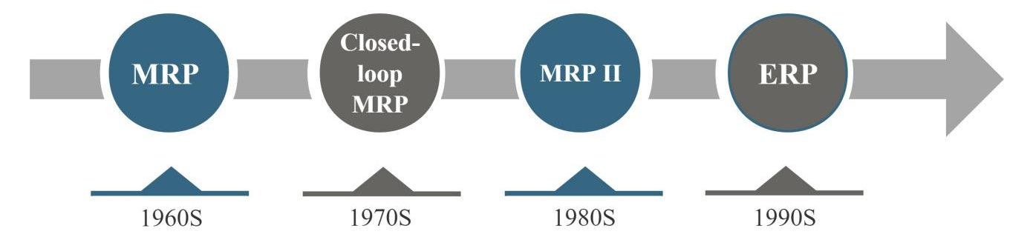

Figure 1.3 ERP development timeline
The main role of ERP [27, p.141]:
- Provide an integrated information system for the full sharing of business data and information.
- Rationalizes and standardizes business processes to improve business efficiency. The duplication of labor in the process of business processing is successfully eliminated, and the standardization and normalization of business processing are ensured.
- The accuracy and timeliness of data are significantly improved because the system can automate data processing. At the same time, analytical methods have become more standardized and diversified, which further promotes the wide application of modern management methods in enterprises.
- Pay attention to internal control and ensure clear division of labor. So that the system can reflect the problems of each link in time, and provide the required data support for performance evaluation.
- Through the application of the system, we can automatically coordinate the business of various departments and realize the unified planning and use of resources. This helps reduce inventory, speed up capital turnover, and coordinate the operation of the entire team.
- Help the decision-makers to make the right decisions. By obtaining the dynamic operation data of the enterprise in real time and combining with the simulation function of the ERP system, the decision-making level can understand the operation status of the enterprise more accurately, so as to make more intelligent decisions.
• Supply Chain Management (SCM) [23, p.233-234].
The supply chain takes the core enterprise as the center, and closely connects suppliers, manufacturers, sellers and end users together to achieve effective control of information flow, logistics and capital flow.
The core of the supply chain management model is to carefully plan, coordinate and control the logistics, information flow and capital flow among the participating organizations and departments in the entire supply chain, aiming to achieve the best allocation of resources and the highest efficiency of operation.
Supply chain management connects suppliers, core enterprises and consumers closely through the effective transmission of early information flows (such as order contracts, purchase orders, etc.) and feedback information flows (such as completion reports, inventory status, sales data, etc.), forming an organic whole. The starting point of supply chain management is to meet the needs of customers, and its management object covers all enterprises in the supply chain. Its objectives include the minimization of total costs, the optimization of customer service quality, and the efficiency of the entire supply chain management process.
In summary, supply chain management aims to reduce the time from design to final delivery of products to consumers, reduce product costs, and meet the increasingly diverse needs of consumers.

1.3. Concept, characteristics and structure of information and analysis management support.
1. Concept of management information systems.
An information system is a collection of interrelated elements or components. These elements or components can input, process, and output data and information, and provide feedback and control mechanisms aimed at achieving specific goals.
Management is a purposeful and conscious practice. It refers to a comprehensive activity in which managers plan, arrange, optimize and control various resources and practice links in order to achieve established goals under specific conditions.
ISO(International Organization for Standardization) defines Management Information System (MIS) as: management information system is a human-computer system that uses the theory and method of system management, takes computer technology, network communication technology and information processing technology as tools and means, and has the functions of processing, storage and transmission of information, as well as the functions of prediction, control, organization and decision-making [27, p.22].
Management information system is not only responsible for collecting, transmitting, storing, processing, maintaining and using the information generated in management activities, but also provides a full range of services for the management decision-making process. It can not only accurately record the actual operation of various activities of the enterprise, but also predict the future trend with the help of the data that has occurred and stored and the decision model, providing a solid basis for decision making.
2. Characteristics of management information systems [27, p.23].
Management information system is built on the basis of data processing system, focusing on the comprehensive collection of management information, efficient transmission, safe storage and accurate processing, is a multi-user sharing system.
Management information system has the following characteristics:
First, it emphasizes the collaborative work of human and computer systems. Some tasks are handled by efficient computer systems, while others that are complex or require human judgment are performed by humans to ensure that people and computer systems can work together harmoniously.
Second, it is a comprehensive system with multiple participants. This system not only covers various types of personnel such as managers, programmers and staff, but also integrates hardware resources such as computers, communication tools, network equipment, as well as various system software and application software.
Finally, as the external environment and internal conditions of the organization change, the management information system can maintain its effectiveness and adaptability through continuous maintenance and update.
3. Management information system structure.
The structure of management information system refers to the framework of the various components of the system and the way of content organization, including conceptual structure, hierarchy structure, functional structure, hardware structure and software structure.
• Conceptual structure of management information system [40, p.16].
The conceptual structure of a management information system consists of the following four core components:
- Source of information. It provides the necessary information input to the system. It can be either a concrete entity or an abstract process or phenomenon.
- Information processor. It is responsible for the collection, processing, storage and efficient and accurate transmission of information to ensure the smooth flow of information in the system.
- Information user. This part usually refers to all levels of management within the company. They rely on information resources provided by management information systems to help them make more informed decisions.
- Information manager. This role is mainly responsible for the daily operation, management and maintenance of the information system, as well as the coordination and communication between various departments, and the optimization of information flow and use efficiency.
The conceptual structure of MIS is shown in Figure 1.4 below.
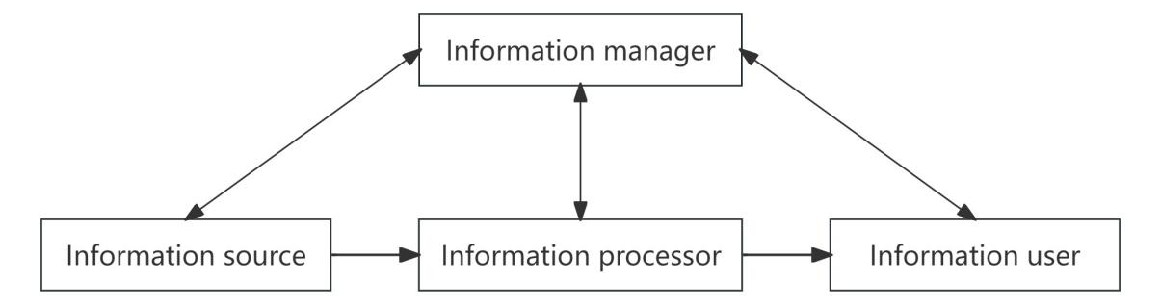

Figure 1.4 The conceptual structure of MIS
• Management information system hierarchy [40, p.16].
The organizational structure of information system can be divided into three levels according to the management level of its service: operational level, tactical level and strategic level. At the same time, general management functions are divided by marketing, production or service, finance, human resources, and so on. These three levels of horizontal (according to function) and vertical (according to management level) division, together constitute the pyramid structure of management information system.
The pyramid hierarchy of MIS is shown in Figure 1.5 below [27, p.25].
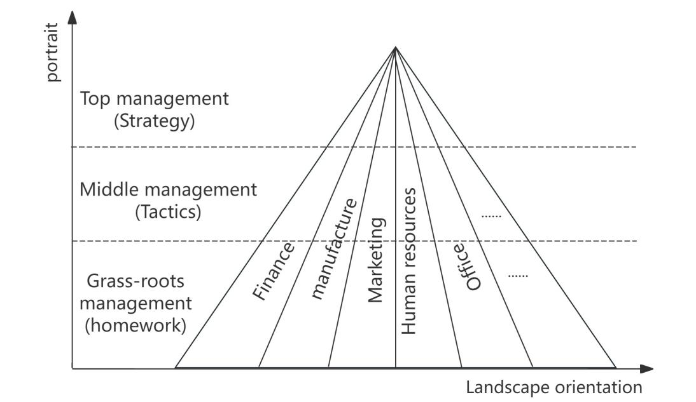

Figure 1.5 The pyramid hierarchy of MIS
• Functional structure of management information system [40, p.17].
From the perspective of users, the management information system covers many subsystems such as management system, supply chain system, production and operation system, financial management system and sales system. As shown in Figure 6 below [6, p.25].
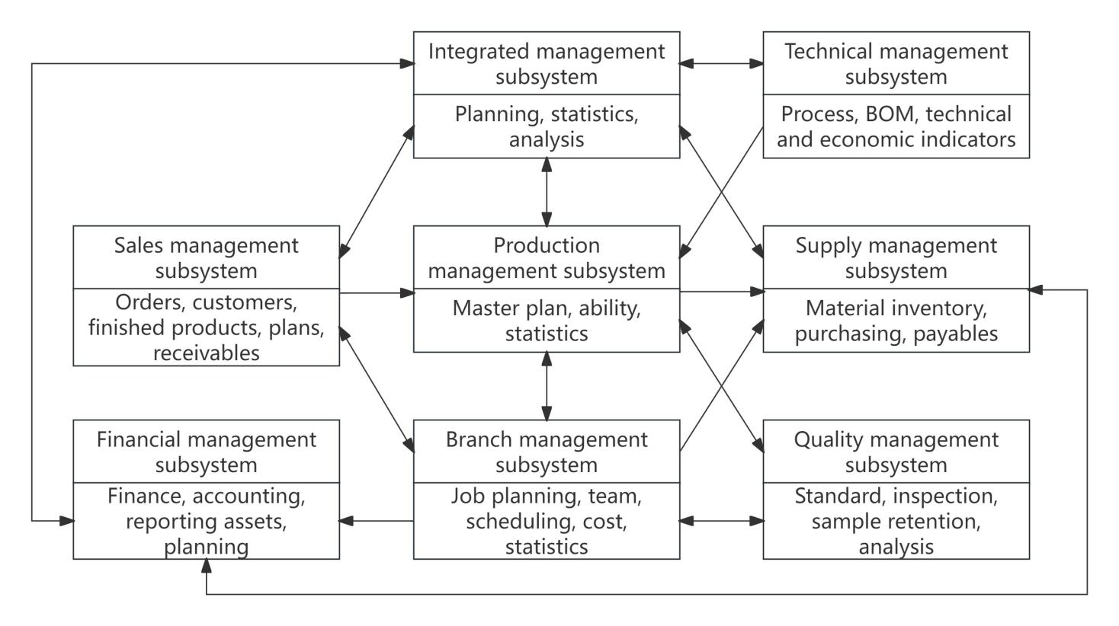

Figure 1.6 The functional structure of the
enterprise subsystem
• Hardware structure of management information system [7, p.31].
The hardware structure of the management information system includes the following types of equipment: computer equipment (such as computer hosts and terminals), communication equipment, and other external equipment connected to the computer (such as network cards, printers, fax machines, etc.).
• Software structure of management information system.
It includes various software or software modules of the management information system. Such as model base system, knowledge base system and public application software.

CHAPTER 2
MODERN TECHNOLOGIES OF INFORMATION AND ANALYTICAL SUPPORT IN MANAGEMENT

2.1. Analysis of the implementation of digital technology in China.
The development of digital economy depends on the support of digital technology. The so-called digital technology is to convert images, text, sound, video and other kinds of information into binary numbers "0" and "1" that can be recognized by electronic computers through specific equipment, and then operate, process, store, transmit and restore them. It is a science and technology closely connected with electronic computers [14].
1. The development of digital technology.
Early development stage: The development of digital technology has gradually developed from vacuum tubes and semiconductor discrete devices to integrated circuits. From the beginning to the middle of the 20th century, electronic devices in this period were dominated by vacuum tubes (also known as vacuum tubes), which dominated the field of electronic technology. In the early 1960s, with the progress of science and technology, analog integrated circuits and digital integrated circuits were developed one after another.
Rapid development stage: Since the mid-1960s, bipolar processes have been used to manufacture small-scale logic devices, marking the initial development of digital integrated devices. By the end of the 1970s, the birth of the microprocessor became an important turning point, and the performance of digital integrated circuits achieved a qualitative leap. By 1988, the integration process had made amazing progress, and up to 35 million components could be integrated on a square centimeter of silicon, and integrated circuits entered the stage of large-scale development.
Application popularization stage: After the 1980s, the large-scale popularization and application of personal computers led human society into the first large-scale digital era. After the mid-1990s, with the large-scale commercial use of the Internet, networking applications have become dominant, and digital technology has ushered in a large-scale development stage [31].
The following figure 2.1.
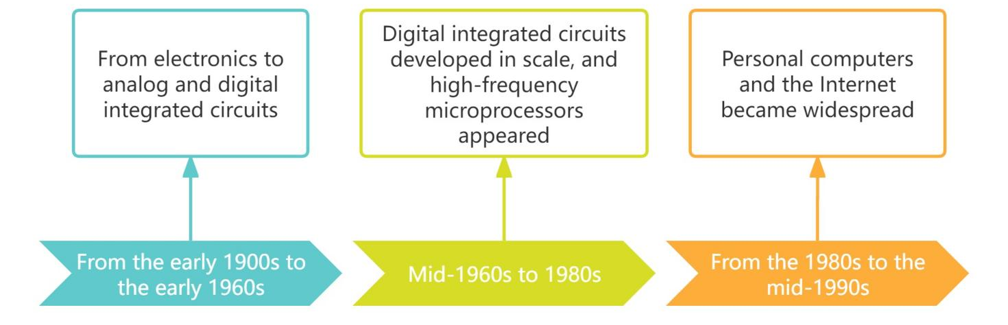

Figure 2.1 Digital technology development process
The development of digital technology mainly benefits from two key technologies: computer and Internet.
First of all, As a representative of information processing technology, the emergence of computers and the development and application of computing power have greatly promoted the collection, storage, processing and processing of data, laying a solid foundation for the rise of digital technology.
Secondly, since the 1990s, the rise of Internet technology has had a profound impact on human production and life. It promotes the generation, exchange and flow of data, and promotes the wide application of digital technology.
Finally, in recent years, the composite application of computers and the Internet has spawned a series of new technologies such as big data, cloud computing, artificial intelligence, Internet of Things, and blockchain. These new technologies provide efficient technical support for data transformation and application.
In the 1990s, China's industry was still in the stage of manual production and machining. However, since the release of China's first national informatization plan in 2002, informatization construction has developed rapidly. This plan has vigorously promoted the development process of Internet +, informatization and mobility [26].
From 2012 to 2015, China's digital informatization construction and Internet technology developed rapidly. In December 2013, the mobile network entered the 4G era. In the first half of 2017, there were nearly 300 million fiber broadband users. Since 2020, great progress has been made in mobile 5G, industrial Internet, artificial intelligence technology and infrastructure construction. In June 2022, compared with December 2021, the number of Internet users in China increased by 19.19 million to 1.051 billion. The Internet penetration rate reached 74.4%, an increase of 1.4 % [25].
The statistical chart of China's Internet users and Internet penetration rate from 2020 to 2022 is shown in Figure 2.2 below.

Figure 2.2 The statistical chart of China's Internet users and Internet penetration rate from 2020 to 2022
In June 2022, compared to December 2021, the number of mobile Internet users in China increased by 17.85 million to 1.047 billion, of which 99.6% used mobile phones to access the internet. The following Figure 2.3 [25].

Figure 2.3 The Statistical Chart of the Scale and Proportion of Mobile Internet Users in China from 2020 to 2022
China has identified a series of national strategies such as the broadband China strategy, the "Internet Plus" strategy and the big data strategy, which has promoted the deep integration of industrialization and information technology, and promoted a new round of industrial transformation and upgrading. In the field of manufacturing, CNC systems and ERP software have been deeply applied, at the same time, innovative models such as smart factories and industrial e-commerce are also being explored. Informatization and the Internet have penetrated into all aspects of social life, and the importance of mobile Internet has become increasingly prominent. New models such as online shopping, online ticket purchase and mobile payment are emerging one after another, and digital lifestyle is gradually becoming the new normal [26].
2. Main content of digital technology [35].
• Big data.
Big data technology has the ability to process and analyze huge data sets to provide strong support for decision making. With big data analytics, companies can better understand customer needs, optimize their own operational processes, and uncover potential business opportunities.
• Cloud computing.
By providing flexible and scalable computing resources, cloud computing gives enterprises the ability to quickly deploy and scale applications based on actual needs. Its benefits include cost-effectiveness, on-demand service delivery and high reliability, resulting in a more efficient IT infrastructure environment for enterprises.
• Internet of Things.
The Internet of Things connects various devices and items to the Internet to achieve intelligent monitoring and management of equipment. Notable features of this technology include real-time connection performance, efficient data acquisition capabilities, and intelligent control capabilities. At present, the Internet of Things is mainly used in many fields such as smart home, intelligent transportation and industrial automation.
• Virtual Reality (VR) and augmented reality (AR).
VR and AR technology is a new mode of interaction between people and digital content, providing users with an immersive experience. At present, these technologies have been widely used in many fields such as games, education, training and marketing.
• Robotic Process Automation (RPA).
RPA technology is widely used in the automated business process of finance, human resources, customer service and other industries. It uses software robots to automatically complete repetitive work tasks and improve work efficiency and accuracy.
• Artificial intelligence [35].
From the technical breakthrough to the expansion of practical application fields, AI technology with deep learning and computer vision as the core is rapidly integrating into the manufacturing industry. Having cutting-edge AI capabilities has become an important symbol to enhance the competitiveness of China's manufacturing industry on a global scale.
- Deep learning. In the past, data analysis mainly relied on classical statistics and computer science, which processed relatively limited data scale and computational efficiency. With the introduction of machine learning methods such as deep learning, enterprises are able to efficiently process and analyze huge data sets to unlock business value. With the ability to transform industrial data into valuable data assets, deep learning has become a key technology for evaluating the digital transformation process in manufacturing.
- Computer vision. Computer vision is a deep learning-based technology that focuses on how machines capture, process, parse, and understand digital image information. Compared with human eyes, computer vision has stronger environmental adaptability and more convenient information integration ability. At present, this technology has been widely used in electrical appliance manufacturing, automobile production, textile and other manufacturing fields.
Advantages and characteristics of artificial intelligence technology:
- Improve production efficiency: Artificial intelligence can automate a large number of repetitive tasks, effectively reduce the reliance on manual operations, and greatly improve production efficiency.
- Improve product quality: With advanced technologies such as computer vision, artificial intelligence can monitor the production process in real time and quickly identify and correct quality problems.
Optimize the production process: Through the analysis of massive data by deep learning algorithms, artificial intelligence can accurately identify bottlenecks in the production process and put forward optimization suggestions.
- Personalized customization: Artificial intelligence technology can produce according to the individual needs of customers to meet the diversified and customized needs.
- Promoting industrial upgrading: With the continuous application of artificial intelligence technology, the manufacturing industry is gradually transforming and upgrading in the direction of high-end and intelligent.
• Industrial internet [35].
As a result of the deep integration of a new generation of information technology and industrial manufacturing, the industrial Internet has created a new manufacturing and service system that runs through the whole industrial chain of industrial manufacturing by comprehensively linking people, machines, goods and systems.
- 5G technology. As the latest generation of cellular mobile technology, 5G has significant advantages such as massive connections, high reliability and low latency, and can effectively respond to and solve complex and diverse needs in various industrial scenarios.
- Blockchain. In the deployment process of the industrial Internet, enterprises need to upload private data to the cloud, and the use of blockchain technology can ensure the security of data sharing among various links within the enterprise, strengthen network encryption and fine control of access rights.
- Digital twins [15]. By integrating multi-source information such as physical model, sensor update data and operation history records, digital twin technology uses multi-disciplinary, multi-physical quantity, multi-scale and multi-probability simulation methods to build an accurate mapping of physical equipment in virtual space and fully show its full life cycle process. In China, the field of intelligent manufacturing pays the most attention to digital twins. Digital twin platforms can compile and visualize all kinds of existing data, making complex data intuitive and understandable.
Advantages and characteristics of industrial Internet technology:
Improve equipment utilization: The industrial Internet uses 5G, edge computing and other technologies to further realize real-time monitoring and remote control of equipment.
Reduce maintenance costs: Simulate the operating state of the equipment and predict possible failures in advance, thereby effectively reducing the maintenance cost of the equipment.
Optimizing supply chain management: The application of blockchain technology makes supply chain information more transparent and traceable, helping to optimize supply chain management.
Improve production safety: real-time monitoring of production environment and equipment status, timely detection of potential safety hazards.
Promoting industrial synergy: The industrial Internet connects the upstream and downstream enterprises of the industrial chain, strengthens the collaboration between each other, and improves the efficiency of the entire industrial chain.
• Low code [35].
Low code platform, with its visual development, model driven and other characteristics, opens up an efficient way for enterprise digital transformation.
By significantly reducing development barriers and time costs, these platforms enable enterprises to quickly and flexibly build and deploy multiple information management systems, including ERP, MES, OA, CRM, and more. With API scripting and other functions, the low-code platform can also easily achieve seamless docking with other internal systems (such as OA, ERP and master data systems), further improving the operational efficiency and system integration capabilities of enterprises.
AI technology can find practical application scenarios in many industries and combine with the specific needs of enterprises, becoming an important tool to promote the digital transformation of traditional industries.
In 2020, the highest proportion of Chinese enterprises applying digital technologies is machine learning and artificial intelligence technology, reaching 25.4%. This was followed by the Internet of Things (iot) at 19.7%. In third place is RPA technology, accounting for 18.3%. Figure 2.4 below [34].

Figure 2.4 Application ratio of digital technology
in Chinese enterprises

In 2020, Chinese enterprises show industry differences in the application of digital technology. Specifically, the semiconductor industry has the highest percentage of digital technology applications, reaching 31.67%. Software development companies followed at 13.33 percent. The proportion of applications in component companies and consumer electronics companies is the same, both 10.83%. The application ratio of optical optoelectronics enterprises is 10.00%, while the application ratio of IT services enterprises is 7.50%. Detailed scale data can be found in Table 2.1 and Figure 2.5.

Table 2.1
Table of the proportion distribution of digital technology application
in various industries in China
Industry data
Year: 2020
Legend number | Industry | Account for percentage
1 | semiconductor | 31.67%
2 | Software development | 13.33%
3 | mods | 10.83%
4 | Consumer electronics | 10.83%
5 | Optical photoelectron | 10.00%
6 | IT service | 7.50%
7 | Computer equipment | 5.83%
8 | Military electronics | 4.17%
9 | Electronic chemicals | 2.50%
10 | Automation equipment | 1.67%
11 | Internet e-commerce | 0.83%
12 | electricity | 0.83%

Figure 2.5 Proportion of digital technologies applied
in various industries in China [12]
3. Application of digital technology [26].
The comprehensive application and technological innovation in the field of digital technology, including communication networks, computers, electronic information and software, has provided a strong driving force for the rapid development of China's information economy. Since 2015, China's broadband network has experienced continuous acceleration and upgrading, and the number of broadband users and its growth rate have achieved significant improvement, increasing by 29.42% compared with 2014.
By the first half of 2017, the scale of optical fiber broadband users has exceeded 300 million, accounting for more than 84% of all broadband users, marking that all cities in the country have basically built optical network cities.
Since then, the pace of China's network speed and quality has not stopped. In 2019, based on the increasingly fierce market competition and the needs of some high-end users, major operators have launched slogans such as "double G double lifting", "Gigabit optical width", "double gigabit", "three gigabit" and "full gigabit", and released corresponding gigabit packages to meet users' pursuit of higher speed and higher quality network services.
At the same time, the world is also paying attention to the development of fixed network technology. At the beginning of 2020, the European Standards Organization ETSI set up the F5G industry Standards Working group specifically to promote the realization of light.
In this context, the relevant Chinese authorities have also taken active actions to jointly carry out relevant research with operators, research institutes and well-known enterprises to promote China's rapid development in this field.
Network communication technology has not only led the construction of China's digital infrastructure, provided long-term support for digital transformation, and promoted the high-quality development of digital China construction.
In recent years, China's Internet broadband users and growth in the following table 2.2 and figure 2.6.

Table 2.2
The number of internet broadband users in China
Annual data
Year : 2014~2023
Year | Number of users  (10,000 households) | Year | Number of users  (10,000 households)
2014 | 20048.34 | 2019 | 44927.86
2015 | 25946.57 | 2020 | 48354.95
2016 | 29720.65 | 2021 | 53578.66
2017 | 34854.01 | 2022 | 58964.84
2018 | 40738.15 | 2023 | 63631

Figure 2.6 The number and growth of internet broadband users in China
(Source: compiled by the author based on [22])
The rapid progress of Internet technology has given birth to the innovation of business models. The deep penetration of information technology into traditional industries has triggered disruptive changes in these industries and spawned many new production and business models. In the field of production, the transformation and upgrading of the manufacturing industry has become a broad consensus. The Internet of Things, RFID and other technologies have been applied in many fields such as home appliances, construction machinery, and at the same time, the application of MES, ERP, CAD/CAM and numerical control systems has also begun to show its results. Digital workshop, smart factory, smart manufacturing and other concepts have gradually become the focus of attention in the market. In addition, the policy support of strategic emerging industries has further promoted the investment boom in related manufacturing industries.
Compared with 2019, the national manufacturing industry has improved in terms of the maturity of intelligent manufacturing capabilities in 2020. Specifically, the number of low-maturity enterprises at level 1 and below decreased by about 10%, while the number of high-maturity enterprises at level 3 and above increased by about 8%.
The changes in enterprise maturity levels can be seen in Figure 2.7 below.

Figure 2.7 The changes in enterprise maturity levels [3]
Enterprises with maturity level 4 and above can build corresponding models and knowledge systems through in-depth data mining of people, resources and manufacturing processes. These companies predict and optimize their core business based on these models, and actively explore innovative manufacturing and business models. On the whole, the current capability maturity of China's intelligent manufacturing is still at a low level. However, manufacturing enterprises have deeply recognized the key role of intelligent manufacturing in enhancing their core competitiveness, so they are gradually integrating intelligent manufacturing into their strategic deployment. This trend has led to a gradual decline in the number of low-maturity enterprises.
With the deep integration of digital technology and enterprise operations, many new scenarios, new models and new services continue to emerge. With the continuous deepening of big data applications and services, the market demand for big data infrastructure continues to grow. The construction of efficient and green data centers and cloud computing infrastructure has accelerated, laying a solid foundation for the application of new technologies such as artificial intelligence, digital twins, and blockchain. Artificial intelligence achieved explosive growth in 2017, and the total investment in the field of artificial intelligence in 2018 exceeded the 100 billion yuan mark. Cutting-edge applications such as autonomous driving and intelligent voice continue to make new breakthroughs, and the market value of related enterprises such as iFlytek and NIO Automobile continues to rise [26].
The application of digital technology has enhanced the capacity of social governance. Especially in the response to the novel coronavirus epidemic, China's digital governance capacity has been significantly enhanced in practice. Various digital tools and solutions, such as the epidemic big data platform, health code, travel big data tracking, and vaccination management platform, have been widely used in epidemic management, helping China quickly build and optimize the epidemic prevention system, and effectively protecting people's lives. As digital technology penetrates deeply into all aspects of production and life, it provides new perceptions and experiences for the way people live and work. Nowadays, digital lifestyles such as online affairs, remote working, online courses and online entertainment have become the norm in the daily life of Chinese people.
Since 2020, new infrastructure construction, represented by 5G, industrial Internet, and artificial intelligence, has become a key driving force for economic recovery and high-quality development during China's regular epidemic prevention and control. In this process, the full rollout of the "East Count West count" project, as well as the accelerated investment and construction of a series of new infrastructure projects such as 5G networks, industrial Internet platforms, and artificial intelligence facilities, has not only promoted the rapid growth of emerging industries such as 5G and charging piles, but also injected new vitality into the development of China's economy.
In terms of the year-on-year change of the investment amount of digital facilities in 2020, there are obvious differences between state-owned enterprises and non-state-owned enterprises. Specifically, among state-owned enterprises, enterprises with investment growth range of 0% to 25% accounted for the largest proportion, reaching 45.45%. Among non-state-owned enterprises, enterprises with investment growth range of 75%-100% accounted for the largest proportion, reaching 33.33%.
As shown in Table 2.3 and Figure 2.8 below [34].
Table 2.3
In 2020 China's digital infrastructure growth table
Industry data
Year: 2020
Change interval | Change in total investment | Changes in the investment amount of state-owned enterprises | Changes in the amount of investment by non-state-owned enterprises
≤0% | 13.79% | 0.00% | 22.22%
0% to 25% | 27.59% | 45.45% | 16.67%
25% to 50% | 17.24% | 18.18% | 16.67%
50% to 75% | 6.90% | 18.18% | 0.00%
75% to 100% | 24.14% | 9.09% | 33.33%
≥100% | 10.34% | 9.09% | 11.11%

Figure 2.8 China's digital infrastructure growth curve in 2020
Under the strategic layout of state-owned enterprises, digital transformation is leading the emergence of a series of new models and new business forms. China's state-owned enterprises, as pioneers of digital transformation, have set a model for digital transformation in a number of industries [26].
Intelligent manufacturing is one of the important directions. Sany Heavy Industry, Xugong Group and other enterprises have established industrial Internet platforms and smart factories, laying a solid foundation for resource sharing and business collaboration in the industrial chain and supply chain.
In the field of energy, petrochina, Sinopec, Yankuang and other energy companies are accelerating the construction of smart grids, smart pipe networks, smart power stations, smart oil fields and smart mines. These companies are committed to improving the level of integrated scheduling, remote operation and intelligent operation and maintenance, and strengthen the planning, construction and operational control of energy assets and resources throughout the lifecycle.
The digital transformation of the construction industry is also well underway. China State Construction and other construction enterprises are widely applying building information modeling, three-dimensional digital collaborative design and artificial intelligence technologies, promoting the deep integration of digitalization and construction of the whole business chain [26].
In addition, in the field of service business, China Resources Group, China Merchants Group and other enterprises are also vigorously promoting the transformation of physical service outlets to virtual smart outlets, and developing user services based on Internet platforms to improve customer experience and enhance customer loyalty.
From 2014 to 2020, China's digital economy scale and a share of GDP are shown in figure 2.9 below [10].

Figure 2.9 Scale and proportion of China's digital economy in GDP
from 2014 to 2020
4. The future trend of the development of digital technology in China [30].
In today's era, digital technology has become an important force to promote social progress, and it is profoundly changing the way we live, work and think at an unprecedented speed. Looking to the future, digital technology will continue to lead the trend of social development and promote mankind to move forward.
- With the wide application of big data technology, the computing technology system is changing from the previous "compute-centric" model to the "data-centric" model. How to build a new computing system with data as the core to adapt to the application needs of big data has become a problem that the future development of digital technology needs to face.
- With the rapid development of artificial intelligence and machine learning technology, we are ushering in a revolution of automation and intelligence. In manufacturing, robots are gradually replacing traditional human labor. In the service sector, chatbots are becoming increasingly popular. These changes are due to the continuous progress of machine learning and deep learning technologies, which are pushing artificial intelligence to a higher level of intelligence and autonomy [29].
- The rise of "cloud conferences". With the vigorous development of the Internet and digital economy, cloud video conferencing has gradually emerged in the field of remote work, becoming a new and important way of working. Looking forward to the future, "cloud conference" will lead the new trend of intelligent office in the whole scene, and help enterprises reduce costs through interaction and collaboration in the whole scene. The immersive conference experience will create a new smart office ecology for enterprises [13].
- With the widespread rise of digital factories, the new retail model is gradually penetrating into all links of the whole industrial chain. With the help of advanced technologies such as AI, cloud computing and blockchain, we can accurately collect and analyze user needs, so as to scientifically predict the production and sales of products. These valuable data are then fed back to various links of the whole industry chain such as production, logistics, warehousing, and so on, completely subvert the traditional post-production sales model [2].
- Online and offline services and experiences will be seamlessly integrated, breaking the original boundaries and moving towards a more prosperous future together. Data intelligence will play a key role in guiding consumers into offline stores, enabling merchants to understand and exceed consumer expectations and provide personalized, efficient services and experiences. At the same time, consumers just need to easily open their mobile phones to fully understand the nearby stores, brands, number of buyers, new trends and promotional activities and other information, to achieve online and offline all-round touch. Whether it is shopping out of the house or online, it will become equally convenient and efficient, bringing consumers an unprecedented shopping experience [2].
- Internet of Things. In the future, iot devices will cover many fields such as mobile devices, wearable equipment, household appliances, medical facilities, industrial detection devices, surveillance cameras, automobiles and even daily clothing. With the information resources provided by the Internet of Things technology, people will be able to make more appropriate choices. At the same time, connected devices will also enable many human-dependent jobs, such as monitoring, management, maintenance, and so on, to gradually become automated.
The deep integration of the three leading technologies of the Internet of Things, data analytics and artificial intelligence will enable humans to achieve the ability to efficiently execute large-scale business transactions without human intervention [32].
- Looking forward to the development trend of the future network, the Internet will be deeply integrated with the real economy, covering a number of key areas such as industrial control, auto autonomous driving, energy Internet, and closely work with the new generation of information technology such as cloud computing and artificial intelligence to jointly contribute to the development of China's digital economy. This integration will strongly promote the vigorous development of future industries such as industrial Internet, energy Internet, computing Internet, satellite Internet, vehicle networking, and mobile communication system (6G) [33].

2.2. Big data technology Information and Analytical Support.
Since 2009, the term "big data" has rapidly become popular in the Internet information technology industry. According to the US Internet Data Center report, the amount of data on the Internet is growing at a rate of 50% per year, and will double every two years. According to statistics, only in the short three years from 2010 to 2012, the total amount of information data has exceeded the sum of the previous 400 years, and human society has entered the era of big data.
1. Definition and characteristics of big data [19, p.62].
The term "Big Data" was originally used to describe collections of data that require simultaneous large-scale batch processing or analysis when updating web search indexes. With the progress of The Times and the emergence of various new technologies, the meaning of big data is no longer limited to referring to the huge amount of data, it also involves the speed of processing these data.
At present, the definition of big data, various institutions and individuals have different understanding, there are certain differences.
The McKinsey Global Institute's Big Data: The Next Frontier for Innovation, Competition, and Productivity defines big data as: "Big data is a collection of data whose size exceeds the capabilities of traditional database software tools to capture, store, manage, and analyze."
Gartner defines Big data as "massive, high-growth, and diverse information assets that require new processing models to enable greater decision-making, insight, and process optimization".
Although the industry has not yet agreed on the definition of big data, there is a basic consensus on the characteristics of big data. IBM proposes that big data should have three core characteristics, which can be summarized as the three V's: Volume, Variety, and Velocity. Then, based on these three V's, a fourth V, Value, is added. Together, these four V's form the fundamental characteristics of big data [19, p.63].
• Volume.
The primary feature of big data is its sheer volume of data. According to research by the International Data Corporation (IDC), the amount of data in the world continues to expand at an alarming rate. Specifically, in 2008, the amount of data generated worldwide reached 0.49 ZB, and in 2009, this figure has grown to 0.8 ZB. In 2010, the global data volume climbed further to 1.2 ZB, and in 2011 it was as high as 1.82 ZB. Entering 2012, the global data volume has reached a staggering size of 2.72 ZB. As of today, the total amount of data generated worldwide is estimated to be close to 50 ZB.
• Variety.
Big data is characterized not only by the rapid growth of its data volume, but also by the increasing richness of data types. At present, the growth of global data volume is not only the expansion of quantity, but also the expansion of data types. Today's data storage is no longer limited to traditional structured data and two-dimensional table forms. With the continuous emergence of Internet multimedia applications, unstructured data such as pictures, sounds, and videos have also ushered in a substantial growth. Especially after entering the Web2.0 era, forums, blogs, micro-blogs, wechat, short videos and other platforms have generated massive unstructured data. According to statistics, unstructured data currently accounts for more than 80% of the total data in the world.
• Velocity
Big data processing requires extremely high speed and timeliness, requiring the ability to quickly extract valuable information from large and diverse data sets to meet the urgent needs of market development.
• Value
The core significance of big data is the value it contains. Data is becoming a new core asset for businesses. By analyzing the large amount of data generated by users, enterprises can accurately grasp the habits and needs of users, and dig deeper into the intrinsic value of these data. Because of this, the value in big data has become the fundamental driving force for many companies to actively pursue user data.
2. Big Data processing [27, p.119].
Big data processing includes four types of systems: individual service-batch type, individual service-real-time type, whole service-batch type, and whole service-real-time type.
• Individual service - Batch processing type.
Individual service - batch processing refers to the collection of data for specific individuals and provides them with tailored optimal solutions, while the timing of feedback is relatively flexible and not strictly restricted. An e-commerce site, for example, will conduct one-on-one marketing campaigns based on users' browsing history and purchase history. Insurance companies, for example, collect and analyze data that can reflect customers' driving habits, such as driving frequency, speed, and the number of hard brakes, and use this as a basis to determine the premium discount given to customers.
• Individual service - real-time.
Individual service - real-time refers to the collection of relevant data for a specific individual, and provide the best solution for the individual in real time. The recommendation is instant, for example, when the customer is near a store or browsing a shopping website, the system will automatically push relevant information. For example, the call center will assign the customer to the operator with the highest liking in real time based on the favorability model between the customer and the operator.
• Total service - Batch type.
Overall service - batch processing type, it first collects and stores massive information, and uses statistical methods to analyze and process these information. The model aims to arrive at a solution that is beneficial to a group or society as a whole, and its feedback results are obtained and the timing of optimization is not limited by time. For example, a hedge fund's investment strategy can be developed by analyzing text content in social networks to predict market movements. Or, using the vast amount of search data accumulated in search engines to predict the trend of cold epidemics.
• Total service - real-time.
Overall service - real-time, which involves the real-time collection, storage and statistical analysis of a large amount of information, and closely combined with the current context, to quickly provide beneficial solutions for a collective or the whole society. For example, by collecting the location data provided by the GPS of many smartphone users, traffic congestion is monitored in real time and this information is instantly fed back into the map software. Another example is the use of electricity consumption information collected by smart meters to monitor and forecast electricity demand in real time.
3. Levels of big data processing [27, p.120].
To use big data to solve real problems, people usually follow the process of "analysis of the past → monitoring of the current situation → optimization of the future prediction and action". As shown in Figure 2.10 below.

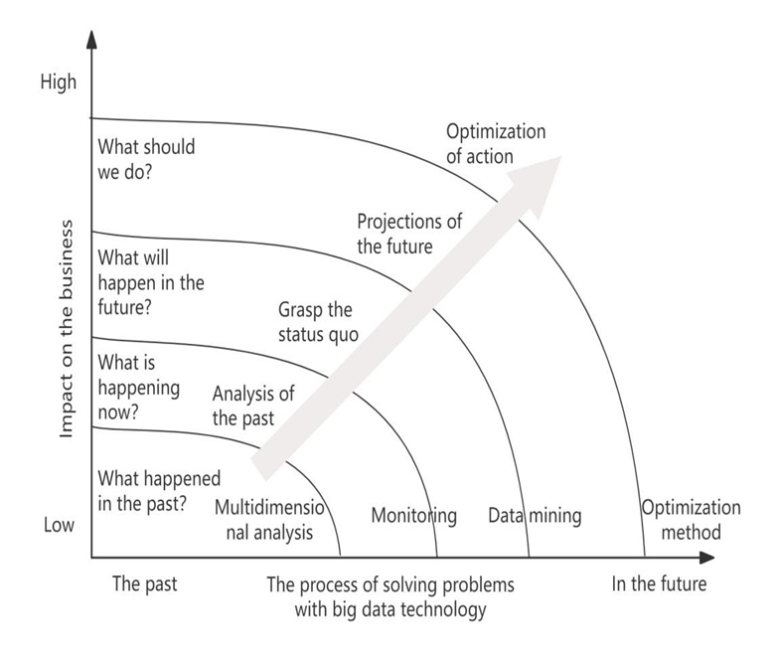

Figure 2.10 Levels of big data processing
• The analysis of go.
The application of big data begins with the collection of data. First, the key is to accumulate historical data and extract rules and knowledge from it, which is the initial step of big data processing. With the wide popularization of the Internet and the in-depth application of the Internet of Things technology, a large amount of information about human activity records and environmental perception is captured and stored. When the data accumulates to a certain scale, it is necessary to use technical means such as data mining and machine learning to dig out patterns that have a substantial impact on the business from the vast ocean of data.
• A grasp of the status quo.
The accurate grasp of the status quo is reflected in the close monitoring of a large number of real-time generated data. This includes real-time monitoring of various types of data, such as traffic conditions, weather information, and the operating status of mechanical devices, in order to detect and identify abnormal values and conditions in a timely manner.

• A prediction for the future.
If can through in-depth analysis of historical data to discover potential rules or patterns, then these patterns can be combined with the current input data, and an effective prediction for the future possible conditions.
• Optimization of action.
Optimization here refers to the optimal strategy and response based on data analysis and prediction results, including selecting the best path, recommending the most appropriate products, delivering the most appropriate information at the best time, and providing the most appropriate discounts for specific customers.
In big data applications, specific models to achieve this optimization are constantly being innovated. How to creatively adjust and improve the actions and strategies taken for specific problems has become an important issue to be solved in the field of big data processing.
4. Big Data technology application.
The application range of big data technology is extremely wide, and it has penetrated many industries. The following details the specific application of big data technology in various industries from several aspects [19, p.68].
• Prediction of disease outbreaks.
By analyzing people's Internet searches, especially for disease symptoms and treatments, Google has been able to predict the likelihood of widespread outbreaks faster and more accurately than the local centers for Disease Control and Prevention.
• Race prediction.
There has always been a passion for predicting sporting events, a hobby that has spawned the gambling industry. With the rise of big data technology, this field has also ushered in new application opportunities. During the 2014 FIFA World Cup in Brazil, companies such as Google, Baidu, Microsoft and Goldman Sachs all launched their own platforms for predicting match results.
• Public opinion monitoring.
With the continuous progress of the Internet, big data technology has become an important tool to accurately grasp the impact of social public opinion, which allows us to grasp and analyze the dynamics of public opinion more quickly, and even manage public opinion effectively in the embryonic stage. In social management, the use of big data technology to monitor public opinion has become a key means.
The major project of the National Social Science Fund, led by Professor Li Xiguang of the International Communication Research Center of Tsinghua University, has successfully developed a social public opinion research and judgment early warning system. As shown in Figure 2.11 below.
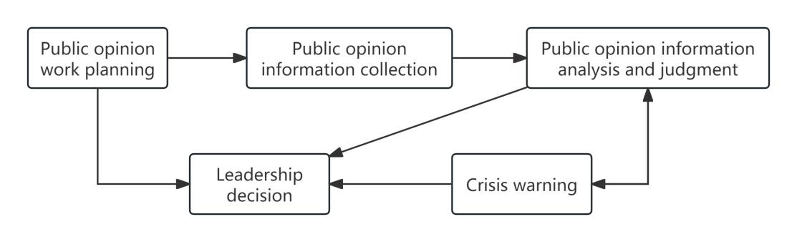

Figure 2.11 Schematic diagram of public
opinion information workflow
The system aims to realize the monitoring, research and early warning of social public opinion, and with the help of big data technology, it can capture and deeply understand the social situation and public opinion in real time. Through scientific analysis and research on current social hot topics, the system is committed to reducing the negative impact of various emergencies, and scientifically predicting the trend of public opinion on major crisis events, so as to provide valuable decision-making reference for crisis management and response.
• City management [19, p.70].
With the acceleration of China's urbanization process, major cities are generally faced with traffic problems. Using LBS location data based on users and vehicles, as well as sensors in various Settings, we can deeply analyze the characteristics of passenger-vehicle travel and predict traffic behavior. These results can guide people to make reasonable travel plans, so as to effectively avoid traffic congestion.
• User behavior analysis.
Companies can gain insight into users' needs by analyzing data such as their search history, browsing history and comments. Based on this, enterprises can carry out targeted product production, improvement and marketing strategy formulation. For example, Baidu uses user preferences for targeted advertising, Alibaba customizes products on the production line according to the characteristics of Tmall users, and Amazon analyzes user click behavior to deliver goods in advance. These are the benefits of big data technology applied to user behavior analysis.
5. Analysis of big data application scenarios of Beijing Coal Machinery Company (Source: compiled by the author based on the actual situation of the enterprise).
China Coal Beijing Coal Mining Machinery Co., LTD. (referred to as Beijing Coal Machinery Company or CBMJ) is a hydraulic support manufacturing enterprise integrating design, production, sales and service. Hydraulic support as a large mechanical equipment in coal mine, the contract value is high, the product structure is complex, a wide range of categories, each process is connected to each other, staggered, the depth of the tasks of various departments, all need certain data support, so that members and managers of various departments can find rules, sum up experience, and formulate strategies.
• Marketing Department.
- Through the user login to the official website of Beijing Coal Machinery Company for product search, telephone consultation and other information statistics, to understand the needs of users.
- The Marketing Department of Beijing Coal Machinery Company adopts the mode of divisional management. Through investigation and statistics of which coal mines are in production and coal mines to be mined in the responsible area, raw coal reserves, mining life, annual output, coal seam conditions, number of workers and other basic data, data tables are formed to reserve information resources for future market development and marketing work.
- Through the investigation of all hydraulic supports in the area (including the products of other manufacturers), master the type and form of hydraulic supports in the area, and lay the foundation for further expanding the marketing market.
• The design department.
- Investigate the underground use of hydraulic support, including: fatigue wear of parts in the equipment, pin bending or shearing, steel weld cracking, hose extrusion, pipe explosion, etc., and through continuous accumulation, the database is formed to provide basis and reference for improving design quality in the future.
- Sorting, statistics, comparison and analysis of the repair reports provided by the after-sales service department, summarizing the causes of problems, promoting the continuous optimization of project design, improving product performance and promoting innovation.
- The product in the production and processing, assembly process prone to problems, such as: interference between parts, installation distance, steel structure parts welding space, rubber pipe extrusion and other issues statistics, probability analysis, accumulation of design experience, improve their technical level.
• The production department.
- Through the user repair, repair parts statistics, summary, sort out the list of vulnerable, easy to replace parts, in advance of the organization of spare parts production, in order to meet the user supply in time.
- Real-time monitoring of the defective rate and scrap rate in the production process of parts, timely correction of equipment processing parameters, and improvement of product quality.
- Analyzing the material utilization rate of steel plate cutting, optimizing the cutting programming process, reducing material waste and reducing production costs.
- Through the analysis of equipment operation data, to predict possible equipment failures, advance maintenance, reduce downtime.
- Comprehensive research and judgment of all links in the production process, such as: plate cutting rate, welding efficiency of structural parts, welding wire consumption, carbon dioxide gas consumption and other data, optimize resource allocation, reduce energy consumption, and achieve green production.
The monthly production quantity and curve of the company's hydraulic support in 2023 are shown in Table 2.4 and Figure 2.12.

Table 2.4
Monthly production of Hydraulic supports
Month | Monthly production of  Hydraulic supports (Unit:frame) | Month | Monthly production of  Hydraulic supports(Unit:frame)
1 | 3421 | 7 | 3887
2 | 2987 | 8 | 4309
3 | 3056 | 9 | 4544
4 | 3233 | 10 | 3987
5 | 3578 | 11 | 3590
6 | 3120 | 12 | 3433

Figure 2.12 Monthly production quantity curve of
Hydraulic support in 2023
As can be seen from the table and figure above, the production quantity of scaffolds presents a linear change, and there are significant differences in the quantity of different months. Among them, the output decreases in February because of the Chinese New Year holiday, and the output decreases seasonally in June and July because of the hot summer.
• The quality department.
- Focus on the control of defective products and waste links in the production process of parts, formulate quality assurance procedures, and reduce the rate of defective products. Accumulate data of defective and reject rate and feed back to production and design department to improve processing methods or design parameters.
- Collect and analyze customer feedback data, understand the parts or components prone to quality problems during underground use, and cooperate with the design department to analyze the causes of problems and improve product design or processing quality.
-Statistical production process such as: steel plate cutting, parts processing, structural welding, warehouse inspection, factory inspection and other links of the weak points, develop targeted training plans to improve workers' production skills.
• After-sales service department.
- Statistical customer feedback data in the process of downhole use of products, more clearly understand and respond to user needs, and timely provide user satisfaction service.
- Make statistics on the parts and faults that are prone to problems in the underground, and give timely feedback to the production and design department. The production department makes spare parts production in advance, and the design department puts forward improvement measures according to the specific situation of user feedback.
CBMJ is currently the leading enterprise in its industry and has won the favor of users and the market with excellent product quality over the years.
Through the analysis of the data of various departments in 2023, the contribution factors of each department to the achievements of the company's products are as follows: marketing accounted for 35%, design strength accounted for 30%, production and processing capacity accounted for 20%, good quality control accounted for 15%, timely after-sales service accounted for 15%, and other departments accounted for 10%. Table 2.5 and Figure 2.13 below show this.

Table 2.5
Each department's contribution to the success of the company's products
Annual data
Year:2023
Legend | Department | Proportion
1 | Marketing | 23%
2 | Design | 20%
3 | Production | 16%
4 | Quality | 18%
5 | Service | 15%
6 | Others | 8%
 | Total | 100%

Product success 100%

Figure 2.13 Each department's contribution to the success of
the company's products

2.3. Technology driving of modern enterprise management.
The efficient operation of management information system depends on the support of information technology. Only by combining information technology and enterprise management closely, can we fully show the role of management information system. The core information technology of management information system covers database technology, communication network technology, cloud computing service and data mining technology.
1. Database technology [37].
A database can be regarded as a complete set of data used for resource sharing in a computer system, which is like an electronic file storage cabinet. This warehouse-style database has enormous storage space and can hold data items ranging from millions to hundreds of millions. In today's internet-led era, data is everywhere and comes from a wide range of sources, such as our travel records, consumption details, Web pages visited and messages sent. Users can add, query, update, and delete data stored in the database.
In China, "Double 11" is a technology hot spot created by Alibaba. Every year on November 11, Alibaba launches a frenzy of shopping promotions on its Taobao and Tmall shopping sites, with the peak trading on the day increasing exponentially.
Table 2.6 below shows Alibaba's transaction records from 2012 to November 11, 2018 [5].
Table 2.6
Transaction volume of Alibaba on November 11, 2012-2018
Number (x) | Year | Turnover (y)-Unit: RMB 100 million
1 | 2012 | 191
2 | 2013 | 362
3 | 2014 | 571
4 | 2015 | 912
5 | 2016 | 1207
6 | 2017 | 1682
7 | 2018 | 2135

The above data can be more intuitively reflected in Figure 2.14, and a trend curve is introduced, through which we can predict the turnover of 2019:
y=31.524×8²+73.095×8+85.714= 2688.01 (100 million) =268.8 billion.
After investigation, the turnover of "Double 11" in 2019 was actually 268.4 billion yuan, and the two are very close.
This method is used to predict the turnover in 2020:
y=31.524×9²+73.095×9+85.714= 3297 (100 million)=329.7 billion.
After investigation, the turnover of "Double 11" in 2020 is actually 498.2 billion yuan, with a large gap between the two.

Figure 2.14 Change trend of Alibaba's turnover during "Double 11"
from 2012 to 2018 (Source: compiled by the author based on [5])
Therefore, the application of trend line has certain limitations. Its biggest feature is that it can reveal the trends and patterns of existing data, but it is difficult to achieve an ideal state when predicting future data. The reason is that the data itself is volatile and complex, and cannot be best fitted simply by the formula of the trend line. However, in some relatively simple data scenarios, trend lines can still be used as a relatively accurate reference for forecasting.
The reason why the above-mentioned turnover in 2020 has a large deviation is because of the great changes in people's consumption patterns caused by the epidemic. In 2019 and previous years, because the trend of curve changes is the same, the prediction is more accurate.
After years of training, Alibaba database system has been continuously practiced, from the initial closed source to open source and then to self-research, the continuous expansion of database architecture, to achieve 100% of the network storage and computing separation coverage, powerful database engine, bring us more data value.
2. Communication network technology [19, p.44-45].
Enterprise management information system depends on computer network environment to run. From the perspective of application purpose, a computer network is a collection formed by connecting computer systems with their own functions (these systems can share hardware, software and data resources). A computer network consists of a computer system, communication links and network nodes.
Depending on the area covered, computer networks can be divided into local area networks and wide area networks.
Local Area Network (LAN) is a communication network that connects various computer network devices to each other over a small geographic area. This network can contain one or more subnets, and the distance between physical devices is usually limited to tens to thousands of meters. Local area networks are often used for communication between offices, a single building, or adjacent blocks.
Wide Area Network (WAN) refers to a wide range of regional networks, its network scope is often more than a few thousand meters, and can even cover a province, a country and even the world. In the operation of enterprises, people need to obtain diversified information, communicate or carry out network business activities through the network, and these needs promote the remote connection between transnational and cross-regional computers and local area networks, thus forming the wide area network. What we usually call the Internet is a typical wide area network.
3. New technology in the digital age.
I. Cloud computing [19, p.52].
In short, cloud computing, as a business computing model, distributes computing tasks to a resource pool composed of many computers, so that users can obtain the corresponding computing power, storage space and information services according to their needs.
According to the National Institute of Standards and Technology (NIST), cloud computing is a pay-per-use model that provides available, convenient, on-demand network access to a configurable shared pool of computing resources (including networks, servers, storage, applications, and services). These resources can be provided quickly with little administrative effort or interaction with service providers.
The main features of cloud computing are [19, p.53]:
Very large scale. The "cloud" has a huge scale, such as Google Cloud Computing has been equipped with more than 1 million servers, it can provide users with unprecedented computing power.
Virtualization. Cloud computing allows users to obtain the required application services through various terminal devices, no matter where they are. In fact, users do not need to know or care about the specific location of the application, just have a laptop or mobile phone, and can do everything through the network service, even to perform complex tasks such as supercomputing.
Strong versatility. Cloud computing is not limited to specific applications, and its powerful "cloud" support can build a variety of applications. At the same time, the same "cloud" environment can support many different applications running in parallel, showing high flexibility.
Low cost. Thanks to the special fault tolerance mechanism of the "cloud", we can use very low cost nodes to build cloud systems. In addition, the automated centralized management of the "cloud" allows a large number of enterprises to avoid the increasing cost of data center management, further reducing operational costs.
High reliability guarantee. Cloud computing ensures high service reliability by adopting fault tolerance of multiple copies of data and interchangeability of compute nodes. Cloud computing offers reliability advantages over using on-premises computers.
Good scalability. The size of the "cloud" can be dynamically adjusted according to the growth of the application and user scale to meet the changing needs.
Provide services on demand. Cloud computing has a huge pool of resources, including compute servers, storage servers, and broadband resources. Users can purchase according to actual needs, and settle according to the billing method similar to water, electricity and gas, which is convenient and flexible.
II. Data mining.
With the continuous progress of information processing technology, the storage, management, application and maintenance of information have become increasingly important. However, although the emergence of a large amount of information has brought people a lot of convenience, it has also been accompanied by a series of problems.
First, it's too much information to digest.
Second, the authenticity of the information is difficult to discern.
Third, information security is also difficult to guarantee.
Fourth, information forms are different, difficult to achieve unified processing. There is a desire to be able to do deeper analysis of this huge amount of data so that it can be used more effectively. Therefore, Data Mining (DM) technology came into being [19, p.71].
Using data mining technology, we can use specific algorithms to search for hidden information from huge data sets. This process is closely related to the field of computer science and relies on a variety of technical means to achieve its goals, such as statistical methods, online analytical processing, intelligence retrieval techniques, machine learning algorithms, expert systems based on past rules of thumb, and pattern recognition.
Application of data mining technology [19, p.79]:
Customer relationship management is a common application area of data mining. In the face of our customers who turned into competitors, how to retain them became a key issue. To solve this problem, the retail industry often digs into customers' spending habits from sales data, analyzes transaction records to find out which product combinations customers prefer, identifies the characteristics of losing customers, and determines the best time to launch new products.
III. Machine learning [27, p.125].
"Machine learning" is a commonly mentioned concept in the field of data mining technology, and it is also an important research topic in artificial intelligence. It is the ability to simulate human learning through computers. This learning process involves the analysis of a number of samples of data in order to extract rules, knowledge representations, judgment criteria, and identify potential patterns.
At the heart of machine learning is exploring and discovering the underlying mathematical relationships between any combination of input and output data. At the beginning of building machine learning models, this relationship is not known in advance. However, when presented with a rich enough data set, the model is able to learn to infer this relationship.
Application areas of machine learning [21]:
• The manufacturing industry.
Machine learning plays an important role in manufacturing, supporting predictive maintenance, quality control, and innovative research. At the same time, machine learning technology can help enterprises optimize logistics solutions, covering key aspects such as asset, supply chain and inventory management. For example, machine learning algorithms allow 3M researchers to analyze the specific effects of small changes in shape, size, and orientation on abrasiveness and durability, helping to improve manufacturing processes.
• Healthcare and Life Sciences.
With the rapid growth of wearable sensors and devices, huge amounts of health data are being collected. Machine learning programs are able to conduct in-depth analysis of this data to provide doctors with real-time diagnostic and treatment support.
• Financial services.
Machine learning is used in finance to help companies optimize risk analysis and regulatory processes. With machine learning, investors can explore new opportunities by analyzing stock market dynamics, evaluating hedge fund performance or adjusting financial services portfolios. At the same time, machine learning can also effectively identify high-risk loan customers and reduce the occurrence of fraud.
Artificial intelligence technology applications in various industries are shown in Table 2.7 and Figure 2.15 below.
Table 2.7
Artificial intelligence technology applications in various industries
Annual data
Year:2024
Legend | Industry | Proportion
1 | Industry | 30.35%
2 | Information technology | 16.43%
3 | Communication service | 10.90%
4 | Public utility | 10.15%
5 | Source of energy | 9.38%
6 | Raw material | 6.38%
7 | finance | 5.38%
8 | Optional consumption | 5.23%
9 | Medicine and health | 3.33%

Figure 2.15 Artificial intelligence technology applications
in various industries
(Source: compiled by the author based on [24])

IV. Internet of Things [8, p.54].
The Internet of Things is defined as the use of sensors, radio frequency identification technology, global positioning system and other technical means, real-time collection of items that need to be monitored, connected and interactive, or the sound, light, heat, electricity, mechanics, chemical, biological and location information in the process. By utilizing a variety of possible network access methods, the Internet of Things enables a wide range of connections between things and things, and between things and people.
The core technology of the Internet of Things can be divided into the following four levels: the first is the perception layer, which is responsible for sensing and identifying information. The second is the network layer, which is responsible for the network transmission of information. Next is the platform layer, which plays the role of information aggregation. Finally, the application layer is responsible for intelligent processing. These four levels together form the core of the Internet of Things technology system.
- Perceptual layer.
Humans rely on the five senses and skin to perceive the external environment through sight, taste, smell, hearing and touch. Similarly, the Internet of Things, through its perception layer, is like having "five senses" and "skin" that can recognize external objects and collect relevant data.
Perception technology mainly solves the problem of data acquisition from the human world to the physical world. The process starts with sensors, digital cameras and other devices that collect all kinds of data from the outside physical world. Subsequently, through radio frequency identification, barcode scanning, speech recognition and other technological means, we can form more sensitive than the biological "vision", "taste", "smell", "hearing" and "touch". With the assistance of sensors and advanced identification technology, objects can capture multi-dimensional data in real time during their interaction with the external environment, and with the help of network communication technology, these data are transmitted to the upper system for more in-depth and intelligent processing.
- Network layer [8, p.55].
If the perception layer sensor in the Internet of Things is likened to its "sense organ", then the communication technology of the network layer is equivalent to the "neural network" of the Internet of Things to transmit data, which is responsible for the safe, accurate and reliable transmission of data.
The transmission network of Internet of Things devices is mainly divided into two categories: wired transmission and wireless transmission, and in practical applications, wireless transmission occupies a dominant position. Wireless transmission technologies include but are not limited to ZigBee, Wi-Fi, Bluetooth, GPRS and 5G.
- Platform layer [8, p.58].
The platform layer of iot is the core of iot intelligence. In the application field of the Internet of Things, people are often named with the word "intelligent", such as smart grid, intelligent transportation, intelligent logistics and so on.
The emergence of platform layer is the result of the refinement of social division of labor. Its existence allows enterprises to focus on building their own application or product network.
- Application layer [8, p.59].
The top layer of the Internet of Things architecture is the application layer, and its key concept is to simulate the "intelligent processing" of human behavior.
The ultimate pursuit of the Internet of Things is a rich variety of applications, so far, the Internet of Things has successfully spawned a series of diversified application industries such as smart home, car networking, public services, smart agriculture and smart logistics.

CHAPTER 3
ANALYSIS OF THE BENEFITS THAT EFFECTIVE INFORMATION AND ANALYTICAL SUPPORT FOR MANAGEMENT DECISIONS

3.1. Identification of key aspects that contribute to increasing the competitiveness and efficiency of the organization.
China Coal Beijing Coal Mining Machinery Co., Ltd. is a traditional machinery manufacturing enterprise. In order to keep up with the pace of the information age and maintain the sustainable development of the enterprise, the company actively carries out digital transformation, promotes the application of information and analytical management support technology, and improves the management level of the enterprise in terms of production mode, organizational structure, marketing mode, internal coordination and customer service, enhance the operation efficiency and market competitiveness of enterprise.
1. Company Profile.
China Coal Beijing Coal Mining Machinery Co., LTD. (hereinafter referred to as Beijing Coal Machinery Company or CBMJ), founded in 1958, is a state-owned enterprise affiliated to China Coal Energy Group, with more than 2000 employees. Company to research and manufacture coal mine machinery hydraulic support as the main business. With an annual production capacity of nearly 400,000 tons, it is one of the largest hydraulic support manufacturers in China. Its products are used in more than 100 key mining areas in major coal bases across the country, and exported to Australia, Vietnam, Kazakhstan and other countries.
The main business activities of CBMJ:
Development, production and sales of hydraulic support and its electronic control system.
Mine pressure analysis, equipment selection and matching.
Product maintenance service.
Product transportation to mine.
Market development.
Technical training.
Product after-sales service.
2. Maturity analysis of project management level of Beijing Coal Machinery Company (Source: compiled by the author based on the actual situation of the enterprise).
The company has a strong technical research and development, production and processing and after-sales service team, also has a strong distribution management ability of the marketing team, but also has a professional level of logistics support team, ready to provide customers with satisfactory service needs.
The hydraulic support of the company is a large mechanical equipment in the coal mine, which is mainly composed of steel plate welding structural parts, hydraulic system and electric control system. It is a typical customized mechanical product. The company will design and manufacture according to the different geological conditions, use habits, technical requirements and project investment of each coal mine.
At present, the Beijing Coal Machinery Company usually carries out product development in the form of Project System. The model has been basically fixed after several rounds of supplement and improvement.
I. In the initial stage, the project was carried out in a single way, as shown in Figure 3.1 below:
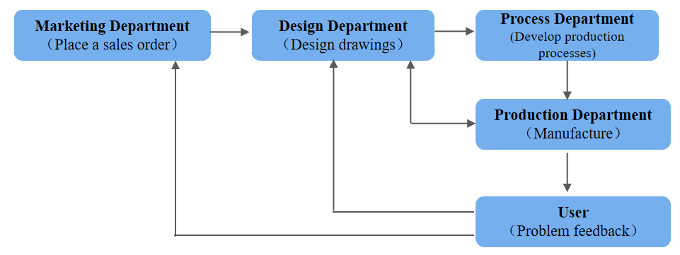

Figure3.1 The initial stage of equipment development

As can be seen from the above chart:
- After the Marketing Department issues the order, the design department carries out product design.
- The process department prepares the manufacturing process according to the drawings.
- The production department will produce according to the process, and ship the product to the user after the production is completed.
The above process is basically normal. However, if the product has a problem in the production process, the production department will either directly feed the information to the design department, communicate with the design department directly, or feed it back to the process department, without a clear feedback line, which is easy to cause confusion.
- If the product has problems with the user, the user will either feedback the information to the design department or the Marketing Department, without a clear feedback line, which is easy to cause confusion.
II. After some experience in product development. As shown in Figure 3.2 below:
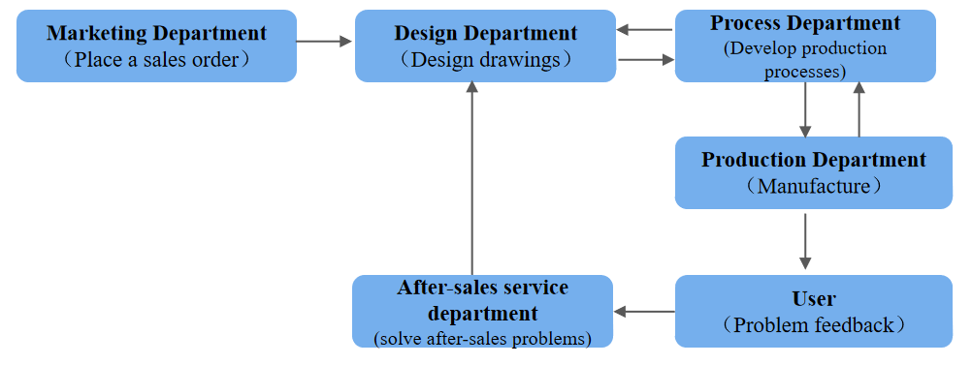

Figure3.2 New departments were added in the course of the project
As can be seen from the above chart:
- The company prohibits the production department to directly reflect the problem to the design department, but through the process department feedback to avoid confusion in the process.
- The company has set up a special after-sales service department to docking users and good after-sales service work.
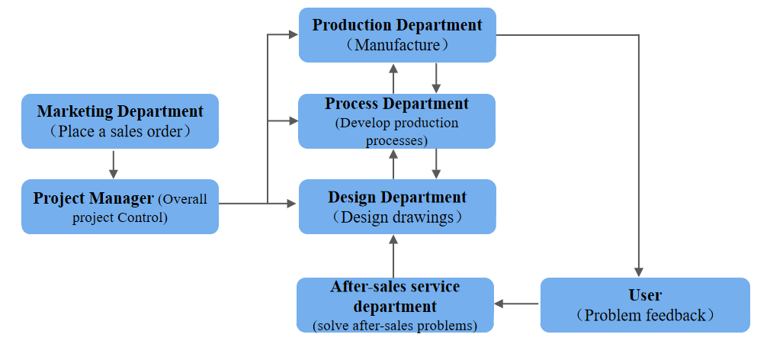
III. Further optimize the product development process.
As shown in Figure 3.3 below:

Figure3.3 Further optimize the product development process
As can be seen from the above chart:
- Project managers are added to the operation of the project, through which the project managers control the overall progress of the design, process and production departments to ensure that the project products are carried out under the supervision of the whole process.
- The design works in parallel with the process department to improve efficiency and shorten the production cycle.
IV. Add comparative functions in the product after-sales process, as shown in Figure 3.4 below.
As can be seen from Figure 3.4:
The project manager sets up a project office to compare the problems reflected by users provided by the after-sales service department, or compare with other products of the company, or compare with other products of other companies, and provide the results to the design department. Improve the technical performance and competitiveness of products by increasing the project office.

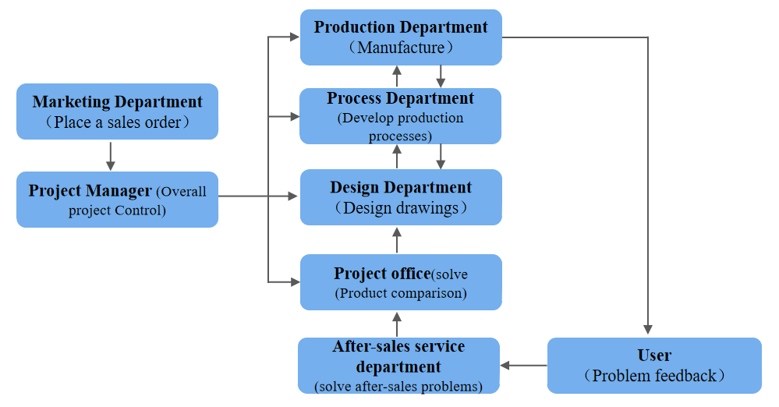

Figure3.4 Add comparative functions
in the product after-sales process
V. According to the comparison results, the design department will optimize and improve the products.
Establish a company project management maturity model based on PMMM, as shown in Figure 3.5 below.
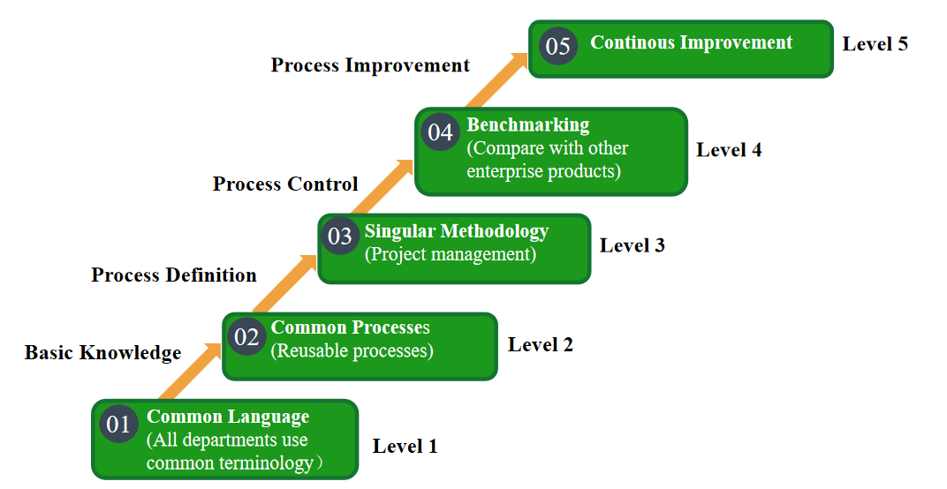

Figure 3.5 Project Management Maturity model based on PMMM [38]
According to the above and PMMM model, we can see that:
At Level1, each department is self-centered and the product line is slightly chaotic.
At Level2, new departments are added and product lines are adjusted. This product line is relatively complete and is used for multiple sets.
At Level3, the project responsibility system for the product has improved the work efficiency and shortened the production cycle.
At Level4, improve the performance and competitiveness of our own products by comparing them with other companies' products.
At Level5, product inadequacies were identified and improved. The project product development completes a virtuous cycle, and the project management level is continuously enhanced.
Through the above analysis, we can see that through the accumulation of experience step by step, the company has continuously improved the development process of project products, and the management level of project product development has gradually increased, and has basically reached the 4-5 level.
3. Analysis of ERP management system of Beijing Coal Machinery Company.
The ERP system integrates and manages the business flow, capital flow and information flow of the enterprise, including production plan, sales execution plan, material requirement plan, procurement plan,financial budget and human resources, as shown in Figure 3.6 below.
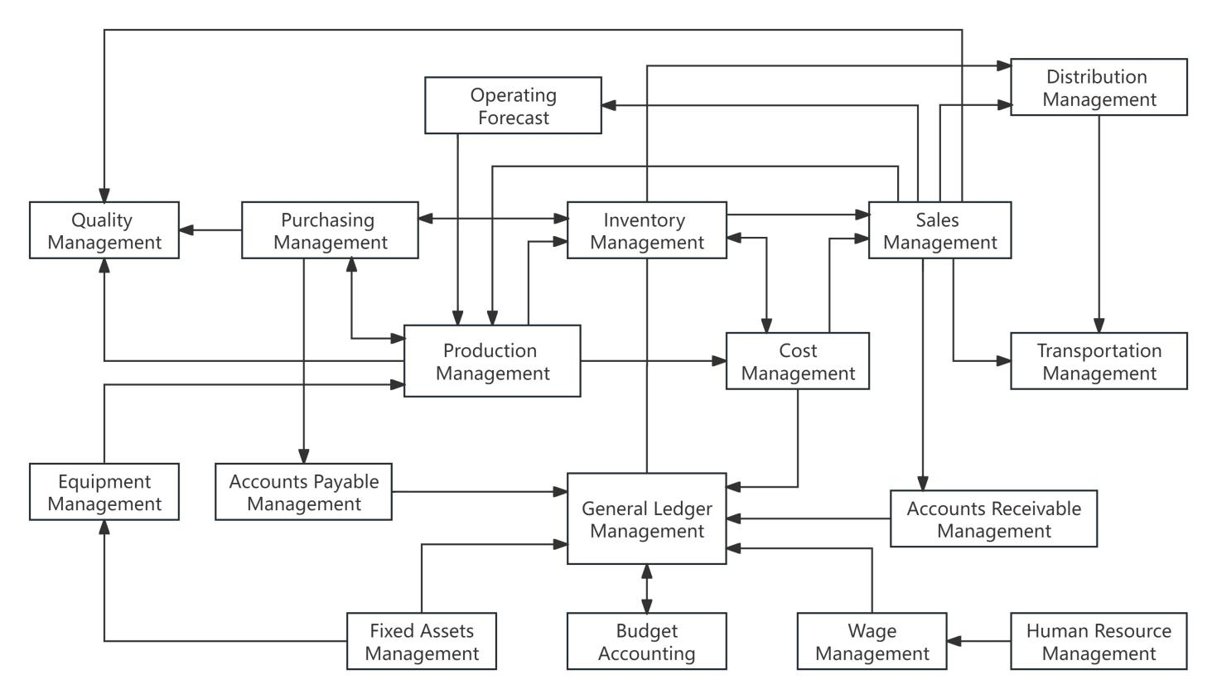

Figure 3.6 The overall process of ERP system
• The company adopts the "Jiandao cloud" system, and the system homepage is shown in Figure 3.7 below.
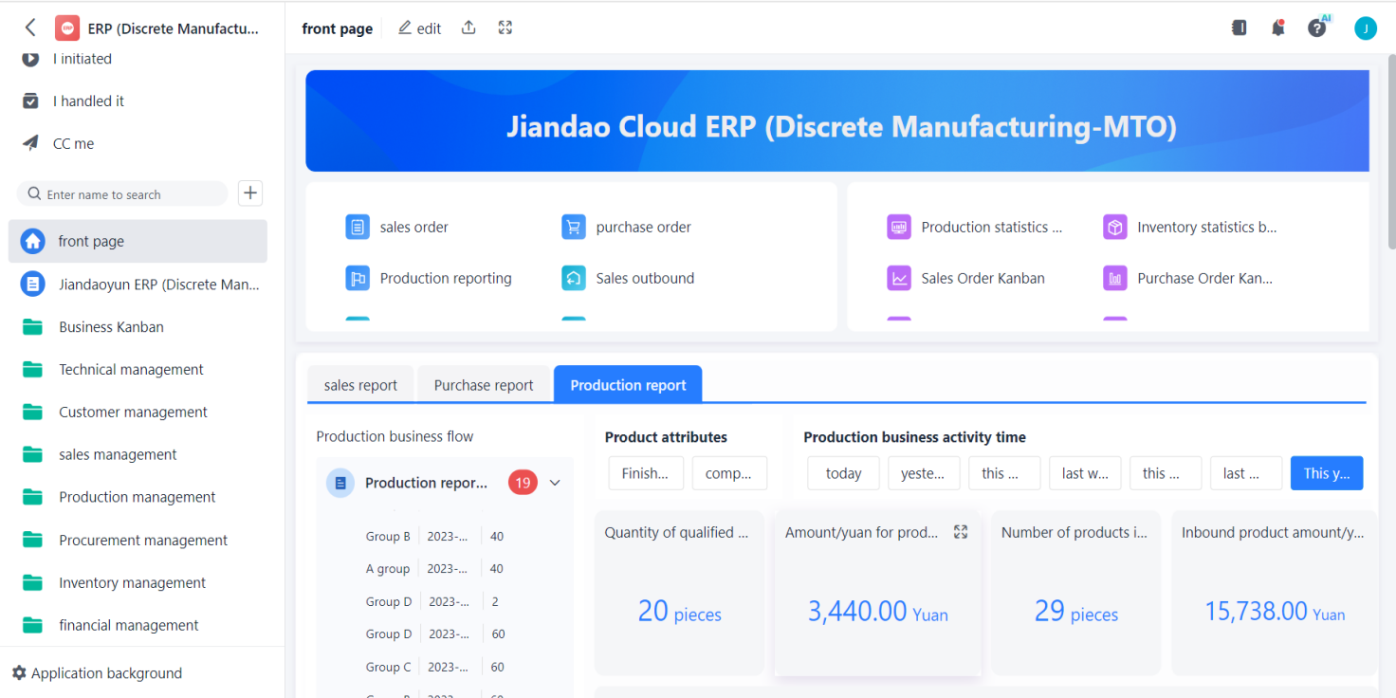

Figure 3.7 System home page
The project home page integrates several modules of the system's technical management, customer management, sales management, production management, procurement management, inventory management, financial management, human resources management, as well as the relevant business and progress of registered personnel. You can view reports for different modules of the project to understand the progress information of the product.
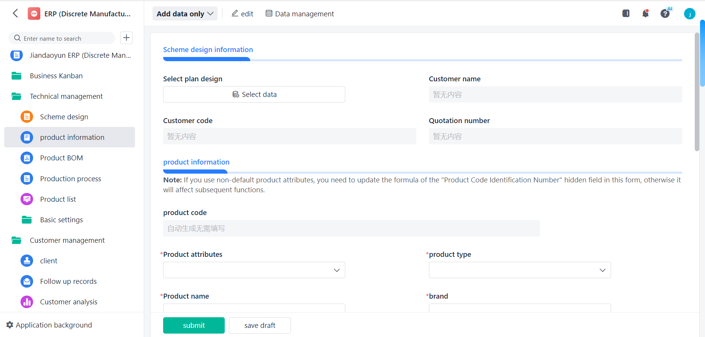
• Technical management module, as shown in Figure 3.8 below.

Figure 3.8 System technical management module
The technical management module is mainly used to publish the product's technical attributes, technical drawings, technical requirements, product specifications and other information. The process department shall formulate the processing route and technology of the product according to the drawings. The production department checks the progress of the technical plan or design drawings, makes the project plan and prepares the raw materials in time. Product specifications are the most important source of technical information, and the production department organizes the production of specific parts according to the specifications of the product drawings.
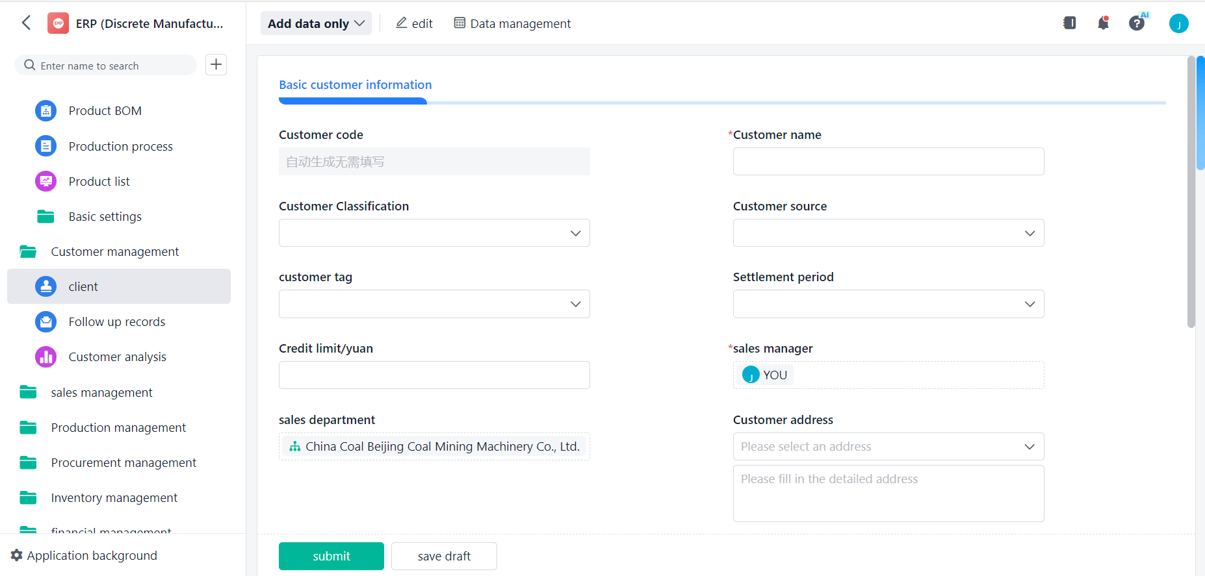

Figure 3.9 Customer management module
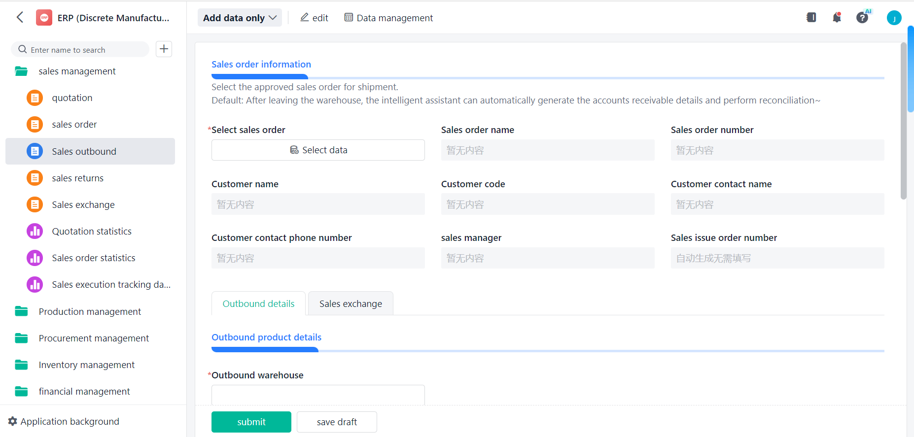
Customer relationship management is used for each department to grasp the user information of a certain product. It can create a customer profile for each customer and manage it by category. Such as: user name, address, sales person and other information. In the current customer-centric information age, the focus of attention of enterprises has gradually changed from the past product orientation to customer orientation, only fully grasp customer information, in order to timely grasp the product dynamics, improve customer satisfaction.

Figure 3.10 Sales management module
Sales order management at the starting point of ERP project management, as the
starting point of the production process, all production plans are formulated and scheduled according to sales orders. Including customer name, customer level, product contract code, product purchase order, manufacturing number, product quantity, delivery date and other information. There is also information about the loss and damage of parts of the equipment at the work site, as well as the delivery and replenishment of goods. At the same time, statistics and analysis of sales orders, including the completion of sales tasks, comparison of the same period, order distribution, etc .
• Production management module, as shown in Figure 3.11 below.
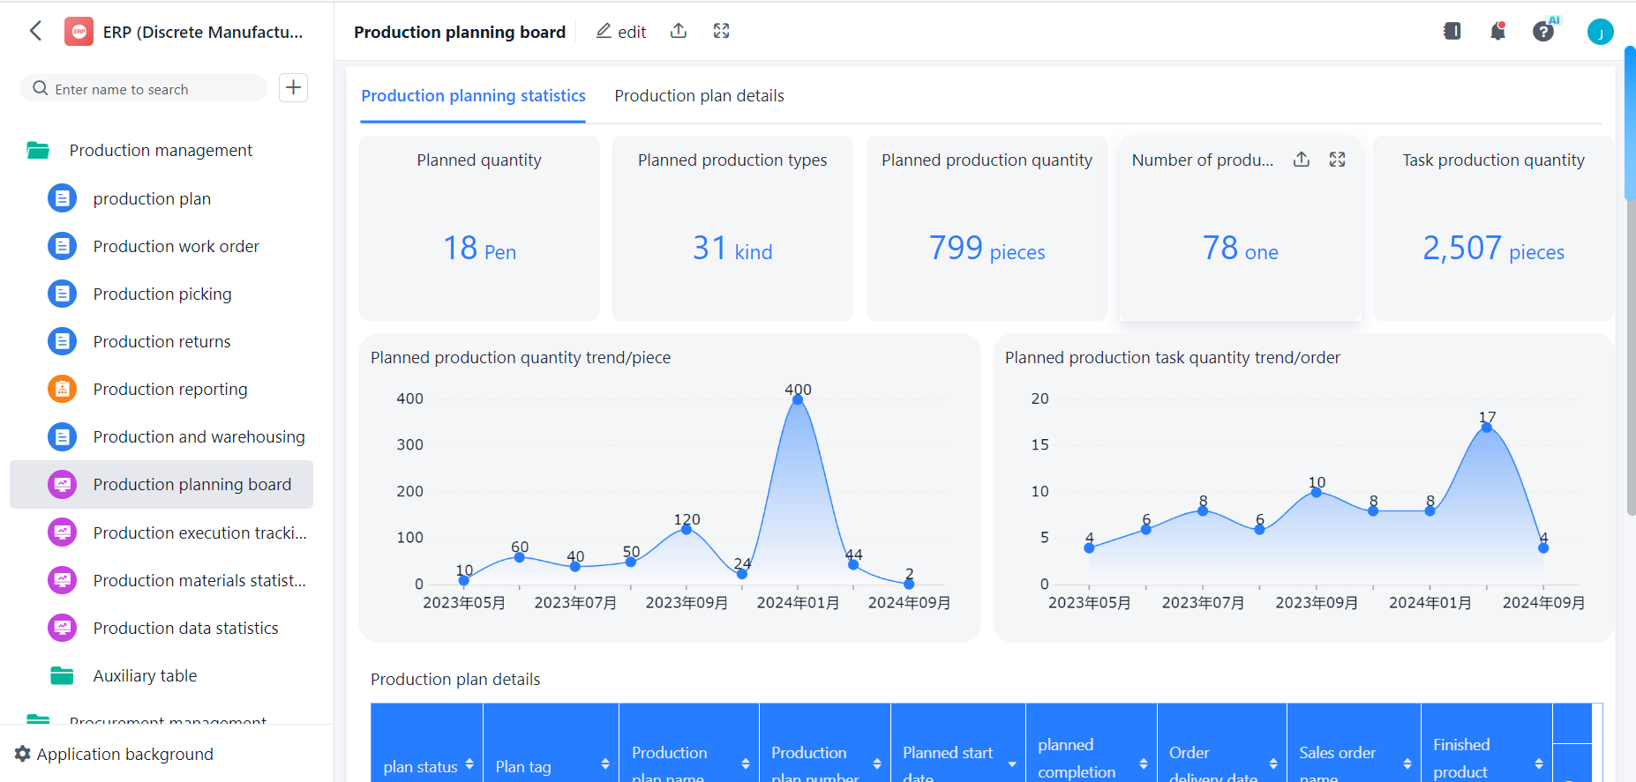

Figure 3.11 Production management module
Production management begins with the entry of customer orders, and plans the types and quantities of products required to be produced in future cycles according to the order entry and production plan. This process first transforms the production plan into a specific product plan, and further refines the detailed schedule down to time and quantity, taking full account of the balance between material requirements and production capacity.
After determining the production quantity of the final product, the production management also needs to determine the specific quantity of processing and procurement based on the bill of materials and compared with the current inventory status. Production management also needs to pay close attention to the production progress of the workshop, allocate production tasks to each workshop reasonably, and sort, manage and monitor the work, so as to form a dynamic work plan that changes with time [40, p.310].
• Procurement management module, as shown in Figure 3.12 below.
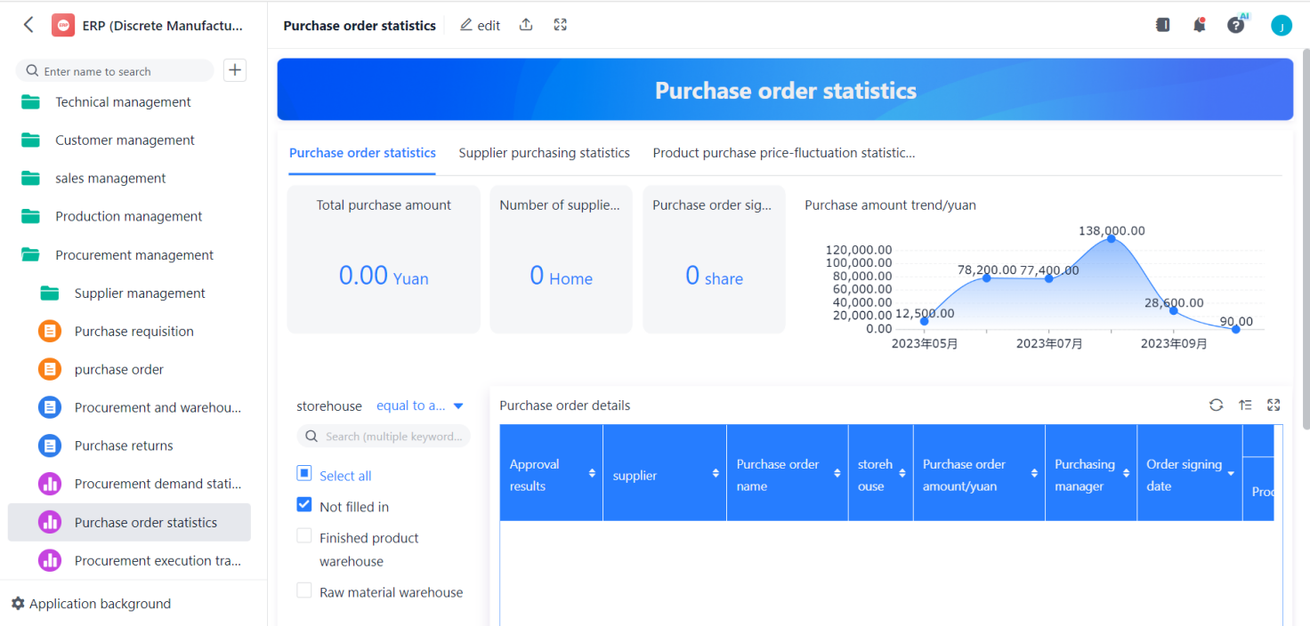

Figure 3.12 Procurement management module
For CBMJ, the purpose of purchasing management is to select quality suppliers based on product order contracts and product purchase schedules, and to ensure the maintenance of optimal safety stock levels. Its core function can provide real-time ordering and acceptance information, effectively track and urge external procurement or commissioned processing of materials, to ensure the delivery of goods on time. Purchasing Management is also responsible for establishing and maintaining supplier files and adjusting inventory costs based on the latest cost information [40, p.311].
The functions of procurement management cover the following aspects:
- Supplier information inquiry: Conduct a comprehensive review of the supplier's ability, reputation and other aspects.
- Prompt management: continuous tracking of materials purchased or commissioned for processing, and prompt timely delivery.
- Procurement and outsourcing processing statistics: statistical procurement and outsourcing processing data of each set of products, establishment of procurement and outsourcing processing files, and cost accounting.
- Price analysis: analyze the market price of raw materials and adjust the inventory cost accordingly.
• Financial management module, as shown in Figure 3.13 below.
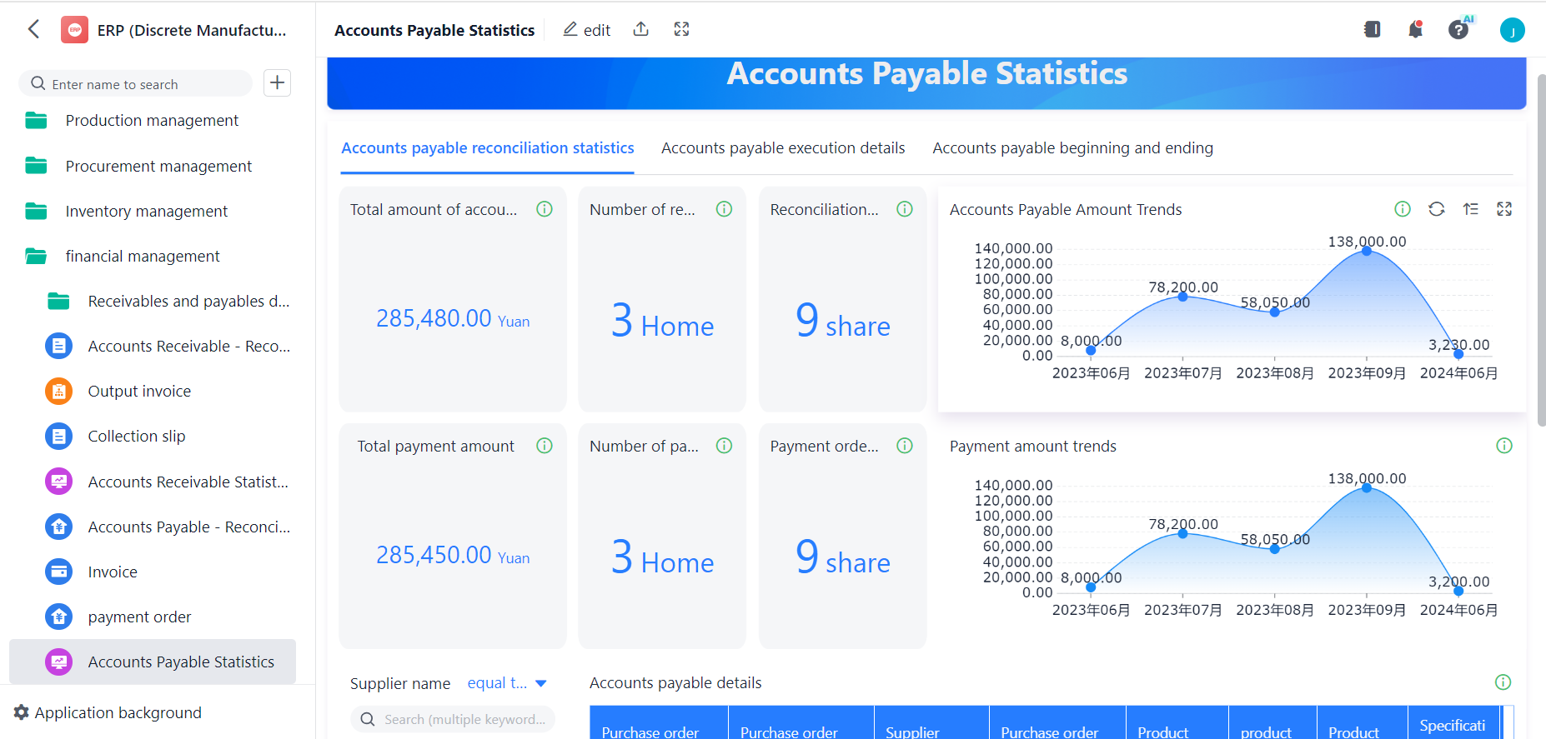

Figure 3.13 Financial management module
Financial management module in ERP software is usually subdivided into accounting and financial management two sub-modules. The accounting sub-module is mainly responsible for comprehensive recording, accurate accounting, real-time reflection and in-depth analysis of the flow process and final results of funds in various business activities of enterprises.
The financial management sub-module mainly relies on the data provided by the accounting sub-module for in-depth analysis, and based on this, a series of forecasting, management and control activities are carried out. This sub-module contains three core functions: financial analysis, financial planning and financial decision-making. Financial analysis aims at financial performance evaluation and account analysis. The financial plan is based on the results of the previous financial analysis, to develop the next phase of the financial plan, financial budget. Financial decision making focuses on money decisions and day-to-day money management [19,p.218].

3.2 Enterprise international market strategy management case.
1. Background introduction.
With the increasing opening of China's foreign market, Chinese coal machinery enterprises have ushered in greater development opportunities. Entering the international market and participating in international competition as soon as possible has become the strategic development direction of many enterprises. Especially in the face of increasingly fierce competition in the domestic market, coal machinery enterprises are constantly seeking new market opportunities and striving for an advantage in international competition.
The international market of Beijing Coal Machinery Company is responsible for its Overseas Development Company, which is a subsidiary of Beijing Coal Machinery Company, specializing in international market development, product sales and after-sales service. Overseas Development Company undertakes international business through cooperation with foreign agents.
On March 1, 2022, Beijing Coal Machinery Company received the bidding invitation from the Australian agent LP Company from the user ANGLO Company, and the bidding project was a set of hydraulic support with model ZY17500.
ANGLO is a famous mining company in Australia and has very strict requirements on its products. This is the first time for Beijing Coal Machinery Company to contact ANGLO's project, the number of project products is as high as 353, and the project amount is huge. Therefore, Beijing Coal Machinery Company attaches great importance to this project and sets up a special project team. At this point, the ZY17500 hydraulic support project of ANGLO Company in Australia was officially launched.
2. Project strategy analysis.
I. Analyze the way in which company choose to enter foreign markets.
As a subsidiary of CBMJ's foreign projects, the Overseas Development Company, formerly known as the International Trade Department of CBMJ, has many years of experience in overseas project operation. In the Australian market, Overseas Development Company has been cooperating with LP Company and have successfully operated a number of Australian projects.
Operation mode: Beijing Coal Machinery Company exports products to Australia and signs business contracts with LP Company. LP Company signed a business contract with the Australian user, and agreed in the contract that the product supplier is China Coal Beijing Coal Mining Machinery Co., LTD.
The performance of the Australian project of cooperation between CBMJ and LP Company is shown in Table 3.1 and Figure 3.14 below.
Table 3.1
Statistical table of the performance of the Australian project of
cooperation between CBMJ and LP Company
Year | Product number | Product quantity (Unit: shelf)
2011 | Y165 | 40
2013 | Y204 | 60
2016 | Y253 | 40
2019 | Y298 | 60
2020 | Y315 | 92
2021 | Y355 | 80
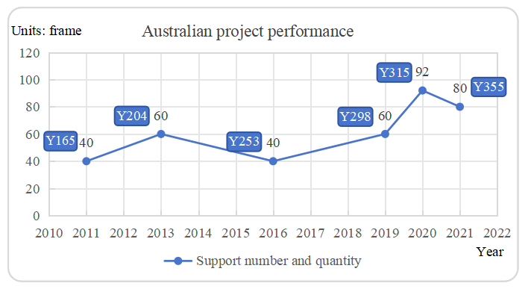

Figure 3.14 Performance statistics of the Australian project of
cooperation between CBMJ and LP Company
Combined with the successful cooperation experience in the past, this project still adopts the same cooperation method as before. This is the Beijing Coal Machinery Company mature export mode of products.
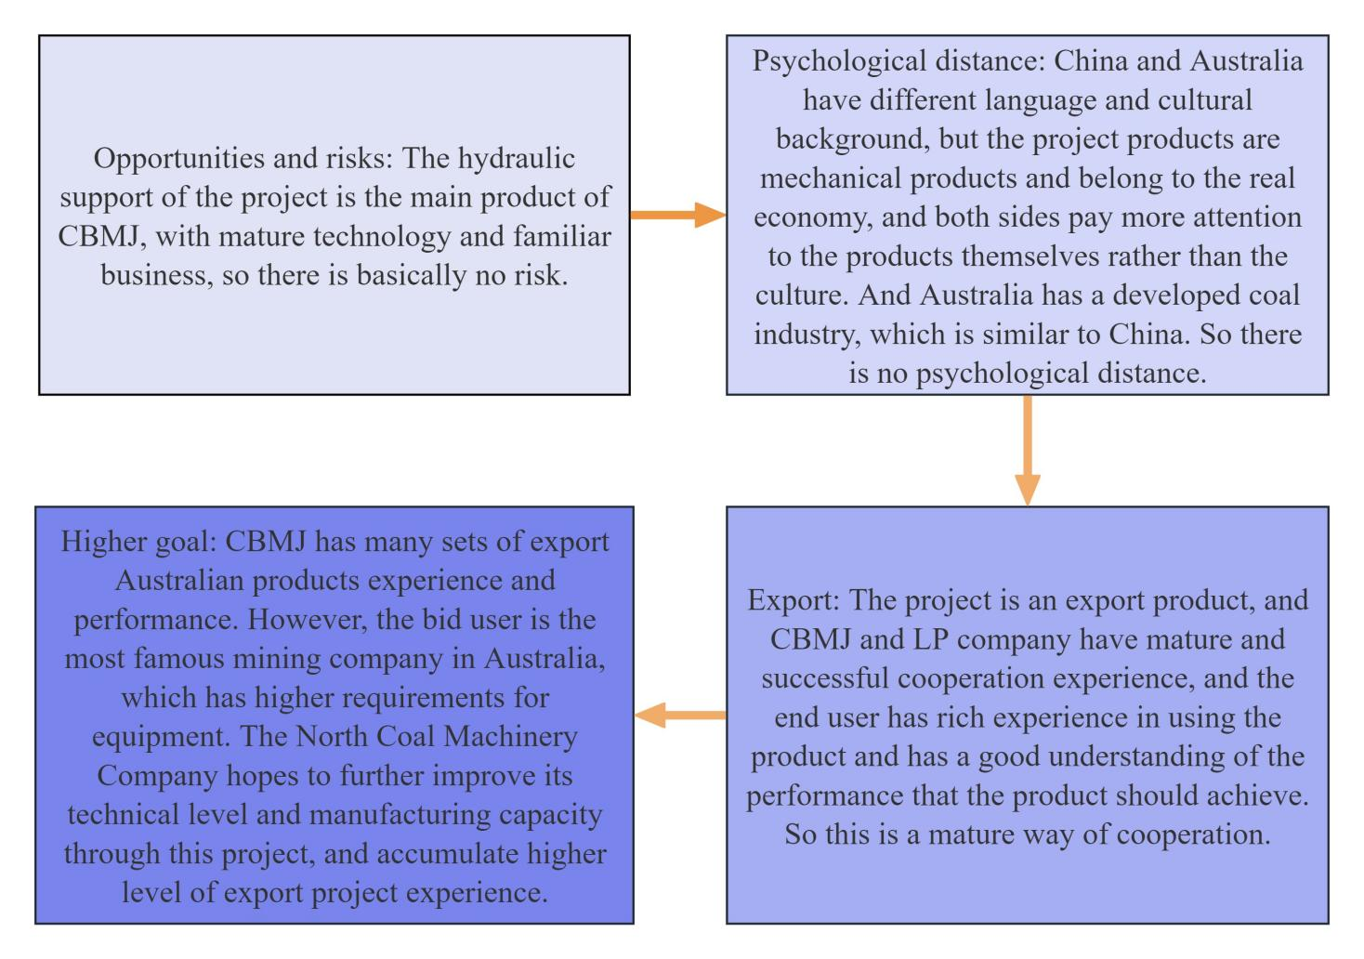
II. Establish UPPSALA model to analyze the degree of internationalization (project management) of CBMJ, as shown in Figure 3.15 below [39].

Figure. 3.15 UPPSALA model of internationalization
(project management) of CBMJ
Through the above analysis, from the perspective of project management, the Beijing Coal Machinery Company is in the fourth stage of the model, the degree of internationalization is relatively mature.
III. Analyze the feasibility of project implementation from its own perspective.
Although Beijing Coal Machinery Company has many successful experiences in providing products to Australian users, neither product specifications nor quantity can be compared with this project. Moreover, the project delivery time is tight, and the user has strict requirements on product technical parameters and manufacturing standards. Beijing Coal Machinery Company must consider the feasibility of undertaking the project independently (or jointly bidding with other companies), or risk losing the Australian market.
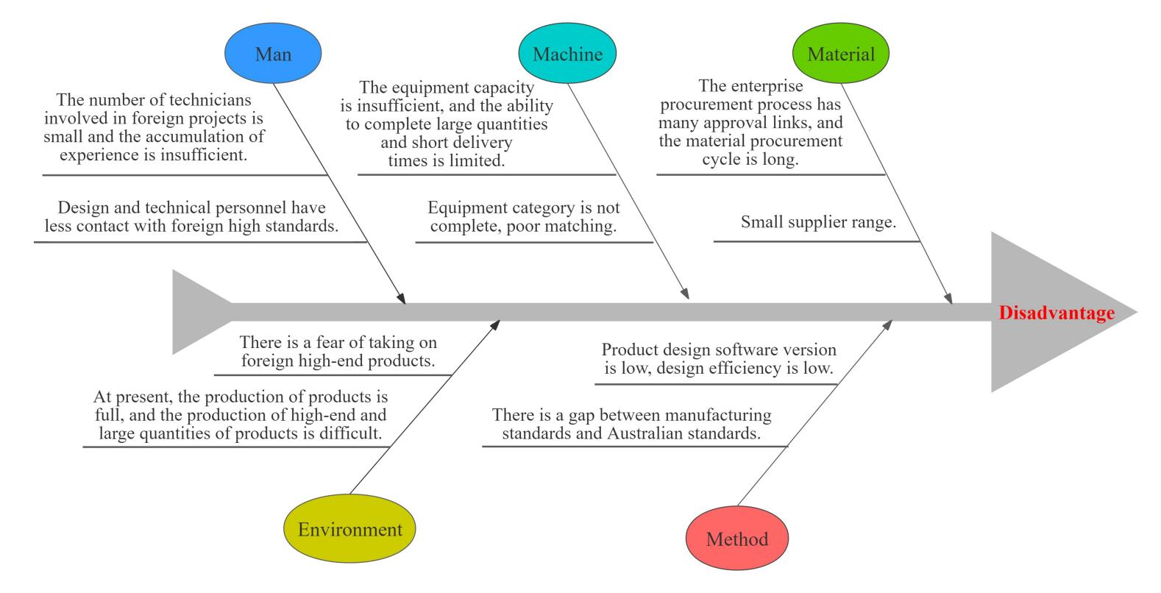
The method of brainstorming was used to establish the fishbone diagram, analyze the disadvantages of the company currently undertaking this project, and find out its own shortcomings in order to find solutions. See Figure 3.16 below.

Figure 3.16 Project undertaking fishbone diagram
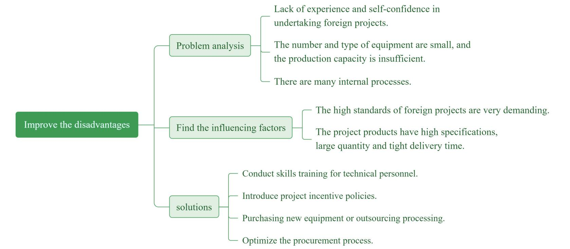
Create a mind map for the above problems and find a solution to the problem, as shown in Figure 3.17 below:

Figure 3.17 Mind map for problem solving
Through the above analysis, we believe that the company has the ability to overcome various difficulties and can undertake this project independently.
3. Formulate the project strategy outline.
I. Objectives of strategy implementation.
Through the effective implementation of the project, the company won orders, provided users with high-performance and high-quality products, and further consolidated the share of the Beijing Coal Machinery Company in the Australian market. At the same time, we will further enhance our technical level and manufacturing capacity to ensure that more products of the company can be in line with the international market, meet the needs of global customers, enhance the competitiveness of the company in the international market, and bring the company broader space for development and more business opportunities.
II. Environmental risk analysis for strategy implementation.
In order to ensure the smooth implementation of the project, the PESTEL method is used to assess the political, economic, social, technical, environmental and legal aspects of the project, and to analyze the possible risks of the project [20].
PESTEL analysis model is a tool to analyze the macro environment of a project, also known as the macro environment analysis. It helps us dissect all the forces in the external environment that impact the organization. The model is designed to delve into the external influences that organizations face, with each letter in its name representing a specific analytical element.
• Political factors.
- Australia is politically and socially stable, pursues an open trade policy and has a good business environment.
- Australia has no import and export restrictions on products and a stable tax policy.China-Australia relations harmony, no political conflict, the two sides in trade, education, science, technology and tourism, and other fields has a broad and deep communication.
The annual import and export statistics of China and Australia from 2016 to 2023 are shown in Figure 3.18 below.

Figure 3.18 Total annual imports and exports of China and Australia
from 2016 to 2023 (Source: compiled by the author based on [1])
• Economic factors
- The Australian economy continues to grow, with services, mining and agriculture being the main pillars.
- Stable monetary policy and interest rates.
- The unemployment rate is low, and the social consumption capacity is strong, promoting domestic demand.
The total GDP of Australia from 2016 to 2023 and its changes are shown in Figure 3.19 below.

Figure 3.19 Total GDP and changes of Australia from 2016 to 2023
(Source: compiled by the author based on [4])
• Social factors.
- Australia has a multicultural society and immigration adds diversity to the Labour market.
- A high level of education and a high level of education system provides a good skill base for the workforce.
• Technical factors.
- Australia excels in scientific research and technological innovation, particularly in biotechnology and information technology.
- The high level of enterprise informatization, the wide promotion and application of digital technology, improve production efficiency and customer experience.
• Environmental factors.
- Australia is surrounded by the sea, most of the area is hot and dry, low rainfall, the climate is warm and suitable.
- Australia pays attention to natural ecological protection, has rich mineral resources, and is an important exporter of iron ore and coal in the world.
• Legal factors.
- Australia has a comprehensive anti-trust law and intellectual property protection law, which together promote a fair competition and innovation environment in the market. Both play an important role in maintaining social and economic order and promoting technological progress.
Through the above analysis, the project products are safe to export to Australia from the political, economic, social, technical, environmental and legal aspects, and the risk is low. In addition, Overseas Development Company of CBMJ has many years of development experience in Australia, and has many years of cooperation with LP company, and has certain ability to resist emergencies. Therefore, through PESTEL analysis of this project, it is believed that the project implementation environment is good and the risk is controllable..

III. Strategic resources.
As a national technology center and one of the top 500 enterprises in China's machinery industry, the company has a deep hydraulic support design heritage and manufacturing capabilities, which can ensure the smooth implementation of the project.
• Advanced design theory and means.
- Use the mechanism optimization design software to analyze and determine the kinematic geometric parameters and mechanical properties.
- 3D design simulation verification.
- Finite element mechanical analysis simulation verification.
• Processing technology support.
The company has ISO3834-2 system qualification certificate and steel structure products European standard EN1090-2 EXC3 certification, as well as the formation of new key technology in recent years - φ480mm and above large diameter cylinder processing technology, 800MPa and above strength steel welding technology guarantee.
• Manufacturing equipment support.
- Steel plate CNC cutting, structural parts manufacturing equipment.
- Hydraulic cylinder processing, surface treatment equipment.
- Hydraulic valve processing equipment.
- The company has complete testing and testing means for the whole frame (45000KN test bench), structural parts, hydraulic cylinders and valves, and the laboratory has CNAS qualification.
IV. Content and timetable of strategy implementation.
According to the requirements of ANGLO's users, the bidding deadline is April 5, 2022, and the product delivery date is March 10, 2023. All bidders must provide the entire completion plan of the product during the bidding stage.
To this end, the project strategy implementation schedule and Gantt chart are formulated, as shown in Table 3.2 and Figure 3.20 below.

Table3.2
Project product strategy implementation schedule
Task stage | Start time | End time | Days used | Instructions
Project bidding | 01 March 2022 | 05 April 2022 | 36 | According to the requirements of the user's bidding documents, complete the support technical scheme and the preparation of bidding documents.
Product design | 06 April 2022 | 10 May  2022 | 35 | Complete product design and issue prototype design drawings.
Prototype technology | 11 May  2022 | 16 May  2022 | 6 | Formulate the processing technology of product prototype.
Prototype production | 17 May  2022 | 30 June  2022 | 45 | Complete prototype production, and invite users to accept.
Mass production | 01 July  2022 | 30 December 2022 | 180 | Production and acceptance of batch products.
despatch | 01 January 2023 | 10 March 2023 | 70 | The batch products by sea to mine.

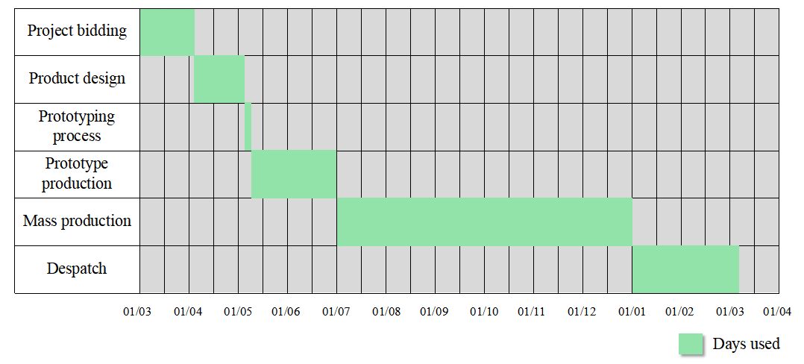

Figure 3.20 Gantt chart

4. Strategy implementation process.
I. Establishment of the project team: The director of the manufacturing department shall be the project manager, and key members shall be selected from various business departments to form the project team. The organizational structure chart is shown in Figure 3.21 below.
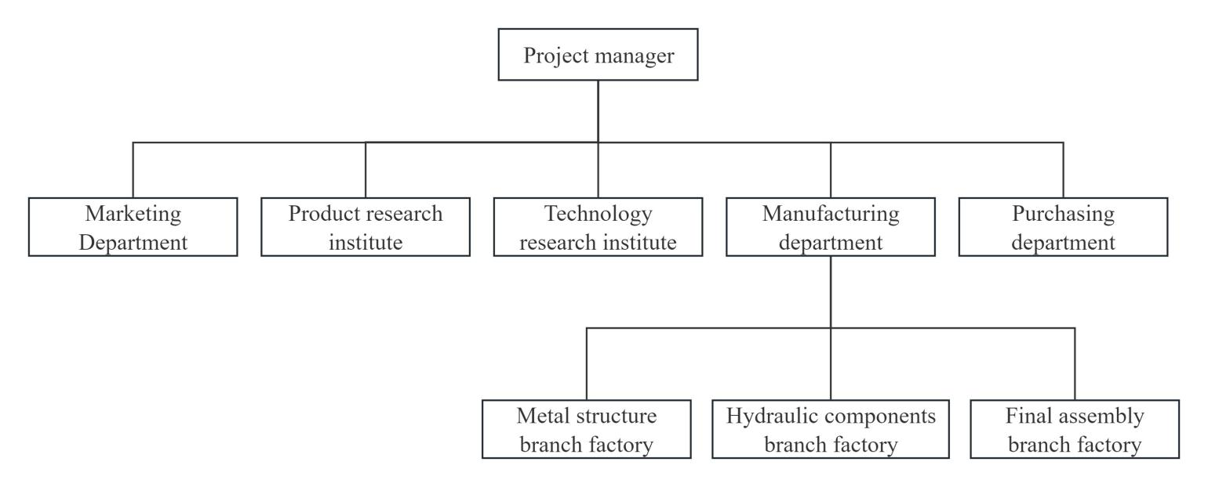

Figure 3.21 Organization chart of the project team
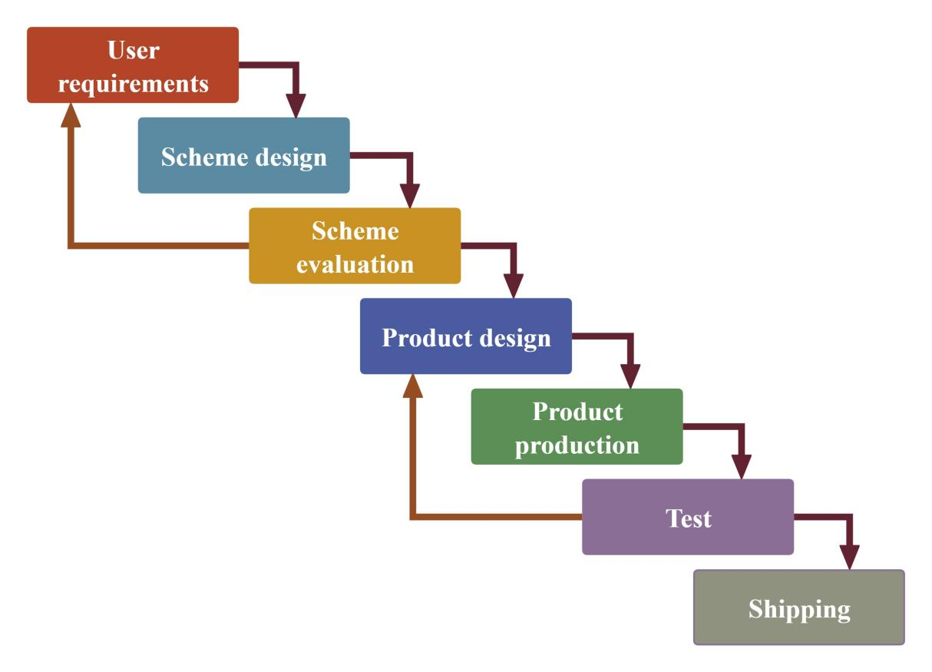
II. Based on the waterfall model, develop the PLC model of project product implementation, as shown in Figure 3.22 below.

Figure 3.22 Project PLC model
III. Strategic actions.
• Bidding stage.
The Product Research Institute and Marketing Department dispatched key personnel to design the technical scheme of hydraulic support and provide business quotations according to the requirements of ANGLO's bidding documents. After the technical plan is submitted, the user puts forward the modification suggestion, and the designer optimizes the plan again. After several rounds of modification, optimization and quotation, the last submission was made on March 30. In the end, CBMJ defeated the powerful JOY and CATERPILLAR from Europe and America and another coal machine manufacturer from China to win the recognition of users and successfully win the order.
• Product design stage.
The Product Research Institute will design the product scheme according to the user's requirements (bidding requirements). After the scheme design is completed, the scheme will be reviewed by internal and external experts invited by the company, and the final scheme will be reported to the user. With the consent of the user, the product enters the specific design stage, the Product Research Institute does the specific design of the support and issues the design drawings, and the Technology Research Institute does the product process.
• Production, testing stages.
The Manufacturing Department organizes each manufacturing branch factory to produce the prototype according to the drawings. The prototype will be tested after the production is completed. The test is mainly to check whether the technical parameters and structural strength of the product meet the requirements of users and standards. After passing the test, the production of batch products will begin. In the process of product manufacturing, the project manager is responsible for coordinating the daily work of the manufacturing department, Purchasing Department and other departments.
• Transport phase
After the batch products are accepted by the user, they are sent to the mine by sea.
IV. Strategic supervision.
To ensure product quality and effective implementation of the project. The project team also applied to the company and asked the quality department of the company to set up a Supervision Group to control the process quality of the project products.
V. Incentive policy.
Taking into account the importance of the project and the difficulty of design and manufacturing, the project team formulated feasible incentive policies to improve the enthusiasm and responsibility of project members.
VI. Strategic assessment.
In the process of product design and manufacturing, the project team has set work objectives at each key node to ensure the smooth realization of the final goal of the project.
5. Strategic results.
The results of the implementation of this strategy are reflected in two aspects:
I. Economic benefits.
The final contract amount of this project is 97.307 million yuan, the investment amount (total cost) is 81.08 million yuan.
The profit achieved by the project is 97.307-8108= 16.227 million yuan.
Profit index PI=97.307/81.08=1.2
II. Social benefits.
- In the bidding stage, the company stood out from many domestic and foreign competitors through excellent technical solutions, and won the order, reflecting the deep technical strength of the company.
- In the production stage, all departments carry out the design, processing and manufacturing in strict accordance with the time nodes and stage objectives formulated by the project team, and do a good job in quality control and supervision to ensure the timely delivery and shipment of products, which has won the satisfaction and trust of users, which reflects the excellent organizational ability and production capacity of CBMJ.
- The implementation of the project has improved the design, manufacturing level and quality control ability of CBMJ, improved the visibility of CBMJ in the international market, especially in the Australian market, and enhanced the competitiveness of the company in the international market. It also successfully achieved the objectives of the implementation of the strategy.
To sum up, the results of this strategy are successful.

3.3. Main challenges and obstacles in the implementation of information and analytical support in management.
In today's Internet and information age, the business competition environment is more intense. Effective information and analytical support are key to business success. Through timely and accurate information collection and scientific data analysis, enterprises can better grasp their own situation, better understand consumer needs, improve product quality and innovation ability, and improve service level.
Over the years, Beijing Coal Machinery Company attaches great importance to the informatization and digital construction of enterprises, and has made a lot of reforms and achieved certain results. However, as a traditional enterprise with many years of history, there are still many problems to be solved and many challenges to realize the full implementation of information and analysis support technology and the realization of large-scale digital transformation of enterprises.
1. Problems and obstacles faced by enterprise management in the information age.
• Insufficient attention to the development of enterprise informatization.
In the information age, enterprises are facing new challenges and higher requirements in management. Enterprises need to continuously improve their information management level, in order to improve the competitiveness of enterprises. However, some enterprise leaders and department heads in the company still adhere to the traditional management model, slow to accept new things, lack sufficient attention to enterprise information management and other emerging things, and sometimes even conflict, resulting in low efficiency of enterprise management and slow development of informatization process.
• Confusion in organization and management.
The information age requires that the management mode of enterprises must be more modern. However, it is difficult to change the inherent thinking mode formed in the Beijing Coal Machinery Company for a long time. The lack of effective communication mechanism among various departments in the company, the evasion of work, and the lack of scientific and effective system and process support naturally lead to the failure to achieve efficient information management.
• The level of information management technology is backward.
Driven by the rapid development of information technology, although the Beijing Coal Machinery Company has begun to promote the enterprise information management, it still faces the challenge of backward information management technology and low-end tools. The main reason is the shortage of information talents in the enterprise, they are not only limited in information professional knowledge and computer technology ability, but also lack sensitivity to the changing modern technology, difficult to master the new skills in the information age, unable to timely discover or update the information management tools applicable to enterprise product and market management, affecting the effectiveness of enterprise information management.
2. Challenges faced by information and analytical support in enterprise management.
• Reform of traditional management system.
Beijing Coal Machinery Company started late in information management, its human resource foundation and information management means are relatively weak. Because it has not fully demonstrated strong technical advantages, it has not been able to make a strong impact on the traditional and outdated management system. This situation makes it difficult for the senior managers of enterprises to make up their minds to carry out a comprehensive reform of the current management system, which affects the development of enterprise management informatization.
• Business process change.
The application of information and digital technology not only requires enterprises to achieve deep technical innovation, but also requires a fundamental change in business operation mode. In order to give full play to the maximum utility of information system, enterprises must carry out a comprehensive transformation of the original business process. In this process, employees need to accept the changes in functions and responsibilities brought about by new business processes, learn to perform new tasks in a new system environment, and understand how their input affects other departments. These new learning requirements and the corresponding organizational changes should be factored into the cost of ERP implementation.
• Big data management and application.
Modern information technology relies on data collection, processing and analysis to provide decision support. With the rapid advancement of big data technology, more opportunities are coming to this field. At present, the Beijing Coal Machinery Company is using Internet technology to realize real-time acquisition and processing of enterprise data, thus improving the accuracy and efficiency of data analysis and decision making. However, it is important to note that most organizations have diverse data sources that include not only internal systems, but also user information, external vendor data, and social media. Therefore, ensuring the correct and efficient collection and storage of data, the timely and accurate analysis of data, and the integration of these data to obtain comprehensive and in-depth analysis and insight are critical to improving the quality of management decisions.
• Data privacy and security.
With the continuous advancement of information technology, the collection and storage of personal and corporate data is becoming more and more popular, and many individuals and organizations are working on this to improve their management effectiveness or meet other needs. However, this trend is accompanied by a number of challenges, including frequent data breaches, illegal access to others' data, and illegal resale of data, which pose serious risks to data privacy and security. Therefore, managers must ensure that the information they process strictly complies with relevant laws and regulations, and take effective measures to ensure the security of customer and company data.
• Technological change.
The rapid development of information technology drives the iterative upgrading of information and analysis support tools. In the face of this trend, enterprises need to maintain a high level of attention to the development of global information technology, continue to learn emerging technologies, and improve the professional skills of the team. Modern consumers' demand for personalized and instant service experience is increasing day by day. Managers should timely update information and analysis support tools, make good use of information and analysis support tools, deeply understand customer needs, constantly introduce personalized services, and optimize customer experience, so as to ensure that enterprises maintain a leading position in the highly competitive market.

CONCLUSIONS

The conducted research allows us to draw the following conclusions and suggestions:
The rapid development of modern information technology such as computer technology, communication network technology and multimedia technology has led human society from the industrial age to the information age. In recent decades, the transformation of traditional industries and the development and utilization of information resources by information technology have received increasing attention. The deepening of information construction in China and the rapid popularization of mobile Internet have spawned a steady stream of data from all walks of life and even around us. The digital economy is gradually growing, and the information society is gradually moving toward digitalization and intelligence. As an advanced stage of information technology, digitalization and intelligence have brought a new round of paradigm change to all industries. A variety of innovative business models and emerging technologies emerge in endlessly, profoundly affecting the development of all walks of life and enterprises. In order to survive and develop, enterprises must keep up with the pace of The Times, constantly strengthen information and digital construction, and accelerate their own digital transformation in order to keep up with the pace of the times.
The digital transformation of enterprises needs the support of information technology. Modern information technology, its core lies in computer technology, and integrates communication technology, information processing technology and control technology and other fields. These technologies have gradually promoted the digital process of enterprise production processes, material flow, transaction processing, capital operation and customer interaction. Information technology promotes the profound change of enterprise management, optimizing the four management functions of enterprise planning, organization, leadership and control. It makes the management system of the enterprise more scientific and systematic, and the management method can be continuously improved. At the same time, information technology has also improved the management level and comprehensive quality of managers, and injected a strong impetus for the digital transformation of enterprises.
The production and operation activities of enterprises and the progress of any industry will inevitably produce massive data. In order to make the most of this data, enterprises must grasp the new technologies brought by the digital age, such as cloud computing, data mining, machine learning, Internet of Things, etc., and truly master the application of these technologies. Only in this way can the value of big data be fully explored, thus bringing substantial changes to enterprises in terms of business model innovation, product iteration, user experience improvement, and organizational management optimization.
Management information and analysis support technology supports the construction and development of enterprise informatization and digitalization. Enterprises should be deeply aware of the key role of information construction, and continue to strengthen their own information ability, information deeply integrated into all levels of enterprises, including production process, circulation links, management decision-making and organizational structure. Based on the actual situation of the enterprise, gradually develop various management information systems suitable for its own management, production and operation and business development, such as customer management system, enterprise resource planning and supply chain management system. Through the application of these systems, enterprises can achieve a comprehensive reengineering of business processes, and thus improve competitiveness and operational efficiency.
This paper introduces the current situation of digital transformation development and digital technology implementation in Chinese enterprises, as well as the application of information technology in China Coal Beijing Coal Mining Machinery Co., LTD.
In terms of big data, the relevant departments of CBMJ use the accumulation in the work to form a database to provide support for management decisions in the business process.
After years of experience and practice, the Beijing Coal Machinery Company has a deep understanding of the importance of management information system to the development of enterprises, and has vigorously developed the ERP system. Through the implementation of information technology, the company has optimized the work flow of various departments, improved the cohesion effect of various departments, and improved the work efficiency.
Through an example of international strategy, this paper also analyzes how to improve the international strategic management ability of the Beijing Coal Machinery Company by means of information technology. Through the implementation of international projects, it not only expands the business scope of the enterprise, but also realizes the dual upgrading of technology and management.
The development of anything is a gradual process. In the process of promoting information construction and realizing digital transformation, enterprises need to have a deep self-cognition first, have the courage to face up to their shortcomings in management level, technical level and staff quality, and have the courage to face challenges in management system adjustment, business process change, data security and enterprise stability. Actively embrace the impact of new technologies, new ways and new environments, break through barriers, and grow strong in the rapidly changing digital economy era.

REFERENCES
1. A Comprehensive Overview of China-Australia Bilateral Trade. URL: https://www.qianzhan.com/analyst/detail/220/190726-8d9ce277.html. (Access date: 24/11/2024).
2. An Analysis of the Top 9 Trends in Future Digital Development. URL: https://www.wenanka.com/post/33221.html. (Access date: 24/11/2024).
3. Analysis of the Current Situation of China's Digital Economy Industry Application Market in 2022: Improvement of Digitalization Level in Smart Manufacturing. URL: https://www.qianzhan.com/analyst/detail/220/220330-73256ea4.html. (Access date: 24/11/2024).
4.Australia-GDP.URL: https://zh.tradingeconomics.com/australia/gdp. (Access date: 24/11/2024).
5. Best Practices for Alibaba's Fourth-Generation Database Architecture. URL: https://baijiahao.baidu.com/s?id=1610192906289491309. (Access date: 24/11/2024).
6. Bu Yanping, Zhou Wei. Management Information System: monograph. Beijing: Tsinghua University Press,2016.
7. Chen Deliang. Theory and Application of Management Information Systems: monograph. Beijing: Posts and Telecommunications Press,2016.
8. Chen Xia, GU Qifeng, Wang Chenguang. Digital transformation: From awareness to Implementation: monograph. Beijing: Posts and Telecommunications Press,2023.
9. China Internet enterprise comprehensive strength index. URL:https://dsj.guizhou.gov.cn/xwzx/gnyw/202211/t20221103_77004521.html. (Access date: 24/11/2024).
10. China's Digital Economy Size and Its Share in GDP from 2015 to 2019. URL:https://data.chinabaogao.com/it/2021/051K4320R021.html. (Access date: 24/11/2024).
11. Codex! The rankings of the World's major countries in the Internet Development Index 2021 are here.URL:https://www.ahwx.gov.cn/wlyj/202109/t20210927_5561137.html. (Access date: 24/11/2024).
12.CSI Information Technology All Share Index. URL: https://finance.sina.com.cn/money/fund/fundzmt/2023-03-27/doc-imynishs1768059.shtml. (Access date: 24/11/2024).
13. Digital Age: Future Ten Years of Technology Trends. URL: https://it.sohu.com/a/552570951_121117085. (Access date: 24/11/2024).
14. Digital technology. URL: https://baike.so.com/doc/192100-32349153.html. (Access date: 24/11/2024).
15. Digital Twin. URL: https://baike.so.com/doc/28704440-32343086.html. (Access date: 24/11/2024).
16. Huan Yuping, Li Yi, Wang Wei. The Road to Digital Transformation: monograph. Beijing: Mechanical industry press,2020.
17. Jia Yi. Modern challenges of management and marketing information support. Papers of the 80th I. I. Mechnikov Odessa National University reporting conference (April 23-25, 2024), Odesa.2024.Oldi +, p. 308-312.
18. Kennech C.Laudon, Jan p.Laudon. Management information system: monograph. Beijing:Tsinghua University Press, Beijing China Renmin University Press,2016.
19. Liu Tenghong. Management Information System: monograph. Beijing: Beijing University of Posts and Telecommunications Press,2015.
20. Lu Qizheng.Impact factors analysis of cross-border e-commerce based on PESTEL model.(2024). URL:https://www.hanspub.org/journal/PaperInformation?paperID=80655. (Access date: 24/11/2024).
21. Machine learning. URL:https://baike.so.com/doc/3290018-32328051.html.
(Access date: 24/11/2024).
22. National date. URL: https://data.stats.gov.cn/easyquery.htm?cn=C01.
(Access date: 24/11/2024).
23. Ni Qingping. Principles of Management information system: monograph. Beijing:Tsinghua University Press, Beijing Jiaotong University Press,2016.
24. State-owned enterprises should accelerate the layout and development of the artificial intelligence industry.
URL: https://www.163.com/dy/article/IRI7VCNK05199NPP.html.
(Access date: 24/11/2024).
25. Statistical Analysis of the Size of China's Internet and Mobile Phone Users in 2022.
URL:https://www.askci.com/news/chanye/20221012/0914061993186.shtml.
(Access date: 24/11/2024).
26. Ten Years Ahead: the development history and enlightenment of China's digital transformation.
URL: https://www.163.com/dy/article/HK000IP20518DM5D.html.
(Access date: 24/11/2024).
27. Teng Jiadong, Xie Lanyun, Liu Wei. Management Information System: monograph. Dalian: Dongbei University of Finance and Economics Press,2015.
28. The development process of ERP.
URL: https://wenda.so.com/q/1514614508210047. (Access date: 24/11/2024).
29. The development trend of digital technology and its impact on society. URL: https://www.360kuai.com/pc/97f4cc51579c27ea6?cota=3&kuai_so=1&sign=
360_57c3bbd1&refer_scene=so_1. (Access date: 24/11/2024).
30.The Future of Numbers: Exploring the Future Trends and Challenges of Digital Technology. URL:https://www.sohu.com/a/772637115_121935815?scm=1019.20001.0.0.0.(Access date: 24/11/2024).
31.The historical development process of digital technology. URL:https://wenda.so.com/q/1384179103066485. (Access date: 24/11/2024)
32. The major technological trends in the future.
URL: https://blog.csdn.net/weixin_33860553/article/details/89730090.
(Access date: 24/11/2024)
33. The new trend of future industry development.URL: https://www.sohu.com/a/717890719_532369. (Access date: 24/11/2024).
34. Top Ten Trends in Digital Transformation of Chinese Enterprises in 2020. URL: https://www.163.com/dy/article/FVGO5VOT0518KCLG.html. (Access date: 24/11/2024).
35. What are the different types of digital technologies, and what are their characteristics and advantages?URL:https://www.bilibili.com/opus/967583795951697924. (Access date: 24/11/2024).
36.What is the Digital Economy? URL:https://wenku.so.com/d/ef9b720ada3a880e26c409bff006fafc.(Access date: 24/11/2024).
37. What is the role of a database?
URL: https://wenda.so.com/q/1638725425213087. (Access date: 24/11/2024).
38. Wu Baijing,Jun Hong,Li Zhongfu.Research and Application of Project Management Maturity Model (PMMM).(2004).URL: https://www.doc88.com/p-3039640326020.html?r=1. (Access date: 24/11/2024).
39. Xu Jiji.An Analysis of the Internationalization Path of Chinese Enterprises Based on UPPSALA Theory.(2018).URL: https://www.doc88.com/p-1913902976021.html. (Access date: 24/11/2024).
40. Yang Mao, Liu Guoguang, Gao Caixia, Zhang Haijun.Management Information System: monograph. Beijing: Tsinghua University Press,2016.
41. Zhou Li, Xiong Xueyuan, Ran Jingliang, Huang Jing, Xiong Min.Theory and Practice of Digital Management: monograph. Chengdu: Southwestern University of Finance and Economics Press,2021.
42. Chaikovska M., Shkeda O. Machine learning algorithm for an artificial neural network for building a model of managerial decision making when developing a marketing strategy. Marketing and Digital Technologies. 2023. Volume 7, No. 2. P.137-146.
43. Chaikovska M., Shkeda O. Analysis of digital indicators of the convergence of behavioral and informational trends of society management in the framework of the societal concept of influencer marketing. Marketing and Digital Technologies. 2022. Volume 6. No. 2. P.73-85.
44. Chukurna O., Tardaskina T., Chaikovska M., Nitsenko V., Pankovets L., Kofman V. Transformation of e-commerce business models in the digital economy. Scientific Bulletin of the National Mining University. 2024, (5): 192 – 199.
45. Chaikovska M., Yashkina O., Filatova V. Artificial Intelligence in Mobile Marketing: Conditions, Obstacles and Prospects of Using. Marketing and Digital Technologies. 2020. Vol. 4. No. 2. P. 53-60.
46. Chaikovska M. Convergence of Green IT technologies and multidimensional transformations of information and analytical support in the digital maturity management of marketing systems. Science, education, culture: collection of articles of the international scientific and practical conference. Comrat: KSU, 2023. Vol. 1. P. 20-24.
47. Chaikovska M. P. Modern technological tools of modeling in the information analytical support of management and marketing. Formation of accounting and analytical support for organizational and managerial support of subjects of the national economy: collection of materials of the International Scientific and Practical Conference (Odessa, May 25, 2022). pp.75-77.
48. Kuznetsov E. A. New normality" of the professional management system. Development of the competitiveness of the economy in the conditions of international integration: macro-, meso- and micro-levels: materials of International science and practice conf. (Odesa, May 25, 2021). Odesa: ONU, 2021. C.23-28.
49. Sadchenko O., Robul I. Economic And Environmental Marketing Space Of The Economics Of Experience. Economic innovations, 2020, 22(1(74)), 129–139.
50. Hrinchenko Y. Design And Dynamics Of Business Ecosystems In The Context Of «Industry 4.0» Concept. Market economy: modern management theory and practice, 2023, 21(1(50)), 149–161.
51. Maslennikov Y., Churkina I. Management research on innovation policy and strategy of a business entity. Market economy: modern theory and practice of management 2022. 21 (2 (51)), 97-112.

